Lab10 Cyber security & Firewall - Intrusion Detection
Chú ý - Lab Firewall: 1234:
1: In: allow http, deny icmp
2: Out: allow icmp, deny ftp
3: Forward
4: NAT OUT (internet)
Cai iptables
sudo apt-get update
sudo apt-get install iptables
--------------------
Cai telnetd
sudo apt-get install telnetd -y
sudo systemctl start inetd
sudo systemctl status inetd (q)
---------------------
Cua kali
sudo apt update
sudo apt install telnetd openbsd-inetd -y
sudo systemctl start openbsd-inetd
sudo systemctl enable openbsd-inetd
------------
Cai dich vu FTP (vsftpd)
sudo apt-get install vsftpd -y
sudo systemctl start vsftpd
sudo systemctl enable vsftpd
sudo systemctl status vsftpd (q)
-----------------------
Cai dich vu HTTP apache2
sudo apt-get install apache2 (Y)
sudo systemctl start apache2
sudo systemctl enable apache2
sudo systemctl status apache2 (q)
--------

ubuntu
Tắt UFW
sudo ufw disable
# Xóa luật UFW khỏi iptables
sudo iptables -F
sudo iptables -X
sudo iptables -t nat -F
sudo iptables -t nat -X

# INPUT
sudo iptables -P INPUT DROP
sudo iptables -A INPUT -p tcp --dport 80 -j ACCEPT
sudo iptables -A INPUT -p tcp --dport 21 -j ACCEPT
sudo iptables -A INPUT -p icmp -j DROP
sudo iptables -A INPUT -p tcp --dport 23 -j DROP

# OUTPUT
sudo iptables -P OUTPUT ACCEPT
sudo iptables -A OUTPUT -p icmp -j ACCEPT
sudo iptables -A OUTPUT -p tcp --dport 23 -j ACCEPT
sudo iptables -A OUTPUT -p tcp --dport 80 -j DROP
sudo iptables -A OUTPUT -p tcp --dport 21 -j DROP

Lưu luật iptables (tránh mất sau khi reboot)
sudo apt install iptables-persistent
sudo netfilter-persistent save
sudo iptables -L -v -n (show cac cong)

Test thu kali
curl http://192.168.1.15 (duoc)
ftp 192.168.1.15 21 (duoc)
telnet 192.168.1.15 23 (chan)
ping 192.168.1.15 (chan)

ubuntu
ping 192.168.1.16 (ip may kali, ko ping dc)
Fix loi
sudo iptables -I INPUT 1 -p icmp -j ACCEPT
sudo netfilter-persistent save
sudo iptables -L -v -n

kali
sudo ss -tuln | grep :23
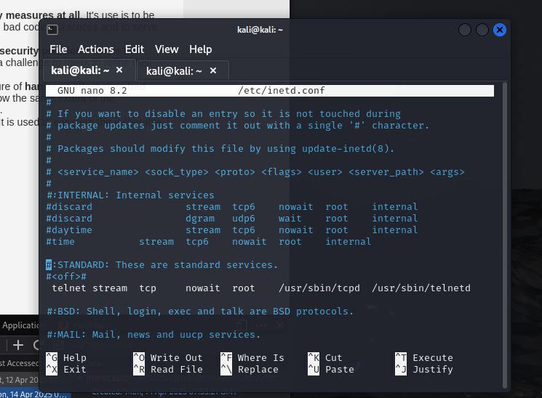
sudo nano /etc/inetd.conf
telnet stream tcp nowait telnet /usr/sbin/telnetd/ telnetd (lam nhu hinh tren. Ctrl x,y,enter)
sudo systemctl restart openbsd-inetd
sudo ss -tuln | grep :23

Nếu lỗi mạng Cách nhanh nhất – reset firewall:
sudo iptables -P INPUT ACCEPT
sudo iptables -P FORWARD ACCEPT
sudo iptables -P OUTPUT ACCEPT
sudo iptables -F
Bật lại card mạng
sudo ip link set ens33 up
Cấp lại đỉa chỉ IP
sudo dhclient ens33
Khởi động lại dịch vụ mạng:
sudo systemctl restart NetworkManager
Cap lai quyen ở phần INPUT,OUTPUT

Forward (3ubuntu, clone. Catmang: may sv 2cat:1Vmnet4(host-only), 2host-only. May ubuntu 1:Vmnet4(host-only). May ubuntu 2host-only)
3 mấy dều cài
sudo apt-get update
sudo apt-get install traceroute
--------
Cấu hình router (may sv)
sudo nano /etc/netplan/01-netcfg.yaml
network:
version:2
renderer: networkd
ethernets:
ens33:
addresses:
- 192.168.110.170/24
nameservers:
addresses:
- 8.8.8.8
- 8.8.4.4

sudo netplan apply

Cấu hình router (may ubuntu 1(source))
sudo nano /etc/netplan/01-netcfg.yaml
network:
version: 2
renderer: networkd
ethernets:
ens37:
addresses:
- 192.168.110.175/24
gateway4: 192.168.110.170
nameservers:
addresses:
- 8.8.8.8
- 8.8.4.4

sudo netplan apply

may sv
sudo sysctl -w net.ipv4.ip_forward=1
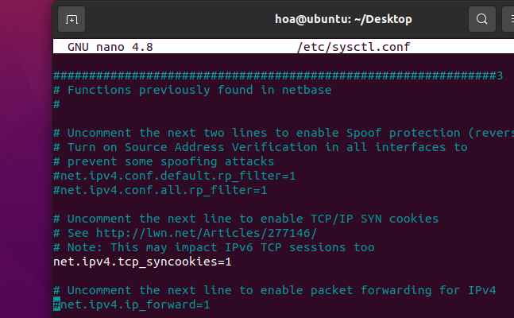
sudo nano /etc/sysctl.conf
sudo sysctl -p
sudo systemctl restart systemd-networkd
sudo netplan apply

may ubuntu 2
sudo ip route del default (xoa cong mac dinh)
sudo ip route add default via 192.168.58.140 (ip may sv)
ip route show (xem)

may sv
cat /proc/sys/net/ipv4/ip_forward (ok:1, loi:0)
Cap quyen forward->run
sudo iptables -A FORWARD -i ens33 -o ens37 -j ACCEPT
sudo iptables -A FORWARD -i ens37 -o ens33 -j ACCEPT
sudo iptables -L -v -n

may 1
sudo ip route add default via 192.168.110.170 (ip may sv)
sudo ip route add 192.168.58.0/24 via 192.168.110.170
sudo systemctl restart systemd-networkd

may 2
sudo ip route add 192.168.110.0/24 via 192.168.58.170

sudo systemctl restart systemd-networkd

