BÀI 1:
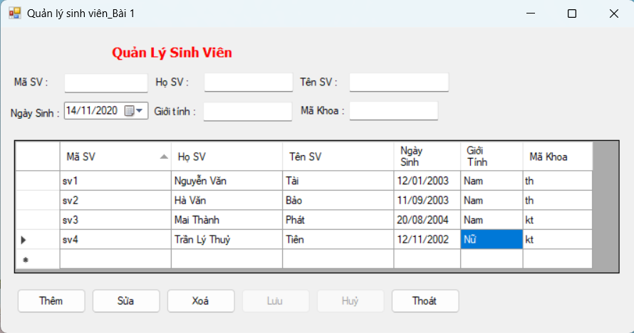
Thực hiện các nút chức năng
Hướng dẫn:
- Xây dựng class có tên: “KetNoiDuLieu”
public class KetNoiDuLieu
{
public SqlConnection cnn = new SqlConnection("Data Source=.;Initial Catalog=QLDIEMSV;Integrated Security=True;");
public void myconnect()
{
cnn.Open();
}
public void myClose()
{
cnn.Close();
}
public DataTable taobang(string sql)
{
DataTable dt = new DataTable();
SqlDataAdapter ds = new SqlDataAdapter(sql,cnn);
ds.Fill(dt);
return dt;
}
public void them(string ma,string ho,string ten,DateTime ngaysinh,string phai, string makhoa)
{
string sql="insert into DMSV(MaSV,HoSV,TenSV,NgaySinh,Phai,MaKhoa)"+ "values('"+ ma +"',N'"+ ho +"',N'"+ ten +"','"+ ngaysinh.ToShortDateString() +"',N'"+ phai +"','"+ makhoa +"')";
SqlCommand cmd = new SqlCommand(sql,cnn);
cmd.ExecuteNonQuery();
}
public void xoa(string ma, string ho, string ten, DateTime ngaysinh, string phai, string makhoa)
{
string sql = "delete from dmsv where MaSV='"+ ma +"'";
SqlCommand cmd = new SqlCommand(sql,cnn);
cmd.ExecuteNonQuery();
}
public void sua(string ma, string ho, string ten, DateTime ngaysinh, string phai, string makhoa)
{
string sql = "update dmsv set HoSV=N'"+ ho +"',TenSV=N'"+ ten +"',NgaySinh='"+ ngaysinh.ToShortDateString() +"',Phai=N'"+ phai +"',MaKhoa='"+ makhoa +"' where MaSV='"+ ma +"'";
SqlCommand cmd = new SqlCommand(sql,cnn);
cmd.ExecuteNonQuery();
}
}
}
//----------------------
Các chức năng trên Form:
KetNoiDuLieu kn = new KetNoiDuLieu();

private void cmd_Thoat_Click(object sender, EventArgs e)
{
this.Close();
kn.myClose();
}
public void LoadDuLieu()
{
string sql = "SELECT * FROM DMSV";
dataGridViewSV.DataSource = kn.taobang(sql);
}

private void Form1_Load(object sender, EventArgs e)
{
kn.myconnect();
LoadDuLieu();
this.cmd_Luu.Enabled = false;
this.cmd_Huy.Enabled = false;
}

private void dataGridViewSV_CellContentClick(object sender, DataGridViewCellEventArgs e)
{
int chiso = -1;
DataTable bang = new DataTable();
bang = (DataTable)dataGridViewSV.DataSource;
chiso = dataGridViewSV.SelectedCells[0].RowIndex;
DataRow hang = bang.Rows[chiso];

txt_MaSV.Text = hang["masv"].ToString();
txt_HoSV.Text = hang["hosv"].ToString();
txt_TenSV.Text = hang["tensv"].ToString();
txt_MaKhoa.Text = hang["makhoa"].ToString();
txt_GioiTinh.Text = hang["phai"].ToString();
dt_NgaySinh.Value = Convert.ToDateTime(hang["ngaysinh"].ToString());
}

private void cmd_Them_Click(object sender, EventArgs e)
{
txt_MaSV.ResetText();
txt_HoSV.ResetText();
txt_MaKhoa.ResetText();
txt_GioiTinh.ResetText();
dt_NgaySinh.ResetText();
txt_TenSV.ResetText();
txt_MaSV.Focus();

this.cmd_Luu.Enabled = true;
this.cmd_Huy.Enabled = true;
this.cmd_Them.Enabled = false;
LoadDuLieu();
}

private void cmd_Luu_Click(object sender, EventArgs e)
{
this.cmd_Them.Enabled = true;
this.cmd_Luu.Enabled = false;
this.cmd_Huy.Enabled = false;

string s = "SELECT * FROM DMSV where MaSV='"+ txt_MaSV.Text +"'";
DataTable dt = new DataTable();
dt = kn.taobang(s);
if(dt.Rows.Count==0)
{
kn.them(txt_MaSV.Text,txt_HoSV.Text,txt_TenSV.Text,dt_NgaySinh.Value,txt_GioiTinh.Text,txt_MaKhoa.Text);

txt_GioiTinh.ResetText();
txt_HoSV.ResetText();
txt_MaKhoa.ResetText();
txt_MaSV.ResetText();
dt_NgaySinh.ResetText();
txt_TenSV.ResetText();
txt_MaSV.Focus();
}
else
{
MessageBox.Show("Mã số sinh viên đã có, vui lòng nhập lại", "Thông Báo",MessageBoxButtons.OK,MessageBoxIcon.Information);
}
LoadDuLieu();
}

private void cmd_Xoa_Click(object sender, EventArgs e)
{
string s = "SELECT * FROM DMSV where MaSV='" + txt_MaSV.Text + "'";
DataTable dt = new DataTable();
dt = kn.taobang(s);
if(dt.Rows.Count !=0)
{
kn.xoa(txt_MaSV.Text, txt_HoSV.Text, txt_TenSV.Text, dt_NgaySinh.Value, txt_GioiTinh.Text, txt_MaKhoa.Text);

txt_GioiTinh.ResetText();
txt_HoSV.ResetText();
txt_MaKhoa.ResetText();
txt_MaSV.ResetText();
dt_NgaySinh.ResetText();
txt_TenSV.ResetText();
txt_MaSV.Focus();
}
else
{
MessageBox.Show("Bạn chưa chọn dữ liệu để xoá", "Thông Báo",MessageBoxButtons.OK,MessageBoxIcon.Information);
}
LoadDuLieu();
}

private void cmd_Sua_Click(object sender, EventArgs e)
{
string s = "SELECT * FROM DMSV where MaSV='" + txt_MaSV.Text + "'";
DataTable dt = new DataTable();
dt = kn.taobang(s);
if(dt.Rows.Count !=0)
{
kn.sua(txt_MaSV.Text, txt_HoSV.Text, txt_TenSV.Text, dt_NgaySinh.Value, txt_GioiTinh.Text, txt_MaKhoa.Text);
}
else
{
MessageBox.Show("Bạn chưa chọn dữ liệu để sửa", "Thông Báo", MessageBoxButtons.OK, MessageBoxIcon.Information);
}
LoadDuLieu();
}

private void cmd_Huy_Click(object sender, EventArgs e)
{
txt_GioiTinh.ResetText();
txt_HoSV.ResetText();
txt_MaKhoa.ResetText();
txt_MaSV.ResetText();
dt_NgaySinh.ResetText();
txt_TenSV.ResetText();
txt_MaSV.Focus();

this.cmd_Them.Enabled = true;
LoadDuLieu();
}
}
//----------------------------------
BÀI 2:
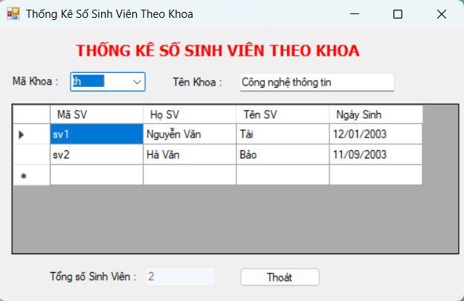
public class KetNoiDuLieu
{
public SqlConnection cnn = new SqlConnection("Data Source=.;Initial Catalog=QLDIEMSV;Integrated Security=True;");
public void myconnect()
{
cnn.Open();
}
public void myclose()
{
cnn.Close();
}
public DataTable taobang(string sql)
{
DataTable dt = new DataTable();
SqlDataAdapter ds = new SqlDataAdapter(sql,cnn);
ds.Fill(dt);
return (dt);
}
}
//----------------------
KetNoiDuLieu kn = new KetNoiDuLieu();
private void cmd_Thoat_Click(object sender, EventArgs e)
{
this.Close();
kn.myclose();
}

private void Form1_Load(object sender, EventArgs e)
{
kn.myconnect();
string sql = "SELECT * FROM DMKHOA";
cbMaKhoa.DataSource = kn.taobang(sql);
cbMaKhoa.DisplayMember = "MaKhoa";
}

private void cbMaKhoa_SelectedIndexChanged(object sender, EventArgs e)
{
//load dữ liệu từ Combobox xuống text
string s = "SELECT * FROM DMKHOA where MaKhoa='" + cbMaKhoa.Text +"'";
DataTable d = kn.taobang(s);
foreach (DataRow hang in d.Rows)
txt_TenKhoa.Text = hang["TenKhoa"].ToString();
//load dữ liệu lên DataGridview
string s1 = "SELECT MaSV,HoSV,TenSV,NgaySinh From DMSV sv,DMKHOA kh where (sv.MaKhoa=kh.MaKhoa) and (kh.MaKhoa='"+ cbMaKhoa.Text +"')";
dataGridViewSV.DataSource = kn.taobang(s1);

string s2 = "SELECT COUNT(MaKhoa) FROM DMSV where MaKhoa='" + cbMaKhoa.Text + "' group by MaKhoa";
txt_TongSV.Text=(dataGridViewSV.Rows.Count-1).ToString();
}
}
//-------------------------------
BÀI 3:
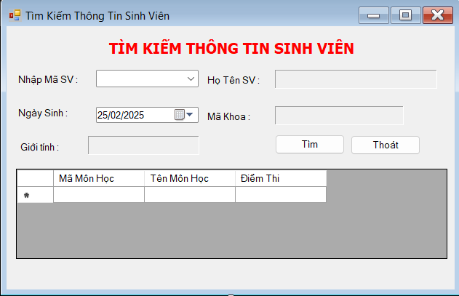

BÀI 4:
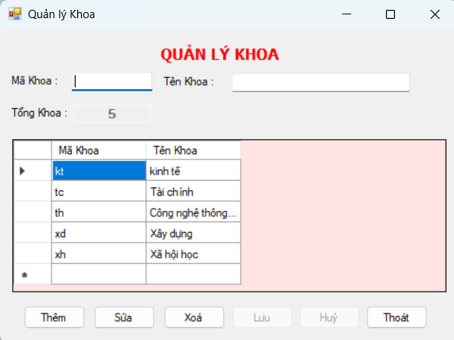
BÀI 5:
