
National College of Ireland
MSc in Artificial Intelligence
Module: Engineering and Evaluating Artificial Intelligence (MSCAI1)
Lecturer: Dr Abdul Razzaq, Dr Abdul Shahid, Sallar Khan
Date of Submission: 26 March 2026

Project Title: Continuous Assessment
Student Name: Enrique Piña Jaime, Dylan Boyle
Student ID: 24218146, 24302911

Design Choice 1 Implemented Chained Multi-Outputs:
In this design, one model family evaluates three chained targets per email instance: Type 2, Type 2 + Type 3, and Type 2 + Type 3 + Type 4. The preprocessing pipeline runs once and the same DatasetBundle is passed to each model implementation through a shared abstract interface. Type 1 is excluded because no classification is required for that column in the provided data.
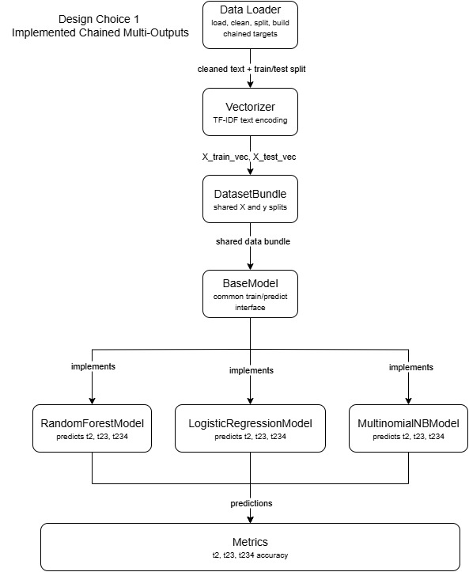

Components Design Choice 1
Component | Type | Responsibility
src/main_controller.py | Controller | Runs the full pipeline: load data, vectorize text, create the DatasetBundle, run the models, and evaluate results
data/Purchasing.csv, data/AppGallery.csv | Data sources | CSV files used as input datasets
src/config.py | Configuration | Defines dataset path, column names, test size, random state, minimum class count, and maximum TF-IDF features
src/preprocessing/data_loader.py | Preprocessing | Loads CSV, applies text cleaning, handles missing labels, builds chained targets (t2, t23, t234), splits train/test
src/preprocessing/text_cleaner.py | Preprocessing | Provides reusable text cleaning utilities used by the loader
src/features/vectorizer.py | Feature engineering | Fits TF-IDF on training text and transforms train and test sets into numeric matrices
src/data_models/dataset_bundle.py | Data model | Encapsulates X_train, X_test and the three target sets (t2, t23, t234) in a single object
src/models/base_model.py | Abstract interface | Defines the common model API: train(data_bundle) and predict(data_bundle)
src/models/random_forest_model.py | Model implementation | Implements BaseModel using three RandomForestClassifier instances, one per chained target
src/models/logistic_regression_model.py | Model implementation | Implements BaseModel using three LogisticRegression instances, one per chained target
src/models/multinomial_nb_model.py | Model implementation | Implements BaseModel using three MultinomialNB instances, one per chained target
src/evaluation/metrics.py | Evaluation | Computes and prints accuracy for each chained target (t2, t23, t234)
tests/test_pipeline.py | Testing | Smoke test that runs the pipeline end to end and validates it completes successfully

Connectors Design Choice 1
Connector | From | To | Description
load and prepare data | main_controller.py | data_loader.py | Controller calls load_dataset() and split_dataset() to read and prepare the data
clean text | data_loader.py | text_cleaner.py | Loader calls clean_text() to normalize raw email text
TF-IDF transform | main_controller.py | vectorizer.py | Controller calls vectorize_text() to fit on training text and transform train/test sets
build bundle | main_controller.py | dataset_bundle.py | Controller packages features and targets into a DatasetBundle object
train and predict | main_controller.py | model instances | Controller instantiates each model class and calls train(data_bundle) and predict(data_bundle) through the shared BaseModel interface.
predictions | model instances | metrics.py | Prediction dictionaries (keys: t2, t23, t234) are passed to evaluate_predictions()
evaluation output | metrics.py | console output | Accuracy results are formatted and printed to the console.
pipeline test | test_pipeline.py | pipeline modules | Smoke test executes the pipeline and checks it runs without errors

Data Elements Design Choice 1
Data Element | Type | Description
Interaction content | text | Primary email text field used as model input
Type 2 / Type 3 / Type 4 | categorical labels | Dependent label columns used to form chained targets
target_t2 | string/categorical | Chained target containing Type 2 only
target_t23 | string/categorical | Chained target combining Type 2 and Type 3
target_t234 | string/categorical | Chained target combining Type 2, Type 3, and Type 4
X_train / X_test | text collections | Training and test text prior to vectorization
X_train_vec / X_test_vec | numeric matrices | TF-IDF feature matrices produced by the vectorizer
y_train_t2 / y_test_t2 | label arrays | Train/test labels for target_t2
y_train_t23 / y_test_t23 | label arrays | Train/test labels for target_t23
y_train_t234 / y_test_t234 | label arrays | Train/test labels for target_t234
DatasetBundle | Python object | Encapsulated container carrying X and y splits for the pipeline
predictions | dict/arrays | Predicted labels for t2, t23, and t234 returned by the model
accuracy metrics | floats | t2_accuracy, t23_accuracy, t234_accuracy

Design Choice 2 Proposed Hierarchical Modelling:
In this design, model instances are chained by level rather than outputs. A Level 1 model predicts Type 2 on the full dataset. Its predictions are used to filter the data into class-specific subsets, and a dedicated Level 2 model is trained on each subset to predict Type 3. The process repeats for Type 4 at Level 3, resulting in multiple model instances whose count scales with the number of classes at each preceding level.
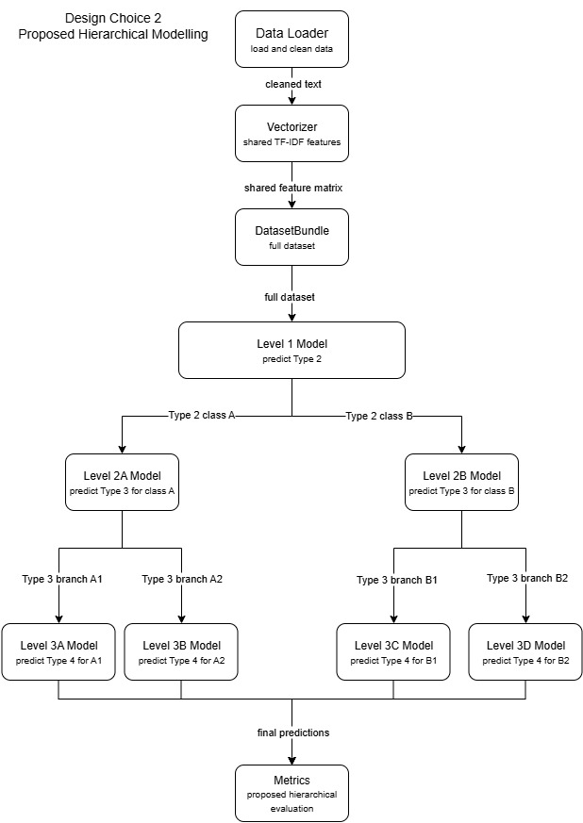

Components Design Choice 2
Component | Type | Responsibility
src/main_controller.py | Controller | Runs the hierarchical pipeline: prepare data, create shared features, run Level 1, create branches, and evaluate results
data/Purchasing.csv, data/AppGallery.csv | Data sources | CSV files used as input datasets
src/config.py | Configuration | Defines dataset path, column names, test size, random state, minimum class count, and maximum TF-IDF features
src/preprocessing/data_loader.py | Preprocessing | Loads CSV, applies text cleaning, handles missing labels, and prepares Type 2, Type 3, and Type 4 labels for hierarchical classification
src/preprocessing/text_cleaner.py | Preprocessing | Provides reusable text cleaning utilities used by the loader
src/features/vectorizer.py | Feature engineering | Creates a shared TF-IDF representation used by all hierarchy levels
src/data_models/dataset_bundle.py | Data model | Full DatasetBundle for Level 1; filtered DatasetBundle instances per branch for Level 2 and Level 3
src/models/base_model.py | Abstract interface | Common train/predict API used by all hierarchy-level model instances
src/models/random_forest_model.py | Model implementation | Reused as the base classifier at each hierarchy level
src/models/logistic_regression_model.py | Model implementation | Alternative classifier available at each hierarchy level
src/models/multinomial_nb_model.py | Model implementation | Alternative classifier available at each hierarchy level
src/evaluation/metrics.py | Evaluation | Computes per-level and end-to-end evaluation metrics for the hierarchy
tests/test_pipeline.py | Testing | Smoke test for the base pipeline used by the hierarchical architecture
Connectors Design Choice 2
Connector | From | To | Description
load and prepare data | main_controller.py | data_loader.py | Proposed controller loads the dataset and prepares the labels for hierarchical classification.
clean text | data_loader.py | text_cleaner.py | Loader calls clean_text() to normalize raw email text before feature generation.
TF-IDF transform | main_controller.py | vectorizer.py | Controller calls vectorize_text() to create a shared TF-IDF representation for all hierarchy levels.
build base bundle | main_controller.py | dataset_bundle.py | Controller packages the full feature matrix and labels into a base DatasetBundle for Level 1.
level 1 classification | dataset_bundle.py | Level 1 model | The full dataset is passed to the Level 1 model to predict Type 2.
filter by Type 2 class | Level 1 predictions | Level 2 models | Predicted Type 2 classes are used to create class-specific subsets for Level 2 Type 3 models.
filter by Type 3 branch | Level 2 predictions | Level 3 models | Predicted Type 3 branches are used to create filtered subsets for Level 3 Type 4 models.
final predictions | Level 3 models | metrics.py | Final branch predictions are collected and passed to the evaluation component.
evaluation output | metrics.py | console output | Proposed hierarchical evaluation reports performance by level and overall hierarchy.

Data Elements Design Choice 2
Data Element | Type | Description
Interaction content | text | Same primary input field as DC1.
Type 2 / Type 3 / Type 4 | categorical labels | Separate labels used at Levels 1, 2, and 3 respectively.
Shared feature matrix | numeric matrix | Single TF-IDF representation used by all hierarchy levels.
Type 2 subsets | filtered datasets | Partitions of the data created per Type 2 class for Level 2.
(Type 2, Type 3) subsets | filtered datasets | Partitions created per (Type 2, Type 3) branch for Level 3.
Level 1 predictions | label arrays | Predicted Type 2 labels.
Level 2 predictions | label arrays | Predicted Type 3 labels per Type 2 branch.
Level 3 predictions | label arrays | Predicted Type 4 labels per (Type 2, Type 3) branch.
Per-level and end-to-end metrics | floats/dicts | Accuracy computed per level and for the overall hierarchy.

