**~Java~**

**Fast-Facts:**

* File and Class names MUST BE EXACT.
* main is a method that defines the entry point for executable java files. It is required for any file intended to run from the command line
* System.out.println(“”) enables us to output something to the command prompt.
* Case Sensitivity: Java is case sensitive this means “Hello” and “hello” have different meaning.
* Class Names: class. Names are written in PascalCase or UpperCamelCase. Each word is capitalized with no spaces in between.
* Method Names: all method names should start with a lower-case letter. If there are multiple words, then the method should be written in lowerCamelCase.
* Program Filename: The name of the program file should match the class name exactly.
* Mandatory Method: Java program processing starts from the **main()** method which is mandatory part of Java program. It should look like this



**Set-Up:**

In order to set JAVA up on the computer we need to download it. Go to the Oracle Website and look for Java SE Development Kit 8 (JDK). The JDK is a development environment for building applications, applets, and components using Java programing language.

We need to install: Java SE Development Kit 8

NOTE: Choose the appropriate package for your operating system.

After its downloads run the file and follow the instructions in the installer.

To check if the installation was successful, open the terminal and type the command: javac

If the JDK was installed correctly you should see something like this:

If the JDK installed incorrectly you may see this:

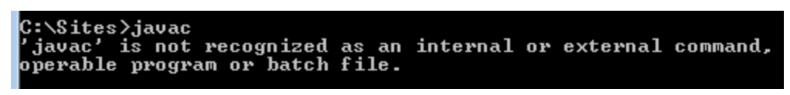

This error means the installer did not put javac into your PATH variable automatically. More commonly found with Windows users.

**OOP:**

**Preview**

Hello World Syntax

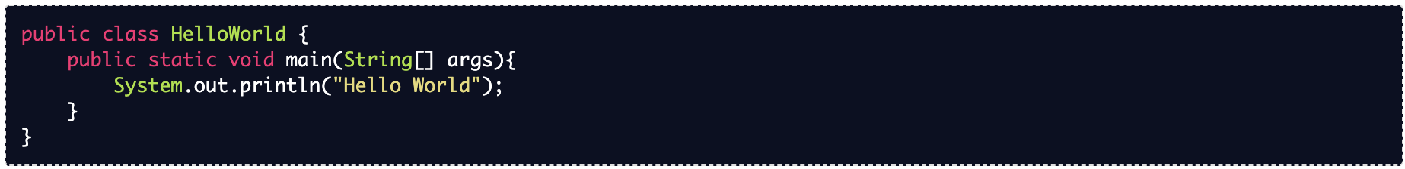

Every application begins with a **class** definition. A class can contain multiple methods (they must be enclosed between the class opening and closing curly brace tag).

The entry point is the **main() method** so it is important to have it. The method signature for the main() method contains three modifiers.

* **public:** this is known as an access modifier. Any public method we write is accessible from any other class or method in our project.
* **static:** means that the method belongs to and is called from the class itself rather than from an instance of the class
* **void:** indicates that the main() method doesn’t return anything

**Variables:**

**Fast-Facts**

type variableName; - The pattern for declaring variable in Java

variableName = value; - to assign a value to a variable.

**Data Types**

-Primitive Types

Note: Primitive types are lowercase

* **int**: an int holds integers, like 4 or -51. It is limited between -2147483648 – 2147483648, or around 2 billion.
* **long**: These are for larger integers up to 2^63, or around 2 quintillion.
* **boolean**: a Boolean represents one of the two values: true or false
* **double**: Doubles are for floating point numbers like 3.14. We will use double rather than float almost exclusively because they are far more precise.
* **char**: The char data type is used to store a single character, like ‘$’ or ‘A’.

-Object Types

Note: Object types are capitalized.

* **Integer**:The Integer class wraps a value of the primitive type int into an object.
* **Long**: The Long class wraps a value of the primitive type long in an object.
* **Boolean**:The Boolean class wraps a value of the primitive type boolean in an object.
* **Double**: The Double class wraps a value of the primitive type double in an object.
* **Character**: The Character class wraps a value of the primitive type char in an object.
* **String**: Represents a sequence of characters, like a Python string.
* **BigInteger**: Represents an integer that can be any size at all.