Dylan Smith

1)

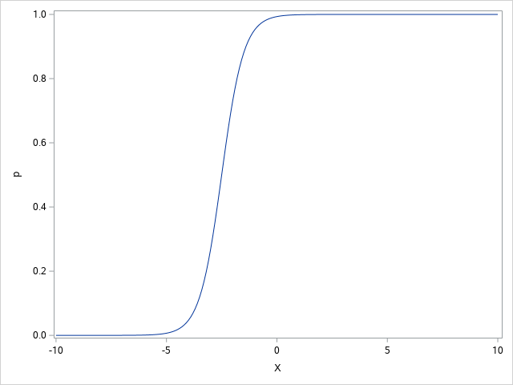

Original Curve

1a-

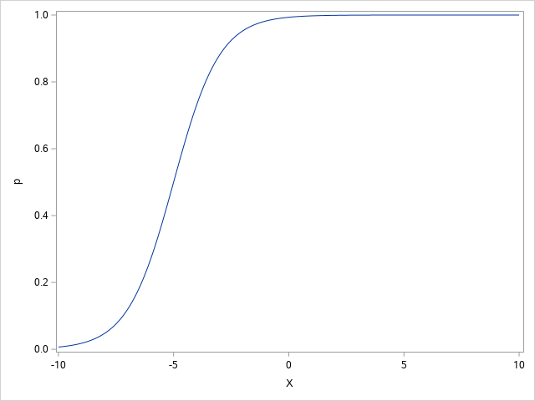

There is an obvious shift to the left on the bottom half of the graph with the rise starting between -10 and -5.

1b-

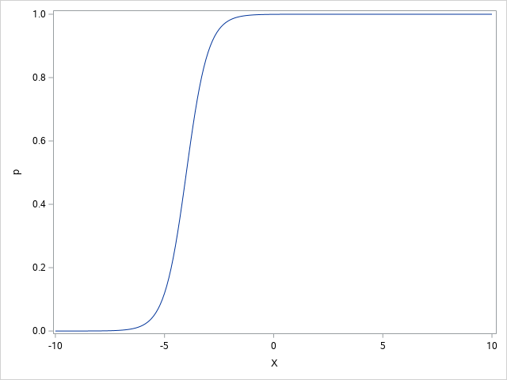

Again, there is a left shift of on the bottom half, but there is a sharper rise over -5.

1c-

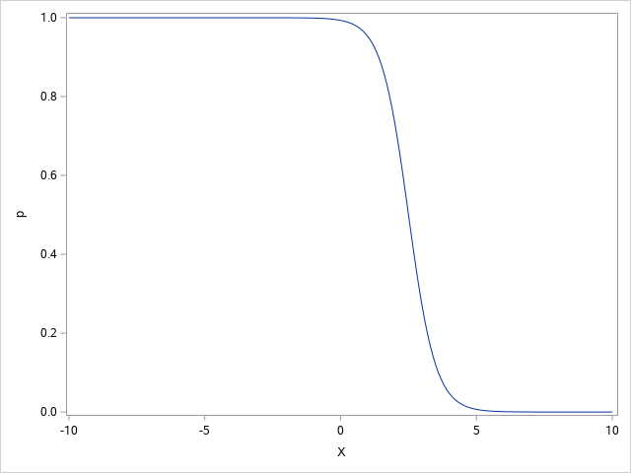

The original curve has been inversed at 0 of the Y axes.

2)

Plot 1 = (2,1)

Plot 2= (2,0)

Plot 3 = (0, -1)

Plot 4 = (2,-1)

Plot 5 = (-2,-1)

Plot 6 = (-2,1)

Plot 7 = (0,0)

Plot 8 = (0,1)

Plot 9 = (-2,0)

3;9.15)

3a-

Odds = -2.086+0.5117×6 = .9842

3b-

.9842/1+.9842 = .496

3c-

Odds = -2.086+0.5117×7=1.4959

3d-

The odds ratio is almost doubled from .98 to 1.5.

3;9.16)

SAS graph-

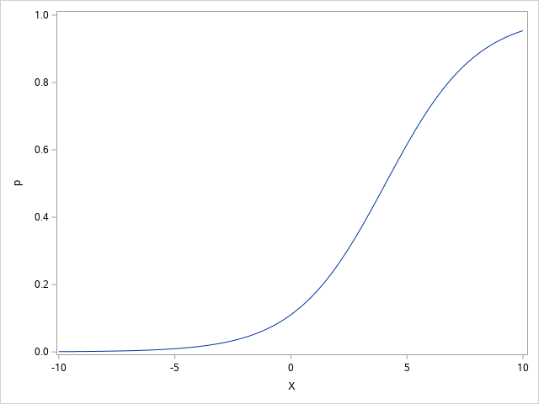

It seems according to the graph that the tumor would need to be around 5 cm to have an 80% probability (this shows an error in either my calculations above or in the making of the graph).

4)

4a-

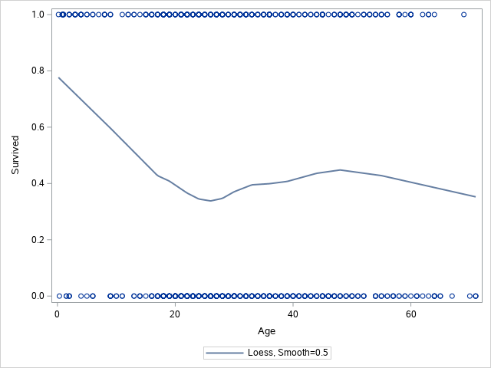

As expected, there is not a clear pattern between age and survival. It is hard to see this due to survived being coded as 1 and 0 for yes and no.

4b-

|  |  |  |
| --- | --- | --- |
| **-2 Log L** | 1025.573 | 1022.723 |

|  |  |  |  |
| --- | --- | --- | --- |
| **Wald** | 2.8260 | 1 | 0.0928 |

Logistic model = 1025.573 – 1022.723 = 2.85

The output of 2.85 when tested for significance shows that there is no significance between Age and Survived with a value of .0928.