MahjongSensei
Interactive Mahjong Learning and Training Platform
Milestone 2 Project README
Orbital 2026 | Target Level of Achievement: Apollo
Team members: Chew An Jie, Dylan Wee

Contents
Contents 2
1. Overview and Motivation 3
2. User Stories 3
3. Technology Stack 3
4. System Architecture 4
5. Authentication and Session Management 4
6. Data Model 5
7. Mahjong Game Engine 6
8. Core Features 7
8.1 Interactive Tutorial 8
8.2 Hand Helper 8
8.3 Interactive Trainer 8
8.4 Points (Tai) System 9
8.5 Solo Play 9
9. API Reference 10
10. Testing 11
11. Bugs and Problems Encountered 11
12. Software Engineering Practices 12
13. Running the Project Locally 13
14. Milestone 2 Project Log 13
Planned for Milestone 3 13

1. Overview and Motivation
MahjongSensei is a web application that helps people learn and improve at Singaporean Mahjong. The game has a steep learning curve: beginners struggle with tile recognition, hand structure, scoring, and deciding which tile to discard, and they rarely have an experienced player on hand to give feedback after each move.
Our motivation is personal. One of us, Dylan, founded MahjongTogether in 2022, a community Mahjong session for the elderly, and the single biggest barrier to participation was always the learning curve. MahjongSensei addresses this by combining guided lessons, real time hand analysis, interactive practice, and a single player game against computer opponents, so a complete beginner can progress from understanding the rules to making stronger decisions on their own.
This document describes the state of the project at Milestone 2. It covers the system architecture, the data model, the Mahjong game engine, each core feature (explained from both a user and a developer perspective), the testing approach, notable bugs we solved, and the software engineering practices we follow.

2. User Stories
- As a beginner, I want to learn the rules and hand structure through clear lessons and quizzes, so that I can start playing without relying on another person to teach me.
- As a learner, I want to see worked examples of valid hands and how they score, so that I understand how winning hands are formed.
- As an intermediate player, I want to enter a hand and receive a recommended discard with reasoning, so that I can compare my own judgement with the system.
- As a practice focused player, I want generated training hands with immediate feedback, so that I can drill my discard decisions and track my accuracy.
- As a player who wants a full game, I want to play a round against computer opponents, so that I can apply what I have learned in a realistic setting.

3. Technology Stack
We use a layered, decoupled stack so that the game logic, the web API, and the user interface can each evolve independently and be tested in isolation.
Layer | Technology | Role in this project
Frontend | React (Create React App), React Router, Axios | Single page application that renders the tutorial, hand tools, trainer and solo game, and talks to the backend over HTTP.
Backend API | Django and Django REST Framework | URL routing, request handling, authentication, and serialization between JSON and the engine and database.
Game logic | Pure Python (object oriented) | Tiles, deck, hands, melds, win detection, valuation, scoring, and the solo game loop. No Django imports, so it is unit testable on its own.
Database | PostgreSQL via the Django ORM | Stores users, profiles, tutorial progress, and trainer sessions and moves. SQLite is supported as a local fallback.
Authentication | SimpleJWT (JSON Web Tokens) | Stateless access and refresh tokens for protected API access.
Testing | Django test runner and Pytest style assertions | Unit, integration, and edge case tests for the engine and the API.

4. System Architecture
The system is organised into four cooperating layers. The React application is the only part the user interacts with directly. Every action that needs game logic or persistent data is sent as an HTTP request through a shared Axios client, which attaches the user's JWT access token. Django REST Framework receives the request, checks authentication, and routes it to the relevant Django app.
The backend is split into three Django apps by responsibility. The users app handles registration and profile data. The game app owns the Mahjong engine, the hand tools, the trainer, and the solo game. The tutorial app owns lesson progress. The game app is deliberately the only layer that imports the Python engine, which keeps the engine reusable across the Hand Helper, the Trainer, and Solo Play. PostgreSQL stores all persistent data and is reached only through the Django ORM.
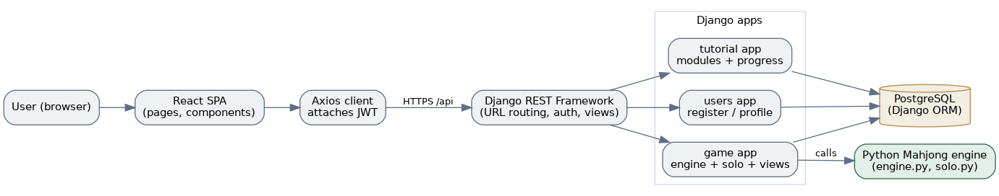
Figure 1. High level architecture and how a request flows from the browser to the engine and database.
Why this split matters: the same valuation and win checking code runs behind three different features and behind the automated tests. If we change how a discard is valued, every feature and test that depends on it picks up the change in one place. Keeping the engine free of Django imports also means we can run and test thousands of simulated games quickly without a database.

5. Authentication and Session Management
Authentication uses JSON Web Tokens. On login the backend issues an access token and a refresh token. The frontend stores both and the Axios client adds the access token to the Authorization header of every request. Because access tokens are short lived, the Axios client also detects an expired token (a 401 response), uses the refresh token to obtain a new access token, retries the original request, and only sends the user back to the login page if the refresh itself fails.
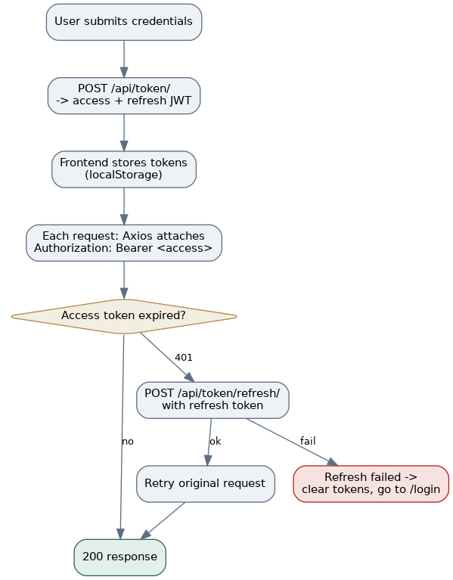
Figure 2. Login, token attachment, and the automatic refresh and retry path.
On a page reload the frontend restores the session by reading the stored token and fetching the profile, so the user does not appear logged out after refreshing. All game and tutorial endpoints require a valid token, so a user can only ever read or change their own data.

6. Data Model
Persistent data is modelled with five tables. The built in Django User holds credentials. Profile extends it with summary statistics. Session and Move record trainer activity, and TutorialProgress records lesson completion. Trainer moves are stored as JSON so that a whole dealt hand, the user's discard, and the engine's correct discard can be saved in one row for later review.
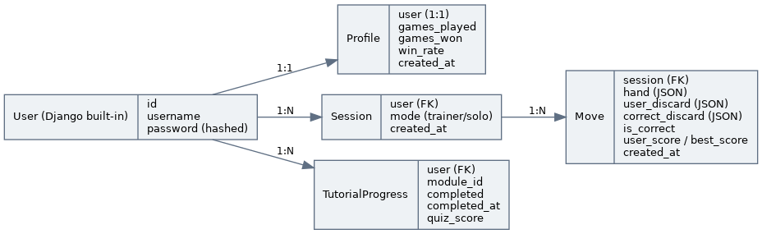
Figure 3. Entity relationship diagram of the persistent data.
Model | Key fields | Purpose
Profile | user (one to one), games_played, games_won, win_rate, created_at | Per user summary stats shown on the profile page; foundation for the future dashboard.
Session | user (FK), mode (trainer or solo), created_at | Groups a user's attempts. Used now by the Trainer.
Move | session (FK), hand, user_discard, correct_discard, is_correct, user_score, best_score, created_at | One trainer round: the dealt hand and how the user's discard compared to the optimal one.
TutorialProgress | user (FK), module_id, completed, completed_at, quiz_score | Records which tutorial modules a user has finished and the quiz score. Unique per user and module.

7. Mahjong Game Engine
The engine in backend/game/engine.py is a set of small object oriented classes. Each has one clear responsibility, which keeps the logic readable and testable. A second module, backend/game/solo.py, builds on these classes to run a full game.
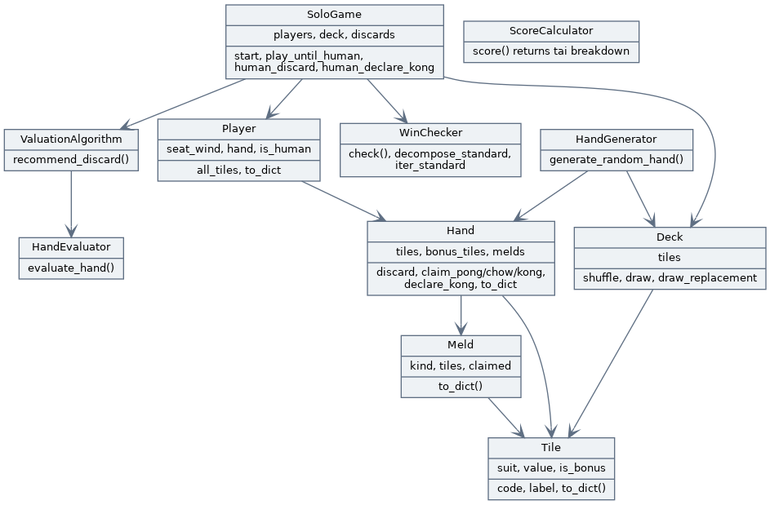
Figure 4. Engine class structure and the main relationships between classes.
Tile, Deck, Hand, Meld. Tile is an immutable tile with a suit, a value, and a bonus flag. Deck builds and shuffles the full 148 tile Singaporean set (108 suited, 28 honours, 8 flowers, 4 animals) and can draw a replacement after a Kong or a bonus draw. Hand separates concealed playable tiles from bonus tiles, and holds locked melds. Meld represents a Pong, Kong, or Chow and carries a claimed flag that marks whether it was taken from another player's discard.
HandGenerator. Draws a valid starting hand, automatically setting aside flower and animal tiles and drawing replacements so the playable hand is always the right size.
HandEvaluator and ValuationAlgorithm. HandEvaluator gives a hand a numeric strength score by rewarding complete sets, pairs, and near sequences and penalising isolated tiles. ValuationAlgorithm tries removing each tile in turn and returns the discard that leaves the strongest remaining hand, together with a short reason. This is the shared brain used by the Hand Helper, the Trainer, and the AI opponents.
WinChecker. Detects a complete hand and which pattern it forms: a standard hand of four sets and a pair, Seven Pairs, or Thirteen Orphans. It is Kong aware, so a winning hand may be 14 to 18 tiles (one extra tile per Kong), and for a standard win it also returns the decomposition (the pair and the four melds) so the scorer can read it.
ScoreCalculator. Scores a winning hand in tai (points). It awards seat wind and round wind Pongs and Kongs, dragon Pongs and Kongs, seat flowers and animals by position, and patterns such as All Pongs and flushes. It enforces a minimum of one tai to win, and when a hand can be read more than one way it scores every reading and keeps the best.

8. Core Features
Each feature is described in three parts: what it does, how it works for a developer (the data flow), and how it feels for a user.

8.1 Interactive Tutorial
Function. A structured, module based tutorial covering tile recognition, meld types (Pong, Kong, Chow), and winning hand basics. Each module ends with a short multiple choice quiz, and completion is saved per user.
Data flow. On opening the page, the frontend calls GET /api/tutorial/modules/, which returns the module catalogue with the current user's completion merged in. Lesson content (the explanatory text and example tiles) lives on the frontend, while completion and quiz scores are persisted on the backend. When the user finishes a quiz, the frontend calls POST /api/tutorial/complete/ with the module id and score, and the backend upserts a TutorialProgress row.
User flow. The user opens Tutorial, sees the list of modules with completion ticks, steps through the lessons with visual tile cards and meld demonstrations, answers the quiz, and sees the module marked complete. Because completion is stored server side, it remains after a page reload or a new login.

8.2 Hand Helper
Function. The user assembles a 14 tile hand with a visual tile picker and receives the recommended discard, with a short reason and a strength score.
Data flow. The frontend posts the selected tiles to POST /api/game/recommend-discard/. The view validates the input (exactly 14 tiles, valid suits and values, no more than four copies of any tile), builds a Hand, and runs ValuationAlgorithm. The chosen discard, reason, and score are returned as JSON and rendered.
User flow. The user taps tiles to build a hand, the counter tracks progress to 14, then presses Recommend Discard and sees which tile to drop and why.

8.3 Interactive Trainer
Function. The app deals a hand and challenges the user to choose the best discard, then scores the choice against the engine and gives immediate feedback. Every attempt is logged so accuracy can be tracked.
Data flow. POST /api/game/trainer/new/ generates a 14 tile hand, saves a pending Move, and returns the tiles without the answer. The user picks a tile and the frontend calls POST /api/game/trainer/submit/. The view scores the chosen discard against ValuationAlgorithm, records the result on the Move, and returns whether it was optimal, the correct discard, and the reasoning. GET /api/game/trainer/history/ returns past attempts and an accuracy percentage.
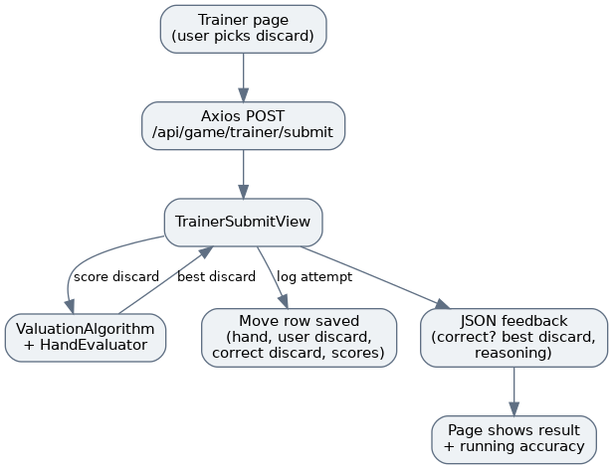
Figure 5. Data flow for submitting a discard in the Trainer.
User flow. The user is dealt a hand, taps the tile they would discard, submits, and immediately sees whether it was the optimal play, what the best discard was, and a running tally of how many they have gotten right.

8.4 Points (Tai) System
Function. Scores a completed hand using Singaporean tai rules, including a wind and position tracker and the rule that a hand must be worth at least one tai to win.
Data flow. POST /api/game/score-hand/ accepts the hand, optional bonus tiles, the player's seat wind, and the round wind. The view checks the hand with WinChecker and scores it with ScoreCalculator, returning the total tai, a breakdown of each source, and whether the minimum tai rule is met. Point values live in a single configuration table in the engine so they can be adjusted to match house rules.
Developer note. Because a hand can often be read in more than one way (for example three Pongs versus three Chows), the scorer enumerates every valid decomposition and keeps the highest scoring reading, which mirrors how a real player would score their hand the best legal way.

8.5 Solo Play
Function. A four player game with the user as East and three computer opponents that use the same valuation engine. The current version implements dealing, the draw and discard turn loop, flower replacement, declaring a concealed Kong, self draw wins, and the washout draw when only the 16 tile reserve remains.
Data flow. The game is stateful, so the SoloGame object is held on the server per user. POST /api/game/solo/new/ deals and starts a game; GET /api/game/solo/state/ returns the user's view of the table with opponents' concealed tiles hidden; POST /api/game/solo/discard/ and POST /api/game/solo/kong/ apply the human's action. After a human move the server runs the AI seats automatically until it is the human's turn again or the game ends, then returns the updated state.
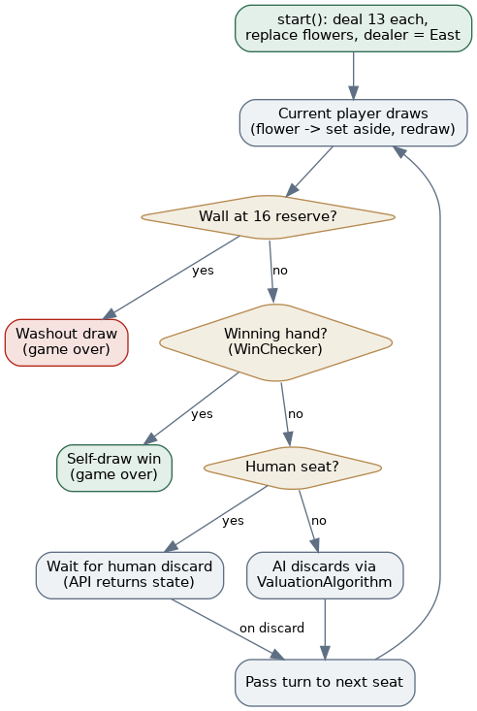
Figure 6. Solo Play turn loop and end conditions.
User flow. The user starts a game, sees their own hand plus opponents shown only as tile counts and exposed melds, taps a tile to discard, and watches the opponents respond, until someone wins by self draw or the wall reaches the reserve and the round is a draw.
Developer note. The soloplay feature is unfinished. Current implementation is a basic proof of concept, while implementation of core game mechanics of claiming melds from discards, winning off discards, as well as game structure features like dealer and wind rotation, and AI behaviour for claiming melds of discards.

9. API Reference
All endpoints under /api/game and /api/tutorial require a valid JWT. The token endpoints issue and refresh credentials.
Method and endpoint | Auth | Purpose
POST /api/users/register/ | No | Create a user and an empty profile.
POST /api/token/ | No | Log in; returns access and refresh tokens.
POST /api/token/refresh/ | No | Exchange a refresh token for a new access token.
GET /api/users/profile/ | Yes | Return the current user's profile and stats.
GET /api/game/random-hand/ | Yes | Generate a random 13 tile hand.
POST /api/game/recommend-discard/ | Yes | Hand Helper: best discard for a 14 tile hand.
POST /api/game/check-win/ | Yes | Check whether a hand is a complete winning hand.
POST /api/game/score-hand/ | Yes | Score a winning hand in tai.
POST /api/game/trainer/new/ | Yes | Deal a trainer hand and log a pending move.
POST /api/game/trainer/submit/ | Yes | Score the user's discard and record the result.
GET /api/game/trainer/history/ | Yes | Past trainer attempts and accuracy.
POST /api/game/solo/new/ | Yes | Start a solo game.
GET /api/game/solo/state/ | Yes | Current solo game state (human's view).
POST /api/game/solo/discard/ | Yes | Human discards a tile in solo play.
POST /api/game/solo/kong/ | Yes | Human declares a concealed Kong.
GET /api/tutorial/modules/ | Yes | Module catalogue with completion merged in.
GET /api/tutorial/progress/ | Yes | The user's tutorial progress rows.
POST /api/tutorial/complete/ | Yes | Mark a module complete with a quiz score.

10. Testing
Testing focuses on the backend, where the game logic lives. The suite currently contains 57 backend test cases and grows with each feature. We test at three levels.
- Unit tests for engine classes: deck construction and counts, hand generation, the evaluator and valuation algorithm, win detection across all three patterns, Kong handling, claimed melds, and the tai scorer.
- Integration tests for the API: authentication is required, the Hand Helper, Trainer, scoring, and Solo Play endpoints return correct results, and game state advances correctly.
- Edge case tests: invalid hands and tile counts, more than four copies of a tile, the minimum one tai rule, the washout at the 16 tile reserve, and a full simulated game that must always terminate.
The frontend is verified to compile cleanly for production with npm run build. Expanding automated component tests with React Testing Library is part of the Milestone 3 plan.

11. Bugs and Problems Encountered
The following problems took real effort to diagnose and fix. We record them here because the debugging is part of the engineering work.

11.1 Trainer returned 500 after a few rounds
Symptom: starting a new trainer hand sometimes failed with a server error. Cause: the view used get_or_create to find the user's trainer session, but React's development mode mounts components twice, which fired two new game requests at once and created two sessions. From then on get_or_create raised MultipleObjectsReturned. Fix: select the most recent session with filter and first, and create one only if none exists, so duplicate sessions are tolerated.

11.2 Login worked but pages broke after a few minutes
Symptom: features failed with a 401 after some idle time. Cause: SimpleJWT access tokens expire quickly and there was no refresh handling, so every request failed once the token expired. Fix: an Axios response interceptor that refreshes the access token on a 401, retries the original request, and only logs the user out if the refresh fails.

11.3 Recurring database errors that a migrate fixed
Symptom: a feature would 500 with a missing table or relation, and running migrate fixed it. Cause: new models had been added but the running database had not had the migrations applied, or the server and the migrate command were pointed at different databases through the SQLite versus PostgreSQL switch. Fix and practice: always run migrate after pulling changes that touch models, and keep the database choice consistent between the server and the migrate command.

11.4 Scoring missed a higher reading of a hand
Symptom: a hand of all Pongs in one suit did not score All Pongs. Cause: the win checker returned a single decomposition, and it happened to read the hand as Pong plus Chows. Fix: the scorer now enumerates every valid decomposition and keeps the highest scoring one.

12. Software Engineering Practices
We follow a small set of disciplined practices appropriate for an Apollo level project.
Parallel, conflict free task division. For Milestone 2 we deliberately split work so that two people could build at once without colliding: one person owned the Trainer inside the game app while the other owned the Tutorial app and its own components, with the shared routing wired up once in advance. This kept merges clean.
Separation of concerns. The Python engine has no Django imports and is kept apart from the API views, so the same logic powers multiple features and can be tested directly.
Test first discipline for logic. Each engine capability and endpoint is added together with tests, and the suite is run before merging.

13. Engineering Practices in Depth
Section 12 summarised the practices we follow. Because disciplined software engineering is a central requirement at the Apollo level, this section documents those practices in more depth and grounds each one in concrete evidence from our own codebase.

13.1 Branching Model and Naming Conventions
We use a trunk based variant of GitHub Flow. The main branch always holds a working build, and no feature is developed directly on it. Every piece of functionality is built on a short lived branch named feature/<area>, for example feature/Tutorial, feature/Hand-Helper, feature/Interactive-Trainer, and feature/SoloPlay. Each branch maps to exactly one feature or issue, which keeps the diff small and makes review focused. Milestone 2 reached main through a sequence of reviewed pull requests, one per feature, so the history reads as a list of completed features rather than a stream of unrelated commits.

13.2 Commit Conventions and History
Commits are small and message led. Each message names the milestone and the unit of work, for example MS2 Hand Helper Final, MS2 Interactive Trainer Final, and MS2 Point system, Kong logic, Claiming melds from discards logic with frontend display. A reader can scan the log and see exactly what each change delivered and which milestone it belonged to, which makes the project history a usable record rather than noise.

13.3 Code Review and Definition of Done
No branch reaches main without a pull request, and the pull request is the checkpoint where the other team member reviews the change before it is merged. We treat a change as done only when four conditions hold: the feature works end to end through the API, new logic is covered by tests, the whole backend suite passes, and the frontend still compiles cleanly with npm run build. This shared definition of done keeps main stable and prevents half finished work from leaking into the trunk.

13.4 Coding Standards and Conventions
Python code follows PEP 8 style and favours small classes with a single responsibility: Tile, Meld, Hand, Deck, HandGenerator, HandEvaluator, ValuationAlgorithm, WinChecker, and ScoreCalculator each do one job. Fixed domain values, such as the tile sets and the tai values in the SCORING table, are named module level constants rather than magic values scattered through the code. Non obvious classes and methods carry docstrings that explain intent. On the frontend we use function components with hooks, one component per file, and a clear split between pages, which are routed screens, and components, which are reusable UI.

13.5 Defensive Programming and Input Validation
The API is the boundary between an untrusted client and the engine, so every endpoint validates its input before the engine ever runs. The Hand Helper requires exactly fourteen playable tiles; a shared parse_tile routine rejects any suit or value that is not a legal numbered or honour tile; a tile count check rejects more than four copies of any tile; the scorer validates that the seat wind and round wind are one of east, south, west, or north; and the win checker accepts fourteen to eighteen tiles so that one extra tile per Kong is allowed. Invalid input returns a clear, specific error instead of failing deep inside the engine.

13.6 Error Handling and HTTP Semantics
The API uses HTTP status codes deliberately so that clients can react correctly. It returns 201 when a resource is created, such as a new trainer move or a new solo game; 400 for malformed input; 401 when authentication is missing or the token has expired; and 404 when a referenced object, such as a trainer move or an active solo game, does not exist. Engine level errors raised as ValueError are caught at the view boundary and converted into 400 responses with a message, so a bad request never surfaces to the user as an unhandled 500.

13.7 Configuration and Secrets Management
Anything that varies between environments is read from a .env file through python-dotenv and is never hard coded. The secret key, the debug flag, the database name and credentials, and the USE_SQLITE switch all come from the environment with safe local defaults, and a committed .env.example documents the required variables without exposing real secrets. The USE_SQLITE flag lets a developer run against a zero setup SQLite database locally while production uses PostgreSQL, with no change to application code.

13.8 Design Patterns and Code Reuse
A few deliberate patterns keep the code flexible. Dependency injection lets the ValuationAlgorithm accept an evaluator, defaulting to HandEvaluator, so the scoring brain can be swapped or mocked in a test. A strategy style separation lets each winning pattern and each scoring reading be evaluated independently. Above all, the engine is kept free of any web framework imports and apart from the API views, so the same logic powers the Hand Helper, the Trainer, and the AI opponents, and the SCORING table externalises the rule set so house rules can be changed in one place. This is the Don't Repeat Yourself principle applied at the level of the whole system.

13.9 Continuous Integration (planned for Milestone 3)
For Milestone 3 we plan to add a GitHub Actions workflow that runs the backend test suite and the frontend build automatically on every pull request, so a branch cannot be merged unless the suite is green. This formalises, with tooling, the manual discipline we already follow by hand today.

14. Mahjong Engine: Algorithms and Data Structures
Section 7 introduced the engine classes. This section explains the algorithms that do the difficult work, because the engine is where most of the project's intellectual complexity lives.

14.1 Tiles and the Wall
A Tile is a small, immutable value object with a suit, a value, and a bonus flag, plus a derived short code such as B3 for three of bamboo and a human readable label. The Deck builds the full one hundred and forty eight tile Singaporean wall: four copies of one to nine in each of the three numbered suits, which is one hundred and eight tiles; four copies of each of the seven honours, which is twenty eight; eight flowers; and four animals. Flowers and animals are flagged as bonus tiles, so they are recognised and set aside consistently everywhere in the engine.

14.2 Winning-Hand Decomposition by Backtracking
The hardest single problem in the engine is deciding whether a set of tiles forms a standard winning hand of four melds and a pair. We solve it with recursive backtracking. The hand is first reduced to a multiset of tile counts. For each tile that appears at least twice we tentatively remove it as the pair, then ask whether the remaining tiles split into exactly four melds. The meld solver always takes the lowest remaining tile and tries, in order, to use it as a Kong, as a Pong, or as the start of a Chow in a numbered suit, recursing on whatever is left; if none of those choices leads to a complete split, it backtracks and tries the next option. Always expanding the lowest tile prunes the search sharply, because every tile must belong to some meld and the lowest tile has very few legal ways to be consumed. The same structure exists in two forms: one returns the first valid split for a fast yes or no win check, and another yields every valid split for the scorer to examine.

14.3 Seven Pairs and Thirteen Orphans
Two special hands are checked directly against the tile counts rather than through decomposition. Seven Pairs is exactly seven distinct tiles, each appearing twice. Thirteen Orphans is one of every terminal and every honour tile with exactly one of them doubled to form the pair. Both are fourteen tile only shapes and are tested before the standard decomposition, since they would never be found by the four meld and a pair search.

14.4 Kong Awareness
A Kong is four identical tiles and counts as a single meld, but it occupies four tiles instead of three, so a winning hand grows by one tile for each Kong it contains. The win checker therefore accepts fourteen to eighteen tiles and treats four of a kind as a valid meld during decomposition. This means a hand with one or more Kongs is recognised and scored correctly rather than being rejected for having the wrong tile count.

14.5 The Discard Valuation Heuristic
The HandEvaluator turns a hand into a single strength number by rewarding structure and penalising waste. The weights below are applied across the whole hand and summed. The ValuationAlgorithm then answers the practical question a player actually asks, which is which tile to throw, by removing each tile in turn, scoring what remains, and returning the tile whose removal leaves the strongest hand, together with a short reason. This one function is the shared judgement used by the Hand Helper, by the Trainer when it marks a user's choice, and by the AI opponents when they decide their own discards.
Shape in the hand | Effect on score | Reasoning
Complete set (Pong or Kong) | Large reward | A finished group is the goal of the hand.
Pair | Moderate reward | A pair can become a Pong or be the hand's eyes.
Run of three consecutive numbers | Large reward | A completed Chow is a finished group.
Two-tile partial run | Small reward | One tile away from a Chow.
One-gap shape (such as 3 and 5) | Small reward | Completes with a single middle tile.
Isolated tile (no pair, no neighbour) | Penalty | Contributes nothing and is the natural discard.

14.6 Scoring the Best Reading of a Hand
Because one winning hand can often be read in more than one way, for example as three Pongs or as a Pong and two Chows, the ScoreCalculator does not trust a single decomposition. It enumerates every valid reading of the hand, scores each one by awarding seat wind and round wind triplets, dragon triplets, All Pongs, half and full flush, and any bonus tiles, and keeps the highest scoring reading. This mirrors how a real player always scores their hand in the best legal way. A configurable minimum of one tai is enforced, so a hand with no scoring value cannot be declared a win.

14.7 A Worked Discard Example
To make the valuation concrete, consider a fourteen tile hand that is close to completion but holds one clearly useless tile, a lone West wind with no pair and no neighbours.
Hand (14 tiles):
bamboo 2, 3, 4 (a complete run)
circles 5, 6, 7 (a complete run)
characters 8, 8, 8 (a complete set)
circles 9, 9 (a pair)
bamboo 6, 7 (a two-tile partial run)
west (isolated honour tile)

The evaluator rewards the two complete runs and the complete set most, adds for the pair and the partial run, and applies a penalty for the isolated West wind. The valuation algorithm removes each tile in turn and re-scores the remainder; removing the West leaves every productive shape intact and scores highest, so the West is returned as the recommended discard with a short reason.
recommend_discard(hand) ->
{
"discard": {"suit": "honour", "value": "west", "code": "Hwest"},
"score": 41,
"reasoning": "Discarding west keeps the strongest remaining
combination of sets, pairs, and near-sequences."
}

14.8 From Recommendation to Marking a Trainer Answer
The Trainer reuses exactly this logic to grade a user. When the user submits a discard, the server computes the best score from the valuation algorithm and the score that results from the user's own discard, then compares them. A choice that ties the best score is accepted as correct, because several discards can be equally good, and the feedback names the optimal tile and explains why whenever the user's choice falls short. The same engine therefore advises in the Hand Helper, grades in the Trainer, and decides moves for the AI, which is the clearest possible illustration of why the engine is kept separate and reused.

15. Quantification of Complexity
The Apollo level asks teams to quantify the complexity of their work. We do so here along three axes: the size and surface of the system, the difficulty of its core algorithms, and the intricacy of the domain it models.

15.1 System Size and Surface
Aspect | Count | Notes
Backend Django apps | 3 | users, game, tutorial, split by responsibility.
Core engine classes | 11 | Tile, Meld, Hand, Deck, HandGenerator, HandEvaluator, ValuationAlgorithm, WinChecker, ScoreCalculator, plus Player and SoloGame.
REST API endpoints | 18 | Auth, profile, hand tools, trainer, solo play, tutorial.
Database models | 4 plus User | Profile, Session, Move, TutorialProgress, on top of Django's User.
React pages | 8 | Login, Register, Home, Profile, Tutorial, Hand Helper, Trainer, Solo Play.
Reusable React components | 5 | AppLayout, TileCard, MeldDemo, Quiz, HandDisplay.
Automated backend tests | 71 | 57 in the game app, 10 in tutorial, 4 in users.

15.2 Algorithmic Complexity
The win checking decomposition is the most complex single algorithm in the project. It is a constraint search over a multiset of tiles with backtracking, exponential in the worst case, but heavily pruned by always expanding the lowest tile and by the fixed target of four melds and a pair, so in practice it resolves instantly on a fourteen to eighteen tile hand. The discard valuation evaluates up to eighteen candidate discards, each of which requires a full hand evaluation, and the scorer enumerates every legal reading of a winning hand; both are bounded and fast. The solo game composes these pieces into a complete turn loop with a guaranteed termination condition in the form of the wall reserve, and that guarantee is itself protected by a test that plays an entire game and asserts it always ends.

15.3 Domain Complexity
Singaporean Mahjong is intricate to model faithfully. There are three numbered suit families, seven honour tiles, and two classes of bonus tile; three distinct winning shapes; the distinction between concealed melds and melds claimed from a discard; replacement draws after a Kong or a flower; and a position dependent scoring system driven by seat winds, the round wind, and per seat flowers. Capturing all of this correctly, and keeping it testable in isolation, is the core engineering challenge of MahjongSensei and the reason the engine is designed as a set of small, independently verifiable classes.

16. Frontend Architecture in Depth
The frontend is a single page React application. Its job is to render the learning tools, manage the user's session, and talk to the backend over HTTP without leaking authentication details into every page.

16.1 Routing and Protected Routes
The application uses React Router. The public routes are the login and register pages; everything else, namely Home, Profile, Tutorial, Hand Helper, Trainer, and Solo Play, is wrapped in a ProtectedRoute. That wrapper checks the authentication state and redirects to the login page when the user is not signed in. While the session is still being restored it shows a brief loading state, so a protected page never flashes its contents before the authentication check has completed.

16.2 The Authentication Context
A single AuthContext, implemented as a React context with a provider, owns login, registration, logout, session restoration, and profile loading, and exposes them to the whole component tree through a useAuth hook. Centralising authentication in one place means no individual page has to re-implement token handling, and the rules for what it means to be logged in live in exactly one file.

16.3 The Shared Axios Client
Every API call goes through one configured Axios instance. A request interceptor attaches the JWT access token to the Authorization header of each outgoing request. A response interceptor watches for a 401 reply, uses the refresh token to obtain a new access token, retries the original request once, and only forces a logout if the refresh itself fails. As a result, pages call the API as if authentication were automatic, because for them it effectively is.

16.4 Reusable Components
The interface is built from a small set of reusable components so that markup is not duplicated across pages. TileCard renders a single tile with suit specific colouring; MeldDemo shows worked examples of Pong, Kong, and Chow groups; Quiz drives the tutorial's multiple choice questions and reports a score; HandDisplay renders a full hand with its exposed melds, concealed tiles, and a row of bonus tiles; and AppLayout provides the shared header, navigation bar, and logout control. Pages compose these components rather than repeating their markup.

16.5 Local State and Request Feedback
Each page manages its own local state with React hooks, including loading flags, error messages, the current hand, the user's selection, and the latest result. This keeps the interface honest about the request lifecycle: a control is disabled while a call is in flight, an error is shown inline if a call fails, and results appear only once the backend has responded.

17. Design Decisions and Alternatives Considered
Good engineering is as much about the options not taken as the ones chosen. For each major decision below we record the alternatives we weighed and why we settled where we did.

17.1 Django REST Framework over a lighter framework
We considered a lighter framework such as Flask or FastAPI, which would have given us a smaller starting footprint. We chose Django with Django REST Framework because it provides authentication, an object relational mapper, migrations, an admin interface, and a mature REST layer out of the box. That let us spend our time on Mahjong logic rather than on rebuilding plumbing that Django already provides.

17.2 JSON Web Tokens over server-side sessions
Server side sessions are simpler to reason about for a single server, but they tie the backend to session storage and fit awkwardly with a separate frontend. We chose stateless JWT access and refresh tokens because they suit a decoupled React client and a possible future mobile client, and they keep the backend free of per user session state. The cost is the need to handle token refresh, which we implemented in the Axios client.

17.3 An engine with no framework imports
We could have written the Mahjong logic directly inside the Django views, which would have been quicker in the very short term. Instead we kept the engine free of any Django imports and separate from the views. This lets us unit test the logic and simulate thousands of games with no database, and reuse one engine across three features. The small cost is a little duplication at the view boundary, where tiles are parsed from JSON, which we judged a worthwhile trade.

17.4 Storing trainer moves as JSON
Rather than spread a trainer round across many narrow columns, we store the dealt hand, the user's discard, and the engine's correct discard as JSON on the Move row. A whole round is therefore one record that can be replayed later, without committing to a rigid schema while the feature is still evolving.

17.5 In-memory state for Solo Play
The solo game is stateful, and during play each user's SoloGame object lives in a server side dictionary keyed by the user. This kept the prototype simple, at the known cost that a server restart loses an in progress game and that results are not yet written to the profile. Persisting solo games to the database is on the Milestone 3 plan; we state the limitation here honestly rather than hide it.

17.6 Frontend-held lesson content
The tutorial's lesson text and example tiles live in the frontend, while only completion and quiz scores are persisted on the backend. This means teaching content can be edited and improved without a database migration, and the backend stays focused on the data that genuinely needs to persist per user.

18. Security Considerations
Security is treated as a first class concern even at the prototype stage, and we are explicit about both what is in place and what remains before the system could be deployed publicly.
- Authenticated by default. Every game and tutorial endpoint requires a valid token, because Django REST Framework is configured to require authentication by default. A user can only ever read or change their own data, and the server always derives the user from the token rather than trusting a user id sent in the request body.
- Token hygiene. Access tokens are short lived, refresh is handled on the client, and logging out clears the stored tokens.
- Password safety. Passwords are stored using Django's hashing and are checked by Django's password validators for minimum length, common passwords, numeric only passwords, and similarity to user details.
- Restricted CORS. Cross origin requests are restricted to the known frontend origins, so the API does not accept browser calls from arbitrary sites.
- Input validation. Validation at the API boundary stops malformed data from reaching the engine or the database in the first place.
Known pre-deployment items. We are equally clear about what is not yet production ready. The development debug flag and the local default secret key are intended for local use only. Before any public deployment we will turn debug off, supply a real secret key from the environment, restrict the allowed hosts, and serve the application over HTTPS. Recording these items is itself part of the engineering discipline we follow.

19. Project Management and Team Collaboration
MahjongSensei is built by a two person team, and a recurring theme of our process is dividing work so that two people can build in parallel without colliding.

19.1 Division of Work by App Boundary
For Milestone 2 we split the work along clean module boundaries. One member owned the game app, which holds the Mahjong engine, the Hand Helper, the Interactive Trainer, the scoring system, and Solo Play, together with the shared frontend shell. The other member owned the tutorial app and its own frontend components, such as the tile cards, meld demonstrations, and the quiz. The routing and navigation that connect the two were agreed and wired up once in advance, so neither member needed to edit the other's files. This deliberate ownership boundary is why our merges stayed clean even though both members were committing throughout the milestone.

19.2 Issues, Milestones, and the Board
Tasks are captured as GitHub issues, each assigned to a single owner so that responsibility is explicit, and grouped under monthly milestones with labels. Linking a pull request to its issue with a closing reference means that merging the code closes the task automatically, which keeps the board and the codebase in step. This issue, milestone, and assignee discipline is part of what the Apollo level expects of a team's planning.

19.3 Milestone Cadence
The project follows the Orbital calendar: ideation and a technical proof of concept for Milestone 1 on the first of June; the working prototype described in this document for Milestone 2 on the twenty ninth of June; an extended system for Milestone 3 on the twenty seventh of July; and final refinement for Splashdown in late August. Each member records the tasks they performed, when, and the hours spent, in the separate project log, so that contributions stay balanced and visible across the team.

20. Glossary of Mahjong and Technical Terms
This glossary collects the Mahjong and technical terms used throughout the document, as a quick reference for readers who are new to either the game or the stack.
Term | Meaning
Suit | One of the three numbered families: Bamboo, Circles, or Characters, each numbered 1 to 9.
Honour tile | A tile with no number: the four winds (East, South, West, North) and three dragons (Red, Green, White).
Bonus tile | A flower or animal tile, unique to Singaporean Mahjong, set aside for points and replaced when drawn.
Meld | A completed group of tiles: a Pong, a Kong, or a Chow.
Pong | Three identical tiles.
Kong | Four identical tiles, counting as one meld but drawing a replacement tile.
Chow | A run of three consecutive numbers in the same numbered suit.
Pair | Two identical tiles; a standard hand needs exactly one pair, sometimes called the eyes.
Concealed meld | A meld formed from your own hand and kept hidden from opponents.
Claimed meld | A meld completed by taking another player's discard; it is exposed and locked.
Tai | The unit of scoring in Singaporean Mahjong; a hand must be worth at least one tai to win.
Seat wind | The wind matching a player's position at the table, which affects scoring and flowers.
Round wind | The prevailing wind of the current round, which affects scoring.
Washout | A drawn round with no winner, declared when the wall reaches its reserve.
Thirteen Orphans | A special winning hand of one of every terminal and honour, with one of them paired.
Seven Pairs | A special winning hand made of seven distinct pairs.
JWT | JSON Web Token; a signed, stateless token used to authenticate API requests.
REST | An architectural style for web APIs based on resources and standard HTTP methods.
ORM | Object Relational Mapper; Django's layer that maps Python models to database tables.
Migration | A versioned, applied change to the database schema generated from model changes.
Interceptor | Axios hook that runs on every request or response, used here to attach and refresh tokens.
Endpoint | A single API URL and method that performs one operation.
Wall | The full shuffled set of tiles from which players draw during a game.
Tile code | A short identifier for a tile, such as B3 for three of bamboo, used across the API and UI.
CORS | Cross-Origin Resource Sharing; the browser rule that controls which sites may call the API.
Serializer | A Django REST Framework component that converts models to and from JSON.
Context (React) | A React mechanism for sharing state, used here to share the authenticated session.
Hook (React) | A function such as useState or useAuth that adds state or behaviour to a component.

21. API Reference: Detailed Examples
Section 9 listed every endpoint in summary form. This section gives concrete request and response examples for the endpoints a developer is most likely to call, so the contract of each one is unambiguous. All bodies are JSON, and every endpoint except registration and the token endpoints requires a valid access token in the Authorization header.

21.1 Register a User
Creates a user and an empty profile. Returns 201 on success.
POST /api/users/register/
{
"username": "demo_player",
"password": "strong_password_123"
}

201 Created
{
"id": 1,
"username": "demo_player"
}

21.2 Log In and Obtain Tokens
Exchanges credentials for a short lived access token and a longer lived refresh token. The frontend stores both.
POST /api/token/
{
"username": "demo_player",
"password": "strong_password_123"
}

200 OK
{
"access": "<jwt-access-token>",
"refresh": "<jwt-refresh-token>"
}

21.3 Recommend a Discard (Hand Helper)
Takes a fourteen tile hand and returns the best tile to discard, with a strength score and a short reason.
POST /api/game/recommend-discard/
{
"tiles": [
{"suit": "bamboo", "value": 3},
{"suit": "bamboo", "value": 4},
... (14 tiles in total)
]
}

200 OK
{
"discard": {"suit": "honour", "value": "west",
"code": "Hwest", "label": "west"},
"score": 41,
"reasoning": "Discarding west keeps the strongest remaining
combination of sets, pairs, and near-sequences."
}

21.4 Check a Winning Hand
Reports whether a hand is complete and which pattern it forms.
POST /api/game/check-win/
{
"tiles": [ ... 14 to 18 tiles ... ]
}

200 OK
{
"is_winning": true,
"pattern": "standard",
"description": "Standard hand: four melds and a pair",
"pair": ["circles", 2],
"melds": [ {"type": "chow", "tile": ["bamboo", 3]}, ... ]
}

21.5 Score a Winning Hand (Tai)
Checks and scores a hand in tai, given the player's seat wind and the round wind, plus any bonus tiles.
POST /api/game/score-hand/
{
"tiles": [ ... ],
"bonus_tiles": [ {"suit": "flower", "value": "red_1"} ],
"seat_wind": "east",
"round_wind": "east"
}

200 OK
{
"win": { "is_winning": true, "pattern": "standard", ... },
"score": {
"is_valid_win": true,
"hand_tai": 3, "bonus_tai": 1, "total_tai": 4,
"breakdown": ["Seat wind pong (east)", "Half flush", ...]
}
}

21.6 Trainer: New Hand and Submit
The trainer deals a hand, the user submits a discard, and the server scores it.
POST /api/game/trainer/new/
201 Created
{
"move_id": 12,
"session_id": 3,
"tiles": [ ... 14 tiles ... ],
"bonus_tiles": [ ... ]
}

POST /api/game/trainer/submit/
{
"move_id": 12,
"discard": {"suit": "honour", "value": "north"}
}

200 OK
{
"is_correct": false,
"your_discard": {"suit": "honour", "value": "north"},
"your_score": 33,
"correct_discard": {"suit": "circles", "value": 9},
"best_score": 37,
"feedback": "Not quite. Discarding 9 circles keeps a stronger hand."
}

21.7 Tutorial: Modules and Completion
Lists modules with the current user's progress merged in, and records completion with a quiz score.
GET /api/tutorial/modules/
200 OK
[
{
"id": "tiles", "title": "Tile Recognition",
"order": 1, "completed": true, "quiz_score": 4
}, ... ]

POST /api/tutorial/complete/
{
"module_id": "melds",
"quiz_score": 3
}

21.8 Profile and Solo Play State
The profile endpoint returns the current user's stats, and the solo state endpoint returns the player's view of the table with opponents' concealed tiles hidden.
GET /api/users/profile/
200 OK
{
"id": 1, "username": "demo_player",
"games_played": 0, "games_won": 0,
"win_rate": 0.0, "created_at": "2026-06-29T08:00:00Z"
}

GET /api/game/solo/state/
200 OK
{
"phase": "discard", "round_wind": "east",
"your_hand": [ ... your tiles ... ],
"players": [ {"seat_wind": "south", "tile_count": 13,
"tiles": null, "melds": [] }, ... ],
"discards": [ ... ], "result": null
}

22. Data Model in Depth
Section 6 introduced the five tables at a high level. This section documents each model field by field, so the persistence layer is fully specified.

22.1 Profile
Extends the built in Django User with the summary statistics shown on the profile page and reserved for the future dashboard.
Field | Type | Description
user | OneToOne to User | The account this profile belongs to.
games_played | Integer | Total games recorded for the user. Defaults to 0.
games_won | Integer | Total games won. Defaults to 0.
win_rate | Float | Wins divided by games, kept for quick display.
created_at | DateTime | When the profile was created. Set automatically.

22.2 Session
Groups a user's attempts within one mode of play. The Trainer uses it today, and Solo Play can reuse it later.
Field | Type | Description
user | ForeignKey to User | Owner of the session.
mode | Char (trainer or solo) | Which feature the session belongs to.
created_at | DateTime | When the session started.

22.3 Move
One trainer round. The dealt hand and the two discards are stored as JSON so the whole round lives in a single row and can be replayed.
Field | Type | Description
session | ForeignKey to Session | The session this move belongs to.
hand | JSON | The full dealt hand of tiles.
user_discard | JSON | The tile the user chose to discard.
correct_discard | JSON | The engine's recommended discard.
user_score | Integer | Strength of the hand after the user's discard.
best_score | Integer | Strength after the optimal discard.
is_correct | Boolean | Whether the user's discard matched the best score.
created_at | DateTime | When the round was played.

22.4 TutorialProgress
Records which modules a user has completed and the quiz score. It is unique per user and module, so completing a module twice updates one row rather than creating duplicates.
Field | Type | Description
user | ForeignKey to User | Owner of the progress row.
module_id | Char | Which module, for example tiles, melds, winning-hands.
completed | Boolean | Whether the module is finished. Defaults to false.
completed_at | DateTime | When it was completed. Null until then.
quiz_score | Integer | The user's score on the module quiz. Null until taken.

23. Engine Class and Method Reference
A compact reference to every class in the engine and the solo module, with its responsibility and the methods that matter most.
Class | Responsibility | Key methods
Tile | An immutable tile. | code, label, to_dict
Meld | A Pong, Kong, or Chow, concealed or claimed. | is_concealed, to_dict
Hand | Concealed tiles, bonus tiles, and melds. | discard, claim_pong, claim_chow, claim_kong, declare_kong, sorted_tiles, to_dict
Deck | The full 148 tile wall. | shuffle, draw, draw_replacement
HandGenerator | Deals a valid starting hand. | generate_random_hand
HandEvaluator | Scores a hand's strength. | evaluate_hand
ValuationAlgorithm | Chooses the best discard. | recommend_discard
WinChecker | Detects and decomposes winning hands. | check, decompose_standard, iter_standard
ScoreCalculator | Scores a winning hand in tai. | score
Player (solo) | A seat at the solo table. | all_tiles, to_dict
SoloGame (solo) | Runs the four player game loop. | start, human_discard, human_declare_kong, public_state

24. Testing in Depth
Testing is concentrated on the backend, where the game logic lives. The suite currently holds seventy one automated tests and grows with every feature: fifty seven in the game app, ten in the tutorial app, and four in the users app. Tests are organised at three levels.

24.1 Unit Tests for Engine Classes
- Deck construction and counts: the wall holds exactly 148 tiles with the right split of suited, honour, flower, and animal tiles.
- Hand generation produces a playable hand of the requested size and sets bonus tiles aside correctly.
- The evaluator and valuation algorithm reward sets, pairs, and runs and pick a sensible discard.
- Win detection across all three patterns: standard, Seven Pairs, and Thirteen Orphans, including Kong aware hands of up to eighteen tiles.
- The tai scorer awards winds, dragons, flushes, and bonus tiles, and keeps the best reading of an ambiguous hand.

24.2 Integration Tests for the API
- Authentication is required: protected endpoints reject requests without a valid token.
- The Hand Helper, Trainer, scoring, and Solo Play endpoints return correct results for known inputs.
- Game state advances correctly: a trainer move is recorded, and a solo game progresses through the turn loop.

24.3 Edge Case Tests
- Invalid hands and tile counts, and more than four copies of a tile, are rejected with a clear error.
- The minimum one tai rule prevents a valueless hand from counting as a win.
- The washout is declared when the wall reaches its reserve.
- A full simulated game always terminates, which guards against an infinite turn loop.
Frontend. The frontend is verified to compile cleanly for production with npm run build. Adding automated component tests with React Testing Library is part of the Milestone 3 plan.

24.4 Running the Tests
The whole backend suite runs with one command, and an individual app can be tested on its own. Tests run against SQLite so no database setup is needed.
cd backend
python manage.py test # run all 71 backend tests
python manage.py test game # only the game app
USE_SQLITE=True python manage.py test tutorial

25. Known Limitations and Risk Register
We keep an honest record of what is incomplete or risky, because naming a limitation is the first step to managing it.
Item | Current state and impact | Plan or mitigation
Solo Play state | Held in memory per user; a server restart loses an in progress game. | Persist solo games to the database in Milestone 3.
Claiming melds in play | The engine can model claimed melds, but Solo Play does not yet let a player claim a discard. | Add claim-from-discard turns and AI claiming in Milestone 3.
AI strength | Opponents use the heuristic evaluator, not probability. | Add a probability based discard model and test it.
No CI yet | Tests are run by hand before merging. | Add a GitHub Actions workflow that gates every pull request.
Production hardening | Debug and a local secret key are for development only. | Disable debug, supply a real secret, restrict hosts, use HTTPS before deployment.
Frontend tests | Verified only by a production build. | Add component tests with React Testing Library.

26. User Testing Plan (Milestone 3)
A teaching tool only succeeds if real beginners learn from it, so Milestone 3 includes structured user testing. Our motivation gives us a natural pool of testers through the community Mahjong sessions that inspired the project.

26.1 Participants and Tasks
We will recruit beginner and improver level players and ask each to complete a short, realistic set of tasks: finish one tutorial module and its quiz, use the Hand Helper on a supplied hand, complete five Trainer rounds, and play one Solo Play game to its end. These tasks exercise every core feature in the order a new user would meet them.

26.2 What We Will Measure
- Task completion: whether each task can be finished without help.
- Time on task and the points where users hesitate or get stuck.
- Discard agreement: whether users find the Hand Helper and Trainer feedback understandable and convincing.
- Perceived usefulness and ease of use, gathered through a short questionnaire after the session.

26.3 How Feedback Feeds Back
Each finding becomes a GitHub issue with a severity, so user feedback flows into the same backlog and review process as the rest of our work. High impact usability problems are scheduled before new features, which keeps the system grounded in what real learners need rather than in what is easiest to build.

27. Repository Structure
The repository is organised so that responsibilities are obvious from the folder layout. The backend is a Django project with three apps, and the frontend is a Create React App project with a clear split between pages, reusable components, shared context, and the API client.
MahjongSensei/
backend/
backend/ project settings, top-level URLs
game/ engine.py, solo.py, views.py, models.py, tests.py
users/ registration, profile model and views
tutorial/ modules, progress model, views, serializers
manage.py
frontend/
src/
pages/ Login, Register, Home, Profile, Tutorial,
HandHelper, Trainer, SoloPlay
components/ AppLayout, TileCard, MeldDemo, Quiz, HandDisplay
context/ AuthContext.jsx
api/ axios.js (shared client and JWT interceptor)
requirements.txt .env.example README

This layout mirrors the architecture: the engine and the features that use it sit in the game app, the tutorial is self contained in its own app, and the frontend keeps routed screens apart from the reusable pieces they are built from. A new contributor can find any feature by following the same boundary in both halves of the codebase.

28. Accessibility, User Experience, and Visual Design
Because the audience includes complete beginners, and in our own motivating case older learners, the interface is designed to be calm, consistent, and forgiving.

28.1 A Consistent Visual Language
Every screen is built from the same shared components and class names, so a tile, a button, a status card, or a meld looks and behaves the same everywhere. Tiles are colour coded by suit, which helps a beginner tell bamboo, circles, and characters apart at a glance, and each tile shows both a short code and a readable label so the meaning is never hidden behind a symbol alone.

28.2 Clear Feedback and Forgiving Interaction
The interface always tells the user what is happening. A control is disabled while a request is in flight, loading text appears while data is fetched, and errors are shown inline in plain language rather than as raw status codes. In the Hand Helper and Trainer a tile can be added and removed freely before submitting, so a mistaken tap is never costly. Feedback in the Trainer is phrased to teach: it names the better discard and explains why, rather than simply marking an answer wrong.

28.3 Toward Stronger Accessibility
Several accessibility foundations are already present, including semantic headings and labelled controls. For Milestone 3 we plan to audit colour contrast on the tiles, ensure every interactive element is reachable and operable by keyboard, and confirm that the layout remains usable at larger text sizes, so the tool serves the widest possible range of learners.

29. Summary and Current Status
At Milestone 2, MahjongSensei has moved from a technical proof of concept to a working prototype with all of its core features in place. A user can register and log in, work through the interactive tutorial, ask the Hand Helper for a recommended discard, drill their decisions in the Trainer with tracked accuracy, score a completed hand in tai, and play a full game against computer opponents in Solo Play. Underneath, a single object oriented Mahjong engine, free of any web framework, powers the analysis, the practice, and the AI, and is protected by seventy one automated tests.
Just as important for an Apollo level submission is how the system was built. The work is divided cleanly between two members along app boundaries, developed on feature branches, reviewed through pull requests, tracked as issues under monthly milestones, and validated by tests before every merge. The design decisions, the limitations, and the risks are documented openly in this README rather than hidden. The next milestone builds on this foundation with claiming melds in Solo Play, a probability based recommendation, a progress dashboard, continuous integration, and structured user testing with real beginners.
This README, together with the project log, the poster, and the demonstration video, forms the Milestone 2 submission. It is written to give an honest and complete account of both what the system does and how it was engineered, in keeping with the standard expected of an Apollo level project.

30. Running the Project Locally
Backend, from the repository root:
python3 -m venv venv
source venv/bin/activate (Windows: venv\Scripts\activate)
pip install -r requirements.txt
cd backend && python manage.py migrate && python manage.py runserver
Frontend, in a second terminal:
cd frontend && npm install && npm start
If PostgreSQL is not set up locally, set USE_SQLITE=True in the .env file to use a local SQLite database instead. Remember to run migrate after any change to the models, and keep the same database setting for both migrate and runserver.

31. Milestone 2 Project Log
The work below was completed for Milestone 2. Dates and hours are recorded separately in the team log.
Area | Work completed
Hand evaluation | HandEvaluator and ValuationAlgorithm, plus the recommend-discard API.
Hand Helper | Tile picker page and recommendation display.
Win detection | WinChecker for standard, Seven Pairs, and Thirteen Orphans, plus the check-win API.
Tutorial | TutorialProgress model and endpoints; lesson and quiz frontend with reusable components.
Trainer | Session and Move models, trainer endpoints, scoring and logging, and the trainer page.
Points system | ScoreCalculator with winds, dragons, flowers and animals, patterns, and the minimum tai rule; score-hand API.
Kong logic | Kong aware win checking (14 to 18 tiles) and concealed Kong with replacement draw.
Claimed melds | Meld claimed flag and claim methods so claimed melds are exposed and locked.
Frontend hand display | Reusable hand display for melds, concealed tiles, and bonus tiles.
Solo Play | Four player engine: dealing, turn loop, AI opponents, flowers, concealed Kong, washout reserve; in memory API and the solo page.
Testing | Backend suite expanded to 57 passing tests across the engine, scoring, and all endpoints.
Debugging | Fixed the trainer session error, token expiry handling, and scoring of multiple hand readings.

Planned for Milestone 3
- Claiming Pong, Kong, and Chow from discards in Solo Play, and scoring the winning hand with the tai system.
- A profile and progress dashboard that draws on the stored sessions, moves, and tutorial progress.
- A stronger valuation approach (for example win probability) and supporting tests.
- Frontend component tests and user testing with beginner players.

