MahjongSensei
Interactive Mahjong Learning and Training Platform
Milestone 2 Project README
Orbital 2026 | Target Level of Achievement: Apollo
Team members: Chew An Jie, Dylan Wee

Contents
Contents 2
1. Overview and Motivation 3
2. User Stories 3
3. Technology Stack 3
4. System Architecture 4
5. Authentication and Session Management 4
6. Data Model 5
7. Mahjong Game Engine 6
8. Core Features 7
8.1 Interactive Tutorial 8
8.2 Hand Helper 8
8.3 Interactive Trainer 8
8.4 Points (Tai) System 9
8.5 Solo Play 9
9. API Reference 10
10. Testing 11
11. Bugs and Problems Encountered 11
12. Software Engineering Practices 12
13. Running the Project Locally 13
14. Milestone 2 Project Log 13
Planned for Milestone 3 13

1. Overview and Motivation
MahjongSensei is a web application that helps people learn and improve at Singaporean Mahjong. The game has a steep learning curve: beginners struggle with tile recognition, hand structure, scoring, and deciding which tile to discard, and they rarely have an experienced player on hand to give feedback after each move.
Our motivation is personal. One of us, Dylan, founded MahjongTogether in 2022, a community Mahjong session for the elderly, and the single biggest barrier to participation was always the learning curve. MahjongSensei addresses this by combining guided lessons, real time hand analysis, interactive practice, and a single player game against computer opponents, so a complete beginner can progress from understanding the rules to making stronger decisions on their own.
This document describes the state of the project at Milestone 2. It covers the system architecture, the data model, the Mahjong game engine, each core feature (explained from both a user and a developer perspective), the testing approach, notable bugs we solved, and the software engineering practices we follow.

2. User Stories
- As a beginner, I want to learn the rules and hand structure through clear lessons and quizzes, so that I can start playing without relying on another person to teach me.
- As a learner, I want to see worked examples of valid hands and how they score, so that I understand how winning hands are formed.
- As an intermediate player, I want to enter a hand and receive a recommended discard with reasoning, so that I can compare my own judgement with the system.
- As a practice focused player, I want generated training hands with immediate feedback, so that I can drill my discard decisions and track my accuracy.
- As a player who wants a full game, I want to play a round against computer opponents, so that I can apply what I have learned in a realistic setting.

3. Technology Stack
We use a layered, decoupled stack so that the game logic, the web API, and the user interface can each evolve independently and be tested in isolation.
Layer | Technology | Role in this project
Frontend | React (Create React App), React Router, Axios | Single page application that renders the tutorial, hand tools, trainer and solo game, and talks to the backend over HTTP.
Backend API | Django and Django REST Framework | URL routing, request handling, authentication, and serialization between JSON and the engine and database.
Game logic | Pure Python (object oriented) | Tiles, deck, hands, melds, win detection, valuation, scoring, and the solo game loop. No Django imports, so it is unit testable on its own.
Database | PostgreSQL via the Django ORM | Stores users, profiles, tutorial progress, and trainer sessions and moves. SQLite is supported as a local fallback.
Authentication | SimpleJWT (JSON Web Tokens) | Stateless access and refresh tokens for protected API access.
Testing | Django test runner and Pytest style assertions | Unit, integration, and edge case tests for the engine and the API.

4. System Architecture
The system is organised into four cooperating layers. The React application is the only part the user interacts with directly. Every action that needs game logic or persistent data is sent as an HTTP request through a shared Axios client, which attaches the user's JWT access token. Django REST Framework receives the request, checks authentication, and routes it to the relevant Django app.
The backend is split into three Django apps by responsibility. The users app handles registration and profile data. The game app owns the Mahjong engine, the hand tools, the trainer, and the solo game. The tutorial app owns lesson progress. The game app is deliberately the only layer that imports the Python engine, which keeps the engine reusable across the Hand Helper, the Trainer, and Solo Play. PostgreSQL stores all persistent data and is reached only through the Django ORM.
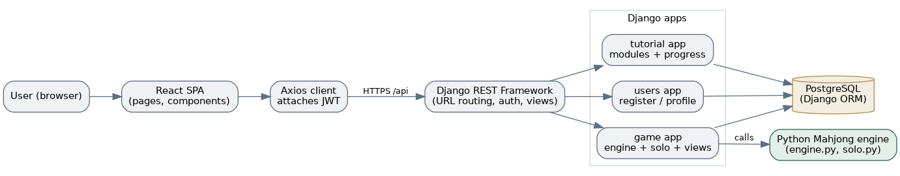
Figure 1. High level architecture and how a request flows from the browser to the engine and database.
Why this split matters: the same valuation and win checking code runs behind three different features and behind the automated tests. If we change how a discard is valued, every feature and test that depends on it picks up the change in one place. Keeping the engine free of Django imports also means we can run and test thousands of simulated games quickly without a database.

5. Authentication and Session Management
Authentication uses JSON Web Tokens. On login the backend issues an access token and a refresh token. The frontend stores both and the Axios client adds the access token to the Authorization header of every request. Because access tokens are short lived, the Axios client also detects an expired token (a 401 response), uses the refresh token to obtain a new access token, retries the original request, and only sends the user back to the login page if the refresh itself fails.
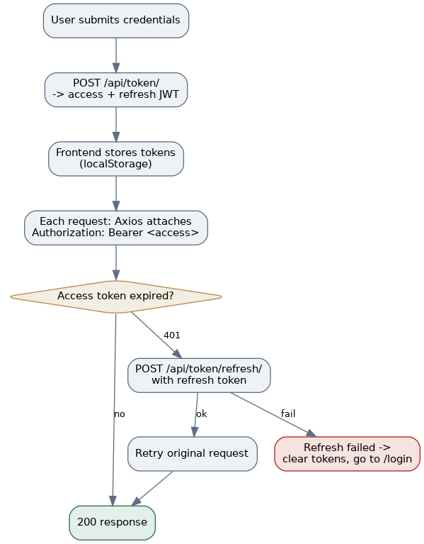
Figure 2. Login, token attachment, and the automatic refresh and retry path.
On a page reload the frontend restores the session by reading the stored token and fetching the profile, so the user does not appear logged out after refreshing. All game and tutorial endpoints require a valid token, so a user can only ever read or change their own data.

6. Data Model
Persistent data is modelled with five tables. The built in Django User holds credentials. Profile extends it with summary statistics. Session and Move record trainer activity, and TutorialProgress records lesson completion. Trainer moves are stored as JSON so that a whole dealt hand, the user's discard, and the engine's correct discard can be saved in one row for later review.
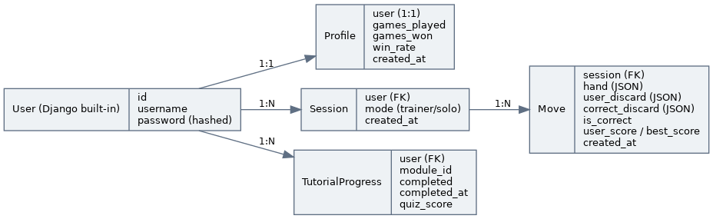
Figure 3. Entity relationship diagram of the persistent data.
Model | Key fields | Purpose
Profile | user (one to one), games_played, games_won, win_rate, created_at | Per user summary stats shown on the profile page; foundation for the future dashboard.
Session | user (FK), mode (trainer or solo), created_at | Groups a user's attempts. Used now by the Trainer.
Move | session (FK), hand, user_discard, correct_discard, is_correct, user_score, best_score, created_at | One trainer round: the dealt hand and how the user's discard compared to the optimal one.
TutorialProgress | user (FK), module_id, completed, completed_at, quiz_score | Records which tutorial modules a user has finished and the quiz score. Unique per user and module.

7. Mahjong Game Engine
The engine in backend/game/engine.py is a set of small object oriented classes. Each has one clear responsibility, which keeps the logic readable and testable. A second module, backend/game/solo.py, builds on these classes to run a full game.
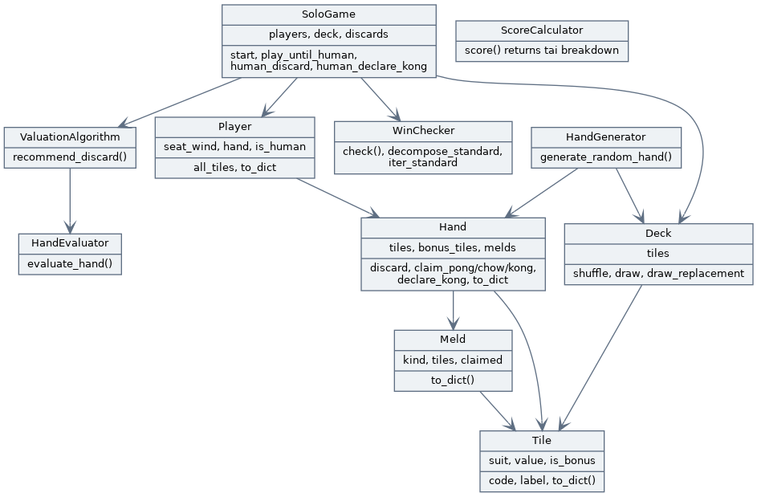
Figure 4. Engine class structure and the main relationships between classes.
Tile, Deck, Hand, Meld. Tile is an immutable tile with a suit, a value, and a bonus flag. Deck builds and shuffles the full 148 tile Singaporean set (108 suited, 28 honours, 8 flowers, 4 animals) and can draw a replacement after a Kong or a bonus draw. Hand separates concealed playable tiles from bonus tiles, and holds locked melds. Meld represents a Pong, Kong, or Chow and carries a claimed flag that marks whether it was taken from another player's discard.
HandGenerator. Draws a valid starting hand, automatically setting aside flower and animal tiles and drawing replacements so the playable hand is always the right size.
HandEvaluator and ValuationAlgorithm. HandEvaluator gives a hand a numeric strength score by rewarding complete sets, pairs, and near sequences and penalising isolated tiles. ValuationAlgorithm tries removing each tile in turn and returns the discard that leaves the strongest remaining hand, together with a short reason. This is the shared brain used by the Hand Helper, the Trainer, and the AI opponents.
WinChecker. Detects a complete hand and which pattern it forms: a standard hand of four sets and a pair, Seven Pairs, or Thirteen Orphans. It is Kong aware, so a winning hand may be 14 to 18 tiles (one extra tile per Kong), and for a standard win it also returns the decomposition (the pair and the four melds) so the scorer can read it.
ScoreCalculator. Scores a winning hand in tai (points). It awards seat wind and round wind Pongs and Kongs, dragon Pongs and Kongs, seat flowers and animals by position, and patterns such as All Pongs and flushes. It enforces a minimum of one tai to win, and when a hand can be read more than one way it scores every reading and keeps the best.

8. Core Features
Each feature is described in three parts: what it does, how it works for a developer (the data flow), and how it feels for a user.

8.1 Interactive Tutorial
Function. A structured, module based tutorial covering tile recognition, meld types (Pong, Kong, Chow), and winning hand basics. Each module ends with a short multiple choice quiz, and completion is saved per user.
Data flow. On opening the page, the frontend calls GET /api/tutorial/modules/, which returns the module catalogue with the current user's completion merged in. Lesson content (the explanatory text and example tiles) lives on the frontend, while completion and quiz scores are persisted on the backend. When the user finishes a quiz, the frontend calls POST /api/tutorial/complete/ with the module id and score, and the backend upserts a TutorialProgress row.
User flow. The user opens Tutorial, sees the list of modules with completion ticks, steps through the lessons with visual tile cards and meld demonstrations, answers the quiz, and sees the module marked complete. Because completion is stored server side, it remains after a page reload or a new login.

8.2 Hand Helper
Function. The user assembles a 14 tile hand with a visual tile picker and receives the recommended discard, with a short reason and a strength score.
Data flow. The frontend posts the selected tiles to POST /api/game/recommend-discard/. The view validates the input (exactly 14 tiles, valid suits and values, no more than four copies of any tile), builds a Hand, and runs ValuationAlgorithm. The chosen discard, reason, and score are returned as JSON and rendered.
User flow. The user taps tiles to build a hand, the counter tracks progress to 14, then presses Recommend Discard and sees which tile to drop and why.

8.3 Interactive Trainer
Function. The app deals a hand and challenges the user to choose the best discard, then scores the choice against the engine and gives immediate feedback. Every attempt is logged so accuracy can be tracked.
Data flow. POST /api/game/trainer/new/ generates a 14 tile hand, saves a pending Move, and returns the tiles without the answer. The user picks a tile and the frontend calls POST /api/game/trainer/submit/. The view scores the chosen discard against ValuationAlgorithm, records the result on the Move, and returns whether it was optimal, the correct discard, and the reasoning. GET /api/game/trainer/history/ returns past attempts and an accuracy percentage.
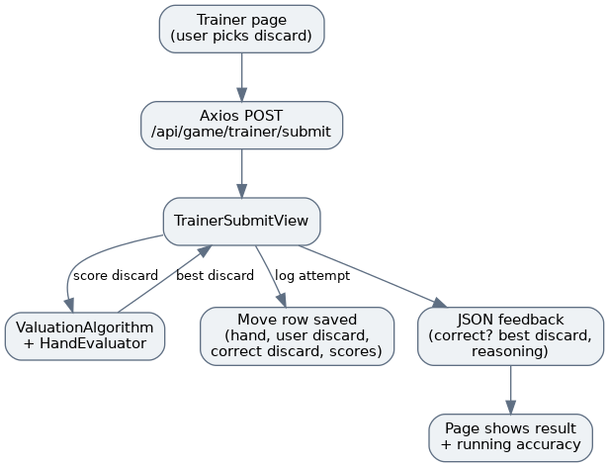
Figure 5. Data flow for submitting a discard in the Trainer.
User flow. The user is dealt a hand, taps the tile they would discard, submits, and immediately sees whether it was the optimal play, what the best discard was, and a running tally of how many they have gotten right.

8.4 Points (Tai) System
Function. Scores a completed hand using Singaporean tai rules, including a wind and position tracker and the rule that a hand must be worth at least one tai to win.
Data flow. POST /api/game/score-hand/ accepts the hand, optional bonus tiles, the player's seat wind, and the round wind. The view checks the hand with WinChecker and scores it with ScoreCalculator, returning the total tai, a breakdown of each source, and whether the minimum tai rule is met. Point values live in a single configuration table in the engine so they can be adjusted to match house rules.
Developer note. Because a hand can often be read in more than one way (for example three Pongs versus three Chows), the scorer enumerates every valid decomposition and keeps the highest scoring reading, which mirrors how a real player would score their hand the best legal way.

8.5 Solo Play
Function. A four player game with the user as East and three computer opponents that use the same valuation engine. The current version implements dealing, the draw and discard turn loop, flower replacement, declaring a concealed Kong, self draw wins, and the washout draw when only the 16 tile reserve remains.
Data flow. The game is stateful, so the SoloGame object is held on the server per user. POST /api/game/solo/new/ deals and starts a game; GET /api/game/solo/state/ returns the user's view of the table with opponents' concealed tiles hidden; POST /api/game/solo/discard/ and POST /api/game/solo/kong/ apply the human's action. After a human move the server runs the AI seats automatically until it is the human's turn again or the game ends, then returns the updated state.
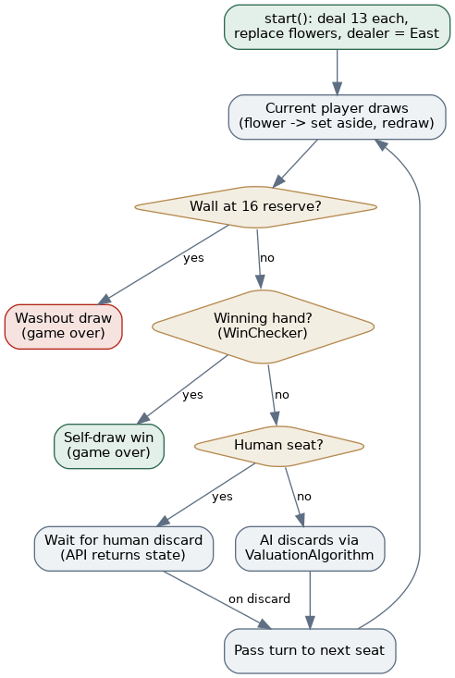
Figure 6. Solo Play turn loop and end conditions.
User flow. The user starts a game, sees their own hand plus opponents shown only as tile counts and exposed melds, taps a tile to discard, and watches the opponents respond, until someone wins by self draw or the wall reaches the reserve and the round is a draw.
Developer note. The soloplay feature is unfinished. Current implementation is a basic proof of concept, while implementation of core game mechanics of claiming melds from discards, winning of discards, as well as game structure features like dealer and wind rotation, and AI behaviour for claiming melds of discards.

9. API Reference
All endpoints under /api/game and /api/tutorial require a valid JWT. The token endpoints issue and refresh credentials.
Method and endpoint | Auth | Purpose
POST /api/users/register/ | No | Create a user and an empty profile.
POST /api/token/ | No | Log in; returns access and refresh tokens.
POST /api/token/refresh/ | No | Exchange a refresh token for a new access token.
GET /api/users/profile/ | Yes | Return the current user's profile and stats.
GET /api/game/random-hand/ | Yes | Generate a random 13 tile hand.
POST /api/game/recommend-discard/ | Yes | Hand Helper: best discard for a 14 tile hand.
POST /api/game/check-win/ | Yes | Check whether a hand is a complete winning hand.
POST /api/game/score-hand/ | Yes | Score a winning hand in tai.
POST /api/game/trainer/new/ | Yes | Deal a trainer hand and log a pending move.
POST /api/game/trainer/submit/ | Yes | Score the user's discard and record the result.
GET /api/game/trainer/history/ | Yes | Past trainer attempts and accuracy.
POST /api/game/solo/new/ | Yes | Start a solo game.
GET /api/game/solo/state/ | Yes | Current solo game state (human's view).
POST /api/game/solo/discard/ | Yes | Human discards a tile in solo play.
POST /api/game/solo/kong/ | Yes | Human declares a concealed Kong.
GET /api/tutorial/modules/ | Yes | Module catalogue with completion merged in.
GET /api/tutorial/progress/ | Yes | The user's tutorial progress rows.
POST /api/tutorial/complete/ | Yes | Mark a module complete with a quiz score.

10. Testing
Testing focuses on the backend, where the game logic lives. The suite currently contains 57 backend test cases and grows with each feature. We test at three levels.
- Unit tests for engine classes: deck construction and counts, hand generation, the evaluator and valuation algorithm, win detection across all three patterns, Kong handling, claimed melds, and the tai scorer.
- Integration tests for the API: authentication is required, the Hand Helper, Trainer, scoring, and Solo Play endpoints return correct results, and game state advances correctly.
- Edge case tests: invalid hands and tile counts, more than four copies of a tile, the minimum one tai rule, the washout at the 16 tile reserve, and a full simulated game that must always terminate.
The frontend is verified to compile cleanly for production with npm run build. Expanding automated component tests with React Testing Library is part of the Milestone 3 plan.

11. Bugs and Problems Encountered
The following problems took real effort to diagnose and fix. We record them here because the debugging is part of the engineering work.

11.1 Trainer returned 500 after a few rounds
Symptom: starting a new trainer hand sometimes failed with a server error. Cause: the view used get_or_create to find the user's trainer session, but React's development mode mounts components twice, which fired two new game requests at once and created two sessions. From then on get_or_create raised MultipleObjectsReturned. Fix: select the most recent session with filter and first, and create one only if none exists, so duplicate sessions are tolerated.

11.2 Login worked but pages broke after a few minutes
Symptom: features failed with a 401 after some idle time. Cause: SimpleJWT access tokens expire quickly and there was no refresh handling, so every request failed once the token expired. Fix: an Axios response interceptor that refreshes the access token on a 401, retries the original request, and only logs the user out if the refresh fails.

11.3 Recurring database errors that a migrate fixed
Symptom: a feature would 500 with a missing table or relation, and running migrate fixed it. Cause: new models had been added but the running database had not had the migrations applied, or the server and the migrate command were pointed at different databases through the SQLite versus PostgreSQL switch. Fix and practice: always run migrate after pulling changes that touch models, and keep the database choice consistent between the server and the migrate command.

11.4 Scoring missed a higher reading of a hand
Symptom: a hand of all Pongs in one suit did not score All Pongs. Cause: the win checker returned a single decomposition, and it happened to read the hand as Pong plus Chows. Fix: the scorer now enumerates every valid decomposition and keeps the highest scoring one.

12. Software Engineering Practices
We follow a small set of disciplined practices appropriate for an Apollo level project.
Parallel, conflict free task division. For Milestone 2 we deliberately split work so that two people could build at once without colliding: one person owned the Trainer inside the game app while the other owned the Tutorial app and its own components, with the shared routing wired up once in advance. This kept merges clean.
Separation of concerns. The Python engine has no Django imports and is kept apart from the API views, so the same logic powers multiple features and can be tested directly.
Test first discipline for logic. Each engine capability and endpoint is added together with tests, and the suite is run before merging.

13. Running the Project Locally
Backend, from the repository root:
python3 -m venv venv
source venv/bin/activate (Windows: venv\Scripts\activate)
pip install -r requirements.txt
cd backend && python manage.py migrate && python manage.py runserver
Frontend, in a second terminal:
cd frontend && npm install && npm start
If PostgreSQL is not set up locally, set USE_SQLITE=True in the .env file to use a local SQLite database instead. Remember to run migrate after any change to the models, and keep the same database setting for both migrate and runserver.

14. Milestone 2 Project Log
The work below was completed for Milestone 2. Dates and hours are recorded separately in the team log.
Area | Work completed
Hand evaluation | HandEvaluator and ValuationAlgorithm, plus the recommend-discard API.
Hand Helper | Tile picker page and recommendation display.
Win detection | WinChecker for standard, Seven Pairs, and Thirteen Orphans, plus the check-win API.
Tutorial | TutorialProgress model and endpoints; lesson and quiz frontend with reusable components.
Trainer | Session and Move models, trainer endpoints, scoring and logging, and the trainer page.
Points system | ScoreCalculator with winds, dragons, flowers and animals, patterns, and the minimum tai rule; score-hand API.
Kong logic | Kong aware win checking (14 to 18 tiles) and concealed Kong with replacement draw.
Claimed melds | Meld claimed flag and claim methods so claimed melds are exposed and locked.
Frontend hand display | Reusable hand display for melds, concealed tiles, and bonus tiles.
Solo Play | Four player engine: dealing, turn loop, AI opponents, flowers, concealed Kong, washout reserve; in memory API and the solo page.
Testing | Backend suite expanded to 57 passing tests across the engine, scoring, and all endpoints.
Debugging | Fixed the trainer session error, token expiry handling, and scoring of multiple hand readings.

Planned for Milestone 3
- Claiming Pong, Kong, and Chow from discards in Solo Play, and scoring the winning hand with the tai system.
- A profile and progress dashboard that draws on the stored sessions, moves, and tutorial progress.
- A stronger valuation approach (for example win probability) and supporting tests.
- Frontend component tests and user testing with beginner players.

