**Dusome’s Disciples – User Manual**

**How to Install:**

After getting the program folder from a USB drive, simply click the “game.bat” file to run the program.

**About the Game:**

 Welcome to the Town of Stonehovel! You are a knight of this town and you must fight off the monsters that have invaded your land, in the name of the king! Most of your army succumbed to these hateful monsters, so you’re the town’s only shot at victory. The root of the problem lies in the Stonehovel cave, where the leader of these monsters resides. Although their leader is very powerful, you have the citizens of Stonehovel on your side, who can sell you armour and weapons to help you on your journey. Will you answer the king’s call to arms?

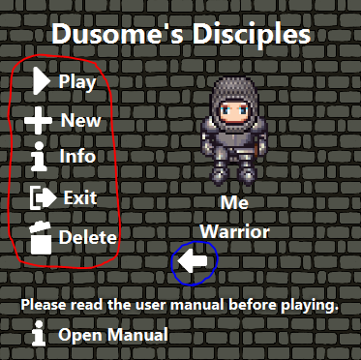

**Menu:**

An image of the menu of the game is to the left. You can create a character by pressing the **New** button and filling out the requested information in the message box. To start playing, simply press the **Play** button. If you have multiple characters, you can click the **Arrows** below your character to shuffle between your characters. The character that is on screen will be the character you play when the **Play** button is pressed. If you ever need to look back on the manual, you can click the **Open Manual** button at the bottom of the screen.

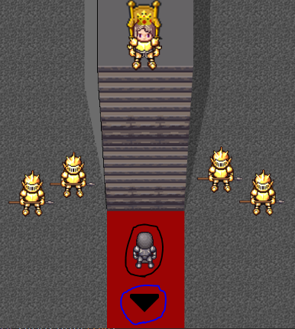

**Castle:**

Starting a new character will put you in the **Castle,** as shown on the left. The character you control is circled in black (In the image, the character is a **Warrior**, if you selected either an archer or mage, their respective sprites will show instead.) You can use **W, A, S and D** to walk around. Walking towards the king will initiate a conversation with him. Click **Space** when any dialogue pops up to exit the conversation. Once you’re done in the castle, walking off screen near the arrow (circled in blue) will bring you to the **Town Menu**. Clicking any of the buttons in this menu will bring you to their respective areas.

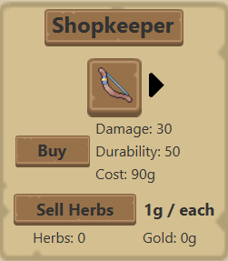**Shopping:**

In Stonehovel, there are **3** shops, the **Shop, Blacksmith** and **Lumberjack** each with unique items that they sell (Explore each shop in-game to find out what items they sell!) Once you get close to the shopkeeper, text will appear, telling you to press **E**, which will open the shop**.** The image to the right shows you the **Shop Menu**. Click the **Arrow** next to the image of the weapon to shuffle through the shopkeeper’s items. Clicking the **Buy** button will purchase the item (If you have enough gold of course!) You **can’t** buy items that are not for your specific class (Warriors can only buy swords; archers can only buy bows and mages can only buy staves. Armour is shared between all classes.) You can see the **stats** of the item beside the Buy Button**.** Weapons will have a **Damage** stat which is how strong the weapon is. Armour items will have **Protection** instead which will soak up some of an attacking enemy’s damage. The **Durability** stat is how much times this item can be used before it breaks. When a **Weapon** breaks, it will not do as much damage as it says it will do. When **Armour** breaks, it will not protect you as much as it says it will do. The **Cost** is the amount of gold it costs to purchase the item. Sometimes, the only information that will be shown is the item’s cost. This means that it is neither a weapon nor armour. **Potions** can be bought which will heal you. These can be used either from the **inventory** or **in battle.**

You can also sell resources (more information about resources can be found below,) to these shopkeepers for gold (By clicking the sell button.) Herbs are 1g, logs are 2g and ore is 3g. Collecting **logs** requires an **axe** while collecting **ores** requires the **pickaxe.** Both of these items can be bought from the **lumberjack.** The **amount** of resources you have can be seen at the bottom of the shop screen and to the left you can see your **gold.**

**Inventory:**

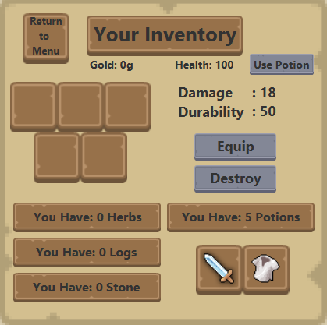 Pressing the **Esc** key will bring up your inventory. Here, you can see the **stats** of your purchased items, the amount of **resources** you have, the number of **potions** you have, your **health** and **gold.** You can also click the **Use Potion** button to heal yourself (if you have potions of course!) It will also not work if you’re already at 100 Health (the max.) You click the image of any item in your inventory to **select** it. The selected item will have a drop shadow effect to it. Clicking the **Equip** button will equip the item to its respective slot (Equipped items are shown in the bottom right.) You can also **Destroy** the selected item using the **Destroy** button (You **can’t** destroy equipped items!) Clicking the **Return to Menu** button in the top right will return you to the menu and save your progress!

**Upgrades/Repairs:**

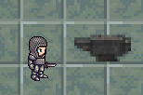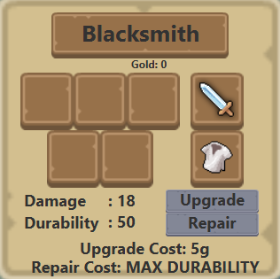 In the **Blacksmith’s** shop, you can use the **anvil** to the right of the room (Again, using **E** to open the menu.) In the anvil you select items as you would in the inventory but instead of equipping and destroying, you can upgrade and repair items. Click the **Upgrade** button will upgrade the selected item, **increasing** the damage or protection (depending on the item) by **2**. You can upgrade an item **5** times and each upgrade will cost an extra **5g.** Clicking the **Repair** button will repair the selected item, returning the durability to its original value, meaning the item is no longer useless! The cost of repairs is **5g.** The **cost** of either **repairing** or **upgrading** an item can be seen at the bottom of the menu.

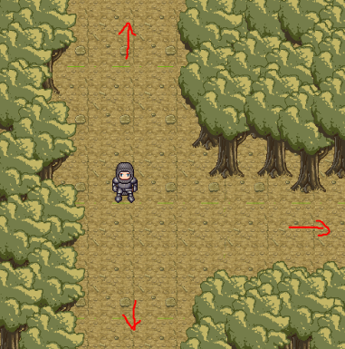**Forest Exploration:**

You can **explore** the forest and explore new areas by reaching the end of the screen (shown by the red arrows.) Walking around while in the forest is dangerous, so make sure you are prepared to fight monsters! You may encounter a monster while in the forest, which will bring you to the combat frame (More information about combat can be found below.) The image used is the **second** area of the forest which splits into **2** paths. Going **down** will lead you to the **Wizard Tower** who is another shopkeeper that sells **Staves** to mages and potions to everyone. Going **right** will lead you deeper into the forest! Going back **up** will bring you to where you just came from and going **up again** will bring you back to Stonehovel. Returning to **Stonehovel** or the **Wizard Tower** will replenish your health back to 100 (free of charge!)

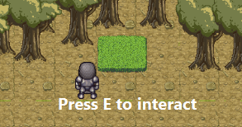 You will find **stronger** enemies the further you explore the forest, so make sure you **return** to Stonehovel often to get better gear and more potions! You will also come across the first resource to collect; **herbs!** You can get herbs by walking close to the herb bushes and clicking **E**. Watch out though, because you’ll never know if there is a monster lurking in the bush! Further into the forest you will find a **lumberyard,** where you can chop logs (again,an **axe** is required!) The rest of the forest is left for you to discover!

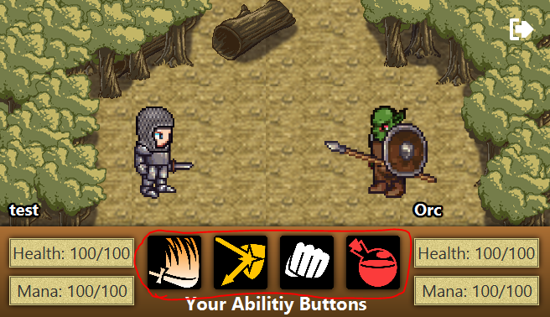**Combat:**

This is the combat frame (above.) You can see **yourself** on the left and the **enemy** on the right. In this image, you can see the names of both you and the enemy and your **health** and **mana** count below these names. Your **abilities** are in between, and each class has their own abilities. Hovering over the **icon** of an ability in-game will give you a brief description of what it does. Each ability costs **mana** (besides the **warrior’s** attack, **punching** and **potions.**) If you don’t have enough mana, you won’t be able to use the ability (Reminder: punching requires **no** mana!) Starting on the **left,** the first ability is your **offensive** ability. This will do damage to the enemy. When you attack, there is a 10% chance to miss, meaning you won’t do any damage, but will still consume mana. There is also a 10% chance to critical hit, meaning you will do **2x** the damage! **Note:** although your ability says you will do between a certain amount of damage, this doesn’t consider the enemy’s **defense**, which will soak up a bit of your weapon’s damage! The second ability is your **defensive** ability. This will be an ability that won’t do damage but instead protect you in a unique way (again, hover over the ability in-game to see how it will help you!) The third ability is your **punch**. When in dire situations, use **punch**, which won’t do much damage, but will regenerate some of your **mana!** The last ability is your **potions** (you start of the game with 5 potions.) The potion will heal you for **20 health** and **30 mana** (but will not heal you past **100** health or mana!) If you **hover** over your character’s image, you will be able to see the durability of your weapon and amour.Your goal is to **defeat** the enemy, by using your **offensive** ability until the enemy reaches 0 health. You will lose if you reach 0 health (you will be sent back to the town and lose a portion of your gold. When the fight ends, you can return to the world by pressing the **Yellow Arrow.** You also get gold as a reward for winning! The **tougher** the enemy, the **more gold** the enemy will have! Clicking the **Exit** button in the top right will let you quit the game early but will **not** save your progress!

