Introduction to Artificial intelligence

Assignment 2

Accompaniment Generation

Danila Korneenko B20-04

**Prologue**

In my humble opinion, all the melodies sound good. However, I cannot vouch for the musical accuracy of this algorithm. And there is a reason for this: I have never been able to fully understand how chords are based on. Therefore, I chose a method that works in all cases: We take the first note in count, after that we determine in a minor or major it should be and then we take a random chord, because it will always be in the key. In such cases it’s always makes good chords.

**Description of the algorithm**

Main parameters:

* **Initial conditions(representation):** First of all, I calculate good chords for the melody by identifying it’s key and then get random(if we cannot say it’s minor or major type of chord for every count) chord and place its number in list. Then I calculate rating of everyone in population(fitness func) how close it to the original chords
* **Variation operators**: Crossover and mutation
  + Crossover: Children create random number N and then N’th genes takes from first parent, other genes from second
  + Mutation: Choose some number of individuals and change some number of their genes(random too)
* **Selection:** Sort generation from best to worst and then “delete” second half of the generation
* **Fitness function:** Calculate rating of how close individual to our generated chords, where “0” rating is the best genome.
* **Stopping criteria:** If we found best genome or number of generations exceed max_num_generations
* **Other important parameters:**
  + Population size = 32
  + Max number of generations = 1000

**Some addition info**

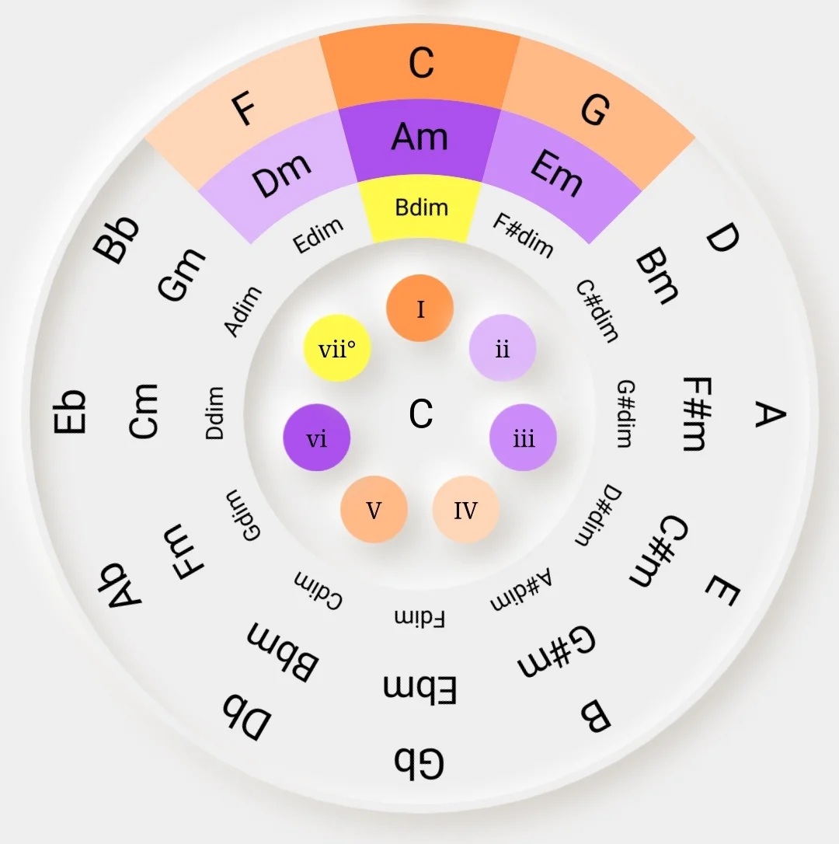For finding notes in tone I’ve used this circle of fifths:

*Input_num*  is responsible for which specific file we will take as input, so if you want to use a file with a different number, just change the first variable: 