Wind plant: United to stand
When you go to seaside and enjoy the soft breeze brush over your face, you may also notice some wind plants stand silently in the distance with its blades rotating slowly. People usually think that those wind plants are just like “fans” that generating power by making use of wind and only need to simply put it in places that gales occur frequently. However, a wind plant actually transforms more than wind energy into electric power to ensure its efficiency. With the development of science, scientists combine more and more new technology to the wind plant.
We all know that the principle of wind power plants revolves around the conversion of wind energy into electrical energy through the rotator in the turbine and electromagnetic induction systems. Wind turbines operate by harnessing the kinetic energy of wind, which causes the blades to rotate. This rotational motion is then converted into electrical energy via a generator. Conventional wind power plant may not work commercially and efficiently. A paper in 2021 stated that in the conventional wind generator, acquiring a stable power is challenging due to the continuous fluctuations in wind velocity. Furthermore, scientists also acknowledged that the main problem of wind-power production is that there are usually low wind speeds and there are more rarely stronger winds [3,4]. So, a wind power plant can not meet our need if works in isolation.
Wind energy can collaborate with other renewable resource
To enhance its efficiency, scientists discover that if combined with other renewable power, wind plants’ efficiency in generating power. For instance, research shows that solar photovoltaics and wind turbines are the closely integrated renewable energy resource into the power grid. And this phenomenon may due to the complementary generation profiles wind power and photovoltaic (solar energy) have. [1,2] This trait enables the whole grid to achieve a more balanced energy output. Scientist make this theory a reality by mathematical modeling that tracks the hybrid system’s maximum power point. This approach is significant for determining the optimal sizing and configuration of the components involved, then assemble them together. And eventually, the system can decrease the possibility of over generation from one resource that would causes negative effects in efficiency.
In fact, wind energy can “cooperate” not only with solar energy but also wave energy. Scientists found that wave energy is more ample and widely distributed than wind energy. While this energy technology has not been fully commercialized currently due to its high costs and issues with reliability. However, if the two kinds of energy equipment can share space, supporting structures, cables, and other infrastructure and combine together, not only the cost of the device can be reduced, but also can capture wind and wave energy and greatly improve the utilization of renewable energy of the ocean. Furthermore, the temporal complementarity between the two resources enables the combined wind plant to generate a more steady and stable power supply. [5,6] As a result, we are able to build wind power plant not only on the ground but also offshore. Countries like Canada has taken advantage of this wind-wave combined energy to generate power. Those scientists’ claims reveal that a wind power plant does not singularly utilize turbine to generate power. Instead, it integrates different kind of energy to reach the top generation efficiency.
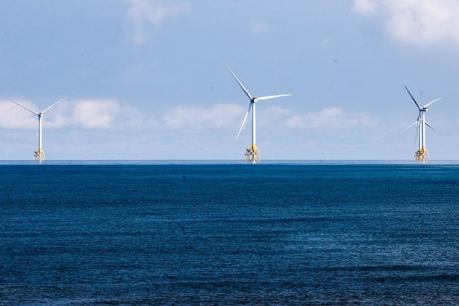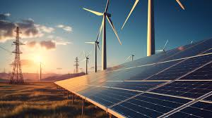
However, those combined plants still have negative effects. Is this combined power plant really environmentally friendly and can reduce our carbon footprint? Unfortunately, research suggests a negative opinion. It shows that emissions to the atmosphere accounted for over 90% of all emissions in the lifetimes of both the wind and the photovoltaic power plants. And this result indicates that building a plant may cause more pollution to the air [10], another paper finds that the inappropriate integration of wind power and other renewable energy may adversely affect the power system by reducing its reliability and stability [11]. Moreover, whether the power plant have influence on nearby residents’ health is still to be verified. Overall, those negative impacts indicate that combining different energies without a proper method to coordinate them may lead to a worse result.
Although the combined wind power plant is not perfect, the steps of exploring wind energy would never stop. As artificial intelligence is developing at a rapid pace, scientists and engineers gradually fix their eye on AI tool. They take advantages of AI model’s superb performance in calculation and data analysis. Some AI models are trained to assist engineer in controlling the plant and forecasting the energy source. AI’s participation brings life to the renewable resource which may be the key to handle the lack of energy.
AI technology is applied to wind power plants as well
AI technology has been developing these years. And algorithms like deep learning empower AI systems the capability to process instant data stream and make relate reactions rapidly. Because of the uncertain nature of renewable resources as well as the complexity of combined power systems, it may be hard and dangerous for human engineer to control the ratio of two resources according to the generating situation. So, researcher apply intelligent controllers designed for active power management to keep frequency steady and nominal under any uncertainty. This research also find that AI participated controller tends to perform better than traditional controller. Similar opinion is proposed in another research which finds that AI control system is able to use previous data, constantly updated forecasts. And effectively delivers a flexible and dependable system architecture that guarantees a continuous power supply to loads under all conditions [13,14]. AI’s control enables the combined power plant to have a stable voltage and rate of work, which is a crucial point that power plant can be merged into the whole power grid safely.
Application of artificial intelligence analysis also makes wind plant more productive. Due to the unpredictable weather system, it was a tricky task for engineers to select a place where gales are likely to occurs. So, it’s obvious that an accurate forecasting result is crucial for increase wind power’s efficiency and lowering energy consumption. As we’ve entered the era of big data, AI is a crucial tool for the task. A report points out that combining diverse resources with concept innovation as well as AI provides the potential for accurate wind energy forecasting. [7,8] Computer science engineers apply various kind of neural network (algorithms that enable AI to learn from new information) to AI, which make them suitable to handle the dynamic, non-linear and sophisticated wind power features. And in the future, scientists believe that using efficient AI-driven hybrid approaches may be a significant solution to achieving an accurate wind power forecasting result [9]. In conclusion, the integration of AI technologies in wind power plants represents a transformative leap towards optimizing renewable energy resources. This not only supports the sustainability goals by reducing dependency on non-renewable energy resources but also promotes economic stability by ensuring a consistent and reliable energy supply. Besides predicting the abundance of the wind energy.
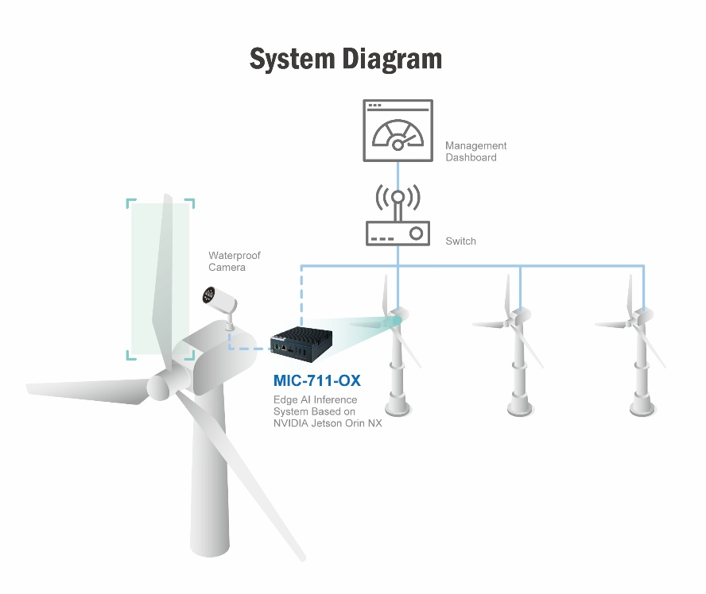
But every coin has two sides. AI model requires a great amount of data to build its data base, which ensure its accuracy of prediction and control. Thus, scientist need to collect sufficient data to train the model. And data collection may require lots of time and labor force. More importantly, as the real environment is more complex and changeable, computer scientists need to put more effort in refining their algorithm in order to improve the quality of data-preprocessing [12]. To sum up, the addition of AI cannot handle those problems once and for all. Instead, misuse of AI technology may increase the economic burden. Even today, algorithm related to data analysis and prediction is still a popular topic of scientific research.
The whole population around the world has reached 8.1 million and it is inescapable that resource issue is one of the most urgent issues in the world. Additionally, overuse of fossil fuel may accelerate the process of climate change of the world, destroying the environment. Although some of technologies are still under development and need more research, there is no doubt that wind energy may be the key element to dealing with those problems. This post shows that wind power is more like an enhancer and uniter, only when combined with other renewable resources and technologies can it reach it maximum. And it is the same for us, we must cooperate and make a joint effort to broaden our way towards a better future.

Reference:
[1]. Muhammad Raiz et.al. “An Optimization-Based Strategy for Solving Optimal Power Flow Problems in a Power System Integrated with Stochastic Solar and Wind Power Energy” Appl. Sci. 2021, 11(15), 6883; https://doi.org/10.3390/app11156883
[2]. Øyvind Sommer Klyve et.al.” Influence of high-resolution data on accurate curtailment loss estimation and optimal design of hybrid PV–wind power plants
” Volume 372, 15 October 2024, 123784
[3]. Shweta Mehroliya et.al. “Comparative Analysis of Conventional Technologies and Emerging Trends in Wind Turbine Generator”
[4] Bartholy et.al. “Selected characteristics of wind climate and the potential use of wind energy in Hungary. Part I ” Idojárás , 105 : 109 – 127 .
[5]. Jinghui Li et.al. “Wind–Wave Coupling Effect on the Dynamic Response of a Combined Wind–Wave Energy Converter” J. Mar. Sci. Eng. 2021, 9(10), 1101; https://doi.org/10.3390/jmse9101101.
[6]. Hafiz Ahsan Said and John V. Ringwood. “Grid integration aspects of wave energy—Overview and perspectives” https://doi.org/10.1049/rpg2.12179
[7]. Erlong Zhao ª, Shaolong Sun ª, Shouyang Wang ^{b} ^{c} ^{d} .” New developments in wind energy forecasting with artificial intelligence and big data: a scientometric insight” https://doi.org/10.1016/j.dsm.2022.05.002
[8]. M. Liu et.al. “Application of hybrid model based on empirical mode decomposition, novel recurrent neural networks and the ARIMA to wind speed prediction” Energy Convers. Manag., 233 (Apr.) (2021), Article 113917
[9]. M. S. H. Lipu et al., "Artificial Intelligence Based Hybrid Forecasting Approaches for Wind Power Generation: Progress, Challenges and Prospects," in IEEE Access, vol. 9, pp. 102460-102489, 2021, doi: 10.1109/ACCESS.2021.3097102. \
[10]. Katarzyna Piotrowska ,*ORCID ,Izabela Piasecka ,Zbigniew Kłos ,Andrzej Marczuk and Robert Kasner. “Assessment of the Life Cycle of a Wind and Photovoltaic Power Plant in the Context of Sustainable Development of Energy Systems” Materials 2022, 15(21), 7778; https://doi.org/10.3390/ma15217778
[11]. Mehmet Rıda Tür , Mohammed Wadi , Abdulfetah Abdela Shobole , Hasan Gündüz “INTEGRATION PROBLEMS OF PHOTOVOLTAIC SYSTEMS-WIND POWER, SOLUTIONS AND EFFECTS ON POWER QUALITY” https://doi.org/10.36222/ejt.737571
[12]. Whang, S.E., Roh, Y., Song, H. et al. Data collection and quality challenges in deep learning: a data-centric AI perspective. The VLDB Journal 32, 791–813 (2023). https://doi.org/10.1007/s00778-022-00775-9
[13]. Prakash Chandra SahuORCID Icon,Ramesh Chandra Prusty &Sidhartha Panda “Active power management in wind/solar farm integrated hybrid power system with AI based 3DOF-FOPID approach” https://doi.org/10.1080/15567036.2021.1956647
[14]. Mahjoub, S., Chrifi-Alaoui, L., Drid, S., & Derbel, N. Control and Implementation of an Energy Management Strategy for a PV–Wind–Battery Microgrid Based on an Intelligent Prediction Algorithm of Energy Production. Energies, 16(4), 1883. https://doi.org/10.3390/en16041883
Tomas calculus.

