Minutes of the DAQ meeting (INFN-CEA)

On 19/09/2025 we met on line for a DAQ meeting.

We have fixed a test of the Marco Prototype at CEA from xx to xx october, in which we would like to check the full compatibility of the scintillator detector with the DREAM DAQ.
INFN will provide the test bench with two bars of scintillators coupled with SiPm and the amplification board. In total 4 channels
The SiPm output is on MCX cable, as well as the pre board.
CEA will provide, toghether with the DAQ, a board to pass from MCX cables to the DAQ cable and a beta source for the tests.
CEA look for a power supply for the electronic board (+- 6V) and high stability and linearity power supply for the SiPm (60 V DC). Otherwise, Marco will bring the modules available at LNGS.
CEA will check where to assemble the test
People intested to partecipate to the tests are welcome

Main test purposes:
- demonstrate the possibility to read the SiPM with the DREAM electronics, with acceptable Signal/Noise ratio.
- evaluate the electronics required to couple the SiPM output to the DREAM, taking into account the length of the expected cables used, e.g. cabling adapters (MCX/Samtec-DREAM), amplifier (probably not), attenuators ? ...

For the test we have prepared a plastic scintillator bar (~500 x 17.5 x 3 mm3) coupled to two SiPM linear arrays on both ends (see Fig. 1 where PMTs are replaced by the SiPMs inserted into the red housing). The scintillator bar is inserted into the SiPM housings (like the red one in figure 1); the SiPM housings are supported by a Bosch like aluminum profiles.

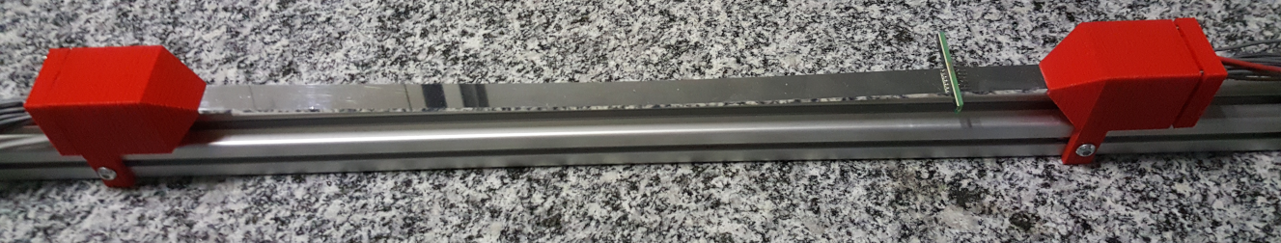Fig. 1: Scintillator Bar coupled to PMTs and an SiPM on top of the scintillator to show the typical size. For the test, the PMTs are replaced by the SiPM of Fig. 12

Each SiPM has 16 pixels (~52 x 3.2 mm2) connected to 4 (2 pins each) channels (4 adjacent pixels ORed on each couple of channels), see Fig 2.

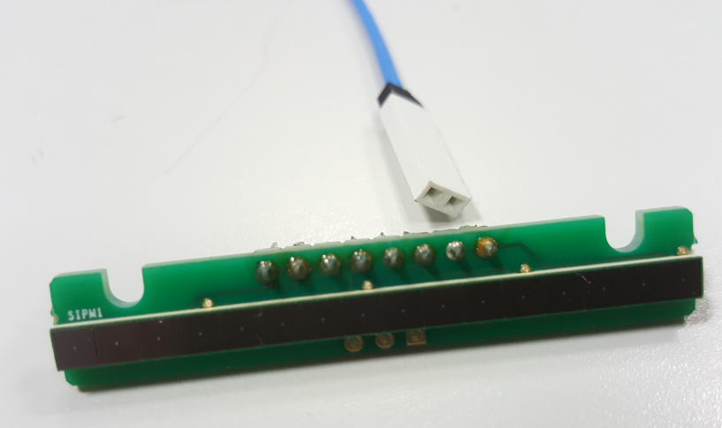
Fig. 2: SiPM line with 16 pixels, grouped into 4 channels for readout (2 pins each group of 4 pixels)

The bias voltage of the SiPM is around 53 V.

Only the two central groups of 4 pixels (~26 mm) can detect the photons from the scintillator bar and can be considered active channels.

The 4 SiPM channels are connected to the interface board of Fig. 3 which distributes the bias voltage and permits the use of NIM (or MCX) cables.

An amplifier (Fig. 4) with 2 input channels is provided. It requires +6 V and -6 V voltage levels (current < 100 mA). The amplifier has 3 outputs: the 2 amplified input (10x) and 1 analog OR of the amplified inputs (/2).

For testing we can consider: one active SiPM channel connected to the amplifier and then to the DREAM MCX/micro-coaxial interface (Fig. 5), while the other active channel directly to the DREAM interface.

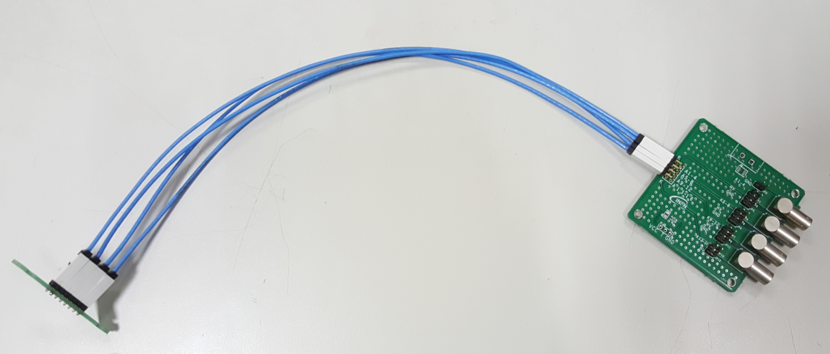
Fig. 3: SiPM connected to the board which distribute the bias voltage (power supply connector and capacitor to be soldered)

Fig. 4: SiPM amplifier

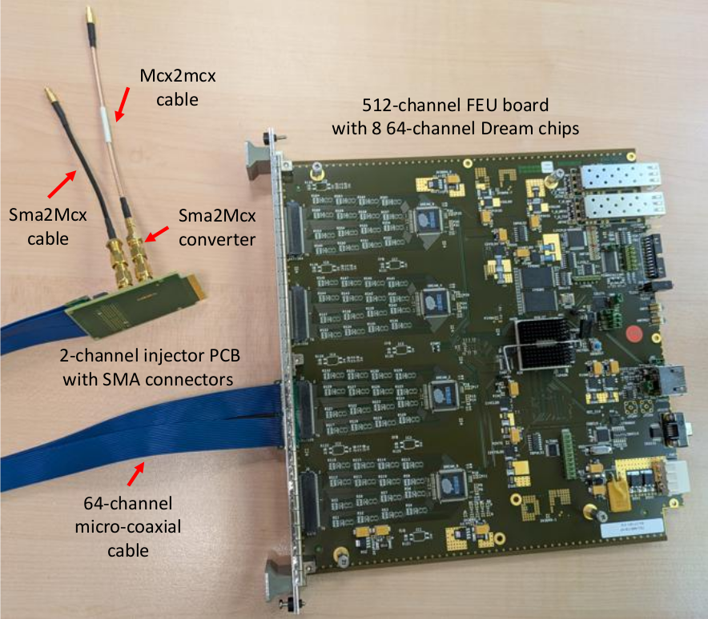
Fig. 5: MCX/micro-coaxial interface and DREAM board
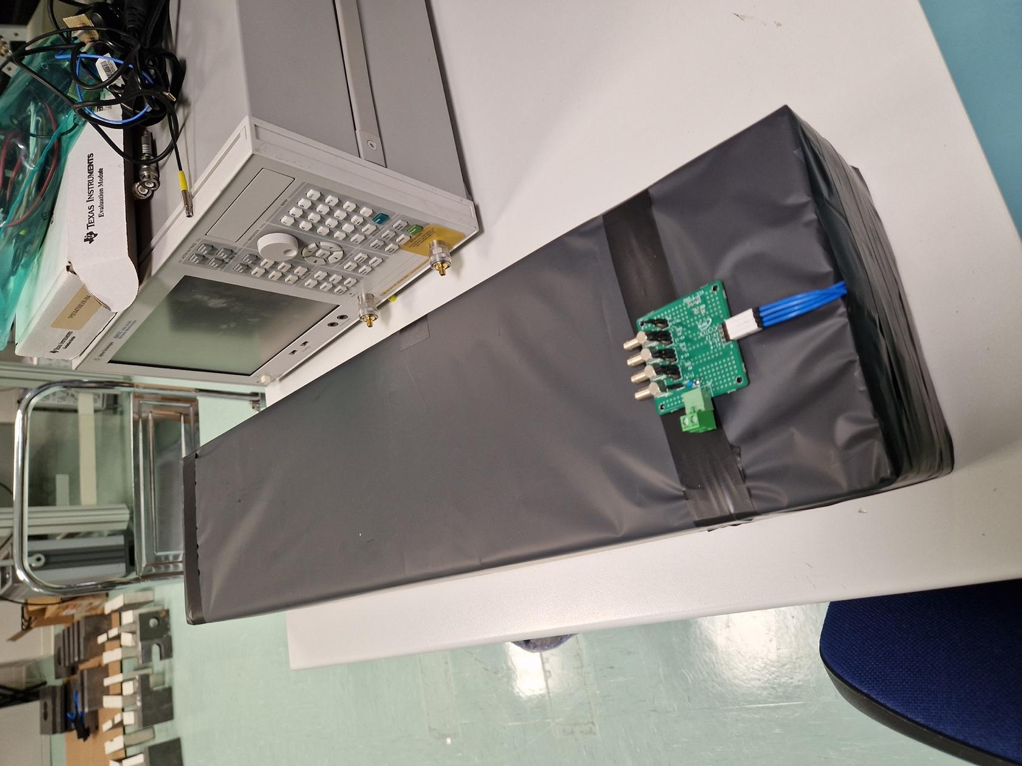
The scintillator bar + SiPMs requires to be operated in light tight conditions. This is achived with black mylar foil wrapped around (see picture)

Marco Already tested the assembly and the obtained signals for the oscilloscope are reported in the figure below where the yellow trace is without amplification and the magenta one with x10.

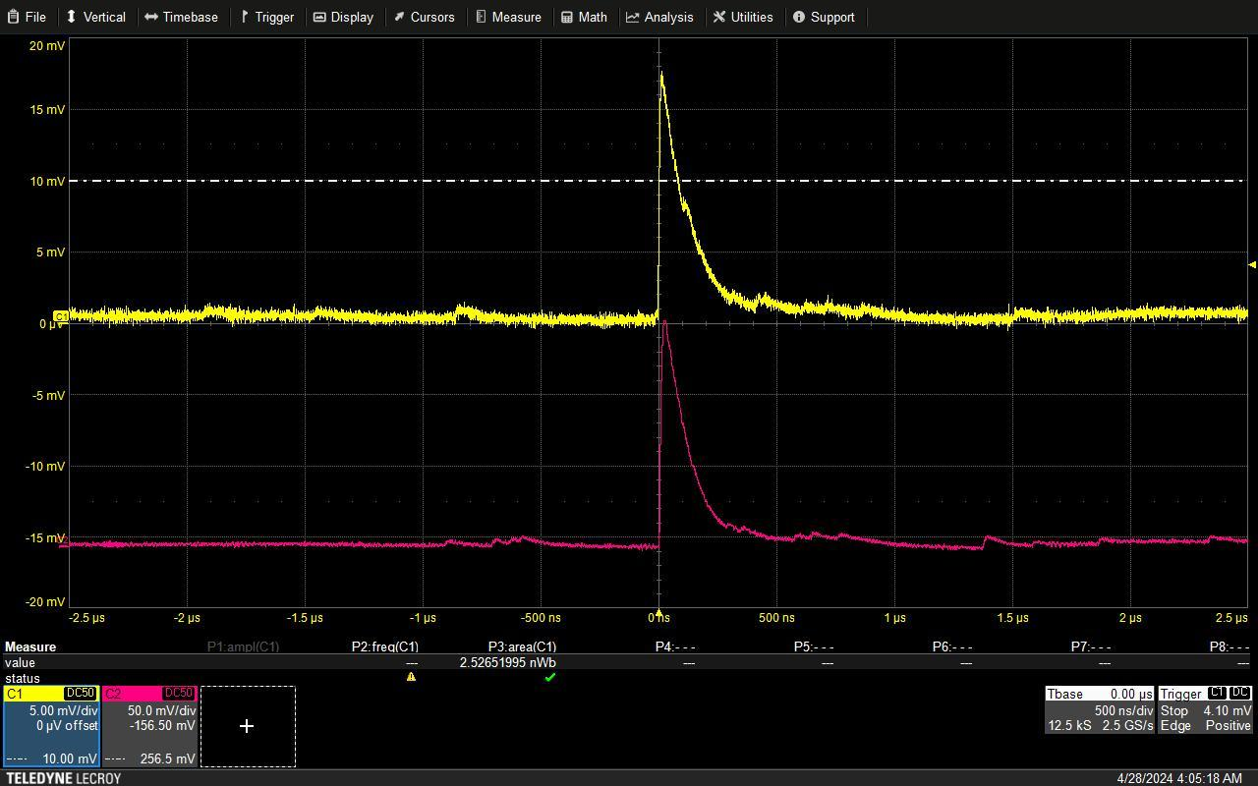

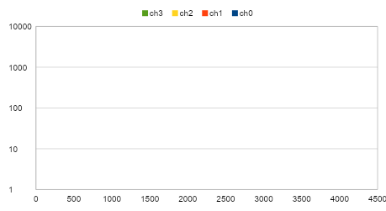
Fig. 6: Charge distribution of the SiPM readout by the CAEN FERS electronic (CITIROC chips); the SiPM is coupled to the scintillator bar, a 90Sr point source is at about 10 cm from the SiPM in contact with the scintillator; only the 2 middle channels ch1 and ch2 provide signals (mean around 1367 and 1072); the two border channels ch0 and ch3 show only the pedestal (mean around 85).

November nTOF Test

Main Test Purposes:
- Evaluate performances of the MicroMegas (e.g. saturation, occupancies …)
- Evaluate the scintillator+SiPM bars (offline ?) trigger performances readout by DREAM electronics
- Develop the analysis software
- ...

Taking into account the uncertainties of the SiPM and electronics providers (which is not under our control) it seems to be more reliable to use the existing bars, SiPMs and light tight box;
- readapt the box to match the microMegas (as much as possibly similar to the final version);
- replace the main plastic parts with metal bars;
- reuse the 20-24 SiPMs (up to 96 channels) and the bars (10-12)
- use the existing SiPM cable adapter and bias supplier cards (fig 3); possibility to solder MCX instead of LEMO

Need to provide the MCX (or LEMO)/Samtec adapter for the dream readout and possibly the amplifiers (depending on the results of the DREAM-SiPM readout test).

Final detector for 2026 measurements

The tiny Samtec coaxial cables (fig. 4) seems to be cheaper than the MCX cables (one Samtec flat = 20 MCX cables) and it offers a simpler solution for light tightness.

Possibly, the current card where the SiPM is soldered can be preserved and a new card with two Samtec connectors can be connected to 5 of the SiPM cards and extract the 20+20 signals (SiPM and I2C of the thermo-sensors).

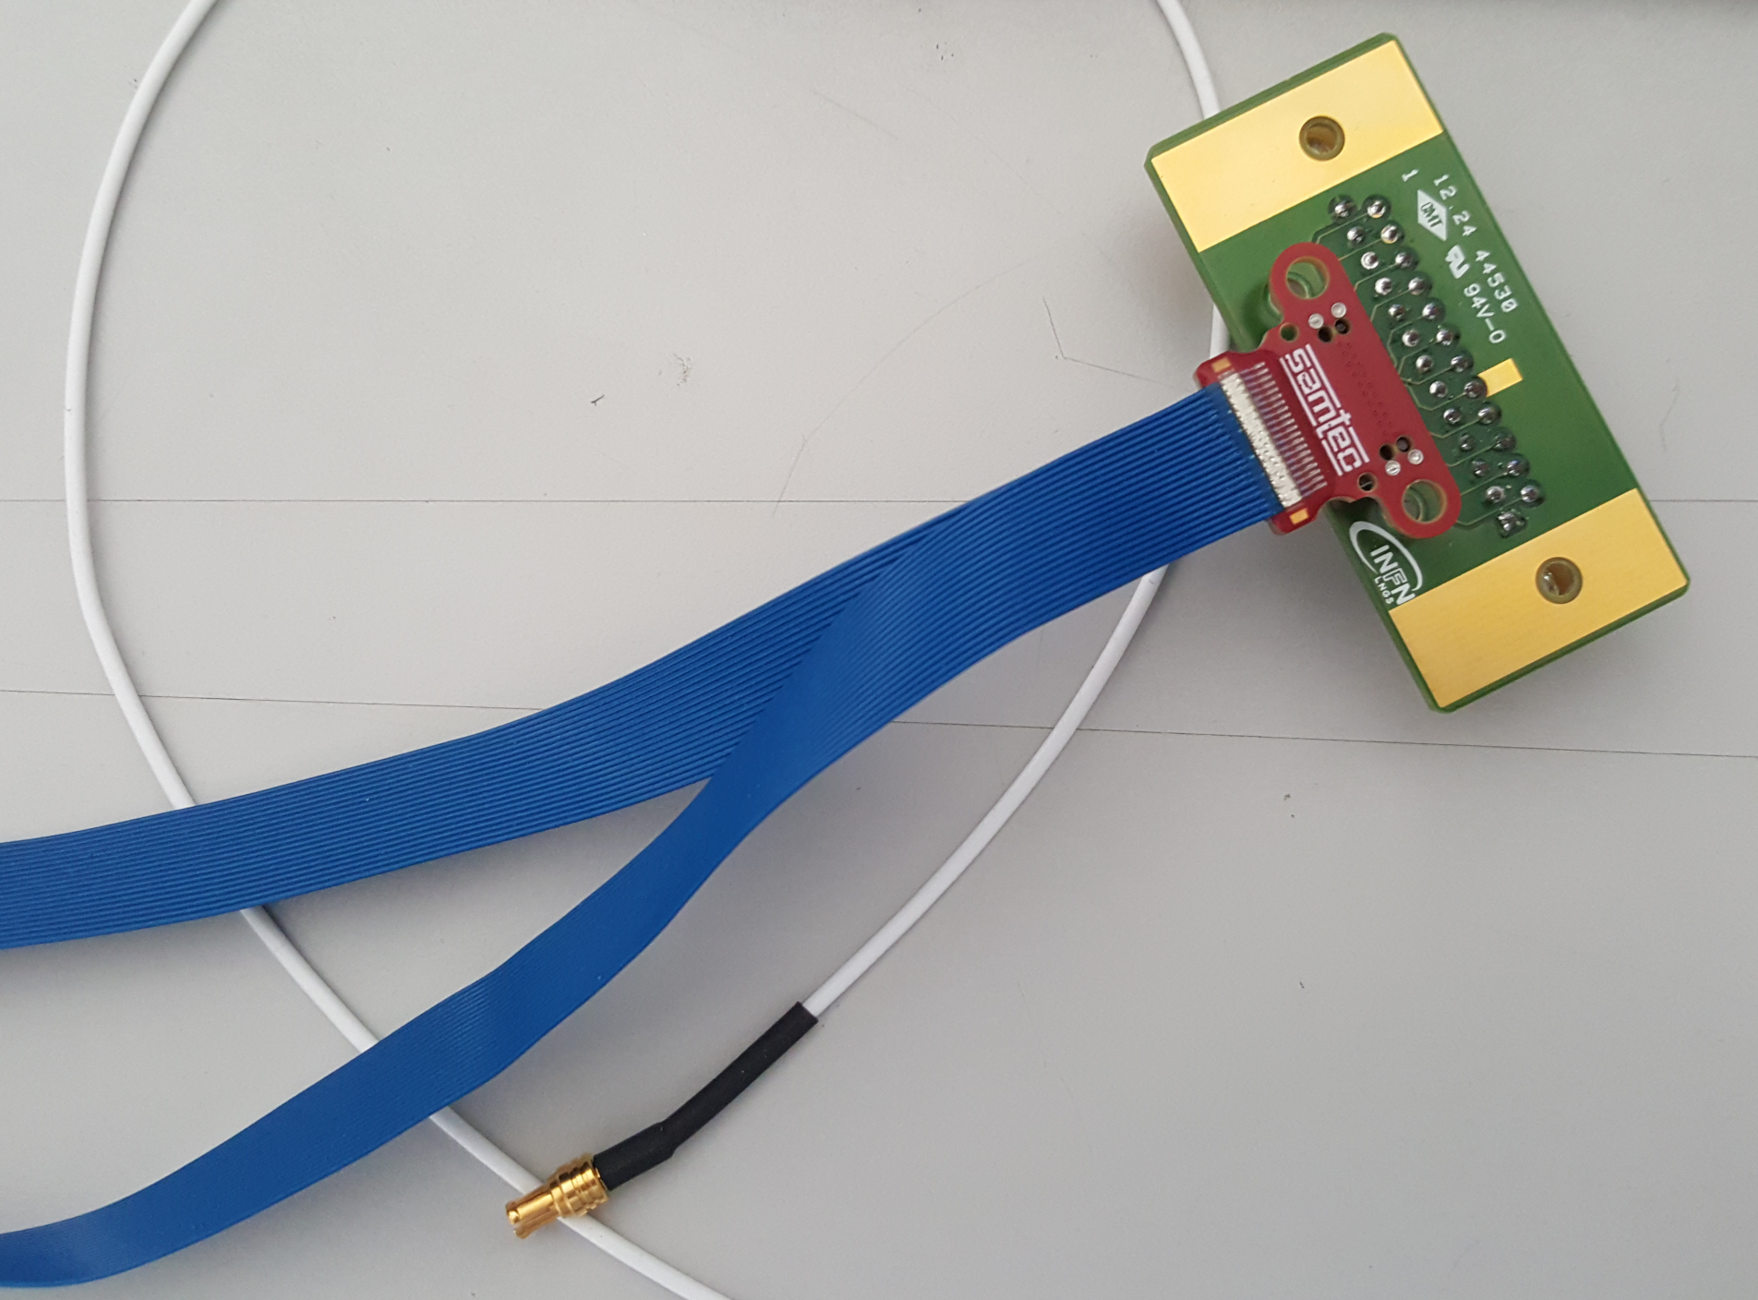
Fig. 7: Blue: Samtec coaxial flat cable (20 channel on each flat) and related connector; white: the MCX cable. One Samtec flat = 20 MCX cables.

Conclusions and to do list

We have fixed a test of the Marco Prototype at CEA from xx to xx October:
Persons joining the tests are from INFN:
Maro D’Incecco
Giorgio Cotto ?
Nicholas Piretti ?
Luigi Cosentino ?

INFN will provide the test bench with two bars of scintillators coupled with SiPm and the amplification boardwhich are redy to be moved to CEA.
CEA will provide, toghether with the DAQ, a board to pass from MCX cables to the DAQ cable and a beta source for the tests.
CEA look for a power supply for the electronic board (+- 6V) and high stability and linearity power supply for the SiPm (60 V DC). Otherwise, Marco will bring the modules available at LNGS.
CEA will check where to assemble the test

Hello Irakli,

some pictures to show you how to connect electronics:

- Blu cables from Sipm, only the central segment of the Sipm, Flag II
and III (2 and 3). The Sipm has 16 channels connected in group of four.

- Black dot on top to connect anode and cathode

- amplifier input has SMA connector (2 inputs)

- amplifier output has MCX connector (3 output, the central one
provide (Ch1+Ch2)*0.5)

Regards.

Marco
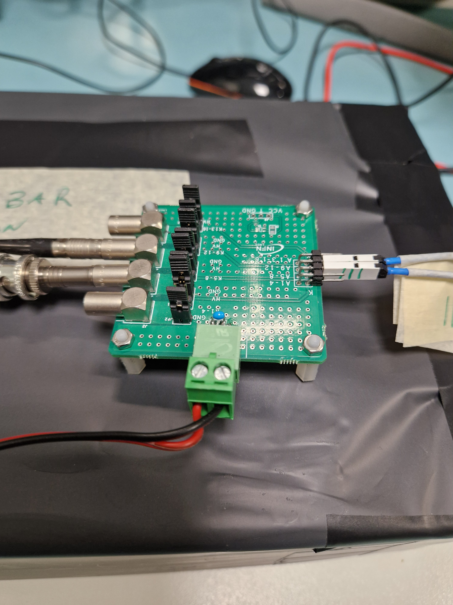
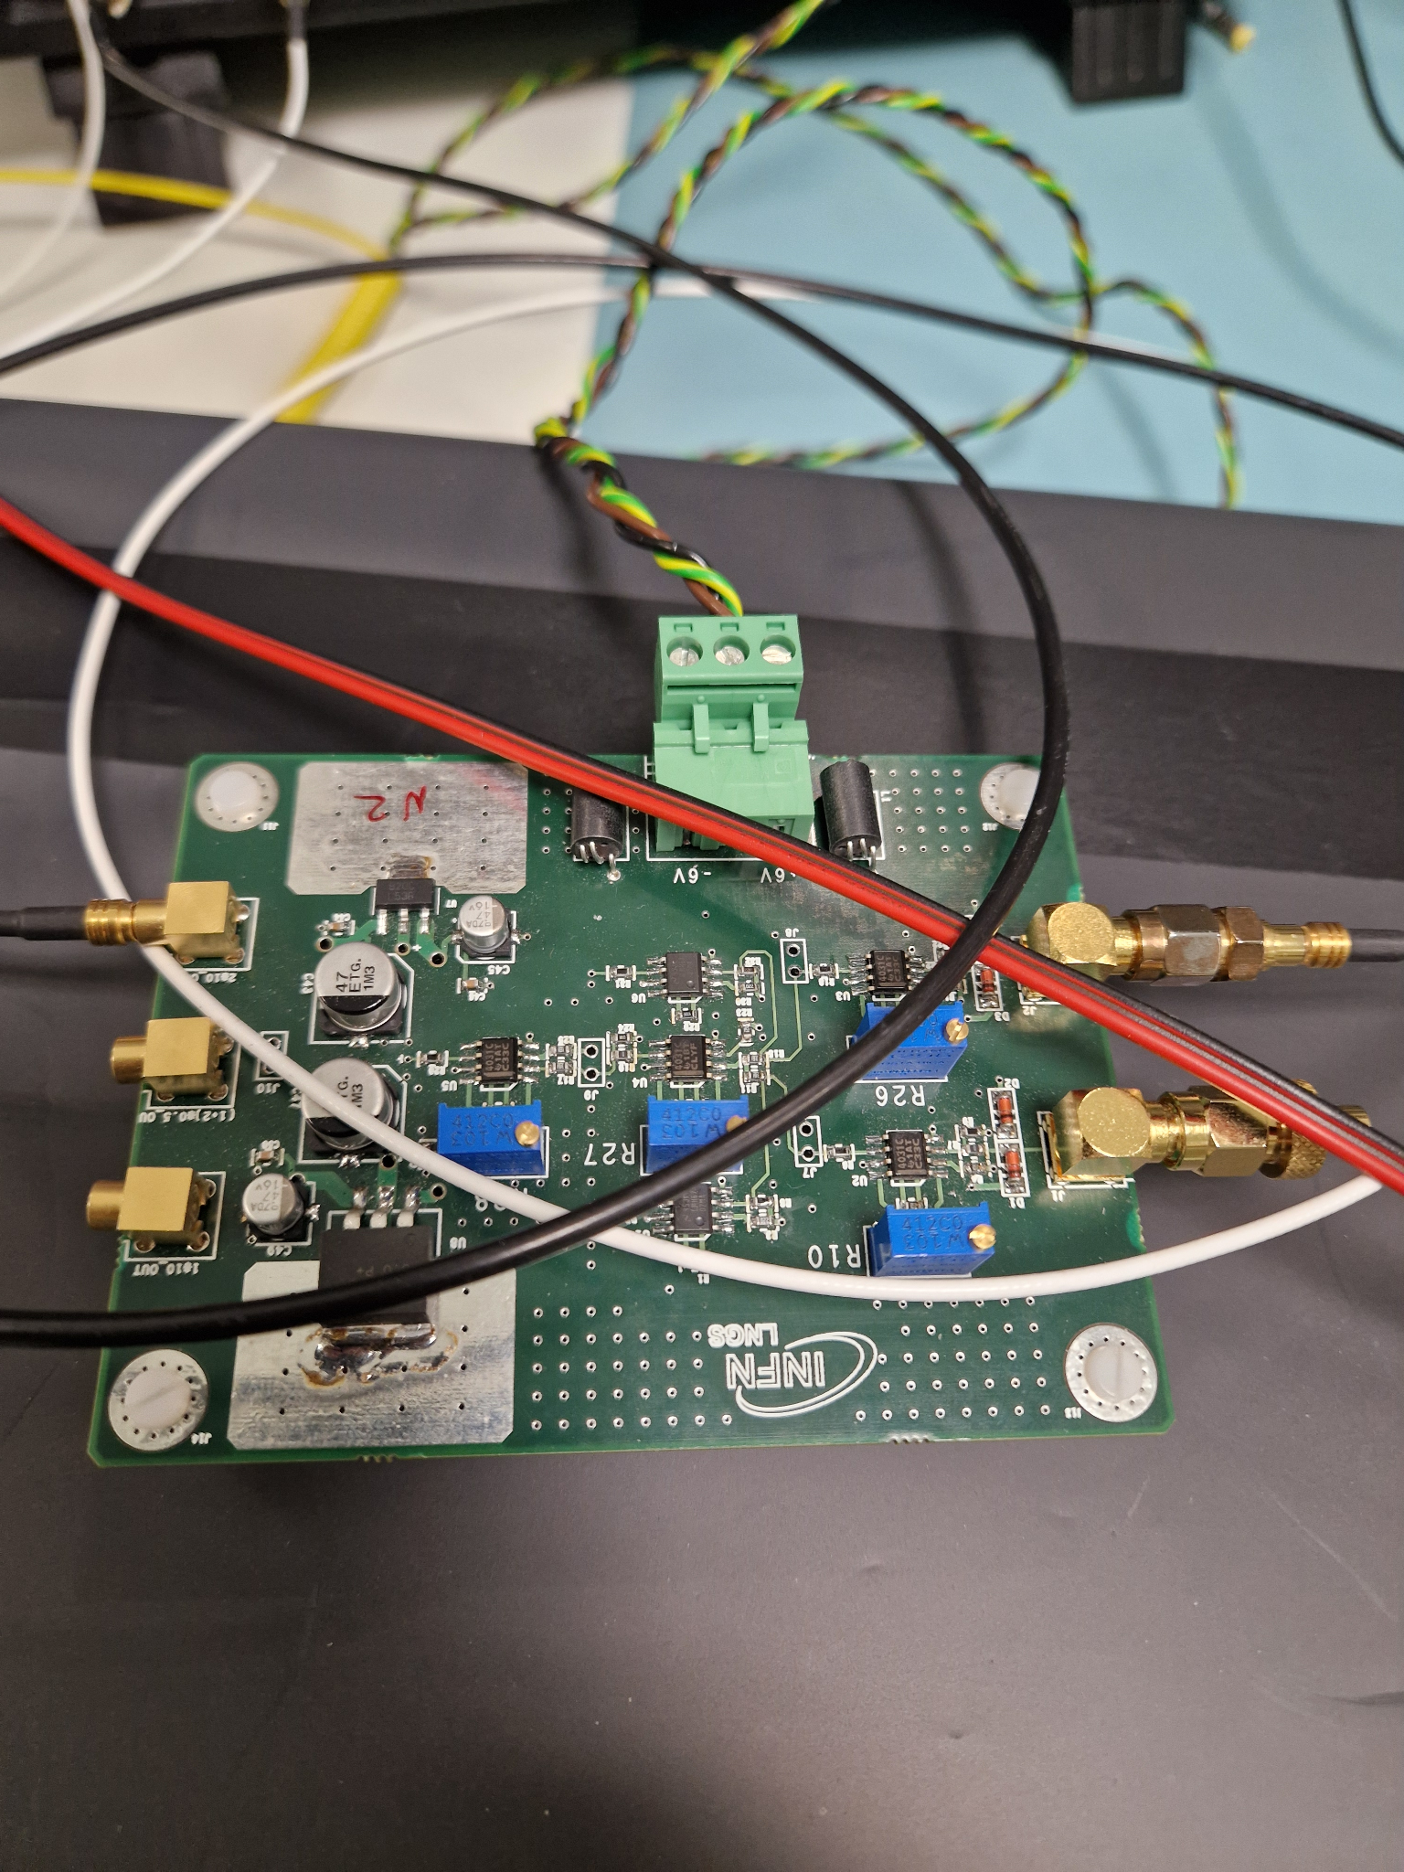

Hello Irakli,

the amplifier card is DC coupled from input to output,

the on board trimmers are used to adjust the dc output for each stage

in a short range.

If you sum at the input a dc bias of 60mV you get an output of 600mV
plus the signal.

Marco

