n_TOF Detectors – ISD Form (Initial Safety Declaration)

Name of the n_TOF Experimental Detector:

X17 Scintillator wall

This document shall be completed by the responsible person of the experimental detector.
Further documentation may be requested to improve the understanding of safety hazards.

The purpose of this document is to provide the following initial information:
- description of the detector, simplified and safety related
- a preliminary hazards identification

The EP Safety Office assists during the creation of this document and makes a first revision of the declared hazards.

Location of the experimentAL DETECTOR
Detectors used in the n_TOF experimental areas 2 .

Description of the experimentAL DETECTOR

Organization
Complete the table below with the correspondent information about the organization of the experiment.
Role | Name | Contact
Responsible person | Pierfrancesco Mastinu | +393495830320
n-TOF EXSO | Giuseppe Tagliente | 60979
EP DSO | Olga Beltramello | 160171
EP Safety Correspondent | Letizia Di Giulio | 168487

Purpose of the detector and description of the installation

The scintillator wall is composed of 20 plastic scintillator bars, each with dimensions of 500 mm x 12 mm x 3 mm. The bars are mounted side-by-side to form a single detection plane.
Each scintillator bar is read out from both ends by Silicon Photomultipliers (SiPMs).
The wall is held within an aluminum frame. The individual detectors are wrapped in a thin plastic reflective material to maximize light collection at the ends, thereby enhancing the signal provided to the SiPMs. The entire frame is closed on the front and back by a thin aluminum plate to shield the scintillators from ambient light.
This wall will be used in combination with MicroMegas gaseous detectors in the X17 experiment. The scintillator wall's purpose is to detect the passage of electrons and positrons and to function as a trigger signal for the MicroMegas chambers placed immediately in front of it.
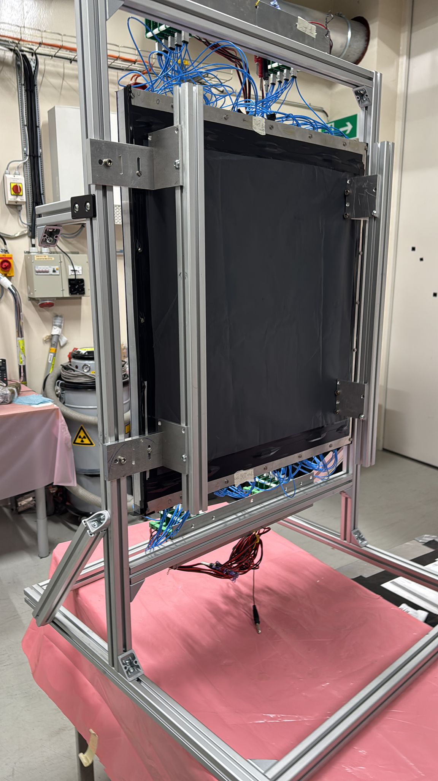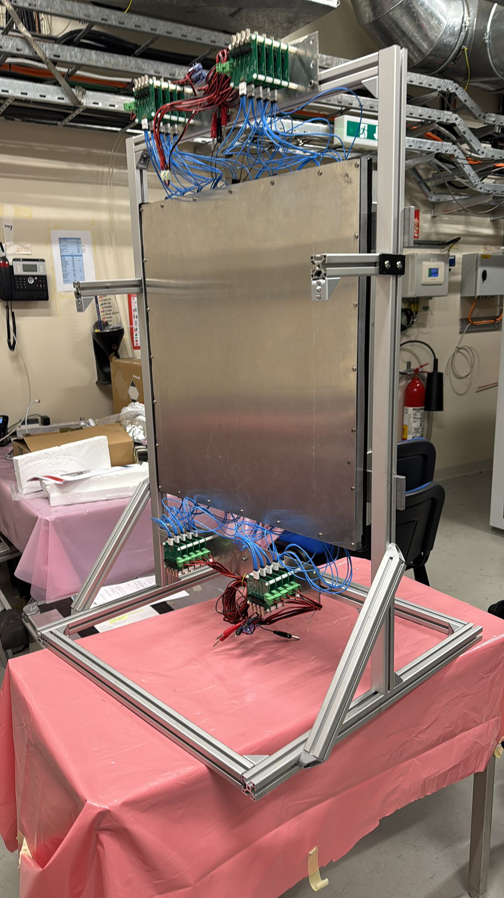
Figure 1 Picture of the scintillator wall mounted on the aluminium support

preliminary hazards identification of the experimentAl Detector
Identify the hazards associated to the detector and its associated equipment. Double click on the boxes and check as appropriate. Provide comments or values under the description.

Domain | Hazards/Hazardous Activities |  | Description | Location/Equipment
Mechanical Safety | Pressure
Mechanical Safety | Vacuum
Mechanical Safety | Lifting equipment
Mechanical Safety | Machinery / Machine Tools
Mechanical Safety | Mechanical energy (moving parts)
Mechanical Safety | Mechanical properties (sharp, rough, slippery)
Mechanical Safety | Industrial Vehicles
Mechanical Safety | Hot Work (e.g. welding, grinding)
Mechanical Safety | Hot/cold surfaces
Mechanical Safety | Vibration
Cryogenic Safety | Cryogenic fluid |  | [fluid] [phase][m3]
Structural Safety | Shielding Walls
Structural Safety | Specific actions/conditions
Electrical and Electro-Magnetic Safety | Electrical equipment and installations | X | 60 [V], <100 [mA]
Electrical and Electro-Magnetic Safety | High Voltage Equipment
Electrical and Electro-Magnetic Safety | Magnetic field |  | [magnetic field] [T]
Electrical and Electro-Magnetic Safety | Equipment in potentially explosive atmospheres
Chemical Safety | Hazardous chemical agent (HCA) |  | [chemical agent], [quantity]
Chemical Safety | CMR (carcinogens, mutagens and substances toxic to reproduction)
Chemical Safety | Toxic/Harmful |  | [fluid], [quantity]
Chemical Safety | Corrosive |  | [fluid], [quantity]
Chemical Safety | Oxidizing |  | [fluid], [quantity]
Chemical Safety | Flammable
Chemical Safety | Potentially explosive atmospheres |  | [fluid], [quantity]
Chemical Safety | Irritant |  | [fluid], [quantity]
Chemical Safety | Asphyxiant |  | [fluid], [quantity]
Chemical Safety | Nanomaterial’s
Chemical Safety | Dangerous for the Environment
Chemical Safety | Asbestos
Biological Safety | Legionella
Biological Safety | Biological Agents
Non-ionizing radiation Safety | Laser, class
Non-ionizing radiation Safety | Radiofrequency
Non-ionizing radiation Safety | Microwaves
Non-ionizing radiation Safety | UV light
Non-ionizing radiation Safety | Electromagnetic (Frequency & Field strength) |  | [frequency] [Hz], [field strength] [Vm⁻¹]
Workplace | Excessive Noise
Workplace | Temperature constraints (non-comfortable)
Workplace | Insufficient Lighting
Workplace | Indoor Air quality (e.g. clean rooms)
Workplace | Confined space
Workplace | Work at height
Workplace | Obstructions in passageways
Workplace | Lone working
Workplace | Falling objects
Workplace | Internal Traffic (e.g. workshops, experiments)
Workplace | Slippery/unstable ground
Workplace | Working outside normal working hours
Environment | Usage/storage of potentially polluting substances (gases, liquids, solids)
Environment | Emissions of substances into the atmosphere
Environment | Discharge of effluents to the site drainage (i.e. infiltration water, rain water, cooling water…)
Environment | Discharge of effluents to sewage (i.e. sanitary water…)
Environment | Activated or radioactive soil
Environment | Polluted or contaminated soil
Environment | Emission of noise harmful for the environment
Environment | Vibrations harmful for the environment
Environment | Odours
Environment | Waste generation
Environment | Significant consumption of resources (e.g. water, electricity gas, fuels, ...)
Worksite | Construction & dismantling activities
Worksite | Co-activity
Fire Safety | Hot works
Fire Safety | Combustible Materials
Fire Safety | Ignition sources
Ionizing Radiation | Target material
Ionizing Radiation | Beam particle type
Ionizing Radiation | Beam intensity
Ionizing Radiation | Beam energy
Ionizing Radiation | Source

