n_TOF X17 Search Status
February 2026 Beam Test — Results, Analysis & Prospects
EAR2, n_TOF, CERN • Internal Document • March 2026

Table of Contents

1. Overview
The goal of this experiment is to search for the hypothetical X17 boson at the n_TOF facility at CERN, using EAR2 (Experimental Area 2), located 20 m directly above the lead spallation target. When a proton bunch strikes the target, a broad neutron energy spectrum is produced. The X17 hypothesis predicts that certain neutron-nuclear interactions will produce the X17 particle, which then immediately decays into an electron–positron (e⁺e⁻) pair. Measuring a peak in the opening angle of these pairs near 120° would provide evidence for the X17.
The full detector concept calls for four 40×40 cm Micromegas (MM) detectors surrounding a pressurised ³He target in an aluminium/carbon vessel. By detecting coincident e⁺e⁻ pairs in neighboring detectors and measuring their relative angle, the experiment can search for a peak in the angular distribution above a smoothly falling pair-production background. For this February 2026 beam test, no ³He target was present. A single prototype MM detector was deployed together with a scintillator wall to characterise detector performance in the n_TOF beam environment, test the DREAM DAQ system, and identify the principal challenges for the full measurement.
The challenges brought into focus during this test can be separated broadly into two measurement regimes: the high-energy region (the first ∼10 μs of each pulse, containing ∼80% of the expected X17 yield) and the thermal neutron region (t > 1 ms, containing ∼20% of the yield). Each presents distinct technical obstacles, which are described in detail in Section 4 and analysed in Section 5.
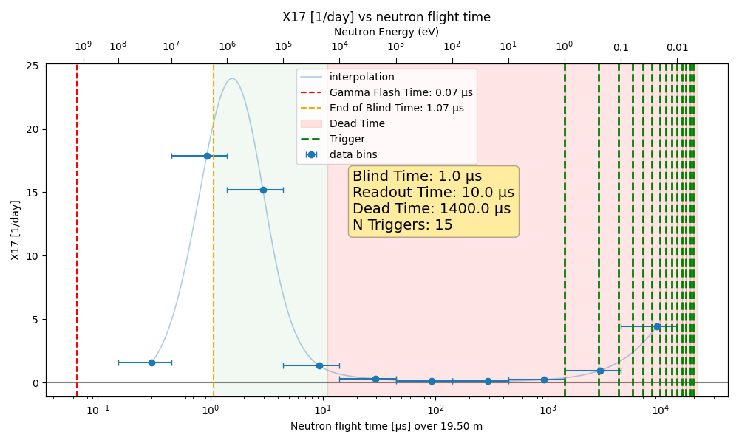
Figure 1: Expected X17 yield vs neutron flight time (or neutron energy). Time t=0 corresponds to when the lead spallation target is hit with a proton bunch. The dashed red line is the arrival of particles traveling at the v=c. The dashed orange line is the estimated time at which we can begin to read after the gamma flash. The green shaded area corresponds to the maximum readout window of Dream. The red shaded area corresponds to the dead time after this readout. The subsequent green dashed lines represent possible self-trigger readouts for a measurement in the thermal region.

1.1 Expected X17 Yield
Figure 1 shows the expected X17 yield as a function of neutron energy and time of flight. A clear peak is visible between 100 keV and 10 MeV, corresponding to a time window of approximately 5 μs after the gamma flash. The DREAM DAQ, sampling at 50 MHz (20 ns sample period) with up to 500 samples per trigger, can cover a maximum window of 10 μs — sufficient to capture the main yield peak. There is then substantial dead time during DREAM readout (approximately 1.4 ms for 500 samples without zero suppression). Very little X17 yield is expected in this dead region between 10 keV and thermal. Yield in the thermal region is substantial and potentially recordable with an appropriate triggering scheme.

1.2 High-Energy Measurement
The majority of the expected X17 yield (∼80%) is concentrated in the first 10 μs of each proton bunch. The DREAM DAQ can record this full window by triggering on a precisely delayed PS pickup signal. However, this measurement faces two severe obstacles:
- DREAM DAQ saturation from the gamma flash: The burst of relativistic particles and gammas that arrives simultaneously at the beginning of the pulse deposits enormous charge in the Micromegas amplification gap, inducing a current that saturates the DREAM front-end electronics. Above a threshold bias voltage on the resistive layer, all DREAM channels return to baseline and remain there for the full readout window — the DAQ is effectively blind precisely when signal of the ~1 MeV neutron yield peak is expected. This is illustrated in the example waveforms in Argon gas below. This was confirmed late in the beam test by reading a single MM strip through the n_TOF oscilloscope-based DAQ, which showed clear signals in the “forbidden” region where DREAM reported nothing. At lower bias on the resistive layer, large signals are visible in this time period after the initial pulse, but at this low voltage the detector is not expected to be sensitive to electron and positron tracks. A balancing act must be performed to keep the amplification field low enough not to saturate the DREAM DAQ, but large enough to be efficient to electron and positron tracks. Section 5 focuses on the analysis of beam data to understand, for each configuration, if there is a range of operating voltage in which we can make the high energy measurement.
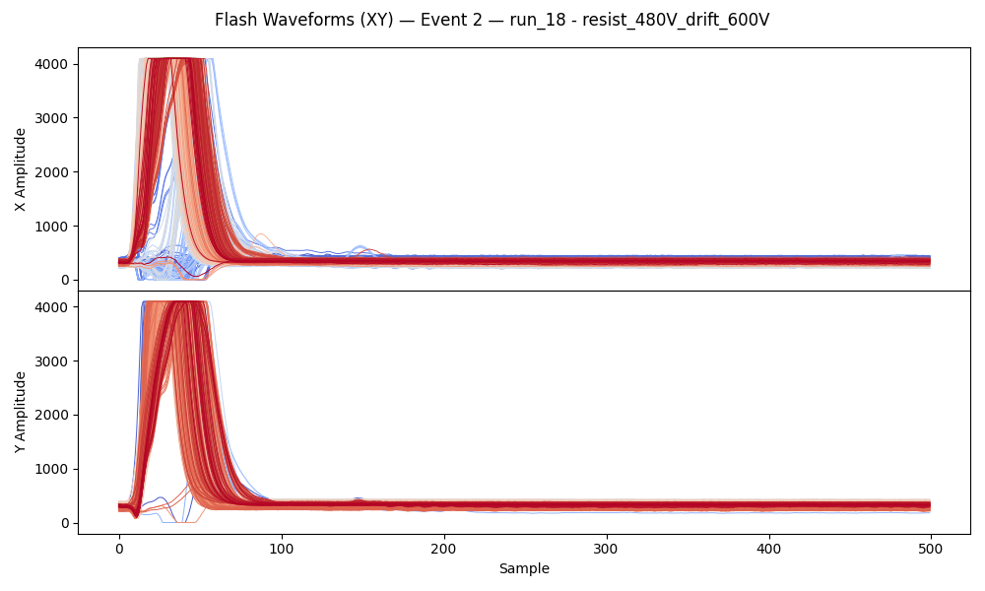
- Large occupancy in the ∼1 MeV neutron peak region: Even if the DAQ is not fully saturated, the high density of neutron-induced signals in the 1–5 μs window makes individual e⁺e⁻ track reconstruction extremely difficult. With helium gas, this problem is compounded by helium’s relatively high neutron sensitivity. An example of the high occupancy in Helium gas is shown below.
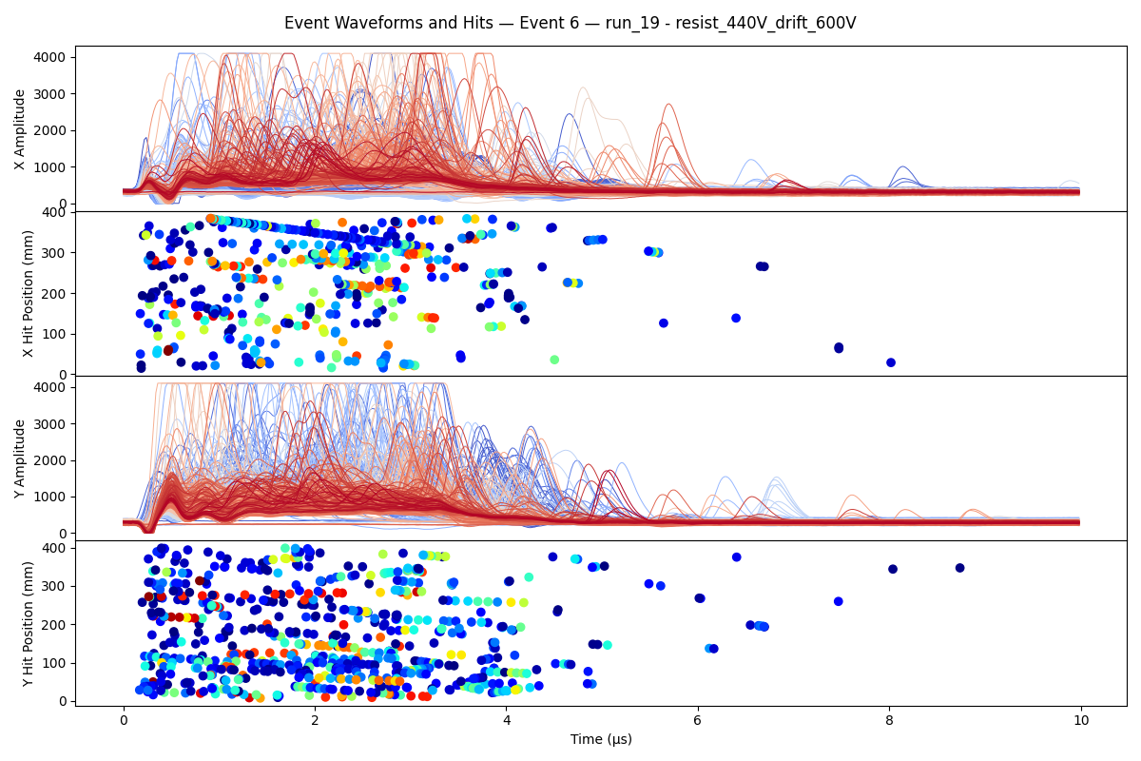
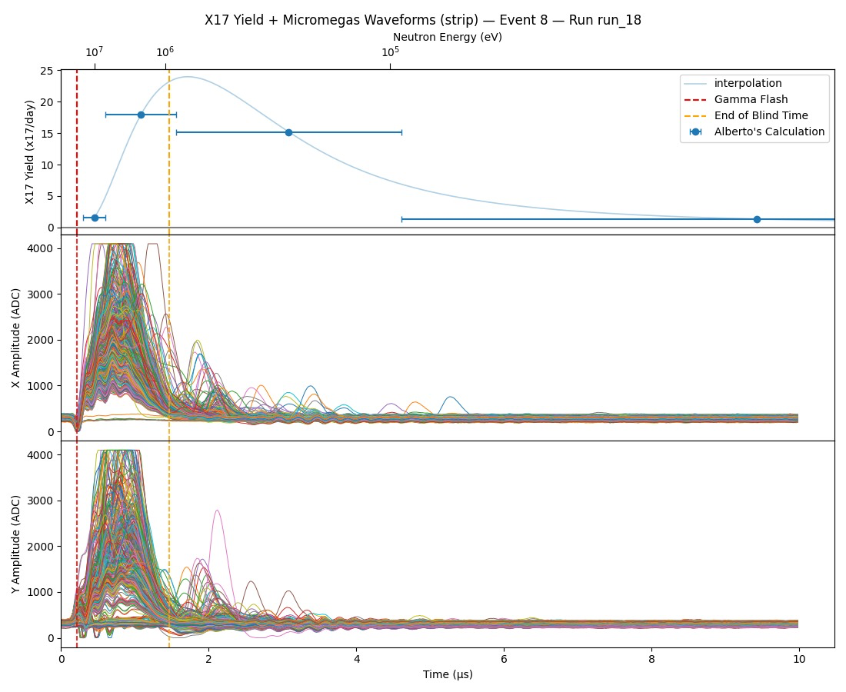

questions:at the beginning I saw this
probably because the voltage was too low, so it cannot be able to detect the e+e- pair. I think that must be clearly indicated that the blinding of DREAM occurs with Ar at the voltage set for the pair detection. – Yes thanks for the feedback, I’ve updated the blinding section to hopefully make this clearer. This plot is indeed from Argon gas (Ar/CF4/Iso 88/10/2) with the Timepix on beam. But it’s at very low voltage, where we don’t expect to be efficient to e+e-, as you say. I’ll try to really expand on this in the Section 5 analysis section.

1.3 Low-Energy (Thermal) Measurement
In the thermal neutron regime, events are well separated in time and the occupancy is very low. Clean identification of coincident e⁺e⁻ pairs should be feasible. The principal drawback is yield: only ∼20% of the total expected X17 statistics fall in this region. Additionally, a suitable triggering strategy has not yet been fully developed or tested. The scintillator wall may provide a viable coincident trigger, but this would require a separate DAQ system.

1.4 Summary of Key Findings
- The DREAM DAQ is confirmed to saturate from the MM detector signal during the gamma flash at operating HV, rendering the high-energy window blind.
- Reducing the drift gap from 30 mm to 6 mm significantly reduces the charge deposited during the flash and increases the HV range over which the DAQ survives, offering a viable path to the high-energy measurement at the expense of track reconstruction.
- Helium/Ethane gas survives the initial gamma flash better than Argon-based gases but is sensitive to neutrons in the subsequent ∼1 MeV yield peak.
- The carbon frame reduced hit rates after the flash by ∼10–20% but did not meaningfully extend the DAQ survival voltage.
- Significant sinusoidal noise was induced by the gamma flash even with no HV on the MMs. Proper grounding of the MX connector cards was found to almost entirely eliminate this noise.
- No strategy tested during this beam test fully solved the DAQ saturation problem. Several potential avenues remain to be explored.

The figure below illustrates the fact that, in beam, the DREAM DAQ saturates before the detector becomes efficient to electrons. The solid lines are the number of hits in the ~1 MeV neutron region. These curves increase with HV, peak, and then go to zero as the DAQ saturates. The dashed lines are two calibrations for electron detection efficiency. We clearly see that the DAQ saturates before we reach a plateau of electron detection efficiency. The data are for Helium/Ethane gas with the empty carbon target.
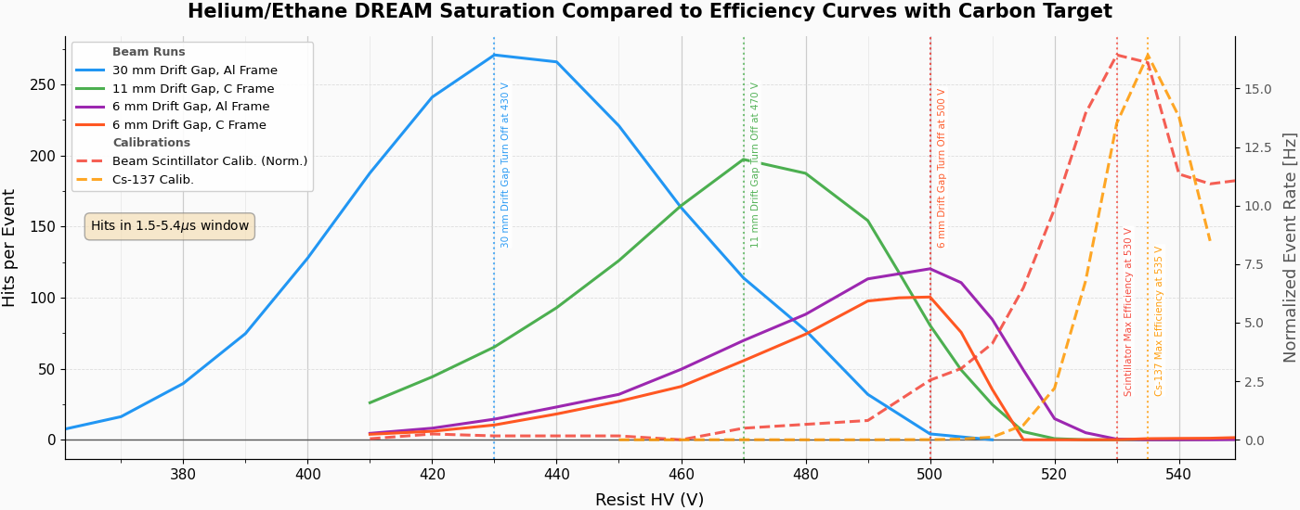

2. Detector
[TODO] Stephan rework this section

2.1 MX17 Concept
The experiment uses resistive-strip Micromegas (MM) detectors. Each detector is a 40×40 cm gas-filled proportional detector with a thin amplification gap (∼150 μm) between a metallic mesh and a resistive readout PCB. Ionising particles crossing the active volume create primary electron–ion pairs in the drift gap. Electrons drift toward the mesh under the applied drift field and are amplified in the high-field amplification gap. The amplified charge is then collected on the readout strips.
The readout PCB uses an XY strip design with 512 strips in each orientation (X and Y), for a strip pitch of approximately 800 μm. The top layer is a pixel pattern alternating between X and Y pixels connected to strips below via vias, intended to balance the charge-sharing between the strip layers. The 512 strips in each orientation are read out in two groups of 256, connected via JZ spring connectors to readout boards (MX boards) equipped with MEC8 connectors, which interface to the DREAM DAQ. When all strips are read out (M1 cards), each orientation fills one DREAM FEU (8 cables); two FEUs are therefore used in total for one detector.

add a picture from the presentation

2.2 Resistive Layer and HV Design
The current detector uses a resistive-strip design, where the resistive layer is segmented into strips connected to HV contacts on the edges of the active area. The production plan calls for a future revision with a plain resistive layer – ∼15 mm of resistive strips insulated in photoresist connecting HV contacts at the border to the pain resistive layer – which should further suppress hotspots that tend to occur near the edges of the active area. The mesh is currently grounded; a proposed future modification would allow the mesh voltage to be pulsed (see Section 6.2).
add a picture with a sketc of the detector

2.3 Bulk Manufacture
…
- Screen printing resistive pattern (strips and/or plain)
- Bulk process
  - Dynamask
  - ASADA mesh tension
- HV test vs resist

2.4 Detector Mechanics
Three mechanical configurations were tested during the February beam test:
- 30 mm drift gap (aluminium frame): The original configuration, designed for micro-TPC operation, in which the 3D track trajectory is reconstructed from the time evolution of hit positions across the readout. This allows tracks to be identified as through-going (MIP-like) and their angles measured, providing separation from point-like energy depositions.
- 6 mm drift gap (aluminium frame, then carbon frame): A new drop-in drift window was introduced mid-run to reduce the active volume and the charge deposited during the gamma flash. This sacrifices micro-TPC tracking capability but substantially improves DAQ survivability during the flash.
- 11 mm drift gap (xxxx frame): Briefly tested on the final day as an intermediate option.
The drift window consists of a double copper layer on mylar film. Simple GEANT4 simulations indicate that ∼3–10 MeV electrons and positrons will undergo some angular scattering as they traverse this window, but the mean deflection is small and should not fundamentally compromise angle measurement.
- Low material active area
  - Readout on rohacell
  - Double copper drift + mylar window
  - Aluminum or carbon chamber
- µTPC mode
  - field degrader ( I would call it gerd ring)
- GFZ to Mec8 with M cards

2.5 Cosmic Bench Tests (CEA Saclay)
Prior to the n_TOF beam test, the detector was characterised at the cosmic bench at CEA Saclay. Cosmic-ray muons were recorded using two 60×60 cm scintillator planes as an external trigger. Preliminary results indicate that:
- The majority of the detector is alive and appears to be mostly efficient.
- Approximately 20% of the area appears dead, most likely due to broken resistive strips.
- With Argon/Isobutane 95/5 gas, the detector reaches near-full efficiency for cosmic MIPs at a resist HV of approximately +490 V.
- Micro-TPC mode track reconstruction has been demonstrated, though full analysis of angular resolution is ongoing.
- [TODO] Complete cosmic bench analysis: efficiency vs. HV curve, micro-TPC track angle resolution, strip occupancy map. Insert figures when available.

2.6 Readout Electronics — DREAM DAQ
The DREAM (Dead-time-REduced Acquisition Module) DAQ system reads out MM strips through Charge-Sensitive Amplifiers (CSAs) with a maximum dynamic range of 600 fC. At a sampling frequency of 50 MHz, up to 510 samples (10.2 μs) can be recorded per trigger. The DAQ was found to be the limiting factor in the gamma flash regime: at sufficiently large MM amplification bias, the large charge from the flash induces a “blinding” of the DREAM ASICs, from which recovery takes longer than the entire 10.2 μs readout window.

3. Scintillator Wall and SiPM Readout
[TODO] Someone more qualified edit/write this section

3.1 Design and Motivation
A scintillator wall consisting of approximately 16 vertical bars (each 2.5 cm wide) was deployed behind the Micromegas detector, covering the full 40×40 cm active area. Four SiPMs (two top, two bottom) instrument each bar for a total of 64 channels. The wall was intended to provide:
- Coincident hit position to help confirm MM track candidates.
- Precise timing for event selection.
- An external trigger for MM readout in calibration and low-energy physics runs.

3.2 SiPM Signal Amplitude and Readout Interface
SiPM signals are of order tens of mV amplitude and ∼100 ns duration, corresponding to a charge of roughly 10–100 pC. DREAM’s CSA has a maximum dynamic range of 600 fC, requiring attenuation by a factor of approximately 20–200. Various strategies were tested:
- Direct connection through CSA: Signal amplitude was too large for the CSA, causing saturation.
- Direct connection to ADC (bypassing CSA): Signal amplitude was too small for acceptable SNR.
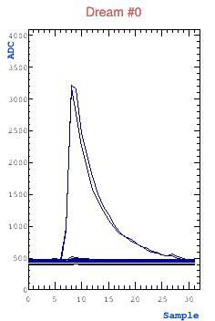
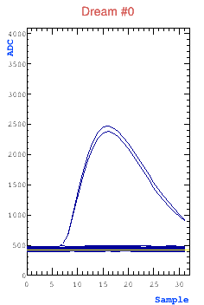
- External amplifier (Marco’s amplifier): Amplifying the signal to go directly to the ADC, bypassing the CSA. This proved successful. Both shaped and unshaped outputs were tested and found to work. In the images below, left is an unshaped example, right is shaped.

- AC-coupled attenuator (capacitor in series): Tested but also found not to work as intended.
- NIM-rack attenuator modules (5–40 dB): Obtained from the CERN electronics pool. After correcting a polarity error in the DREAM configuration, attenuated signals were observed on DREAM, though a large amount of cross-talk and amplitude calibration issues were identified and not fully resolved.

3.3 Gamma Flash Saturation of SiPMs
As observed in November 2025, the SiPMs saturate completely during the gamma flash when positioned in the beam. This presents a dual problem: the SiPMs cannot see signals for a significant recovery time, and they inject large charge into the DREAM electronics, producing saturation effects similar to those from the MM detector itself.

3.4 Gamma Flash Mitigation Strategies for SiPMs
Two approaches were tested to protect the SiPMs and/or DREAM during the gamma flash:
- Voltage gate on SiPM bias: A pulse generator applied a −5 V pulse to the SiPM bias just before and during the gamma flash, with the intent of taking the SiPMs below their operating threshold. The conclusion was that the SiPMs did not recover in time for the signal window of interest.
- Signal-side switches: Two types of electronic switches were used to divert the SiPM output to ground during the flash and redirect it to the DAQ afterward. These were found not to be successful, for reasons that require further investigation.
- [TODO] Provide more detail on switch types tested, failure modes, and possible follow-up. Assign to SiPM team for completion.

3.5 SiPM as an External Trigger
The most successful use of the SiPM wall during the beam test was as an external oscilloscope trigger for DREAM. Two adjacent SiPM channels were amplified and their sum fed to an oscilloscope threshold trigger, which then triggered DREAM readout. This configuration allowed:
- Suppression of random MM discharges (which do not deposit energy in the scintillator).
- Selection of cosmic-ray events and Cs-137 during beam-off periods for MM calibration.
- Beam-on runs selecting events where a charged particle was coincident in both the MM and scintillator.
The data from these triggering configurations are not yet fully analysed, but preliminary inspection shows promising calibration curves.
- [TODO] Full analysis of SiPM-triggered MM data for cosmic efficiency turn-on and beam-on charged particle rates.

4. February 2026 Beam Test — Overview of Operations

4.1 Setup and Initial Commissioning (January 31 – February 2)
The detector and DAQ were set up in EAR2 beginning January 31. Initial noise levels were poor. The dominant noise source was later identified as the MX connector cards (M1 cards); after grounding these firmly to the carbon frame via dedicated cables, the sinusoidal noise was almost entirely eliminated. Early HV cable grounding issues were also addressed.
First beam was received on February 2. The PS pickup trigger was configured with a delay of 9.4 μs to align the readout window a few hundred nanoseconds before the arrival of the gamma flash.

4.2 Gas Configurations Tested
The following gas mixtures were used during the beam test:
Gas Mixture | Period | Key Characteristics Observed
Ar/CF4/Isobutane 88/10/2 | Feb 2–7, Feb 9–11 | Strong gamma flash saturation; op. V ~490 V; high spark rate at elevated V
He/Ethane 96.5/3.5 | Feb 3–7, Feb 20–Mar 2 | Survives initial gamma flash at low resist HV; very sensitive to 1 MeV neutrons; op. V ~500–540 V
Ar/CF4/CO2 45/40/15 | Feb 9–11 | Tested briefly; op. V ~680–800 V; high operating V outside usable flash window
Ar/CF4 90/10 | Feb 10–16 | Tested with and without B4C target; op. V region seems incompatible with flash survival
Ar/CO2 70/30 | Feb 16–Mar 1 | Op. V ~680–720 V; seems incompatible with flash window (saturation well below op. V)

4.3 Samples Used
Several samples were used in the EAR2 area during the test to vary the neutron/gamma environment seen by the detector:
- No target (empty target holder): Baseline reference for detector response.
- Lead target: Primarily a gamma-producing target; produces similar MM response to empty target in He gas, suggesting He is relatively transparent to gammas.
- B4C (Boron Carbide, 2.5 mm): Strong neutron absorber. Produces substantially higher hit rates in the 3–10 μs time window with He gas, confirming sensitivity to presumably neutrons in the ~1 MeV yield peak.
- Carbon target: Used to simulate physics runs without the real He³ target; increases signal rates compared to empty.
- Note: A plastic beam-pipe cap was discovered still in place during several runs (Runs 23, 56, 57, 58.
A Polyethylene (PE) + Lead shielding stack was placed around the beam pipe to test background reduction. It appeared to increase noise substantially, but this was probably due to displaced ground cabling. The increased noise made the results of this shielding test inconclusive, though no significant reduction in the signal rate was observed.

4.4 Drift Gap Variations
The drift gap was changed twice during the test to study the effect on DAQ survivability:
- 30 mm (original): Standard micro-TPC configuration. Large active volume; large charge during gamma flash; DREAM saturates well below operating HV in all gases tested.
- 6 mm (from February 18): New drift window installed. Reduced active volume by factor 5; reduced charge per flash event; significantly extended the HV range before DAQ saturation. Micro-TPC tracking sacrificed.
- 11 mm (final days): Intermediate gap, obtained by stacking shims. Briefly tested to get a third data point on the drift gap spectrum. Has not yet been analyzed. Expected damage to the detector mesh when changing to this drift gap.

4.5 Frame Material
On February 26, the aluminium detector frame was replaced with a carbon frame. The carbon frame reduces the material budget in the detector acceptance and changes the gamma/neutron interaction rate within the frame itself. Preliminary comparison of hit-rate-vs-HV curves (Runs 136 vs. earlier aluminium runs) indicates a ∼10–20% reduction in total hit rate after the flash, but no significant change in the HV at which DREAM saturates. This suggests the carbon frame is likely not worth the added complexity, though further analysis is needed to confirm.

4.6 Notable Operational Events
- February 4: Noise generator tests confirmed that the MX connector cards act as receiving antennas for electromagnetic interference. A ferrite on the DREAM cable provided a factor of ∼2 reduction but did not solve the problem alone.
- February 9: Cs-137 and Y-88 radioactive sources placed for MM efficiency calibration. Source runs provided the most reliable efficiency turn-on data.
- February 11: Detector moved to horizontal position for SiPM-triggered cosmic data collection.
- February 19: Single MM strip read through n_TOF DAQ (1 GHz oscilloscope + pre-amplifier), confirming signals in the DREAM-blind region and thus proving DAQ saturation as the dominant failure mode.
- February 25: NbLM detectors installed in EAR2 alongside the MM setup.
- February 28: Stephan’s attenuator circuit and Marco’s electronic switch tested on a single MM channel without success.
- March 2: Full detector dismounted and returned to CEA. Data transfer to EOS (/eos/experiment/ntof/data/x17/feb_beam/) completed.

5. Beam Test Results and Analysis

5.1 MM MIP Efficiency vs Flash Blindness
The most critical analysis from this beam test is the characterization in each configuration of at which resist HV the MM detector is capable of detecting electron/positron tracks compared to at which HV the detector becomes blind from the gamma flash.

5.1.1 Calibration
A critical question for our MM detector is when it becomes efficient to the electrons and positrons we are looking for. While we may see some type of signal after the gamma flash at lower resist HV, it is entirely possible that the gain is too low in these cases to actually see any signal tracks passing through the detector. If we operated in this condition for the physics measurement, it would be a disaster.

We therefore must find a way to calibrate our detector and ensure that we operate at appropriate resist bias such that the detector is sensitive to signal tracks. The gold standard for this calibration is the cosmic bench at Saclay. There, we have a clean and reliable external reference track and can analyze the response of our detector to a known track passing through it. However, only a small amount of Saclay cosmic data is available and only with Argon/Isobutante 95/5 gas, which was not present/tested at n_TOF.

Without the Sacaly cosmic calibration, several ideas were explored for some measure of calibration at n_TOF during the beam test.

Cs-137 Source Runs
Cs-137 was the primary calibration source used during the beam test, providing a ∼662 keV gamma line and a beta spectrum with endpoint at ∼514 keV. This is lower in energy than the ∼3–10 MeV electrons and positrons of interest; the calibration therefore provides a conservative lower bound on the operating HV required for MIP detection. With Ar/CO2 70/30 gas, the Cs-137 efficiency turn-on occurs around 680 V (onset) and reaches a plateau near 720 V. Comparison of these values with the beam-induced DAQ saturation curve in the same gas shows that the detector must be operated at ≥720 V to be efficient to Cs-137 electrons, while the DREAM DAQ saturates by ∼680 V in beam conditions. There is therefore no working voltage range for Ar/CO2 70/30 with 30 mm drift. (Don’t details, double check and add plots)
With He/Ethane and 6 mm drift, a Cs-137 scan (Run 97) was performed. Preliminary inspection suggests the efficiency onset may occur at lower resist HV than for Ar/CO2. Full analysis is ongoing.
- [TODO] Complete Cs-137 efficiency vs. HV analysis for He/Ethane 96.5/3.5 with 6 mm drift. Compare turn-on to beam-induced saturation curve. Insert figures.

SiPM-Triggered Cosmic and Beam Runs
Runs 52–54 (detector horizontal, SiPM trigger) and several later beam runs provide a dataset for measuring MM efficiency to through-going tracks coincident with scintillator hits. Initial event displays (February 12–13 analysis) show candidate cosmic tracks in both X and Y strips, with qualitatively reasonable micro-TPC signatures in the 30 mm drift configuration. Full efficiency analysis as a function of HV is needed.
- [TODO] Analyse SiPM-triggered MM data (Runs 52–54, Runs 142) for efficiency vs. HV. Insert figures.

Self-Triggered Scintillator Beam Data
In some runs, a scintillator bar was used as an oscilloscope trigger for beam data, with the idea that charged particles interacting in the thermal neutron time window would deposit energy in the scintillator and trigger the readout. Setting a higher oscilloscope threshold preferentially selected larger-amplitude scintillator signals, improving signal-to-noise. Analysis of these runs showed a population of events with very large numbers of MM hits (consistent with random discharges) as well as a filtered population with moderate hit counts. The filtered rate as a function of resist HV showed a turn-on, plateau, and slight decrease — qualitatively consistent with the expected MIP efficiency curve, though the plateau at high HV may be suppressed by increasing discharge contamination.
- [TODO] Complete analysis of scintillator-triggered beam runs. Insert rate-vs-HV plot for clean vs. all events.

Run 63 Ar CO2 with 30 mm drift Cs137 Scan
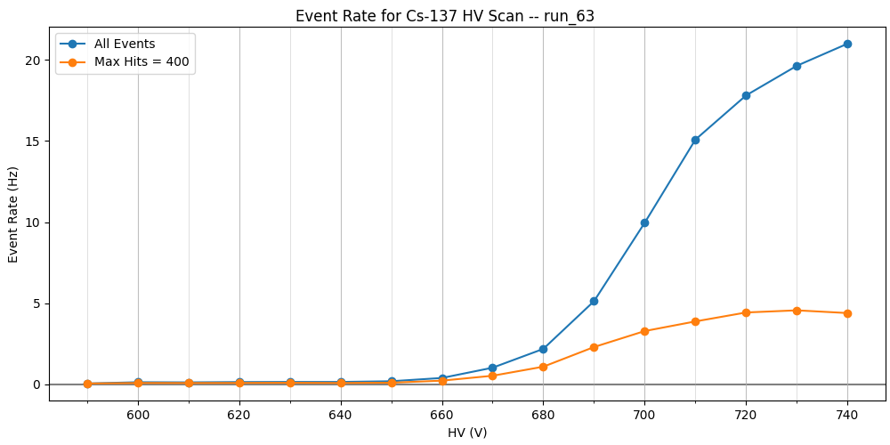

Run 94 Helium/Ethane with 6 mm drift Beam Scintillator Trigger
Better
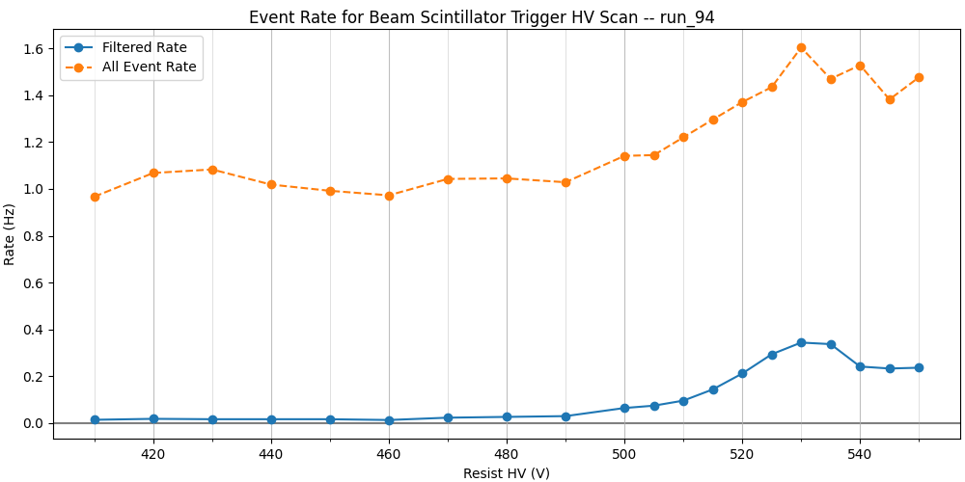

Run 97 Helium/Ethane with 6 mm drift Cs137 Scan with Scintillator Trigger
Cs-137 triggering on Scintillator did not seem to go well. Betas must not make it through.

Run 98 Helium/Ethane with 6 mm drift Cs137 Scan Self Trigger
Better

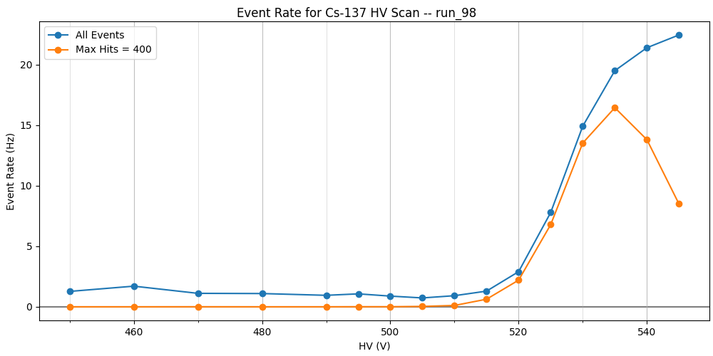

5.1.2 Measuring Flash Blindness HV
The primary analysis metric developed during the beam test is the mean number of reconstructed strip hits per event as a function of resist HV, evaluated separately in three time windows:
- Flash window (0–1.5 μs): Dominated by the gamma flash; used to identify the onset of detector response. Hit count increases monotonically until the full detector fires (∼1000 strips).
- Signal window (1.5–5.4 μs): Roughly encompasses the ∼1 MeV neutron yield peak and the expected X17 signal region. At intermediate HV, a peak is observed as the detector turns on. At high HV, the count drops sharply to zero as DREAM saturates.
- Post-peak window (5.4–10 μs): Higher-energy region; generally lower hit rate, but the same principle as the signal window applies.
This hit-rate-vs-HV curve has become the primary diagnostic for the DAQ survivability in a given configuration. It allows direct comparison of detector configurations to assess how much HV range is available between the onset of MIP sensitivity and the onset of DAQ blindness.

Caveats: The hit reconstruction algorithm requires each strip waveform to return to baseline before a new hit can be registered. In the high-occupancy flash environment, pile-up on individual strips can cause the apparent turn-off curve to be slightly steeper (i.e., the DAQ may survive a few extra volts of HV compared to what the curves suggest). Additionally, the amplitude of surviving hits is not yet accounted for; if DREAM partial saturation suppresses signal amplitudes, MIP tracks may be lost before the hit count drops to zero. These effects are expected to be small but will be quantified in the ongoing analysis.

Argon/CF4/Isobutane with 30mm Drift Gap
At the beginning of the beam test, we started with Argon/CF4/Isobutane (88/10/2) gas and a 30 mm drift gap. Before switching to helium on Feb 4, we were only able to measure with the timepix on the beam: run_18 in the plot below. We briefly switched back to this gas from helium on Feb 7, but the helium had likely not flushed all the way. With this caveat, we see in the plot below that the carbon target has an earlier increase in hits in the first two time windows. It therefore turns off earlier in the second time window, compared to the timepix target. It is interesting to note that in the last time window, the curves seem to overlap, though the run with the timepix sees more hits, while in the other windows the timepix target sees fewer hits.
We were running low on this gas and therefore did not switch back during the remainder of the test. Crucially, we do not have any dedicated calibration data for the gas. This means that we likely won’t be able to reliably calibrate the gas to know when we become efficient to our signal.
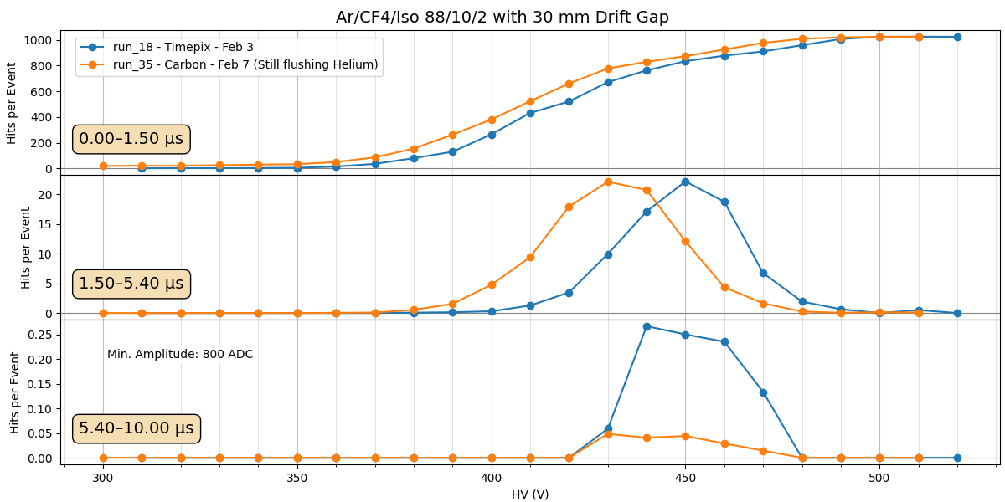

Run | Date | Start | Target | Time (h) | Notes / Issues
18 | 03-Feb | 5:05 PM | Timepix | 1.022 | HV scan; first 2 runs 0V/0V and 0V/300V
35 | 07-Feb | 6:11 PM | Carbon | 6.977 | Gas swap He→Ar; flushing; 9.4 µs delay

We then briefly investigate the effect of the minimum ADC cut. When counting hits, we only count those in which the amplitude is greater than some ADC count, always indicated in the top left corner of the bottom plot. By default, we’ll use 800 ADC which, at least in these early runs, is large enough to filter out the initial E&M wave oscillations. This produces a nice turn on curve in the early gamma flash window.
The plots below show the effect of lowering the 800 ADC cut to 500 ADC and 300 ADC. We see that there are significant differences in all plots, but the general behavior commented on above for the 800 ADC cut remains roughly the same.
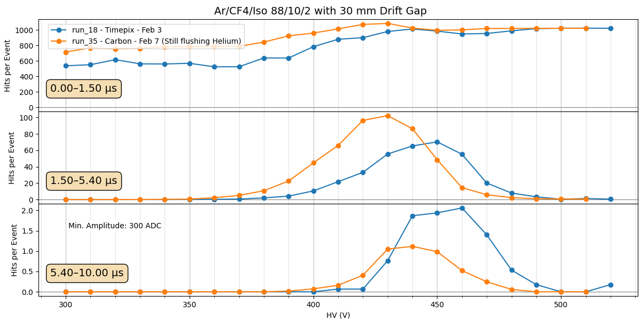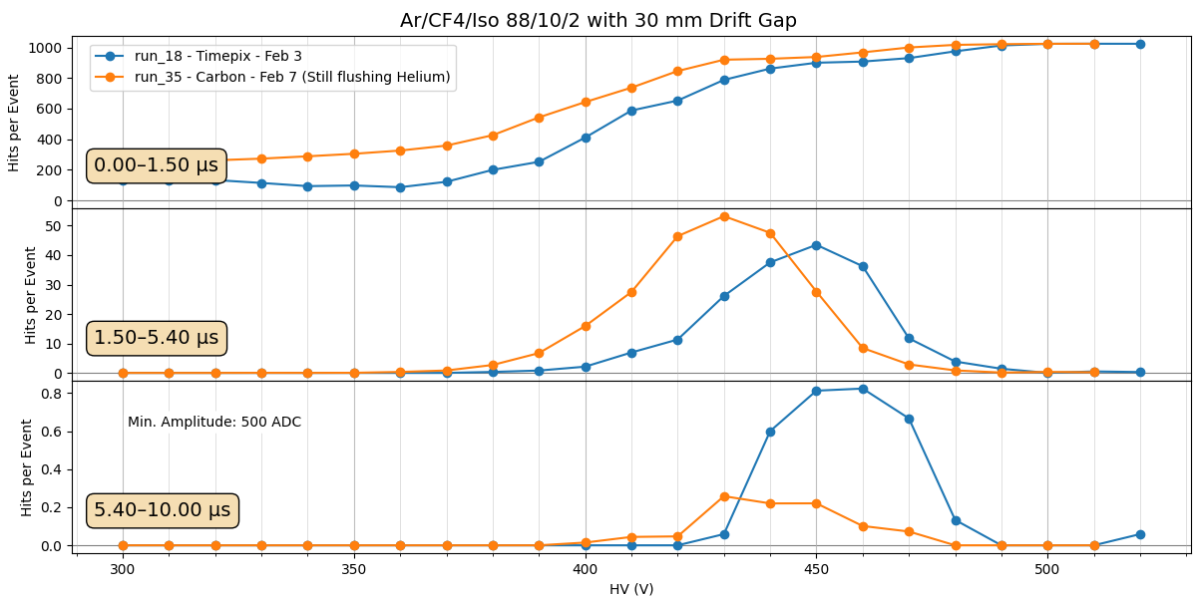

Helium/Ethane with 30mm Drift Gap
On Feb 4, we switched to Helium/Ethane (96.5/3.5) gas in the 30mm drift gap. Over the next 2 days, we measured with various targets, the turn off curves shown below. We also added paraffin and lead shielding around the beam pipe on Feb 6. This seemed to have no significant effect, though increased the E&M noise in the detector, likely due to knocking grounding cables a bit loose in the stacking of shielding.
We find several interesting features when comparing different samples in the Helium gas. Looking first at the turn ons, it appears that the carbon sample turns on earliest in all time windows. This is consistent with what was observed in the Argon/CF4/Isobutane gas, suggesting that the carbon target may really be scattering more high energy particles/neutrons into our detector. The carbon then consequently turns off earlier than the other samples. The next “loudest” sample is the B4C, though it seems to turn on significantly later than the carbon sample and then turn off later. The B4C also sees significantly more hits in the latest time window, implying that the cross-section is larger for keV neutrons. Finally, the lead sample is almost indistinguishable from the empty sample runs, which are all relatively consistent.
My guess is that the carbon is scattering more high energy particles/neutrons due to its larger volume. Both the B4C and Lead samples are very thin discs, while the carbon is a large cylinder(ish) with an aluminum rod also in the beam. My guess would be that this simple increase of material on the beam leads to increased scattering and earlier turn on/off. This is the carbon capsule we plan to use for the actual experiment, so we should take these results seriously and recognize that for the experiment we will likely have even more signal and therefore a very early turn off.
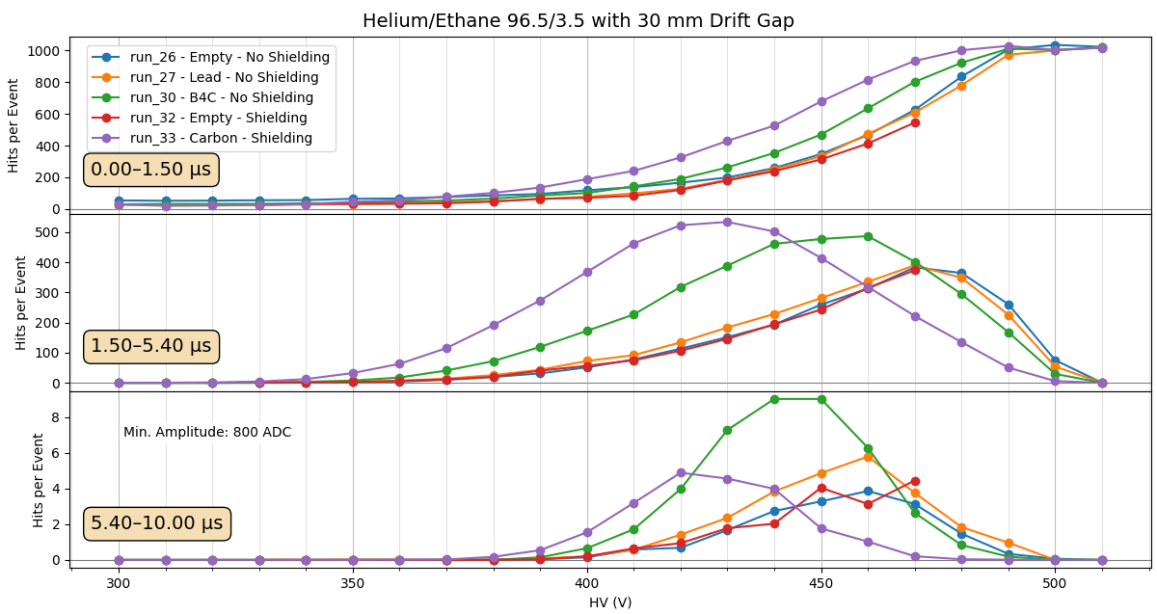

Run | Date | Start | Target | Time (h) | Notes / Issues
26 | 04-Feb | 7:56 PM | None | 14.418 | Overnight HV scan; no target
27 | 05-Feb | 11:40 AM | Lead | 5.301 | Lead target; step scan then stats run
30 | 05-Feb | 7:07 PM | B4C | 14.54 | Overnight HV scan
32 | 06-Feb | 11:27 AM | None | 6.699 | Long HV scan; new noise possibly introduced
33 | 06-Feb | 6:48 PM | Carbon | 4.606 | Overnight HV scan with carbon target

Argon/CF4/CO2 with 30mm Drift Gap
On Feb 9, we switched to Argon/CF4/CO2 (45/40/15) gas. This gas was kept for only a day, as we were not able to find a reasonable operating voltage. The figure below shows that the gamma flash started to appear at 700V, but the voltage needed to go much higher. We subsequently pushed and took some self triggered runs (which could in theory be analyzed in this manner later with some significant logistics), but we never found a good place to operate and therefore abandoned this gas.
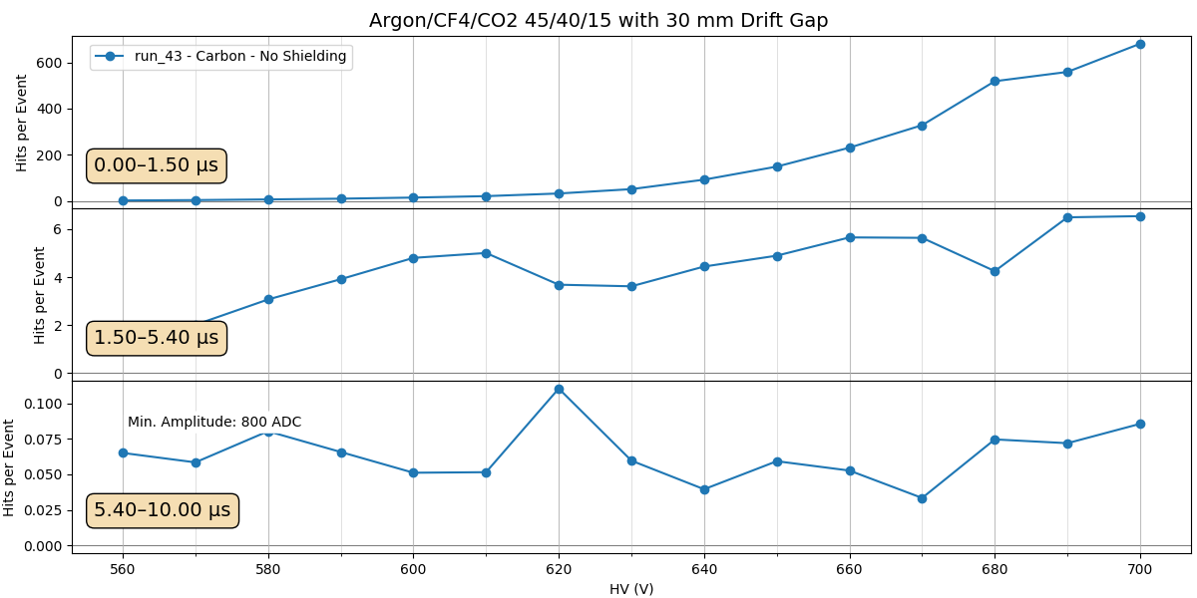

Run | Date | Start | Target | Time (h) | Notes / Issues
43 | 09-Feb | 6:29 PM | Carbon | 4.569 | Flush run

Argon/CF4 with 30mm Drift Gap
Pass
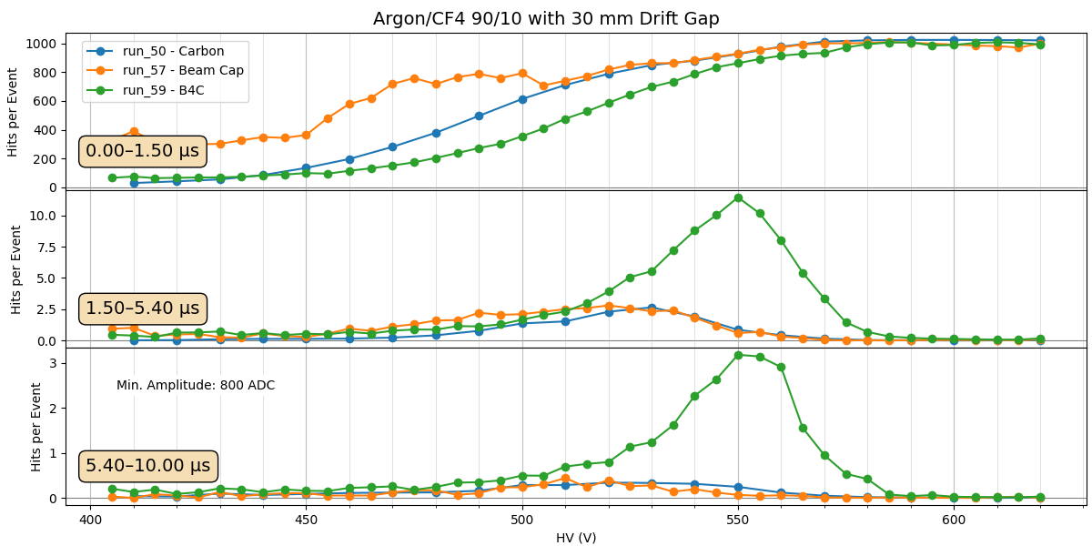

Run | Date | Start | Target | Time (h) | Notes / Issues
50 | 10-Feb | 12:56 AM | Carbon | 8.777 | Beam+carbon; overnight HV scan after flush
57 | 13-Feb | 9:00 AM | Beam Cap | 4.706 | Cap left on!
59 | 13-Feb | 8:28 PM | B4C | 12.106 | Cap removed; B4C installed

Argon/CO2 with 30mm Drift Gap
Pass
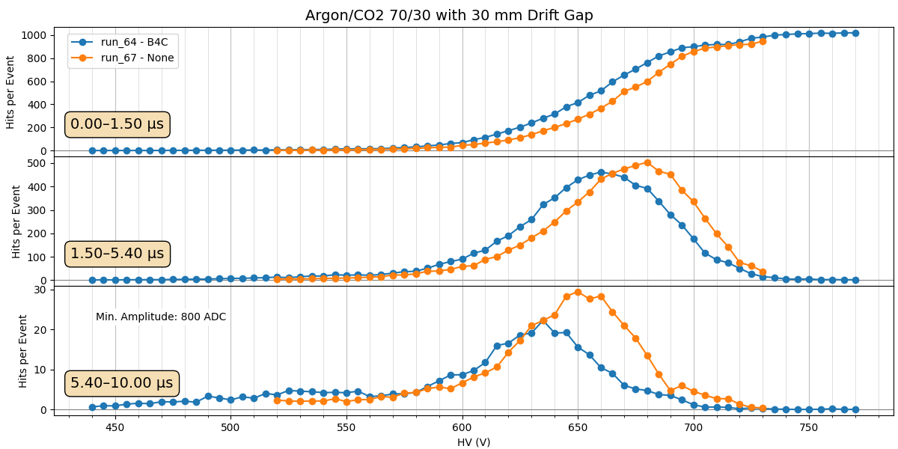

Run | Date | Start | Target | Time (h) | Notes / Issues
64 | 16-Feb | 5:09 PM | B4C | 5.755 | Beam returning; still flushing
67 | 17-Feb | 7:40 PM | None | 3.652 | No target HV scan

Argon/CO2 with 6mm Drift Gap at -1000V Drift Voltage
Pass
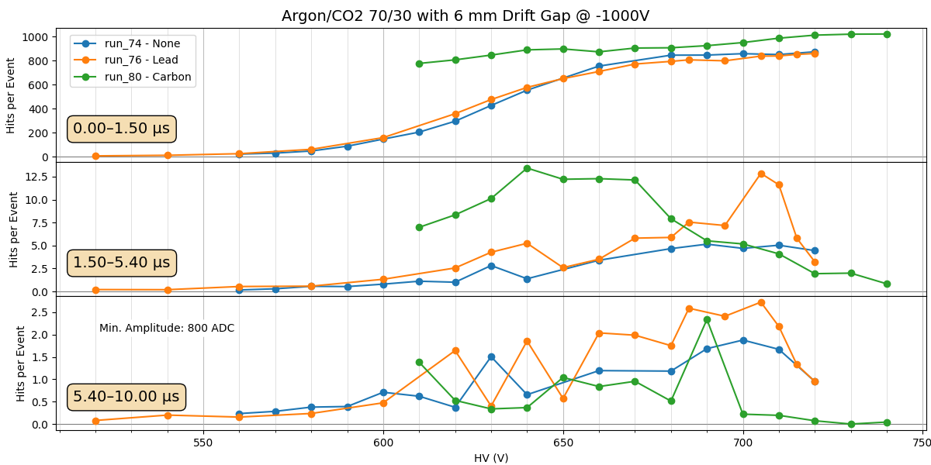

Helium/Ethane with 6mm Drift Gap at -1000V Drift Voltage
Pass

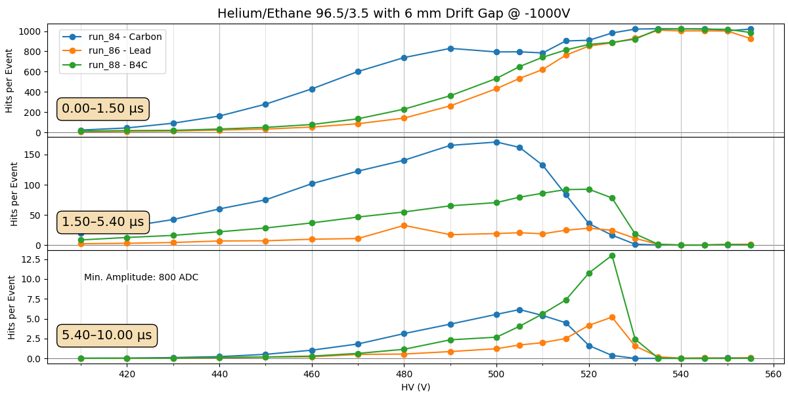

Argon/CO2 in Carbon Frame with 6mm Drift Gap at -1000V Drift Voltage
Not very clean curves. Will have to take another look later.
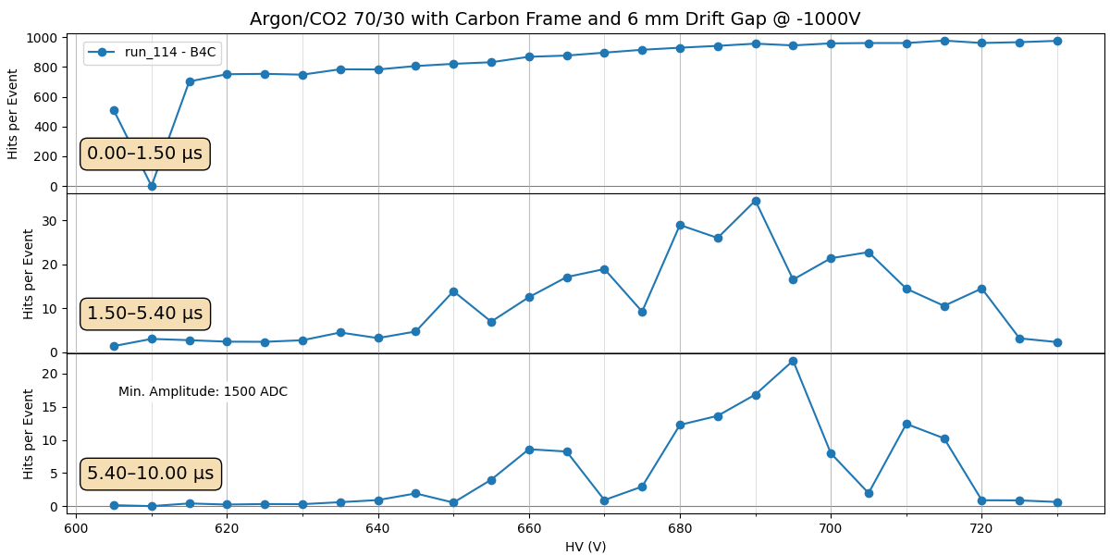

Helium/Ethane in Carbon Frame with 6mm Drift Gap at -1000V Drift Voltage
Pass
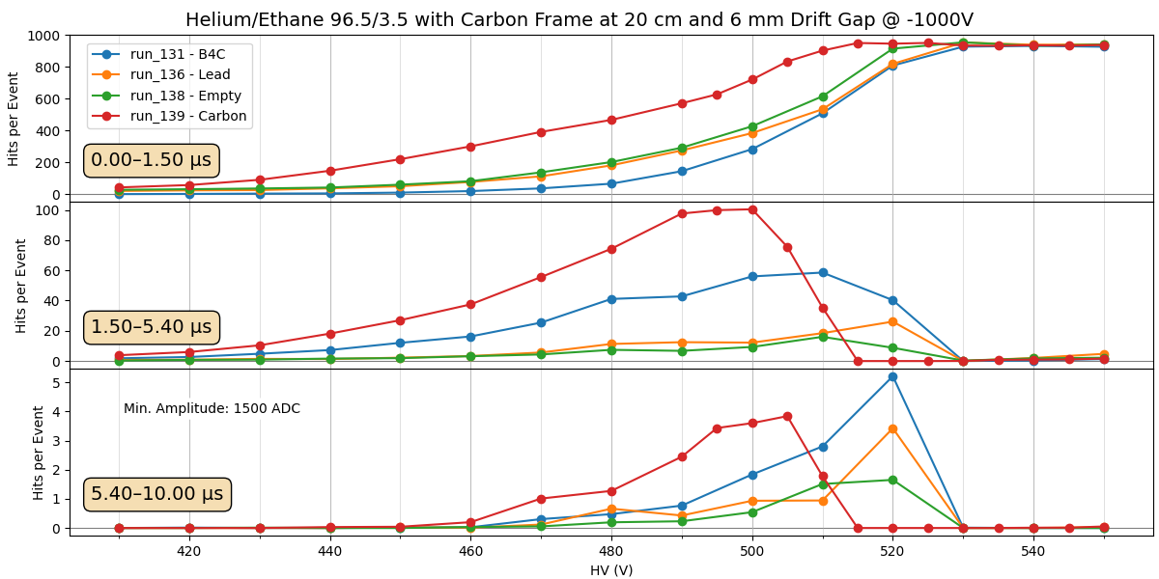

Helium/Ethane in Carbon Frame with 11mm Drift Gap at -800V Drift Voltage
Pass
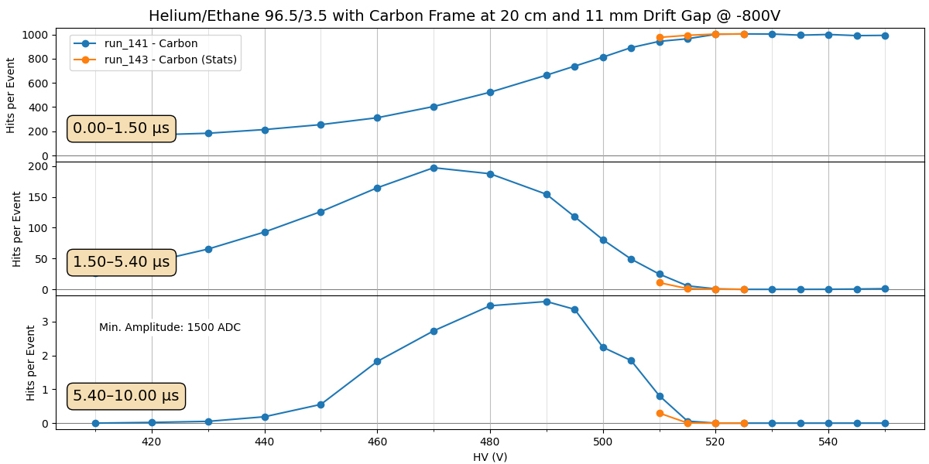

Helium/Ethane with Carbon Target at 20cm Drift Gap Comparison
Putting together all configurations with Helium/Ethane (96.5/3.5) gas and the Carbon target at 20 cm from the detector, we can see a clear dependence of the turn off voltage depending on the size of the drift gap. Looking at the 1.5-5.4 microsecond window, we see the 30 mm drift gap configuration start to turn off around 430V, the 11 mm gap turns off around 470V, and the 6 mm gap turns off around 500V. This conforms to our expectations: as we reduce the active volume, we integrate less charge and the DREAM electronics are able to tolerate higher amplification.
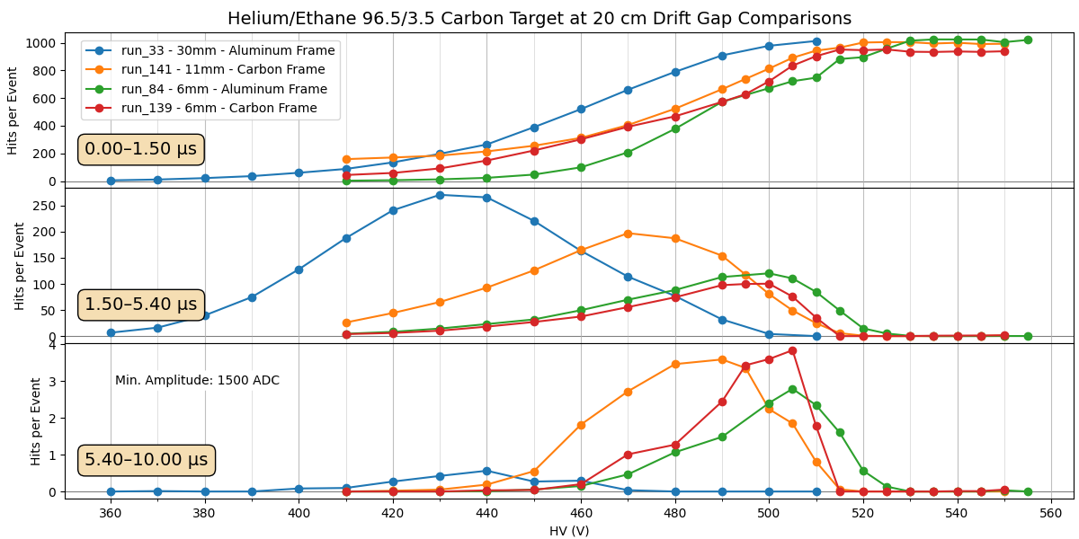
Other:
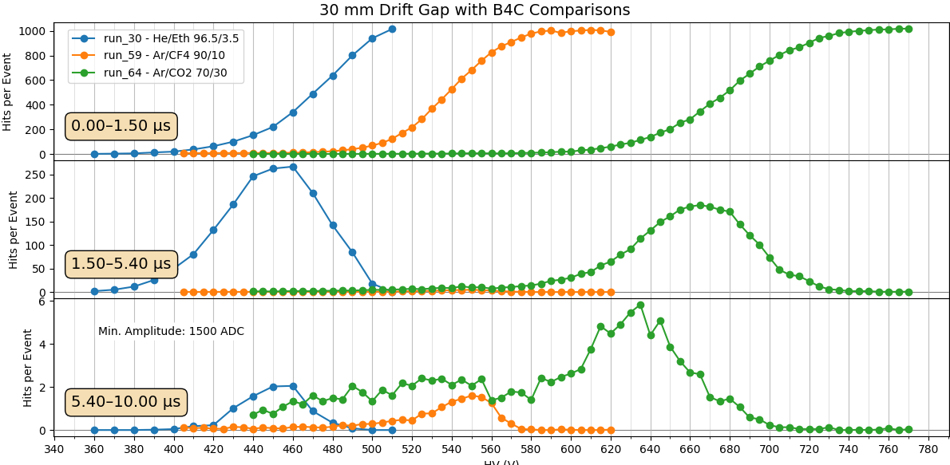

5.1.3 Comparing DREAM Saturation Turn Off with Calibration Detection Efficiency Turn On

The key question for the high energy measurement is whether the DAQ is still alive (not saturated) in a Resist HV region where the detector can efficiently detect electrons. The figure below shows that this does not appear to be the case for Helium/Ethane gas with the empty carbon capsule sample.
The solid lines show the average number of hits per event in the detector in the 1.5-5.4 us time window after the flash, where the X17 signal is expected. We find that the hit rate increases with HV as the detector begins to operate. At some point, the DAQ begins to saturate from the charge from the gamma flash, and the hit rate begins to decrease – eventually to zero. I use the peak of these distributions to demarcate the beginning of the “Turn Off”. Even before this point, we should already be experiencing the saturation effects, as we would expect the number of hits to continue increasing with HV. However, even at these Turn Off peaks where we know we are experiencing saturation effects, it is possible that we may still be able to operate (carefully). As a note, we are also integrating over different bunch intensities in this plot – this may slew an underlying sharper turn off. This could be fixed in the future using the beam intensity data and matching timestamps bunch-by-bunch.
We find that with the 30 mm drift gap the detector turns off very early, at 430V. As the drift gap is reduced, the detector survives to larger HV: 470V at 11 mm and 500V for 6 mm. We attribute this behaviour to the reduction in active volume of the detector. The number of primaries being produced and subsequently amplified will scale monotonically with the active volume. As it is reduced, the DREAM DAQ sees less charge and therefore can survive at larger amplification.
The dashed lines show two separate attempts to measure the detector’s sensitivity to electrons: one using the beam coincidence with a scintillator signal and another using a Cs-137 source. These methods are described above. We find that there are significant differences in the turn on curves for these two methods, which we don’t expect to be perfectly accurate. However, both seem to plateau around the same voltage: 530V for the scintillator coincidence method and 535V for the Cs-137 method. This suggests that the detector only becomes fully efficient in this range. However, these estimates are not ideal, and the best solution would be to test the detector in the Saclay cosmic bench with the same gas to be used at n_TOF.

The conclusion from the figure above is that, for this gas and the empty carbon capsule, we are not able to detect signal electrons and positrons in the high energy region. In the Figure below, we plot the Turn Off HV vs the detector’s drift gap to more quantitatively visualize the trend. We have only three points, so fitting a trendline is not well constrained. We take two physically feasible models: an inverse power dependence and an exponential. In both cases, we can try to extrapolate down to lower drift gap and see how close we get to where we expect that the detector will be efficient to electrons. In both cases, we find that around 3mm or lower, we may be reasonably close to operating.
However, this data and analysis is not robust enough to make definitive predictions. We can be confident that decreasing the drift gap will allow us to push to higher Resist HV before DREAM saturates. We are not able to say with confidence at which drift gap we will be able to reach electron efficiency, especially without reliable calibration curves from the CEA cosmic bench.

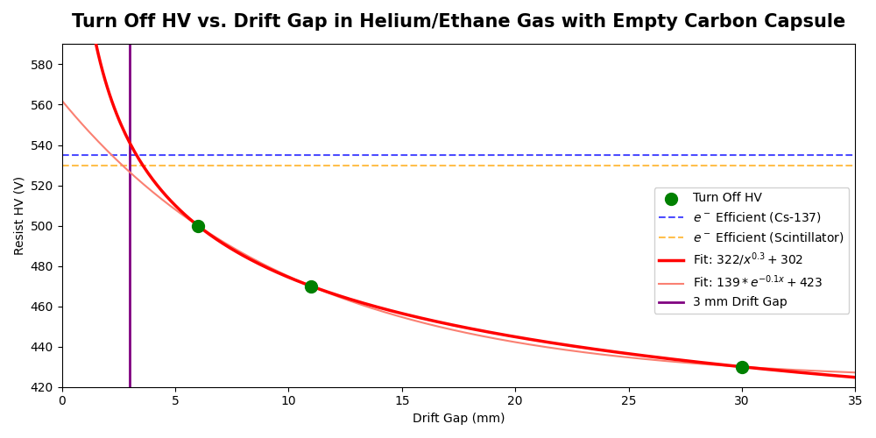

5.2 Grounding and Noise
The most significant antenna of electromagnetic noise (present when no HV applied to detector) was identified as the MX connector cards (M1 cards). These pick up electromagnetic interference from the n_TOF environment and send it directly to the DREAM DAQ. After firmly grounding the cards in the carbon frame configuration using dedicated cables, the sinusoidal noise component was essentially eliminated on 3 of the 4 cards. Screws on the card backs were also grounded for redundancy.
Additional grounding improvements adopted during the test and recommended for the final detector:
- MX connector cards must have explicit ground cables soldered to their grounding pads, plus grounded screws on the back for redundancy.
- HV box must include explicit chassis ground.
- The outer mylar gas window should be connected to ground if possible.
- A copper PCB should be glued under the detector stiffener and connected to ground.
These grounding schemes should be validated with Simone’s noise generator prior to the next beam test.

5.3 Gas Comparison: Argon vs. Helium
The two primary gas families tested show complementary strengths and weaknesses in the n_TOF beam environment:
Argon-based gases (all mixtures tested) show strong sensitivity to the gamma flash itself: all strips saturate immediately as the flash arrives, even at relatively low resist HV (∼450–490 V for Ar/CF4/Iso). This behaviour is consistent with the high cross-section of argon for photoelectric and Compton interactions in the gamma energy range. As a consequence, the DREAM DAQ saturates in the Ar-based configurations at or below the MIP-detection threshold, leaving essentially no usable window.
Helium/Ethane gas (96.5/3.5) survives the initial gamma flash more cleanly at comparable resist HV. In runs with the 6 mm drift gap, a window is visible in which the detector responds to activity in the ∼1 MeV neutron peak without the DREAM being immediately saturated. However, helium is highly sensitive to neutrons, producing a large background of point-like hit events in this same time window.
- [TODO] Quantitative comparison of turn-on (calibration) vs. turn-off (beam) curves for each gas with 6 mm drift. Insert figure here once analysis is complete.

5.4 Drift Gap Reduction: 30 mm vs. 6 mm
Reducing the drift gap from 30 mm to 6 mm has the following observed effects:
- Hit rate in the signal window with He gas and B4C target is reduced by approximately a factor consistent with the volume ratio (×5 reduction expected; observed approximately ×4–5).
- The HV at which DREAM saturates is shifted upward significantly, creating a wider usable window between MIP efficiency turn-on and DAQ blindness.
- With He/Ethane and 6 mm drift, there appears to be a HV region (approximately 510–530 V) where the detector is approaching MIP efficiency while the DAQ is not yet fully saturated. This is not clearly achievable with the 30 mm drift.
- The time structure of hits is tighter (shorter spread in drift time), as expected for a smaller drift volume.
The sacrifice is the loss of micro-TPC tracking capability: at 6 mm drift, there is insufficient longitudinal separation between track endpoints to reconstruct 3D track angles. The detector instead operates in “hit mode”, recording only the projected strip positions of each hit.
- [TODO] Insert comparison figure: signal-window hits/event vs. resist HV for 30 mm and 6 mm drift with He/Ethane gas. Confirm quantitative assessment.

5.5 DREAM Saturation Confirmation
A definitive test of whether the blindness after the gamma flash was due to the MM detector or the DREAM DAQ was performed on February 19. A single MM strip was disconnected from the DREAM cable and connected through a pre-amplifier to the n_TOF 1 GHz oscilloscope DAQ. Clear, large-amplitude signals were observed on the oscilloscope in the time window during which DREAM reported nothing. This confirms conclusively that DREAM is the limiting element, not the MM detector itself.
In addition, a DREAM gain scan was performed (Runs 99–103): changing the DREAM dynamic range from 600 fC to 100 fC had no significant effect on the HV at which the saturation began, consistent with a current-driven saturation at the CSA input rather than a digital saturation of the ADC range.
The test of moving a single DREAM channel from FEU 5 to the unprotected FEU 6 (Run 104) also made no difference, ruling out a protection circuit as the source of the blindness.

5.6 Flash Mitigation Strategies Tested

5.6.1 Attenuator Circuit (Stephan)
A passive attenuator circuit was connected between the MM strip output and the DREAM input for a single channel, aiming to reduce the flash charge to within DREAM’s linear range while still preserving a measurable fraction of the MIP signal. Preliminary observations (Run 130) show the recovery time is visible in the attenuated channel, suggesting the approach has merit. However, attenuating by a factor sufficient to prevent DREAM saturation would also reduce MIP signals by the same factor, potentially below threshold. This renders a flat attenuation scheme unlikely to be successful. A smart gain-switching circuit (see Section 6) would be superior.

5.6.2 Electronic Switch (Marco)
An electronic switch was inserted between the MM strip output and DREAM for a single channel, with the switch timed to divert the flash signal to ground and reconnect to DREAM after the flash had passed. Testing (Runs 131–133) showed that the switching transient itself induced a saturation-level signal across all connected DREAM channels, likely due to the fast voltage edge coupling into the sensitive DREAM inputs. A low-pass filter (56 Ω + 56 pF) was added in series (Run 137) but made no significant improvement. The conclusion is that standard electronic switches are not suitable for this application. A switch specifically designed for sensitive low-current applications might work, but one has not been identified nor tested.

5.6.3 Mesh Voltage Pulsing (Proposed, Untested, Unlikely)
A proposed strategy to mitigate gamma flash saturation involves "switching" the Micromegas mesh. By floating the mesh and applying a positive pulse (~ +100 V) just before the flash, the amplification field is dropped below the ionization threshold, rendering the detector insensitive. The mesh is then rapidly shorted to ground (over ~ 1 microsecond) to restore the field for subsequent neutron events.
However, an order-of-magnitude calculation suggests that the transient charge induced by this discharge would likely exceed the charge from the gamma flash itself.

1. Baseline: The Gamma Flash Signal
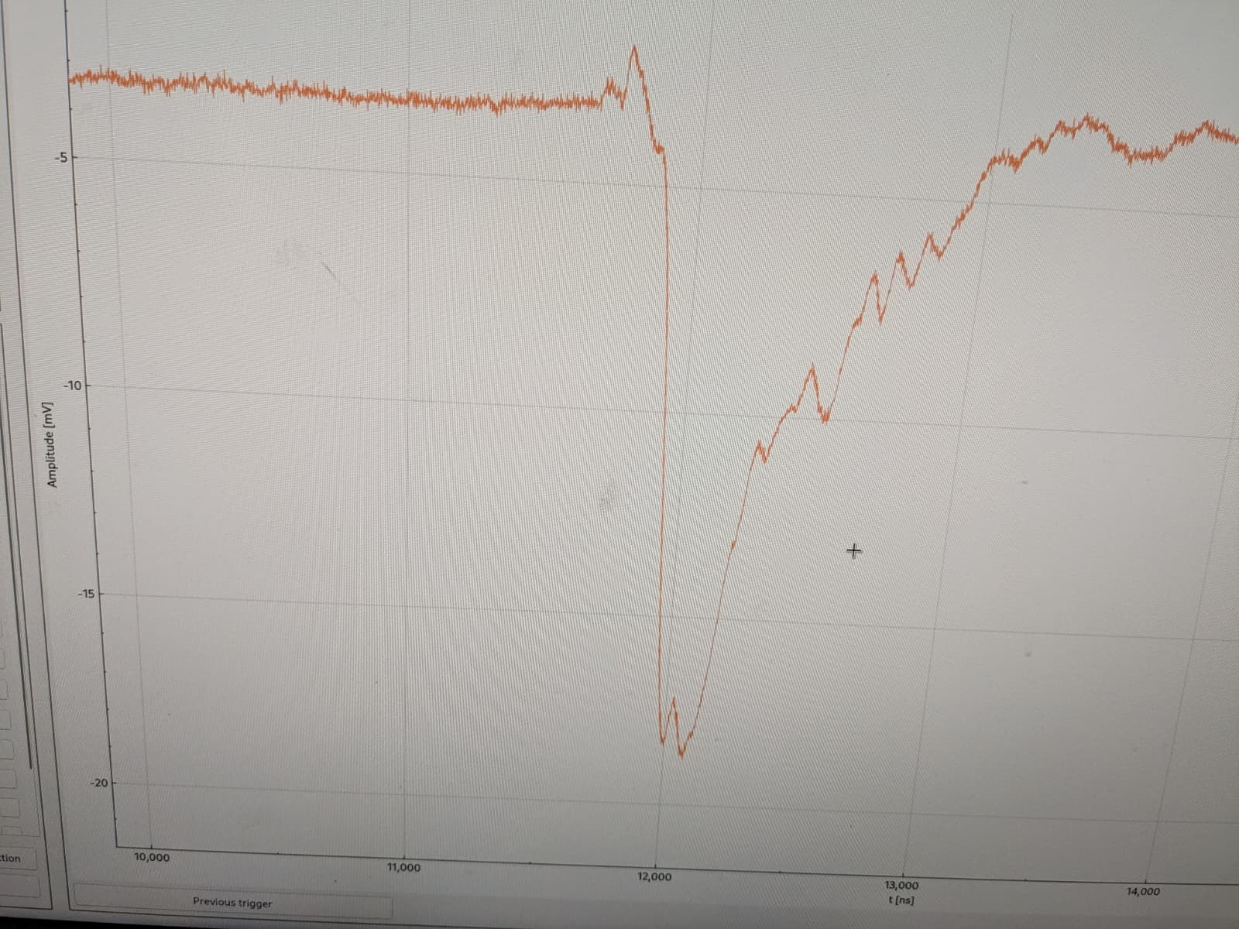
To establish a threshold, we characterize the existing gamma flash pulse observed on the n_TOF DAQ:
- Observed Amplitude: -15 mV
- Pulse Width: ~ 300 ns
- Impedance: 50 Ohms
The total charge (Q_flash) deposited per strip is:
(15 mV / 50 Ohms) * 300 ns = ~ 90 pC
This current level is already sufficient to totally saturate the DREAM front-end electronics.

2. Comparison: Mesh Switching Induced Charge
The detector’s active area (40 x 40 cm²) and small amplification gap (150 microns) create a significant capacitance (C_mesh) of approximately 10 nF. If the mesh is pulsed to 100 V, the total stored charge is:
Q_total = 10 nF * 100 V = 1000 nC
Assuming the charge is distributed equally between the X and Y orientations (50/50 split) and across the 512 strips per orientation:
Q_strip = 500 nC / 512 strips = ~ 1000 pC

3. Conclusion
The induced charge from a 100 V mesh discharge is approximately 10 times larger than the charge from the gamma flash itself. Even reducing the switching voltage to 10 V—likely the minimum required to suppress gain—would still induce ~ 100 pC per strip, roughly the same magnitude as the gamma flash.
Unless a method for extremely slow ramping or sophisticated common-mode rejection is implemented, mesh switching does not appear to be a viable solution for protecting the DREAM electronics. A simple bench test—draping a mesh over a readout board and measuring the discharge transient on an oscilloscope—could be performed to confirm these estimates before further development.

5.7 MM Efficiency-Saturation Overlaps

5.7.1 Helium Ethane 96.5/3.5
In Helium gas using a SiPM trigger to calibrate the detector, we seem to see an efficiency turn on occurring around 525 V and plateauing until 535 V. This almost overlaps with the detector saturation measurement, where we see the detector seem to saturate at 520 V. At 520 V on the resist, the detector may still be alive after the flash and also efficient to electron and positron tracks.
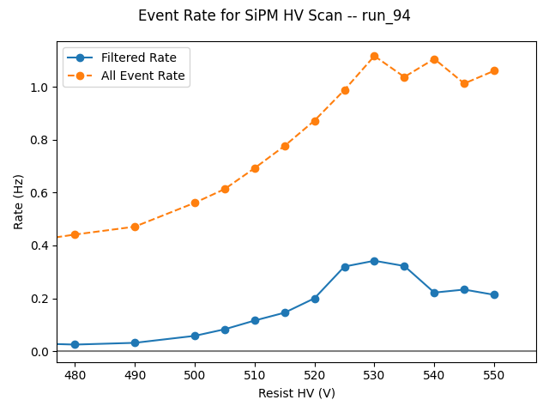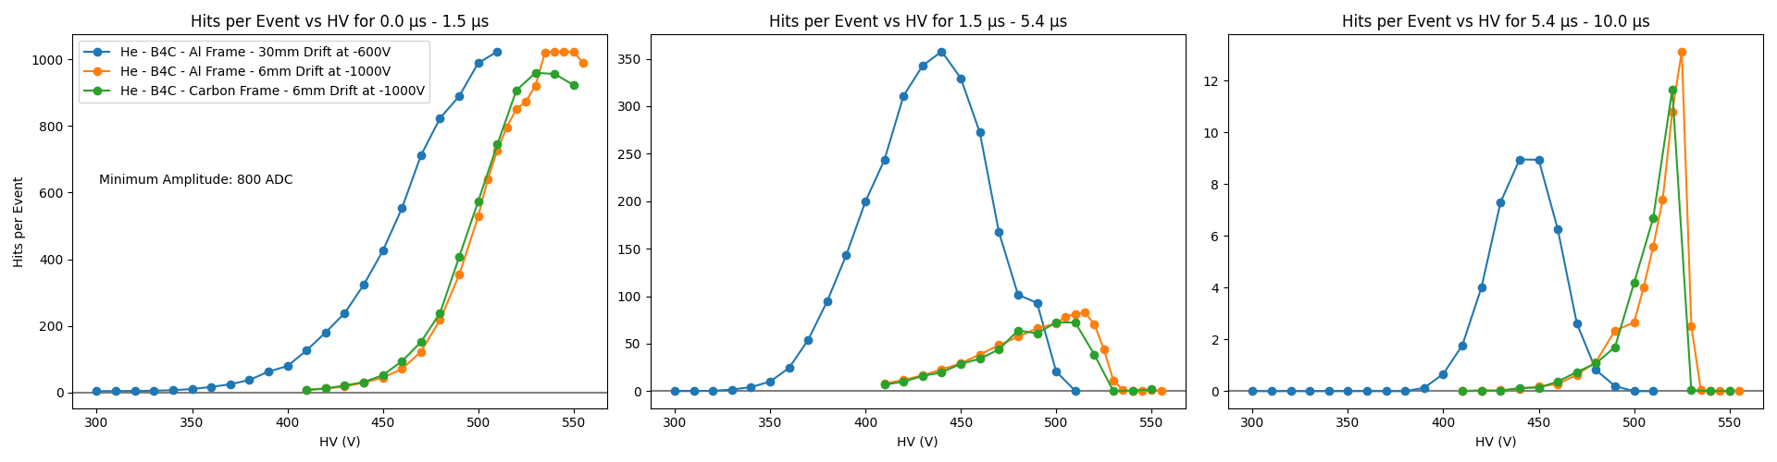

6. Prospects and Outlook

6.1 Path to a High-Energy Measurement
Making a measurement in the 0–10 μs window requires operating the Micromegas at a HV sufficient to detect ∼3–10 MeV MIP-like electrons and positrons, while keeping the DREAM DAQ alive through the gamma flash. From the February beam test, the following is concluded:
- With 30 mm drift and Argon gas: Not feasible. The DREAM saturates before the detector reaches MIP efficiency for all Ar-based gases tested.
- With 6 mm drift and He/Ethane: Potentially feasible. There appears to be a narrow HV window (estimated ∼515–530 V) where the detector may be approaching MIP efficiency and the DREAM is not yet fully saturated. Full calibration data is needed to confirm.
- With 6 mm drift and Neon gas (untested): Neon’s lower Z than Argon should make it less sensitive to gamma interactions, while its higher Z than Helium should reduce neutron sensitivity. If this “goldilocks” behaviour is confirmed, Neon could outperform both Ar and He. The obstacle is cost (∼8k EUR/month) and the lack of testing time.
If a working voltage window is confirmed, the high-energy measurement with 6 mm drift will operate in hit mode rather than micro-TPC mode. Electron/positron tracks will not be reconstructed in 3D; instead, coincident hits in opposite detectors will be paired and their relative angle estimated from projected strip positions. The expected combinatorial background (random uncorrelated pairs) should produce a flat angular distribution, allowing an X17 peak at ∼120° to be identified above it, at the cost of a reduced signal-to-background ratio.
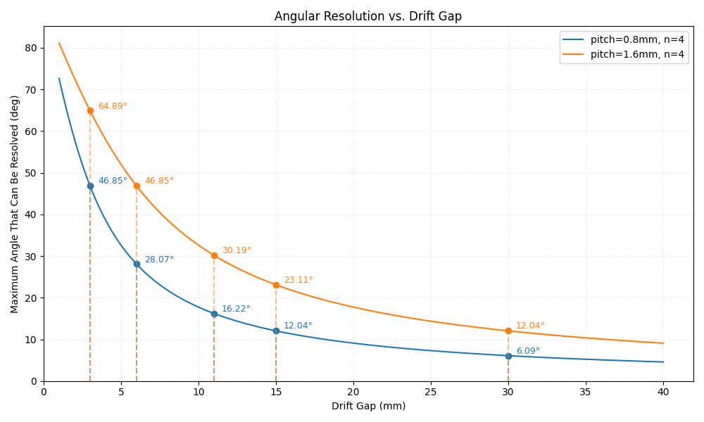

6.2 Unproven Mitigation Strategies

6.2.1 Mesh Voltage Pulsing
As described in Section 5.6.3, applying a positive pulse to the floating mesh before and during the gamma flash could render the amplification gap inoperative during the flash, preventing large charge from reaching the DREAM electronics. The key question is whether the fast discharge of the mesh after the flash generates its own DREAM-saturating transient. Order of magnitude estimates find that the charge induced by this pulsing is the same order as the flash itself, making this strategy unlikely to work.

6.2.2 Low-Current Switch
The electronic switch tested in February may have been inappropriate for the very low current levels of the MM signal. A switch specifically designed for sensitive analogue applications (e.g., CMOS analogue switches with low charge injection) might avoid the large transient that saturated DREAM. However, such devices would need to be found, characterised, and made into boards for ∼2000 channels. This is likely not feasible for July if not started immediately.

6.2.3 CEA Gain-Switching Board
CEA has developed an automatic gain-switching ASIC that could in principle suppress the flash signal and restore normal gain afterward. The main questions are whether enough boards exist for the full detector, whether they are compatible with the MM signal interface, and whether they can be procured and tested in time. The current assessment is that this is logistically unlikely for July but should be investigated urgently.

6.2.4 Neon Gas
Neon-based gas mixtures have not yet been tested. The prediction, based on its intermediate Z (Ne: Z=10 vs. He: Z=2 vs. Ar: Z=18), is that it will be less sensitive to the gamma component of the flash than Argon while being less sensitive to neutrons than Helium. Simulations of the relative sensitivity of each gas to MIP-like electrons, gammas, and neutrons would be highly valuable. If the predictions are favourable, borrowing a neon bottle from the GDD lab for a test in May would be the most expedient path.

6.3 Low-Energy (Thermal) Measurement
If no solution is found for the high-energy DAQ saturation problem before July, a fallback could be to focus on the thermal neutron measurement (~20% of total X17 yield). The advantages are: low occupancy, clean event topology, and no gamma flash problem in the signal window. The challenges are: (1) a triggering strategy must be developed and tested; self-triggering on individual MM strips is dominated by random discharges; (2) triggering on coincident hits between two MMs (as needed for a ∼120° pair) via the DREAM self-trigger system is not known to be feasible and has not been investigated; and (3) the SiPM wall as a coincident trigger depends on availability of a separate DAQ system and resolution of the SiPM interface issues described in Section 3.

7. Timeline and Next Steps

7.1 Immediate Priorities (March 2026)
- Data analysis: Complete efficiency vs. HV curves for all gas/drift configurations; produce beam-induced saturation curves; identify working windows.
- Detector mechanics: Begin fabrication of the next prototype detector incorporating lessons learned (improved grounding scheme, plain resistive layer).
- Readout board order: Contact the preferred PCB manufacturer (with existing project credit) immediately to obtain lead time and pricing for the MX readout boards. Decision on board design (full 512 ch vs. combined strips) must follow.
- Mesh pulsing circuit: Design and bench-test a circuit to float and pulse the Micromegas mesh voltage, to be tested in May. Unlikely to work by order of magnitude estimation.
- Gas simulation: Run simulations of He, Ar, Ne gas mixtures to compare relative MIP, gamma, and neutron sensitivities. Use to guide gas choice for May and July.

7.2 May 2026 Beam Test
A beam time slot in May has been confirmed, though details remain to be resolved (exact duration). The May test should aim to:
- Validate the new detector design and improved grounding.
- Test the mesh pulsing strategy for flash mitigation. Unlikely to work.
- Characterise the new detector’s efficiency with calibration sources and cosmics. Ideally done at Saclay cosmic bench with same gas if possible!
- If possible, test with neon gas (coordinate with GDD for bottle access).
- Commission the new standalone DAQ system (space TCM + 1–2 FEUs borrowed from CEA — permission process currently ongoing and must be resolved promptly).
- [TODO] Confirm May beam time window and resolve CEA TCM/FEU loan permission. Assign to experiment spokesperson.

7.3 July 2026 Final Measurement
The July measurement requires the full four-detector setup. Key outstanding questions and logistics:
- Four final MM detectors must be produced, characterised, and shipped to CERN. Mechanics can be built with 30 mm drift gap and adapted to smaller gaps post-May if no flash solution is found.
- Readout boards: Currently insufficient boards exist to read out all 4 detectors. Two scenarios:
  - Full readout (8 FEUs, 64 DREAM cables, 16–20 new boards): Maximum information; requires 8 FEUs from CEA, which conflicts with SPS beam test resources. Unlikely.
  - Half readout (4 FEUs, 32 DREAM cables): Read every other strip (or combine pairs). This doubles charge per strip, potentially worsening saturation if flash solution not found. Angular resolution is degraded (factor 2 in pitch; insert plot of minimum resolvable angle vs. drift gap).
  - Creative half-readout: Skip outer 15 mm dead zone strips in each orientation and redistribute channel density to the active central area. This requires a bespoke board design but may improve physics performance with limited channel count.
- The 3He target and its pressure vessel must be prepared for use in EAR2.
- The full triggering and DAQ strategy must be finalised, including coincidence logic.
- [TODO] Insert plot: minimum angular resolution vs. drift gap for 800 μm pitch and 1.6 mm (combined) pitch.
- [TODO] Finalise readout board design and submit order. Critical path item.

7.4 Summary Table
Period | Milestone | Key Items
March 2026 | Analysis & Design | Efficiency analysis complete; readout board order submitted; mesh pulsing circuit designed
April 2026 | Fabrication | New prototype detector built; gas simulations complete; CEA DAQ loan confirmed
May 2026 | Beam Test | Test new detector, grounding, mesh pulsing, neon gas; commission new DAQ
June 2026 | Production | Four final detectors built; readout boards received and tested; 3He target design finalised
July 2026 | Final Measurement | Four-detector physics run; X17 search in e⁺e⁻ channel

Appendix: Run Summary
The following table summarises the key runs from the February 2026 beam test. Full run details are available in the logbook and at /eos/experiment/ntof/data/x17/feb_beam/.
Run | Date | Trigger | Gas | Target | Drift (mm) | Frame | Notes
15 | Feb 2 | Self | Ar/CF4/Iso | Timepix | 30 | Al | First HV scan; 450–490 V; rate 0.18→1.43 Hz
16 | Feb 2 | Self | Ar/CF4/Iso | Timepix | 30 | Al | HV scan 490–525 V; discharges at 505 V
17 | Feb 2 | PS | Ar/CF4/Iso | Timepix | 30 | Al | First PS-triggered HV scan; CEA HV crate; cut short by bad config
18 | Feb 3 | PS | Ar/CF4/Iso | Timepix | 30 | Al | HV scan 0–520 V; 1 min/step; first detailed flash study
19 | Feb 3 | PS | He/Eth | Timepix | 30 | Al | Gas swap Ar→He; overnight scan + long stat run
26 | Feb 4 | PS | He/Eth | None | 30 | Al | Overnight HV scan; no target; step 5 V
27 | Feb 5 | PS | He/Eth | Lead | 30 | Al | Lead target; first target comparison; hit/event vs. HV
29 | Feb 5 | PS | He/Eth | B4C | 30 | Al | B4C target; quick HV scan
30 | Feb 5 | PS | He/Eth | B4C | 30 | Al | Overnight HV scan; B4C vs. no target comparison
32 | Feb 6 | PS | He/Eth | PE+Pb | 30 | Al | PE+Pb shield test; increased noise observed
33 | Feb 6 | PS | He/Eth | Carbon | 30 | Al | Carbon target; HV scan
34 | Feb 6 | Self | He/Eth | Carbon | 30 | Al | Self-trigger; cosmic hunt; 2 hr/step
36 | Feb 7 | Self | Ar/CF4/Iso | Carbon | 30 | Al | 24 hr long run at 490 V; cosmic search
38 | Feb 9 | PS | Ar/CF4/Iso | Cs-137+Y88 | 30 | Al | Source runs; efficiency calibration
50 | Feb 10 | PS | Ar/CF4 90/10 | Carbon | 30 | Al | New gas; HV scan with beam
52 | Feb 11 | SiPM | Ar/CF4 90/10 | None | 30 | Al | Detector horizontal; SiPM-triggered cosmics; 5 hr
54 | Feb 12 | SiPM | Ar/CF4 90/10 | None | 30 | Al | MM resist scan; SiPM trigger; cosmics
59 | Feb 13 | PS | Ar/CF4 90/10 | B4C (2mm) | 30 | Al | Overnight HV scan; cap removed from beam pipe
66 | Feb 17 | Self | Ar/CO2 70/30 | B4C | 30 | Al | 1 hr/step; efficient range scan
69 | Feb 18 | PS | Ar/CO2 70/30 | B4C (2.5mm) | 6 | Al | First 6 mm drift run; tripped at 0 V drift
71 | Feb 19 | PS | Ar/CO2 70/30 | B4C | 6 | Al | Key comparison: 0 V vs. 1000 V drift field; confirms 6 mm alive
74 | Feb 19 | PS | Ar/CO2 70/30 | Empty | 6 | Al | HV scan 720–560 V; drift −1000 V
80 | Feb 20 | PS | Ar/CO2 70/30 | Carbon | 6 | Al | HV scan resist + drift; carbon target
84 | Feb 21 | PS | He/Eth | Carbon | 6 | Al | He gas + 6 mm drift; first combination
88 | Feb 22 | PS | He/Eth | B4C | 6 | Al | B4C + He/Eth + 6 mm; key configuration
97 | Feb 24 | SiPM/Self | He/Eth | Cs-137 | 6 | Al | Cs-137 efficiency scan; key calibration run
107 | Feb 24 | PS | He/Eth | B4C | 6 | Al | Long stat run; drift + resist scan
112 | Feb 26 | PS | Ar/CO2 70/30 | B4C | 6 | Carbon | First carbon frame run
114 | Feb 26 | PS | Ar/CO2 70/30 | B4C | 6 | Carbon | PS HV scan; carbon frame
126 | Feb 28 | PS | He/Eth | Lead | 6 | Carbon | Carbon frame + He/Eth; grounding improved; key comparison
128 | Feb 28 | PS | He/Eth | B4C | 6 | Carbon | HV scan; test mesh pulsing window
136 | Feb 28 | PS | He/Eth | Lead | 6 | Carbon | Al vs. carbon frame comparison; ∼10–20% hit reduction
139 | Mar 1 | PS | He/Eth | Carbon | 6 | Carbon | Carbon target; long run at 515 V
141 | Mar 1 | PS | He/Eth | Carbon | 11 | Carbon | First 11 mm drift; intermediate gap test
143 | Mar 1 | PS | He/Eth | Carbon | 11 | Carbon | Long stat run at 510–520 V; final dataset

