**This instruction is to explain the function of each part in the user interface.**

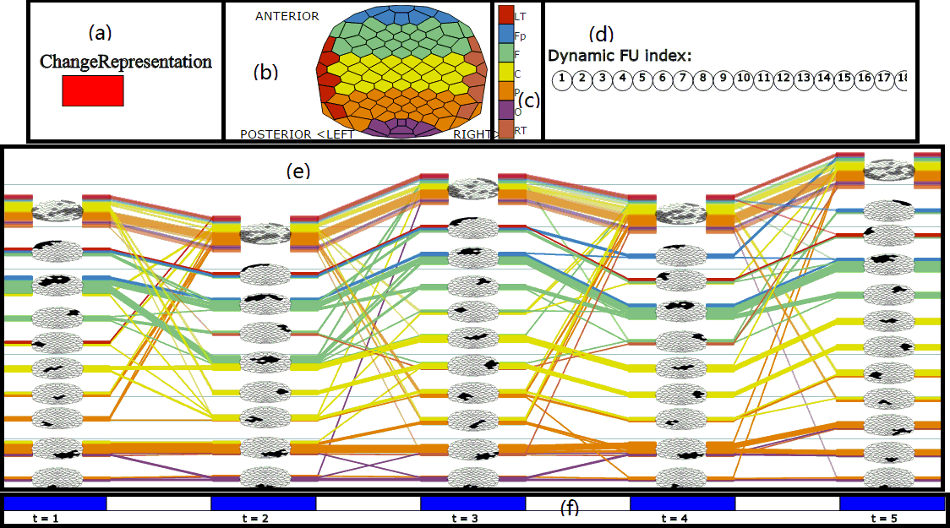

**(a):** Change the timeline representation in **(f)**. Click the red rectangle area in **(a)**, the partial FU map in **(f)** will disappear, and click the red rectangle area again the partial FU will appear.

**(b):** Electrode placement layout for reference purposes. Move mouse over the cell representing electrode in **(b)**, current cell and corresponding line in **(e)** will be highlighted, and the region to which this electrode belongs will be highlighted in **(c)**.

**(c):** Color legend for brain regions. Move mouse over one of these seven bars, electrodes of the brain region corresponding to the selected bar will be highlighted in **(b)** and **(e)**.

**(d):** Dynamic FU Index. Move mouse over one of these circles, this circle and FUs belong to this dynamic FU in **(e)** will be highlighted.

**(e):** Timeline representation window: the main window is for showing the evolution of coherence networks. Move mouse over lines (except the lines with less opacity, usually on the top of each time step; these lines are not included in the FUs above a specified size), the dynamic FU to which these lines/electrodes belong will be highlighted. The dynamic FU index also will be highlighted in **(d).**

**(f):** Time ticks: each blue rectangle area represents a time step and they are separated by white gap. Move mouse over one of these blue areas, FUs at this time step will be highlighted in **(b)** and **(e)**, and dynamic FUs index whose members appearing at this time step will be highlighted in **(d)**.

Move the mouse to the white gap between blue areas, the FUs at previous time step and following time step will be highlighted in **(e)** and their time-annotated FU map will be displayed in **(b)**.