Dr. Geo aim is to be an open, easy to study, modify and extend interactive geometry software. It is distributed with its source code you can modify while using it. Ten years old kids use Dr. Geo to explore Euclidean geometric sketch, agile kids extend and program it with its embedded dynamic Smalltalk language and user interface.
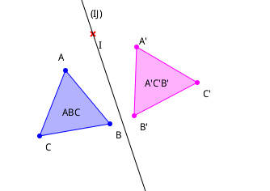

Just like other interactive geometry software such as Cabri, Cinderella, Geogebra, Carmetal, with Dr. Geo the user creates a geometric sketch and manipulates it according to its constraints. What sets Dr.Geo apart from the other geometry software is the possibility of studying and even modifying/extending its source code while s/he is using it to create a figure.
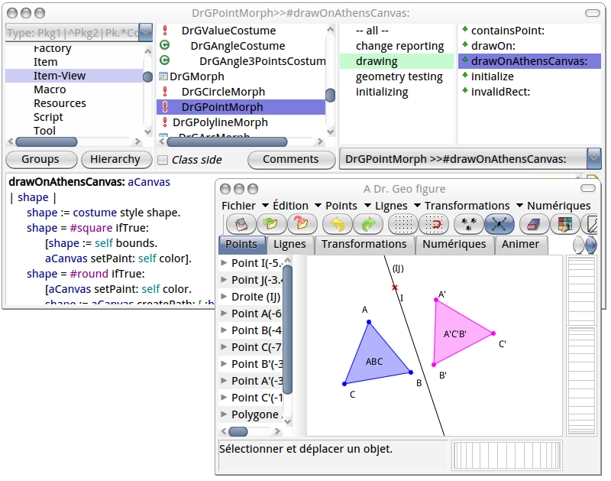

All in all, its philosophy is also to empower the user with direct access to the Dr. Geo arcane and programming. For example, with script, one can build a geometric sketch to compute the slope at an arbitrary location of a given curve.
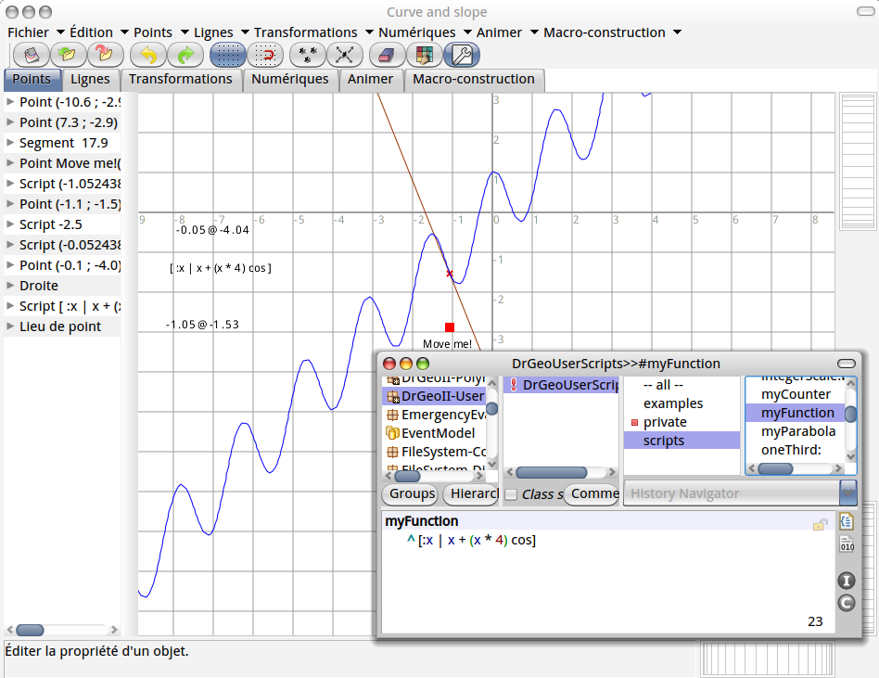

Or the user can describe a recursive curve with Smalltalk programmed sketch.

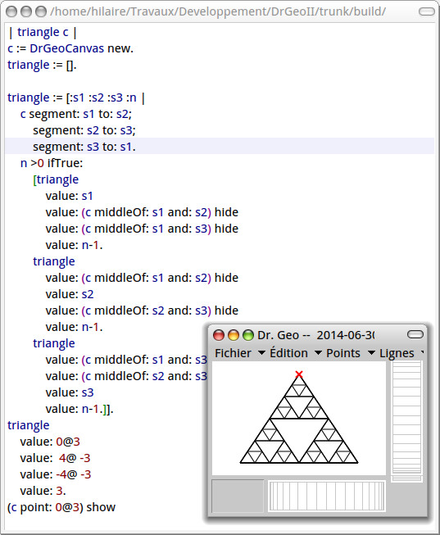

It is distributed as an universal portable application: you can install it in a usb stick and run it anywhere, from a GNU/Linux, Windows or Mac OSX workstation: Dr. Geo is Modify-me Ready! But don't be afraid, if you only want to design interactive sketch, Dr. Geo is intuitive and easy to use.

It is also tablet ready for both Android and iPad.

Explore, Discover, Enjoy and Share!

