**Supplementary Material**

**Table S1**

Century extension input parameters. Refer to the extensions user's guide for detailed explanations of each parameter, found on the LANDIS-II website: [www.landis-ii.org](http://www.landis-ii.org). Species-specific parameters represent species sensitivity to temperature and drought and estimates of % lignin and C:N ratios in various plant parts. The parameters are drawn from the original CENTURY model (<http://www.nrel.colostate.edu/projects/century/manual4/man96.html>) or from the literature, where available. Century calculates species-specific establishment probability within each ecoregion based on species sensitivity to growth, temperature, and soil moisture.

|  |  |  |  |  |  |  |  |  |  |  |  |  |  |  |  |  |
| --- | --- | --- | --- | --- | --- | --- | --- | --- | --- | --- | --- | --- | --- | --- | --- | --- |
| Physiological parameters for 11 tree species and 4 shrub functional groups found in the Lake Tahoe Basin, CA, NV, USA. GDD: Growing Degree Days | | | | | | | | | | |  |  |  |  |  |  |
| Species or functional group | Functional type | Nitrogen tolerance | GDD min | GDD max | Min. Jan. Temp. (C) | Max Drought | Leaf longevity (yrs.) | Leaf lignin (%) | Fine root lignin (%) | Wood lignin (%) | Coarse root lignin (%) | Leaf CN ratio | Fine root C:N ratio | Wood C:N ratio | Coarse root C:N ratio | Litter C:N ratio |
| *Pinus jeffreyi* | 1 | N | 555 | 2149 | -5 | 0.94 | 6.0 | 0.28 | 0.2 | 0.25 | 0.25 | 48 | 48 | 250 | 167 | 100 |
| *Pinus lambertiana* | 1 | N | 815 | 2866 | -5 | 0.90 | 2.5 | 0.17 | 0.2 | 0.25 | 0.25 | 53 | 53 | 278 | 185 | 100 |
| *Calocedrus decurrens* | 1 | N | 837 | 2938 | 18 | 0.99 | 4.0 | 0.1 | 0.2 | 0.25 | 0.25 | 48 | 48 | 500 | 333 | 100 |
| *Abies concolor* | 1 | N | 540 | 2670 | -10 | 0.93 | 8.0 | 0.17 | 0.2 | 0.25 | 0.25 | 30 | 30 | 333 | 222 | 100 |
| *Abies magnifica* | 1 | N | 483 | 1144 | -18 | 0.87 | 8.0 | 0.17 | 0.2 | 0.25 | 0.25 | 30 | 30 | 250 | 167 | 100 |
| *Pinus contorta* | 1 | N | 276 | 993 | -18 | 0.87 | 3.5 | 0.25 | 0.2 | 0.25 | 0.25 | 48 | 48 | 500 | 333 | 100 |
| *Pinus monticola* | 1 | N | 155 | 1016 | -18 | 0.82 | 7.0 | 0.31 | 0.2 | 0.25 | 0.25 | 37 | 37 | 500 | 333 | 100 |
| *Tsuga mertensiana* | 1 | N | 235 | 894 | -18 | 0.80 | 4.5 | 0.24 | 0.2 | 0.25 | 0.25 | 80 | 80 | 333 | 222 | 100 |
| *Pinus albicaulis* | 1 | N | 230 | 950 | -18 | 0.90 | 5.5 | 0.27 | 0.2 | 0.25 | 0.25 | 80 | 80 | 333 | 222 | 100 |
| *Populus tremuloides* | 2 | N | 600 | 3000 | -10 | 0.82 | 1.0 | 0.18 | 0.2 | 0.25 | 0.25 | 62 | 62 | 333 | 222 | 100 |
| Non N-fixing resprouting shrubs | 3 | N | 400 | 4000 | -10 | 0.99 | 1.5 | 0.25 | 0.2 | 0.25 | 0.25 | 56 | 56 | 333 | 222 | 100 |
| Non N-fixing obligate seeding shrubs | 3 | N | 400 | 4000 | -10 | 0.97 | 1.5 | 0.25 | 0.2 | 0.25 | 0.25 | 59 | 59 | 333 | 222 | 100 |
| N-fixing resprouting shrubs | 3 | Y | 400 | 4000 | -10 | 0.97 | 1.5 | 0.25 | 0.2 | 0.25 | 0.25 | 20 | 28 | 333 | 222 | 50 |
| N-fixing obligate seeding shrubs | 3 | Y | 400 | 4000 | -10 | 0.99 | 1.5 | 0.25 | 0.2 | 0.25 | 0.25 | 20 | 30 | 333 | 222 | 50 |

**Table S2**

Functional type parameters for the species list in Table 1. Refer to the extensions user's guide for detailed explanations of each parameter, found on the LANDIS-II website: [www.landis-ii.org](http://www.landis-ii.org). The tree species and shrub functional groups were further classified into functional types, where temperature, Leaf Area Index (LAI), and water limitations were parameterized for monthly growth (e.g., NPP) patterns, specifically in response to the dry summers and below-freezing winter temperatures found at the LTB. The vegetation within the LTB is well-adapted to the droughty summer months and benefits mainly from the spring snowmelt and early autumn rainfall. As such, the functional groups were parameterized to allow productivity (hence, minimal water and soil moisture limitations) during the dry summer months. The CENTURY default LAI values were used for conifers and hardwoods, while shrubs were adjusted for reduced NPP.

|  |  |  |  |  |  |  |  |  |  |  |  |  |  |  |  |
| --- | --- | --- | --- | --- | --- | --- | --- | --- | --- | --- | --- | --- | --- | --- | --- |
| Name | Functional type index | PPDF1 mean | PPDF2 max | PPDF1 shape 1 | PPDF1 shape 2 | NPP leaf (%) | BTOLAI | KLAI | MAXLAI | PPRPTS2 | PPRPTS3 | Wood decay rate | Wood mortality (%/mo.) | Age mortality shape | Leaf Drop Month |
| Conifers | 1 | 23.0 | 40.0 | 0.05 | 6.0 | 0.2 | 0.002 | 5000 | 10 | 0.2 | 0.1 | 1.0 | 0.002 | 10.0 | 9.0 |
| Hardwoods | 2 | 23.0 | 35.0 | 0.05 | 7.0 | 0.3 | 0.002 | 5000 | 20 | 0.2 | 0.1 | 1.0 | 0.002 | 10.0 | 9.0 |
| Shrubs | 3 | 23.0 | 32.0 | 0.05 | 10.0 | 0.3 | 0.002 | 500 | 5 | 0.2 | 0.1 | 1.0 | 0.002 | 10.0 | 9.0 |
|  | | | | | | | | | | | | |  |  |  |

**Table S3**

Initial values of carbon and nitrogen in various soil organic pools. Refer to the extensions user's guide for detailed explanations of each parameter, found on the LANDIS-II website: [www.landis-ii.org](http://www.landis-ii.org). Also see Fig. S1.

|  |  |  |  |  |  |  |  |  |  |
| --- | --- | --- | --- | --- | --- | --- | --- | --- | --- |
| Ecoregion | SOM1 C (surface) | SOM1 N (surface) | SOM1 C (soil) | SOM1 N (soil) | SOM2 C | SOM2 N | SOM3 C | SOM3 N | Mineral N |
| Eastside Forest & Woodland | 75.0 | 3.0 | 100.0 | 10.0 | 3000.0 | 50.0 | 300.0 | 15.0 | 3.0 |
| Upper Montane | 75.0 | 3.0 | 100.0 | 10.0 | 3000.0 | 50.0 | 300.0 | 15.0 | 3.0 |
| Subalpine | 75.0 | 3.0 | 100.0 | 10.0 | 3000.0 | 50.0 | 300.0 | 15.0 | 3.0 |
| Montane shrubland | 75.0 | 3.0 | 100.0 | 10.0 | 3000.0 | 50.0 | 300.0 | 15.0 | 3.0 |
| Riparian areas | 75.0 | 3.0 | 100.0 | 10.0 | 3000.0 | 50.0 | 300.0 | 15.0 | 3.0 |
| SOM1: Soil Organic Matter fast pool; SOM2: Soil Organic Matter fast pool; SOM3: Soil Organic Matter passive pool | | | | | | | | | |

**Table S4**

Ecoregion fixed parameters for the Lake Tahoe Basin, CA, NV, USA. Refer to the extensions user's guide for detailed explanations of each parameter, found on the LANDIS-II website: [www.landis-ii.org](http://www.landis-ii.org). The spatial ecoregion dataset, initial soil conditions, and soil properties were developed from national soil databases (NRCS, SSURGO).

|  |  |  |  |  |  |  |  |  |  |  |  |  |  |  |  |  |
| --- | --- | --- | --- | --- | --- | --- | --- | --- | --- | --- | --- | --- | --- | --- | --- | --- |
| Ecoregion | Soil depth (cm) | % Clay fraction | % Sand fraction | Field capacity | Wilting point | Storm flow fraction | Base flow fraction | Drainage | Atmospheric N (slope) | Atmospheric N (intercept) | Latitude | Decay rate Surface soil | Decay rate SOM1 | Decay rate SOM2 | Decay rate SOM3 | Denitrification |
| Eastside Forest & Woodland | 100 | 0.070 | 0.714 | 0.109 | 0.055 | 0.4 | 0.4 | 0.691 | 0.08 | 0.005 | 39.02 | 0.4 | 1 | 0.02 | 0.0002 | 0.5 |
| Upper Montane | 100 | 0.050 | 0.786 | 0.090 | 0.046 | 0.4 | 0.4 | 0.815 | 0.08 | 0.005 | 39.02 | 0.4 | 1 | 0.02 | 0.0002 | 0.5 |
| Subalpine | 100 | 0.061 | 0.744 | 0.097 | 0.051 | 0.4 | 0.4 | 0.735 | 0.08 | 0.005 | 39.02 | 0.4 | 1 | 0.02 | 0.0002 | 0.5 |
| Montane shrubland | 100 | 0.078 | 0.718 | 0.090 | 0.060 | 0.4 | 0.4 | 0.826 | 0.08 | 0.005 | 39.02 | 0.4 | 1 | 0.02 | 0.0002 | 0.5 |
| Riparian areas | 100 | 0.068 | 0.704 | 0.123 | 0.053 | 0.4 | 0.4 | 0.523 | 0.08 | 0.005 | 39.02 | 0.4 | 1 | 0.02 | 0.0002 | 0.5 |

**Table S5**

References for input parameters to the Century extension as well as species parameters (for Tables 1, S1-4):

Brown JK, Smith JK (2000) Wildland fire in ecosystems: effect of fire on flora. General Technical Report RMRS-GTR-42-vol. 2. Ogden, UT, US Department of Agriculture, Rocky Mountain Research Station, 257 p.

Busing RT (2007) A Spatial Landscape Model of Forest Patch Dynamics and Climate Change. US Geological Survey, Reston, Virginia, 50  pp.

Burns RM, Honkala BH (1990) Silvics of North America: 1. Conifers; 2. Hardwoods. Agricultural Handbook 654. Vol. 2, pp. 877. USDA Forest Service, Washington, DC.

Chen JM, Rich PM, Gower ST, Norman JM, Plummer S (1997) Leaf area index of boreal forests: Theory, techniques, and measurements. *J. Geophys. Res.,* **102,** 29429-29443.

Fowells HA (1941) The period of seasonal growth of ponderosa pine and associated species, *Journal of Forestry*, **39**, 601-608.

Hughes T, Latt C, Tappeiner J, Newton M (1987) Biomass and Leaf-Area Estimates for Varnishleaf Ceanothus, Deerbrush, and Whiteleaf Manzanita. *Western Journal of Applied Forestry,* **2,** 124-128.

Kercher JR, Axelrod MC (1984) Process model of fire ecology and succession in a mixed-conifer forest. *Ecology,* **65,** 1725-1742.

Miller C, Urban DL (1999) Interactions between forest heterogeneity and surface fire regimes in the southern Sierra Nevada. *Canadian Journal of Forest Research,* **29,** 202-212.

Miller C, Urban DL (1999) A model of surface fire, climate and forest pattern in the Sierra Nevada, California, *Ecological Modelling*, **114**, 113-135.

Miller WW, Johnson DW, Karam SL, Walker RF, Weisberg PJ (2010) A Synthesis of Sierran Forest Biomass Management Studies and Potential Effects on Water Quality, *Forests,* **1,** 131-153.

Royce EB, Barbour MG (2001) Mediterranean climate effects. II. Conifer growth phenology across a Sierra Nevada ecotone, *American Journal of Botany,* **88**, 919-932.

Sakai A, Weiser CJ (1973) Freezing resistance of trees in North America with reference to tree regions, *Ecology*, **54**, 118-126.

Scheller RM, Hua D, Bolstad PV, Birdsey RA, Mladenoff DJ (2011) The effects of forest harvest intensity in combination with wind disturbance on carbon dynamics in Lake States Mesic Forests. *Ecological Modelling,* **222,** 144-153.

Spanner MA, Pierce LL, Running SW, Peterson DL (1990) The seasonality of AVHRR data of temperate coniferous forests: Relationship with leaf area index. *Remote Sensing of Environment,* **33,** 97-112.

Tarnay L, Gertler AW, Blank RR, Taylor GE (2001) Preliminary measurements of summer nitric acid and ammonia concentrations in the Lake Tahoe Basin air-shed: implications for dry deposition of atmospheric nitrogen. *Environmental Pollution,* **113,** 145-153.

Weishampel JF, Urban DL, Shugart HH, Smith JB, Jr. (1992) Semivariograms from a forest transect gap model compared with remotely sensed data. *Journal of Vegetation Science,* **3,** 521-526.

Zinke PJ, Stangenberger AG, Post WM, Emanuel WR, Olson. JS (1998) Global Organic Soil Carbon and Nitrogen. Oak Ridge National Laboratory Distributed Active Archive Center, Oak Ridge, Tennessee.

Zolbrod AN, Peterson DL (1999) Response of high-elevation forests in the Olympic Mountains to climatic change. *Canadian Journal of Forest Research,* **29,** 1966-1978.

**Table S6**

Fire regime parameter inputs for the Dynamic Fire extension used for the Lake Tahoe Basin, CA, NV. Please refer to the extensions user's guide for detailed explanations of each parameter, found on the LANDIS-II website: [www.landis-ii.org](http://www.landis-ii.org). Also refer to Syphard et al. 2011 for details on fire regime and fuel types for Sierra Nevada, similar to this study. FMC: Foliar moisture content.

|  |  |  |  |  |  |  |  |  |  |  |  |  |  |  |  |
| --- | --- | --- | --- | --- | --- | --- | --- | --- | --- | --- | --- | --- | --- | --- | --- |
| **Fire Region** | **Region size (ha)** | **mu** | **sigma** | **Maximum Size/Duration** | **Spring FMC Low** | **Spring FMC High** | **Spring High Proportion** | **Summer FMC Low** | **Summer FMC High** | **Summer High Proportion** | **Fall FMC Low** | **Fall FMC High** | **Fall High Proportion** | **Default Open Fuel Type Index** | **Number of Fires (ignitions) yr-1** |
| Lower-elevation | 9,603 | 5.2 | 0.32 | 4500 | 135 | 175 | 0.05 | 85 | 100 | 0.89 | 75 | 90 | 0.1 | 31 | 1 |
| Mid-elevation | 28,777 | 5.3 | 0.32 | 4500 | 135 | 175 | 0.05 | 85 | 100 | 0.89 | 75 | 90 | 0.1 | 31 | 1 |
| Higher-elevation | 31,194 | 5.2 | 0.32 | 4500 | 135 | 175 | 0.05 | 85 | 100 | 0.89 | 75 | 90 | 0.1 | 31 | 1 |

Notes on fire region delineation: Fire region map was reclassified from a continuous fire ignition density image that was estimated using a spatial point pattern modeling approach (Loudermilk *et al.* 2012, Yang *et al.* 2007) from historical fire occurrence database (<http://www.fs.usda.gov/detail/r5/landmanagement/gis/?cid=STELPRDB5327833>, accessed 19 June 2012)

Notes on fire ignitions: Although different fire regions possess different fire ignition densities, their number of fire ignitions per year was all set to one (the lowest non-zero integer) after multiplying fire region size. This parameter was set to this low value because we only simulated fires > 0.1 ha, a threshold often used to remove extremely small fires in the analysis that otherwise contribute little in total area burned and fire risk assessment (Miranda et al. 2012).

Loudermilk EL, Stanton, Alison E., Scheller, Robert M., Weisberg, Peter J., Yang, Jian, Dilts, Thomas E., Skinner, Carl (2012) Final Report: Management Options for Reducing Wildfire Risk and Maximizing Carbon Storage under Future Climate Changes, Ignition Patterns, and Forest Treatments In: Southern Nevada Public Lands Management Act. pp 100. Pacific Southwest Research Station, Tahoe Center for Environmental Studies, Incline Village, NV.

Miranda BR, Sturtevant BR, Stewart SI, Hammer RB (2012) Spatial and temporal drivers of wildfire occurrence in the context of rural development in northern Wisconsin, USA. *International Journal of Wildland Fire*, **21**, 141-154.

Yang J, He HS, Shifley SR, Gustafson EJ (2007) Spatial Patterns of Modern Period Human-Caused Fire Occurrence in the Missouri Ozark Highlands. *Forest Science*, 53, 1-15.

**Table S7**

Response of C dynamics to climate change; represented by % difference in mean landscape C between the A2 and base climate scenarios at simulation year 2110 (100 year simulations). Negative values refer to a reduction in, e.g., total C from base climate to A2 climate at year 2110. Refer to Fig. 5 and 6 of original text for graphical representation.

|  |  |
| --- | --- |
| C variable | % Difference at year 2110 |
| Total C | -15% |
| ANPP | -20% |
| Live C | -17% |
| Detrital C | -14% |
| SOC | -6% |

**Table S8**

Individual species response to climate change, represented here as an approximate positive or negative % difference (to nearest 5%) of mean aboveground live biomass between both A2 or B1 climate and base climate at year 2110. Note that there were some instances were species responded to climate change for a brief period, but illustrated little to no difference in biomass by year 2110. These species are noted by * and see narrative below for details.

|  |  |  |  |  |
| --- | --- | --- | --- | --- |
|  | **Response to Climate Change** | | |  |
| **Species or functional group** | **+/-** | **A2** | **B1** | **Response type** |
| *Pinus jeffreyi\** | - | 10% | 0% | growth, regeneration |
| *Pinus lambertiana* | + | 25% | 25% | growth, regeneration |
| *Calocedrus decurrens\** | + | 0% | 0% | growth, regeneration |
| *Abies concolor* | + | 5% | 10% | growth, regeneration |
| *Abies magnifica* | - | 50% | 25% | regeneration |
| *Pinus contorta* | - | 60% | 40% | regeneration |
| *Pinus monticola* | - | 55% | 40% | regeneration |
| *Tsuga mertensiana* | - | 40% | 40% | regeneration |
| *Pinus albicaulis\** | + | 5%* | 0% | growth, regeneration (-) |
| *Populus tremuloides* | + | 100% | 50% | re-sprout after fire |
| Non N-fixing resprouting shrubs | + | 95% | 40% | re-sprout after fire |
| Non N-fixing obligate seeding shrubs | + | 25% | 25% | growth |
| N-fixing resprouting shrubs | + | 100% | 60% | re-sprout after fire |
| N-fixing obligate seeding shrubs | + | 5% | 5% | growth |

*Narrative on species response*: Simulation results indicated that individual species behaved uniquely in response to changes in climate. Species-dependent effects included both reduced or stimulated establishment ability and positive growth response. This was seen for both A2 and B1 climate. Increased fire activity (from climate change) increased tree mortality and altered dynamics between various shade and fire tolerant species. Positive responses to climate change were found (in decreasing order of magnitude) for sugar pine (*Pinus lambertiana*), white fir (*Abies concolor*), incense cedar (*Calocedrus decurrens*), and Jeffrey pine (*Pinus jeffreyi*). Sugar pine, white fir, and incense cedar illustrated positive growth, and to a lesser degree, enhance regeneration (establishment ability), in response to climate change. Of the four species, Jeffrey pine was least stimulated by changes in climate. For all climate scenarios, Jeffrey pine steadily increased in biomass for about 50 years (2060) then leveled off. Growth was only stimulated during the 1st half of the century (e.g., ~10% more biomass in B1 climate). After 2050, warmer conditions slowed growth and reduced establishment ability. Despite this, enhanced fire activity in the B1 climate allowed enough regeneration to stabilize landscape biomass of Jeffrey pine near base climate values. Incense cedar also illustrated this temporary stimulation from climate change, with 5% more biomass during the 1st half of the century (A2 and B1 climate), but converged the latter half. Aspen (*Populus tremuloides*) and the re-sprouting shrubs responded positively to the increase in fire activity (e.g., A2 climate) due to their innate ability to re-sprout vigorously after fire. Although aspen responded positively to more wildfire activity, it was proportionately still a small component of the landscape. Also, note there is very little whitebark pine (*Pinus albicaulis*) within the study area and there was very little noticeable response to climate change, but recorded a slight positive growth response with the A2 climate. Regeneration (establishment ability) for whitebark pine was still negatively impacted by climate change, as noted in the manuscript text.

**Table S9**

More details on precipitation effects on Build-Up Index (BUI), continued from the text.

Precipitation effects on BUI were more evident when temperature was lower. This was observed when we applied our second experimental approach (examining temperature and precipitation independently), specifically for the A2 precipitation-only scenario. The A2 precipitation-only scenario simulated the lowest temperature and precipitation of all scenarios. The variability of precipitation associated with the A2 climate reset the BUI throughout the season (more so than the base precipitation), with intermittent ‘bursts’ of rainfall. Therefore, despite the lower annual precipitation of the A2 precipitation-only scenario, the increased seasonal variability in precipitation lowered the overall availability of combustible fuels (lower average BUI). These interacting effects of low ignition potential (FFMC) and low available combustible fuel (BUI) over the season resulted in the lowest overall area burned and fire severity of all scenarios. The effect of rising temperatures dampened the effect of variable precipitation on BUI, where no differences in average BUI were found for either A2 climate or A2 temperature-only. In other words, the increased flammability of fine fuels ultimately outweighed fuel availability. Furthermore, as more area burned throughout the A2 climate, fewer fuels were available simply because more were consumed by fire (as compared to base climate). This effect of precipitation on BUI was ultimately minimal compared to the temperature effects on fine fuel moisture and the overarching impact of rising temperatures driving changes in the system as a whole. In addition, changes in precipitation (increase or decrease) will most likely not have a significant effect on fire weather because most of the rainfall at the LTB either occurs outside the summer season or as snowfall. Essentially, the summers (fire season) are already dry. Changes in temperature that may cause earlier snowmelt may have more impact (extending dry season) than changes in precipitation throughout the year.

**Fig. S1**

An example of growth response to temperature for the “conifer” functional group developed from the 4 PPDF parameters from Table S2.

**Fig. S2**

Range of soil organic matter (SOM) decay rates explored when calibrating initial soil organic carbon initial conditions and accumulation rates. SOM2 represented the slow soil pool (SOM2) in the Century extension in LANDIS-II. See Table S3. Decay rate of 0.02 was chosen for this study.

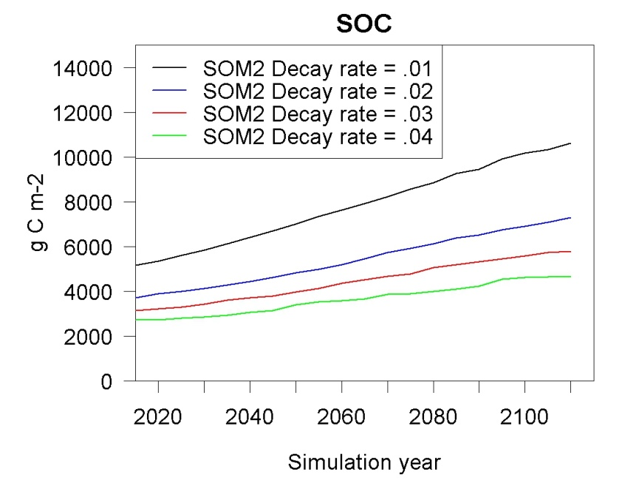

**Fig. S3**

Area burned (ha) per year comparison between base and A2 climate scenario simulations.

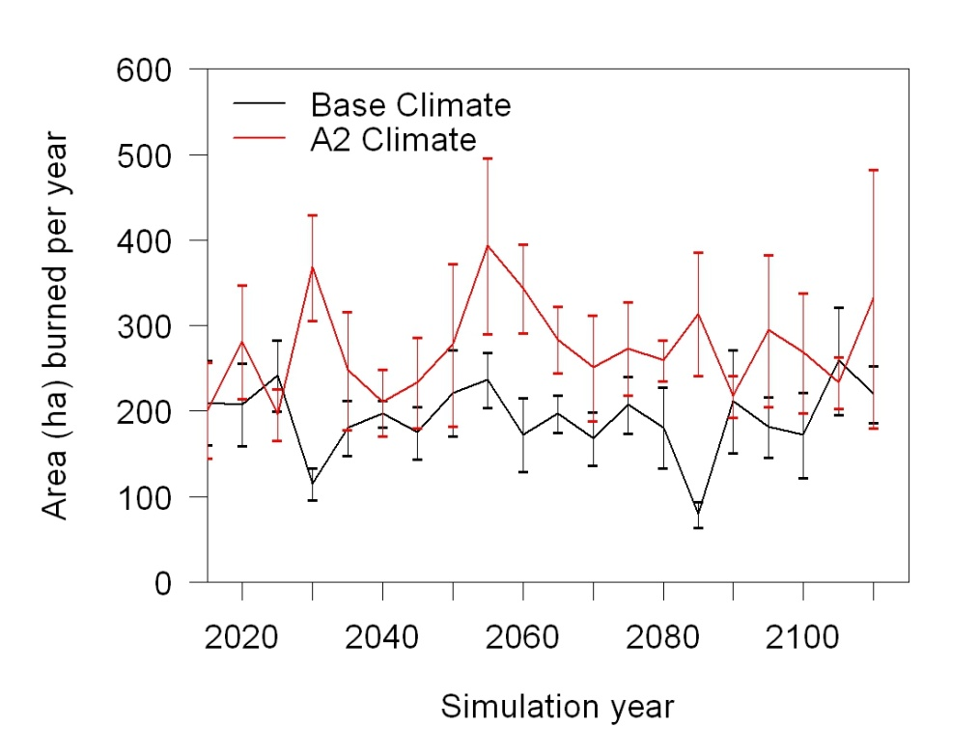

Output fire summary statistics, mean (standard deviation) across 100 year simulations and five replicate runs.

|  |  |  |  |  |
| --- | --- | --- | --- | --- |
| **Climate Scenario** | **Fire Rotation Period (yrs.)** | **Mean**  **Fire Size (ha)** | **Max**  **Fire Size (ha)** | **Mean Annual**  **Area Burned (ha)** |
| Base Climate | 360 (12) | 62 (110) | 848 (212) | 192 (91) |
| B1 Climate | 338 (30) | 70 (128) | 1141 (247) | 205 (105) |
| A2 Climate | 293 (19) | 89 (150) | 1295 (774) | 274 (130) |