Main Screen to be loaded onto

Option to click to view more cars for sale which takes you to wireframe 3

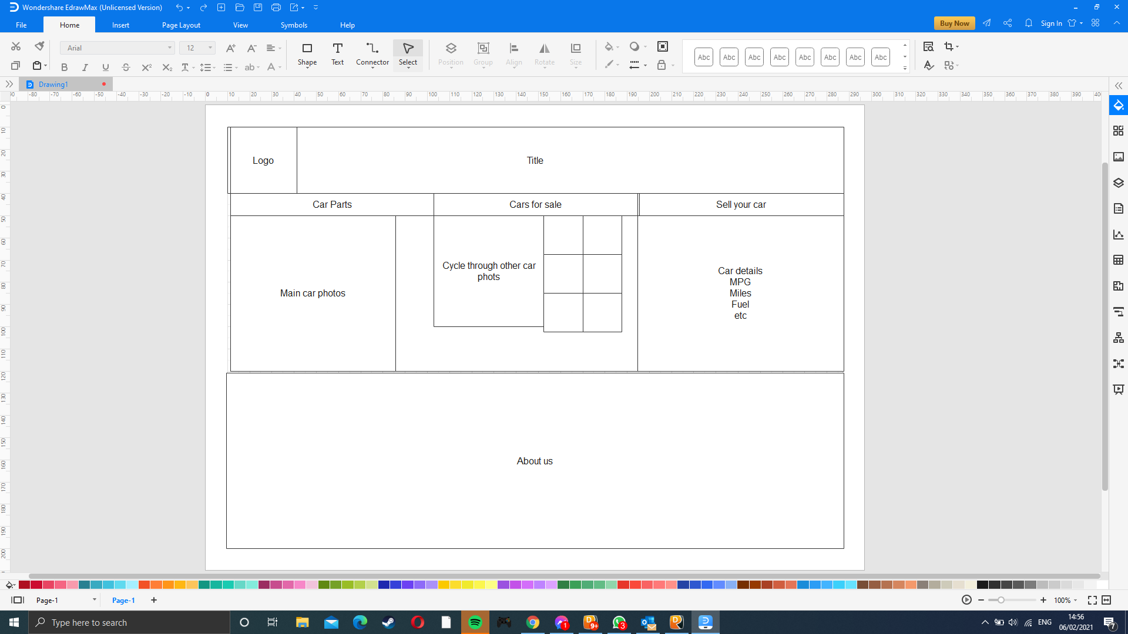

When Car Parts clicked it alters the pictures to show car parts

Same option to go to wireframe 3 but instead of showing cars for sale it shows parts for sale

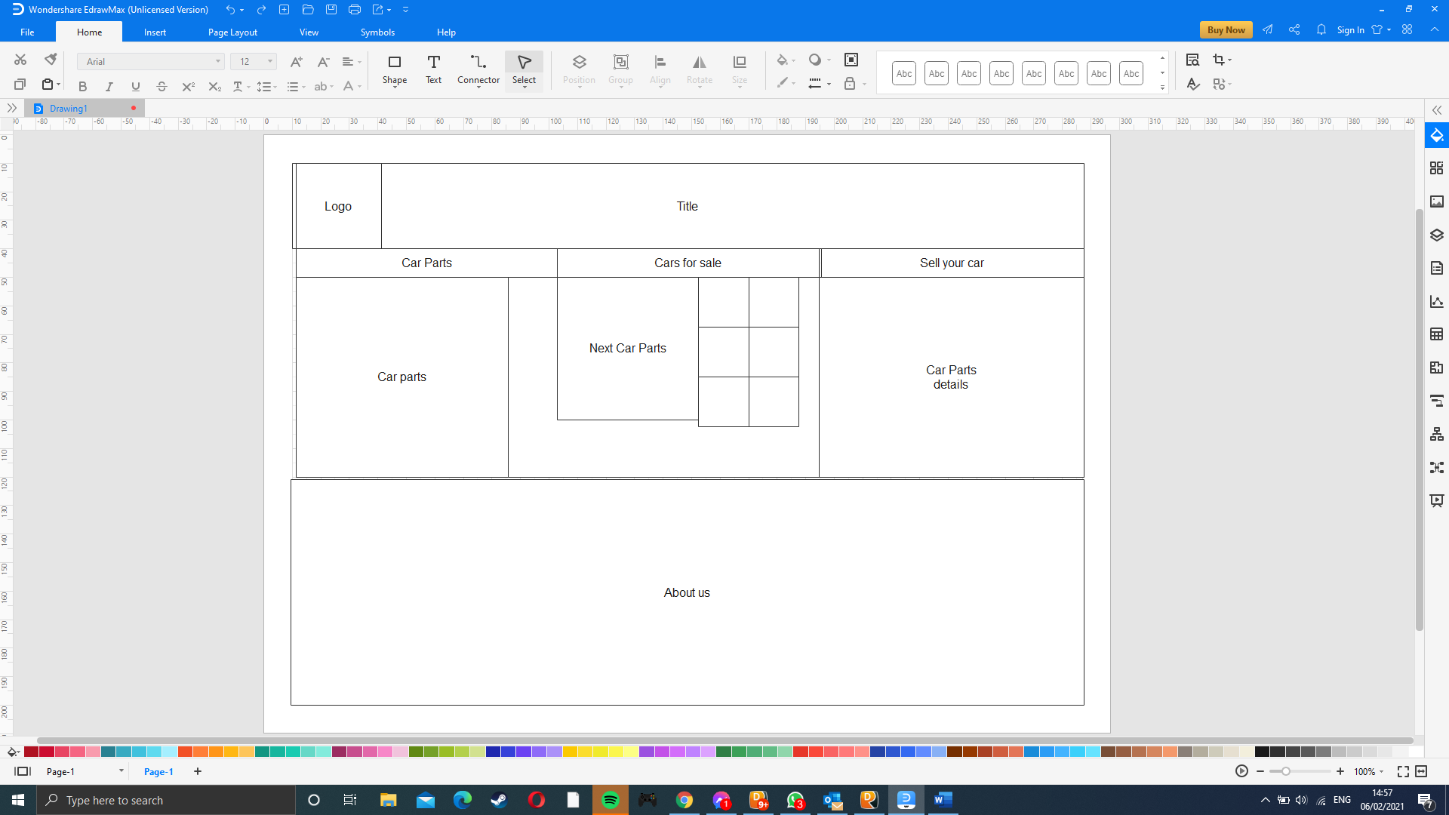

Wireframe 3

Shows details about car/part which can each be filtered by

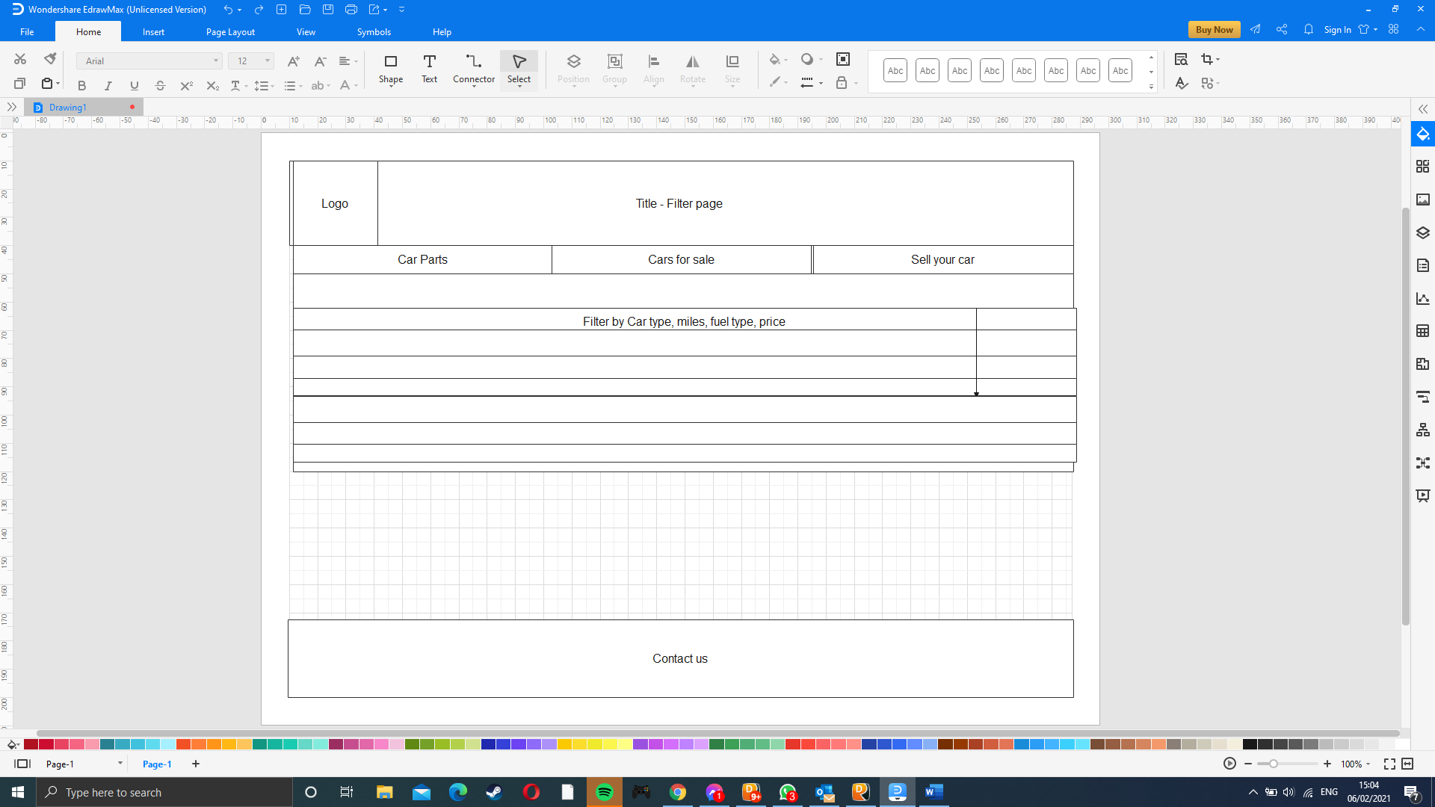

When you click the sell your car you are immediately taken to a form where you put in some base level options about your car and how to contact you so that you can arrange a meeting to sell your car

