**Design a system for washing machine such that whenever it is filled , a Red LED turns on and if it is empty, a Green LED blinks once every 20 ms.**

Hardware :-

|  |  |  |
| --- | --- | --- |
| **Name** | **Quantity** | **Component** |
| U1 | 1 | Arduino Uno R3 |
| DIST1 | 1 | Ultrasonic Distance Sensor |
| D1 | 1 | Green LED |
| D2 | 1 | Red LED |

Setup :-

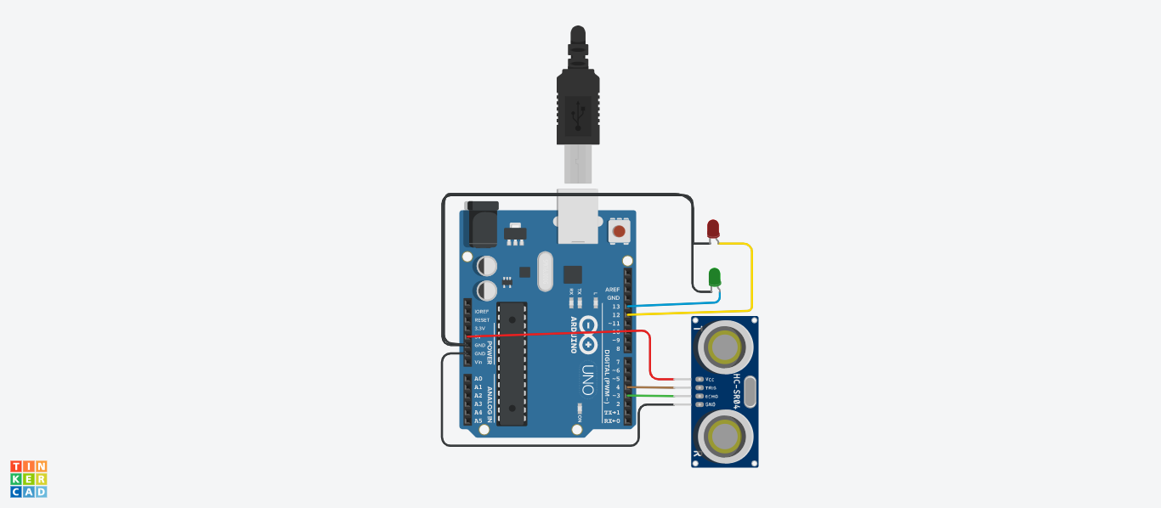

So we had connected an ultrasonic distance sensor, two LED’s with the Arduino and programmed it as follow :-

#define echoPin 3

#define trigPin 4

long duration,distance;

void setup()

{

Serial.begin(9600);

pinMode(trigPin,OUTPUT);

pinMode(echoPin,INPUT);

pinMode(12,OUTPUT);

pinMode(13,OUTPUT);

}

void loop()

{

digitalWrite(trigPin,LOW);

delayMicroseconds(2);

digitalWrite(trigPin,HIGH);

delayMicroseconds(10);

digitalWrite(trigPin,LOW);

duration = pulseIn(echoPin,HIGH);

distance = duration/58.2;

Serial.println(distance);

Serial.println("cm");

delay(50);

if(distance<=10)

{

digitalWrite(13,HIGH);

delay(20);

digitalWrite(13,LOW);

digitalWrite(12,LOW);

}

else

{

digitalWrite(12,HIGH);

}

}

**Functionality :-**

So the given system work with the help of ultrasonic sensors as the ultrasonic sensors are fitted below the rotatory part of the washing machine with a glass visibility at that side and the ultrasonic waves are continuesly transmitted and received when there is no clothes in the machine and the Red LED is being turned on ,As the clothes are kept in the machine the ultrasonic path gets disturbed or distorted and the Green LED glows up on a interval of 20 ms. This is how a person gets to know whether the machine is empty or full.

**Precautions :-**

The precautions that we need to keep in mind while performing this experiment are:-

* The wires are inserted properly and tightly at the required points so that the circuit doesn’t get short.
* The two pins of the LED should be connected at their appropriate point that is the positive point should be connected with the p pin and the negative point should be connected with the negative pin.
* We should take care that the circuit is closed .

**Learning Outcomes :-**

* Through this experiment I have learned how to connect different hardware with an arduino board to form a parallel series.
* By doing this experiment , I have gained the skill of making different kinds of patterns of light using LEDs and arduino board.