**Bynd Test Dec2017** 17/12/2017 **– Gordon Cumming**

This test dispays videos from a Youtube url and each of the videos has a play button

Hitting the play button takes you to a video-detail page which lets you run the selected video and gives title, date of production and description.

I used routerLink for routing between the pages and used a route.param technique to read several variables passed from the you-tube page to the video-detail page.

I used an iframe to run the videos but iframes don’t seem to work with template literals and hence I had to dynamically populate the src url in the class ngOnInit() method.

This working version runs client side with **ng serve -p=1234** and although I’ve added the code for Angular Universal and Server Side Rendering with State Transfer– this part is not working. It’s using the standard @angular/cli 1.5 and Angular 5.0 with several files added but have hit a bug and although it generates the dist/server.js file and dist/server/* bundles – there is a bug which I’m trying to fix – I’ll send it later – no matter if I’ve fixed the bug or not. Hence Node dist/server.js generates an error.

I was going to use Angular material but ended up, realizing it wasn’t required - However I’ve used @angular/flex-layout for the list of videos.

I started adding some bits of code for Unit and End to End testing but ran out of time.

Here’s some screen shots from the working code

Clicking the play button takes you to the video-detail page which then lets you run the video.

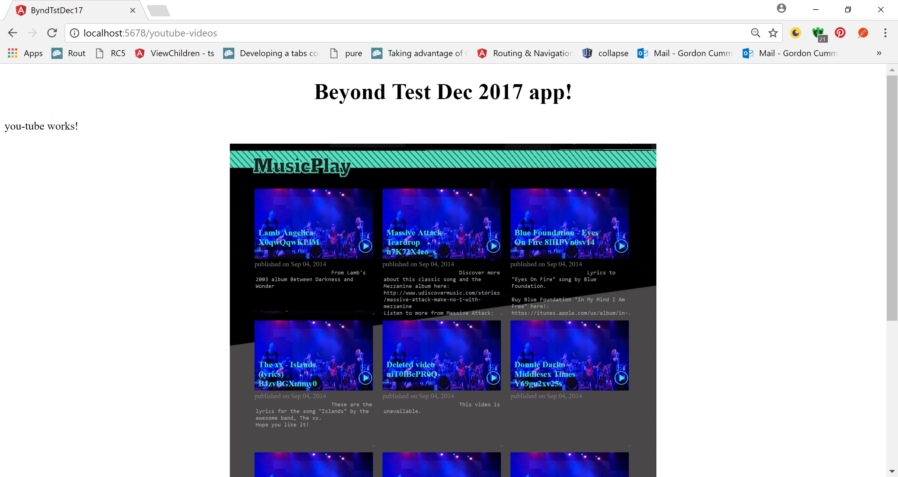

Clicking the back button takes you back to the Play List

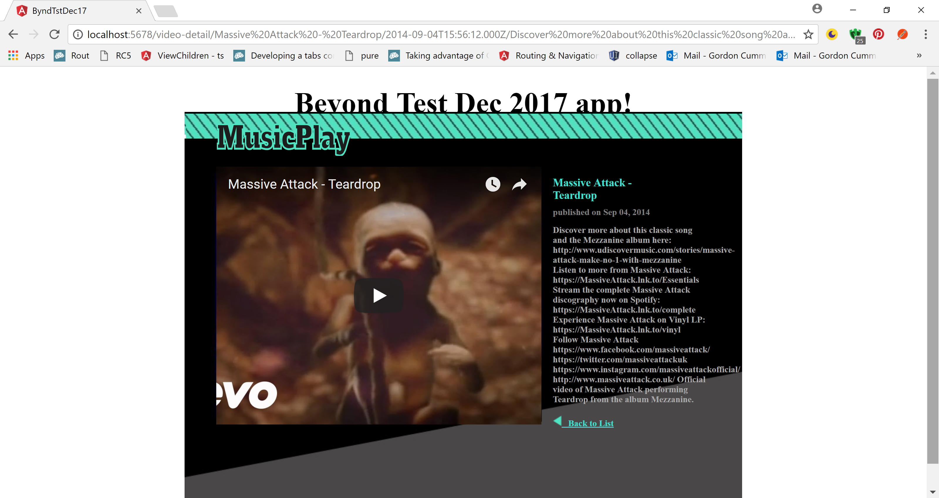

Selecting the 3rd video I get this

