

Expertisecentrum voor Methoden en Informatie

Dynamo-Hia - Architecture NotebookUser Interface

Component Inventory

Document property Author


RIJKSINSTITUUT VOOR VOLKSGEZONDHEID EN MILIEU

Document properties
Dynamo-Hia - Architecture NotebookUser Interface – Component Inventory

Auteur: | René Mondeel
Versie: | 0.01
Datum: | 16 – 06 - 2008
Status: | Concept
Bestand: | /tmp/lo/0000.doc

Toc

1 Introduction 5
2 5

Document history
Version | Date | Author | Comment
0.01 | 16-08-2008 | René Mondeel

Introduction
The result of the Dynamo-HIA is required to be software that can remain usefull after central funding and therefore central support has ceased. A standalone application is the most simple solution to meet this goal.
A further requirement is platform independence. Java was chosen to this end.
The resulting software must be as easy to use as possible. A windowed graphical userinterface with a clear navigation structure, pervasive high quality help and both mouse and keyoard support fits this bill.

The framework choice
When a graphical needs to be developed in a Java environment the two main candidates are Swing (mainly developed by Sun) and the Eclipse Rich Client Platform.
Using the ERCP and JfreeChart for the graphics:
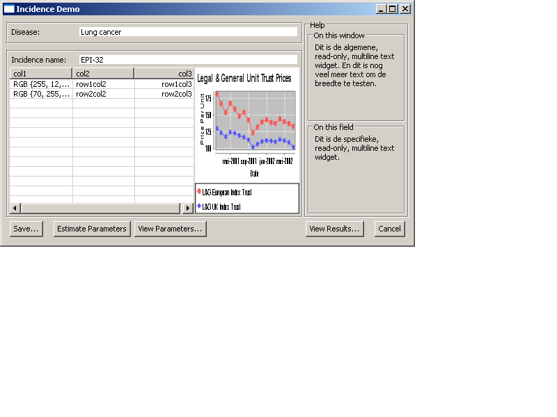

Modularisation
Because the user interface will eventually contain a numbers of windows in the order of 30 it makes sense to build them in a modular fashion to facilitate reuse.
The toplevel pattern for the windows opening from the base treeview is a button-panel at the bottom.
The pattern that promises the highest return is the windows that enable configuration of the data for the dynamic behaviour of the model.

