

Expertisecentrum voor Methoden en Informatie

Dynamo-Hia - Architecture Notebook

Development guidelines

René Mondeel


RIJKSINSTITUUT VOOR VOLKSGEZONDHEID EN MILIEU

Document properties
Dynamo-Hia - Architecture Notebook - Development guidelines

Author: | René Mondeel
Version: | 0.90
Date: | 18 – 11 – 2009
Status: | Concept
File location: | /tmp/lo/0000.doc

Table of contents

1 Purpose 5
2 Architectural goals and philosophy 5
3 Assumptions and dependencies 5
4 Architecturally significant requirements 5
5 Decisions, constraints, and justifications 5
5.1 Programming language 5
5.2 Testing 6
5.3 User interface 6
5.4 Choices within the Eclipse Rich Client Platform 7
5.5 Error handling 8
5.6 Display of graphs and charts 9
5.7 Data storage 9
5.8 Configuration package 9
6 Architectural Mechanisms 10
6.1 Generic user interface to enter data 10
6.2 Unit testing 10
6.3 Error handling 10
6.4 Help function 10
6.5 User data size 10
7 Key abstractions 10
7.1 Main Functions 10
7.2 User data input 10
8 Layers or architectural framework 10
9 Architectural views 11
9.1 Logical view 12
9.2 Implementation/operational view 13
9.3 Process view 18
9.4 Deployment views 18

Document history
Version | Date | Author | Comment
0.9 | 18-11-2009 | René Mondeel | First version.

Introduction
This document contains a description of the steps nescessary to install a development environment for the Dynamo-HIA project on a personal computer.

Each chapter contains a context paragraph that describes choices made for and further possibilities for the step.

Prerequisites
For this procedure to work the user must be connected to the RIVM network inside the firewall (otherwise the versioning system cannot be reached) and logged in in the EMI context (for the mapping of the Q drive to be correct).

Context
The procedure is described for the Windows operating system only. It has only been tested with the files metioned on Windows XP professional.
The files nescessary for this installation are provided below “Q:\Projecten\EMI-DYNAMO-HIA\IDE_Install”.

They are current at the time of writing but newer versions may be substituted when available and compatible.
The Dynamo-HIA software uses features of Java 1.6, so that is the minimum version.
A JDK is needed for certain Ant build files to work.

Because the Dynamo-HIA software as well as the Eclipse are Java based install on other operating systems is feasible.

Step 1: Installing a Java development kit
First a Java development kit must be installed. This kit provides the virtual machine for running Eclipse and the Dynamo-HIA software.

Procedure
Run “Q:\Projecten\EMI-DYNAMO-HIA\IDE_Install/jdk-6u17-windows-i586.exe”. Do a default install. (Todo: Add details here)

Context
A Sun JDK has been selected. A JDK from IBM or another source may be used.

Step 2: Unzipping the “reference” Eclipse directory

Procedure
Unzip “Q:\Projecten\EMI-DYNAMO-HIA\IDE_Install/dynamo_ref.zip” to the root of the “C:” drive.

Context
Currently Dynamo-HIA refers to this directory for its plugins. It is also hardcoded in several Ant-scripts.

Step 3: Installing Eclipse
Next the Eclipse integrated development environment must be installed. A version with extensions for plugin development (Dynamo-HIA is an Eclipse plugin) has been selected.

Procedure
Unzip “Q:\Projecten\EMI-DYNAMO-HIA\IDE_Install/eclipse-rcp-galileo-SR1-win32.zip” to the location you want to install Eclipse in.
In this example “”C:\location” is assumed.
You can now start Eclipse by running “C:\location\eclipse\eclipse.exe”.

Step 4: Installing the Subclipse plugin
Now the Subclipse pluging must be installed. This plugin is nescessary for the use of the Subversion versioning system.

Procedure
First start Eclipse as described in Procedure.
Next choose “Help” from the menu-bar and “Install new software” from the menu. The window below opens:

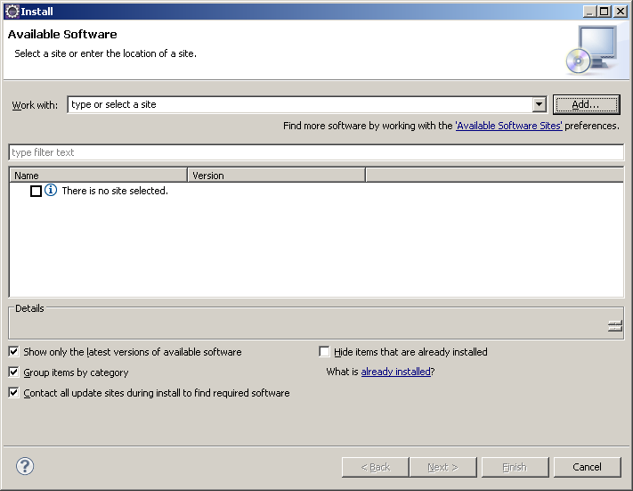

Click “Add”, then “Local” and select “Q:\Projecten\EMI-DYNAMO-HIA\IDE_Install\Subclipse\1_4_8” in the “Browse for folder” window. Click “OK” twice. Now you should be back in the window above, only now with the choices shown below.
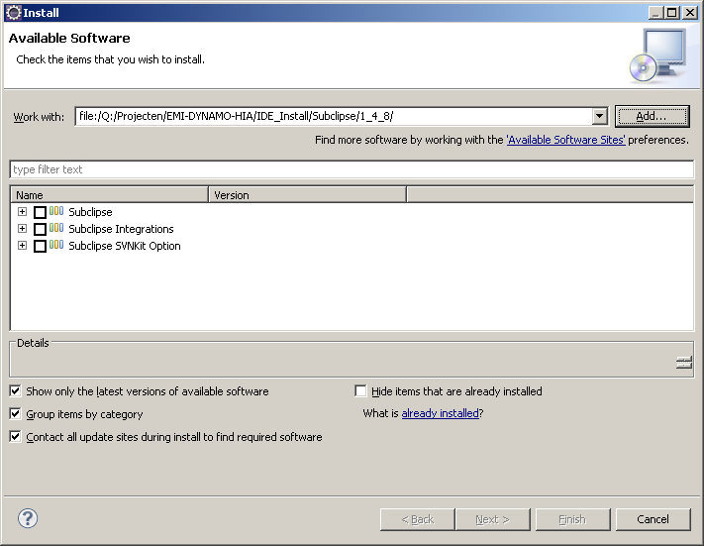

Check the three boxes and click “Finish”. Dependencies are checked and the “Install details” will be shown. Click “Next”, the radiobutton in front of “I accept ….” And “Finish”.
Click “OK” in the “Security warning”. After the install has completed click “Yes” to restart Eclipse.

Step 5: Checking out the nescessary projects
Select the “New project” button (the leftmost button on the tool-bar). The following window opens:

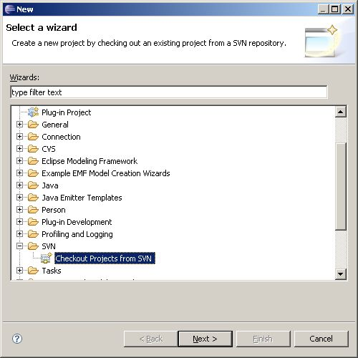

Select the above item (only present when Subclipse is installed) and click “Next”.
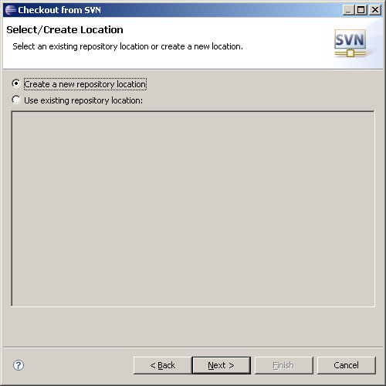

Click “Next”.

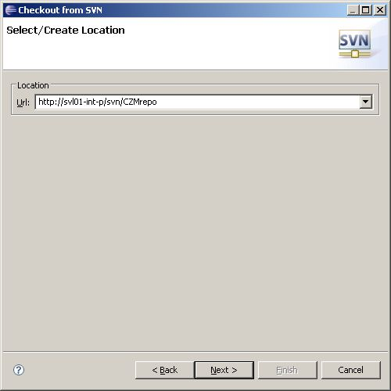

Type in the URL and click “Next”.

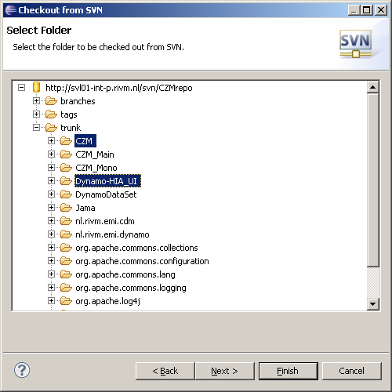

Select the above projects under “trunk” and click “Finish”. This takes a while to finish.
To test select “nl.rivm.emi.dynamo.ui.main.test.TestBaseStorageTreeScreen” from “Dynamo-HIA/src”. Right-click and choose “Run as” and “Junit test”.
Now the Dynamo-HIA software should start up.

