

Expertisecentrum voor Methoden en Informatie

Dynamo-Hia - Architecture Notebook

René Mondeel


RIJKSINSTITUUT VOOR VOLKSGEZONDHEID EN MILIEU

Document properties
Dynamo-Hia - Architecture Notebook

Auteur: | René Mondeel
Versie: | 1.2
Status: | Concept
Bestand: | /tmp/lo/0000.doc

Toc

1 Introduction 5
2 Directory and file tree plus actions 6
2.1 Simulations (directory) 6
2.2 ReferenceData directory 7

Document history
Version | Date | Author | Comment
1 | 22-01-2009 | René Mondeel | Initial version, one on one part taken from Userdata.doc.
1.1 | 2-2-2009 | René Mondeel | Data part pruned, more realized windows.
1.2 | 5-2-2009 | René Mondeel | Minor changes plus Relative risks for diability added.
1.3 | 6-2-2009 | René Mondeel | Risk factor context menu (2.2.2.1) implemented.
1.3 | 9-2-2009 | René Mondeel | Prevalences screen for categorical riskfactors (1.1.1.1.8)added.  Relative risks for death for categorical risk factors (1.1.1.1.10) added.  Relative risks for death for continuous risk factors (1.1.1.1.11) added.  Relative risks for disability for categorical risk factors (1.1.1.1.13) added.

Introduction
The Dynamo-HIA software is about preparing a configuration for, running of and viewing the results of the runs of a health impact analysis model.
This is all about data. The configuration data is contained in XML files on the filesystem of the user execution environment(computer). All data used and produced by the application resides in a base-directory, that can be selected at startup time.

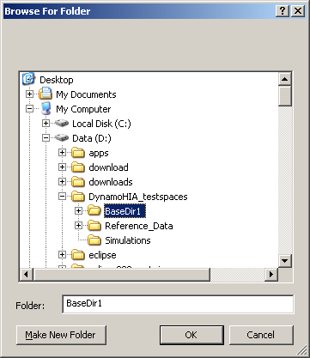

In this way a user can keep various environments on the same computer.
This document describes the layout of the tree nodes (directories or files) plus the actions that can be taken by the user at these nodes.
The screens that appear as a result of these action are included in versions from the functional design, technical design and technical realization. The last two will usually be in the form of text and a printscreen respectively.

Directory and file tree plus actions
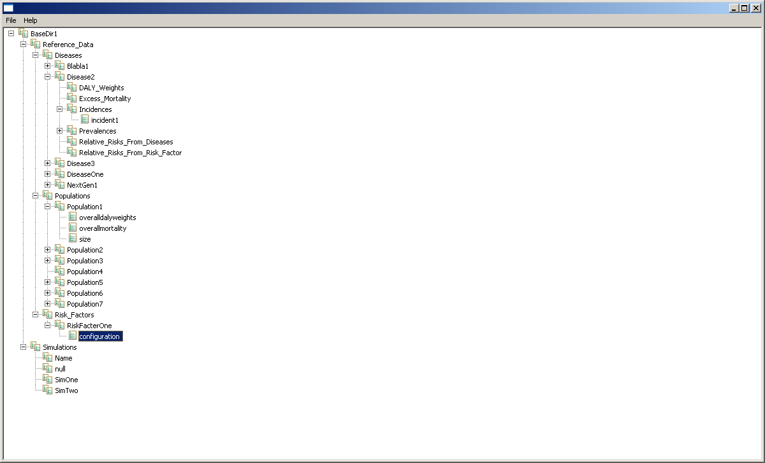

All paths described below are relative to the base-directory. The depth in the Word heading-hierarchy corresponds to the depth in the directory tree.
The directories that have the term “standard directory” directly below their header are automatically generated by the software when needed.

Simulations (directory)
Standard directory.

Actions in context menu.
New simulation | W01 opens with blank fields.

-Doesn’t work anymore.

<Simulation name> (user created directories with unique names)
Each directory contains one copy of the simulation configuration file configuration.xml, any number of scenario (directories/files ?) and a results directory with any number of result files.

configuration.xml (file with the basic simulation configuration)
Its content is maintained through W01.

Actions in context menu.
Edit | W01 opens with the content of the configuration file

modelconfiguration(Directory)

parameters(Directory)

results(Directory)

ReferenceData (directory)
Standard directory

populations (directory)
Standard directory
Actions in context menu.
New population | Window opens where a population name can be entered. When “Cancel” is selected the window closes and nothing happens, when “Save” is selected a subdirectory with the entered name is created.

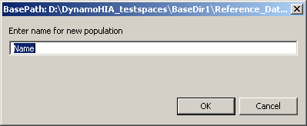

<Population name>(user created directories with unique names)
Actions in context menu.
New size | Opens W11 with default(?) values.  When the file is already present, the choice is disabled (or absent altogether).
New overall mortality | Opens W12 with default(?) values.  When the file is already present, the choice is disabled (or absent altogether).
New newborns | Opens W13 with default(?) values.  When the file is already present, the choice is disabled (or absent altogether).
New overall DALY weight | Opens W14 with default(?) values.  When the file is already present, the choice is disabled (or absent altogether).
Actions (context menu):, , and n. Each action opens the corresponding maintenance window
        - size.xml(file with population size per age and per sex)
Actions in context menu.
Edit population size | Opens W11.

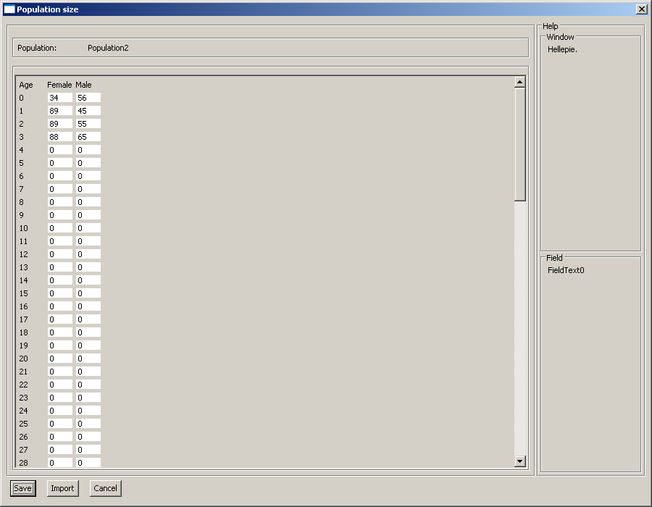

        - overallmortality.xml(file with overall mortality per age and per sex)
Actions in context menu.
Edit | Opens W12.

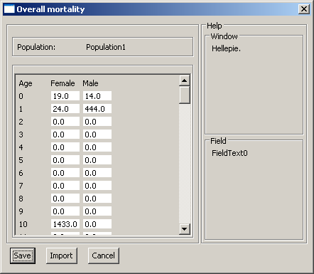
        - newborns.xml(file with newborns per age and per sex)
Actions in context menu.
Edit | Opens W13.

        - overalldalyweights.xml(file with overall DALY weights per age and per sex)
Actions in context menu.
Edit | Opens W14.

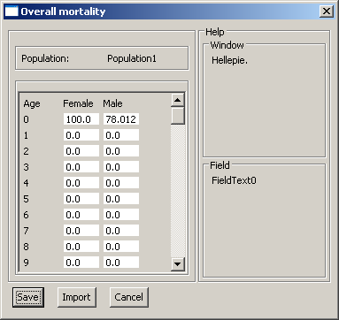
-Title incorrect.

risk factors(directory)
Actions in context menu.
New | Window opens where a risk factor name can be enbtered. When “Cancel” is selected the window closes and nothing happens, when “Save” is selected a subdirectory with the entered name is created.

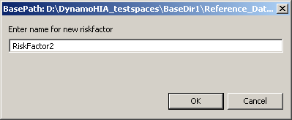

<Risk factor name>(user created directories with unique names)
Actions in context menu.
Create Risk Factor configuration | A Risk Factor type selection screen opens. After the selection has been confirmed a relevant configuration screen(W20) opens.  Disabled when any of the following have produced a result.
Add transition | The relevant version of W21 opens. Enabled after “Configure” has produced a valid result. Disabled when already present.
Add prevalence | The relevant version of W22 opens. Enabled after “Configure” has produced a valid result. Disabled when already present.
Add relative risk for death | The relevant version of W23 opens. Enabled after “Configure” has produced a valid result. Disabled when already present.
Add relative risk for disability | The relevant version of W23 opens. Enabled after “Configure” has produced a valid result. Disabled when already present.

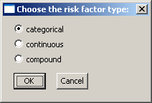 svn191
        - configuration.xml(file with basic riskfactor configuration(for all types of risk factors.))
Actions in context menu.
Edit | The relevant W20 opens with limited(?) functionality.

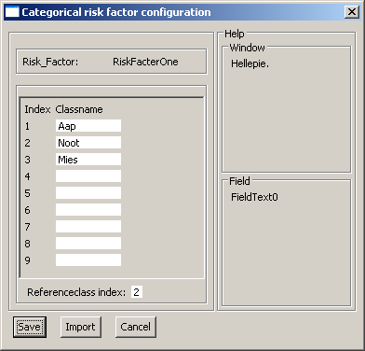 svn191

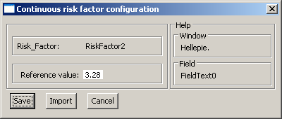

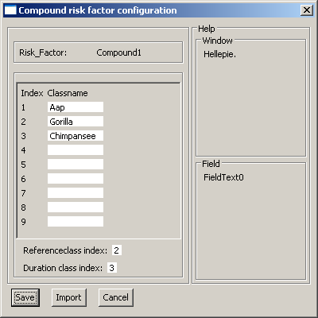

        - <transitionname>(user created directories with unique names.)
Actions in context menu.
Edit | W21 “Transition Matrix” opens.

transitionmatrix.xml(file with transition probabilities (for categorical and compound risk factors.))
Actions in context menu.
Edit | W21 “Transition Matrix” opens.

transitiondrift.xml(file with transition probabilities (for categorical and compound risk factors.))
Actions in context menu.
Edit | W21 “Transition Drift” opens.
        - prevalence.xml(file with distribution per age, sex and class (for categorical and compound risk factors.))
Actions in context menu.
Edit | W22 “Categorical prevalence” opens.

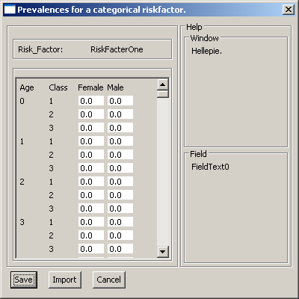
        - prevalence.xml(file with distribution parameters per age and sex(for continuous risk factors.))
Actions in context menu.
Edit | W22 “Continuous prevalence” opens.
        - durationdistribution.xml(file with distribution parameters per age, sex and duration(for compound risk factors.))
Actions in context menu.
Edit | W22 “Duration distribution” opens.
        - relriskfordeath.xml(file with multiplication factor per age, sex and class (for categorical risk factor only.))
Actions in context menu.
Edit | W23 “Categorical relative risk for death” opens.

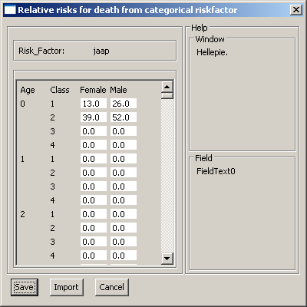
        - relriskfordeath.xml(file with multiplication factor per age and sex (for continuous risk factor only.))
(?) Independent of value?
Actions in context menu.
Edit | W23 “Continuous relative risk for death” opens.

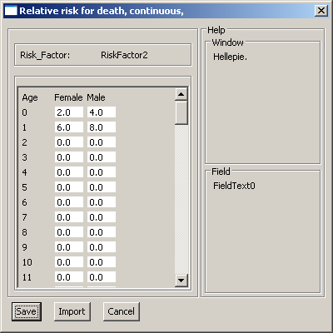
        - relriskfordeath.xml(file with multiplication factor per age, sex, class and parameters for the “duration class”. (for compound risk factor only))
Actions in context menu.
Edit | W23 “Compound relative risk for death” opens.
        - relriskfordisability.xml(file with multiplication factor per age, sex and class (for categorical risk factor only.))
Actions in context menu.
Edit | W23 “Categorical relative risk for disability” opens.

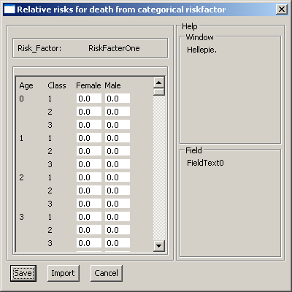
        - relriskfordisability.xml(file with multiplication factor per age and sex (for continuous risk factor only.))
(?) Independent of value?
Actions in context menu.
Edit | W23 “Continuous relative risk for disability” opens.
        - relriskfordisability.xml(file with multiplication factor per age, sex, class and parameters for the “duration class”. (for compound risk factor only))
Actions in context menu.
Edit | W23 “Compound relative risk for disability” opens.

diseases(directory)
Actions in context menu.
New | Window opens where a disease name can be entered. When “Cancel” is selected the window closes and nothing happens, when “Save” is selected a subdirectory with the entered name is created.

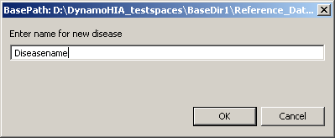

<Disease name> (user created directories with unique names)
Actions in context menu.
Add prevalence | W31 opens. Disabled when already present.
Add incidence | W32 opens. Disabled when already present.
Add excess mortality | W33 opens. Disabled when already present.
Add relative risk from riskfactor | A window opens that enables the user to select one of the configured risk factors. After confirming the choice the relevant version of W34 opens. Disabled when already present.
        - Prevalences (automatically created directory)
Actions in context menu.
New prevalence file | A popup window asking for a filename opens. When a filename that does not yet exist has been entered W31 opens.

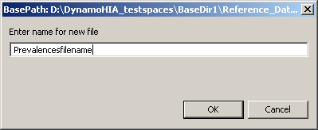

<unique filename>.xml (file with prevalences (percentage) by age and by sex)
Actions in context menu.
Edit | W31 opens.

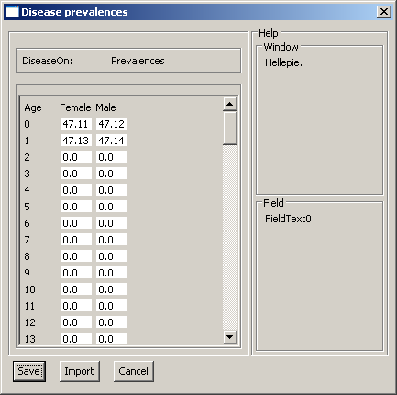
        - Incidences (automatically created directory)
Actions in context menu.
New incidence file | A popup window asking for a filename opens. When a filename that does not yet exist has been entered W32 opens.

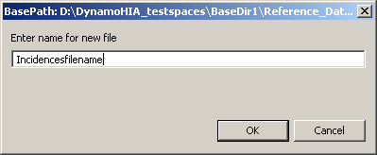

<unique filename>.xml (file with incidences by age and by sex)
Actions in context menu.
Edit | W32 “Disease incidence” opens

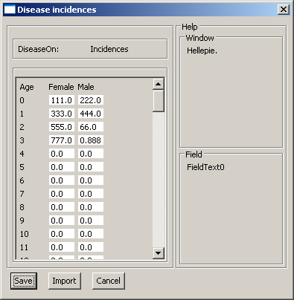
        - Excess_mortalities (automatically created directory)
Actions in context menu.
New excess mortalities file | A popup window asking for a filename opens. When a filename that does not yet exist has been entered W33 opens.

<unique filename>.xml (file with unit type plus unit, acutely fatal and cured fraction per age and sex)
Actions in context menu.
Edit | W33 “Excess mortality” opens

        - Relative_Risks_From_Risk_Factor (automatically created directory)
Actions in context menu.
New relative risks file | A popup window containing a field for entering the filenamepart plus a dropdownbox for selecting the risk factor that is the source of the risk opens. When a filename that does not yet exist has been entered the version of W34 corresponding with the riskfactortype opens.

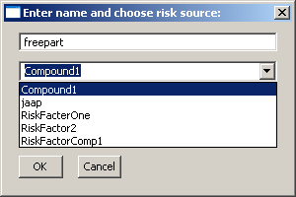

<filenamepart><Riskfactorname>.xml (Filename before the dot is unique. Content of the file depends on the type of riskfactor whose name was chosen.)
Actions in context menu.
Edit | Relevant W34 opens

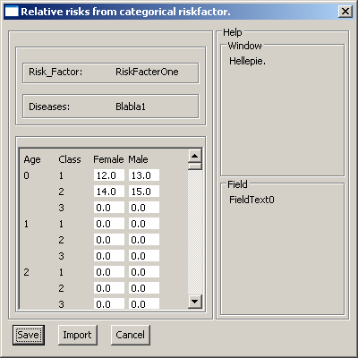

-Classnames?

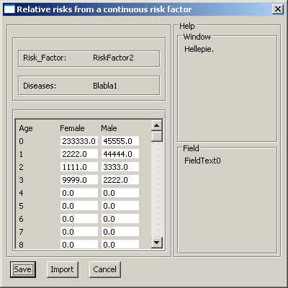

Relative_Risks_From_Diseases (automatically created directory)
Actions in context menu.
New relative risks file | A popup window containing a field for entering the filenamepart plus a dropdownbox for selecting the disease that is the source of the risk opens. When a filename that does not yet exist has been entered W35 opens.

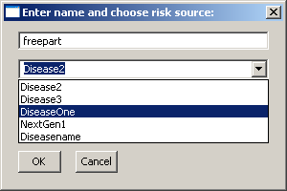

< filenamepart ><Diseasename>.xml(Filename before the dot is unique. The disease the file is made under cannot be chosen. File with multiplier per age and sex)
Actions in context menu.
Edit | W35 opens

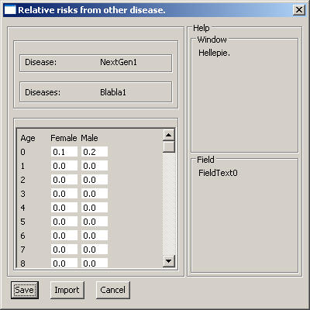
        - DALY_Weights (automatically created directory)
Actions in context menu.
New DALY weights file | A popup window asking for a filename opens. When a filename that does not yet exist has been entered W?? opens.

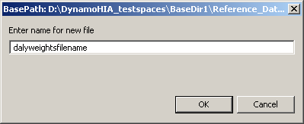

<unique filename>.xml(file with values (0-100) per age and sex)
Actions in context menu.
Edit | Window “Daly weights” opens

