

Expertisecentrum voor Methoden en Informatie

Dynamo-Hia - Architecture Notebook

Development guidelines

J. de Bruin, R. Mondeel


RIJKSINSTITUUT VOOR VOLKSGEZONDHEID EN MILIEU

Document properties
Dynamo-Hia - Architecture Notebook - Development guidelines

Author: | J. de Bruin, R. Mondeel
Version: | 0.01
Date: | 16 – 06 - 2008
Status: | concept
File location: | /tmp/lo/0000.doc

Toc

1 Purpose 5
2 Architectural goals and philosophy 5
3 Assumptions and dependencies 5
4 Architecturally significant requirements 5
5 Decisions, constraints, and justifications 5
5.1 Programming language 5
5.2 Testing 6
5.3 User interface 6
5.4 Choices within the Eclipse Rich Client Platform 7
5.5 Error handling 8
5.6 Display of graphs and charts 9
5.7 Data storage 9
5.8 Configuration package 9
6 Architectural Mechanisms 10
6.1 Generic user interface to enter data 10
6.2 Unit testing 10
6.3 Error handling 10
6.4 Help function 10
6.5 User data size 10
7 Key abstractions 10
7.1 Main Functions 10
7.2 User data input 10
8 Layers or architectural framework 10
9 Architectural views 11
9.1 Logical view 12
9.2 Implementation/operational view 13
9.3 Process view 18
9.4 Deployment views 18

Document history
Version | Date | Author | Comment
0.1 | 16-06-2008 | J. de Bruin | First version.
0.2 | 04-07-2008 | R. Mondeel | Added some architectural views.

Purpose
The aim of the DYNAMO-HIA (DYNAmic MOdel for Health Impact Assesment) is to develop a tool to assess the health impact of policies. This tool will quantify the health impact of policies in the European Union (EU) through their influence on health determinants.
This document describes the philosophy, decisions, constraints, justifications, significant elements, and any other overarching aspects of the system that shape the design and implementation.

Architectural goals and philosophy
The software will be developed in such manner that it can remain useful also when funding is depleted and therefore central support has ceased. Therefore the software will be developed as a platform independent standalone application and won’t be server based.

The software will use the MAP-SOR model as developed by RIVM-EMI and will be designed to interface with this package.

Assumptions and dependencies
The following dependencies and assumptions are relevant for the architectural decisions made in this document:
- The MAP-SOR aCDM model will be used to perform the actual calculations. This model will be developed in Java, partly as a parallel process.
- Part of the software will be a model parameter estimation module, which will be developed by Hendriek Boshuizen..

Architecturally significant requirements
The following requirements are identified:
- The software should be platform independent and run on MS Windows 2000, XP, Vista, Linux and Apple iMac.
- The software will be developed as stand alone application and not server based, due to performance issues regarding dataset size. Another reason to develop a stand alone application is the fact that funding is restricted and a server based application needs funding to maintain the software,
- The MAP-SOR aCDM model will be used to perform the actual calculations.
- A sample dataset will be availabel for download from the Dynamo-Hia website.
- The development process will be based on the (R)UP development methodology.
- The model output must be suitable with standard spreadsheet software.

Decisions, constraints, and justifications
This chapter outlines the basic decisions and constraints which have been made during the initiation phase of the development process. This resulted in a set of guiding development principles.

Programming language
Decision: Java has been chosen as programming language.
Justification: Java is platform independent and the Map-Sor aCDM is also written using this language.

Testing

Introduction
Tests used to be performed after the initial coding of a module had been completed. (you can’t test something that isn’t there, can you?) On the other side of the spectrum is something called “Test driven development”, where first the tests are written (derived from the functional specification) that must succeed when the module functions as specified. When no source code is present all tests must fail. After that the module is written for them to test.

Decision
In this project a hybrid solution is used, for more complex pieces of functionality so called unit-tests are written that each test an aspect of the functionality of the code under development. Beside the functionality provided when everything is as expected tests of unexpected circumstances should be included here. (E.G.: What happens if this parameterfile is missing…)
After the development of the module is completed the tests should be run regularly as regression tests to safeguard against problems introduced when developing seemingly unrelated code.

Implementation
Unit tests are written using the Junit framework (version 4.1). The source code for the tests is placed in separate packages with names ending on “test”. The code that is tested resides in the package below it. The separate package is created because then it is easy to exclude the testing code from production releases. Regression testing is not implemented yet.

User interface

Initial choice
Within the java community there are two framework candidate for developing user interfaces:
- Swing, developed by Sun and based on the Abstract Window Toolkit.
- Eclipse Rich Client Platform (RCP) developed as part for the Eclipse IDE and uses the Standard Widget Toolkit.
A basic window form has been implemented as proof of concept to decide which framework is most suitable for this application. Based on the results as displayed in Table 1 the Eclipse Rich Client Platform has been chosen as standard user interface framework.

Item | Swing | Eclipse Rich Client Platform | Priority (1=low, 5=high)
Layout | Layout is defined by the programmer. | Layout is based on the operation system settings. | 4
 | + program layout is identical for every platform and os. | - programmer cannot define the layout exactly
 | - a specific look and feel has to be developed for this tool and implemented for every form. | + layout is looks like any other program running on the users computer and has a familiar layout.
 | - increase of implementation time | + programmer doesn’t need to bother about layout and can use a set of standard controls. This saves time.
Usability | - layout is fixed, visually disabled users with large font settings cannot use the software. | ++ os settings are applied. | 5
Platform independency | + 100% pure java | +/- Since the standard operation system controls are used a platform specific distribution is mandatory. | 1
Rapid application design (RAD) | + RAD possible using the NetBeans IDE | - RAD not available | 1 (see software logical view)
Installation | + one easy install for all platfroms | +/- a platform independent installer | 1
Performance | Java controls. | OS controls, should result in a better performance. | 1
EMI Development standards | -- NetBeans is currently not used by EMI | ++ Eclipse is the development standard. | 4
Table 1 Swing versus the Eclipse Rich Client Platform

Choices within the Eclipse Rich Client Platform

Introduction
The Eclipse solution for building Rich Clients is a vast toolbox with lots of possibilities at various levels. Two main levels can be distinguished in the platform: SWT (the Standard Widget Toolkit) mainly providing one on one support for the user interface building blocks and jFace that offers support that is based on the Objects living behind the interface. SWT components are for instance on the level of label and field. JFace offers for instance a tableviewer that controls a number of fields depending on the dimensions of the java Object containing the table data.

Complexity

Justification
Because the project will be built by developers new to RCP the model to use for the client is chosen to be as simple as possible without throwing overboard advanced possibilities such as databinding.

Decision
This thought is the basis that the client will not be developed as an Eclipse plugin but as a standalone java application.

Prototype
As of 20080714 the current source code is contained in the Dynamo-HIA_UI_Copy project in a CVS repository on host “sh02-td” with repository path “d:/cvs/repo/dynamo_hia_ui”.

Starting and stopping

Decision
The application will be startable by running a script file either from the command line or via an icon on a graphical desktop. After startup a basedirectory for the data to be used can be selected. The last basedirectory used (if available) is filled out as the default value.
When running a menubar is provided with at least a “File” entry. This dropdown menu contains a “Quit” options to leave the application. This option is only enabled when all windows beside the navigaation tree are closed.

Navigation

Decision
The function of navigating between the various files containing configurations of simulations, incidences etc. within the client will be provided by a tree-control. After reviewing various solutions a jFace TreeViewer based solution was selected as the most suitable candidate.

Prototype
A very basic viewer prototype can be found in the “nl.rivm.emi.dynamo.treecontrol” package. The use of the relating Classes can be seen in the corresponding unit-test: TestTreeViewerPlusCustomMenu.java (of course in the test-subpackage).

Array parameters

Decision
For the various array-type (with mostly age and gender as dimensions) data the choice is between a standard jFace tableviewer or an assembly of SWT widgets. The latter is preferred because the layout can be made to conform to the user expectance (as specified in the functional design).

Prototype
A protype can be run through “nl.rivm.emi.dynamo.ui.parametercontrols.test.TestScrollingYearNumberList.java”.

Data binding

Decision
Instead of implementing a multitude of listeners to handle state-changes of the user interface the concept of data-binding was chosen to connect the view with the backing Object.

Prototype
The navigation-treeviewer code uses a Provider Model design pattern. For the actual prototype code, see under navigation/implementation above.
The array-parameter code uses jFace databinding and a Model View Controller design pattern. A prototype can be run through: “nl.rivm.emi.dynamo.ui.parametercontrols.prototype.test.TestAgeGenderList.java”. The left and the right three fields are each backed by the same model.

Error handling
Decision
Error handling is needed at various levels.
On the user interface level error prevention is currently the choice. The user interface does not accept keystrokes thar lead to unacceptable data in the field.
Handling for erroneous data must however still be provided. A user may submit a file with unacceptable data for instance or ranges may change rendering certain configurations invalid. Feedback is going to be given through the color of the field: Yellow is incorrect, but saveable; Red is incorrect and cannot be saved. Currently it is the objective of the design that fields cannot become red through input from the user interface.
When errors occur at a location that is perceived as part of the workflow by the user a popup window will be provided containing a description of the error plus an OK button. After clicking the OK button the user is placed back in the screen he/she started from.
For actions that provide progress information non-fatal errors during execution will result in “Errors” lfeedback after the action has completed. Fatal errors result in “Failed” feedback without completing the action. In both cases clear information will be provided about the error(s) that have occured.
Actions that do not provide prograss information will provide the “Errors” and “Failed” feedback via a popup window.
Non-fatal errors will either be handled in the software flow or by throwing and catching exceptions within the action execution.
Fatal errors will typically throw exceptions that will be caught at the level where the action was started, aborting it in the process.

Prototype
Error prevention is prototyped in “nl.rivm.emi.dynamo.ui.parametercontrols.prototype.test.TestAgeGenderList.java”. The accepted range are integers from 0 through 95 for the first and fourth fields. When a field is cleared its background is set to yellow, indicating it is not correct, but can be saved. The red background color is not implemented yet.

Display of graphs and charts
Many controls are available within the open source community that can be used for the display of charts and graphs. The JFreeChart component has been used for other RIVM/EMI projects and is suitable for the Dynamo Hia Model tool.

Data storage

Decision
All data will be stored as XML data files in a predefined file system. The name of the file will correspondent with the name used in the user interface.

Constraint
The initial download size of application plus supplied (demo-) data is limited to 300 Mega Bytes.
Simulations for a large number of individuals currently produce large population files. Since the model must by user requirement dump a result file for each step data storage space may rapidly be exhausted. Ways to reduce the amount of data produced will be added. An example is the addition of a module that on the fly compresses a population into a statistical result, greatly reducing storage use.

Configuration package
A proof of concept will be developed to investigate whether a general approach can be uses for the input of model parameters, scenario parameters, running parameters and output options. All files have some common characteristics and a general approach can be more efficient than developing an input form for each type of input file.
Fundamental principles are:
- Each file-type will be described by a XML Schema (XSD) document.
- A set of common input controls with corresponding standard validation options will be developed.
- A default import form will be developed with a set of common functions:
  - Must have) open a xml file of a certain type. Based on the input data as described in the XSD document a set of controls specific to the document type will be displayed on de import form;
  - (Must have) The user can modify the data on the form;
  - (Must have) The user can safe the form data;
  - (Should have depending on filetype) Import of comma separated file data;
  - (Nice to have) The clipboard can be used to enter data.

Architectural Mechanisms

Generic user interface to enter data
Input en validatie van gegevens gebruiker.
[Describe the purpose, attributes, and function of the architectural mechanism.]

Unit testing

Error handling

Help function

User data size
[Describe the purpose, attributes, and function of the architectural mechanism.]

Key abstractions

Main Functions
The software tool will have three main functions:
- An interface where users can enter raw model parameters, scenario parameters and running options. All user input will be saved to disk. This part of the software includes a parameter estimation module and a module to generate an initial population.
- Generate raw model output: the user selects a set of estimated model parameters, scenario parameters and running options and a raw model output will be generated.
- Post processing: based on a set of output options the raw data is post processed into a series of final populations and a set of reports.

User data input
A generic data input mechanism will be developed to support this function.

Layers or architectural framework
The data entry module of the software package will be developed using a model viewer architecture and XML documents as data store.
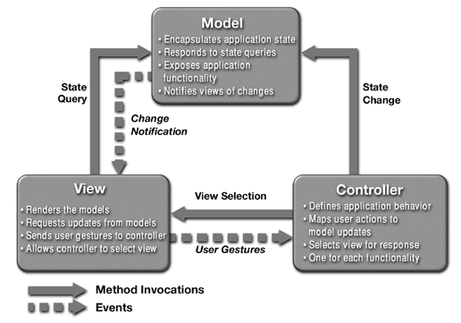
Figure 1 Model View Controller architecture
The decomposition of the application in layers will be pointed out in the Logical Architectural View (Paragraph 9.1)

Architectural views
This part of the architecture notebook describes the system using the 4+1 Views of Software Architecture:
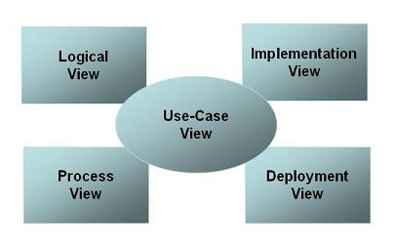
Figure 2 4+1 view model
- Use-case view: Describes functionality of the system, its external interfaces, and its principal users. The use-case view contains the Use-Case Model. This view is described as part as the Global Functional Design and Detailed Functional Design.
- Logical view: Describes how the system is structured in terms of units of implementation. The elements are packages, classes, and interfaces. The relationship between elements shows dependencies, interface realizations, part-whole relationships, and so forth.
- Implementation/operational view: Describes how development artifacts are organized in the file system. The elements are files and directories (any configuration items). This includes development artifacts and deployment artifacts.
- Process view: Describes how the run-time system is structured as a set of elements that have run-time behavior and interactions. Run-time structure often bears little resemblance to the code structure. It consists of rapidly changing networks of communication objects. The elements are components that have run-time presence (processes, threads, Enterprise JavaBeans™ (EJB™), servlets, DLLs, and so on), data stores, and complex connectors, such as queues. Interaction between elements varies, based on technology. This view is useful for thinking about run-time system quality attributes, such as performance and reliability. This view is optional when using the 4+1 Views.
- Deployment view: Describe how the system is mapped to the hardware. [Describe the architectural views that you will use to describe the software architecture. This illustrates the different perspectives that you will make available to review and to document architectural decisions.]

Logical view
The application will developed using a classical n-tier architecture ()
JB TODO beschrijven van de lagen en belangrijkste componenten.
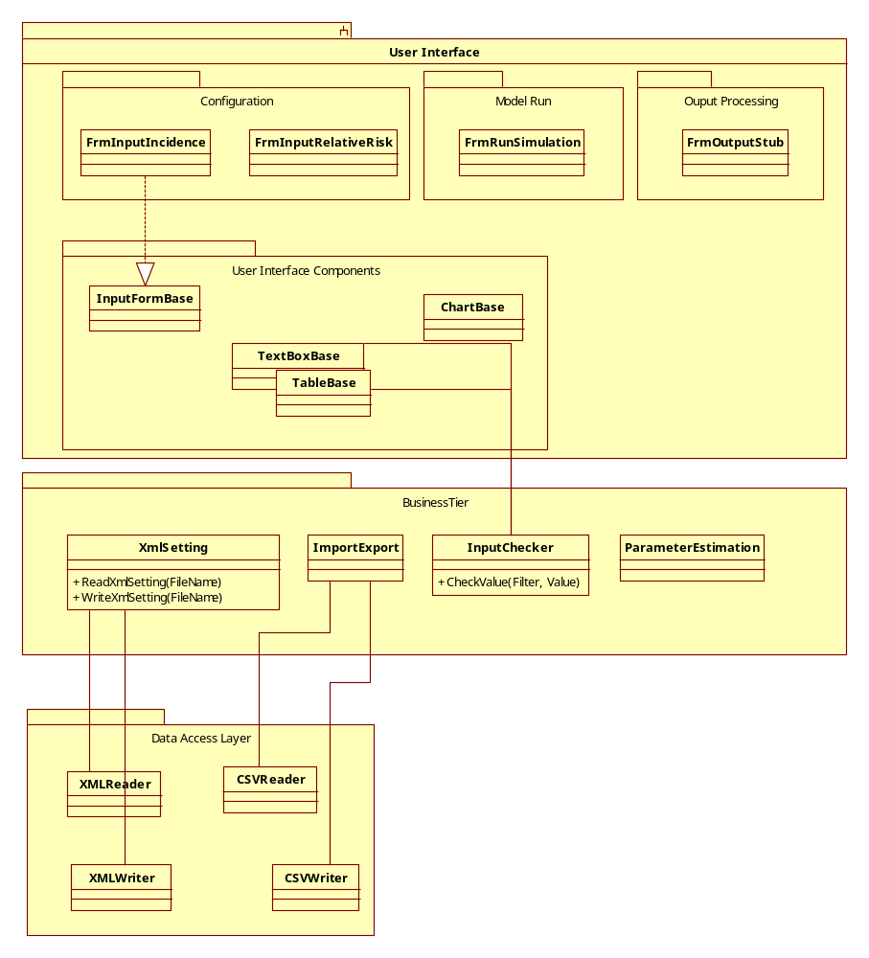
Figure 3 Logical View

Implementation/operational view

Preface
In this view a walkthrough of the main uses of the application is described. It is not feasible to describe all Classes employed by the application so for each usecase a single example is given. Important concepts in the architecture get a paragraph of their own.
The reader can then use the javadoc and the source code to explore the parallel paths.

Introduction
The operation of the model software can be divided in four phases: Startup, configuration, simulation and evaluation. Below you will find descriptions for each of these phases.

Startup
Startup of the application is possible in two different ways:
During development it is run from within the Eclipse integrated development environment. Running the unit-test nl.rivm.emi.dynamo.ui.main.test.TestBaseStorageTreeScreen will start the application.
When a release is to be run DYNAMO-HIA.exe from the “DYNAMO-HIA Application\eclipse” directory contained in the release must be started.

The user must now select a base-directory (the last used (if any) directory is selected as the default):

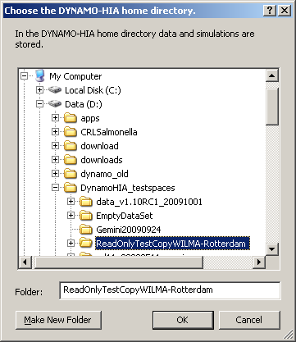

This screen is a standard SWT DirectoryDialog and is opened in nl.rivm.emi.dynamo.ui.startup.BaseDirectoryHandler.

When the basedirectory has been chosen (and initialized after a confirmation by the user if nescessary) the main navigationwindow opens

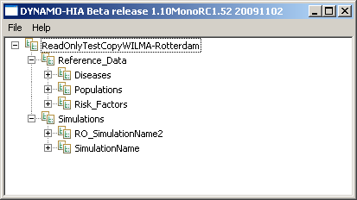

(nl.rivm.emi.dynamo.ui.startup.BaseStorageTreeScreen) and startup has been completed.

Configuration

Tree
The tree that is visible is implemented in nl.rivm.emi.dynamo.ui.treecontrol.StorageTree. Not everything that is present on disk is visible in the tree. The content is filtered by nl.rivm.emi.dynamo.ui.treecontrol.NodeFilter.
nl.rivm.emi.dynamo.ui.treecontrol.FileNode-s are decorated with icons indicating their status. This is done in nl.rivm.emi.dynamo.ui.treecontrol.FileTreeLabelProvider.
The organization follows the structure of the navigation tree. The nodes in the tree that contain collections of other nodes (Simulations, Reference Data, Populations etc.) correspond with directories on the filesystem. Leaf nodes are files with the name in the tree being the filename minus the XML extension.

Context-menu
The way to get something done in the tree is right-clicking on a node. When actions have been configured (in nl.rivm.emi.dynamo.ui.treecontrol.menu.StorageTreeMenuFactory) for that node a context-menu will pop up. The actions that are possible at that time shown in black. The actions that are not possible at that time are greyed out.

Action
Creating a configuration file starts by clicking on a contextmenu-entry on the containing directory like the one below.

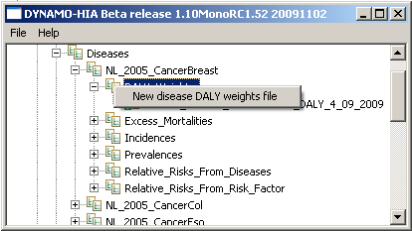

When only one file is possible you go straght to the edit window, otherwise a window opens up allowing you to enter a name for the file and maybe even more choices.
In this case nl.rivm.emi.dynamo.ui.actions.FreeNameXMLFileAction is started.

Dialog
This action opens nl.rivm.emi.dynamo.ui.dialogs.ImportExtendedInputTrialog

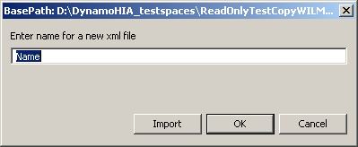

allowing you to enter a name with which the file will be stored after adding an “xml” extension. The import button allows the user to import a configurationfile that must have the same format as the file that is going to be created.
Factory
When the “OK” button is clicked a Factory is selected (by nl.rivm.emi.dynamo.data.factories.dispatch.FactoryProvider) based on the rootelementname of the file that is to be produced eventually.
The factory (nl.rivm.emi.dynamo.data.factories.DALYWeightsFactory
In this case produces a default modelobject.

ModelObject
Each valid file structure has a corresponding object structure, in this case the nl.rivm.emi.dynamo.data.objects.DALYWeightsObject.

XMLTagEntity
Each xml-element in the file structure has a corresponding Class that is derived from nl.rivm.emi.dynamo.data.types.atomic.base.XMLTagEntity and implements either the nl.rivm.emi.dynamo.data.types.interfaces.WrapperType, the nl.rivm.emi.dynamo.data.types.interfaces.ContainerType or the nl.rivm.emi.dynamo.data.types.interfaces.PayloadType interface. These interfaces control the manufacture of the modelobject.

AtomicType
This class is an atomic type, for instance nl.rivm.emi.dynamo.data.types.atomic.Percent. It contains fields and methods that are used at various stages of the modelobject life cycle. These have been pushed up to superclasses (see diagram below) as much as possible.

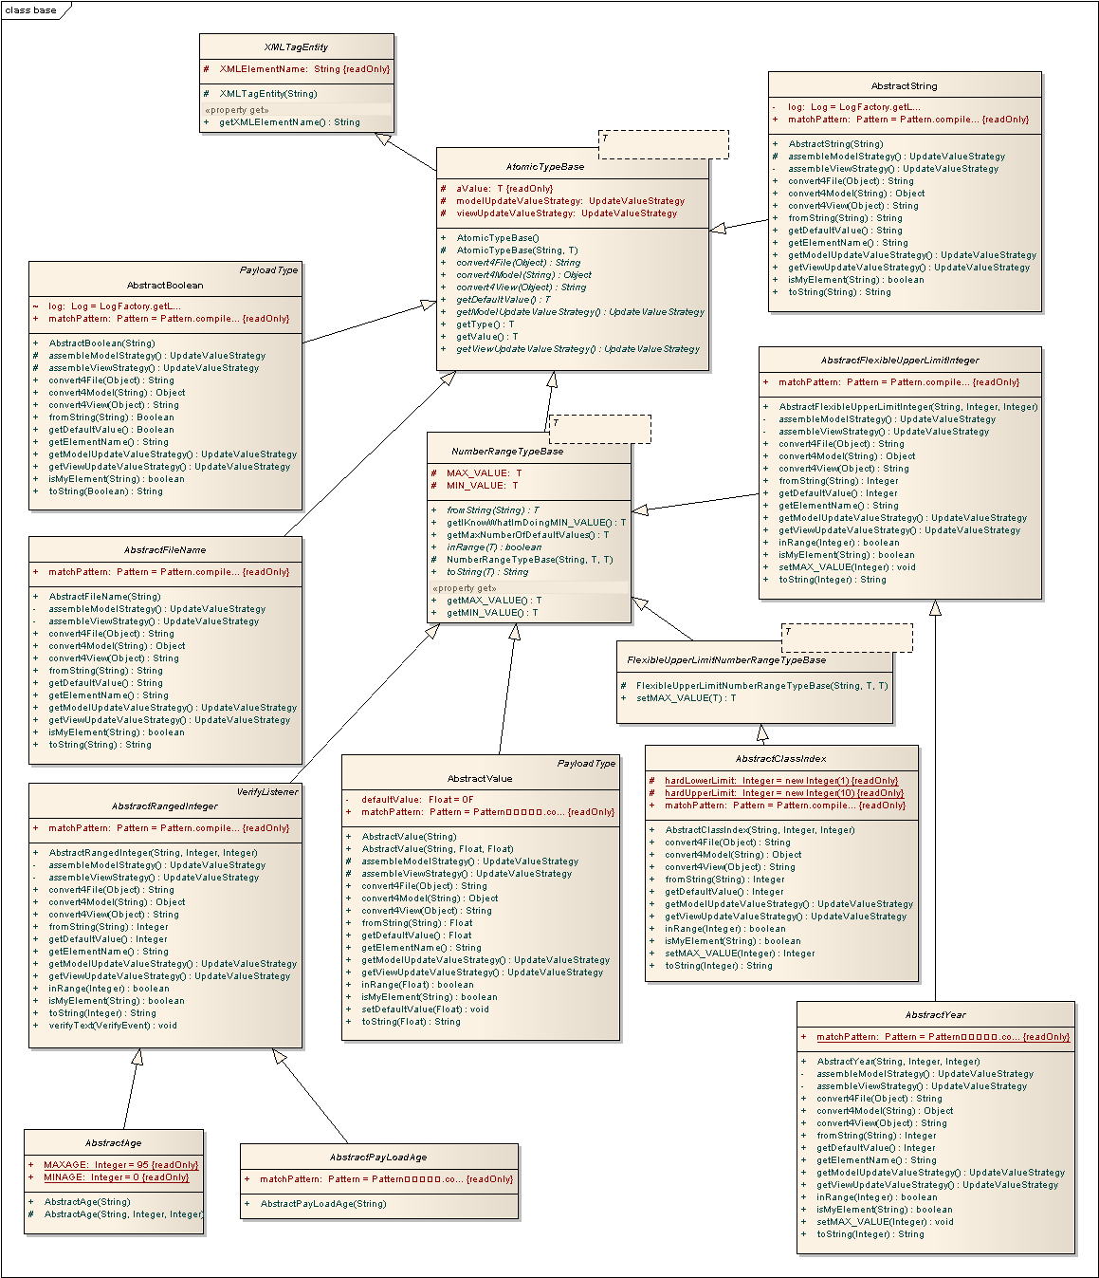
It describes the Java type of the resulting Object and contains among others converters that can convert the value contained to and from the String format(used in databinding for instance), a minimum and maximum value when applicable and a default value that is used when a fresh modelobject must be made.

Default modelobject construction
In order to be able to construct a default modelobject the factory needs a leafnodelist of which the following is an example:

LeafNodeList leafNodeList = new LeafNodeList();
leafNodeList.add(new AtomicTypeObjectTuple(XMLTagEntitySingleton
.getInstance().get("age"), null));
leafNodeList.add(new AtomicTypeObjectTuple(XMLTagEntitySingleton
.getInstance().get("sex"), null));
leafNodeList.add(new AtomicTypeObjectTuple(XMLTagEntitySingleton
.getInstance().get("percent"), null));

The first two entries are ContainerTypes and result in a Map in a Map. The third entry is a PayloadType<Float> that results in Float instances with defaultvalue 0 being put into the lower level Map.

Non default modelobject construction
When a file is imported via the dialog or an existing file is opened the construction of the modelobject is controlled by the xml structure of the file.

Schema
The structure of the file is checked by a schema before it is read in to minimize the possibility of inconsistent data. These schemas are stored in the schemas directory. This directory is located in the Dynamo-HIA directory for development purposes and in the “DYNAMO-HIA Application\eclipse” directory in the release.
When a file has been created or changed outside of the user interface a two stage strategy is employed: When the file doesn’t validate against the XML-schema provided it is rejected and will not be editable through the user interface. When schema requirements are met, but for instance range errors are present the content of the file will be displayed while the background-color of the erroneous field(s) indicates warnings (yellow) and/or errors(red). When a file contains errors it cannot be saved.

Edit window
When the file has been validated the edit window opens. In this example nl.rivm.emi.dynamo.ui.main.DALYWeightsModal (Classdiagram plus its parents below).

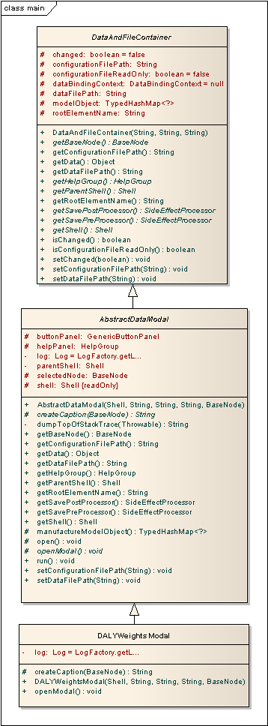
All these modal (only one can be open at a time) windows contain a nl.rivm.emi.dynamo.ui.panels.HelpGroup on the right and a nl.rivm.emi.dynamo.ui.panels.button.GenericButtonPanel at the bottom (see below in its actual onscreen appearance).

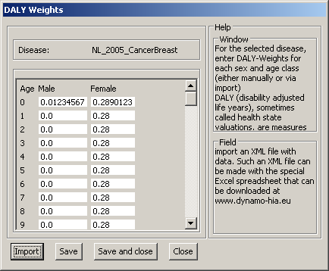

The fields are connected to the modelobject through standard Jface databinding in this case.
The buttons are connected to selection-listeners. For instance when the Import-button is clicked nl.rivm.emi.dynamo.ui.listeners.selection.ImportSelectionListener is activated.

Simulation
Beside full manual management the parameter estimation module will produce parameter-files based on available empiric data.
Functionality will be provided in the navigation tree to indicate when parameter-files contain errors or configurations are inconsistent.
Support for automatically updating relevant configurations when a parameter-file is renamed could be considered.
At the simulation stage state data for the simulated individuals will be output in xml-format.
During the evaluation stage the produced simulation data can be aggregated in various ways for reports and charts.

Process view
The software will present itself to the user as a single application using a consistent interface.

Under the hood the runtime architecture of the software will at the highest level consist of a management thread that controls the user-interface and the preparation and the evaluation processes. From this thread a simulation thread can be started via the “Run” button. Progress will be reported back during the execution.

Deployment views
An installer of the software package will be available on the Dynamo-Hia website (Figure 4). The user installs the software package on his machine and can run the software locally. A set of sample data will be provided via the website.
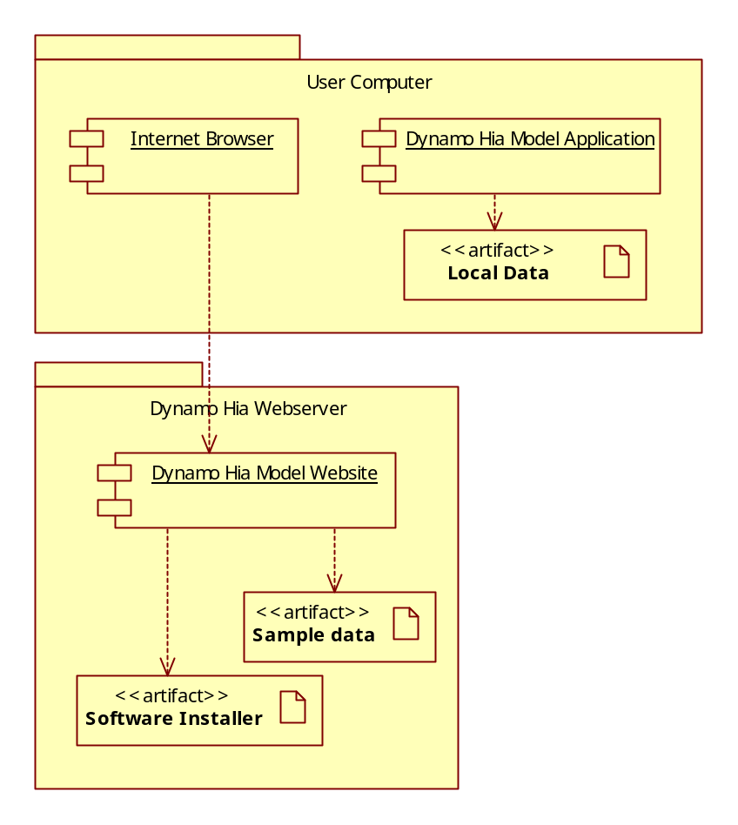

Figure 4 Deployment view

Kruchten, Phillipe B., The 4+1 View Model of Architecture, IEEE Software, vol. 12, no. 6, pp 42-50, November 1995

