Dynamotypes for Dummies Model Walkthrough

Contact information to go here

clear all

addpath('Walkthrough helper files');

# *Literature*

Before we give a brief walkthrough of the model, we would like to list out resources that may be useful in learning the ins and outs of the model. We understand that people interested in the model may have varying degrees of mathematical proficiency. While it is not necessary to have a deep rigorous understanding of all the math involved in the construction and employment of this model, we do think that having some experience with differential equations and linear algebra will greatly improve the reader's ability to understand and utilize the model.

Here is the list of useful materials:

Using unfoldings of high codimension singularities to model fast-slow bursters (i.e. the approach used in this model):

* Bertram, Richard, et al. "Topological and phenomenological classification of bursting oscillations." *Bulletin of mathematical biology* 57.3 (1995): 413-439. **Uses these unfoldings for bursting**
* Izhikevich, Eugene. "Neural Excitability, Spiking, and Bursting." 2000. **A very accessible introduction to bursting, uses some unfoldings; establishes the taxonomy of fast-slow bursters**
* Golubitsky, Martin, Kresimir Josic, and Tasso J. Kaper. "An unfolding theory approach to bursting in fast–slow systems." *Global analysis of dynamical systems*. CRC Press, 2001. 282-313. **Formalizes and extends the approach of Bertram et al**
* Saggio, Maria Luisa et al. "Fast-Slow Bursting in the Unfolding of a High Codimension Singularity and the Ultra-Slow Transitions of Classes." 2017. **Systematically extends the work of Golubitsky et al to codimension 3 and proposes models for all classes of Izhikevich’s taxonomy (planar only)**

Using fast-slow bursters to classify and model seizures

* Jirsa, Viktor et al. "On the Nature of Seizure Dynamics." 2014. **Extends Izhikevich taxonomy to seizures and proposes one type of burster to model the most common seizure type**
* Saggio, Maria Luisa et al. "A Taxonomy of Seizure Dynamotypes." 2020. **Extends the approach of Jirsa et al to the full (planar) taxonomy, using the model in the Saggio et al 2017**
* Crisp, Dakota et al. "Quantifying Epileptogenesis in Rats with Spontaneous and Responsive Brain State Dynamics." 2020. **Application of the taxonomy**
* Saggio, Maria Luisa & Jirsa, Viktor. "Phenomenological Mesoscopic Models for Seizure Activity." 2022. **A review**
* Depannemaecker, Damien et al. "A unified physiological framework of transitions between seizures, sustained ictal activity and depolarization block at the single neuron level." 2022. **It also maps a new neural model to the unfolding used in Saggio et al 2017**
* Szuromi, Matthew et. al. "Optimization of Ictal Aborting Stimulation Using the Dynamotype Taxonomy." *2023.* **Application of the model to stimulation**

If the reader is new to nonlinear dynamics, we highly suggest they start by reading Strogatz, Steven. *Nonlinear Dynamics and Chaos.*. Particularly, Parts I & II of the book. Part III is on chaos and does not apply. If one is in a rush, they could probably skip all of Chapter 4 and Sections 3.6-3.7, 6.5-6.8, 7.2-7.6, and 8.6-8.7.

Next, we suggest reading Izhikevich (2000), Jirsa (2014), Saggio (2017), and Saggio (2020) in chronological order. You could skip Izhikevich, but we think even a cursory reading helps set the stage well for the following papers. It also gives great visualizations.

The other papers are supplementary and discuss a range of uses and applications of the model. These may be interesting depending on what the reader intends to use the model for.

Finally, if the reader would like to understand the theory behind the construction of the model in Saggio (2017), they should read Bertram and Golubitsky.

# *Brief introduction to dynamical theory*

To understand more of how the equations predict this map, you must understand the dynamical systems governing the differential equations, including a stable point, unstable point, saddle point, stable limit cycle, and unstable limit cycle.

|  |
| --- |
|  |

# *Framework*

*(Much of the following is adapted or pulled directly from Saggio and Szuromi Papers.)*

The model uses fast-slow bursting to simulate seizures. A simple fast-slow burster is characterized by two rhythms: the fast rhythms of oscillations in the active or bursting state and the slow rhythm of transitions between the active and resting state.

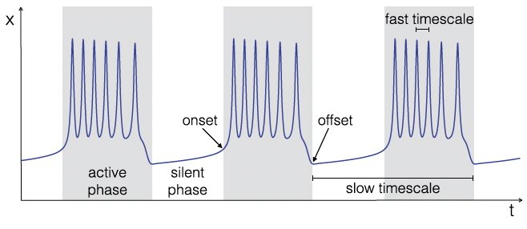

The oscillations in the bursting state are described by the time evolution of a fast subsystem (fast variables). In contrast, the transition between resting and bursting states is dictated by the time evolution of a slow subsystem (slow variables), which produces a bifurcation in the fast subsystem. Bifurcations are sudden, qualitative changes in the behavior of a dynamical system as specific parameters, known as the bifurcation parameters, are varied smoothly. For these transitions (bifurcations) to be determined by the slow subsystem, the bifurcation parameters of the fast subsystem must depend on the slow variables.

The general mathematical framework used to produce this bursting is:

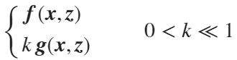

Where  is the n-dimensional state vector of the fast variables, and  is the m-dimensional vector of slow variables. The dots represent derivatives with respect to time. F and g are functions. 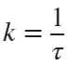, where 𝜏 is the characteristic time constant of the separation of the fast and slow rhythms. We require k to be significantly less than one to ensure a quasi-static variation of parameters.

Resting states are represented as stable fixed-point solutions, and bursting states are represented as stable limit cycles in the fast subsystem (Izhikevich, 2010). When no applied stimuli are present, to transition from a resting state to a bursting state, a bifurcation must occur that alters the existence or stability of the fixed point, and there must be a stable limit cycle after the bifurcation occurs. To transition back to rest from bursting, the converse must occur.

Applied stimuli cause state switches by forcing a transition between coexisting attractors. In this case, the system must be bistable, and the forcing must move the system into the alternative attractor's basin.

# *Bursting Classes & The Unfolding*

In planar systems, there are six codim-1 bifurcations that can act as either the onset or offset for the bursting state. Four act as onset bifurcations: Saddle-Node (SN), Saddle-Node on an Invariant Circle (SNIC), Supercritical Hopf (SupH), and Subcritical Hopf (SubH). Four act as offset bifurcations: SNIC, SupH, Saddle-Homoclinic (SH), and Fold Limit Cycle (FLC). This yields sixteen unique pairs of planar onset and offset bifurcations, shown in Table 1, which we call the bursting class (Saggio et al., 2017).

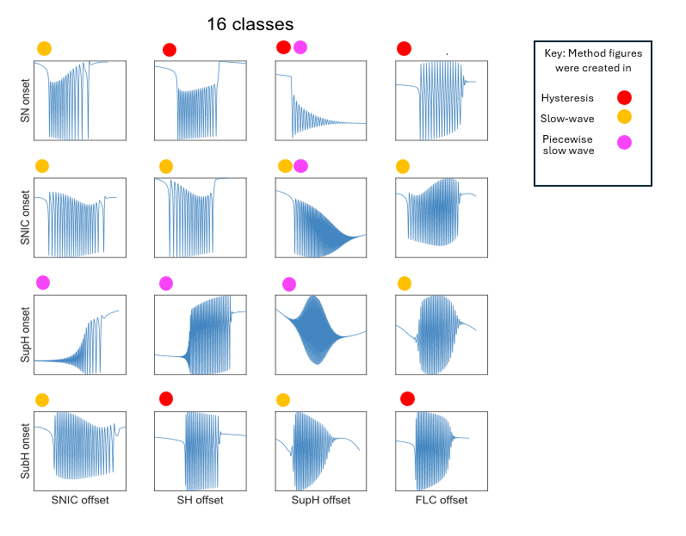

Table 1

A fast subsystem which allows for construction of all 16 bursting classes is created through "unfolding" a singularity of high codimension. The resultant equations are:

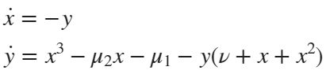

Here, 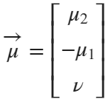 is our parameter vector, which defines the parameter space. We often examine spherical "slices" of this parameter space, as the topological structure for large 3D regions can be inferred from the segregated regions on the sphere. Bifurcation manifolds in parameter space intersect the sphere, leaving curves which segregate the surface. In our diagrams below, we flatten this sphere for better visualization. Below is the 2d flattened diagram and the corresponding 3d projection.

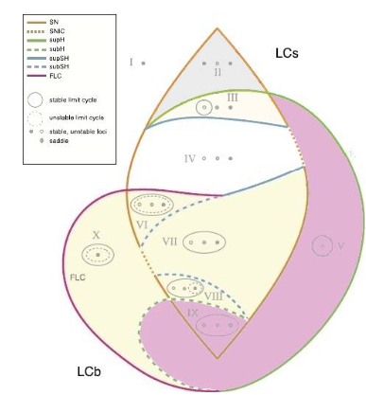

In this framework, a seizure corresponds to a stable limit cycle for sustained oscillations, while the resting state is modeled as a stable fixed point. There is also another fixed point solution, different from the resting state, which we named ‘active rest’ and consider as part of the ictal regime. Which, among these behaviors, are possible in the model depends on the values of its parameters. The input parameters m*u2, mu1,* and *nu* of the differential equations and algorithm that govern the Saggio-Jirsa fast subsystem rely on a three dimensional spherical map. At each point of the map, that is, for any precise choice of the three parameters values, the system exhibits specific behaviors. This map includes a rest and active rest region (grey), a rest/seizure or bistable region (yellow), and a seizure region (purple) that govern the behavior of the seizure. It also includes several bifurcation curves that enclose these regions and correspond to transitions among those behaviors. To manipulate the behavior of the model to create seizures, one would vary the input coordinates m*u2, mu1,* and *nu* to create a specific path within the map. Now understanding the behavior of these dynamical systems, you can begin to understand the behavior of the map in each region.

|  |  |  |
| --- | --- | --- |
| Region Number | Topology | Description of behavior |
| I | Single stable point | Behavior in this region will be attraction to the stable fixed point, will see time series at a steady amplitude, |
| II | Two stable points, one saddle point | Behavior in this region will be attraction to the two stable fixed points and repulsion from the saddle point. System may oscillate between two fixed points. Wiil see time series at a steady amplitude |
| III | One stable point, one saddle point, one stable limit cycle with unstable point inside | Behavior in this region will be attraction to both the stable limit cycle and stable point, thus making it bistable, will see timeseries bursting in limit cycle or at a steady amplitude at the fixed point |
| IV | One stable point, one saddle point, one fixed point | Behavior in this region will be attraction to the stable point and repulsion from the saddle and unstable point, timeseries will show rest on |
| V | Stable limit cycle with unstable point inside | Behavior in this region will be attraction to the limit cycle, timeseries will show bursting |
| VI | Stable limit cycle with unstable limit cycle inside with stable, saddle, and unstable point inside | Behavior in this region will be attraction to both the stable limit cycle and stable point, thus making it bistable, will see timeseries bursting in limit cycle or at a steady amplitude at the fixed point |
| VII | Stable limit cycle with stable, saddle, and unstable point inside | Behavior in this region will be attraction to both the stable limit cycle and stable point, thus making it bistable, will see timeseries bursting in limit cycle or at a steady amplitude at the fixed point |
| VIII | Stable limit cycle with unstable point, saddle point and unstable limit cycle with fixed point inside | Behavior in this region will be attraction to both the stable limit cycle and stable point, thus making it bistable, will see timeseries bursting in limit cycle or at a steady amplitude at the fixed point |
| IX | Stable limit cycle with two unstable points and one saddle point inside | Behavior in this region will be attraction to the limit cycle, timeseries will show bursting |
| X | Stable limit cycle with unstable limit cycle and stable point inside | Behavior in this region will be attraction to both the stable limit cycle and stable point, thus making it bistable, will see timeseries bursting in limit cycle or at a steady amplitude at the fixed point |

These segregated regions define different dynamical regimes (shown in the next section), of which there are three predominant types: *monostable rest*, *monostable active*, and *bistable*. The bistable regions can be categorized further:

* *Limit Cycle big (LCb)* - A stable fixed point and a stable limit cycle exist. The fixed point lies on the interior of the limit cycle.
* *Limit Cycle small (LCs)* - A stable fixed point and a stable limit cycle exist. The fixed point lies on the exterior of the limit cycle.
* *Active Rest* - Two stable fixed points exist.

In the diagrams below, the topological structure of phase space (the fixed points and limit cycles) are sketched in gray in the corresponding regions of parameter space.

***Note:* when in an LCs or Active Rest bistable region, a jump between attractors results in a DC shift in the timeseries.**

figure;

get_plot()

axis off;

xlabel('\mu_2')

ylabel('-\mu_1')

zlabel('\nu')



# *Bursting Paths & Burster Types*

To create a burster, we must identify a path through parameter space that “connects” onset and offset bifurcation curves. We call this path the bursting path; it is the set of parameter values along which the system varies in order to exhibit the proper sequence of bifurcations that yield a burster. To create a burster of a particular class, we must find a path that appropriately connects the correct onset and offset bifurcations. Movement of the system along this path is accomplished by parameterizing the bursting path in terms of the slow variables, .

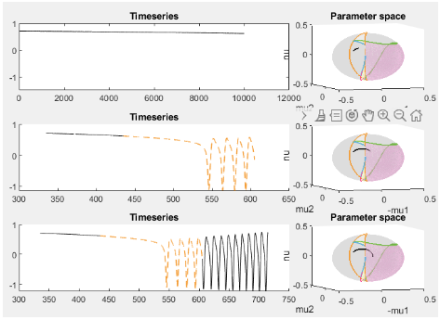

The traversal of this path is driven by the slow oscillation of the system. The slow oscillation can occur through two mechanisms:

* *Slow-wave burster -* The slow subsystem is a self-sustained oscillator, thus feedback from the fast to the slow subsystem is not required. In this case, the slow subsystem must be at least two-dimensional, .
* *Hysteresis-loop burster -* The slow subsystem oscillates due to feedback from the fast subsystem. This can occur if the fast subsystem shows hysteresis between the silent and active states, which can be used to inform the slow subsystem about the state of the fast subsystem (e.g., by baseline). In this case, one slow variable is enough, .

# Adding noise into the equation of the simulation

Seizures generated using Saggio et al.’s dynamical model of fast-slow bursting are mostly realistic, but they lack certain features of human sEEG recordings, such as noise. We added dynamical pink noise to our simulated seizures. Pink noise was chosen because it closely resembles noise in the brain (i.e. 1/f noise).

Dynamical noise, or parametric noise, was added to the fast variable (*x*) of the model equations (see Saggio 2017). This represents noise in the brain (i.e. random voltage fluctuations) that creates small perturbations, some of which may push the system into or out of the seizure state (da Silva 2003, Maturana 2020). In the hysteresis model, additional noise stops the hysteresis effect, and the system undergoes noise induced transitions as opposed to bifurcation induced transitions.

In the slow wave model, individual bifurcations responded differently to additional dynamical noise. The SubH and SupH bifurcations produce seizures that were unaffected by noise. The SN and SNIC bifurcations do not clearly start the seizure or have the visual characteristics we typically associate with the bifurcation at high levels of noise. Note this may be a biproduct of the proximity to the bistability region. This may also explain why SNIC bifurcations are so hard to spot in human data and account for 3% of all human data seizures.

# *Hysteresis-Loop Bursters*

## Slow Dynamics

For hysteresis-loop bursters, the simplest construction of a path is an arc (a segment of a great circle) on the sphere. This arc is drawn from a point on the offset curve through a bistable region to a point on the onset curve. We design the slow dynamics so that the traversal of this path works as follows. When the system is at rest, the parameters should change so that the system moves towards the onset bifurcation. When the system is in an active state, the system should move towards offset. Using a one dimensional slow-subsystem, this means we want  to increase if the system is at rest, and decrease if the system is seizing. The following formulation accomplishes this:

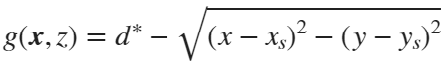

Here,  are the coordinates of the resting state. We note that  always. We also note that 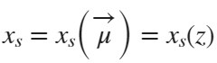 since .

This formulation essentially measures the distance between the current location of the system and the resting state. If this distance is below a threshold, ,  increases, and the parameters approach critical onset values. When above the threshold,  is negative, and we approach offset.

## Parametrization

For the slow dynamics to generate a hysteresis-loop burster, we need an appropriate parametrization of  (bursting path). As we said, the simplest way is to make an arc connecting points on onset and offset curves using a segment of a great circle.

First, we choose points in parameter space,  and . Where  lies on the offset curve, and  lies on the onset. Given these choices the parametric equation is then



where

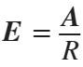 and 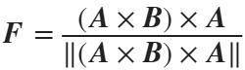

Given that the system begins at rest with , and that the arc path connecting  to  solely passes through bistable regions, this parametrization (coupled with the slow dynamics above) will produce a hysteresis-loop burster.

## Paths

5 of the 16 burster types can be created using hysteresis-loop bursters

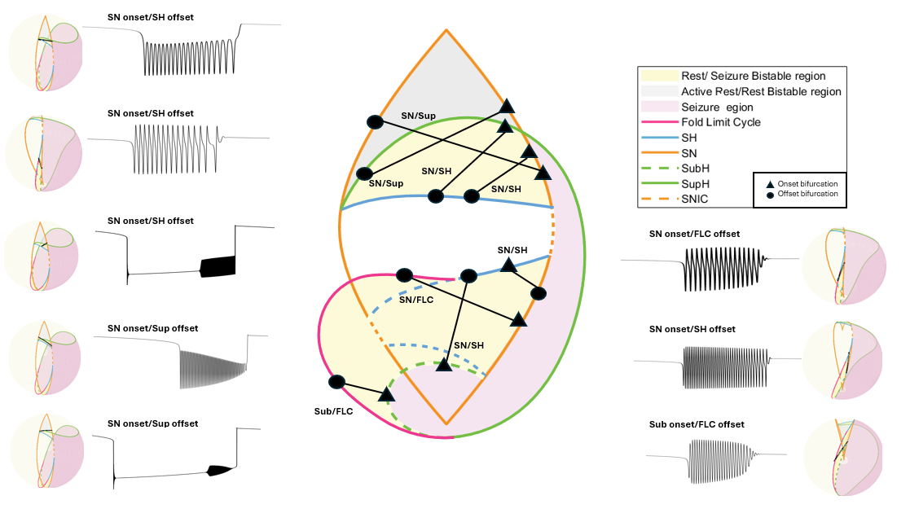

## CODE

### Settings

clear all

% Settings - Integration

x0=[0;0;0]; % initial conditions (must be a column)

% Settings - Model

% focus

b = 1.0;

% radius of the sphere, do not change

R = 0.4;

% The dstar parameter is an excitability parameter that controls the ratio between duration of seizure and duration of rest. When dstar is smaller or equal to zero, no seizure activity is possible, and the system will always stay at rest. For small';

% positive values of dstar, seizure and rest occur. For sufficiently big values of dstar, only seizure activity is possible. '

dstar = 0.5;

%%'The parameter k determines how many oscillations in the burst by setting the speed.The faster the movement the the less the number of oscillations per burst, and vise versa.

k=0.000015;

% The N parameter controls solution of resting state. Upper Branch (Case 1): Smoother transitions, reduced hysteresis. Lower Branches (Cases 2 and 3): Potential for hysteresis, with complex, path-dependent responses and multiple equilibria. The systems

% state may not revert immediately when external conditions are reversed, creating the characteristic hysteresis loop.

N = 1;

%length of time the simulation will run for

tmax = 170000;

%Integration step/Sampling rate of the simulation, assume it is represented in miliseconds

tstep = 0.01;

%%class wanted to run, input '2s', '2b', '3s','4b','10', '11' '14', '16'

%this shows what labels correspond to what class : '2s - SN/SH', '2b-SN/SH', '3s- SN/SUP','4b - SN/FLC ','10-SN/SH', '11-SN/Sup' '14-SN/Sub', '16-SN/Sup'

class = '10';

%% function takes in class, and gets a randomized point on each

%% bifurcation curve

[onset_curve,offset_curve]=hysteresis_random_path(class);

onset_curve_length=length(onset_curve);

offset_curve_length=length(offset_curve);

%%choose specific points. These points will be the index of the total curve

%%length found in the previous two lines. The number chosen must be less

%%than the total length of the particular curve

% onset_index = 11; %start at first point on the onset curve

% offset_index = 3; %end at 50th point on the offset curve

% A = offset_curve(:,offset_index);

% B = onset_curve(:,onset_index);

% uncomment this code to do random path

% % One random path - select random point on onset curve and offset curve

random_onset_index=randsample(onset_curve_length,1);

random_offset_index=randsample(offset_curve_length,1);

A = offset_curve(:,random_offset_index);

B = onset_curve(:,random_onset_index);

### Integration

tspan = 0:tstep:tmax;

% Create arc path

[E, F] = Parametrization_2PointsArc(A,B,R);

N_t = length(tspan);

X = zeros(3,N_t);

xx = x0;

%Dynamical pink noise, or parametric noise, is added to the fast variable (x) of'the governing model equations. This represents noise in the brain

%i.e. random voltage fluctuations) that creates small perturbations, some of which'may push the system into or out of the seizure state.

sigma = 00;

Rn = [pinknoise([1,N_t],-1, sigma);pinknoise([1,N_t],-1, 00);pinknoise([1,N_t],-1, 00)];

for n = 1:N_t

% Euler-Meruyama method

Fxx = HysteresisLoop_Model(tspan(n),xx,b,k,R,dstar,E,F,N);

xx = xx + tstep*Fxx + sqrt(tstep)*Rn(:,n);

X(:,n) = xx;

end

x = X';

t = tspan;

% Onset happens when you leave the resting state. In the absence of noise you can use peaks in the z variable.

% With noise, you need to explicitly track the distance between the resting state and the current state of the system.

% When it exceeds dstar, that should be good. Vice versa for offset. In the model function you will see another function

% used called resting state. This function calculates the x coordinate for the fixed points, x_rs (y coordinate is always 0).

% Then just take the distance between (x_rs, 0) and (x, y), the current position of the system.

% If you look at the equations for zdot you will see this is how z “knows how to turn around

z = x(:,3);

% Calculate Bursting Path

mu2 = R.*(E(1).*cos(z)+F(1).*sin(z));

mu1 = -R.*(E(2).*cos(z)+F(2).*sin(z));

nu = R.*(E(3).*cos(z)+F(3).*sin(z));

figure;

grid off;

set(gca, 'XColor', 'none');

plot(t,x(:,1),'LineWidth',1,'DisplayName','x', 'Color','k');

xticks([])

hold on

plot(t,x(:,3),'r','LineWidth',2,'DisplayName','z')

hold off

xlabel('t')

title('Timeseries')

legend('Location','northwest','FontSize',18)



figure;

get_plot();

plot3(mu2,-mu1,nu,'k', 'DisplayName', 'Bursting Path', 'LineWidth',3);

xlabel('\mu_2')

ylabel('-\mu_1')

zlabel('\nu')



# SLOW-WAVE BURSTERS - CIRCULAR

## Parametrization

Slow wave bursters must be self-sustaining oscillations. In other words, the direction in which the bursting path is traversed will not change due to feedback from the fast subsystem (i.e. whether the system is active or resting). Thus, the simplest way to construct a slow wave path is to draw a closed loop (circle) which is traversed in a single direction, driven by a dummy variable at constant velocity:



We need 3 initial points in parameter space to define the circle on the sphere. Call them , , . Here, the traversal of the path is intended to pass through these points in sequential order. The unique circle which passes through these points can be described as the intersection of the sphere and the plane which passes through these 3 points. First, we define the plane. We start with the normal vector:

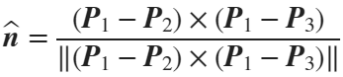

Letting 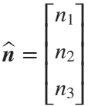, the equation of the plane is the standard formulation:



where is the signed distance from the origin to the plane. Note , ,  refer to coordinates in parameter space here.

Using the pythagorean identity, we find that the radius of the smaller circle is .

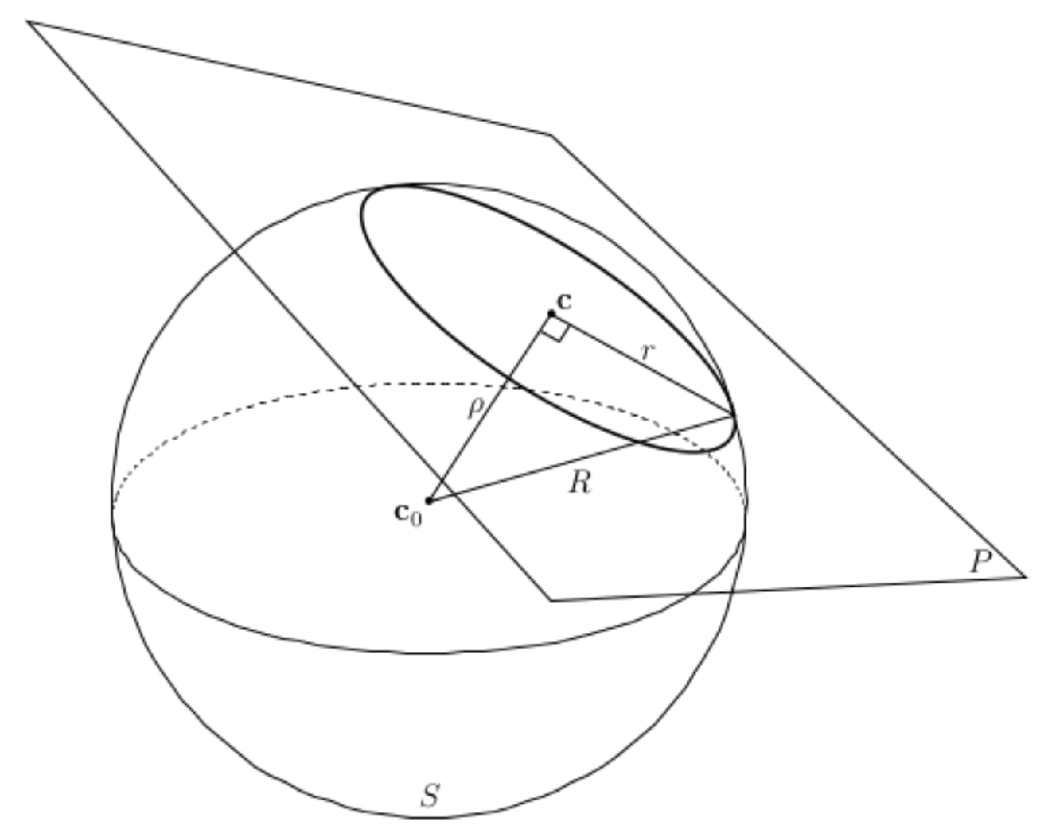

The center of the smaller circle is . This allows us to construct the following parametrization:



where

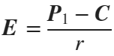 and .

This step is similar to the hysteresis-loop path because it is constructed by making a great circle on the smaller sphere centered at  with radius .

## Paths

8 of the 16 burster types are created using slow-wave bursters

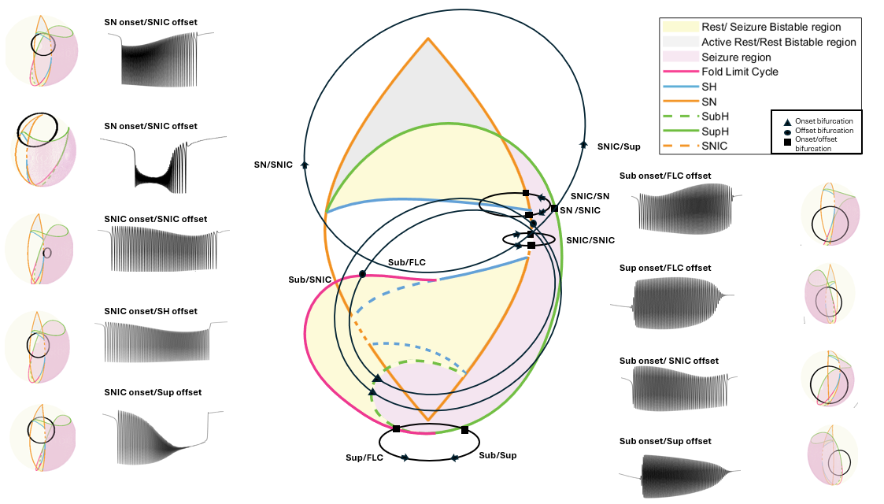

## CODE

### Settings

clear all

% SETTINGS - INTEGRATION

x0=[0;0;0]; % initial conditions (must be a column)

% Settings - Model

% focus

b = 1.0;

% radius of the sphere, do not change

R = 0.4;

%%'The parameter k determines how many oscillations in the burst by setting the speed.The faster the movement the the less the number of oscillations per burst, and vise versa.

k = 0.004;

%length of time the seizure will run for

tmax = 4000;

%Integration step/Sampling rate of the simulation

tstep = 0.01;

%%class wanted to run, input 1,5, 6,7,8,9,12,13,15

%this shows what labels correspond to what class : '1 - SN/SNIC', '5

%-SNIC/SNIC', '6 - SNIC/SH','7 - SNIC/SUP','8-Sub/FLC', '9-Sup/SNIC'

%'12-Sup/FLC', '13-Sub/SNIC', '15-Sub/Sup',

class = 5;

%% function takes in class 2,4,14,16, and gets a randomized point on each bifurcation curve

[onset_curve,offset_curve,offset_curve2, flag] = slow_wave_circular_random_path(class);

onset_curve_length=length(onset_curve);

offset_curve_length=length(offset_curve);

%%choose specific points

onset_index = 1;

offset_index = 10;

if flag == 2 || flag == 3

p1 = onset_curve(:,onset_index);

p2 = offset_curve(:,offset_index);

else

p1 = onset_curve(:,onset_index);

p2 = offset_curve2(:,offset_index);

p3 = offset_curve;

end

% uncomment this code to do random path

% % One random path - select random point on onset curve and offset curve

onset_curve_length=length(onset_curve);

offset_curve_length=length(offset_curve);

random_onset_index=randsample(onset_curve_length,1);

random_offset_index=randsample(offset_curve_length,1);

if flag == 2 || flag == 3

p1 = onset_curve(:,random_onset_index);

p2 = offset_curve(:,random_offset_index);

p3 = offset_curve2;

else

p1 = onset_curve(:,random_onset_index);

p2 = offset_curve2(:,random_offset_index);

p3 = offset_curve;

end

### Integration

tspan = 0:tstep:tmax;

% Create circular path based 3 defining points

[E, F, C, r] = Parametrization_3PointsCircle(p1',p2',p3');

if class == 13

E = -E;

end

N_t = length(tspan);

X = zeros(3,N_t);

xx = x0;

sigma = 40;

Rn = [pinknoise([1,N_t],-1, sigma);pinknoise([1,N_t],-1, 00);pinknoise([1,N_t],-1, 00)];

mu2_big = zeros(1, length(N_t));

mu1_big = zeros(1, length(N_t));

nu_big = zeros(1, length(N_t));

for n = 1:N_t

%Euler-Meruyama method

[Fxx, mu2, mu1,nu] = SlowWave_Model(tspan(n),xx,b,k,E,F,C,r);

xx = xx + tstep*Fxx + sqrt(tstep)*Rn(:,n);

X(:,n) = xx;

mu2_big(n) = mu2;

mu1_big(n) = mu1;

nu_big(n) = nu;

end

x = X';

t = tspan;

%%Onset and offset calculation, calculates radians to the bifurcation

%%curve, then uses tstep and k variables to compute onset location

plot_onset_offset = 0;

if(floor((((2*pi)/k)/tstep)) < N_t)

plot_onset_offset = 1;

point1 = p1' - C;

point2 = p2' - C;

point3 = p3'-C;

point1 = point1 / norm(point1) * r;

point2 = point2 / norm(point2) * r;

point3 = point3 / norm(point3) * r;

% Compute the quaternion for rotation

theta1 = acos(dot(point1, point2) / (r^2));

%%%change here

numPoints1 = floor((theta1/k)/tstep);

point = [mu2_big(numPoints1), -mu1_big(numPoints1), nu_big(numPoints1)];

if round(point,2) == round(p2,2)'

onset_index = numPoints1;

else

numPoints1 = floor(((2*pi - theta1)/k)/tstep);

onset_index = numPoints1;

theta1 = theta1-2*pi;

end

theta2 = acos(dot(point1, point3) / (r^2));

numPoints2 = floor(((theta2)/k)/tstep);

point = [mu2_big(numPoints2), -mu1_big(numPoints2), nu_big(numPoints2)];

if round(point,2) == round(p2,2)'

%offset_index = numPoints2;

else

numPoints2 = floor(((2*pi - theta2)/k)/tstep);

theta2 = 2*pi - theta2;

offset_index = numPoints2;

end

theta3 = 2*pi;

numPoints3 = floor(((theta3)/k)/tstep);

point = [mu2_big(numPoints3), -mu1_big(numPoints3), nu_big(numPoints3)];

offset_index = numPoints3;

end

if class == 15 || class == 12

onset_index_temp = onset_index;

onset_index = offset_index;

offset_index = onset_index_temp + floor((((2*pi)/k)/tstep));

end

% Calculate Bursting Path

z=0:0.01:2*pi;

mu2=C(1)+r*(E(1)*cos(z)+F(1)*sin(z));

mu1=-(C(2)+r*(E(2)*cos(z)+F(2)*sin(z)));

nu=C(3)+r*(E(3)*cos(z)+F(3)*sin(z));

### Plotting

figure;

plot(t,x(:,1),'LineWidth',1, 'Color','k')

hold on

if(plot_onset_offset == 1)

scatter(t(onset_index), 1);

scatter(t(offset_index),1)

end

xlabel('t')

ylabel('x')

title('Timeseries')



figure;

get_plot();

plot3(mu2, -mu1, nu, 'k', 'DisplayName', 'Bursting Path', 'LineWidth',3);

xlabel('\mu_2')

ylabel('-\mu_1')

zlabel('\nu')



# SLOW-WAVE BURSTERS - PIECEWISE

## Parametrization

Slow wave bursters must be self-sustaining oscillations. In other words, the direction in which the bursting path is traversed will not change due to feedback from the fast subsystem (i.e., whether the system is active or resting. In certain classes, paths cross the saddle node bifurcation and exhibit dc shifts. If these secondary dynamics are undesirable, one can manipulate the path to not cross the saddle-node bifurcation. While slow wave circles are theoretically plausible to achieve this goal, they are practically difficult because some onset-offset pairs are challenging to connect with continuous pathways without crossing other bifurcations. To address this, we can construct piecewise paths using the slow wave method. In addition, this approach allows a bursting pathway to begin and end in different locations in the state space, rather than returning to the original starting point.

To do this, direct pathways between defined points are used to move through specific locations. Four arcs are created on the surface of the sphere to make a piecewise arc path using 4 points. The first point is a fixed point in the rest region. The second point is a point on the onset bifurcation curve. The third point is a randomized point in the limit cycle region. The fourth point is a point in the offset bifurcation curve. The arc paths are created from the rest point to first onset bifurcation point, first bifurcation point to limit cycle point, limit cycle point to second bifurcation point, and offset bifurcation point to the rest point, to create a continuous path. Next, to calculate the total time the path traversed, the path was scaled by the k variable and t step variable. Note that unlike the previous two methods, this method only traverses the path one time during the simulation. We produced 5 classes with this method

## Paths

5 of the 16 burster types are created using slow-wave piecewise bursters

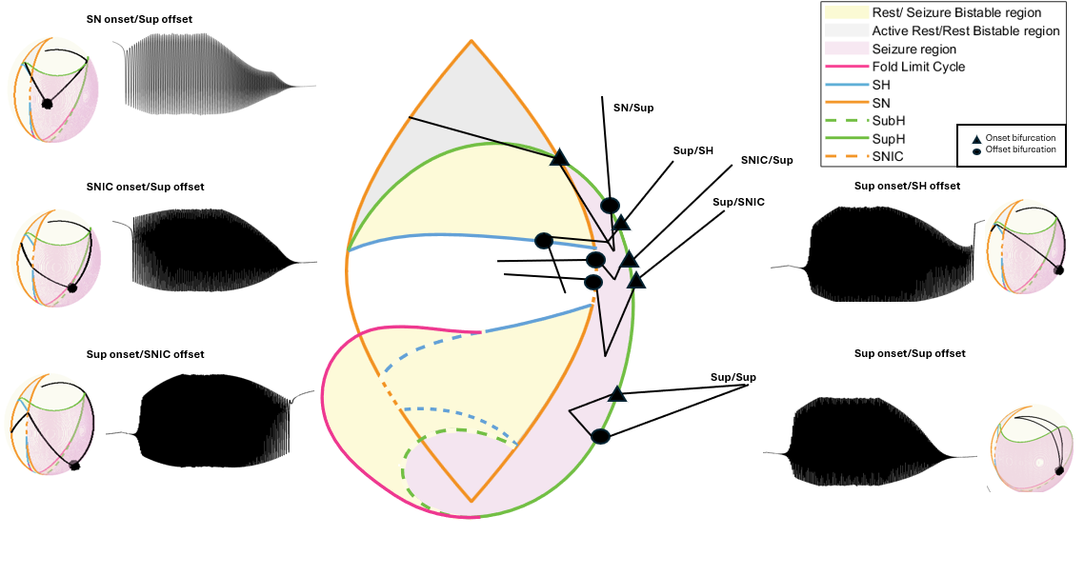

# CODE

### Settings

clear all

% SETTINGS - INTEGRATION

x0=[0;0;0]; % initial conditions (must be a column)

% Settings - Model

% focus

b = 1.0;

% radius of the sphere, do not change

R = 0.4;

%%'The parameter k determines how many oscillations in the burst by setting the speed.The faster the movement the the less the number of oscillations per burst, and vise versa.

k = 0.004;

%Integration step/Sampling rate of the simulation

tstep = 0.01;

%%class wanted to run, input 3,7,9,10,11

%this corresponds to '3 - SN/Sup', '7 - SNIC/Sup', '9- Sup/SNIC', '10 -Sup/SH',

% '11 - Sup/Sup'

class = 11;

[p0,onset_curve,p1_5,offset_curve,p3]=piecewise_random_path(class);

onset_curve_length=length(onset_curve);

offset_curve_length=length(offset_curve);

%%choose specific points

onset_index = 1;

offset_index = 44;

p1 = onset_curve(onset_index,:);

p2 = offset_curve(offset_index,:);

% uncomment this code to do random path

% % One random path - select random point on onset curve and offset curve

% random_onset_index=randsample(onset_curve_length,1);

% random_offset_index=randsample(offset_curve_length,1);

% p1 = onset_curve(:,random_onset_index);

% p2 = offset_curve(:,random_offset_index);

stall_val = 30000;

[mu2_straight_path0,mu1_straight_path0,nu_straight_path0,rad1] = sphereArcPath(k,tstep,p0,p1);

[mu2_straight_path0_5,mu1_straight_path0_5,nu_straight_path0_5,rad2] = sphereArcPath(k,tstep,p1,p1_5);

points = repmat(p1_5, stall_val, 1)';

%path noise sigma

sigma = 100;

Rn = [pinknoise([1,length(points)],-1, sigma);pinknoise([1,length(points)],-1, sigma);pinknoise([1,length(points)],-1, sigma)];

points = points + Rn;

[mu2_straight_path,mu1_straight_path,nu_straight_path,rad3] = sphereArcPath(k,tstep,p1_5,p2);

[mu2_straight_path1,mu1_straight_path1,nu_straight_path1,rad4] = sphereArcPath(k,tstep,p2,p3);

mu2_all = [mu2_straight_path0, mu2_straight_path0_5, points(1, :), mu2_straight_path, mu2_straight_path1];

mu1_all = [mu1_straight_path0, mu1_straight_path0_5, points(2, :), mu1_straight_path, mu1_straight_path1];

mu1_all = -mu1_all;

nu_all = [nu_straight_path0, nu_straight_path0_5, points(3,:), nu_straight_path, nu_straight_path1];

N_t = length(mu2_all);

X = zeros(3,N_t);

xx = x0;

%signal pink noise sigma

sigma = 00;

Rn = [pinknoise([1,N_t],-1, sigma);pinknoise([1,N_t],-1, 00);pinknoise([1,N_t],-1, 00)];

mu2_big = zeros(1, length(N_t));

mu1_big = zeros(1, length(N_t));

nu_big = zeros(1, length(N_t));

%%get onset index by finding Radians to bifurcation, and getting index

%%through k and tstep parameters

onset_index = floor((rad1/k)/tstep);

offset_index = floor(((rad1+rad2+rad3)/k)/tstep) + stall_val;

for n = 1:N_t

%%Euler-Meruyama method

[Fxx,mu2,mu1,nu] = SlowWave_Model_piecewise(0,xx,b,k,mu2_all(n), mu1_all(n),nu_all(n));

xx = xx + tstep*Fxx + sqrt(tstep)*Rn(:,n);

X(:,n) = xx;

mu2_big(n) = mu2;

mu1_big(n) = mu1;

nu_big(n) = nu;

end

x = X';

seizure = x(:,1);

figure;

plot(seizure,'k');

hold on;

scatter(onset_index,1);

scatter(offset_index,1);



figure;

hold on;

get_plot();

hold on;

plot3(mu2_all, -mu1_all, nu_all, 'k', 'LineWidth',2, 'DisplayName', 'Bursting Path');



# Postprocessing

Seizures generated using Saggio et al.’s dynamical model of fast-slow bursting have similar bursting patterns as human seizures, but they lack certain features of human sEEG recordings, such as noise. We added dynamical pink noise to our simulated seizures. Pink noise was chosen because it closely resembles noise in the brain. Dynamical noise, or parametric noise, was added to the fast variable (*x*) of the model equations (see Saggio 2017) to represent noise in the brain (i.e. random voltage fluctuations) that creates small perturbations, some of which may push the system into or out of the seizure state (da Silva 2003, Maturana 2020). In the hysteresis model, additional noise **stops** the hysteresis loop bursting, and the system undergoes noise induced transitions as opposed to bifurcation induced transitions.

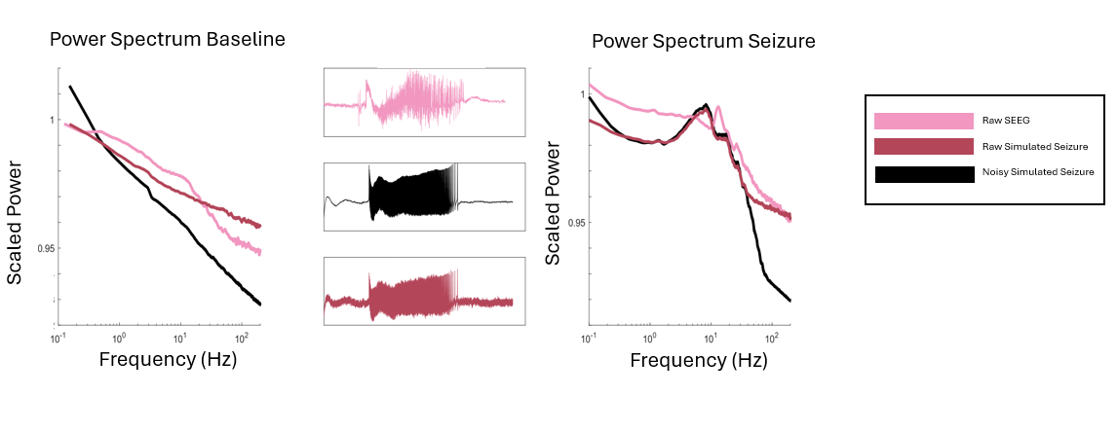

clear all;clc;

%input class [1, '2s', '2b', 3, '4s', 5, 6, 7, 8, 9, 10, 11, 12, 13, '14', 15, '16']

%this shows what labels correspond to what class :

%slow-wave

% '1 - SN/SNIC', '5 -SNIC/SNIC', '6 - SNIC/SH','8-Sub/FLC',

%'12-Sup/FLC', '13-Sub/SNIC', '15-Sub/Sup',

%piecewise

% '3 - SN/Sup', '7 - SNIC/Sup', '9- Sup/SNIC', '10 -Sup/SH', '11 - Sup/Sup'

%hysteresis: ,

% '2s - SN/SH', '2b-SN/SH',

% '4b - SN/FLC', '14-SN/Sub', '16-SN/Sup'

class = 12;

tstep = 0.01;

sigma = 50;

[onset, offset, data] = bifurcation_all_class(class, tstep, sigma);

[pks,locs] = findpeaks(data, 'MinPeakProminence', 0.35);

fs = 1/(0.01*tstep);

t = (0:length(data)-1) / fs;

figure;

plot(data, 'Color',[180/255, 70/255, 90/255]);

hold on;

plot(locs, pks, 'ro'); % Plot peaks with red circles

title(['Number of Peaks: ', num2str(numel(locs))]);

hold off;



%%Getting average spike rate

time_in_seconds = locs / fs; % Convert peak indices to seconds

spike_rates = diff(time_in_seconds);

average_frequency = mean(spike_rates);

fprintf('The average frequency of the signal is %.2f Hz\n', average_frequency);

The average frequency of the signal is 0.01 Hz

We adjust the sampling rate of simulated seizures such that spike frequency was consistent with clinical guidelines. According to AES, a seizure consists of rhythmic bursting activity between 1-30 Hz

if average_frequency < 1 || average_frequency > 30

% Calculate spike rates

spike_rates = diff(time_in_seconds);

% Adjust spike rates to achieve a mean average spiking rate of 5 Hz

target_avg_spike_rate = (1/10); % Hz

% Calculate the current average spiking rate

current_avg_spike_rate = mean(spike_rates);

% Calculate the adjustment factor

adjustment_factor = target_avg_spike_rate / current_avg_spike_rate;

% Adjust spike rates

adjusted_spike_rates = spike_rates * adjustment_factor;

% Calculate the mean average spiking rate after adjustment

mean_avg_spike_rate = mean(adjusted_spike_rates);

% Calculate the new sampling frequency

new_sampling_frequency = fs / adjustment_factor;

disp('New sampling frequency (Hz):');

disp(new_sampling_frequency);

disp('New average frequency of the signal (Hz):');

disp(1/target_avg_spike_rate)

end

New sampling frequency (Hz):

646.9880

New average frequency of the signal (Hz):

10

%add pink noise over

min_val = min(highpass(data(:), 5, fs));

max_val = max(highpass(data(:), 5, fs));

Spontaneous DC shifts reflect alterations in the excitation level of neuronal membrane potentials. The rapid charge accumulation at the electrode-electrolyte interface causes electrode polarization which induces a baseline drift that is distinguished by an electrode’s material properties. Modern EEG recording equipment uses alternating current (AC) amplifiers with low-frequency high-pass filters to perform baseline correction once amplifier saturation occurs. To emulate the residual baseline drift observed from platinum-iridium electrodes in human EEG, we applied 6th order digital high-pass filters with cutoff frequencies between 0.1 and 1 Hz

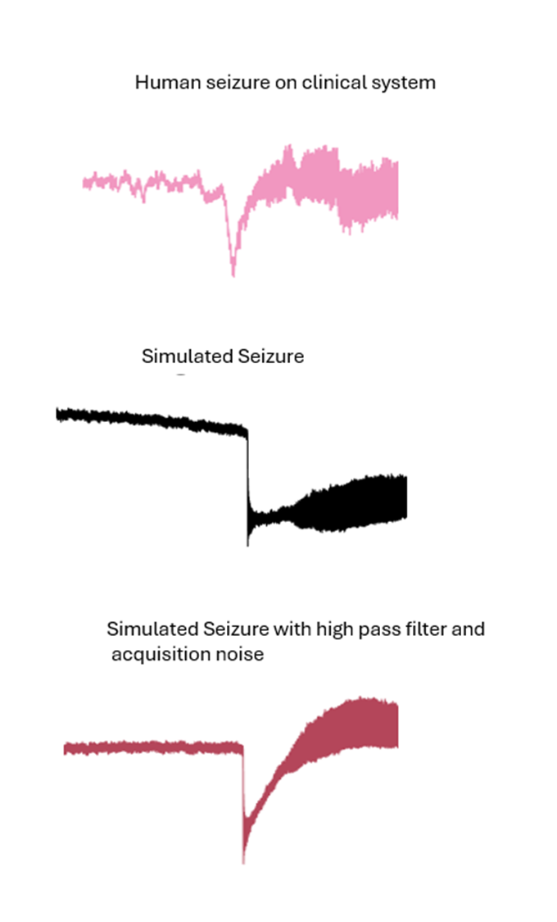

HPF = designfilt('highpassiir', ... % Response type

'FilterOrder',4, ... % Filter Order Specification

'HalfPowerFrequency',0.1, ...

'DesignMethod','butter', ... % Design method

'SampleRate',fs); % Sample rate

data = filter(HPF, data);

figure;

plot(t,data, 'Color',[180/255, 70/255, 90/255]);

title('Electrode drift')



We added 0%, 20%, and 40% signal acquisition pink noise. In the first, we did not add any signal acquisition noise. In the second, we added pink noise that was 20% of the signal amplitude, to represent mediocre recording conditions. In the third, we added pink noise that was 40% of the signal amplitude, to represent poor recording conditions. Signal acquisition noise is picked up by the electrodes used to record brain activity. This neural activity of surrounding brain tissue can be modeled as “pink noise”, or 1/f spatial noise with a normal error distribution (Lennon 2000). The amplitude of signal acquisition noise depends on the signal-to-noise ratio. We generated several datasets to represent variability in clinical recording conditions. We found adding pink noise caused the power spectrums to match.

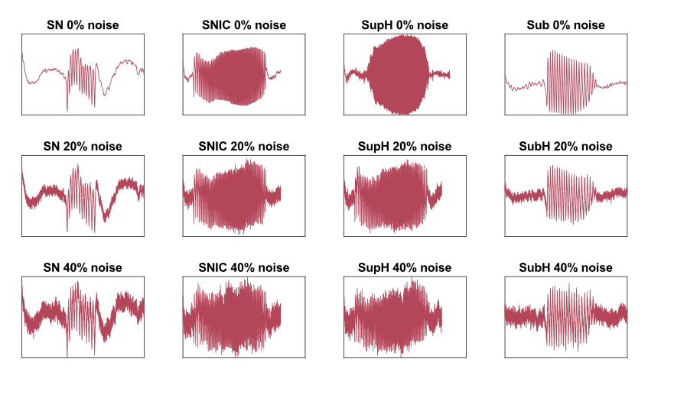

data = (data - min_val) / (max_val - min_val);

rms_signal = get_amp(data);

normalized_data = data;

noisy_data_20 = add_pink_noise(normalized_data, rms_signal, 0.2);

noisy_data_40 = add_pink_noise(normalized_data, rms_signal,0.4);

%%Flipping the data to double the dataset

doubled_data = normalized_data;

flipped_data = (doubled_data*-1)+1;

%%Flipping the data to double the dataset

normalized_data_1 = noisy_data_20;

doubled_data = normalized_data_1;

flipped_data_1 = (doubled_data*-1)+1;

%%Flipping the data to double the dataset

normalized_data_40 = noisy_data_40;

doubled_data_40 = normalized_data_40;

flipped_data_40 = (doubled_data_40*-1)+1;

%Normalizing the data between 0 and 1 and plotting

figure

subplot(2, 3, 1);

data = normalized_data;

min_val = min(data(:));

max_val = max(data(:));

data = (data - min_val) / (max_val - min_val);

normalized_data = data;

plot(t,normalized_data, 'Color',[180/255, 70/255, 90/255]); % Interpolated data

xlabel('Time');

ylabel('Data, 0 percent noise');

subplot(2, 3, 2);

data = flipped_data;

min_val = min(data(:));

max_val = max(data(:));

data = (data - min_val) / (max_val - min_val);

flipped_data = data;

plot(t,flipped_data, 'Color',[180/255, 70/255, 90/255]); % Interpolated data

xlabel('Time');

ylabel('Data, 0 percent noise');

subplot(2, 3, 3);

data = normalized_data_1;

min_val = min(data(:));

max_val = max(data(:));

data = (data - min_val) / (max_val - min_val);

normalized_data_1 = data;

plot(t,normalized_data_1, 'Color',[180/255, 70/255, 90/255]);

xlabel('Time');

ylabel('Data, 20 percent noise');

subplot(2, 3, 4);

data = flipped_data_1;

min_val = min(data(:));

max_val = max(data(:));

data = (data - min_val) / (max_val - min_val);

flipped_data_1 = data;

plot(t,flipped_data_1, 'Color',[180/255, 70/255, 90/255]);

xlabel('Time');

ylabel('Data, 20 percent noise');

subplot(2, 3, 5);

data = normalized_data_40;

min_val = min(data(:));

max_val = max(data(:));

data = (data - min_val) / (max_val - min_val);

normalized_data_40 = data;

plot(t,normalized_data_40, 'Color',[180/255, 70/255, 90/255]);

xlabel('Time');

ylabel('Data, 40 percent noise');

subplot(2, 3, 6);

data = flipped_data_40;

min_val = min(data(:));

max_val = max(data(:));

data = (data - min_val) / (max_val - min_val);

flipped_data_40 = data;

plot(t,flipped_data_40, 'Color',[180/255, 70/255, 90/255]);

xlabel('Time');

ylabel('Data, 40 percent noise');



This plot shows the final post-processed data, once it has been electrode-drift corrected, flipped to double the dataset, and approximately 20% and 40%% signal acquisition noise has been added overtop