# PROJECT TITLE: SMART MOVERS

## ONE PAGER

## OVERVIEW

### 1.PROJECT BACKGROUND AND DESCRIPTION

The selected project involves a smart mover system that includes activities such as allowing vehicle owners who provide moving services in a certain area to register into the system and get advertisements and a platform for them to showcase their services to potential customers.

### 2. SCOPE OF PROJECT

This project will cover vehicle owners’ registration, movers publishing their services on the platform for customers to see and peruse.

Functionalities such as creating a post, reading a post, updating or editing a post and deleting a post by the mover will be covered as well as customer ratings and feedback module.

### 3.REQUIREMENTS

This project will be web based and hence will have the following requirements.

1. Computer.
2. Web browser (chrome, Firefox, opera, Microsoft edge).
3. An internet connection

### 4.DELIVERABLES

A UI/UX design prototype of the system.

Technical documentation of the system

A responsive and functional web application

User guide and documentation

Code accessible on GitHub repository

### 5. MODULES

The system will have several modules as listed below.

1. User module(customer, The Mover(service provider)).
2. Service posting and advertising module.
3. Customer rating and feedback module.
4. Post sharing module.
5. Mover searching Module.

## SYSTEM FLOW CHART DIAGRAM

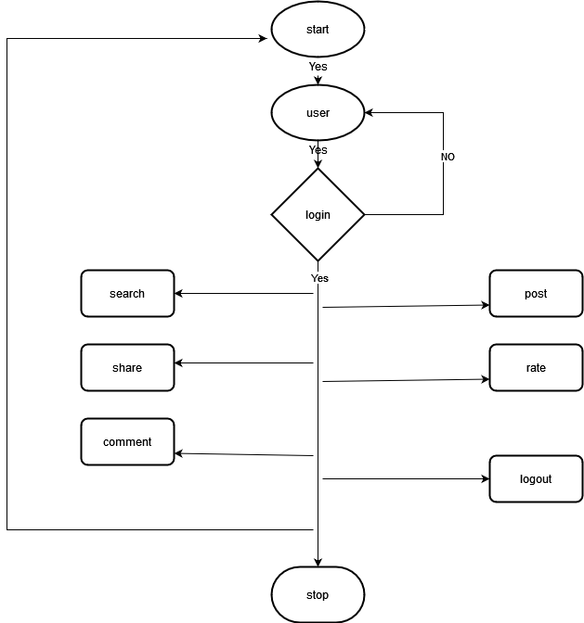

### PROJECT DESIGN SAMPLES

#### HOMEPAGE

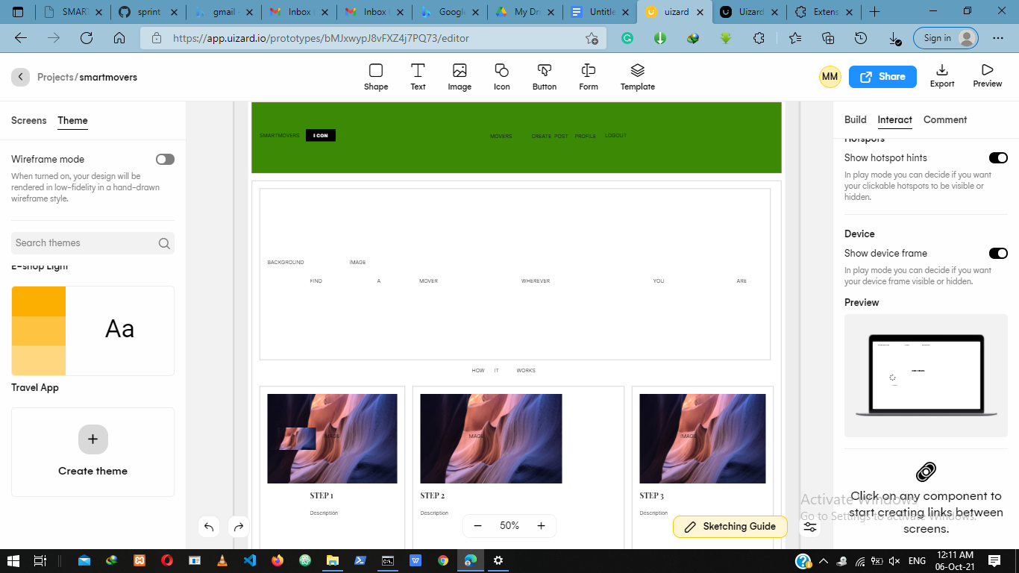

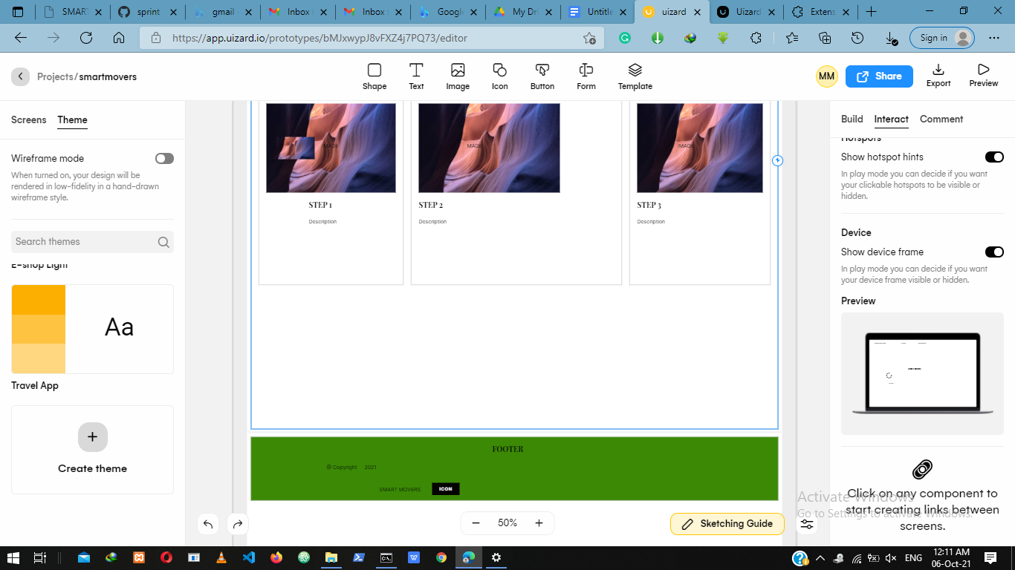

#### CREATE POST PAGE

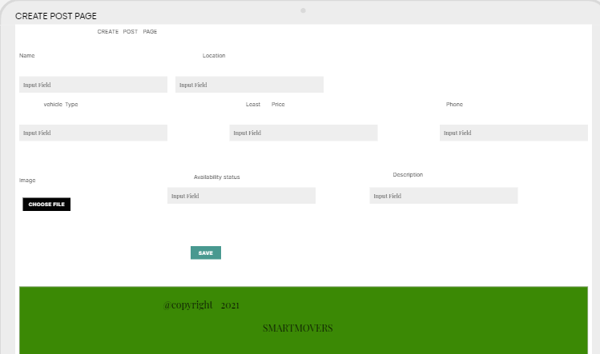

MOVER’S DETAIL PAGE



RATING PAGE



REGISTRATION PAGE

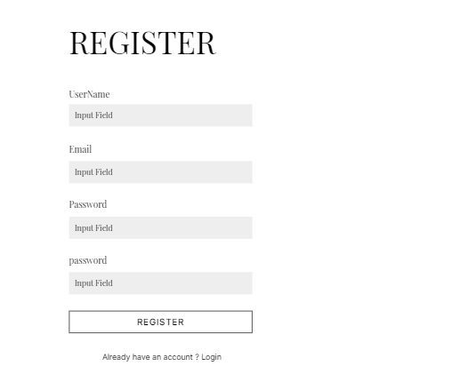

LOGIN PAGE

