**Integration of dynaTrace into Maven and WebDriver**

Contents

Step 1 - Get Agents Injected (Global System Variables) 2

Browser 2

Global System Variables 2

Eclipse 2

Web Driver 2

Verify 3

Step 2 - Get Timers Injected (Selenium/Web Driver Integration) 4

Timers 4

Disable Autotimers 4

Helper Classes 4

Step 3 - Automate dynaTrace Server Steering (Maven/Ant Integration) 5

3.1. Install dynaTrace Automation library for Maven 5

3.2. Adjust files in Maven M2 repository after installation 5

3.3. Add/Adjust dynaTrace properties in pom.xml 5

3.4. Add dynaTrace project to <projects> section 5

3.5. Verify dynaTrace goal 5

3.6. Get full list of Maven commands (see Appendix B) 5

Next Steps 5

Additional Resources 7

Appendix A - Maven Properties 8

Appendix B - Maven Commands 10

# Step 1 - Get Agents Injected (Global System Variables)

## Browser

Firefox and IE are supported. To get latest version numbers supported please check the release notes.

<https://apmcommunity.compuware.com/community/display/PROD/dynaTrace+4.2+Release+Notes>

## Global System Variables

DT_AGENTACTIVE=true

DT_AGENTNAME=Browser

DT_SERVER=YOURDTSERVERHOSTNAME

## Eclipse

Keep in mind you have to modify the system variables to each Run Configuration in Eclipse.

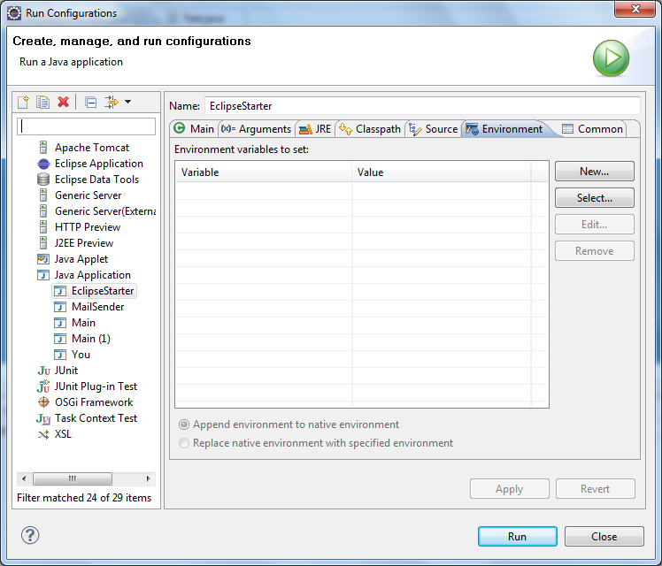

## Web Driver

That means that the dynaTrace browser plug-in will be disabled. Keep in mind that Web Driver will start the browser with a naked profile. In Firefox you need to create a profile and configure it in your WebDriver initialization.

<http://support.mozilla.org/en-US/kb/profile-manager-create-and-remove-firefox-profiles>

## Verify

Process Explorer allows you to check the environment variables set on a process. That way you can check if the DT_ environment variables have been picked up by FireFox or IE.

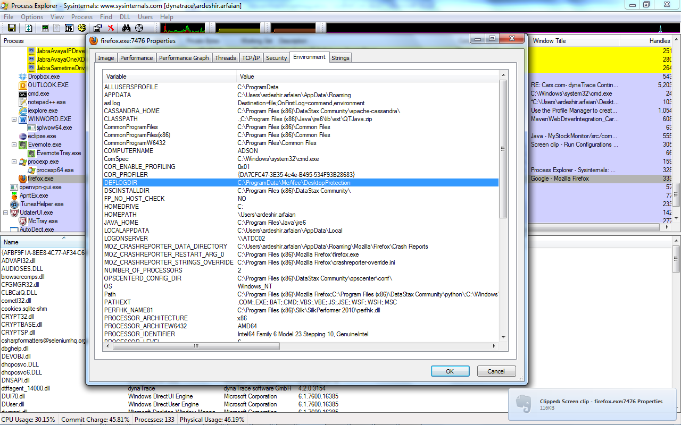

# Step 2 - Get Timers Injected (Selenium/Web Driver Integration)

## Timers

Check Additional Resources section.

## Disable Autotimers

If you are using custom defined timers you need to disable the autotimers.

## Helper Classes

Check Additional Resources section for link to Selenium/WebDriver Helper Classes.

Challenge in WebDriver: you have to customize the Helper Classes usage. One example is to integrate the WebDriverHelper accessors into the customized/extended WebDriver class.

# Step 3 - Automate dynaTrace Server Steering (Maven/Ant Integration)

## 3.1. Install dynaTrace Automation library for Maven

Note: Watch out for spaces in script

mvn install:install-file -DgroupId=dynaTrace -DartifactId=dtAutomation -Dversion=3.5 -Dpackaging=maven-plugin -Dfile=C:\path\to\dtAutomation\3.5\dtAutomation.pom

## 3.2. Adjust files in Maven M2 repository after installation

In the dynaTrace library in the m2 repository e.g. C:\Users\ardeshir.arfaian\.m2\repository\dynatrace\dtAutomation\3.5 you need to fix the following.

a) delete dtAutomation-3.5.jar

b) rename dtAutomation.jar to dtAutomation-3.5.jar

## 3.3. Add/Adjust dynaTrace properties in pom.xml

See properties in Appendix A

## 3.4. Add dynaTrace project to <projects> section

<plugin>

<groupId>dynaTrace</groupId>

<artifactId>dtAutomation</artifactId>

<version>3.5</version>

</plugin>

## 3.5. Verify dynaTrace goal

mvn dynaTrace:dtAutomation:3.5:startRecording

## 3.6. Get full list of Maven commands (see Appendix B)

mvn help:describe -DgroupId=dynaTrace -DartifactId=dtAutomation -Ddetail=true

## Next Steps

1. Identify stable unit tests which fit for performance testing
2. Setup useful Timers in Test Scripts  
   Create Hierarchical Timer   
   [<RunID>#]{<TimerNamePart>/}<TimerNameLeaf>
3. Assign Tests (Timers) to individual developers/architects
4. Fix Multiple Browser instances startup at same time
5. Eliminate Collector automatically numbering individual agents
6. Build Comparison Dashboards
7. Build Regression Tracking dashboards
8. Automate Extraction / Analysis of Dashboards using REST interfaces
9. Separate QA and CI environment
10. Automate Storage of individual CI build runs
11. Automate reporting based on individual build runs

# Additional Resources

dynaTrace in Continuous Integration <https://apmcommunity.compuware.com/community/display/PUB/dynaTrace+in+Continuous+Integration+-+The+Big+Picture>

Automation Library <https://apmcommunity.compuware.com/community/display/DL/Automation+Library+for+dynaTrace>

User Defined Timers

<https://apmcommunity.compuware.com/community/display/DOCDT42/User-defined+Timers>

REST Reporting

<https://apmcommunity.compuware.com/community/display/DOCDT42/REST+Interfaces>

<https://apmcommunity.compuware.com/community/display/DOCDT42/Server+REST+Interfaces>

<https://apmcommunity.compuware.com/community/display/DOCDT42/Server-+and+Clientside+XML+Reporting>

<https://apmcommunity.compuware.com/community/display/DOCDT42/REST+Filters>

Legacy Maven Plugin & Sample

<https://apmcommunity.compuware.com/community/display/DL/Maven+plugin>

Selenium & WebDriver Integration

<https://apmcommunity.compuware.com/community/display/PUB/How+to+include+dynaTrace+in+your+Selenium+Tests>

<https://apmcommunity.compuware.com/community/display/DL/Selenium+and+WebDriver+Integration>

# Appendix A - Maven Properties

<properties>

<!-- Setting default values for dynaTrace Maven goals that operate on a system profile: startRecording, stopRecording, clearSession, activateConfiguration, enableProfile -->

<dynaTrace.username>admin</dynaTrace.username>

<dynaTrace.password>admin</dynaTrace.password>

<dynaTrace.serverUrl>http://localhost:8020</dynaTrace.serverUrl>

<dynaTrace.systemProfile>GoSpace</dynaTrace.systemProfile>

<!-- This property will be used to store the actual Session Name for e.g.: Start/Stop Recording -->

<dynaTrace.sessionNameProperty>dynaTrace.sessionName</dynaTrace.sessionNameProperty>

<!-- Following is a list of properties for goal: startRecording -->

<dynaTrace.sessionName>My Stored Session</dynaTrace.sessionName>

<dynaTrace.sessionDescription>My stored Session Description</dynaTrace.sessionDescription>

<dynaTrace.recordingOption>all</dynaTrace.recordingOption> <!-- other options: violations|timeseries -->

<dynaTrace.sessionLocked>false</dynaTrace.sessionLocked>

<dynaTrace.appendTimestamp>false</dynaTrace.appendTimestamp>

<!-- Following is a list of properties for goal: stopRecording -->

<dynaTrace.doReanalyzeSession>true</dynaTrace.doReanalyzeSession> <!-- true to trigger reanalyze session after stop recording -->

<dynaTrace.reanalyzeSessionTimeout>60000</dynaTrace.reanalyzeSessionTimeout> <!-- timeout to wait till reanalyze session is finished - in ms (default: 60000) -->

<dynaTrace.reanalyzeSessionPollingInterval>5000</dynaTrace.reanalyzeSessionPollingInterval> <!-- polling interval while waiting for reanalyze to be finished in ms (default:5000) -->

<dynaTrace.reanalyzeStatusProperty>dynaTrace.status</dynaTrace.reanalyzeStatusProperty> <!-- property that will be set with true when reanalyze was finished within the timeout-->

<!-- Following is a list of properties for goal: reanalyzeSession -->

<dynaTrace.sessionName>My Stored Session</dynaTrace.sessionName>

<dynaTrace.reanalyzeSessionTimeout>60000</dynaTrace.reanalyzeSessionTimeout> <!-- timeout to wait till reanalyze session is finished - in ms (default: 60000) -->

<dynaTrace.reanalyzeSessionPollingInterval>5000</dynaTrace.reanalyzeSessionPollingInterval> <!-- polling interval while waiting for reanalyze to be finished in ms (default:5000) -->

<dynaTrace.reanalyzeStatusProperty>dynaTrace.status</dynaTrace.reanalyzeStatusProperty> <!-- property that will be set with true when reanalyze was finished within the timeout-->

<!-- Following is a list of properties for goal: clearSession -->

<!-- only takes the dynaTrace.systemProfile -->

<!-- Following is a list of properties for goal: activateConfiguration -->

<dynaTrace.configuration>GoSpace light</dynaTrace.configuration>

<!-- Following is a list of properties for goal: enableProfile -->

<dynaTrace.enable>true</dynaTrace.enable>

<!-- Following is a list of properties for goal: getAgentInfo -->

<dynaTrace.infoForAgentByIndex>0</dynaTrace.infoForAgentByIndex> <!-- index of the agent that information should be returned, e.g.: 0, 1, 2, ... -->

<dynaTrace.infoForAgentByName>GoSpaceFrontend</dynaTrace.infoForAgentByName> <!-- Name of the agent that information should be returned -->

<dynaTrace.agentCountProperty>dynaTrace.agentCount</dynaTrace.agentCountProperty> <!-- Property that will be set with the number of agents based on the criteria passed by infoForAgentByXXX -->

<dynaTrace.agentNameProperty>dynaTrace.agentName</dynaTrace.agentNameProperty> <!-- Property that will be set with the first agent name that matches the search criteria -->

<dynaTrace.agentHostNameProperty>dynaTrace.agentHostName</dynaTrace.agentHostNameProperty> <!-- Property that will be set with the first agent host name that matches the search criteria -->

<dynaTrace.agentProcessIdProperty>dynaTrace.agentProcessId</dynaTrace.agentProcessIdProperty> <!-- Property that will be set with the first processid that matches the search criteria -->

<!-- Following is a list of properties for Memory and Thread Dump goals: memoryDump, threadDump -->

<!-- <dynaTrace.agentHostName>MYMACHINE</dynaTrace.hostName> --> <!-- will take this from the output of getAgentInfo -->

<!-- <dynaTrace.agentName>GoSpaceFrontend</dynaTrace.agentName> --> <!-- will take this from the output of getAgentInfo -->

<!-- <dynaTrace.agentProcessId>1234</dynaTrace.processId> --> <!-- will take this from the output of getAgentInfo -->

<dynaTrace.sessionLocked>false</dynaTrace.sessionLocked>

<dynaTrace.waitForDumpTimeout>60000</dynaTrace.waitForDumpTimeout> <!-- How long to wait for the dump in ms -->

<dynaTrace.waitForDumpPollingInterval>5000</dynaTrace.waitForDumpPollingInterval> <!-- How often to poll for the status till we reach the timeout -->

<dynaTrace.dumpStatusProperty>dynaTrace.status</dynaTrace.dumpStatusProperty> <!-- Property that will be set with the status. true when succeeded - false when we ran into the timeout -->

<!-- Following is a list of properties for Memory Dump goal only: memoryDump -->

<dynaTrace.dumpType>simple</dynaTrace.dumpType> <!-- other options: extended|selective -->

<dynaTrace.memoryDumpNameProperty>dynaTrace.dumpName</dynaTrace.memoryDumpNameProperty> <!-- Property that retrieves the memory dump name -->

<!-- Following is a list of properties for Thread Dump goal only: threadDump -->

<dynaTrace.threadDumpNameProperty>dynaTrace.dumpName</dynaTrace.threadDumpNameProperty> <!-- Property that retrieves the thread dump name -->

<!-- Following is a list of properties for Reporting goal only: createReport -->

<dynaTrace.dashboardName>RulesDashboard</dynaTrace.dashboardName>

<dynaTrace.source>live:GoSpace</dynaTrace.source>

<!-- <dynaTrace.comparison>stored:Stored Session</dynaTrace.comparison> -->

<dynaTrace.iteratorDashboard>TransactionDashboard</dynaTrace.iteratorDashboard>

<!-- <dynaTrace.xmlToFile>output.xml</dynaTrace.xmlToFile> -->

<dynaTrace.reportDir>./results</dynaTrace.reportDir>

<dynaTrace.createHtml>true</dynaTrace.createHtml>

<!-- Following is a list of properties for Reporting goal only: architectureValidation -->

<dynaTrace.source>live:GoSpace</dynaTrace.source>

<!-- <dynaTrace.comparison>stored:Stored Session</dynaTrace.comparison> -->

<dynaTrace.errorProperty>./results/dynaTrace.error</dynaTrace.errorProperty>

<dynaTrace.reportFile>./results/archivalresults.xml</dynaTrace.reportFile>

<dynaTrace.archiValFile>archivalrules.xml</dynaTrace.archiValFile>

</properties>

# Appendix B - Maven Commands

[INFO] Scanning for projects...

[INFO]

[INFO] ------------------------------------------------------------------------

[INFO] Building dynaTrace Automation 3.5

[INFO] ------------------------------------------------------------------------

[INFO]

[INFO] --- maven-help-plugin:2.1.1:describe (default-cli) @ dtAutomation ---

[INFO] dynaTrace:dtAutomation:3.5

Name: dynaTrace Automation

Description: (no description available)

Group Id: dynaTrace

Artifact Id: dtAutomation

Version: 3.5

Goal Prefix: dtAutomation

This plugin has 14 goals:

dtAutomation:activateConfiguration

Description: (no description available)

Implementation:

com.dynatrace.diagnostics.automation.maven.DtActivateConfiguration

Language: java

Bound to phase: pre-integration-test

Available parameters:

configuration

Expression: ${dynaTrace.configuration}

The configuration name to activate

mavenProject (Default: ${project})

(no description available)

password (Default: admin)

Expression: ${dynaTrace.password}

The password

profileName

Expression: ${dynaTrace.systemProfile}

The system profile to use.

serverUrl (Default: http://localhost:8020)

Expression: ${dynaTrace.serverUrl}

The dynaTrace server URL

username (Default: admin)

Expression: ${dynaTrace.username}

The username

dtAutomation:architectureValidation

Description: (no description available)

Implementation:

com.dynatrace.diagnostics.automation.maven.DtArchitectureValidation

Language: java

Bound to phase: verify

Available parameters:

archiValFile

Expression: ${dynaTrace.archiValFile}

The architecture validation rule file

comparison

Expression: ${dynaTrace.comparison}

The comparison source

errorProperty

Expression: ${dynaTrace.errorProperty}

The property name to report back errors

mavenProject (Default: ${project})

(no description available)

password (Default: admin)

Expression: ${dynaTrace.password}

The password

reportFile

Expression: ${dynaTrace.reportFile}

The output file name

serverUrl (Default: http://localhost:8020)

Expression: ${dynaTrace.serverUrl}

The dynaTrace server URL

source

Expression: ${dynaTrace.source}

The data source

username (Default: admin)

Expression: ${dynaTrace.username}

The username

dtAutomation:clearSession

Description: (no description available)

Implementation: com.dynatrace.diagnostics.automation.maven.DtClearSession

Language: java

Bound to phase: pre-integration-test

Available parameters:

mavenProject (Default: ${project})

(no description available)

password (Default: admin)

Expression: ${dynaTrace.password}

The password

profileName

Expression: ${dynaTrace.systemProfile}

The system profile to use.

serverUrl (Default: http://localhost:8020)

Expression: ${dynaTrace.serverUrl}

The dynaTrace server URL

username (Default: admin)

Expression: ${dynaTrace.username}

The username

dtAutomation:createReport

Description: (no description available)

Implementation: com.dynatrace.diagnostics.automation.maven.DtCreateReport

Language: java

Bound to phase: verify

Available parameters:

comparison

Expression: ${dynaTrace.comparison}

Optional comparison data source

createHtml

Expression: ${dynaTrace.createHtml}

Output directory

dashboardName

Expression: ${dynaTrace.dashboardName}

The data source

iteratorDashboard

Expression: ${dynaTrace.iteratorDashboard}

Optional iterating Dashboard

mavenProject (Default: ${project})

(no description available)

password (Default: admin)

Expression: ${dynaTrace.password}

The password

reportDir

Expression: ${dynaTrace.reportDir}

Output directory

serverUrl (Default: http://localhost:8020)

Expression: ${dynaTrace.serverUrl}

The dynaTrace server URL

source

Expression: ${dynaTrace.source}

The data source

username (Default: admin)

Expression: ${dynaTrace.username}

The username

xmlToFile

Expression: ${dynaTrace.xmlToFile}

Output xml file for the results

dtAutomation:enableProfile

Description: (no description available)

Implementation: com.dynatrace.diagnostics.automation.maven.DtEnableProfile

Language: java

Bound to phase: pre-integration-test

Available parameters:

enable (Default: true)

Expression: ${dynaTrace.enable}

Enable or disable the profile

mavenProject (Default: ${project})

(no description available)

password (Default: admin)

Expression: ${dynaTrace.password}

The password

profileName

Expression: ${dynaTrace.systemProfile}

The system profile to use.

serverUrl (Default: http://localhost:8020)

Expression: ${dynaTrace.serverUrl}

The dynaTrace server URL

username (Default: admin)

Expression: ${dynaTrace.username}

The username

dtAutomation:getAgentInfo

Description: (no description available)

Implementation: com.dynatrace.diagnostics.automation.maven.DtGetAgentInfo

Language: java

Bound to phase: verify

Available parameters:

agentCountProperty

Expression: ${dynaTrace.agentCountProperty}

(no description available)

agentHostNameProperty

Expression: ${dynaTrace.agentHostNameProperty}

(no description available)

agentNameProperty

Expression: ${dynaTrace.agentNameProperty}

(no description available)

agentProcessIdProperty

Expression: ${dynaTrace.agentProcessIdProperty}

(no description available)

infoForAgentByIndex (Default: -1)

Expression: ${dynaTrace.infoForAgentByIndex}

(no description available)

infoForAgentByName

Expression: ${dynaTrace.infoForAgentByName}

(no description available)

mavenProject (Default: ${project})

(no description available)

password (Default: admin)

Expression: ${dynaTrace.password}

The password

serverUrl (Default: http://localhost:8020)

Expression: ${dynaTrace.serverUrl}

The dynaTrace server URL

username (Default: admin)

Expression: ${dynaTrace.username}

The username

dtAutomation:memoryDump

Description: (no description available)

Implementation: com.dynatrace.diagnostics.automation.maven.DtMemoryDump

Language: java

Bound to phase: verify

Available parameters:

agentName

Expression: ${dynaTrace.agentName}

The agents name

dumpStatusProperty

Expression: ${dynaTrace.dumpStatusProperty}

(no description available)

dumpType (Default: simple)

Expression: ${dynaTrace.dumpType}

(no description available)

hostName

Expression: ${dynaTrace.agentHostName}

The host name of the agent

mavenProject (Default: ${project})

(no description available)

memoryDumpNameProperty

Expression: ${dynaTrace.memoryDumpNameProperty}

(no description available)

password (Default: admin)

Expression: ${dynaTrace.password}

The password

processId

Expression: ${dynaTrace.agentProcessId}

The process id of the agent

profileName

Expression: ${dynaTrace.systemProfile}

The system profile to use.

serverUrl (Default: http://localhost:8020)

Expression: ${dynaTrace.serverUrl}

The dynaTrace server URL

sessionLocked (Default: true)

Expression: ${dynaTrace.sessionLocked}

(no description available)

username (Default: admin)

Expression: ${dynaTrace.username}

The username

waitForDumpPollingInterval (Default: 5000)

Expression: ${dynaTrace.waitForDumpPollingInterval}

(no description available)

waitForDumpTimeout (Default: 60000)

Expression: ${dynaTrace.waitForDumpTimeout}

(no description available)

dtAutomation:reanalyzeSession

Description: (no description available)

Implementation: com.dynatrace.diagnostics.automation.maven.DtReanalyzeSession

Language: java

Bound to phase: verify

Available parameters:

mavenProject (Default: ${project})

(no description available)

password (Default: admin)

Expression: ${dynaTrace.password}

The password

serverUrl (Default: http://localhost:8020)

Expression: ${dynaTrace.serverUrl}

The dynaTrace server URL

username (Default: admin)

Expression: ${dynaTrace.username}

The username

dtAutomation:restartCollector

Description: (no description available)

Implementation: com.dynatrace.diagnostics.automation.maven.DtRestartCollector

Language: java

Bound to phase: pre-integration-test

Available parameters:

mavenProject (Default: ${project})

(no description available)

password (Default: admin)

Expression: ${dynaTrace.password}

The password

serverUrl (Default: http://localhost:8020)

Expression: ${dynaTrace.serverUrl}

The dynaTrace server URL

username (Default: admin)

Expression: ${dynaTrace.username}

The username

dtAutomation:restartServer

Description: (no description available)

Implementation: com.dynatrace.diagnostics.automation.maven.DtRestartServer

Language: java

Bound to phase: pre-integration-test

Available parameters:

mavenProject (Default: ${project})

(no description available)

password (Default: admin)

Expression: ${dynaTrace.password}

The password

serverUrl (Default: http://localhost:8020)

Expression: ${dynaTrace.serverUrl}

The dynaTrace server URL

username (Default: admin)

Expression: ${dynaTrace.username}

The username

dtAutomation:setTestInformation

Description: Sets Test Meta Data Information for Test Automation

Implementation:

com.dynatrace.diagnostics.automation.maven.DtSetTestInformation

Language: java

Bound to phase: pre-integration-test

Available parameters:

additionalProperties

(no description available)

agentGroup

(no description available)

marker

Expression: ${dynaTrace.marker}

(no description available)

mavenProject (Default: ${project})

(no description available)

password (Default: admin)

Expression: ${dynaTrace.password}

The password

profileName

Expression: ${dynaTrace.systemProfile}

The system profile to use.

serverUrl (Default: http://localhost:8020)

Expression: ${dynaTrace.serverUrl}

The dynaTrace server URL

username (Default: admin)

Expression: ${dynaTrace.username}

The username

versionBuild

Expression: ${dynaTrace.versionBuild}

(no description available)

versionMajor

Expression: ${dynaTrace.versionMajor}

(no description available)

versionMilestone

Expression: ${dynaTrace.versionMilestone}

(no description available)

versionMinor

Expression: ${dynaTrace.versionMinor}

(no description available)

versionRevision

Expression: ${dynaTrace.versionRevision}

(no description available)

dtAutomation:startRecording

Description: (no description available)

Implementation: com.dynatrace.diagnostics.automation.maven.DtStartRecording

Language: java

Bound to phase: pre-integration-test

Available parameters:

appendTimestamp

Expression: ${dynaTrace.appendTimestamp}

(no description available)

mavenProject (Default: ${project})

(no description available)

password (Default: admin)

Expression: ${dynaTrace.password}

The password

profileName

Expression: ${dynaTrace.systemProfile}

The system profile to use.

recordingOption (Default: all)

Expression: ${dynaTrace.recordingOption}

(no description available)

serverUrl (Default: http://localhost:8020)

Expression: ${dynaTrace.serverUrl}

The dynaTrace server URL

sessionDescription

Expression: ${dynaTrace.sessionDescription}

(no description available)

sessionLocked

Expression: ${dynaTrace.sessionLocked}

(no description available)

sessionName

Expression: ${dynaTrace.sessionName}

(no description available)

sessionNameProperty

Expression: ${dynaTrace.sessionNameProperty}

(no description available)

username (Default: admin)

Expression: ${dynaTrace.username}

The username

dtAutomation:stopRecording

Description: (no description available)

Implementation: com.dynatrace.diagnostics.automation.maven.DtStopRecording

Language: java

Bound to phase: post-integration-test

Available parameters:

doReanalyzeSession

Expression: ${dynaTrace.doReanalyzeSession}

(no description available)

mavenProject (Default: ${project})

(no description available)

password (Default: admin)

Expression: ${dynaTrace.password}

The password

profileName

Expression: ${dynaTrace.systemProfile}

The system profile to use.

reanalyzeSessionPollingInterval (Default: 5000)

Expression: ${dynaTrace.reanalyzeSessionPollingInterval}

(no description available)

reanalyzeSessionTimeout (Default: 60000)

Expression: ${dynaTrace.reanalyzeSessionTimeout}

(no description available)

reanalyzeStatusProperty

Expression: ${dynaTrace.reanalyzeStatusProperty}

(no description available)

serverUrl (Default: http://localhost:8020)

Expression: ${dynaTrace.serverUrl}

The dynaTrace server URL

sessionNameProperty

Expression: ${dynaTrace.sessionNameProperty}

(no description available)

username (Default: admin)

Expression: ${dynaTrace.username}

The username

dtAutomation:threadDump

Description: (no description available)

Implementation: com.dynatrace.diagnostics.automation.maven.DtThreadDump

Language: java

Bound to phase: verify

Available parameters:

agentName

Expression: ${dynaTrace.agentName}

The agents name

dumpStatusProperty

Expression: ${dynaTrace.dumpStatusProperty}

(no description available)

hostName

Expression: ${dynaTrace.agentHostName}

The host name of the agent

mavenProject (Default: ${project})

(no description available)

password (Default: admin)

Expression: ${dynaTrace.password}

The password

processId

Expression: ${dynaTrace.agentProcessId}

The process id of the agent

profileName

Expression: ${dynaTrace.systemProfile}

The system profile to use.

serverUrl (Default: http://localhost:8020)

Expression: ${dynaTrace.serverUrl}

The dynaTrace server URL

sessionLocked

Expression: ${dynaTrace.sessionLocked}

(no description available)

threadDumpNameProperty

Expression: ${dynaTrace.threadDumpNameProperty}

(no description available)

username (Default: admin)

Expression: ${dynaTrace.username}

The username

waitForDumpPollingInterval (Default: 5000)

Expression: ${dynaTrace.waitForDumpPollingInterval}

(no description available)

waitForDumpTimeout (Default: 60000)

Expression: ${dynaTrace.waitForDumpTimeout}

(no description available)

[INFO] ------------------------------------------------------------------------

[INFO] BUILD SUCCESS

[INFO] ------------------------------------------------------------------------

[INFO] Total time: 2.030s

[INFO] Finished at: Tue Aug 21 14:23:15 EDT 2012

[INFO] Final Memory: 8M/153M

[INFO] ------------------------------------------------------------------------