# Extended Mail Action Plugin

Eugene Turetsky, Compuware Corp

Contents

Extended Mail Action Plugin 1

1. Plugin parameters 3

1.1. dynaTrace Server 3

1.2. dynaTrace Server REST Port 4

1.3. dynaTrace Server User 4

1.4. dynaTrace User Password 4

1.5. SMTP Mail server Parameters 4

1.5.1. SMTP Host 4

1.5.2. SMTP Port 4

1.5.3. SMTP Secure Connection (SSL) 4

1.5.4. SMTP User 4

1.5.5. SMTP User Password 4

1.6. From 5

1.7. To 5

1.8. CC 5

1.9. BCC 5

1.10. Subject Prefix 5

1.11. Subject 5

1.12. Subject Suffix 6

1.13. Body Header 6

1.14. Body 6

1.15. Body Footer 6

1.16. Dashboard Names 6

1.17. Reports filtering by Agent Name/Host 6

1.18. Reports filtering by Agent Group 7

1.19. Reports filtering by custom timeframe 7

1.20. Agents 7

1.21. Agent Groups 7

1.22. Monitors 8

1.23. Collectors 8

1.24. Hosts 8

2. Filtering 9

3. Reports 10

3.1 Reports filtering 11

4. Custom text 11

Figure 1 Measure configuration for agents 9

Figure 2 Measure configuration for monitors 10

Figure 3 Measure configuration for agent groups 10

Figure 4 Body Header example 14

Figure 5 Content of the BodyExample.html page 15

Figure 6 Screenshot of the BodyExample.html page in Outlook 15

### Plugin parameters

Plugin has the following parameters:

* dynaTrace Server*
* dynaTrace Server REST Port
* dynaTrace Server User
* dynaTrace User Password
* SMTP Host*
* SMTP Port*
* SMTP Secure Connection (SSL)*
* SMTP User
* SMTP User Password
* From*
* To
* CC
* BCC
* Subject Prefix
* Subject
* Subject Suffix
* Body Header
* Body
* Body Footer
* Dashboard Names
* Reports filtering by Agent Name/Host
* Reports filtering by Agent Group
* Reports filtering by Custom Timeframe
* Agents
* Agent Groups
* Monitors
* Collectors
* Hosts  
    
  *\* Indicates required parameter*

The following sections of the document contain details for each of the above parameters

### dynaTrace Server

Description: Name of the dynaTrace server. It could contain DNS name or IP address. This parameter is required.

Default Value: localhost

### dynaTrace Server REST Port

Description: REST interface port number. This parameter is optional.

Default Value: 8020

### dynaTrace Server User

Description: User name that will be used connect to dynaTrace server to generate PDF reports through the REST interface. This parameter is optional.

Default Value: admin

### dynaTrace User Password

Description: Password of the dynaTrace user. This parameter is optional.

Default Value: None

### SMTP Mail server Parameters

Next five sub-sections contain parameters for a mail server used by the plugin. Make sure that these parameters are set correctly by emulating incident and getting notification e-mail from the plugin. This parameter is optional.

#### SMTP Host

Description: Mail server host. This parameter is required.

Default Value: None

#### SMTP Port

Description: Mail server port number. This parameter is required.

Default Value: 25 for non-SSL connections

#### SMTP Secure Connection (SSL)

Description: Boolean value which indicates if SSL communication is used. This parameter is required.

Default Value: False, i.e. box is unchecked

#### SMTP User

Description: User which will be connecting to the SMTP server. This parameter is set for SSL connections. This parameter is optional.

Default Value: None

#### SMTP User Password

Description: Password for the user which will connect to the SMTP server. This parameter is set for SSL connections. This parameter is optional. It is required when SSL communication is used by the SMTP server.

Default Value: None

### From

Description: E-mail address which plugin sends e-mail from. This parameter is required.

Default Value: Template name@company-name.com. This template must be removed during plugin setup process.

### To

Description: E-mail address or semicolon (“;”) separated list of e-mail addresses or address groups which plugin sends e-mail to. This parameter is optional, however, To, CC, or BCC parameters should have at least one e-mail address that plugin will send e-mail to.

Default Value: Template group [Incident Email Group]. This template must be removed during plugin setup process otherwise exception will be thrown.

### CC

Description: E-mail address or semicolon (“;”) separated list of e-mail addresses or address groups which plugin CC e-mail to. This parameter is optional, however, To, CC, or BCC parameters should have at least one e-mail address that plugin will send e-mail to.

Default Value: Template group [Incident Email Group]. This template must be removed during plugin setup process otherwise exception will be thrown.

### BCC

Description: E-mail address or semicolon (“;”) separated list of e-mail addresses or address groups which plugin BCC e-mail to. This parameter is optional, however, To, CC, or BCC parameters should have at least one e-mail address that plugin will send e-mail to.

Default Value: Template group [Incident Email Group]. This template must be removed during plugin setup process otherwise exception will be thrown.

### Subject Prefix

Description: Text which will pre-pend e-mail’s subject. This parameter is optional. Predefined variables (see description in section below) can be embedded in the subject prefix text.

Default Value: None

Example: “My prefix”

### Subject

Description: Text which will be placed in the Subject area of the e-mail. When parameter is set it will replace OOTB subject. This parameter is optional. Predefined variables (see description in section below) can be embedded in the subject text.

Default Value: None

Example: “My subject”

### Subject Suffix

Description: Text which will append e-mail’s subject. This parameter is optional. Predefined variables (see description in section below) can be embedded in the subject suffix text.

Default Value: None

Example: “My suffix”

### Body Header

Description: Body Header is HTML table which will pre-pend e-mail’s body. Body Header is multiline parameter. This parameter is optional. Predefined variables (see description in section below) can be embedded in the HTML table.

Default Value: None

Example: <table><tr><td>This is my Body Header</td></tr></table>

### Body

Description: Body is HTML page which replaces OOTB e-mail’s body. Body is multiline parameter. This parameter is optional. Predefined variables (see description in section below) can be embedded in the HTML table.

Default Value: None

Example: <html><body><table><tr><td>This is my Body </td></tr></table></body></html>

### Body Footer

Description: Body Footer is HTML table which will append e-mail’s body. Body Footer is multiline parameter. When this parameter is present it replaces OOTB body footer. This parameter is optional. Predefined variables (see description in section below) can be embedded in the HTML table.

Default Value: None

Example: <table><tr><td>This is my Body Footer</td></tr></table>

### Dashboard Names

Description: dashboard name or semicolon (“;”) separated list of dashboard names. This parameter is optional. When it is present plugin will generate PDF file for every dashboard in the list and attach them to the e-mail.

Default Value: None

### Reports filtering by Agent Name/Host

Description: Boolean value which indicates if incident’s agents will be applied as a REST filter to the reports from item 1.16.

Default Value: false

### Reports filtering by Agent Group

Description: Boolean value which indicates if incident’s agent groups will be applied as a REST filter to the reports from item 1.16.

Default Value: false

### Reports filtering by custom timeframe

Description: Boolean value which indicates if incident’s start and end dates will be applied as a REST filter to the reports from item 1.16.

Default Value: false

### Agents

Description: Java regular expression pattern which represents dynaTrace agent name or semicolon (“;”) separated list of Java regular expression patterns which represent dynaTrace agent names that plugin will use to filter incidents. When this parameter is present, e-mail will be sent by the plugin only if there is at least one agent from the list which initiated the incident(s). This parameter is optional.

Default Value: None

Note: Java regular expressions are case sensitive. Please see more about Java regular expression patterns [here](http://docs.oracle.com/javase/7/docs/api/java/util/regex/Pattern.html).

Examples: “Agent[XYZ]” matches “AgentX”, or “AgentY”, or “AgentZ”.   
“Agent.*” matches “Agent123”, “Agent4567”, and “AgentAnyTextHere”.  
“.*Agent.*” matches any text which contains “Agent” pattern inside, e.g. “AnyTextHereAgentAnyTextThere”.  
“agent[0-9]” matches “agent0”, “agent1”, etc. but does not match “Agent0”, “Agent1”, etc. because pattern is case sensitive.

### Agent Groups

Description: Java regular expression pattern which represents dynaTrace agent group name or semicolon (“;”) separated list of Java regular expression patterns which represent dynaTrace agent group names that plugin will use to filter incidents. When this parameter is present, e-mail will be sent by the plugin only if there is at least one agent group from the list which initiated the incident(s). This parameter is optional.

Default Value: None

Note: Java regular expressions are case sensitive. Please see more about Java regular expression patterns [here](http://docs.oracle.com/javase/7/docs/api/java/util/regex/Pattern.html).

Examples: See section 1.20.

### Monitors

Description: Java regular expression pattern which represents dynaTrace monitor name or semicolon (“;”) separated list of Java regular expression patterns which represents dynaTrace monitor names that plugin will use to filter incidents. When this parameter is present, e-mail will be sent by the plugin only if there is at least one monitor from the list which initiated the incident(s). This parameter is optional.

**Note**

Plugin enhances underlying dynaTrace interface and adds ability for monitor incidents to filter by monitor’s hosts. Customer can add monitor’s host name to the hosts’ parameter to get notifications only when incident was triggered by the monitor running on the given host.

Default Value: None

Note: Java regular expressions are case sensitive. Please see more about Java regular expression patterns [here](http://docs.oracle.com/javase/7/docs/api/java/util/regex/Pattern.html).

Examples: See section 1.20.

### Collectors

Description: Java regular expression pattern which represents dynaTrace collector name or semicolon (“;”) separated list of Java regular expression patterns which represents dynaTrace collector names that plugin will use to filter incidents. When this parameter is present, e-mail will be sent by the plugin only if there is at least one collector from the list which initiated the incident(s). This parameter is optional.

Default Value: None

Note: Java regular expressions are case sensitive. Please see more about Java regular expression patterns [here](http://docs.oracle.com/javase/7/docs/api/java/util/regex/Pattern.html).

Examples: See section 1.20.

### Hosts

Description: Java regular expression pattern which represents host name or semicolon (“;”) separated list of Java regular expression patterns which represents host names that plugin will use to filter incidents. When this parameter is present, e-mail will be sent by the plugin only if there is at least one host from the list which initiated the incident(s). This parameter is optional.

Default Value: None

Note: Java regular expressions are case sensitive. Please see more about Java regular expression patterns [here](http://docs.oracle.com/javase/7/docs/api/java/util/regex/Pattern.html).

Examples: See section 1.20.



## **Filtering**

List of agents/monitors/agent groups/collectors/hosts which are described above are used to filter incidents. Plugin sends e-mail only if incident was triggered by at least one agent, or agent group, or monitor, or collector, or host from the above lists. Make sure that “create a measure for each agent” and/or “create a measure for each host” option is checked for filtering. See Figure 1 – 2 for details. Agent groups should be selected in order to filter by agent group names. For details please see Figure 3.

**Note**

* To avoid missing e-mails for important incidents use extra caution when setting up filtering parameters
* Check plugin’s log for the following message "Incident(s) were raised but notification e-mail was not sent." to make sure that notifications for the incidents were not missed.

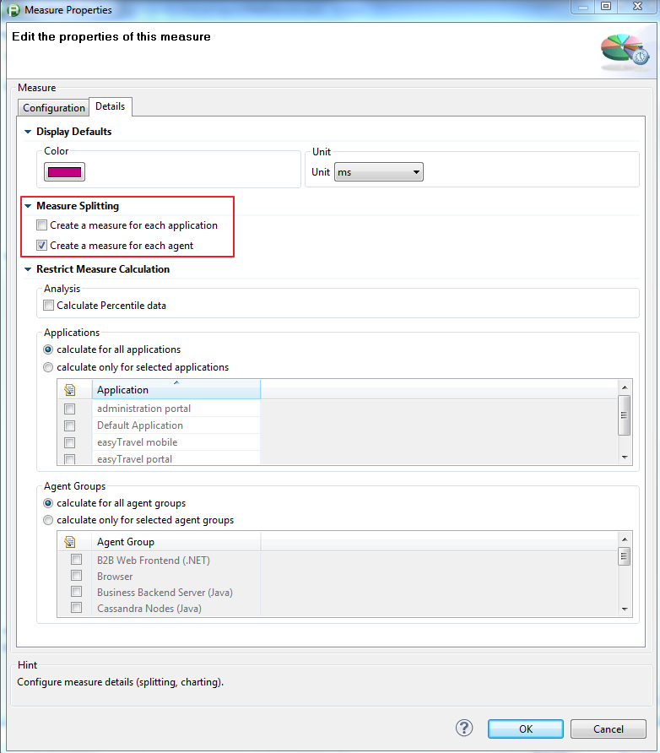

Figure Measure configuration for agents

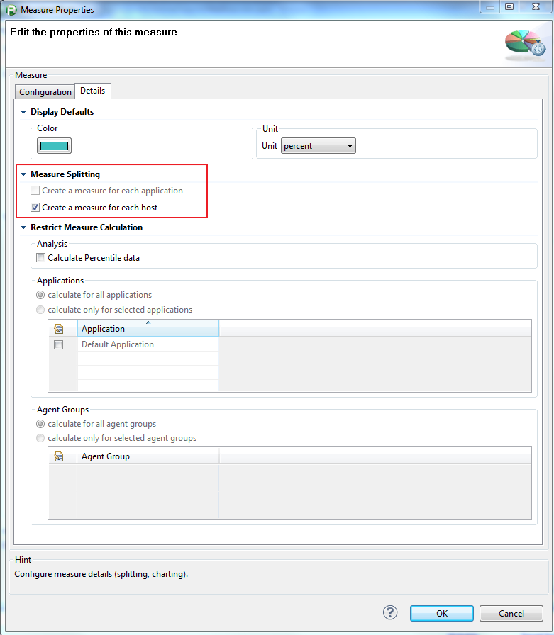

Figure 2 Measure configuration for monitors

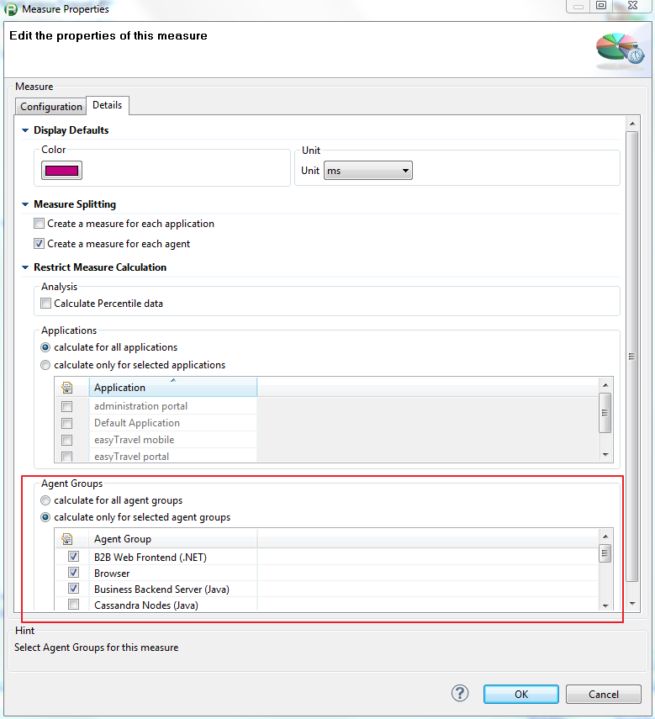

Figure 3 Measure configuration for agent groups

## Reports

Customer has ability to enter list of dashboards (OOTB and/or custom dashboards) that will be attached to the e-mail. See Dashboard Names parameter above.

## Reports filtering

Customer has ability to filter reports by agent names/hosts, agent groups, and custom timeframe. See Reports filtering parameters above.

## Custom text

There are the following parameters that can customize content of the notification e-mail which is sent by plugin:

1. Subject prefix
2. Subject
3. Subject suffix
4. Body Header (multiline)
5. Body (multiline)
6. Body Footer (multiline)

The first three parameters contain plain text while the Body parameter is a HTML page which is following the HTML syntax requirements, Body Header and Body Footer parameters are HTML tables. The Body parameter could be as simple as <html><body><table><tr><td>My Body</td></tr></table></body></html> or as complex as in the example at the end of this section. There are no restrictions on how/what body HTML page or body HTML tables should contain. It is absolutely up to user to design and use them by the plugin.

As mentioned above,

* Subject parameter is replacing OOTB subject when it is set by a user;
* Body parameter is replacing OOTB body when it is set by a user;
* Body Footer parameter is replacing OOTB body footer when it is set by a user.

Custom text parameters can use predefined variables embedded into their text. Values of these variables calculated at run time. Plugin maintains 139 predefined variables. They are:

* + *AGENT_NAME*,
  + *AGENT_NAME_1*,
  + *AGENT_NAME_2*,
  + *AGENT_NAME_3*,
  + *AGENT_NAME_4*,
  + *AGENT_NAME_5*,
  + *AGENT_HOST*,
  + *AGENT_HOST_1*,
  + *AGENT_HOST_2*,
  + *AGENT_HOST_3*,
  + *AGENT_HOST_4*,
  + *AGENT_HOST_5*,
  + *AGENT_HOST_IP_ADDRESS*,
  + *AGENT_HOST_IP_ADDRESS_1*,
  + *AGENT_HOST_IP_ADDRESS_2*,
  + *AGENT_HOST_IP_ADDRESS_3*,
  + *AGENT_HOST_IP_ADDRESS_4*,
  + *AGENT_HOST_IP_ADDRESS_5*,
  + *ALL_AGENT_NAMES*,
  + *ALL_AGENT_HOSTS*,
  + *ALL_AGENT_HOSTS_IP_ADDRESSES*,
  + *ALL_AGENTS*,
  + *AGENT_GROUP_NAME*,
  + *AGENT_GROUP_NAME_1*,
  + *AGENT_GROUP_NAME_2*,
  + *AGENT_GROUP_NAME_3*,
  + *AGENT_GROUP_NAME_4*,
  + *AGENT_GROUP_NAME_5*,
  + *ALL_AGENT_GROUP_NAMES*,
  + *MONITOR_NAME*,
  + *MONITOR_NAME_1*,
  + *MONITOR_NAME_2*,
  + *MONITOR_NAME_3*,
  + *MONITOR_NAME_4*,
  + *MONITOR_NAME_5*,
  + *MONITOR_HOST*,
  + *MONITOR_HOST_1*,
  + *MONITOR_HOST_2*,
  + *MONITOR_HOST_3*,
  + *MONITOR_HOST_4*,
  + *MONITOR_HOST_5*,
  + *MONITOR_HOST_IP_ADDRESS*,
  + *MONITOR_HOST_IP_ADDRESS_1*,
  + *MONITOR_HOST_IP_ADDRESS_2*,
  + *MONITOR_HOST_IP_ADDRESS_3*,
  + *MONITOR_HOST_IP_ADDRESS_4*,
  + *MONITOR_HOST_IP_ADDRESS_5*,
  + *ALL_MONITOR_NAMES*,
  + *ALL_MONITOR_HOSTS*,
  + *ALL_MONITOR_HOSTS_IP_ADDRESSES*,
  + *ALL_MONITORS*,
  + *COLLECTOR_NAME*,
  + *COLLECTOR_NAME_1*,
  + *COLLECTOR_NAME_2*,
  + *COLLECTOR_NAME_3*,
  + *COLLECTOR_NAME_4*,
  + *COLLECTOR_NAME_5*,
  + *COLLECTOR_HOST*,
  + *COLLECTOR_HOST_1*,
  + *COLLECTOR_HOST_2*,
  + *COLLECTOR_HOST_3*,
  + *COLLECTOR_HOST_4*,
  + *COLLECTOR_HOST_5*,
  + *COLLECTOR_HOST_IP_ADDRESS*,
  + *COLLECTOR_HOST_IP_ADDRESS_1*,
  + *COLLECTOR_HOST_IP_ADDRESS_2*,
  + *COLLECTOR_HOST_IP_ADDRESS_3*,
  + *COLLECTOR_HOST_IP_ADDRESS_4*,
  + *COLLECTOR_HOST_IP_ADDRESS_5*,
  + *ALL_COLLECTOR_NAMES*,
  + *ALL_COLLECTOR_HOSTS*,
  + *ALL_COLLECTOR_HOSTS_IP_ADDRESSES*,
  + *ALL_COLLECTORS*,
  + *SERVER_NAME*,
  + *SERVER_NAME_1*,
  + *SERVER_NAME_2*,
  + *SERVER_NAME_3*,
  + *SERVER_NAME_4*,
  + *SERVER_NAME_5*,
  + *SERVER_HOST_IP_ADDRESS*,
  + *SERVER_HOST_IP_ADDRESS_1*,
  + *SERVER_HOST_IP_ADDRESS_2*,
  + *SERVER_HOST_IP_ADDRESS_3*,
  + *SERVER_HOST_IP_ADDRESS_4*,
  + *SERVER_HOST_IP_ADDRESS_5*,
  + *ALL_SERVER_HOSTS_IP_ADDRESSE*S
  + *ALL_SERVER_NAMES*,
  + *DYNATRACE_SERVER_NAME*,
  + *DYNATRACE_SERVER_REST_PORT,*
  + *MESSAGE*,
  + *RULE_NAME*,
  + *RULE_DESCRIPTION*,
  + *SENSITIVITY*,
  + *SESSION_ID*,
  + *SESSION_NAME*,
  + *START_TIME*,
  + *END_TIME*,
  + *DURATION*,
  + *IS_OPEN*,
  + *IS_CLOSED*,
  + *SEVERITY*,
  + *KEY*,
  + *STATE*,
  + *SYSTEM_PROFILE*,
  + *APPLICATION*,
  + *VIOLATED_MEASURE_NAME*,
  + *VIOLATED_MEASURE_DESCRIPTION*,
  + *VIOLATED_MEASURE_VALUE*,
  + *VIOLATED_MEASURE_UNIT*,
  + *VIOLATED_MEASURE_SPLITTINGS*,
  + *VIOLATED_MEASURE_TRESHOLD_UPPER_SEVERE*,
  + *VIOLATED_MEASURE_TRESHOLD_LOWER_SEVERE*,
  + *VIOLATED_MEASURE_TRESHOLD_UPPER_WARNING*,
  + *VIOLATED_MEASURE_TRESHOLD_LOWER_WARNING*,
  + *VIOLATED_MEASURE_METRIC_NAME*,
  + *VIOLATED_MEASURE_METRIC_DESCRIPTION*,
  + *VIOLATED_MEASURE_METRIC_GROUP*,
  + *VIOLATED_MEASURE_METRIC_UNIT*,
  + *VIOLATED_TRIGGER_VALUE_SOURCE_TYPE*,
  + *VIOLATED_TRIGGER_VALUE_SOURCE_NAME*,
  + *VIOLATED_TRIGGER_VALUE_SOURCE_HOST*,
  + *VIOLATED_TRIGGER_VALUE*,
  + *VIOLATION_HEADER_1*,
  + *VIOLATION_MESSAGE_1*,
  + *VIOLATION_HEADER_2*,
  + *VIOLATION_MESSAGE_2*,
  + *VIOLATION_HEADER_3*,
  + *VIOLATION_MESSAGE_3*,
  + *VIOLATION_HEADER_4*,
  + *VIOLATION_MESSAGE_4*,
  + *VIOLATION_HEADER_5*,
  + *VIOLATION_MESSAGE_5*,
  + *INCIDENT_STARTED_ENDED*,
  + *IMAGE_WARNING_OK,*
  + *DASHBOARD_URL_1,*
  + *DASHBOARD_URL_2,*
  + *DASHBOARD_URL_3,*
  + *DASHBOARD_URL_4,*
  + *DASHBOARD_URL_5.*

The following notation is used to embed variables in the text:

* ${variable-name}, where variable-name is one of the names from the above list.

Next is example of the custom text:

“I do not like incidents, especially when they are coming from the agent ${AGENT_NAME} which is running on the host ${AGENT_HOST}”.

Plugin jar file in the src directory contains examples of custom Body Header, Body Footer, and Body parameters. The BodyHeaderExample.html file is a fragment of the HTML page which contains HTML table with 52 variables (see Figure 4).

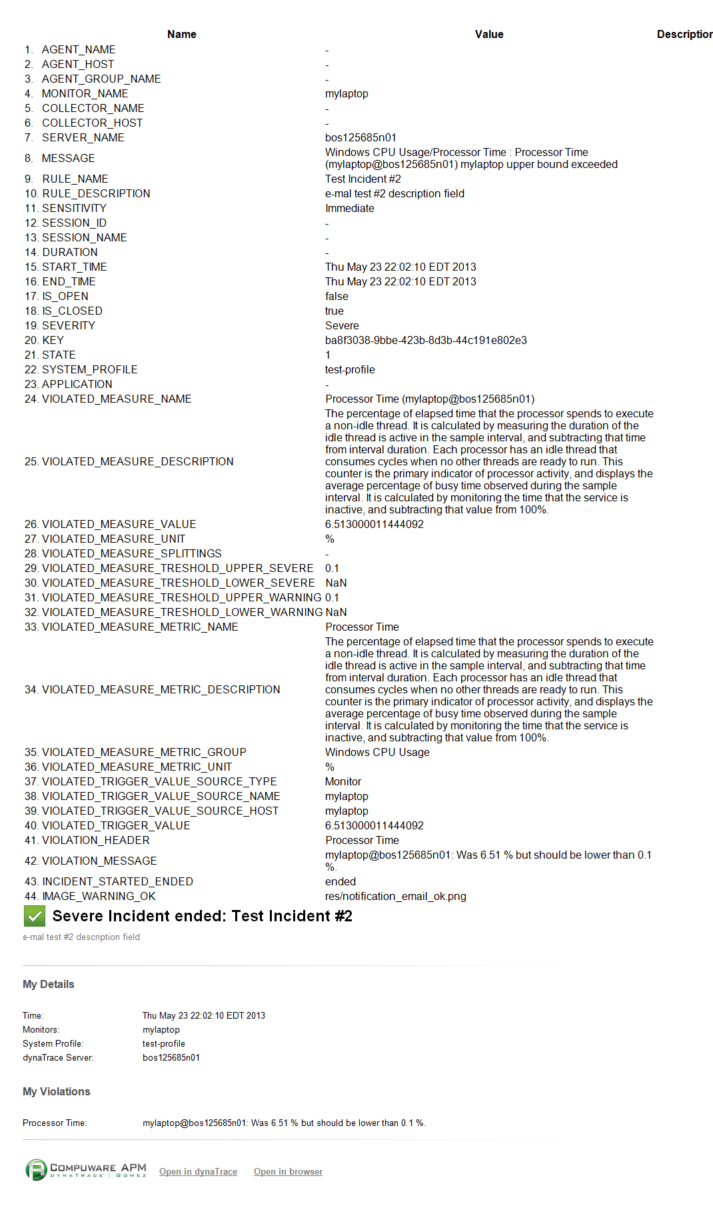

Figure 4 Body Header example

The BodyExample.html contains example of how the OOTB notification e-mail can be customized by fully replacing it with Body parameter. Figure 5 contains content of the BodyExample.html file. Places where predefined variables were inserted in the Body HTML page are highlighted in yellow. Figure 6 contains customized e-mail screenshot in Outlook.

<!DOCTYPE HTML PUBLIC "-//W3C//DTD HTML 4.01 Transitional//EN">

<html>

<head>

<style type=*"text/css"*>**body** {font-family: *Arial*;}</style></head>

<body style="font-family: *'Arial'*; margin: *24px*; color: *#505050*;">

<table style="border: *0px*;" cellpadding=*"0"* cellspacing=*"0"*><tr><td style="width: *5px*; margin-right: *8px*;"><img

src=*"dtbundleresource:${IMAGE_WARNING_OK}"* /></td><td style="width: *795px*;"><div style="font-size: *1.5em*; font-weight:

*bold*;">${SEVERITY} Incident ${INCIDENT_STARTED_ENDED}: ${RULE_NAME}</div></td></tr><tr><td colspan=*"2"*><div

style="font-size: *0.8em*; color: *#737373*; margin-top: *5px*; width: *800px*;">${RULE_DESCRIPTION}</div></td></tr></table>

<br><div><img style="margin-top: *20px*;" src=*"dtbundleresource:res/separator.png"*></div><br><div style="font-weight:

*bold*;">My Details</div>

<table style="border: *0px*; margin-top: *5px*;" cellpadding=*"0"* cellspacing=*"0"*><tr><td style="vertical-align: *top*;

width: *180px*;"><div style="font-size: *0.8em*;">Time:</div></td><td><div style="font-size: *0.8em*;">${START_TIME}</div></td>

</tr><tr><td style="vertical-align: *top*; width: *180px*;"><div style="font-size: *0.8em*;">Monitors:</div></td>

<td><div style="font-size: *0.8em*;">${MONITOR_NAME}</div></td></tr><tr><td style="vertical-align: *top*; width:

*180px*;"><div style="font-size: *0.8em*;">System Profile:</div></td><td><div style="font-size: *0.8em*;">${SYSTEM_PROFILE}</div></td>

</tr><tr><td style="vertical-align: *top*; width: *180px*;"><div style="font-size: *0.8em*;">dynaTrace Server:</div></td>

<td><div style="font-size: *0.8em*;">${SERVER_NAME}</div></td></tr></table>

<br><br><div style="font-weight: *bold*;">My Violations</div>

<table style="border: *0px*; margin-top: *5px*;" cellpadding=*"0"* cellspacing=*"0"*><tr><td style="vertical-align: *top*; width: *180px*;">

<div style="font-size: *0.8em*;">${VIOLATION_HEADER_1}:</div></td><td><div style="font-size: *0.8em*;">

${VIOLATION_MESSAGE_1}</div></td></tr></table><div><img style="margin-top: *20px*;" src=*"dtbundleresource:res/separator.png"*></div>

<table><tr><td style="width: *200px*;"><div><img style="margin-top: *20px*;" src=*"dtbundleresource:res/compuware_logo.png"*></div></td>

<td style="width: *140px*;"><div><a style="a: *link*:*text-decoration*:*underline*; font-size: *0.8em*; font-weight: *bold*; color: *#505050*;

a: *visited*:*text-decoration*:*underline*; font-size: *0.8em*; font-weight: *bold*; color: *#505050*; a: *hover*:*text-decoration*:*underline*;

font-size: *0.8em*; font-weight: *bold*; color: *#808080*;" href=*"http://127.0.0.1:8020/webstart/Client/client.jnlp?&amp;*

*argument=-reuse&amp;argument=-incident&amp;argument==${SYSTEM_PROFILE}&amp;argument=${KEY}"*>Open in dynaTrace</a></div></td><td style="width: *125px*;"><div><a style="a: *link*:*text-decoration*:*underline*; font-size: *0.8em*; font-weight: *bold*;

color: *#505050*; a: *visited*:*text-decoration*:*underline*; font-size: *0.8em*; font-weight: *bold*; color: *#505050*;

a: *hover*:*text-decoration*:*underline*; font-size: *0.8em*; font-weight: *bold*; color: *#808080*;"

href=*"http://127.0.0.1:8020/rest/html/management/dashboards"*>Open in browser</a></div></td></tr></table>

</body></html>

Figure Content of the BodyExample.html page

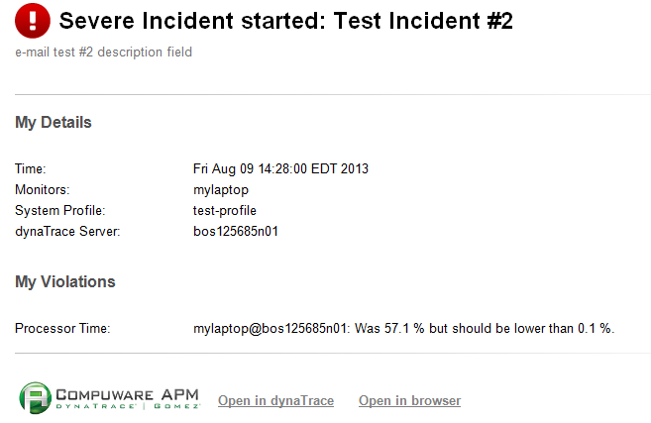

Figure Screenshot of the BodyExample.html page in Outlook