# 

# Workaround of incorrect sensitivity issue for built-in OOTB incidents for dynaTrace action plugins

Eugene Turetsky

January 18, 2014

Contents

Workaround for action plugins of incorrect sensitivity issue for built-in OOTB incidents 1

Description of the problem 3

Difference between Email Notification and Extended Mail Action plugins 3

Examples of the problem 3

Workaround 4

Examples of the e-mails after applying work around 5

Conclusion 6

## Table of Figures

Figure 1 Correct information about closed incident provided by the Email Notification plugin 3

Figure 2 Incorrect duration and end time of the closed incident provided by the Extended Mail Action plugin 4

Figure 3 Correct information of the opened incident provided by the Email Notification plugin 4

Figure 4 Incorrect end time and status of the opened incident provided by the Extended Mail Action plugin 4

Figure 5 Correct duration and end time of the closed incident provided by the Extended Mail Action plugin 5

Figure 6 Correct information about closed incident provided by the Email Notification plugin 5

Figure 7 Correct status information and no end time for the open incident 5

Figure 8 Correct information of the opened incident provided by the Email Notification plugin 6

## Description of the problem

For the built in OOTB incidents, which are not based on measures but rather on internal events, dynaTrace engine passes to the plugin incorrect information in the incident object (i.e. in the object which implements the *com.dynatrace.diagnostics.pdk.Incident* interface). This incorrect information affects the following fields:

* End time of the incident;
* Incident duration;
* Incident status.

This issue relates to the incorrect sensitivity of incidents, i.e. instead of “immediate” sensitivity these incidents have “perViolation” sensitivity. This issue exhibits in any action plugin for OOTB incidents including [Extended Mail Action](https://community.compuwareapm.com/community/display/DL/Extended+EMail+Action+Plugin) plugin, [Generic Execution](https://community.compuwareapm.com/community/display/DL/Generic+Execution+Plugin) plugin, etc.

## Difference between Email Notification and Extended Mail Action plugins

Why product based built-in Email Notification plugin generates correct notification e-mails while any action plugin including the Extended Mail Action plugin receives incorrect data from the dynaTrace engine? This is happening because product based built-in Email Notification plugin is built into the dynaTrace engine while the Extended Mail Action plugin is OSGI based plugin and hence is getting information from the dynaTrace engine through the *com.dynatrace.diagnostics.pdk.ActionEnvironment* interface. The *com.dynatrace.diagnostics.pdk.ActionEnvironment* interface contains reference to the *com.dynatrace.diagnostics.pdk.Incident* interface which contains incorrectly populated fields.

## Examples of the problem

Below examples were created in the test environment for the easyTravel application. Tests triggered the “Application Process Unavailable (unexpected)” incident.

Screenshots depicted on Figure 1 and Figure 3 show that built-in OOTB Email Notification plugin populates end time, incident duration, and incident status correctly. Screenshots depicted on Figure 2 and Figure 4 show that the Extended Mail Action plugin populates end time, incident duration, and incident status incorrectly.

Figure 1 depicts correct duration and end time of the closed “Application Process Unavailable (unexpected)” incident provided by the built-in OOTB Email Notification plugin.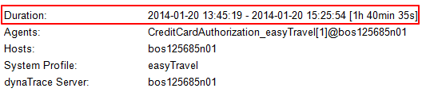

Figure 1 Correct information about closed incident provided by the Email Notification plugin

Figure 2 depicts incorrect duration and end time highlighted in yellow of the closed “Application Process Unavailable (unexpected)” incident provided by the Extended Mail Action plugin. Duration should have been 1h 40min 35s and end time should have been 2014-01-20 15:25:54.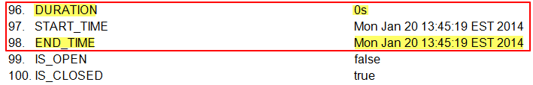

Figure 2 Incorrect duration and end time of the closed incident provided by the Extended Mail Action plugin

Figure 3 depicts correct information of the opened “Application Process Unavailable (unexpected)” incident provided by the built-in OOTB Email Notification plugin.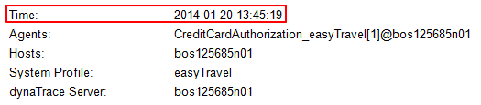

Figure 3 Correct information of the opened incident provided by the Email Notification plugin

Figure 4 depicts incorrect end time, IS_OPEN, and IS_CLOSED data highlighted in yellow of the opened “Application Process Unavailable (unexpected)” incident provided by the Extended Mail Action plugin. End time should have not been set because incident is in progress (opened), IS_OPEN should have been set to *true*, and IS_CLOSED should have been set to *false*.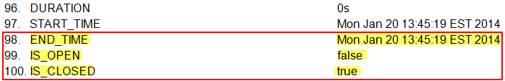

Figure 4 Incorrect end time and status of the opened incident provided by the Extended Mail Action plugin

## Workaround

dynaTrace Lab provided the following workaround to mitigate this problem. Below workaround is based on changing sensitivity of the incident from “perViolation” to “immediate”. Next are detailed steps of the work around:

1. Go to <dt-home>\ server\conf\profiles directory.
2. Make a backup of the <profile-name>.profile.xml file.
3. Open the <profile-name>.profile.xml file with any editor.
4. Find the <incidentrule> tag for the “Application Process Unavailable (unexpected)” incident (see screenshot below).
   1. Note the value of the id attribute (line 2521 in the example) of the sensitivity tag which is equal to “perViolation”.   
      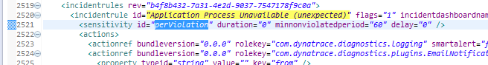
5. Change value of the id attribute of the sensitivity tag from “perViolation” to “immediate”:  
   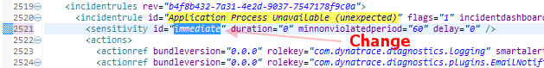
6. Save changes
7. Restart dT infrastructure components (i.e. dT server, collector, etc.)

## Examples of the e-mails after applying work around

Figure 5 shows duration, end time, and status of the closed “Application Process Unavailable (unexpected)” incident provided by the Extended Mail Action plugin. This data matches exactly to the data provided by the built-in OOTB Email Notification plugin (see Figure 6).

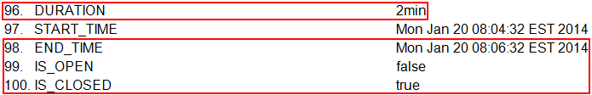

Figure 5 Correct duration and end time of the closed incident provided by the Extended Mail Action plugin

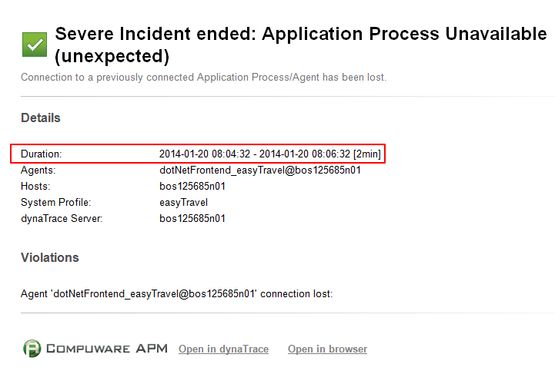

Figure 6 Correct information about closed incident provided by the Email Notification plugin

Figure 7 shows no duration, no end time, and correct status for the opened “Application Process Unavailable (unexpected)” incident. This data is accurate and matches exactly to the data provided by the built-in OOTB Email Notification plugin (see Figure 8).

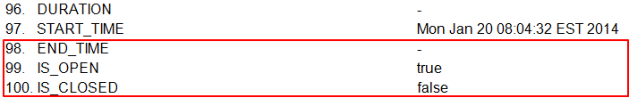

Figure 7 Correct status information and no end time for the open incident

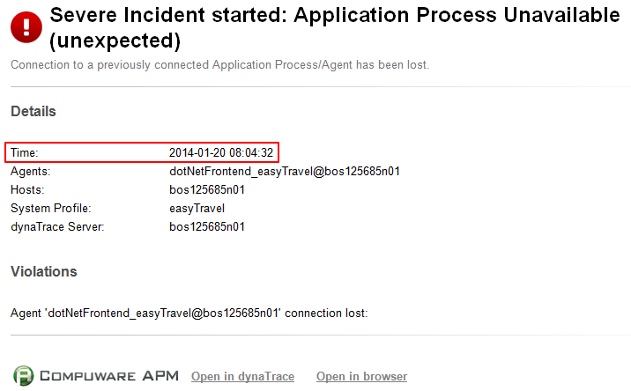

Figure 8 Correct information of the opened incident provided by the Email Notification plugin

## Conclusion

Examples, which depicted results of tests after described workaround was applied to the dynaTrace systems profile, show that now the Extended Mail Action plugin generates correct information in the notification e-mails. This confirms that workaround described in this document fixed the issue of incorrect duration, end time, and status of the incident for the dynaTrace action plugins.