Лаб1
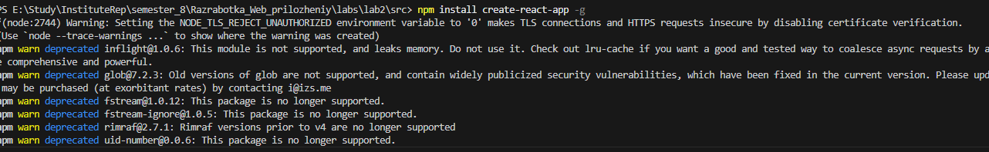
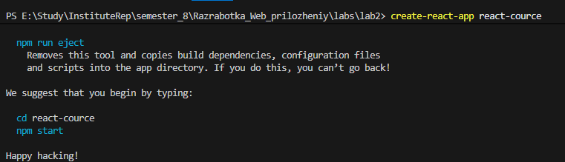
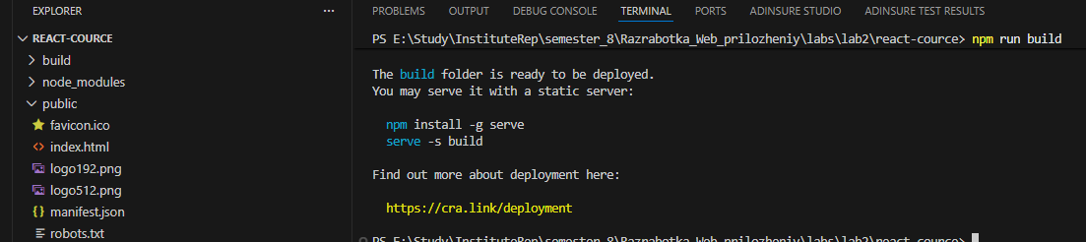
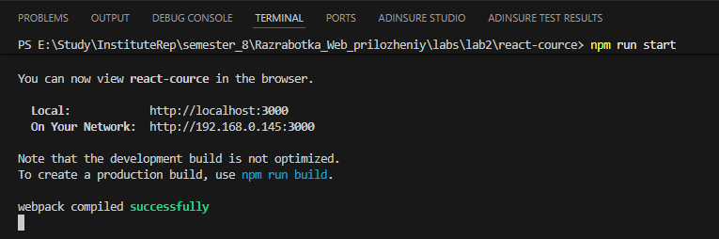
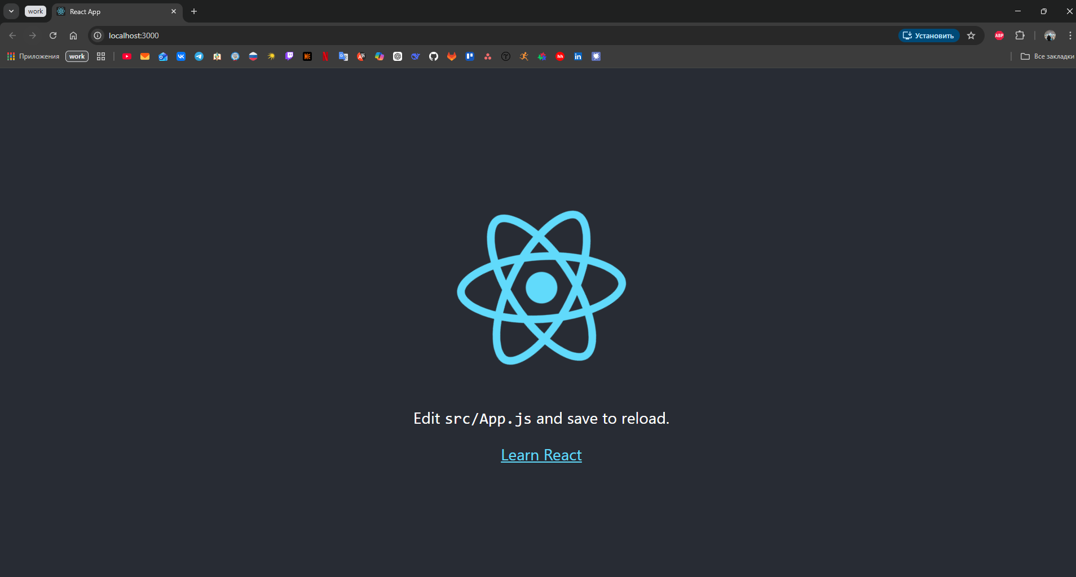
Лаб2
------ List ------
import React from 'react';
import Element from './Element';

function List({ value }) {
return (
<ul>
{value.map((item, index) => (
<li key={index}>
<Element value={item} />
</li>
))}
</ul>
);
}

export default List;

------ Element ------
import React from 'react';

function Element({ value }) {
return <span>{value}</span>;
}

export default Element;

------ App.js ------
import React from 'react';
import logo from './logo.svg';
import './App.css';
import List from './components/List';

function App() {
const array = ['Belyaev', 'Demin', 'Sergunov'];

return (
<div className="App">
<header className="App-header">

{/* Logo */}
<img src={logo} className="App-logo" alt="logo" />

{/* Text */}
<p>Lab rab 2</p>

{/* Link */}
<a
className="App-link"
href="https://www.youtube.com/watch?v=dQw4w9WgXcQ"
target="_blank"
rel="noopener noreferrer"
>
Learn React
</a>

{/* Array */}
<List value={array} />

</header>
</div>
);
}

export default App;

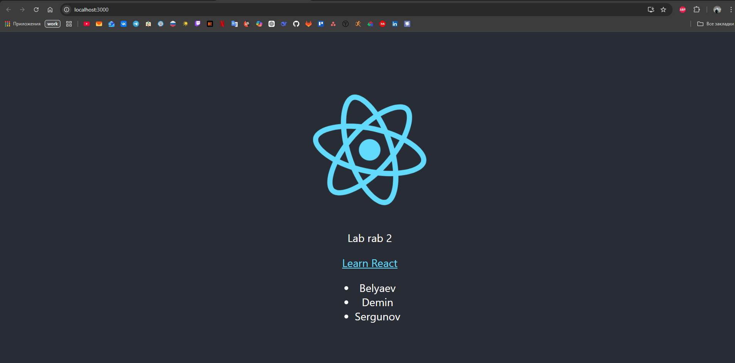
Лаб3
------ App.js ------
import React, { useState, useEffect } from 'react';
import logo from './logo.svg';
import './App.css';
import List from './components/List';
import SearchInput from './components/SearchInput';
import useFilter from './hooks/useFilter';

const INITIAL_ARRAY = ['Belyaev', 'Demin', 'Sergunov'];

function App() {
const [searchTerm, setSearchTerm] = useState('');
const filteredArray = useFilter(INITIAL_ARRAY, searchTerm);

// Title update
useEffect(() => {
if (searchTerm.trim() === '') {
document.title = 'useEffect hook example';
} else {
document.title = `Найдено элементов: ${filteredArray.length}`;
}
}, [searchTerm, filteredArray]);

const handleSearchChange = (e) => {
setSearchTerm(e.target.value);
};

return (
<div className="App">
<header className="App-header">
<img src={logo} className="App-logo" alt="logo" />
<p>Lab rab 2</p>
<a className="App-link" href="https://www.youtube.com/watch?v=dQw4w9WgXcQ" target="_blank" rel="noopener noreferrer" >
Learn React
</a>

<SearchInput value={searchTerm} onChange={handleSearchChange} />

<List value={filteredArray} />
</header>
</div>
);
}

export default App;

------ SearchInput.js ------
import React from 'react';

function SearchInput({ value, onChange }) {
return (
<div style={{ margin: '20px' }}>
<input
type="text"
placeholder="Поиск..."
value={value}
onChange={onChange}
/>
</div>
);
}

export default SearchInput;

------ useFilter.js ------
import { useState, useEffect } from 'react';

function useFilter(initialArray, searchTerm) {
const [filteredArray, setFilteredArray] = useState(initialArray);

useEffect(() => {
const filtered = initialArray.filter(item =>
item.toLowerCase().includes(searchTerm.toLowerCase())
);
setFilteredArray(filtered);
}, [initialArray, searchTerm]);

return filteredArray;
}

export default useFilter;

