Министерство науки и высшего образования Российской Федерации
Пензенский государственный университет
Кафедра «Вычислительная техника»

ОТЧЁТ
по лабораторной работе № 8
по курсу «Проектирование программного обеспечения микропроцессорных систем»
на тему «Ввод-вывод данных через последовательный порт»
Вариант №7

Выполнили:
Студенты группы 22ВВП1
Беляев Д. И.
Демин М. С.
Сергунов М. Р.

Приняли:
Бычков А. С.
Никишин К.И.

Пенза 2025
Цель работы
Изучение методов ввода-вывода данных через последовательный порт.
Ход работы
Разработали программу, осуществляющую ввод-вывод данных через последовательный порт.
Листинг программы
;===============================================================================
; UART INITIALIZATION (MODE 1, 8-BIT UART, VARIABLE BAUD RATE)
;===============================================================================

CLR SM0 ; SM0=0, SM1=1 → UART Mode 1 (8-bit UART)
SETB SM1 ; 1 start bit, 8 data bits, 1 stop bit

;-------------------------------------------------------------------------------
; Enable double baud rate (PCON.7 = SMOD = 1)
;-------------------------------------------------------------------------------

MOV A, PCON ; Read PCON so we don’t overwrite other bits
SETB ACC.7 ; Set SMOD = 1 → doubles UART baud rate
MOV PCON, A ; Write back updated value to PCON

;-------------------------------------------------------------------------------
; Enable UART receiver
;-------------------------------------------------------------------------------

SETB REN ; REN=1 → allow receiving bytes via UART

;===============================================================================
; TIMER1 CONFIGURATION FOR UART BAUD RATE
; Timer1 Mode 2 = 8-bit auto-reload (standard for UART)
; TH1 = TL1 = 243 → reload every 13 counts (baud depends on SMOD & clock)
;===============================================================================

MOV TMOD, #20H ; Timer1 Mode 2 (auto-reload), Timer0 unchanged
MOV TH1, #243 ; Reload value (256 - 13) = 243
MOV TL1, #243 ; Load initial counter value
SETB TR1 ; Start Timer1 (TCON.TR1=1)

;===============================================================================
; RECEIVE PHASE INITIALIZATION
; R1 → write pointer for received data buffer
; R0 → remaining number of bytes to receive
;===============================================================================

MOV R1, #47H ; Start address of receive buffer
MOV R0, #0AH ; Expecting 10 bytes

;===============================================================================
; RECEIVE LOOP
; Each received byte may have parity information stored in bit7.
;===============================================================================

RECEIVE_BYTE:
JNB RI, $ ; Wait until hardware sets RI (byte received)
CLR RI ; Must clear RI before next reception

MOV A, SBUF ; Read received byte from UART buffer

;-------------------------------------------------------------
; PARITY HANDLING — MSB (ACC.7) carries parity bit
;
; If ACC.7 = 0 → no parity bit present → skip processing.
; If ACC.7 = 1 → parity bit included:
; - Clear ACC.7 to restore the original 7/8 data bits
; - Use flag P to determine actual parity of data
; - Store parity mode flags in register B:
; B.4 = 1 → parity enabled
; B.0 = 0 or 1 → even/odd behavior
;-------------------------------------------------------------

JNB ACC.7, STORE_BYTE ; If bit7=0 → no parity included → skip checks

CLR ACC.7 ; Remove parity bit from the received value
; (This also updates CPU parity flag P)

JNB P, PARITY_EVEN ; If P=0 → even number of 1s → parity is EVEN

;----------- ODD parity case ---------------
MOV B, #10H ; B = 00010000b → parity enabled, odd mode
SJMP STORE_BYTE

PARITY_EVEN:
MOV B, #11H ; B = 00010001b → parity enabled + invert rule

;-------------------------------------------------------------
; Store cleaned data byte (with parity bit removed)
;-------------------------------------------------------------

STORE_BYTE:
MOV @R1, A ; Save received data to memory buffer
INC R1 ; Move pointer to next storage location

DEC R0 ; Decrement remaining receive count
MOV A, R0
JNZ RECEIVE_BYTE ; If more bytes expected → continue receiving

CLR REN ; Disable receiver after reception finished

;===============================================================================
; PREPARE FOR TRANSMISSION
;===============================================================================

MOV R1, #47H ; Reset buffer pointer to start of received data

MOV R0, #51H ; Address for termination byte
MOV @R0, #00H ; Write terminating zero (optional protocol)

MOV R0, #0BH ; Number of bytes to transmit (11 bytes)

;===============================================================================
; TRANSMIT LOOP
; Recreate parity bit in ACC.7 before sending each byte
;===============================================================================

TRANSMIT_BYTE:
MOV A, @R1 ; Load next data byte
INC R1 ; Advance buffer pointer

;-------------------------------------------------------------
; PARITY GENERATION BEFORE SENDING
;
; If B.4 = 0 → parity disabled → skip all parity logic
; If B.4 = 1 → parity enabled:
; - CPU flag P = parity of A (auto-computed)
; - C = P or inverted P depending on B.0
; - ACC.7 = C → insert parity bit into MSB for transmission
;-------------------------------------------------------------

JNB B.4, SEND_BYTE ; If parity disabled → skip parity logic

MOV C, P ; C = parity of A (CPU-calculated)
JNB B.0, SET_PARITY ; If B.0=0 → use C as-is

CPL C ; Else invert parity (different parity scheme)

SET_PARITY:
MOV ACC.7, C ; Insert parity into MSB

;-------------------------------------------------------------
; UART TRANSMISSION
;-------------------------------------------------------------

SEND_BYTE:
MOV SBUF, A ; Start UART transmission

JNB TI, $ ; Wait until transmission completes (TI=1)
CLR TI ; Clear TI for the next byte

DEC R0 ; Count transmitted bytes
MOV A, R0
JNZ TRANSMIT_BYTE ; Continue until all bytes are sent

;===============================================================================
; ENDLESS LOOP (PROGRAM END)
;===============================================================================

END_PROGRAM:
SJMP END_PROGRAM ; Stop program here forever
Результат работы программы:
Ввод и вывод 10 символов (123qwe456!) в режиме без паритета
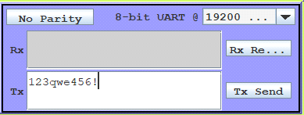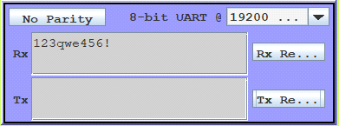
Ввод и вывод 10 символов (qwe123rty&) в режиме чётного паритета
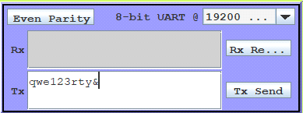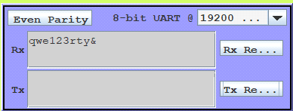
Ввод и вывод 10 символов (Hi,Error!!) в режиме нечётного паритета
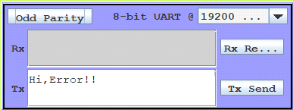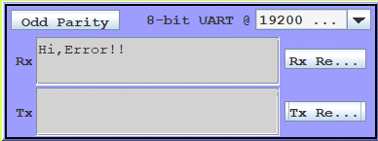
Вывод
В ходе выполнения лабораторной работы были изучены методов ввода-вывода данных через последовательный порт.

