Министерство науки и высшего образования РФ
Пензенский государственный университет
Кафедра «Вычислительная техника»

ОТЧЕТ
по лабораторной работе №5
по дисциплине «Графические интерфейсы Android и Qt»
на тему «Работа с многопоточностью»

Выполнили: студенты группы 22ВВП1
Беляев Д. И.
Демин М. С.
Сергунов М. Р.

Приняли:
Кузнецов А. В.

Пенза 2025
Название
Работа с многопоточностью
Цель работы
Научиться работать с многопоточностью
Задание
Лабораторная работа 3
1. Изменить проект созданный в лабораторной работе № 4 таким образом, чтобы запросы из пользовательского интерфейса к БД выполнялись в отдельных потоках.
2. Провести рефакторинг: заменить использование findViewById на ViewBinding

Листинг
plugins {
alias(libs.plugins.android.application)
alias(libs.plugins.kotlin.android)
}
android {
namespace = "com.example.application"
compileSdk = 36
defaultConfig {
applicationId = "com.example.application"
minSdk = 24
targetSdk = 36
versionCode = 1
versionName = "1.0"
testInstrumentationRunner = "androidx.test.runner.AndroidJUnitRunner"
}
buildTypes {
release {
isMinifyEnabled = false
proguardFiles(
getDefaultProguardFile("proguard-android-optimize.txt"),
"proguard-rules.pro"
)
}
}
compileOptions {
sourceCompatibility = JavaVersion.VERSION_11
targetCompatibility = JavaVersion.VERSION_11
}
kotlinOptions {
jvmTarget = "11"
}
buildFeatures {
viewBinding = true
}
}
dependencies {
implementation(libs.androidx.core.ktx)
implementation(libs.androidx.appcompat)
implementation(libs.material)
implementation(libs.androidx.activity)
implementation(libs.androidx.constraintlayout)
testImplementation(libs.junit)
androidTestImplementation(libs.androidx.junit)
androidTestImplementation(libs.androidx.espresso.core)
}

<manifest xmlns:android="http://schemas.android.com/apk/res/android"
xmlns:tools="http://schemas.android.com/tools"
package="com.example.application">
<application
android:allowBackup="true"
android:dataExtractionRules="@xml/data_extraction_rules"
android:fullBackupContent="@xml/backup_rules"
android:icon="@mipmap/ic_launcher"
android:label="@string/app_name"
android:roundIcon="@mipmap/ic_launcher_round"
android:supportsRtl="true"
android:theme="@style/Theme.Application">
<activity
android:name=".activities.LoginActivity"
android:exported="true">
<intent-filter>
<action android:name="android.intent.action.MAIN" />
<category android:name="android.intent.category.LAUNCHER" />
</intent-filter>
</activity>
<activity android:name=".activities.MenuActivity" android:exported="true" />
<activity android:name=".activities.RegisterActivity" android:exported="true" />
<activity android:name=".activities.ProfileActivity" android:exported="true" />
<activity android:name=".activities.SettingsActivity" android:exported="true" />
<activity android:name=".activities.AdminActivity" android:exported="true" />
<activity android:name=".activities.AuthLogActivity" android:exported="true" />
</application>
</manifest>

package com.example.application.activities
import android.content.Intent
import android.os.Bundle
import android.widget.ArrayAdapter
import androidx.appcompat.app.AppCompatActivity
import androidx.lifecycle.lifecycleScope
import com.example.application.databinding.ActivityAdminBinding
import com.example.application.helpers.DatabaseHelper
class AdminActivity : AppCompatActivity() {
private lateinit var db: DatabaseHelper
private lateinit var binding: ActivityAdminBinding
private var currentUserId: Int = -1
override fun onCreate(savedInstanceState: Bundle?) {
super.onCreate(savedInstanceState)
binding = ActivityAdminBinding.inflate(layoutInflater)
setContentView(binding.root)
currentUserId = intent.getIntExtra("currentUserId", -1)
db = DatabaseHelper(this)
db.getAllUsersAsync(lifecycleScope) { users ->
val adapter = ArrayAdapter(
this,
android.R.layout.simple_list_item_1,
users.map { "${it.name} (${if (it.isAdmin == 1) "Admin" else "User"})" }
)
binding.lvUsers.adapter = adapter
binding.lvUsers.setOnItemClickListener { _, _, position, _ ->
startActivity(Intent(this, ProfileActivity::class.java).apply {
putExtra("userId", users[position].id)
putExtra("currentUserId", currentUserId)
})
}
}
binding.btnShowLog.setOnClickListener {
startActivity(Intent(this, AuthLogActivity::class.java))
}
}
}

package com.example.application.activities
import android.os.Bundle
import androidx.appcompat.app.AppCompatActivity
import com.example.application.databinding.ActivityAuthLogBinding
import com.example.application.helpers.AuthLogger
class AuthLogActivity : AppCompatActivity() {
private lateinit var binding: ActivityAuthLogBinding
override fun onCreate(savedInstanceState: Bundle?) {
super.onCreate(savedInstanceState)
binding = ActivityAuthLogBinding.inflate(layoutInflater)
setContentView(binding.root)
binding.tvLog.text = AuthLogger.readLog(this)
binding.btnClear.setOnClickListener {
AuthLogger.clearLog(this)
binding.tvLog.text = "Лог пуст"
}
}
}

package com.example.application.activities
import android.content.Intent
import android.os.Bundle
import android.widget.Toast
import androidx.appcompat.app.AppCompatActivity
import androidx.lifecycle.lifecycleScope
import com.example.application.databinding.ActivityLoginBinding
import com.example.application.helpers.AuthLogger
import com.example.application.helpers.DatabaseHelper
import com.example.application.helpers.ThemeManager
class LoginActivity : AppCompatActivity() {
private lateinit var db: DatabaseHelper
private lateinit var binding: ActivityLoginBinding
override fun onCreate(savedInstanceState: Bundle?) {
super.onCreate(savedInstanceState)
ThemeManager.applyTheme(this)
binding = ActivityLoginBinding.inflate(layoutInflater)
setContentView(binding.root)
db = DatabaseHelper(this)
binding.btnLogin.setOnClickListener {
val login = binding.etLogin.text.toString().trim()
val password = binding.etPassword.text.toString()
db.loginUserAsync(lifecycleScope, login, password) { user ->
if (user != null) {
AuthLogger.logAuth(this, user.login)
startActivity(Intent(this, MenuActivity::class.java).apply {
putExtra("currentUserId", user.id)
})
} else {
Toast.makeText(this, "Неверный логин или пароль", Toast.LENGTH_SHORT).show()
}
}
}
binding.btnRegister.setOnClickListener {
startActivity(Intent(this, RegisterActivity::class.java))
}
}
}

package com.example.application.activities
import android.content.Intent
import android.os.Bundle
import android.view.View
import androidx.appcompat.app.AppCompatActivity
import androidx.lifecycle.lifecycleScope
import com.example.application.databinding.ActivityMenuBinding
import com.example.application.helpers.DatabaseHelper
class MenuActivity : AppCompatActivity() {
private lateinit var db: DatabaseHelper
private lateinit var binding: ActivityMenuBinding
private var currentUserId: Int = -1
override fun onCreate(savedInstanceState: Bundle?) {
super.onCreate(savedInstanceState)
binding = ActivityMenuBinding.inflate(layoutInflater)
setContentView(binding.root)
db = DatabaseHelper(this)
currentUserId = intent.getIntExtra("currentUserId", -1)
db.getUserByIdAsync(lifecycleScope, currentUserId) { currentUser ->
if (currentUser?.isAdmin == 1) {
binding.btnAdmin.visibility = View.VISIBLE
} else {
binding.btnAdmin.visibility = View.GONE
}
}
binding.btnProfile.setOnClickListener {
startActivity(Intent(this, ProfileActivity::class.java).apply {
putExtra("userId", currentUserId)
putExtra("currentUserId", currentUserId)
})
}
binding.btnSettings.setOnClickListener {
startActivity(Intent(this, SettingsActivity::class.java))
}
binding.btnAdmin.setOnClickListener {
startActivity(Intent(this, AdminActivity::class.java).apply {
putExtra("currentUserId", currentUserId)
})
}
binding.btnExit.setOnClickListener { finish() }
}
}

package com.example.application.activities
import android.os.Bundle
import android.view.View
import android.widget.Toast
import androidx.appcompat.app.AppCompatActivity
import androidx.lifecycle.lifecycleScope
import com.example.application.databinding.ActivityProfileBinding
import com.example.application.helpers.DatabaseHelper
class ProfileActivity : AppCompatActivity() {
private lateinit var db: DatabaseHelper
private lateinit var binding: ActivityProfileBinding
private var profileUserId: Int = -1
private var currentUserId: Int = -1
override fun onCreate(savedInstanceState: Bundle?) {
super.onCreate(savedInstanceState)
binding = ActivityProfileBinding.inflate(layoutInflater)
setContentView(binding.root)
db = DatabaseHelper(this)
profileUserId = intent.getIntExtra("userId", -1)
currentUserId = intent.getIntExtra("currentUserId", -1)
db.getUserByIdAsync(lifecycleScope, profileUserId) { profileUser ->
db.getUserByIdAsync(lifecycleScope, currentUserId) { currentUser ->
profileUser?.let {
binding.tvName.text = "Имя: ${it.name}"
binding.tvEmail.text = "Email: ${it.email}"
binding.tvLogin.text = "Логин: ${it.login}"
}
if (currentUser != null && currentUser.isAdmin == 1 &&
profileUser != null && profileUser.isAdmin == 0 &&
profileUser.id != currentUser.id
) {
binding.btnMakeAdmin.visibility = View.VISIBLE
binding.btnMakeAdmin.setOnClickListener {
db.makeAdminAsync(lifecycleScope, profileUser.id) {
Toast.makeText(this, "Пользователь теперь администратор", Toast.LENGTH_SHORT).show()
binding.btnMakeAdmin.visibility = View.GONE
}
}
} else {
binding.btnMakeAdmin.visibility = View.GONE
}
}
}
}
}

package com.example.application.activities
import android.content.Intent
import android.os.Bundle
import android.widget.Toast
import androidx.appcompat.app.AppCompatActivity
import androidx.lifecycle.lifecycleScope
import com.example.application.databinding.ActivityRegisterBinding
import com.example.application.helpers.DatabaseHelper
class RegisterActivity : AppCompatActivity() {
private lateinit var db: DatabaseHelper
private lateinit var binding: ActivityRegisterBinding
override fun onCreate(savedInstanceState: Bundle?) {
super.onCreate(savedInstanceState)
binding = ActivityRegisterBinding.inflate(layoutInflater)
setContentView(binding.root)
db = DatabaseHelper(this)
binding.btnSave.setOnClickListener {
val name = binding.etName.text.toString().trim()
val email = binding.etEmail.text.toString().trim()
val login = binding.etLoginReg.text.toString().trim()
val password = binding.etPasswordReg.text.toString()
if (name.isEmpty() || login.isEmpty() || password.isEmpty()) {
Toast.makeText(this, "Заполните все поля", Toast.LENGTH_SHORT).show()
return@setOnClickListener
}
db.registerUserAsync(lifecycleScope, name, email, login, password) { id ->
if (id > 0) {
Toast.makeText(this, "Регистрация успешна", Toast.LENGTH_SHORT).show()
startActivity(Intent(this, LoginActivity::class.java))
finish()
} else {
Toast.makeText(this, "Ошибка регистрации", Toast.LENGTH_SHORT).show()
}
}
}
}
}

package com.example.application.activities
import android.os.Bundle
import androidx.appcompat.app.AppCompatActivity
import com.example.application.databinding.ActivitySettingsBinding
import com.example.application.helpers.ThemeManager
class SettingsActivity : AppCompatActivity() {
private lateinit var binding: ActivitySettingsBinding
override fun onCreate(savedInstanceState: Bundle?) {
super.onCreate(savedInstanceState)
binding = ActivitySettingsBinding.inflate(layoutInflater)
setContentView(binding.root)
binding.btnTheme.setOnClickListener {
ThemeManager.toggleTheme(this)
recreate()
}
}
}

package com.example.application.helpers
import android.content.Context
import java.io.File
import java.text.SimpleDateFormat
import java.util.*
object AuthLogger {
private const val FILE_NAME = "auth_log.txt"
fun logAuth(context: Context, login: String) {
val timestamp = SimpleDateFormat("yyyy-MM-dd HH:mm:ss", Locale.getDefault()).format(Date())
val entry = "$timestamp — Пользователь [$login] вошёл в систему\n"
val file = File(context.filesDir, FILE_NAME)
file.appendText(entry)
}
fun readLog(context: Context): String {
val file = File(context.filesDir, FILE_NAME)
return if (file.exists()) file.readText() else "Лог пуст"
}
fun clearLog(context: Context) {
val file = File(context.filesDir, FILE_NAME)
if (file.exists()) file.writeText("")
}
}

package com.example.application.helpers
import android.content.ContentValues
import android.content.Context
import android.database.sqlite.SQLiteDatabase
import android.database.sqlite.SQLiteOpenHelper
import kotlinx.coroutines.CoroutineScope
import kotlinx.coroutines.Dispatchers
import kotlinx.coroutines.launch
import kotlinx.coroutines.withContext
data class User(
val id: Int,
val name: String,
val email: String,
val login: String,
val password: String,
var isAdmin: Int
)
class DatabaseHelper(context: Context) :
SQLiteOpenHelper(context, "users.db", null, 1) {
override fun onCreate(db: SQLiteDatabase) {
db.execSQL(
"""
CREATE TABLE users (
id INTEGER PRIMARY KEY AUTOINCREMENT,
name TEXT,
email TEXT,
login TEXT UNIQUE,
password TEXT,
isAdmin INTEGER DEFAULT 0
)
"""
)
}
override fun onUpgrade(db: SQLiteDatabase, oldVersion: Int, newVersion: Int) {
db.execSQL("DROP TABLE IF EXISTS users")
onCreate(db)
}
// FUNCTIONS
fun registerUser(name: String, email: String, login: String, password: String): Long {
val db = writableDatabase
val cursor = db.rawQuery("SELECT COUNT(*) FROM users", null)
cursor.moveToFirst()
val count = cursor.getInt(0)
cursor.close()
val isAdmin = if (count == 0) 1 else 0
val values = ContentValues().apply {
put("name", name)
put("email", email)
put("login", login)
put("password", password)
put("isAdmin", isAdmin)
}
return db.insert("users", null, values)
}
fun registerUserAsync(
scope: CoroutineScope,
name: String,
email: String,
login: String,
password: String,
callback: (Long) -> Unit
) {
scope.launch(Dispatchers.IO) {
val id = registerUser(name, email, login, password)
withContext(Dispatchers.Main) { callback(id) }
}
}
fun loginUser(login: String, password: String): User? {
val db = readableDatabase
val cursor = db.rawQuery(
"SELECT id, name, email, login, password, isAdmin FROM users WHERE login=? AND password=?",
arrayOf(login, password)
)
return if (cursor.moveToFirst()) {
val u = User(
cursor.getInt(0),
cursor.getString(1),
cursor.getString(2),
cursor.getString(3),
cursor.getString(4),
cursor.getInt(5)
)
cursor.close()
u
} else {
cursor.close()
null
}
}
fun loginUserAsync(
scope: CoroutineScope,
login: String,
password: String,
callback: (User?) -> Unit
) {
scope.launch(Dispatchers.IO) {
val user = loginUser(login, password)
withContext(Dispatchers.Main) { callback(user) }
}
}
fun getAllUsers(): List<User> {
val db = readableDatabase
val cursor = db.rawQuery("SELECT * FROM users", null)
val list = mutableListOf<User>()
while (cursor.moveToNext()) {
list.add(
User(
cursor.getInt(0),
cursor.getString(1),
cursor.getString(2),
cursor.getString(3),
cursor.getString(4),
cursor.getInt(5)
)
)
}
cursor.close()
return list
}
fun getAllUsersAsync(scope: CoroutineScope, callback: (List<User>) -> Unit) {
scope.launch(Dispatchers.IO) {
val users = getAllUsers()
withContext(Dispatchers.Main) { callback(users) }
}
}
fun getUserById(userId: Int): User? {
val db = readableDatabase
val cursor = db.rawQuery("SELECT * FROM users WHERE id=?", arrayOf(userId.toString()))
return if (cursor.moveToFirst()) {
val u = User(
cursor.getInt(0),
cursor.getString(1),
cursor.getString(2),
cursor.getString(3),
cursor.getString(4),
cursor.getInt(5)
)
cursor.close()
u
} else {
cursor.close()
null
}
}
fun getUserByIdAsync(scope: CoroutineScope, userId: Int, callback: (User?) -> Unit) {
scope.launch(Dispatchers.IO) {
val user = getUserById(userId)
withContext(Dispatchers.Main) { callback(user) }
}
}
fun makeAdmin(userId: Int) {
val db = writableDatabase
val values = ContentValues().apply { put("isAdmin", 1) }
db.update("users", values, "id=?", arrayOf(userId.toString()))
}
fun makeAdminAsync(scope: CoroutineScope, userId: Int, callback: () -> Unit) {
scope.launch(Dispatchers.IO) {
makeAdmin(userId)
withContext(Dispatchers.Main) { callback() }
}
}
}

package com.example.application.helpers
import android.content.Context
import androidx.appcompat.app.AppCompatDelegate
object ThemeManager {
private const val PREFS = "app_prefs"
private const val KEY_THEME = "theme_mode"
fun applyTheme(context: Context) {
val prefs = context.getSharedPreferences(PREFS, Context.MODE_PRIVATE)
val mode = prefs.getInt(KEY_THEME, AppCompatDelegate.MODE_NIGHT_NO)
AppCompatDelegate.setDefaultNightMode(mode)
}
fun toggleTheme(context: Context) {
val prefs = context.getSharedPreferences(PREFS, Context.MODE_PRIVATE)
val current = prefs.getInt(KEY_THEME, AppCompatDelegate.MODE_NIGHT_NO)
val next = if (current == AppCompatDelegate.MODE_NIGHT_YES) AppCompatDelegate.MODE_NIGHT_NO else AppCompatDelegate.MODE_NIGHT_YES
prefs.edit().putInt(KEY_THEME, next).apply()
AppCompatDelegate.setDefaultNightMode(next)
}
}

<LinearLayout xmlns:android="http://schemas.android.com/apk/res/android"
android:id="@+id/adminLayout"
android:orientation="vertical"
android:padding="16dp"
android:layout_width="match_parent"
android:layout_height="match_parent">
<ListView
android:id="@+id/lvUsers"
android:layout_width="match_parent"
android:layout_height="0dp"
android:layout_weight="1"/>
<Button
android:id="@+id/btnShowLog"
android:layout_width="match_parent"
android:layout_height="wrap_content"
android:text="@string/btn_show_logs"/>
</LinearLayout>

<LinearLayout xmlns:android="http://schemas.android.com/apk/res/android"
android:orientation="vertical"
android:padding="16dp"
android:layout_width="match_parent"
android:layout_height="match_parent">
<TextView
android:id="@+id/tvLog"
android:text="@string/hint_auth_logs"
android:layout_width="match_parent"
android:layout_height="0dp"
android:layout_weight="1"
android:scrollbars="vertical" />
<Button
android:id="@+id/btnClear"
android:text="@string/btn_clear_logs"
android:layout_width="match_parent"
android:layout_height="wrap_content" />
</LinearLayout>

<?xml version="1.0" encoding="utf-8"?>
<ScrollView xmlns:android="http://schemas.android.com/apk/res/android"
android:fillViewport="true"
android:layout_width="match_parent"
android:layout_height="match_parent">
<LinearLayout
android:orientation="vertical"
android:gravity="center_horizontal"
android:padding="24dp"
android:layout_width="match_parent"
android:layout_height="wrap_content">
<ImageView
android:src="@mipmap/ic_launcher"
android:layout_width="120dp"
android:layout_height="120dp"
android:contentDescription="@string/app_name"
android:layout_marginBottom="16dp"/>
<EditText
android:id="@+id/etLogin"
android:layout_width="match_parent"
android:layout_height="wrap_content"
android:hint="@string/hint_login"
android:inputType="text"
android:layout_marginBottom="8dp"/>
<EditText
android:id="@+id/etPassword"
android:layout_width="match_parent"
android:layout_height="wrap_content"
android:hint="@string/hint_password"
android:inputType="textPassword"
android:layout_marginBottom="16dp"/>
<Button
android:id="@+id/btnLogin"
android:layout_width="match_parent"
android:layout_height="wrap_content"
android:text="@string/btn_login"
android:layout_marginBottom="8dp"/>
<Button
android:id="@+id/btnRegister"
android:layout_width="match_parent"
android:layout_height="wrap_content"
android:text="@string/btn_register"
android:layout_marginBottom="8dp"/>
</LinearLayout>
</ScrollView>

<?xml version="1.0" encoding="utf-8"?>
<LinearLayout xmlns:android="http://schemas.android.com/apk/res/android"
android:orientation="vertical"
android:gravity="center_horizontal"
android:padding="24dp"
android:layout_width="match_parent"
android:layout_height="match_parent">
<Button
android:id="@+id/btnProfile"
android:layout_width="match_parent"
android:layout_height="wrap_content"
android:text="@string/btn_profile"
android:layout_marginBottom="8dp"/>
<Button
android:id="@+id/btnSettings"
android:layout_width="match_parent"
android:layout_height="wrap_content"
android:text="@string/btn_settings"
android:layout_marginBottom="8dp"/>
<Button
android:id="@+id/btnAdmin"
android:layout_width="match_parent"
android:layout_height="wrap_content"
android:text="@string/btn_admin"
android:visibility="gone"
android:layout_marginBottom="8dp"/>
<Button
android:id="@+id/btnExit"
android:layout_width="match_parent"
android:layout_height="wrap_content"
android:text="@string/btn_exit" />
</LinearLayout>

<?xml version="1.0" encoding="utf-8"?>
<ScrollView xmlns:android="http://schemas.android.com/apk/res/android"
android:fillViewport="true"
android:layout_width="match_parent"
android:layout_height="match_parent">
<LinearLayout
android:orientation="vertical"
android:padding="24dp"
android:layout_width="match_parent"
android:layout_height="wrap_content">
<TextView
android:id="@+id/tvName"
android:text="@string/hint_name"
android:textSize="18sp"
android:layout_marginBottom="8dp"
android:layout_width="match_parent"
android:layout_height="wrap_content"/>
<TextView
android:id="@+id/tvEmail"
android:text="@string/hint_email"
android:textSize="16sp"
android:layout_marginBottom="8dp"
android:layout_width="match_parent"
android:layout_height="wrap_content"/>
<TextView
android:id="@+id/tvLogin"
android:text="@string/hint_login"
android:textSize="16sp"
android:layout_marginBottom="16dp"
android:layout_width="match_parent"
android:layout_height="wrap_content"/>
<Button
android:id="@+id/btnMakeAdmin"
android:layout_width="match_parent"
android:layout_height="wrap_content"
android:text="@string/btn_make_admin"
android:visibility="gone"/>
</LinearLayout>
</ScrollView>

<?xml version="1.0" encoding="utf-8"?>
<ScrollView xmlns:android="http://schemas.android.com/apk/res/android"
android:fillViewport="true"
android:layout_width="match_parent"
android:layout_height="match_parent">
<LinearLayout
android:orientation="vertical"
android:gravity="center_horizontal"
android:padding="24dp"
android:layout_width="match_parent"
android:layout_height="wrap_content">
<EditText
android:id="@+id/etName"
android:layout_width="match_parent"
android:layout_height="wrap_content"
android:hint="@string/hint_name"
android:inputType="textPersonName"
android:layout_marginBottom="8dp"/>
<EditText
android:id="@+id/etEmail"
android:layout_width="match_parent"
android:layout_height="wrap_content"
android:hint="@string/hint_email"
android:inputType="textEmailAddress"
android:layout_marginBottom="8dp"/>
<EditText
android:id="@+id/etLoginReg"
android:layout_width="match_parent"
android:layout_height="wrap_content"
android:hint="@string/hint_login"
android:inputType="text"
android:layout_marginBottom="8dp"/>
<EditText
android:id="@+id/etPasswordReg"
android:layout_width="match_parent"
android:layout_height="wrap_content"
android:hint="@string/hint_password"
android:inputType="textPassword"
android:layout_marginBottom="16dp"/>
<Button
android:id="@+id/btnSave"
android:layout_width="match_parent"
android:layout_height="wrap_content"
android:text="@string/btn_save"/>
</LinearLayout>
</ScrollView>

<?xml version="1.0" encoding="utf-8"?>
<LinearLayout xmlns:android="http://schemas.android.com/apk/res/android"
android:orientation="vertical"
android:gravity="center_horizontal"
android:padding="24dp"
android:layout_width="match_parent"
android:layout_height="match_parent">
<Button
android:id="@+id/btnTheme"
android:layout_width="match_parent"
android:layout_height="wrap_content"
android:text="@string/btn_theme" />
</LinearLayout>

<resources>
<string name="app_name">Учебное приложение</string>
<!-- Hints / labels -->
<string name="hint_login">Логин</string>
<string name="hint_password">Пароль</string>
<string name="hint_name">Имя</string>
<string name="hint_email">Email</string>
<string name="hint_auth_logs">Лог авторизации</string>
<string name="label_name">Имя</string>
<string name="label_email">Email</string>
<string name="label_login">Логин</string>
<!-- Buttons -->
<string name="btn_login">Вход</string>
<string name="btn_register">Регистрация</string>
<string name="btn_exit">Выход</string>
<string name="btn_profile">Профиль</string>
<string name="btn_settings">Настройки</string>
<string name="btn_admin">Администрирование</string>
<string name="btn_save">Сохранить</string>
<string name="btn_theme">Сменить тему</string>
<string name="btn_make_admin">Сделать администратором</string>
<string name="btn_show_logs">Показать лог авторизаций</string>
<string name="btn_clear_logs">Очистить лог</string>
<!-- Misc -->
<string name="toast_invalid">Неверный логин или пароль</string>
<string name="toast_reg_ok">Регистрация успешна</string>
<string name="toast_reg_err">Ошибка регистрации</string>
<string name="toast_became_admin">Пользователь стал администратором</string>
</resources>

Работа программы
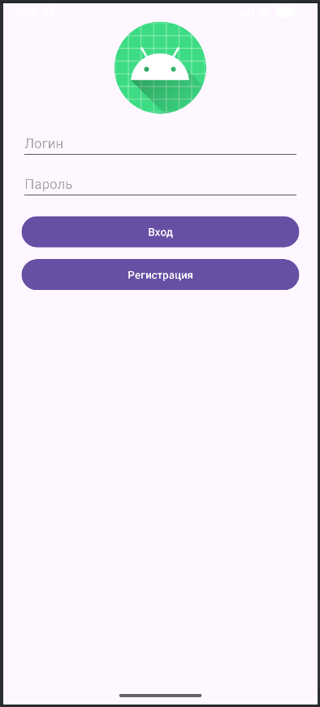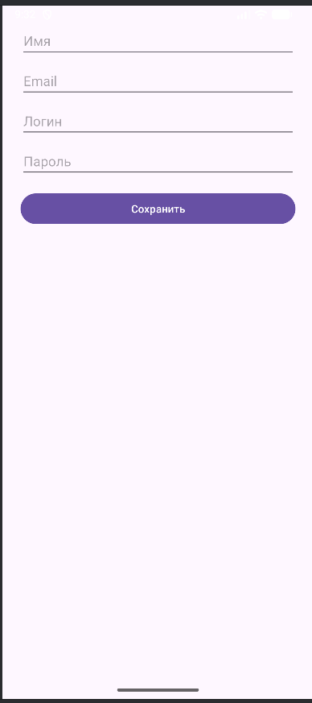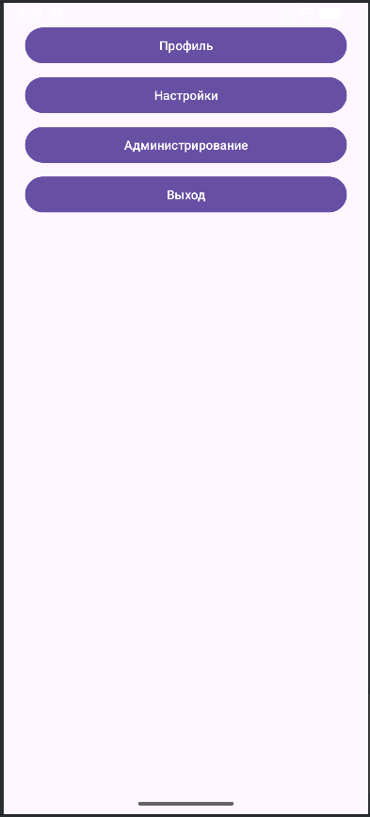
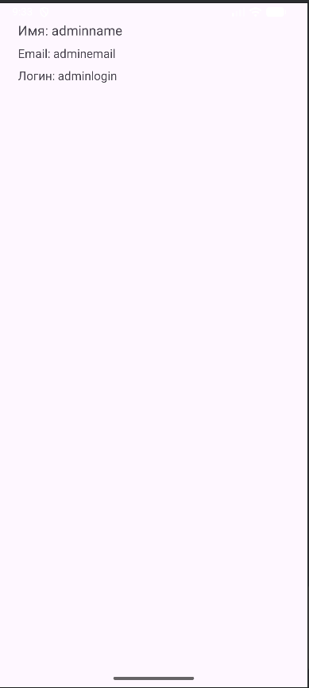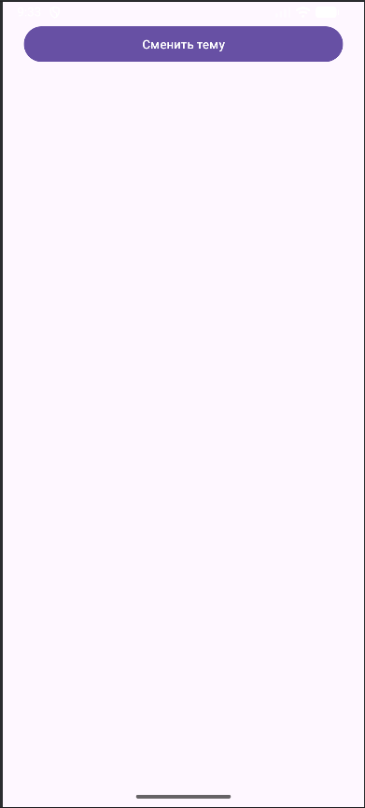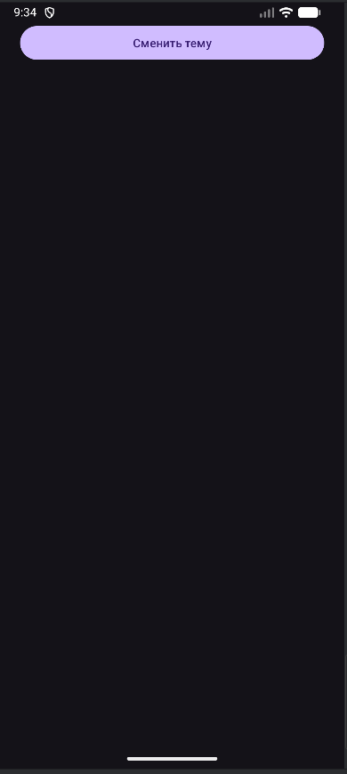
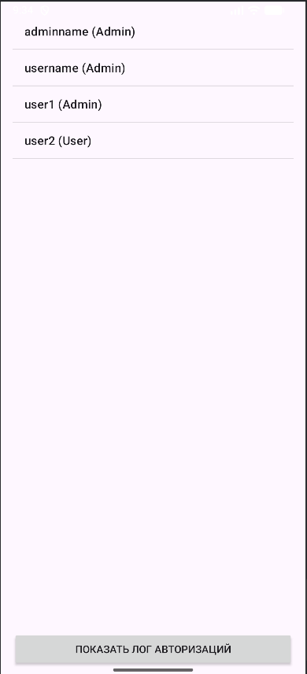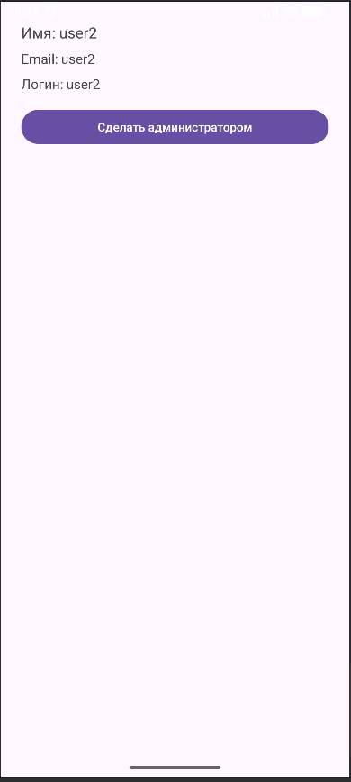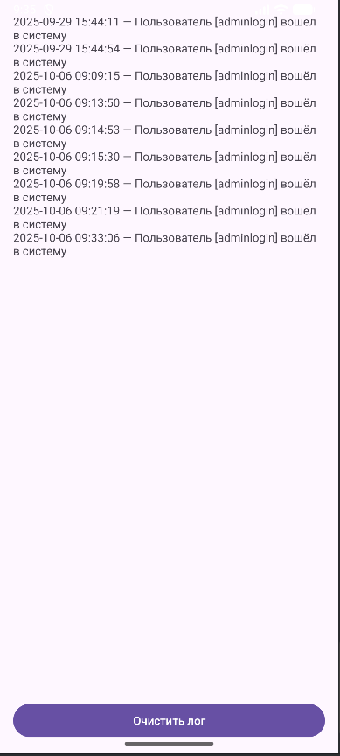

Вывод
Научились работать с многопоточностью

