Министерство науки и высшего образования РФ

Пензенский государственный университет

Кафедра «Вычислительная техника»

**ОТЧЕТ**

по лабораторной работе №5

по дисциплине «Программирование на языке Java»

на тему «Многопоточность в Java»

Выполнили: студенты группы 22ВВП1

Беляев Д. И.

Демин М. С.

Приняли:

Юрова О. В.

Карамышева Н. С.

Пенза 2025

**Название**

Многпоточность в Java

**Цель работы**

Научиться создавть многопточные приложения с использованием стандартных средст языка Java

**Задание**

Модифицировать приложение из предыдущей лабораторной работы, реализовав вычисление определенного интеграла в нескольких дополнительных потоках (число потоков определяется номером варианта), снимая нагрузку с основного потока и предотвращая "подвисание" графического интерфейса. Варианты с номерами до 5 включительно реализуют многопоточность путем наследования от класса Thread, остальные реализуют интерфейс Runnable. Оформление лабораторной работы должно быть выполнено в соответствии с требованиями, приведенными в Приложении 2.

**Ход работы**

1. Реализовали класс, который наследуется от Thread  
   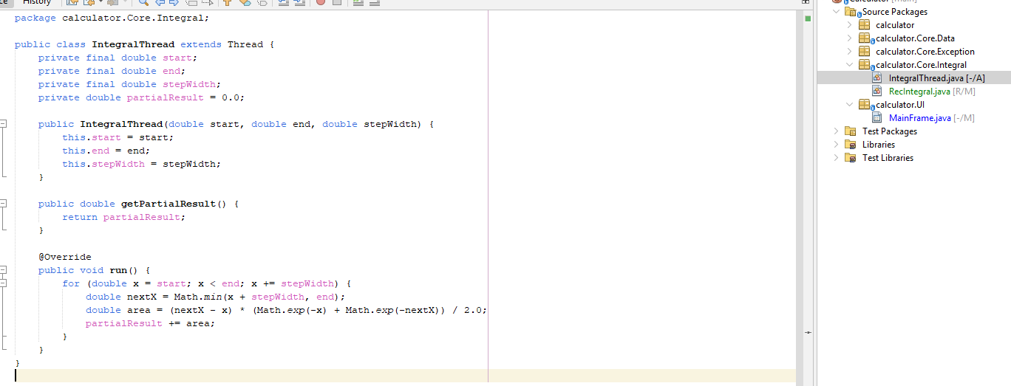
2. Добавили метод в RecIntegral, который отвечает за многопточный подсчет  
   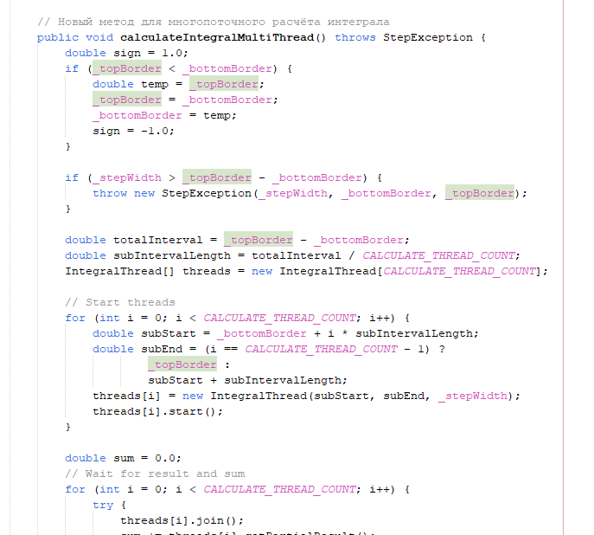  
   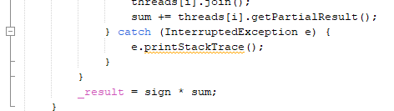
3. Изменили функцию вычисления для работы с многопоточной функцией  
   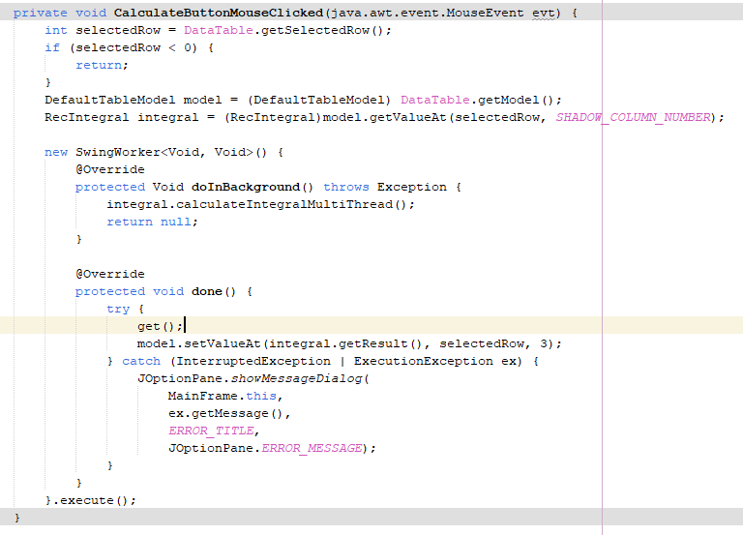

*Дополнительное задание*

Изменили на callable и future

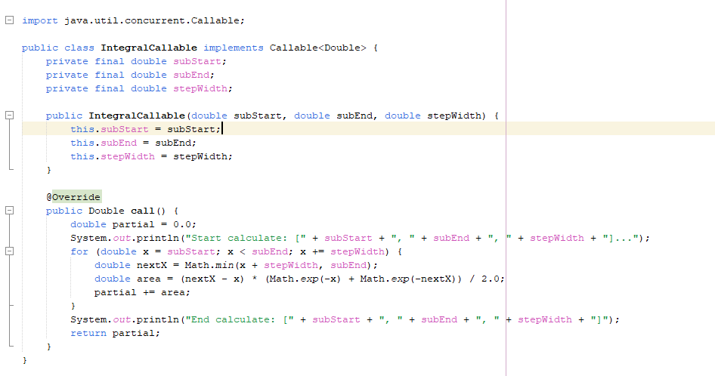

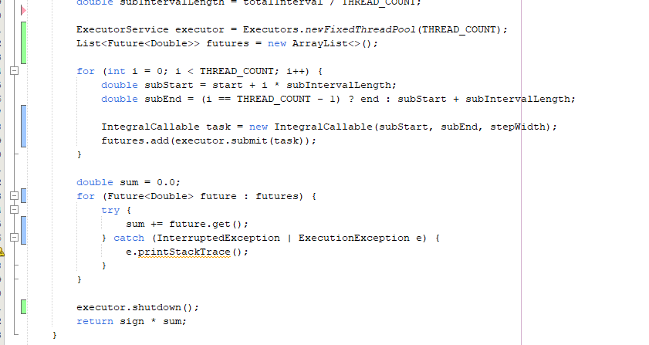

**Листинг**

*MainFrame.java*

package calculator.UI;

import calculator.Core.Data.DataManager;

import calculator.Core.Exception.IntegralValueException;

import calculator.Core.Integral.RecIntegral;

import java.io.File;

import java.io.IOException;

import java.util.ArrayList;

import java.util.concurrent.ExecutionException;

import javax.swing.JFileChooser;

import javax.swing.JOptionPane;

import javax.swing.JTable;

import javax.swing.SwingWorker;

import javax.swing.filechooser.FileNameExtensionFilter;

import javax.swing.table.DefaultTableModel;

public class MainFrame extends javax.swing.JFrame {

// Shadow column

private static final int SHADOW_COLUMN_NUMBER = 4;

private static final String SHADOW_COLUMN_TITLE = "ShadowColumn";

// Load/Save files

private static final String TEXT_EXTENSION = ".txt";

private static final String BINARY_EXTENSION = ".calcbin";

private static final String TEXT_FILTER_DESCRIPTION = "Text Files (*" + TEXT_EXTENSION + ")";

private static final String BINARY_FILTER_DESCRIPTION = "Calc Binary Files (*" + BINARY_EXTENSION + ")";

private static final String SAVE_ERROR_MESSAGE = "Save error: ";

private static final String LOAD_ERROR_MESSAGE = "Load error: ";

// MessageBox

private static final String ERROR_TITLE = "Error";

private ArrayList<RecIntegral> _integrals;

/**

* Creates new form MainFrame

*/

public MainFrame() {

initComponents();

_integrals = new ArrayList<>();

DataTable.removeColumn(DataTable.getColumn(SHADOW_COLUMN_TITLE));

FileSaveMenuAsTextItem.addActionListener(e -> saveAsText());

FileSaveMenuAsBinaryItem.addActionListener(e -> saveAsBinary());

FileLoadMenuFromTextItem.addActionListener(e -> loadFromText());

FileLoadMenuFromBinaryItem.addActionListener(e -> loadFromBinary());

}

@SuppressWarnings("unchecked")

// <editor-fold defaultstate="collapsed" desc="Generated Code">

private void initComponents() {

jMenuItem1 = new javax.swing.JMenuItem();

DataTableScrollPanel = new javax.swing.JScrollPane();

DataTable = new javax.swing.JTable();

TopBorderLabel = new javax.swing.JLabel();

BottomBorderLabel = new javax.swing.JLabel();

StepWidthLabel = new javax.swing.JLabel();

TopBorderTextField = new javax.swing.JTextField();

BottomBorderTextField = new javax.swing.JTextField();

StepWidthTextField = new javax.swing.JTextField();

AddButton = new javax.swing.JButton();

DeleteButton = new javax.swing.JButton();

CalculateButton = new javax.swing.JButton();

ClearTableButton = new javax.swing.JButton();

FillTableButton = new javax.swing.JButton();

MenuBar = new javax.swing.JMenuBar();

FileMenu = new javax.swing.JMenu();

FileSaveMenu = new javax.swing.JMenu();

FileSaveMenuAsTextItem = new javax.swing.JMenuItem();

FileSaveMenuAsBinaryItem = new javax.swing.JMenuItem();

FileLoadMenu = new javax.swing.JMenu();

FileLoadMenuFromTextItem = new javax.swing.JMenuItem();

FileLoadMenuFromBinaryItem = new javax.swing.JMenuItem();

jMenuItem1.setText("jMenuItem1");

setDefaultCloseOperation(javax.swing.WindowConstants.EXIT_ON_CLOSE);

DataTable.setModel(new javax.swing.table.DefaultTableModel(

new Object [][] {

},

new String [] {

"Верхняя граница", "Нижняя граница", "Ширина шага", "Результат", "ShadowColumn"

}

) {

boolean[] canEdit = new boolean [] {

false, false, false, false, false

};

public boolean isCellEditable(int rowIndex, int columnIndex) {

return canEdit [columnIndex];

}

});

DataTableScrollPanel.setViewportView(DataTable);

TopBorderLabel.setFont(new java.awt.Font("Segoe UI", 0, 14)); // NOI18N

TopBorderLabel.setText("Верхняя граница");

TopBorderLabel.setName(""); // NOI18N

BottomBorderLabel.setFont(new java.awt.Font("Segoe UI", 0, 14)); // NOI18N

BottomBorderLabel.setText("Ширина шага");

StepWidthLabel.setFont(new java.awt.Font("Segoe UI", 0, 14)); // NOI18N

StepWidthLabel.setText("Нижняя границы");

TopBorderTextField.setFont(new java.awt.Font("Segoe UI", 0, 14)); // NOI18N

BottomBorderTextField.setFont(new java.awt.Font("Segoe UI", 0, 14)); // NOI18N

StepWidthTextField.setFont(new java.awt.Font("Segoe UI", 0, 14)); // NOI18N

AddButton.setFont(new java.awt.Font("Segoe UI", 0, 14)); // NOI18N

AddButton.setText("Добавить");

AddButton.addMouseListener(new java.awt.event.MouseAdapter() {

public void mouseClicked(java.awt.event.MouseEvent evt) {

AddButtonMouseClicked(evt);

}

});

DeleteButton.setFont(new java.awt.Font("Segoe UI", 0, 14)); // NOI18N

DeleteButton.setText("Удалить");

DeleteButton.addMouseListener(new java.awt.event.MouseAdapter() {

public void mouseClicked(java.awt.event.MouseEvent evt) {

DeleteButtonMouseClicked(evt);

}

});

CalculateButton.setFont(new java.awt.Font("Segoe UI", 0, 14)); // NOI18N

CalculateButton.setText("Вычислить");

CalculateButton.addMouseListener(new java.awt.event.MouseAdapter() {

public void mouseClicked(java.awt.event.MouseEvent evt) {

CalculateButtonMouseClicked(evt);

}

});

ClearTableButton.setText("Очистить");

ClearTableButton.addMouseListener(new java.awt.event.MouseAdapter() {

public void mouseClicked(java.awt.event.MouseEvent evt) {

ClearTableButtonMouseClicked(evt);

}

});

FillTableButton.setText("Восстановить");

FillTableButton.addMouseListener(new java.awt.event.MouseAdapter() {

public void mouseClicked(java.awt.event.MouseEvent evt) {

FillTableButtonMouseClicked(evt);

}

});

FileMenu.setText("File");

FileSaveMenu.setText("Save...");

FileSaveMenuAsTextItem.setText("As txt");

FileSaveMenu.add(FileSaveMenuAsTextItem);

FileSaveMenuAsBinaryItem.setText("As binary");

FileSaveMenu.add(FileSaveMenuAsBinaryItem);

FileMenu.add(FileSaveMenu);

FileLoadMenu.setText("Load...");

FileLoadMenuFromTextItem.setText("From txt");

FileLoadMenu.add(FileLoadMenuFromTextItem);

FileLoadMenuFromBinaryItem.setText("From binary");

FileLoadMenu.add(FileLoadMenuFromBinaryItem);

FileMenu.add(FileLoadMenu);

MenuBar.add(FileMenu);

setJMenuBar(MenuBar);

javax.swing.GroupLayout layout = new javax.swing.GroupLayout(getContentPane());

getContentPane().setLayout(layout);

layout.setHorizontalGroup(

layout.createParallelGroup(javax.swing.GroupLayout.Alignment.LEADING)

.addGroup(javax.swing.GroupLayout.Alignment.TRAILING, layout.createSequentialGroup()

.addGap(48, 48, 48)

.addGroup(layout.createParallelGroup(javax.swing.GroupLayout.Alignment.LEADING, false)

.addComponent(TopBorderLabel, javax.swing.GroupLayout.DEFAULT_SIZE, javax.swing.GroupLayout.DEFAULT_SIZE, Short.MAX_VALUE)

.addComponent(StepWidthLabel, javax.swing.GroupLayout.DEFAULT_SIZE, javax.swing.GroupLayout.DEFAULT_SIZE, Short.MAX_VALUE)

.addComponent(BottomBorderLabel, javax.swing.GroupLayout.DEFAULT_SIZE, javax.swing.GroupLayout.DEFAULT_SIZE, Short.MAX_VALUE))

.addGroup(layout.createParallelGroup(javax.swing.GroupLayout.Alignment.LEADING)

.addGroup(layout.createSequentialGroup()

.addGap(18, 18, 18)

.addGroup(layout.createParallelGroup(javax.swing.GroupLayout.Alignment.LEADING)

.addComponent(StepWidthTextField, javax.swing.GroupLayout.DEFAULT_SIZE, 314, Short.MAX_VALUE)

.addComponent(BottomBorderTextField)))

.addGroup(layout.createSequentialGroup()

.addGap(16, 16, 16)

.addComponent(TopBorderTextField)))

.addGap(18, 18, 18)

.addGroup(layout.createParallelGroup(javax.swing.GroupLayout.Alignment.LEADING, false)

.addComponent(CalculateButton, javax.swing.GroupLayout.Alignment.TRAILING, javax.swing.GroupLayout.DEFAULT_SIZE, javax.swing.GroupLayout.DEFAULT_SIZE, Short.MAX_VALUE)

.addComponent(DeleteButton, javax.swing.GroupLayout.Alignment.TRAILING, javax.swing.GroupLayout.DEFAULT_SIZE, javax.swing.GroupLayout.DEFAULT_SIZE, Short.MAX_VALUE)

.addComponent(AddButton, javax.swing.GroupLayout.Alignment.TRAILING, javax.swing.GroupLayout.DEFAULT_SIZE, javax.swing.GroupLayout.DEFAULT_SIZE, Short.MAX_VALUE))

.addGap(48, 48, 48))

.addGroup(layout.createSequentialGroup()

.addContainerGap()

.addComponent(DataTableScrollPanel)

.addContainerGap())

.addGroup(javax.swing.GroupLayout.Alignment.TRAILING, layout.createSequentialGroup()

.addContainerGap()

.addComponent(ClearTableButton, javax.swing.GroupLayout.DEFAULT_SIZE, javax.swing.GroupLayout.DEFAULT_SIZE, Short.MAX_VALUE)

.addPreferredGap(javax.swing.LayoutStyle.ComponentPlacement.RELATED)

.addComponent(FillTableButton, javax.swing.GroupLayout.PREFERRED_SIZE, 317, javax.swing.GroupLayout.PREFERRED_SIZE)

.addContainerGap())

);

layout.setVerticalGroup(

layout.createParallelGroup(javax.swing.GroupLayout.Alignment.LEADING)

.addGroup(javax.swing.GroupLayout.Alignment.TRAILING, layout.createSequentialGroup()

.addGap(15, 15, 15)

.addGroup(layout.createParallelGroup(javax.swing.GroupLayout.Alignment.BASELINE)

.addComponent(TopBorderLabel)

.addComponent(TopBorderTextField, javax.swing.GroupLayout.PREFERRED_SIZE, javax.swing.GroupLayout.DEFAULT_SIZE, javax.swing.GroupLayout.PREFERRED_SIZE)

.addComponent(AddButton))

.addGap(18, 18, 18)

.addGroup(layout.createParallelGroup(javax.swing.GroupLayout.Alignment.LEADING)

.addComponent(DeleteButton, javax.swing.GroupLayout.Alignment.TRAILING, javax.swing.GroupLayout.PREFERRED_SIZE, 27, javax.swing.GroupLayout.PREFERRED_SIZE)

.addGroup(layout.createParallelGroup(javax.swing.GroupLayout.Alignment.BASELINE)

.addComponent(StepWidthLabel)

.addComponent(BottomBorderTextField, javax.swing.GroupLayout.PREFERRED_SIZE, javax.swing.GroupLayout.DEFAULT_SIZE, javax.swing.GroupLayout.PREFERRED_SIZE)))

.addGap(18, 18, 18)

.addGroup(layout.createParallelGroup(javax.swing.GroupLayout.Alignment.BASELINE)

.addComponent(BottomBorderLabel)

.addComponent(StepWidthTextField, javax.swing.GroupLayout.PREFERRED_SIZE, javax.swing.GroupLayout.DEFAULT_SIZE, javax.swing.GroupLayout.PREFERRED_SIZE)

.addComponent(CalculateButton))

.addGap(18, 18, 18)

.addComponent(DataTableScrollPanel, javax.swing.GroupLayout.PREFERRED_SIZE, 122, javax.swing.GroupLayout.PREFERRED_SIZE)

.addPreferredGap(javax.swing.LayoutStyle.ComponentPlacement.RELATED)

.addGroup(layout.createParallelGroup(javax.swing.GroupLayout.Alignment.BASELINE)

.addComponent(ClearTableButton)

.addComponent(FillTableButton))

.addContainerGap(javax.swing.GroupLayout.DEFAULT_SIZE, Short.MAX_VALUE))

);

pack();

}// </editor-fold>

private void AddButtonMouseClicked(java.awt.event.MouseEvent evt) {

// Check if all fields field

String topBorderFieldText = TopBorderTextField.getText();

String bottomBordeFieldText = BottomBorderTextField.getText();

String stepWidthFieldText = StepWidthTextField.getText();

if (stringIsNullOrEmpty(topBorderFieldText) ||

stringIsNullOrEmpty(bottomBordeFieldText) ||

stringIsNullOrEmpty(stepWidthFieldText)) {

return;

}

// Try to convert

double topBorder;

double bottomBorder;

double stepWidth;

try {

topBorder = Double.parseDouble(topBorderFieldText);

bottomBorder = Double.parseDouble(bottomBordeFieldText);

stepWidth = Double.parseDouble(stepWidthFieldText);

} catch (NumberFormatException e) {

return;

}

// Step must be greater then zero

if (stepWidth <= 0) {

return;

}

// Add data to table

RecIntegral integral;

try {

integral = new RecIntegral(topBorder, bottomBorder, stepWidth);

} catch(IntegralValueException ex){

JOptionPane.showMessageDialog(

this,

ex.getMessage(),

ex.getExceptionName(),

JOptionPane.ERROR_MESSAGE);

return;

}

_integrals.add(integral);

AddIntegralToTable(DataTable, integral);

}

private void DeleteButtonMouseClicked(java.awt.event.MouseEvent evt) {

// Check if row selected

int selectedRow = DataTable.getSelectedRow();

if (selectedRow < 0) {

return;

}

// Remove row

DefaultTableModel model = (DefaultTableModel)DataTable.getModel();

_integrals.remove(

(RecIntegral)model.getValueAt(selectedRow, SHADOW_COLUMN_NUMBER));

model.removeRow(selectedRow);

}

private void CalculateButtonMouseClicked(java.awt.event.MouseEvent evt) {

int selectedRow = DataTable.getSelectedRow();

if (selectedRow < 0) {

return;

}

DefaultTableModel model = (DefaultTableModel) DataTable.getModel();

RecIntegral integral = (RecIntegral)model.getValueAt(selectedRow, SHADOW_COLUMN_NUMBER);

new SwingWorker<Void, Void>() {

@Override

protected Void doInBackground() throws Exception {

integral.calculateIntegralMultiThread();

return null;

}

@Override

protected void done() {

try {

get();

model.setValueAt(integral.getResult(), selectedRow, 3);

} catch (InterruptedException | ExecutionException ex) {

JOptionPane.showMessageDialog(

MainFrame.this,

ex.getMessage(),

ERROR_TITLE,

JOptionPane.ERROR_MESSAGE);

}

}

}.execute();

}

private void ClearTableButtonMouseClicked(java.awt.event.MouseEvent evt) {

((DefaultTableModel) DataTable.getModel()).setRowCount(0);

}

private void FillTableButtonMouseClicked(java.awt.event.MouseEvent evt) {

DefaultTableModel model = (DefaultTableModel) DataTable.getModel();

model.setRowCount(0);

for (RecIntegral integral : _integrals) {

AddIntegralToTable(DataTable, integral);

}

}

private void saveAsText() {

JFileChooser chooser = new JFileChooser();

FileNameExtensionFilter textFilter =

new FileNameExtensionFilter(

"Text Files (*" + TEXT_EXTENSION + ")",

TEXT_EXTENSION.replace(".", ""));

chooser.setFileFilter(textFilter);

if (chooser.showSaveDialog(this) == JFileChooser.APPROVE_OPTION) {

File file = chooser.getSelectedFile();

// Append the .txt extension if it is missing.

if (!file.getName().toLowerCase().endsWith(TEXT_EXTENSION)) {

file = new File(file.getAbsolutePath() + TEXT_EXTENSION);

}

try {

DataManager.saveDataAsText(file, _integrals);

} catch (IOException e) {

JOptionPane.showMessageDialog(this, SAVE_ERROR_MESSAGE + e.getMessage());

}

}

}

private void saveAsBinary() {

JFileChooser chooser = new JFileChooser();

FileNameExtensionFilter binFilter = new FileNameExtensionFilter(

BINARY_FILTER_DESCRIPTION,

BINARY_EXTENSION.replace(".", ""));

chooser.setFileFilter(binFilter);

if (chooser.showSaveDialog(this) == JFileChooser.APPROVE_OPTION) {

File file = chooser.getSelectedFile();

// Append the .calcbin extension if it is missing.

if (!file.getName().toLowerCase().endsWith(BINARY_EXTENSION)) {

file = new File(file.getAbsolutePath() + BINARY_EXTENSION);

}

try {

DataManager.saveDataAsBinary(file, _integrals);

} catch (IOException e) {

JOptionPane.showMessageDialog(this, SAVE_ERROR_MESSAGE + e.getMessage());

}

}

}

private void loadFromText() {

JFileChooser chooser = new JFileChooser();

FileNameExtensionFilter textFilter = new FileNameExtensionFilter(

TEXT_FILTER_DESCRIPTION,

TEXT_EXTENSION.replace(".", ""));

chooser.setFileFilter(textFilter);

if (chooser.showOpenDialog(this) == JFileChooser.APPROVE_OPTION) {

File file = chooser.getSelectedFile();

// Validate the file extension.

if (!file.getName().toLowerCase().endsWith(TEXT_EXTENSION)) {

JOptionPane.showMessageDialog(this,

"Please select a file with " + TEXT_EXTENSION + " extension");

return;

}

try {

_integrals = DataManager.loadDataFromText(file);

for (RecIntegral integral : _integrals) {

AddIntegralToTable(DataTable, integral);

}

} catch (IOException e) {

JOptionPane.showMessageDialog(this, LOAD_ERROR_MESSAGE + e.getMessage());

}

}

}

private void loadFromBinary() {

JFileChooser chooser = new JFileChooser();

FileNameExtensionFilter binFilter = new FileNameExtensionFilter(

BINARY_FILTER_DESCRIPTION,

BINARY_EXTENSION.replace(".", ""));

chooser.setFileFilter(binFilter);

if (chooser.showOpenDialog(this) == JFileChooser.APPROVE_OPTION) {

File file = chooser.getSelectedFile();

// Validate the file extension.

if (!file.getName().toLowerCase().endsWith(BINARY_EXTENSION)) {

JOptionPane.showMessageDialog(this,

"Please select a file with " + BINARY_EXTENSION + " extension");

return;

}

try {

_integrals = DataManager.loadDataFromBinary(file);

for (RecIntegral integral : _integrals) {

AddIntegralToTable(DataTable, integral);

}

} catch (IOException e) {

JOptionPane.showMessageDialog(this, LOAD_ERROR_MESSAGE + e.getMessage());

} catch (ClassNotFoundException e) {

JOptionPane.showMessageDialog(this, e.getMessage());

}

}

}

private void AddIntegralToTable(JTable table, RecIntegral integral) {

double result = integral.getResult();

((DefaultTableModel)table.getModel()).addRow(

new Object[]{

integral.getTopBorder(),

integral.getBottomBorder(),

integral.getStepWidth(),

result == Double.NaN ? "" : result,

integral});

}

private boolean stringIsNullOrEmpty(String str) {

return str == null || str.trim().isEmpty();

}

// Variables declaration - do not modify

private javax.swing.JButton AddButton;

private javax.swing.JLabel BottomBorderLabel;

private javax.swing.JTextField BottomBorderTextField;

private javax.swing.JButton CalculateButton;

private javax.swing.JButton ClearTableButton;

private javax.swing.JTable DataTable;

private javax.swing.JScrollPane DataTableScrollPanel;

private javax.swing.JButton DeleteButton;

private javax.swing.JMenu FileLoadMenu;

private javax.swing.JMenuItem FileLoadMenuFromBinaryItem;

private javax.swing.JMenuItem FileLoadMenuFromTextItem;

private javax.swing.JMenu FileMenu;

private javax.swing.JMenu FileSaveMenu;

private javax.swing.JMenuItem FileSaveMenuAsBinaryItem;

private javax.swing.JMenuItem FileSaveMenuAsTextItem;

private javax.swing.JButton FillTableButton;

private javax.swing.JMenuBar MenuBar;

private javax.swing.JLabel StepWidthLabel;

private javax.swing.JTextField StepWidthTextField;

private javax.swing.JLabel TopBorderLabel;

private javax.swing.JTextField TopBorderTextField;

private javax.swing.JMenuItem jMenuItem1;

// End of variables declaration

}

*RecIntegral.java*

package calculator.Core.Integral;

import calculator.Core.Exception.StepException;

import calculator.Core.Exception.IntegralValueException;

import java.io.Serializable;

public class RecIntegral implements Serializable {

private static final long serialVersionUID = 1L;

private static final int CALCULATE_THREAD_COUNT = 5;

private static final double MINIMAL_DOUBLE_VALUE = 0.000001;

private static final double MAXIMUM_DOUBLE_VALUE = 1000000;

private double _topBorder = 0.0;

private double _bottomBorder = 0.0;

private double _stepWidth = 0.0;

private double _result = 0.0;

public RecIntegral(double topBorder, double bottomBorder, double stepWidth) throws IntegralValueException {

this(topBorder, bottomBorder, stepWidth, Double.NaN);

}

public RecIntegral(

double topBorder,

double bottomBorder,

double stepWidth,

double previewResult)

throws IntegralValueException {

_topBorder = topBorder;

_bottomBorder = bottomBorder;

// Проверка значений на допустимый диапазон

if (bottomBorder < MINIMAL_DOUBLE_VALUE || bottomBorder > MAXIMUM_DOUBLE_VALUE ||

topBorder < MINIMAL_DOUBLE_VALUE || topBorder > MAXIMUM_DOUBLE_VALUE ||

stepWidth < MINIMAL_DOUBLE_VALUE || stepWidth > MAXIMUM_DOUBLE_VALUE) {

throw new IntegralValueException(

MINIMAL_DOUBLE_VALUE, MAXIMUM_DOUBLE_VALUE);

}

_stepWidth = stepWidth;

_result = previewResult;

}

public double getTopBorder() { return _topBorder; }

public double getBottomBorder() { return _bottomBorder; }

public double getStepWidth() { return _stepWidth; }

public double getResult() { return _result; }

// Метод для последовательного расчёта интеграла (с сохранением старой реализации)

public void calculateIntegral() throws StepException {

double sign = 1.0;

if (_topBorder < _bottomBorder) {

double temp = _topBorder;

_topBorder = _bottomBorder;

_bottomBorder = temp;

sign = -1.0;

}

if (_stepWidth > _topBorder - _bottomBorder) {

throw new StepException(_stepWidth, _bottomBorder, _topBorder);

}

double sum = 0.0;

for (double x = _bottomBorder; x < _topBorder; x += _stepWidth) {

double nextX = Math.min(x + _stepWidth, _topBorder);

double area = (nextX - x) * (Math.exp(-x) + Math.exp(-nextX)) / 2.0;

sum += area;

}

_result = sign * sum;

}

// Новый метод для многопоточного расчёта интеграла

public void calculateIntegralMultiThread() throws StepException {

double sign = 1.0;

if (_topBorder < _bottomBorder) {

double temp = _topBorder;

_topBorder = _bottomBorder;

_bottomBorder = temp;

sign = -1.0;

}

if (_stepWidth > _topBorder - _bottomBorder) {

throw new StepException(_stepWidth, _bottomBorder, _topBorder);

}

double totalInterval = _topBorder - _bottomBorder;

double subIntervalLength = totalInterval / CALCULATE_THREAD_COUNT;

IntegralThread[] threads = new IntegralThread[CALCULATE_THREAD_COUNT];

// Start threads

for (int i = 0; i < CALCULATE_THREAD_COUNT; i++) {

double subStart = _bottomBorder + i * subIntervalLength;

double subEnd = (i == CALCULATE_THREAD_COUNT - 1) ?

_topBorder :

subStart + subIntervalLength;

threads[i] = new IntegralThread(subStart, subEnd, _stepWidth);

threads[i].start();

}

double sum = 0.0;

// Wait for result and sum

for (int i = 0; i < CALCULATE_THREAD_COUNT; i++) {

try {

threads[i].join();

sum += threads[i].getPartialResult();

} catch (InterruptedException e) {

e.printStackTrace();

}

}

_result = sign * sum;

}

}

*IntegralThread.java*

package calculator.Core.Integral;

public class IntegralThread extends Thread {

private final double start;

private final double end;

private final double stepWidth;

private double partialResult = 0.0;

public IntegralThread(double start, double end, double stepWidth) {

this.start = start;

this.end = end;

this.stepWidth = stepWidth;

}

public double getPartialResult() {

return partialResult;

}

@Override

public void run() {

for (double x = start; x < end; x += stepWidth) {

double nextX = Math.min(x + stepWidth, end);

double area = (nextX - x) * (Math.exp(-x) + Math.exp(-nextX)) / 2.0;

partialResult += area;

}

}

}

**Результат выполнения программы**

Сохранение в текстовом формате

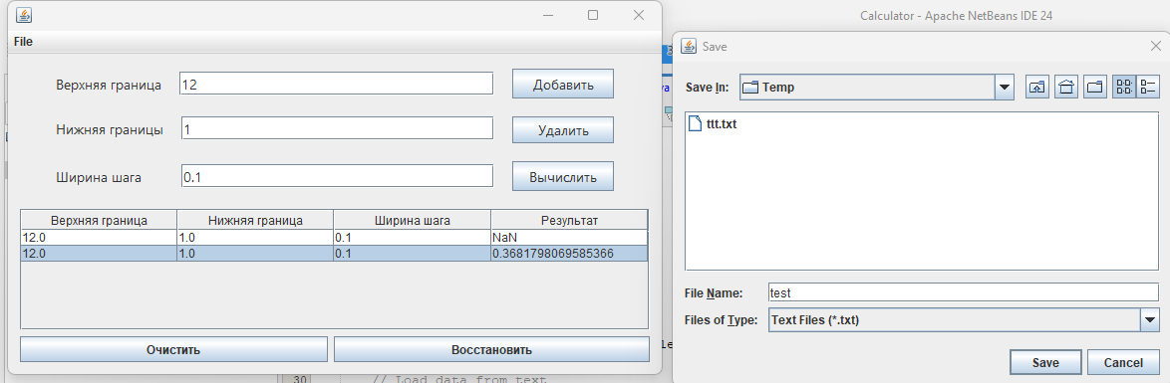

**Вывод**

Научились создавать многопточные приложения с использованием стандартных средств языка Java