# AGORA How To

Written by Alexandra LOUIS (alouis {at} biologie {dot} ens {dot} fr), Matthieu MUFFATO (muffato {at} ebi {dot} ac {dot} uk), and Hugues ROEST CROLLIUS (hrc {at} ens {dot} fr).  
DYOGEN Laboratory, Institut de Biologie de l’École Normale Supérieure (IBENS)  
46 rue d’Ulm, 75005 Paris

**Table of contents:**

* Introduction
  + History
  + What AGORA does and does not do
* Input file formats
* Running AGORA
  + AGORA with no selection of constrained families
  + AGORA with selection of constrained families
  + Advanced AGORA usage
* Output file formats

## Introduction

### History

AGORA stands for “Algorithm for Gene Order Reconstruction in Ancestors” and was developed by Matthieu Muffato during his PhD (2007-2010) in the DYOGEN Laboratory at the École normale supérieure in Paris. Since then it has been constantly used in the group, especially to generate ancestral genomes for the [Genomicus](https://www.genomicus.biologie.ens.fr/genomicus) online server for comparative genomics. Many algorithms used in AGORA are described in details in Matthieu’s thesis, available only in French [(Muffato 2010)](https://www.biblio.univ-evry.fr/theses/2010/2010EVRY0040.pdf) and the core algorithm used to build and linearise the adjacency graph is described in a separate study [(Berthelot et al 2015)](https://www.cell.com/cell-reports/pdfExtended/S2211-1247(15)00204-1).

### What AGORA does and does not do

AGORA takes as input a set of extant gene lists, a species tree linking the genomes, and phylogenetic gene trees reconciled with the species tree. It can produce linear ancestral gene orders (with transcriptional orientation) at any node of the species tree. This may result in very long successive ancestral adjacencies or CARs (Contiguous Ancestral Regions) if the data allows it (e.g. closely related extant genomes with contiguous sequence assemblies) or very short ones if the data does not allow it (e.g. extant genes distributed in short scaffolds, or very rearranged extant genomes).

AGORA does not reconstruct:

* ancestral nucleotide and protein sequences,
* circular chromosomes, unless they are canonically represented in a linear fashion like the mitochondrial genome.

AGORA can be run in two modes. The first and simplest uses all possible adjacencies found in extant genomes to reconstruct ancestral adjacencies, eventually leading to ancestral genomes. In principle this should work fine if the genomes are perfectly sequenced and annotated, but they rarely are. Also, gene duplications are difficult to resolve accurately in gene phylogenies, and AGORA is sensitive to errors in gene trees. A second, more complex version first identifies “constrained” gene familes, on the basis of a user-defined criterion. Typically this can be a requirement that there are as many genes on a tree as there are species, thus limiting the chances that duplications have occurred. AGORA first builds a temporary ancestral genome with these genes (ignoring all other families) as a constrained backbone. Then, it use remaining gene families to fill in the space between constrained genes, but without breaking a chain of constrained genes.

In this HowTo, all the paths are relative to the root of the repository. The individual script commands usually complete within seconds on the example dataset, using less than 300 MB of memory, while the complete reconstructions themselves take between 30 seconds and 1 minute.

## Input file formats

To reconstruct ancestral gene orders, AGORA needs 3 kinds of files (see [example/data/](../example/data)):

* A species tree, e.g. [example/data/Species.nwk](../example/data/Species.nwk)
* A set of extant gene trees reconciled with the species tree, e.g. [example/data/GeneTreeForest.nhx.bz2](../example/data/GeneTreeForest.nhx.bz2).
* The list and positions of the genes of each extant genomes, e.g. [example/data/genes/genes.M1.list.bz2](../example/data/genes/genes.M1.list.bz2). Extant genes that are not in a tree are **not** used for gene order reconstruction.

### Species tree

The species tree is expected in Newick format. See the example species tree:

* [example/data/Species.nwk](../example/data/Species.nwk) – Newick format
* [example/data/Species.pdf](../example/data/Species.pdf) – Graphical representation

Only the node names matter, as they are used to match extant genomes and name the ancestral genomes.

⚠ **Warning**: Internal labels (e.g. “Amniota” or “Anc659123”) have to be unique as they are used to refer to ancestors and name files !

### Gene trees

AGORA expects the gene trees to be in NHX format with the following keys:

1. S gives the taxon name, which must exist in the species tree
2. D indicates the type of the node:
   * D=N for speciation nodes
   * D=Y for duplication nodes, which can be marked as “dubious” with an extra DD=Y. Dubious duplications are considered like speciation nodes when extracting the gene families.

See an example family:

* [example/data/Family1.nhx](../example/data/Family1.nhx) – NHX format
* [example/data/Family1.pdf](../example/data/Family1.pdf) – Graphical representation

The forest file is merely the concatenation of all the families. See the example forest:

* [example/data/GeneTreeForest.nhx.bz2](../example/data/GeneTreeForest.nhx.bz2) – NHX format

### Gene lists

The *genes* files used by AGORA contain the list of genes on each extant genome. The format is tab-separated values, in 5 mandatory columns (the 6^th is optional). One file must be provided per extant genome.

The fields are:

1. Name of the chromosome (text).
2. Start position of the gene (integer).
3. End position of the gene (integer).
4. Gene orientation (1 or -1)
5. Gene identifier (text)
6. Transcript identifier (text, optional)

AGORA only cares about the order of the genes on each chromosome, so the coordinates can be 0-based or 1-based, inclusive or not, etc, as long as the same convention is used throughout each file.

⚠ **Warning**: The gene identifiers have to be consistent with the ones used in the gene trees.

⚠ **Warning**: The genes files must be named consistently with the names of the species in the species tree, using the format prefix.species_name.suffix.

For example, if the species in the species tree are: HUMAN, MOUSE, DOG, genes files have to be named:

* prefix.HUMAN.suffix, e.g. genes.HUMAN.list
* prefix.MOUSE.suffix
* prefix.DOG.suffix

If the species are Homo.sapiens, Mus.musculus and Canis.familiaris, genes files have to be named:

* prefix.Homo.sapiens.suffix, e.g. genes.Homo.sapiens.list
* prefix.Mus.musculus.suffix
* prefix.Canis.familiaris.suffix

In [example/data](../example/data), the five species named in the [species tree](../example/data/Species.nwk) are M1, M2, M3, M4, and M5, and the genes files are named [genes.M1.list.bz2](../example/data/genes/genes.M1.list.bz2), etc.

## Running AGORA

General AGORA workflow

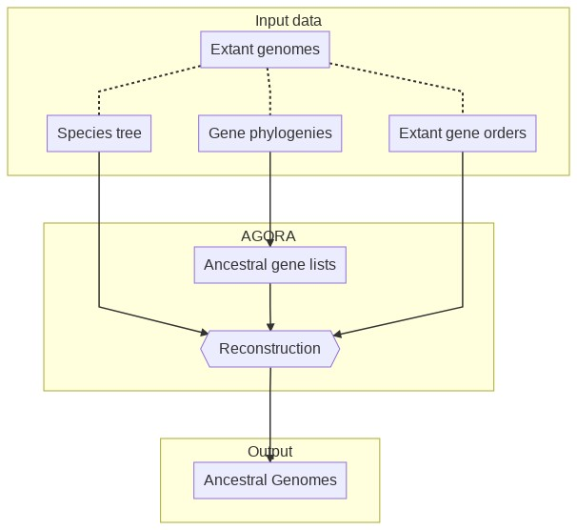

The reconstruction can be perfomed with different approaches, explained below, and the output is a set of CARs. AGORA comes with two presets (predefined workflows) and a mechanism to *roll your own* workflow:

* AGORA with no selection of constrained families
* AGORA with selection of constrained families
* Advanced AGORA usage

#### Notes

All AGORA scripts automatically creates the necessary output directories given to them as command line arguments. This excludes standard output / error shell redirections, which must still be valid paths.

AGORA supports several compression formats for input and output files:

* gzip – .gz extension
* bzip2 – .bz2 extension
* LZMA – .lzma and .xz extensions (needs the pyliblzma Python package)

Compression / decompression costs extra CPU time, but decreases file transfer times and storage footprint (typically 6x with bzip2). Compression is also supported on the standard output by adding +gz, +bz2, +lzma, or +xz on the command-line.

### AGORA with no selection of constrained families

This is the simplest and quickest reconstruction. AGORA compares all extant genomes pairwise to extract conserved adjacencies, generates the ancestral adjacency graphs and linearises them to produce CARs.

AGORA workflow with no selection of constrained families

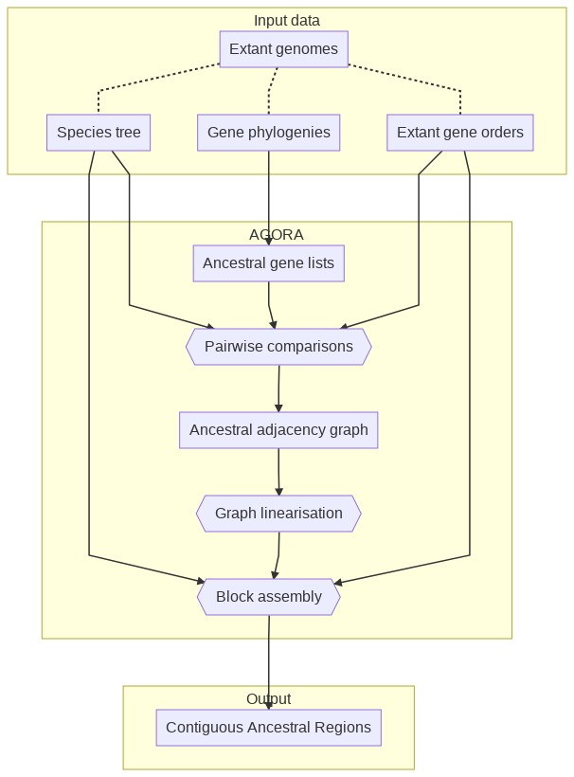

In this mode, the reconstruction is composed of three steps akin to a genome assembly:

* The pairwise comparisons provide “reads” of the ancestral genomes
* The reads are assembled into contigs (“Graph linearisation” step)
* The contigs are assembled into scaffolds (“Scaffolding” step)

#### All in one: agora-basic.py

The agora-basic.py script sets AGORA to run these three steps sequentially. The only parameters that have to be given are the paths to the input files: species tree, gene trees and gene lists.

src/agora-basic.py /path/to/species-tree.nwk /path/to/gene-trees.nhx /path/to/genes.%s.list

There are three optional Command-line parameters:

* By default the files will be created in the current directory. Add the -workingDir=output_dir option to change the output directory (which will be automatically created).
* By default AGORA uses all the cores available on the machine. Use the -nbThreads=XX option to control this.
* By default AGORA will reconstruct *every* ancestor. To limit the reconstruction to one ancestor and all its descendants (say Boreoeutheria), add the -target=Boreoeutheria option. To reconstruct Boreoeutheria *only*, use -target==Boreoeutheria (with two =) instead.

To regenerate the reference output of the example dataset, run:

src/agora-basic.py \  
 example/data/Species.nwk \  
 example/data/GeneTreeForest.nhx.bz2 \  
 example/data/genes/genes.%s.list.bz2 \  
 -workingDir=example/results \  
 -nbThreads=1

#### Step by step

The scripts can also be run step by step. In the following command lines, A0 represents the name of the target ancestor for the reconstructions (here the root of the example species tree). As with the -target option, A0 means that this ancestor and all its descendants will be reconstructed. To *only* reconstruct A0, give =A0 to the scripts.

##### Extraction of ancestral gene content

The first step in AGORA is to identify all ancestral genes for all ancestral genomes, and print them in one file per target ancestral genome. The ALL.extractGeneFamilies.py script takes as input the species tree, the forest of gene trees and a template to name the output files.

mkdir -p example/results/ancGenes  
src/ALL.extractGeneFamilies.py \  
 example/data/Species.nwk \  
 example/data/GeneTreeForest.nhx.bz2 \  
 -OUT.ancGenesFiles=example/results/ancGenes/all/ancGenes.%s.list.bz2 \  
 +bz2 \  
 > example/results/GeneTreeForests.withAncGenes.nhx.bz2 \  
 2> example/results/ancGenes/ancGenes.log

Be careful to provide the correct path to write the *ancGenes* files (ancGenes/all/ancGenes.%s.list.bz2), it will be important if you use AGORA on constrained families in a second step (see article). The %s is automatically replaced by the extant and ancestral species name, as indicated in the species tree.

ancGenes files are tab-separated files, with the following two fields:

1. Ancestral gene names (generated by AGORA)
2. A space separated list of extant copies of this ancestral gene, in the genome of extant species.

On the standard output, the script produces the forest of gene trees, rewritten with the ancestral gene names at each node, in NHX format. Note that the rest of the scripts will use these ancGenes files rather than the forest of gene trees.

##### Pairwise comparisons

This step compares extant genomes in all possible pairwise combinations to identify conserved adjacencies.

mkdir -p example/results/pairwise/pairs-all/  
src/buildSynteny.pairwise-conservedPairs.py \  
 example/data/Species.nwk \  
 A0 \  
 -OUT.pairwise=example/results/pairwise/pairs-all/%s.list.bz2 \  
 -genesFiles=example/data/genes/genes.%s.list.bz2 \  
 -ancGenesFiles=example/results/ancGenes/all/ancGenes.%s.list.bz2 \  
 2> example/results/pairwise/pairs-all/log

##### Graph linearisation

This step integrates all the pairwise comparisons identified above for each ancestor and combine them into adjacency graphs, from which a first set of CARs are derived.

mkdir -p example/results/ancBlocks/denovo-all/  
src/buildSynteny.integr-denovo.py \  
 example/data/Species.nwk \  
 A0 \  
 example/results/pairwise/pairs-all/%s.list.bz2 \  
 +searchLoops \  
 -OUT.ancBlocks=example/results/ancBlocks/denovo-all/blocks.%s.list.bz2 \  
 -LOG.ancGraph=example/results/ancBlocks/denovo-all/graph.%s.log.bz2 \  
 -ancGenesFiles=example/results/ancGenes/all/ancGenes.%s.list.bz2 \  
 2> example/results/ancBlocks/denovo-all/log

##### Scaffolding

In this step, we basically reiterate the same process (pairwise comparisons and integration into an adjacency graph) but on the previous CARs, which allows finding higher-level adjacencies. The result is a set of CARs made of CARs, that are much longer than in the previous steps.

mkdir -p example/results/ancBlocks/denovo-all.groups/  
src/buildSynteny.integr-scaffolds.py \  
 example/data/Species.nwk \  
 A0 \  
 -IN.ancBlocks=example/results/ancBlocks/denovo-all/blocks.%s.list.bz2 \  
 -OUT.ancBlocks=example/results/ancBlocks/denovo-all.groups/blocks.%s.list.bz2 \  
 -LOG.ancGraph=example/results/ancBlocks/denovo-all.groups/graph.%s.log.bz2 \  
 -genesFiles=example/data/genes/genes.%s.list.bz2 \  
 -ancGenesFiles=example/results/ancGenes/all/ancGenes.%s.list.bz2 \  
 2> example/results/ancBlocks/denovo-all.groups/log

##### Conversion to ancestral genomes

The previous script outputs the ancestral reconstructions as *blocks* files There is a last script to convert these files to a format very similar to the input *genes* files, named *ancGenomes*:

mkdir -p example/results/ancGenomes/standard  
src/convert.ancGenomes.blocks-to-genes.py \  
 example/data/Species.nwk \  
 A0 \  
 -IN.ancBlocks=example/results/ancBlocks/denovo-all.groups/blocks.%s.list.bz2 \  
 -OUT.ancGenomes=example/results/ancGenomes/standard/ancGenome.%s.list.bz2 \  
 -ancGenesFiles=example/results/ancGenes/all/ancGenes.%s.list.bz2 \  
 2> example/results/ancGenomes/standard/log

More information about these files in Output file formats below.

### AGORA with selection of constrained families

This approach builds ancestral adjacencies considering a subset of the genes. The idea here is to build “constrained” ancestral adjacency scaffolds, and to insert within these adjacencies the remaining ancestral genes.

AGORA workflow with selection of constrained families

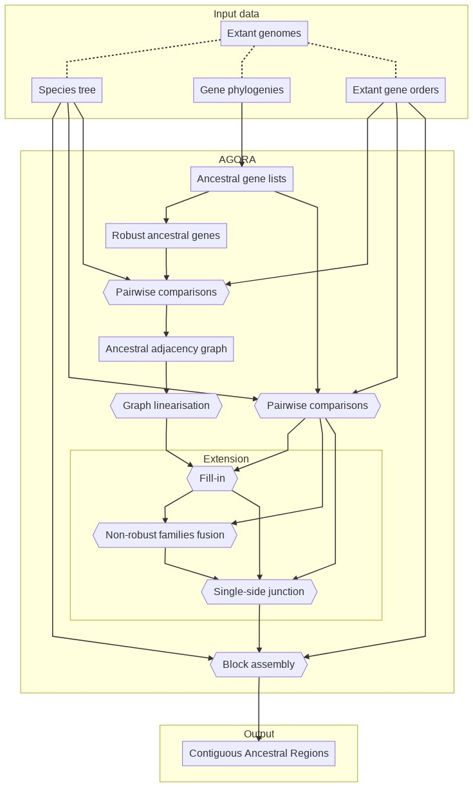

From the complete list of ancestral genes, AGORA identifies a subset of constrained genes according to a user-defined criterion. It compares all extant genomes pairwise (considering all genes and constrained genes separately), build the adjacency graphs on the comparisons of constrained genes and linearise them to obtain constrained contigs. It then *fills these in* with non-constrained genes, builds contigs of non-constrained genes (*non-constrained families fusion*) and inserts these in the filled-in constrained contigs (*single side junction*). Finally it assembles the resulting contigs (scaffolding) into ancestral genomes.

#### All in one: agora-vertebrates.py

The whole workflow can be run automatically with agora-vertebrates.py using the same syntax as agora-basic.py

src/agora-vertebrates.py /path/to/species-tree.nwk /path/to/gene-trees.nhx /path/to/genes.%s.list

This configuration file is set to select the genes families that have exactly the same number of extant genes as extant species (i.e. *minSize* and *maxSize* parameters equal to 1). Having undergone fewer losses and duplications, the synteny signal of those families is less ambiguous and their adjacencies easier to compare and more conserved. These two parameters can be changed according to the dynamics of the species considered.

src/agora-vertebrates.py /path/to/species-tree.nwk /path/to/gene-trees.nhx /path/to/genes.%s.list -minSize=0.9 -maxSize=1.1

To regenerate the reference output of the example dataset, run:

src/agora-vertebrates.py \  
 example/data/Species.nwk \  
 example/data/GeneTreeForest.nhx.bz2 \  
 example/data/genes/genes.%s.list.bz2 \  
 -workingDir=example/results \  
 -nbThreads=1

#### Step by step

##### Selection of constrained genes

This script filters the complete set of ancestral genes and selects the ones that match the required number of extant genes (relative to the number of extant species.

⚠ **Warning**: this assumes you have already extracted the ancestral genes from the gene trees (see running AGORA with no selection of constrained families).

src/ALL.filterGeneFamilies-size.py \  
 example/data/Species.nwk \  
 A0 \  
 example/results/ancGenes/all/ancGenes.%s.list.bz2 \  
 example/results/ancGenes/size-%s-%s/ancGenes.%s.list.bz2 \  
 1.0 \  
 1.0 \  
 2> example/results/ancGenes/size.log

##### Pairwise comparison

This step is run once for all ancestral genes, and once for the set of constrained families.

For all ancestral genes:

mkdir -p example/results/pairwise/pairs-all  
src/buildSynteny.pairwise-conservedPairs.py \  
 example/data/Species.nwk \  
 A0 \  
 -OUT.pairwise=example/results/pairwise/pairs-all/%s.list.bz2 \  
 -genesFiles=example/data/genes/genes.%s.list.bz2 \  
 -ancGenesFiles=example/results/ancGenes/all/ancGenes.%s.list.bz2 \  
 2> example/results/pairwise/pairs-all/log

For the constrained gene families:

mkdir -p example/results/pairwise/pairs-size-1.0-1.0  
src/buildSynteny.pairwise-conservedPairs.py \  
 example/data/Species.nwk \  
 A0 \  
 -OUT.pairwise=example/results/pairwise/pairs-size-1.0-1.0/%s.list.bz2 \  
 -genesFiles=example/data/genes/genes.%s.list.bz2 \  
 -ancGenesFiles=example/results/ancGenes/size-1.0-1.0/ancGenes.%s.list.bz2 \  
 2> example/results/pairwise/pairs-size-1.0-1.0/log

##### Graph linearisation

This step integrates all the pairwise comparisons of constrained genes identified above for each ancestor and combines them into adjacency graphs, from which a first set of CARs are derived.

mkdir -p example/results/ancBlocks/denovo-size-1.0-1.0  
src/buildSynteny.integr-denovo.py \  
 example/data/Species.nwk \  
 A0 \  
 example/results/pairwise/pairs-size-1.0-1.0/%s.list.bz2 \  
 -OUT.ancBlocks=example/results/ancBlocks/denovo-size-1.0-1.0/blocks.%s.list.bz2 \  
 -LOG.ancGraph=example/results/ancBlocks/denovo-size-1.0-1.0/graph.%s.log.bz2 \  
 -ancGenesFiles=example/results/ancGenes/all/ancGenes.%s.list.bz2 \  
 2> example/results/ancBlocks/denovo-size-1.0-1.0/log

##### “Fill-in” integration

This step inserts non-constrained genes in each interval of the ancestral contigs, following paths in the complete ancestral adjacency graph.

mkdir -p example/results/ancBlocks/denovo-size-1.0-1.0.refine-all  
src/buildSynteny.integr-fillin.py \  
 example/data/Species.nwk \  
 A0 \  
 example/results/pairwise/pairs-all/%s.list.bz2 \  
 -IN.ancBlocks=example/results/ancBlocks/denovo-size-1.0-1.0/blocks.%s.list.bz2 \  
 -OUT.ancBlocks=example/results/ancBlocks/denovo-size-1.0-1.0.refine-all/blocks.%s.list.bz2 \  
 -LOG.ancGraph=example/results/ancBlocks/denovo-size-1.0-1.0.refine-all/graph.%s.log.bz2 \  
 2> example/results/ancBlocks/denovo-size-1.0-1.0.refine-all/log

##### “Fusion” integration

This step takes all the remaining singletons (+onlySingletons option), which are mostly non-constrained genes, and tries to assemble them into contigs.

mkdir -p example/results/ancBlocks/denovo-size-1.0-1.0.refine-all.extend-all  
src/buildSynteny.integr-fusion.py \  
 example/data/Species.nwk \  
 A0 \  
 example/results/pairwise/pairs-all/%s.list.bz2 \  
 +onlySingletons \  
 -IN.ancBlocks=example/results/ancBlocks/denovo-size-1.0-1.0.refine-all/blocks.%s.list.bz2 \  
 -OUT.ancBlocks=example/results/ancBlocks/denovo-size-1.0-1.0.refine-all.extend-all/blocks.%s.list.bz2 \  
 -LOG.ancGraph=example/results/ancBlocks/denovo-size-1.0-1.0.refine-all.extend-all/graph.%s.log.bz2 \  
 2> example/results/ancBlocks/denovo-size-1.0-1.0.refine-all.extend-all/log

##### “Insertion” integration

This step inserts the contigs of non-constrained families created above and inserts them in the CARs.

mkdir -p example/results/ancBlocks/denovo-size-1.0-1.0.refine-all.extend-all.halfinsert-all  
src/buildSynteny.integr-insertion.py \  
 example/data/Species.nwk \  
 A0 \  
 example/results/pairwise/pairs-all/%s.list.bz2 \  
 -IN.ancBlocks=example/results/ancBlocks/denovo-size-1.0-1.0.refine-all.extend-all/blocks.%s.list.bz2 \  
 -REF.ancBlocks=example/results/ancBlocks/denovo-size-1.0-1.0.refine-all/blocks.%s.list.bz2 \  
 -OUT.ancBlocks=example/results/ancBlocks/denovo-size-1.0-1.0.refine-all.extend-all.halfinsert-all/blocks.%s.list.bz2 \  
 -LOG.ancGraph=example/results/ancBlocks/denovo-size-1.0-1.0.refine-all.extend-all.halfinsert-all/graph.%s.log.bz2 \  
 2> example/results/ancBlocks/denovo-size-1.0-1.0.refine-all.extend-all.halfinsert-all/log

##### Scaffolding

Like in non-constrained mode, this step does pairwise comparisons and a graph linearisation of the CARs themselves, which allows finding higher-level adjacencies.

mkdir -p example/results/ancBlocks/denovo-size-1.0-1.0.refine-all.extend-all.halfinsert-all.groups  
src/buildSynteny.integr-scaffolds.py \  
 example/data/Species.nwk \  
 A0 \  
 -IN.ancBlocks=example/results/ancBlocks/denovo-size-1.0-1.0.refine-all.extend-all.halfinsert-all/blocks.%s.list.bz2 \  
 -OUT.ancBlocks=example/results/ancBlocks/denovo-size-1.0-1.0.refine-all.extend-all.halfinsert-all.groups/blocks.%s.list.bz2 \  
 -LOG.ancGraph=example/results/ancBlocks/denovo-size-1.0-1.0.refine-all.extend-all.halfinsert-all.groups/graph.%s.log.bz2 \  
 -genesFiles=example/data/genes/genes.%s.list.bz2 \  
 -ancGenesFiles=example/results/ancGenes/all/ancGenes.%s.list.bz2 \  
 2> example/results/ancBlocks/denovo-size-1.0-1.0.refine-all.extend-all.halfinsert-all.groups/log

##### Conversion to ancestral genomes

This step converts the *blocks* files to *ancGenomes*:

mkdir -p example/results/ancGenomes/constrained  
src/convert.ancGenomes.blocks-to-genes.py \  
 example/data/Species.nwk \  
 A0 \  
 -IN.ancBlocks=example/results/ancBlocks/denovo-size-1.0-1.0.refine-all.extend-all.halfinsert-all.groups/blocks.%s.list.bz2 \  
 -OUT.ancGenomes=example/results/ancGenomes/constrained/ancGenome.%s.list.bz2 \  
 -ancGenesFiles=example/results/ancGenes/all/ancGenes.%s.list.bz2 \  
 2> example/results/ancGenomes/constrained/log

More information about these files in Output file formats below.

### Advanced AGORA usage

#### agora.py script

The AGORA method is also available through a script named agora.py, which runs all the steps of the reconstructions according to a configuration file.

The configuration file lists the input and output paths, and describes the steps of the workflows. The agora-basic.py and agora-vertebrates.py scripts are equivalent to the [agora-basic.ini](../conf/agora-basic.ini) and [agora-vertebrates.ini](../conf/agora-vertebrates.ini) configuration files.

For instance, this will run reconstructions directly, without selecting constrained families:

src/agora.py conf/agora-basic.ini -workingDir=output_dir

The script also accepts the -nbThreads=XX parameter.

#### AGORA with different selections of constrained families

The selection of constrained families can be further tuned to use multiple sets of constrained genes. Along the *1.0-1.0* constrained families used above, we can define other, more relaxed, sets, like *0.9-1.1*, which tolerates a 10% deviation between the number of extant genes and extant species, and so forth.

The following two configuration files showcase different ways of running AGORA with multiple sets of constrained families, and demonstrate the power of using a configuration file.

##### Different parameters for each ancestor

The [agora-multi-constrained.ini](../conf/agora-multi-constrained.ini) configuration file tells AGORA to use multiple filters on different ancestors, and how to conbine the results.

Run the entire workflow with agora.py:

src/agora.py conf/agora-multi-constrained.ini -workingDir=output_dir

##### Indicative steps

The most efficient way of extracting multiple sets of constrained families is to do all at once, for instance:

src/ALL.filterGeneFamilies-size.py \  
 example/data/Species.nwk \  
 A0 \  
 example/results/ancGenes/all/ancGenes.%s.list.bz2 \  
 example/results/ancGenes/size-%s-%s/ancGenes.%s.list.bz2 \  
 1.0,0.9,0.77 \  
 1.0,1.1,1.33 \  
 2> example/results/ancGenes/multi-size.log

Pairwise comparisons would have to be run on each set independently. Then these different sets can be used on different ancestors to generate the first set of ancestral adjacencies, e.g.:

mkdir -p example/results/ancBlocks/denovo-size-1.0-1.0  
src/buildSynteny.integr-denovo.py \  
 example/data/Species.nwk \  
 =A3 \  
 example/results/pairwise/pairs-size-1.0-1.0/%s.list.bz2 \  
 -OUT.ancBlocks=example/results/ancBlocks/denovo-size-1.0-1.0/blocks.%s.list.bz2 \  
 -LOG.ancGraph=example/results/ancBlocks/denovo-size-1.0-1.0/graph.%s.log.bz2 \  
 -ancGenesFiles=example/results/ancGenes/all/ancGenes.%s.list.bz2 \  
 2> example/results/ancBlocks/denovo-size-1.0-1.0/log  
  
mkdir -p example/results/ancBlocks/denovo-size-0.9-1.1  
src/buildSynteny.integr-denovo.py \  
 example/data/Species.nwk \  
 =A1,=A2 \  
 example/results/pairwise/pairs-size-0.9-1.1/%s.list.bz2 \  
 -OUT.ancBlocks=example/results/ancBlocks/denovo-size-0.9-1.1/blocks.%s.list.bz2 \  
 -LOG.ancGraph=example/results/ancBlocks/denovo-size-0.9-1.1/graph.%s.log.bz2 \  
 -ancGenesFiles=example/results/ancGenes/all/ancGenes.%s.list.bz2 \  
 2> example/results/ancBlocks/denovo-size-0.9-1.1/log

These sets can be combined by running the copy script multiple times, like this:

mkdir -p example/results/ancBlocks/denovo-size-custom  
src/buildSynteny.integr-copy.py \  
 example/data/Species.nwk \  
 =A3 \  
 -IN.ancBlocks=example/results/ancBlocks/denovo-size-1.0-1.0/blocks.%s.list.bz2 \  
 -OUT.ancBlocks=example/results/ancBlocks/denovo-size-custom/blocks.%s.list.bz2 \  
 2> example/results/ancBlocks/denovo-size-custom/log

##### Iterative reconstructions with less and less constrained families

The [agora-iterative-constrained.ini](../conf/agora-iterative-constrained.ini) configuration file use the same multiple filters (*1.0-1.0*, *0.9-1.1*, *0.77-1.33*) but on **every** ancestor. Compared to the [agora-vertebrates.ini](../conf/agora-vertebrates.ini) workflow, it first extends the *1.0-1.0* reconstructions with the “less constrained” *0.9-1.1* families only, then with the “even less constrained” *0.77-1.33* families, and finally with the complete set of families.

Test it agora.py:

src/agora.py conf/agora-iterative-constrained.ini -workingDir=output_dir

## Output file formats

### The *blocks* files

These files are present under example/results/ancBlocks/*. Each of these contains a file per ancestral reconstructed genome (e.g. blocks.A0.list.bz2). The files are tab-separated, and values in each field are further separated by single spaces.

The fields are:

1. Name of the ancestral species.
2. Number of genes in the ancestral block.
3. List of gene IDs. Each ID corresponds to the line number in the corresponding *ancGenes* file (the full one) of this ancestor (starting from 0).
4. Gene transcriptional orientation (strand) within the block.
5. A relative confidence index for each inter-block linkage.
   * The values in parenthesis are the size of the initial blocks.
   * The values without parenthesis represent the number of time the two adjacent blocks are adjacent in extant species.

* The sum of the lengths of the initial blocks (numbers in parenthesis) is thus equal to the size of the whole block (field number 2)

For instance, the following line represents a block of 8 genes in A0 made of 2 sub-blocks (of respectively 5 and 3 genes) linked by an adjacency of score 6.

A0 8 4559 4179 10099 15638 1304 10998 5675 13765 -1 -1 -1 1 1 -1 -1 1 (5) 6 (3)

### The *ancGenome* files

The *ancGenomes* files are a simpler way of accessing the content of the ancestral genomes, and can be found under example/results/ancGenomes/*.

They are very similar to the input *genes* files. They are tab-separated and contain 5 columns:

1. Name of the ancestral block.
2. Relative start position of the ancestral gene.
3. Relative end position of the ancestral gene.
4. Ancestral gene orientation within the block.
5. Ancestral gene names, separated by a space. The first name corresponds to the ancestral gene, subsequent ones are the list of extant copies of this ancestral gene, in the genome of extant species.

Coordinates follow the same convention as [BED files](https://en.wikipedia.org/wiki/BED_(file_format)#Coordinate_system). The start coordinate is 0-based while the end coordinate is 1-based. Thus the first gene in a block has got the coordinates 0 and 1, and the sixth gene 5 and 6.