

Ecommerce Applications Development

Diploma in Information Technology

AY 2023/24 Semester 2

Individual Assignment
(25% of Overall Assessment)

Duration: Week 16 - 17

Deadline for Submission:
9th February 2024 (Friday), 12:00 PM

Class group | : | P03
Tutor | : | Anand Ravi Despande
Team ID | : | 2
Date of submission | :
Late | : | YES / NO

Please fill in your Student Number and Name as appeared on your student card:

Topics | Student ID | Student Name | Grade
Strategy in promoting the ecommerce website | S10227735B | Ong Jia Yuan
Legal issues faced | S10222049J | Owen Wong Hoi Yang
Personalization service to the shoppers | S10222747H | Khoo Jun Jie

Penalty for late submission:
10% of the marks will be deducted every day after the deadline.
No submission will be accepted after 16th February 2024, 12:00 pm.

Table of Contents
Pages
1. Strategy in Promoting the Ecommerce Website 3
1.1. Market Analysis: 3
1.2. Marketing Strategies: 3
2. Legal Issues Faced 5
2.1 Data Privacy and Protection 5
2.2 Intellectual Property Rights 5
2.3 Consumer Protection Laws 5
2.4 Solutions and Recommendations 6
3. Personalization Service to the Shoppers 7
3.1 Benefits of Personalization Service: 7
3.1.1 Tailored User Experience 7
3.1.2 Improved Customer Service 7
3.1.3 Customer Engagement 7
3.1.4 Data Utilization 7
3.2 Personalization Service Implementation: 8
3.2.1 Behavioural Tracking 8
3.2.2 Adaptive Online Store Experience 8
3.2.3 Membership and Shopper Profile 8
3.2.4 Collaborative Filtering 8
4. References 10

1. Strategy in Promoting the Ecommerce Website

1.1. Market Analysis:
Understanding the target audience is crucial for tailoring marketing strategies effectively in the competitive e-commerce landscape. The e-commerce market has seen significant expansion with key players like Amazon, Alibaba, and Walmart innovating through product launches and partnerships. Consumer trends, such as the preference for convenient shopping solutions and evolving technology, play a major role in shaping market dynamics. Additionally, initiatives like Amazon's recent move to democratize online shopping in South Asia highlight the importance of adapting to regional consumer needs and preferences​​ (Mordor Intelligence, 2023).
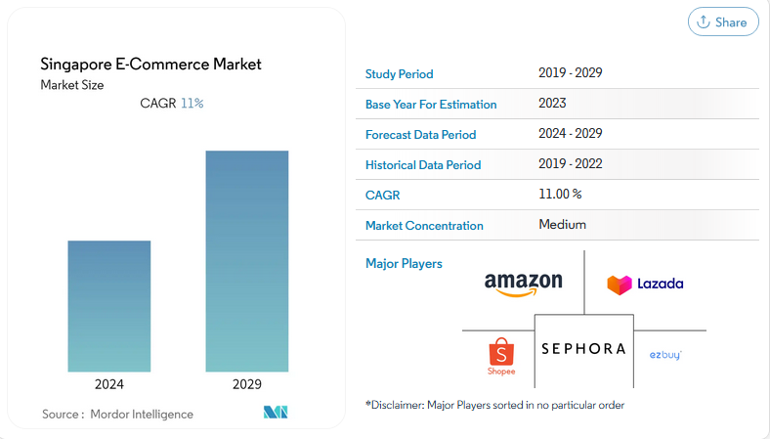

1.2. Marketing Strategies:
1. Digital Marketing:
- SEO: Implementing search engine optimization is vital for increasing website visibility. This involves keyword research, optimizing site structure, and content creation.
- Social Media: Utilizing platforms like Facebook, Instagram, and Twitter is essential for brand awareness and engagement, requiring engaging content and interactive campaigns.
- Email Campaigns: Personalized email marketing is effective in reaching both potential and existing customers, involving segmenting email lists and crafting tailored messages.
2. Partnerships and Collaborations:
- Collaborating with influencers and other brands helps in expanding market reach through co-marketing initiatives and cross-promotional activities.
3. Promotional Offers:
- Discounts, loyalty programs, and limited-time offers are key to attracting and retaining customers, with customer data analysis aiding in creating resonating offers.
Implementation Plan: A detailed implementation plan is essential for the success of e-commerce marketing strategies. This should include a clear timeline with key milestones, specifying the specific actions to be taken, the parties responsible for each action, and the deadlines for each phase of the strategy. This structured approach ensures that all aspects of the marketing strategy are executed in a timely and efficient manner.
Evaluation Metrics: The effectiveness of the implemented e-commerce marketing strategies should be gauged using specific metrics. These include monitoring website traffic, conversion rates, and customer engagement levels. Regularly analyzing these metrics using analytics tools provides valuable insights into which strategies are working and which need adjustment, guiding future marketing efforts and strategy refinement.
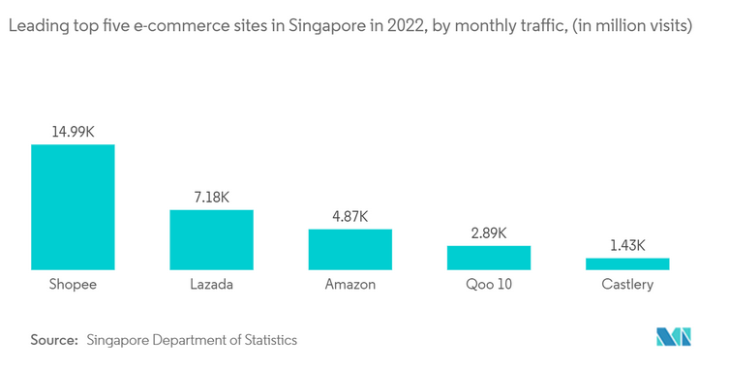

2. Legal Issues Faced
E-commerce websites operate in a dynamic legal landscape where they must navigate various legal issues to ensure compliance and protect their business interests. Understanding these legal challenges is crucial for the sustainable operation of any online marketplace.



2.1 Data Privacy and Protection

One of the most significant legal challenges for e-commerce sites involves data privacy and protection. E-commerce businesses collect vast amounts of personal data, such as names, addresses, and payment information. They must comply with regulations like the General Data Protection Regulation (GDPR) in the European Union and the California Consumer Privacy Act (CCPA) in the United States. These laws mandate strict guidelines on data collection, storage, and usage, including obtaining consent from users and providing them with control over their data (GDPR.eu, 2020).

2.2 Intellectual Property Rights

E-commerce platforms must also be vigilant about intellectual property rights. This involves ensuring that products sold on their website do not infringe upon patents, copyrights, or trademarks. Failure to monitor and address intellectual property infringement can lead to legal disputes and significant financial penalties (WIPO, 2021).

2.3 Consumer Protection Laws

Consumer protection laws are another critical area. These laws, which vary by country, are designed to protect consumers from unfair business practices. They include regulations on product quality, advertising, and return policies. E-commerce sites must ensure that their practices comply with these laws to avoid legal consequences and maintain customer trust (FTC, 2022).

2.4 Solutions and Recommendations

To address these issues, e-commerce websites should implement comprehensive data protection policies, regularly audit their product listings for potential intellectual property violations and stay updated on consumer protection laws in different jurisdictions. Investing in legal expertise and technology solutions for compliance can be a proactive approach to mitigate these risks.

In conclusion, e-commerce websites face significant legal challenges in data privacy, intellectual property rights, and consumer protection. Addressing these issues effectively requires a combination of legal knowledge, technology, and a commitment to ethical business practices.

3. Personalization Service to the Shoppers
Personalization service to the shoppers is very important to improve the shopping experience for the shoppers in e-commerce websites. Implementing effective personalization requires careful consideration of various factors to ensure relevance, engagement, and eventually higher sales.



3.1 Benefits of Personalization Service:

3.1.1 Tailored User Experience

Personalization in e-commerce can significantly enhance the shopping experience. Using data analytics, websites offer personalized recommendations, creating a unique and engaging shopping journey for each user.

3.1.2 Improved Customer Service

Customized customer service solutions like AI-driven chatbots and personalized support systems can address individual concerns effectively, leading to higher customer satisfaction rates.

3.1.3 Customer Engagement

Personalized marketing campaigns can lead to deeper customer engagement. By sending tailored emails and offers based on past shopping behavior, e-commerce businesses can increase repeat visits and sales.

3.1.4 Data Utilization

Leveraging customer data responsibly to personalize experiences is the key to better service. Analyzing browsing patterns, purchase history, and preferences can lead to improved product recommendations and customer satisfaction.

3.2 Personalization Service Implementation:

3.2.1 Behavioural Tracking

E-commerce websites can track shoppers’ behaviors, such as product view and time spent on pages, to understand shopper preferences and intent. This data informs personalized recommendations and targeted marketing strategies, ensuring that shoppers find what they’re looking for effortlessly.

3.2.2 Adaptive Online Store Experience

Personalization enables the dynamic adaptation of the online store’s interface and content based on individual shopper behavior and preferences. For instance, frequent browsing of specific product categories prompts the website to prioritize related products or promotions, enhancing the overall shopping experience.

3.2.3 Membership and Shopper Profile

Membership or shopper profile systems gather valuable data about user preferences, purchase history, and demographics. With this information, e-commerce websites can offer personalized product recommendations, discounts, and promotions specifically for each member’s interests and needs.

3.2.4 Collaborative Filtering

Collaborative filtering algorithms analyze the behavior and preferences of similar shoppers to make personalized recommendations. By leveraging the collective information of the shopper community, e-commerce platforms can ensure that shoppers discover products or content that align with their interests and preferences.

According to 55% of marketers, the #1 benefit of personalization is better visitor engagement and customer experiences (Moran, 2024).
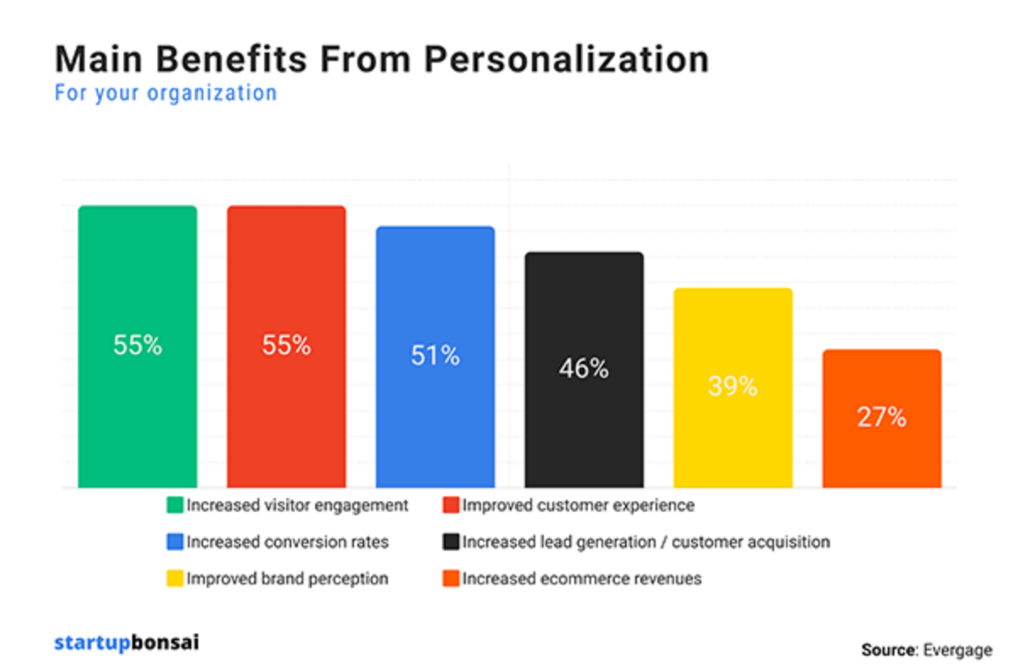

4. References

- GDPR.eu. (2020). General Data Protection Regulation (GDPR) Compliance Guidelines.
- World Intellectual Property Organization (WIPO). (2021). Intellectual Property and E-commerce: How to Take Care of Your Business’ IP.
- Federal Trade Commission (FTC). (2022). Consumer Protection Principles for E-commerce.
- Sahin, B. (2023). E-Commerce Personalization: Your Complete Guide.
- Moran, M. (2024). 55+ Top Personalization Statistics For 2024 (+ Facts And Trends).

