

Ecommerce Applications Development

Diploma in Information Technology

AY 2023/24 Semester 2

Team cum Individual Assignment
(30% of Overall Assessment)

Duration: Week 16 - 17

Deadline for Submission:
3rd February 2024 (Sunday), 12:00 PM

Class group | : | P03
Tutor | : | Anand Ravi Despande
Team ID | : | 2
Date of submission | :
Late | : | YES / NO

Please fill in your Student Number and Name as appeared on your student card:

Functions | Student ID | Student Name | Team Grade | Grade
Shopping Cart | S10227735B | Ong Jia Yuan
Checkout | S10222049J | Owen Wong Hoi Yang
Product Catalog | S10222747H | Khoo Jun Jie

Penalty for late submission:
10% of the marks will be deducted every day after the deadline.
No submission will be accepted after 10th February 2024, 12:00 pm.

Integration of System (Group Component)
Done By: Everyone

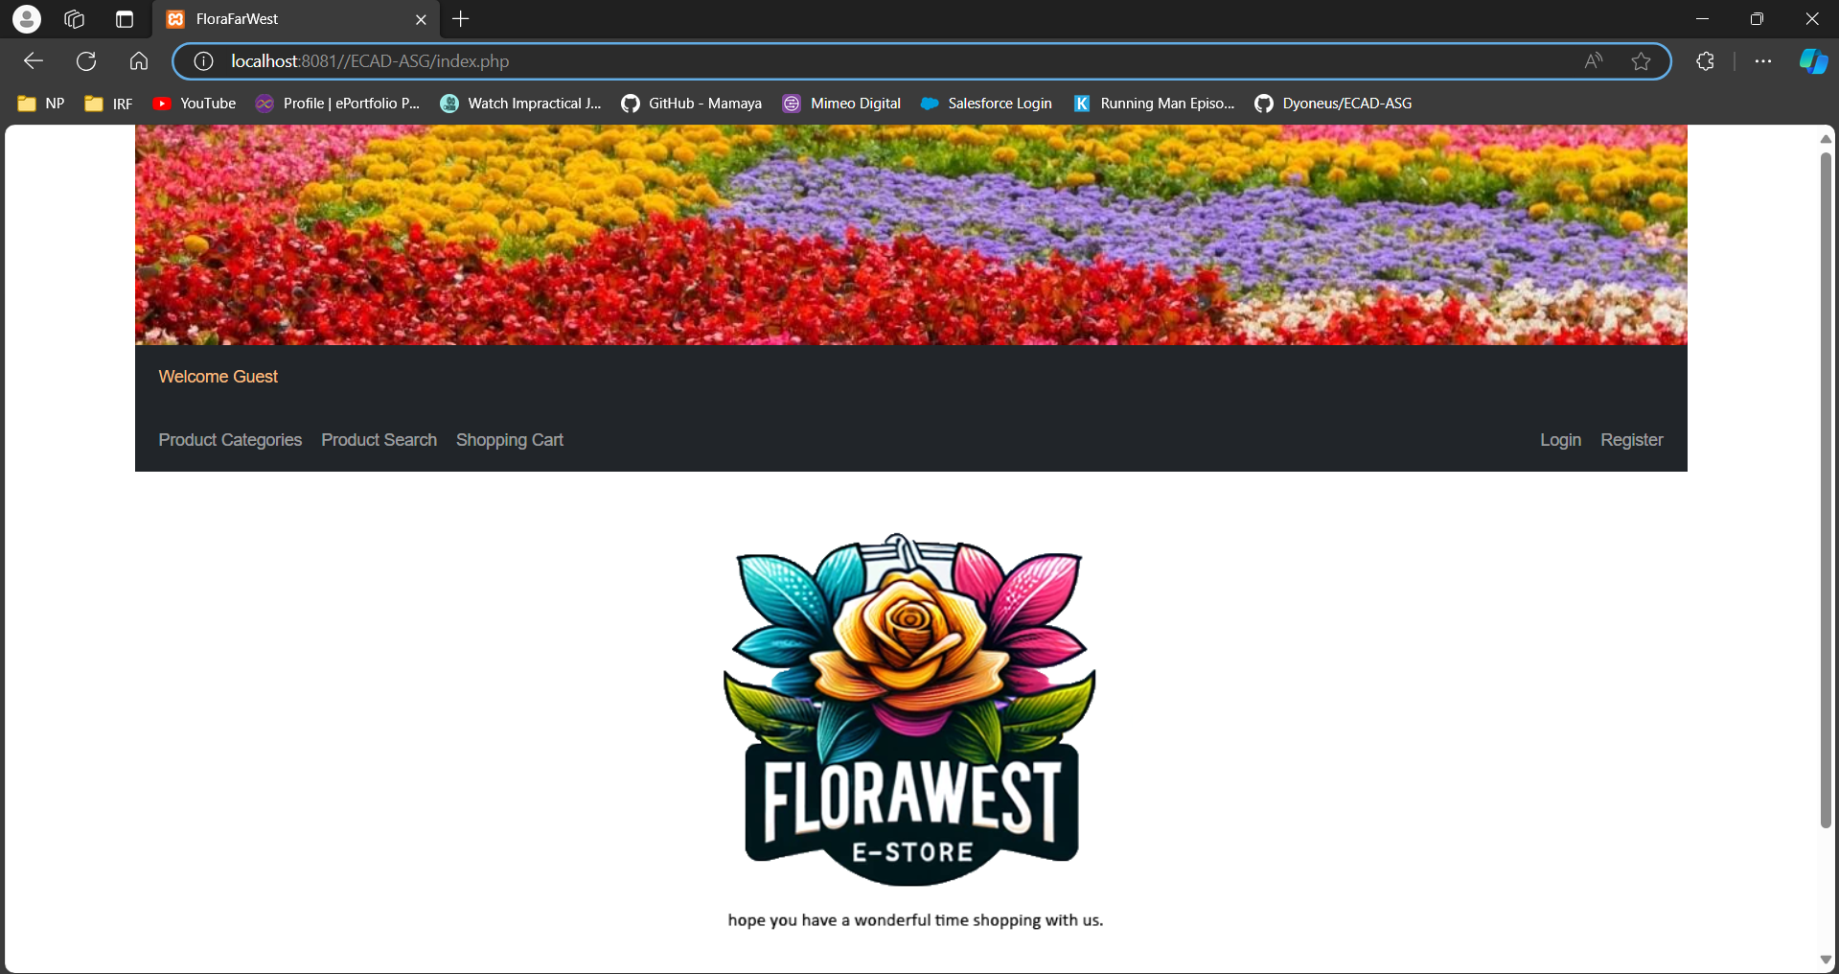

Site Name: FloraFarWest

FloraFarWest is an enchanting online storefront offering a vibrant selection of floral arrangements and garden essentials to patrons across Singapore. This website is a haven for garden enthusiasts and those seeking to infuse their spaces with the natural beauty of flowers.

Our virtual store boasts an intuitive and minimalist design with our emblematic logo positioned at the upper left corner of the webpage. Directly beneath it lies a streamlined navigation bar, leading you seamlessly through the diverse categories of offerings. Recognizing the importance of accessibility, our website is crafted to be fully responsive. The navigation bar conveniently transforms into a compact dropdown menu on smaller screens, ensuring an effortless browsing experience on mobile devices.

The aesthetic of FloraFarWest is characterized by a palette of soothing colors—crisp white, verdant green, and floral accents—that mirror the tranquility of a blooming garden. White serves as the backdrop for clarity and freshness, while green shades represent growth and vitality, adorning the navigation bar. Accent colors drawn from our floral selection are peppered throughout the site, highlighting key features and buttons for navigation.

Prominently displayed, our logo and brand name at the middle of the page serve as a constant reminder of the FloraFarWest experience. A click on the picture above will always guide visitors back to our home page.

The main page greets visitors with a warm welcome message, set against the backdrop of our lush floral collection, instantly conveying the essence of our product range. Special deals and featured blooms are showcased here, inviting customers to explore the beauty on offer.

For assistance or inquiries, customers are welcomed to reach out through our dedicated contact channel at florafarwest@np.edu.sg. Copyright and legal information is discreetly placed in the footer, maintaining the clean and uncluttered design of our site. FloraFarWest is designed for ease, mirroring the simplicity and beauty of nature, while providing a seamless shopping experience for all things floral.

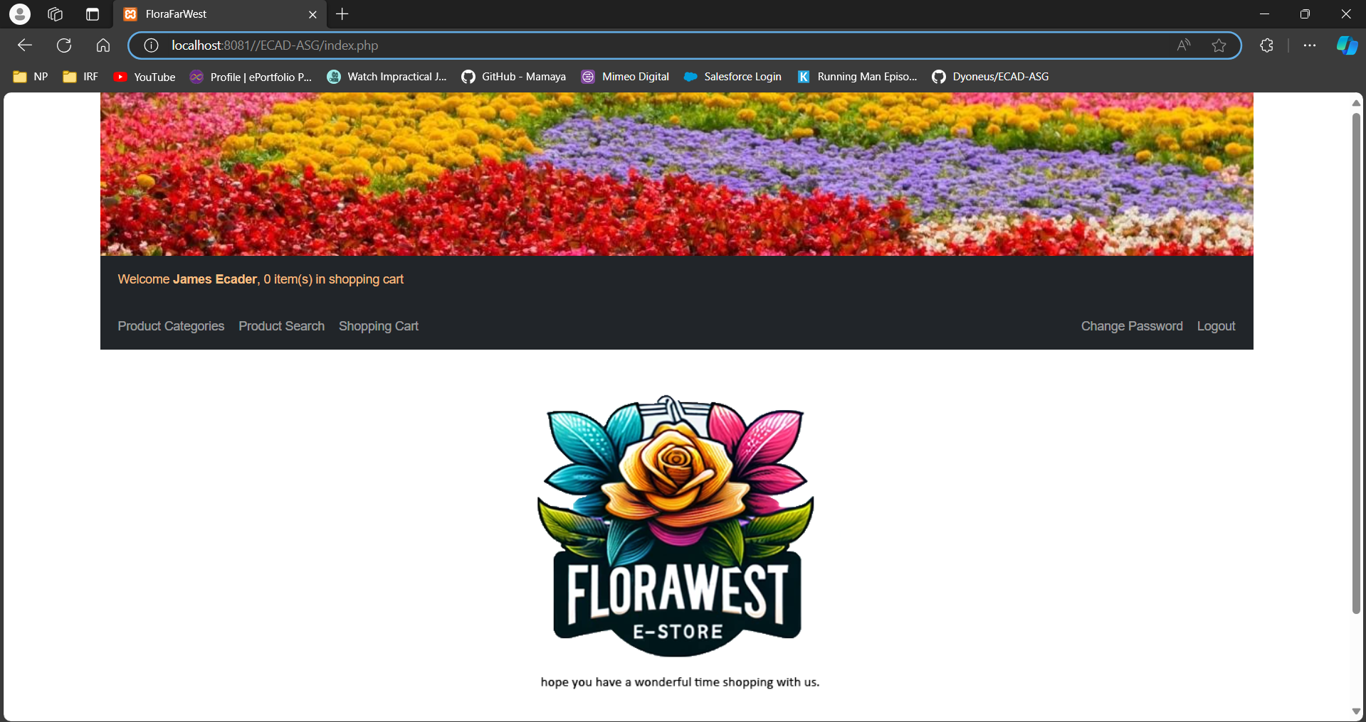

This is the default home page of FloraFarWest which contains links to other pages of the website and allows the accessing of other functions. Assuming the user has logged in as shown in the screenshot above, the other pages and functionalities of the website that the user can access would be the “Product Categories”, “Product Search”, “Shopping Cart”, “Change Password” and “Logout”.

When a user logs into the site as a shopper, the greetings message would change, along with the shopper’s cart information. The greetings message now shows “Welcome [shopper name], [number of items in shopping cart] item(s) in shopping cart” while the cart information would display details of the products this specific shopper has added into his cart. If the user did not login, the greeting message would only be “Welcome Guest”, as seen from the screenshot at the start of this section.

Login Page

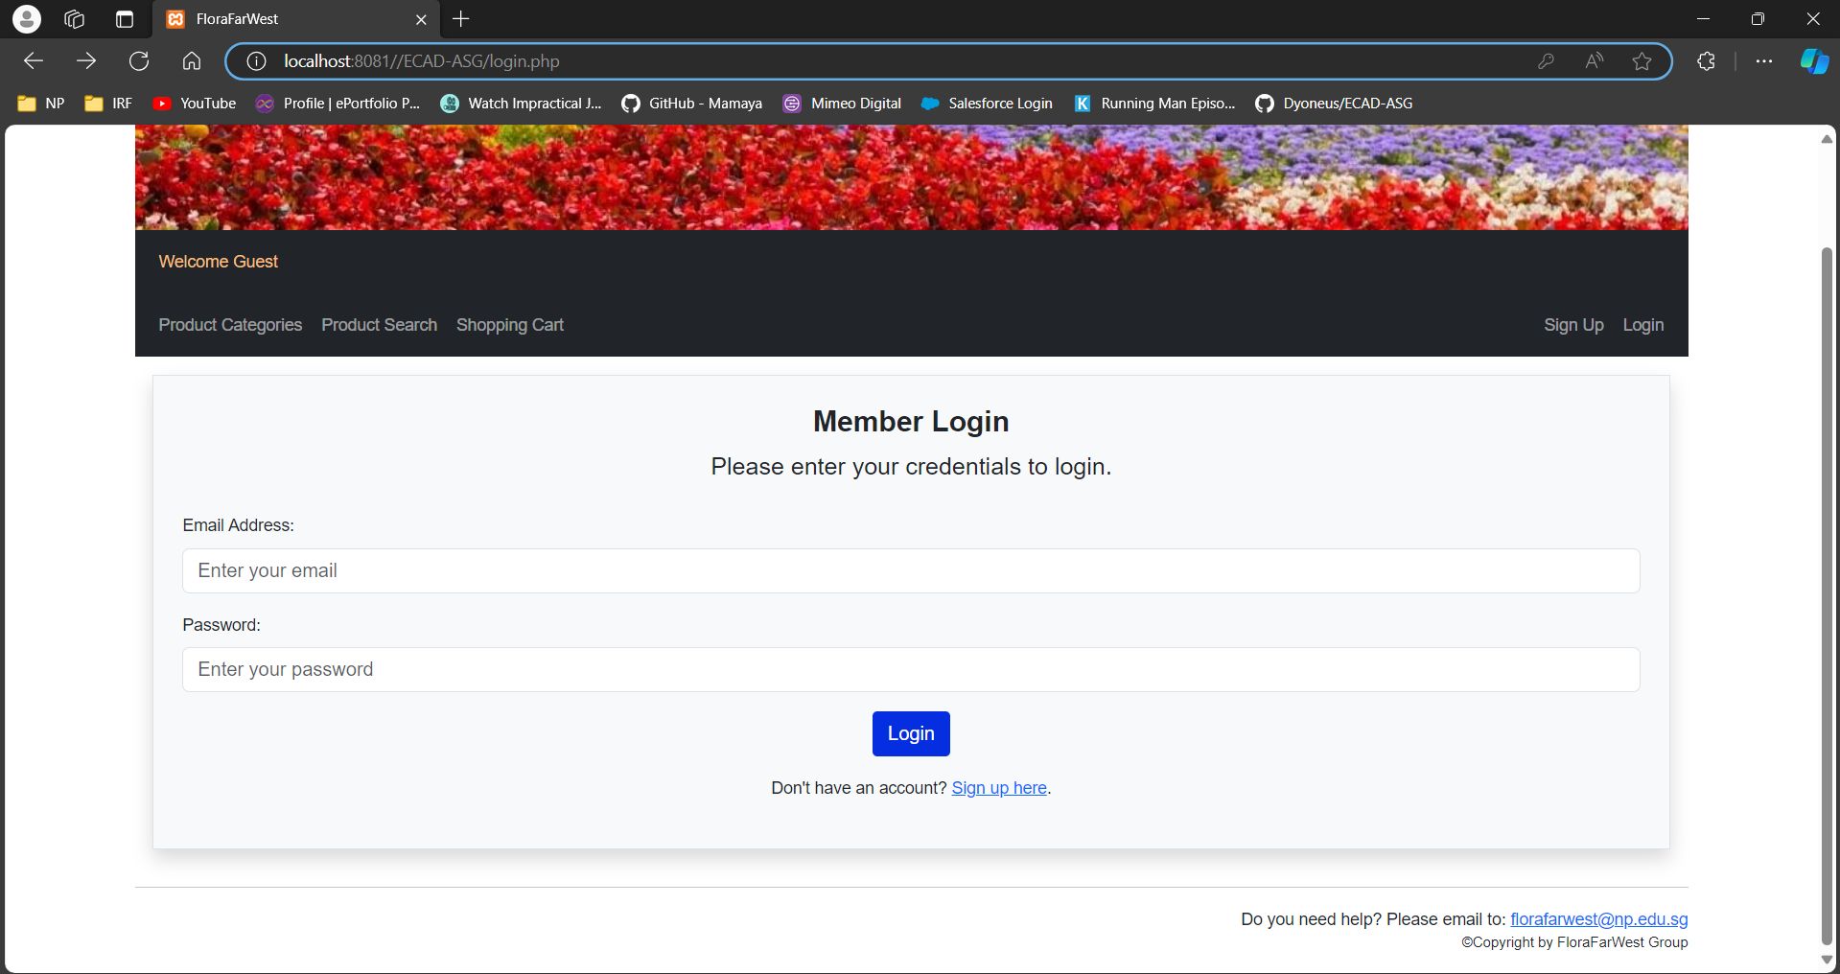

This is the login page for FloraFarWest. In order to purchase a product, a user has to login with its email address and password. If the user is new to FloraFarWest and wishes to purchase a product from FloraFarWest, the user has to register for an account before making any purchase.

Regardless, without logging in, a user can already browse the products, services and promotions offered by FloraFarWest. The user is also allowed to register their account if they do not have one. Validation is also done here if an existing shopper logged in to verify its credentials and error message will be displayed if the credentials are entered incorrectly.

Product Catalog (Individual Component)
Done By: Khoo Jun Jie S10222747H

Shopping Cart (Individual Component)
Done By: Ong Jia Yuan S10227735B

Checkout (Individual Component)
Done By: Owen Wong Hoi Yang S10222049J

Features

Shopping Cart Delivery
Link: Index.php → shoppingcart.php or productdetails.php → shoppingcart.php

When subtotal < $300

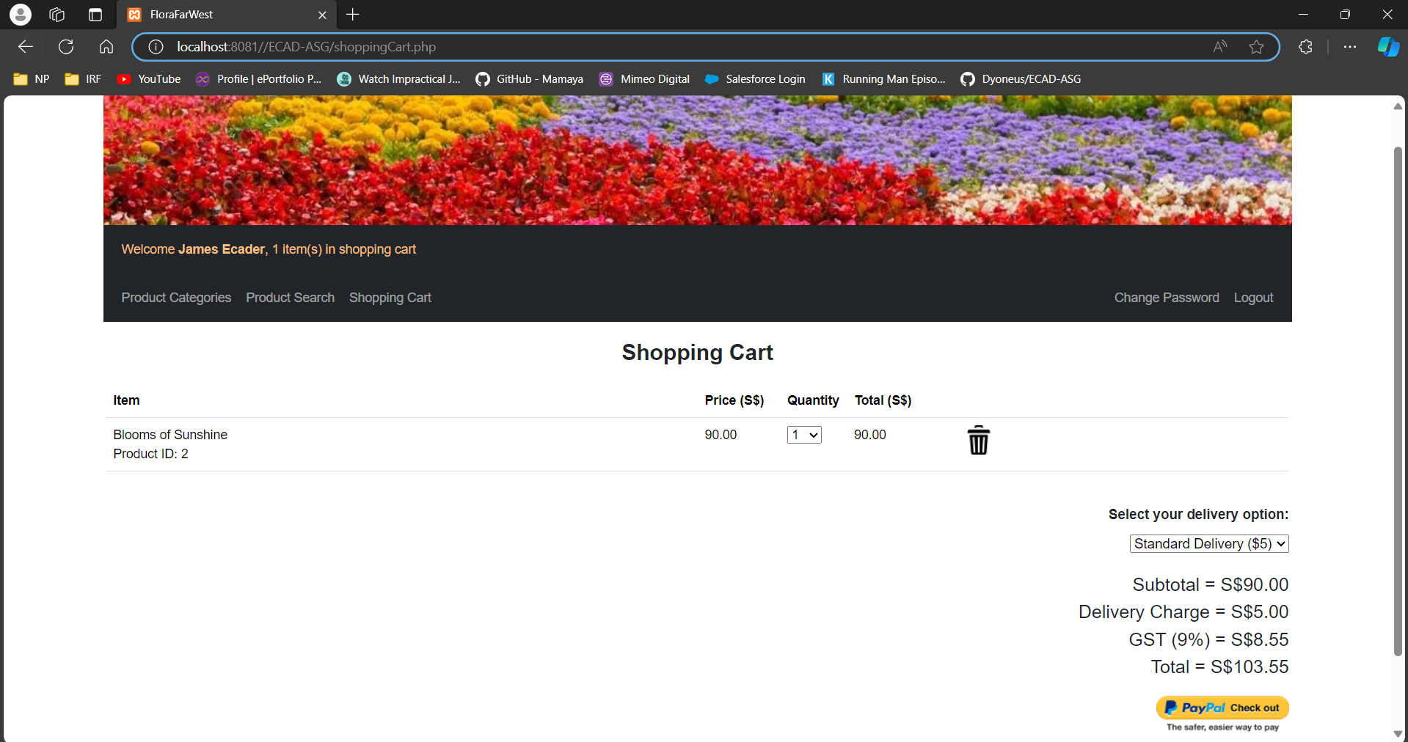
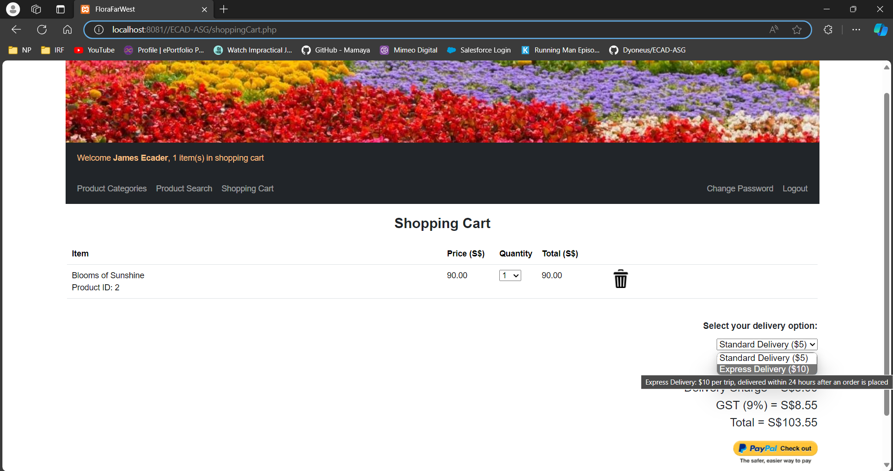

When subtotal > $300

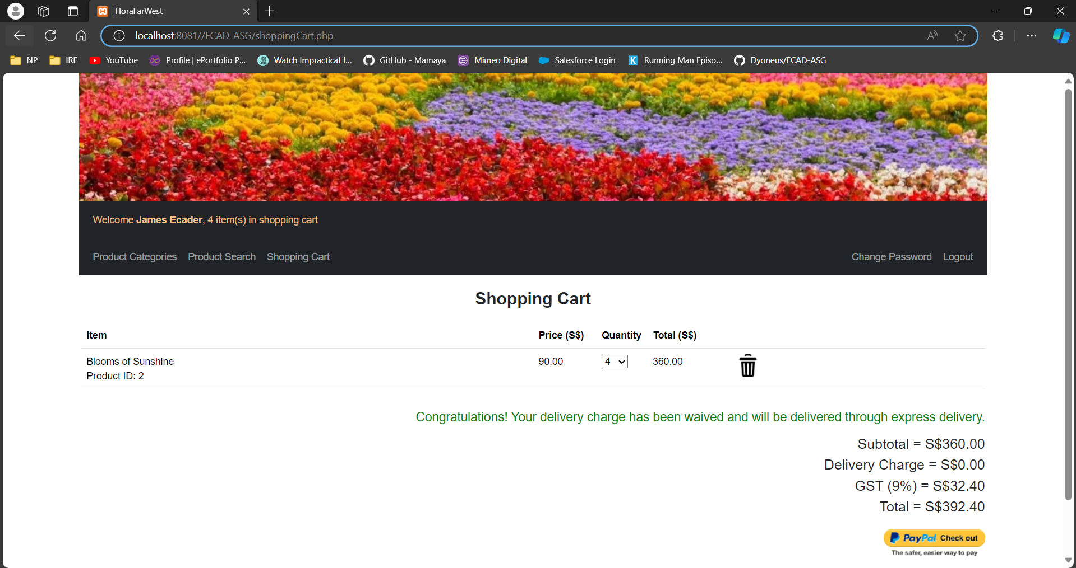

Description:
The screenshot above shows the shopping cart page. To access the shopping cart page, the user has to login as a member first. On this page, the user can see the product(s) which he/she added to their shopping cart, they are also able to choose between the 2 different modes of delivery - normal and express delivery. Normal delivery costs $5 and the product will only be delivered within 2 working days while express delivery costs $10 and will be delivered within 24 hours.

The default delivery mode is normal delivery. Hence, the default option and delivery fee are set at $5. If the user were to select the express delivery, the dropbox and delivery fee would change to $10. If the subtotal amount is more than $300, the delivery charge will be waived, and express delivery will be the delivery mode. The user can check out by clicking on the “Paypal check out” button at the bottom right of the shopping cart page.

Not Enough Stock
Link: Index.php → shoppingcart.php or productdetails.php → shoppingcart.php → checkoutProcess.php

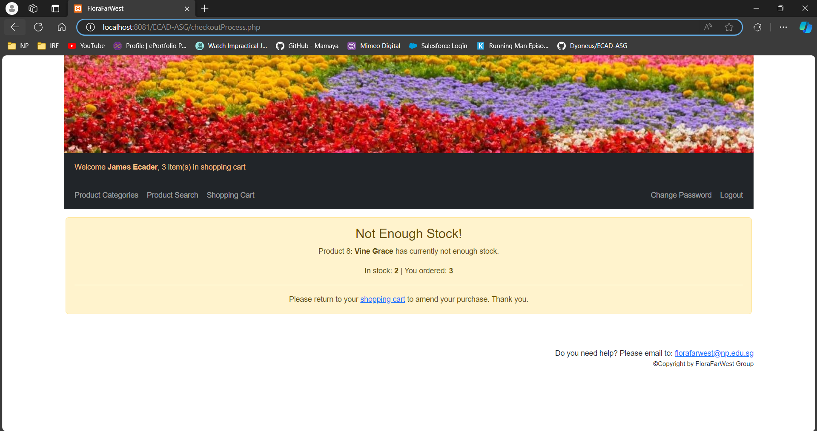

Description
Upon clicking the “Paypal check out” button, if the system detects that there isn’t enough stock of what the user wants to buy, the page will show that there is “Not Enough Stock!”. It will also show which product does not have enough stock and show how much is in stock for the user to buy. Ther user will be able to click the hyperlink to redirect the user back to the shopping cart to edit their cart.

PayPal
Link: Index.php → shoppingcart.php → mypaypal.php
When subtotal < $300

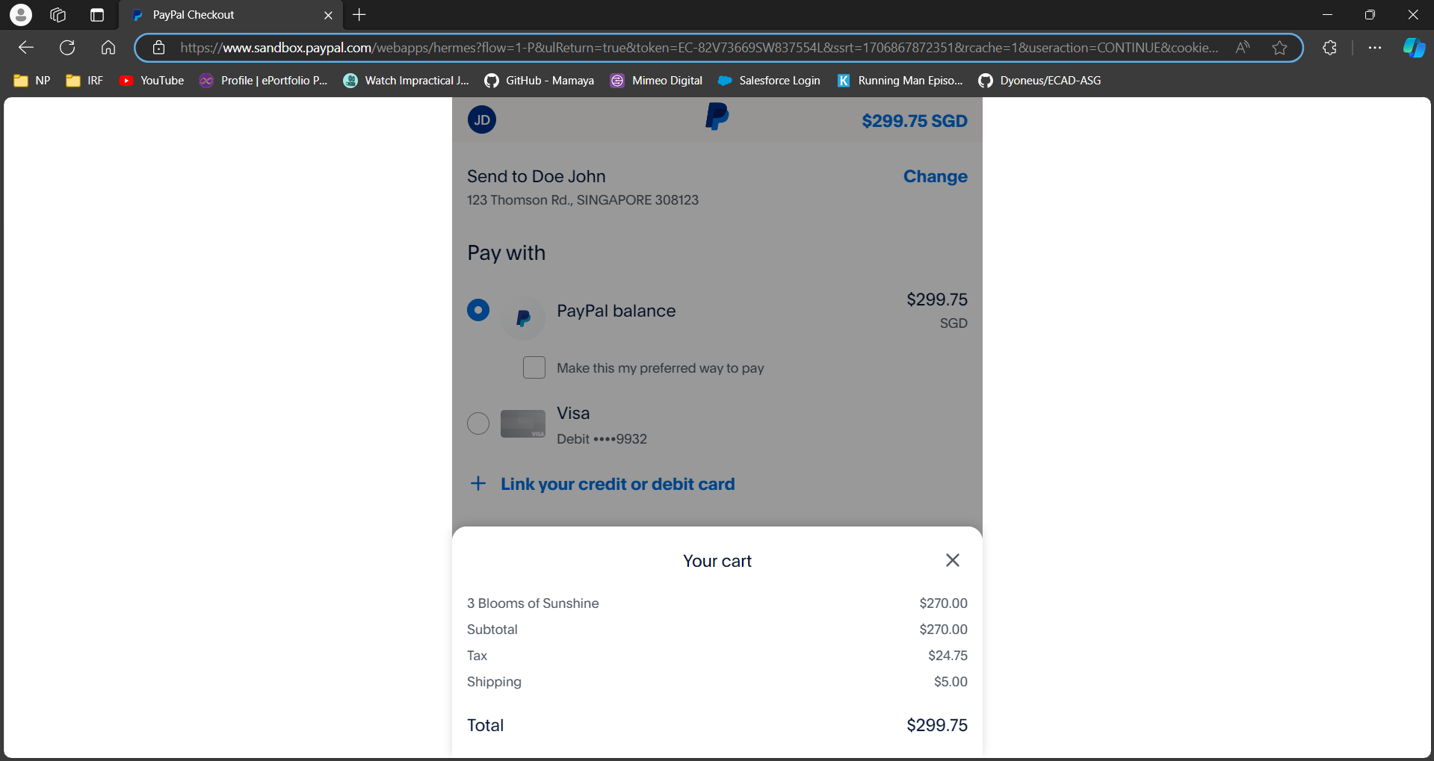

When subtotal > $300

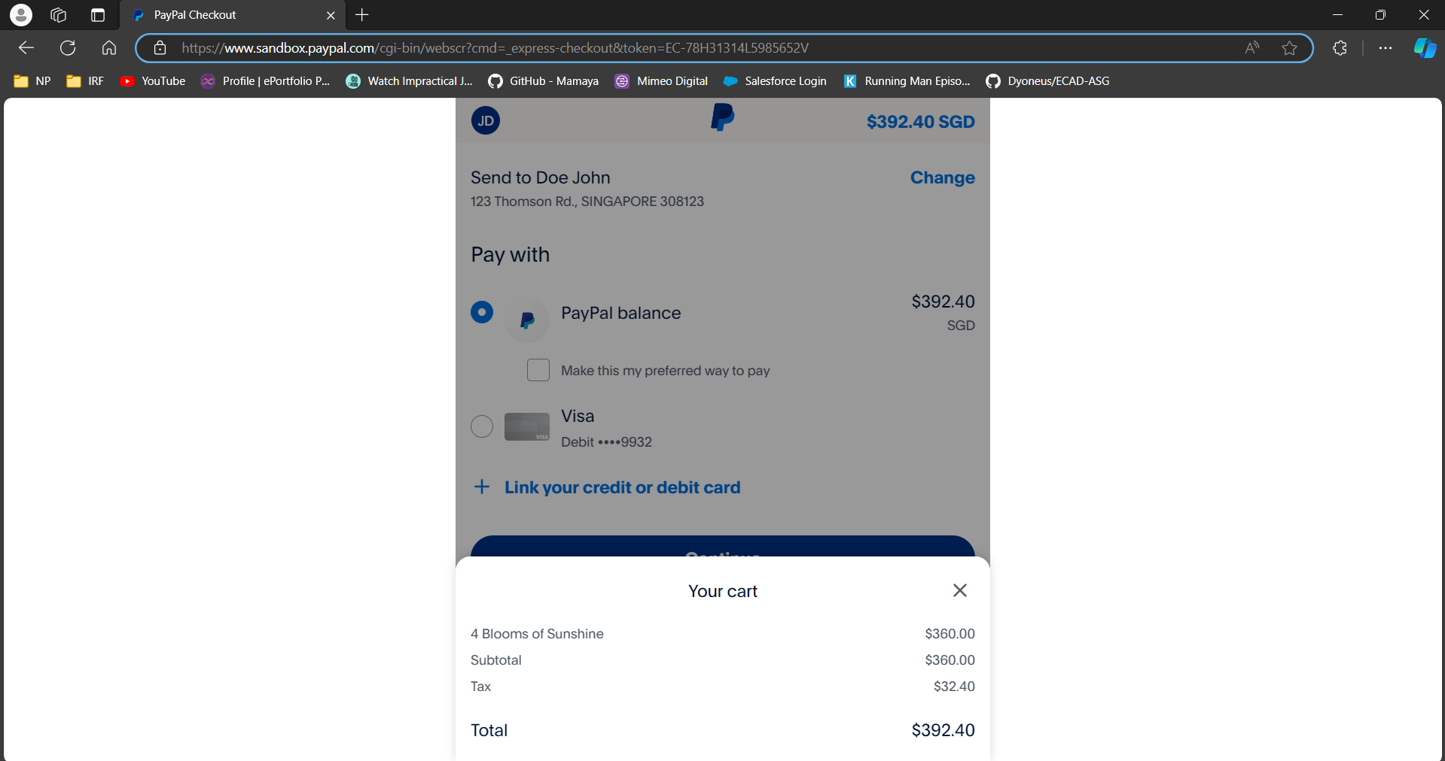

Description:
Upon clicking the “Paypal check out” button, the user will be redirected to the paypal page. On this page, the user can change their delivery address if necessary and the details of his/her purchase is shown - the product name and price, total costs of the
items, gst price calculated based on the current gst rate, delivery fee based on the type of delivery method the user chose on the shopping cart page and total amount to be paid. If the amount is more than $300, the delivery fee will be waived so the delivery fee will not be shown.

Order Confirmation page
Link: Index.php → shoppingcart.php → mypaypal.php → orderconfirmed.php

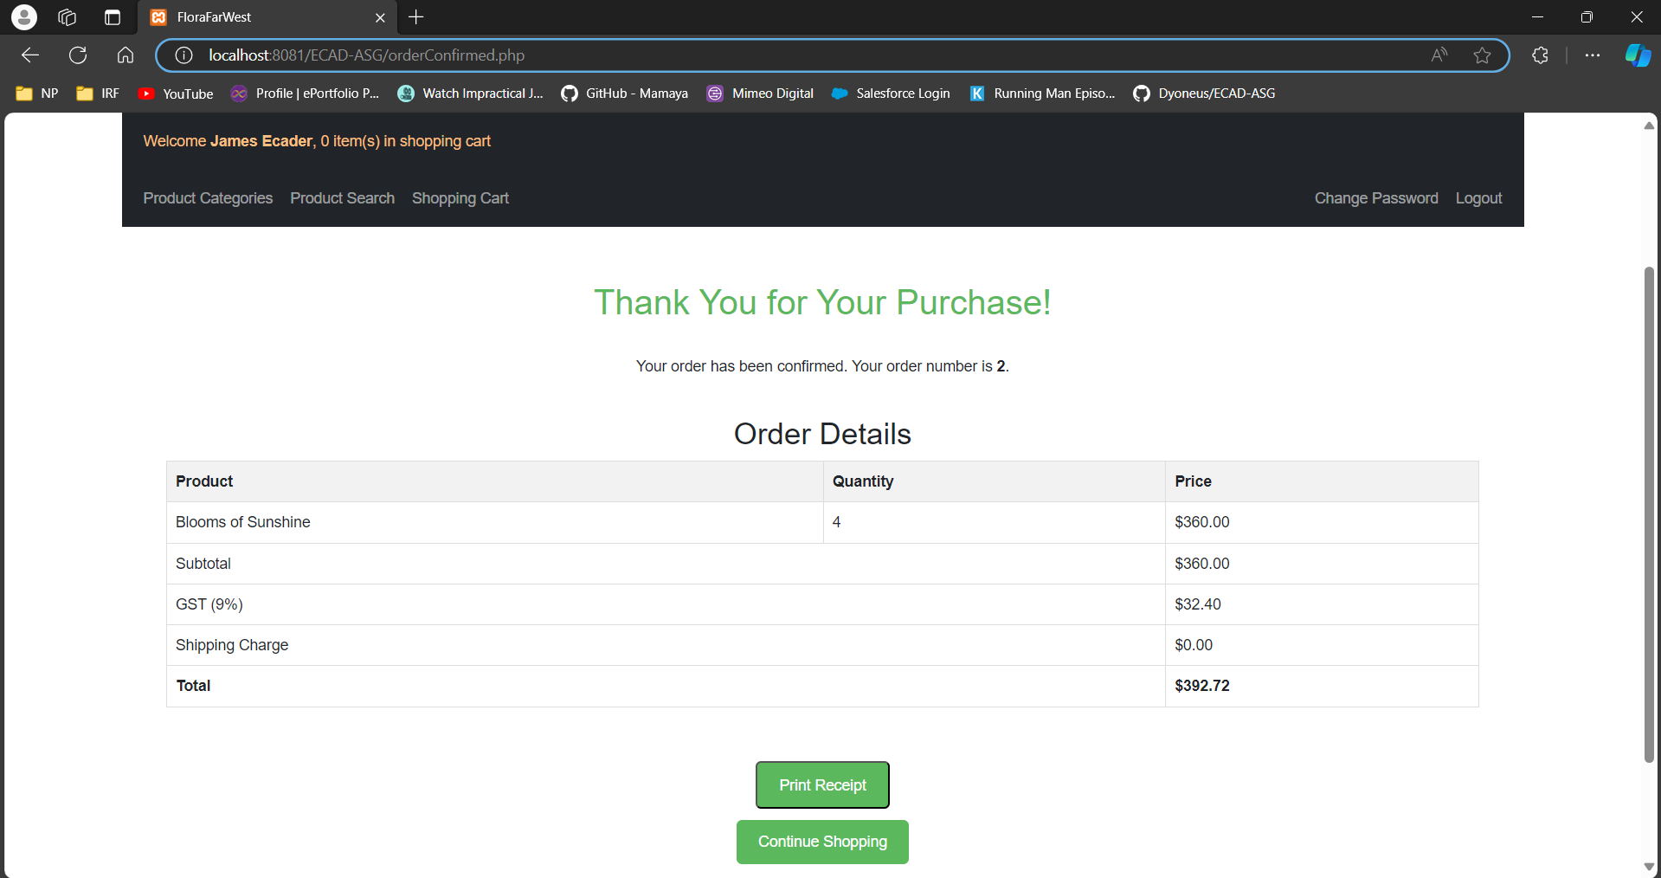

Description
When the checkout is successful, the user will be redirected to this confirmation page. On this confirmation page, the user can see the order ID of their order for future references. This page also shows the purchased product name and quantity, and amount breakdown paid. Additionally, after the order is confirmed, the inventory level in the database will be updated accordingly. After checking out, if there are any items that the user forgot to purchase, there is a button to redirect the user back to the home page to continue their shopping.

Additional Features

Print Receipt
Link: Index.php → shoppingcart.php → mypaypal.php → orderconfirmed.php → printReceipt.php

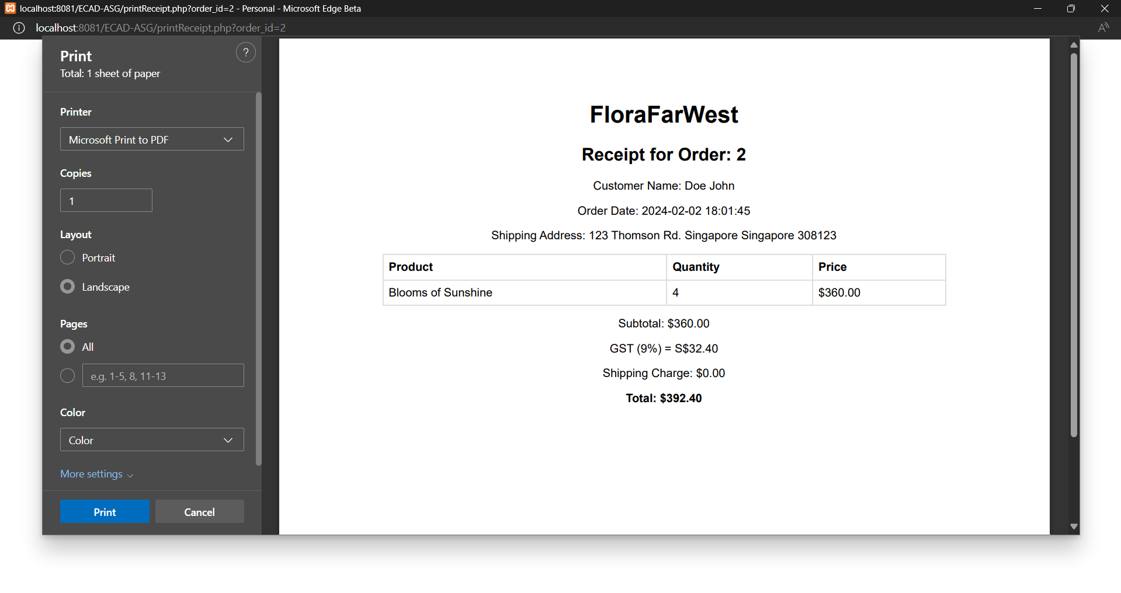
Description
After checking out, if users would like to print a receipt, they would be able to click the print receipt button and it will generate a receipt for the user to print with the printing function at the side. It will show the order id, customer name, order date, shipping address, product, quantity, price and the amount breakdown for ease of reference.

