Design Review

Submission Detail | Student Entry
GROUP ID | IS07 [confirm group ID]

Purpose
Document the system requirements, hardware connections, RTOS task structure, behavioural models, assumptions, and AI-supported design reasoning before major implementation. Treat this Week 6 submission as an architecture freeze before full integration and Tribunal 1. The design may change later, but major changes must be justified with engineering evidence.

How to use this template
- This is an architecture-freeze document. The team may improve the design later, but major changes must be justified during Tribunal 1.
- Use AI assistants for ideation, critique, and gap checking. Do not paste AI output directly as the final design.
- Summarise, challenge, correct, and justify AI suggestions using engineering reasoning.
- Keep all artefacts consistent: requirements, pin layout, RTOS task table, task interaction diagram, statecharts, assumptions, and AI evidence.

Team Role and Subsystem Ownership
Identify each buddy’s primary subsystem responsibility. The role does not need to match the examples exactly, but every major hardware and software responsibility should have a clear owner.
Buddy | Student ID | Primary subsystem / responsibility
Buddy 1 | [Student ID] | WiFi communication, command and telemetry — subsystems/sub_telemetry.* (JSON framing, topic design, 250 ms publish schedule, pluggable transport sink: console today, UDP then MQTT; command subscription; link-state / heartbeat and connection recovery).
Buddy 2 | [Student ID] | Motion control — drivers/drv_motor.*, drivers/drv_encoder.*, subsystems/sub_motion.* (PWM motor driver, encoder edge counting, fixed-point odometry, 50 Hz PID speed control, queued forward/backward/turn API with completion callbacks, motion calibration and PID tuning report).
Buddy 3 | [Student ID] | IR line following and barcode decoding — drivers/drv_ir.*, subsystems/sub_line.*, subsystems/sub_barcode.* (sensor calibration, line-position estimate and P-steer, junction/lead-in detection, Code 39 edge-width decoding, navigation-command generation A/B/C/D).
Buddy 4 | [Student ID] | IMU terrain and motion monitoring — drivers/drv_imu.*, subsystems/sub_terrain.* (LSM303DLHC bring-up on I2C0, calibration, pitch/tilt, hump detection FSM, peak-height estimate and run maximum, motion classification, impact detection, terrain analysis report).
Buddy 5 | [Student ID] | Ultrasonic scanning and obstacle avoidance — drivers/drv_servo.*, drivers/drv_ultrasonic.*, subsystems/sub_scan.* (non-blocking HC-SR04 ping, coarse 30°→fine 6° servo sweep, obstacle profile, avoidance plan, line-recovery hand-off). Also integration owner for the shared mission state machine subsystems/sub_nav.* and core/ framework.

Submission Instructions
- Complete every required section.
- Diagrams may be produced using any suitable tool, but labels must remain readable when inserted into this document.
- AI assistants may support drafting. The team remains responsible for technical correctness, consistency, and the ability to explain every decision.
- Use consistent names across the requirements, hardware sketch, task table, task interaction diagram, and statecharts.

1. Requirements
State what the system must do and the important quality or timing constraints. Requirements should be specific, testable, and traceable to the proposed design (you may add more FR and/or NFR as needed).

1.1 Functional Requirements
ID | Requirement
FR1 | The car shall follow a black line track autonomously using the two digital IR line sensors, with no remote-control input during a run.
FR2 | The car shall detect a barcode lead-in (both line sensors black) and decode Code 39 symbols A–D from the IR barcode sensor while moving.
FR3 | The car shall execute the decoded navigation command — A: turn left, B: turn right, C: go straight, D: U-turn — as encoder-controlled moves.
FR4 | The car shall detect a speed hump from IMU pitch and publish HUMP_BEGIN / HUMP_END events.
FR5 | The car shall estimate each hump's peak height and report the highest peak of the run (sub_terrain_max_peak_mm).
FR6 | The car shall detect an obstacle on or near the line ahead using a forward-facing ultrasonic watch ping while following.
FR7 | On detection the car shall slow, perform a coarse (30°–150°, 30° steps) then fine (6° steps) servo sweep and produce an obstacle profile: location, width, closest point, left and right clearance.
FR8 | The car shall choose a bypass plan (stop / continue / turn left / turn right) from the profile and execute it as queued encoder moves without collision.
FR9 | After bypassing, the car shall search for, reacquire and resume following the original line.
FR10 | The car shall publish telemetry (robot state, speed, encoder counts, line status, barcode, hump peak, scan results, distance) over WiFi/MQTT and accept commands on a subscribed topic.
FR11 | The car shall publish a heartbeat / link-state message and recover the network connection automatically if it drops.
FR12 | The car shall brake both motors and enter STOPPED on an impact event, an aborted move, or when no safe bypass route exists.

1.2 Non-Functional Requirements
ID | Requirement
NFR1 | Line sensors shall be sampled every 5 ms (200 Hz) and the steering command updated on every sample.
NFR2 | The motion PID loop shall run every 20 ms (50 Hz) and publish ODOMETRY on every cycle.
NFR3 | The IMU shall be sampled every 10 ms (100 Hz); hump detection latency shall be ≤ 50 ms from the pitch threshold crossing.
NFR4 | No driver or subsystem shall busy-wait. All waits use tk_wai_flg / tk_dly_tsk; the HC-SR04 10 µs trigger uses a hardware TIMER alarm, not a delay loop.
NFR5 | ISRs shall only timestamp, count and publish (bounded, target < 10 µs); all processing runs in tasks.
NFR6 | Telemetry shall be published every 250 ms and shall never delay a control task (Telemetry task runs at the lowest priority, 10).
NFR7 | All arithmetic shall be integer / fixed-point (no FPU on RP2040): distances in µm, speeds in mm/s, duty in permille.
NFR8 | Event publish shall complete in bounded time from ISR or task context (64-entry ring per lane; overflow is counted, never blocks).
NFR9 | Source shall conform to the Barr-C Embedded C Coding Standard (module_verb naming, _t typedefs, braces on every block, fixed-width types, ≤ 80-column lines).
NFR10 | Every GPIO number and tuning constant shall be defined once in core/rc_config.h; no other file hard-codes a pin.

2. Hardware Integration Pin Layout
Sketch how sensors, actuators, displays, communication modules, and power connections interface with the Robo Pico. Label pins and interfaces such as GPIO, ADC, PWM, I2C, SPI, and UART.

Device / Module | Type | Signal Name | Sensor label | Pico GPIO Pin | Interface | Notes / RTOS Task Owner
Left motor (Robo Pico M2) | Actuator | MOTOR_L_A / MOTOR_L_B | M2A / M2B | GP10 / GP11 | PWM slice 5 ch A/B, 20 kHz | Fixed by Robo Pico. Left wheel on the MOTOR 2 terminal. Driven only by drv_motor from the Motion task (signed permille duty).
Right motor (Robo Pico M1) | Actuator | MOTOR_R_A / MOTOR_R_B | M1A / M1B | GP8 / GP9 | PWM slice 4 ch A/B, 20 kHz | Fixed by Robo Pico. Right wheel on the MOTOR 1 terminal. Motion task.
Left wheel encoder (A/B) | Sensor | ENC_L_A / ENC_L_B | A / B | GP0 / GP1 | GPIO input; A rising-edge IRQ, B sampled in the ISR | Grove port 1 (one cable: GND, 3V3, A, B). A edges counted in the IO_BANK0 ISR (rc_gpioirq), B read there for direction; count read by the Motion task every 20 ms. GP0/GP1 are also UART0, so every build is CONSOLE=usb_cdc.
Right wheel encoder (A/B) | Sensor | ENC_R_A / ENC_R_B | A / B | GP7 / GP28 | GPIO input; A rising-edge IRQ, B sampled in the ISR | Grove port 7 (one cable). Same as left. Direction is measured from channel B at each A edge, not inferred from the commanded duty.
IR line sensor 1 (left) | Sensor | IR_LINE_L | DO | GP16 | GPIO input, polled | Grove port 4, DO only (AO unused). Sampled by the Sense task every 5 ms → LINE_SAMPLE; consumed by sub_line.
IR line sensor 2 (right) | Sensor | IR_LINE_R | DO | GP6 | GPIO input, polled | Grove port 5, DO only. Its AO MUST stay unconnected: Grove 5's second signal pin is GP26, the barcode AO. Sense task, as left.
IR barcode sensor (analogue) | Sensor | IR_BARCODE_A | AO | GP26 (ADC0) | ADC | Grove port 6. Analogue level for threshold calibration (drv_ir_read_raw); owned by drv_ir.
IR barcode sensor (digital) | Sensor | IR_BARCODE_D | DO | GP27 | GPIO input, both-edge IRQ | Grove port 6. Edge timestamps in IO_BANK0 ISR → BARCODE_EDGE → sub_barcode (FAST dispatcher).
HC-SR04 ultrasonic TRIG | Sensor | ULTRA_TRIG | Trig | GP2 | GPIO output + TIMER alarm 1 | Grove port 2. 12 µs pulse ended by the TIMER ISR; owned by drv_ultrasonic under the Scan task.
HC-SR04 ultrasonic ECHO | Sensor | ULTRA_ECHO | Echo | GP3 | GPIO input, both-edge IRQ + TIMER alarm 2 timeout | Grove port 2. 5 V output — MUST pass through a 1 kΩ / 2 kΩ resistor divider. Rise/fall timestamps in ISR → ULTRA_RESULT.
Scan servo | Actuator | SERVO_SCAN | SIG | GP15 | PWM slice 7 ch B, 50 Hz | Robo Pico servo port 4. Owned by drv_servo under the Scan task.
LSM303DLHC IMU (SDA) | Sensor | I2C0_SDA | SDA | GP4 | I2C0 @ 0x19 (accel) / 0x1E (mag) | Grove port 3. GP4/GP5 are I2C0 SDA/SCL in silicon; the port's I2C0 driver is re-pinned from GP8/GP9 (the right motor, MOTOR 1) to GP4/GP5 and opened as "iica". Sampled by Sense task at 100 Hz.
LSM303DLHC IMU (SCL) | Sensor | I2C0_SCL | SCL | GP5 | I2C0 | As above.
Status LED (external) | Indicator | STATUS_LED | LED | GP19 | GPIO output | GPIO breakout header. Blink task liveness. Pico W on-board LED hangs off the CYW43, not an RP2040 pin. BOARD_LED_PIN moved from GP16 (now line sensor 1).
WiFi (CYW43439) | Comms | — | — | On-board (GP23/24/25/29 via PIO-SPI) | CYW43 driver (port libwifi) | Telemetry task sink: UDP first, then MQTT. Development-profile radio in the mtk3smp-rp2040 port.
Console (USB CDC) | Comms | — | — | none — Pico USB port | USB CDC (TinyUSB); CONSOLE=usb_cdc build | tm_printf debug output and the console telemetry sink used until WiFi is up. UART0 is not used: GP0/GP1 belong to the left encoder.
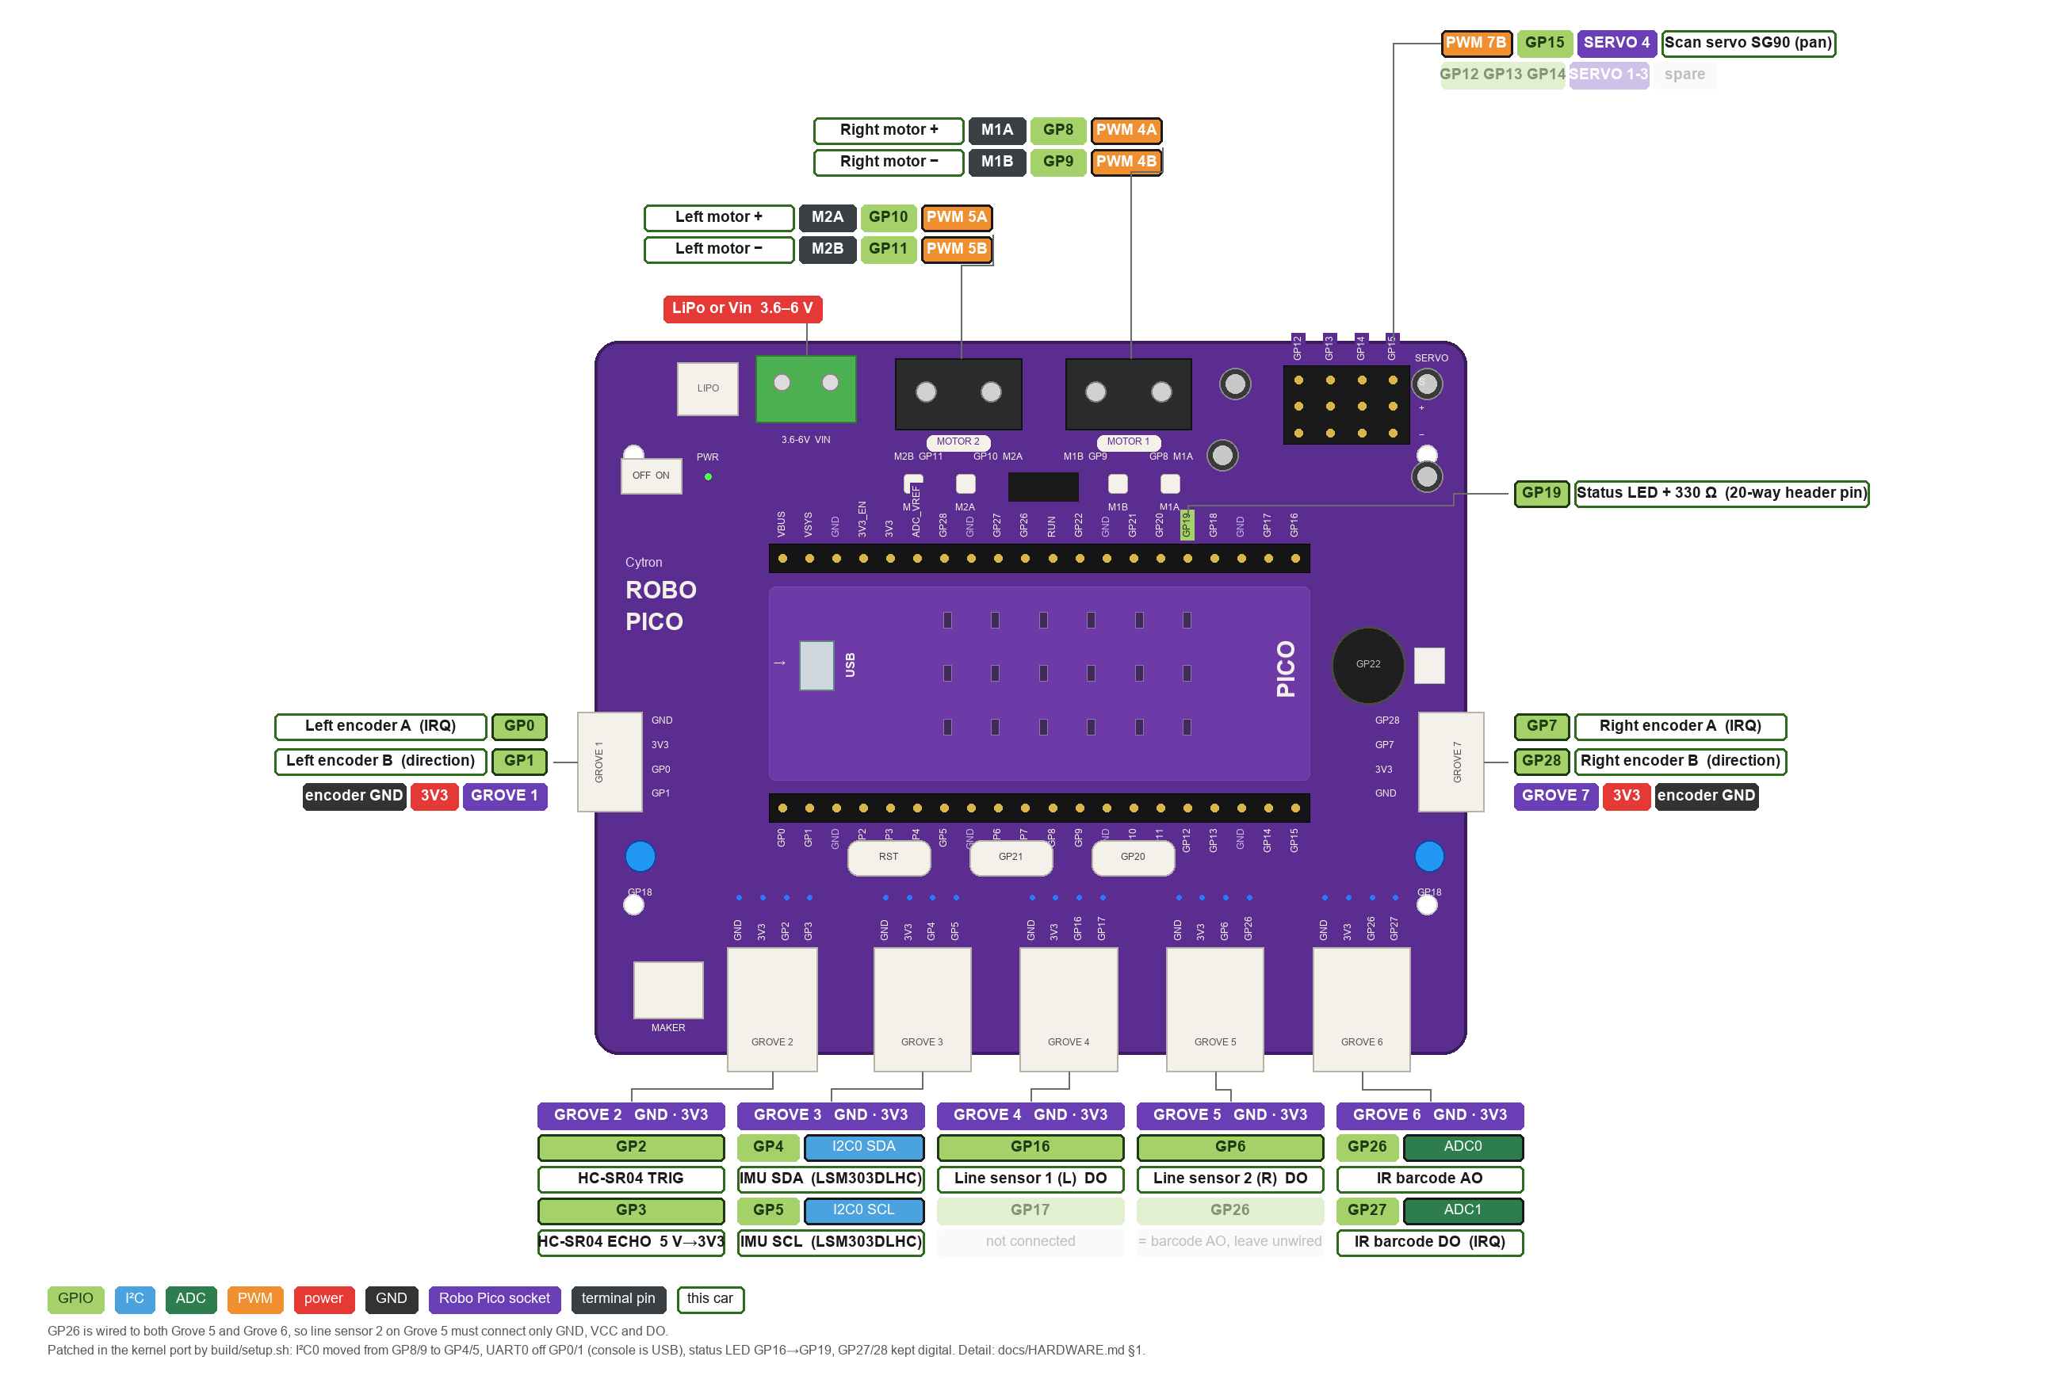
Figure 2a: The Robo Pico as wired for this car. Chips fan out from each connector: GPIO number, function in use (I²C / ADC / PWM) and the device on that socket; faded chips are parts of the board not used. Left motor on the MOTOR 2 terminal, right motor on MOTOR 1, servo on header port 4, one Grove cable per sensor.
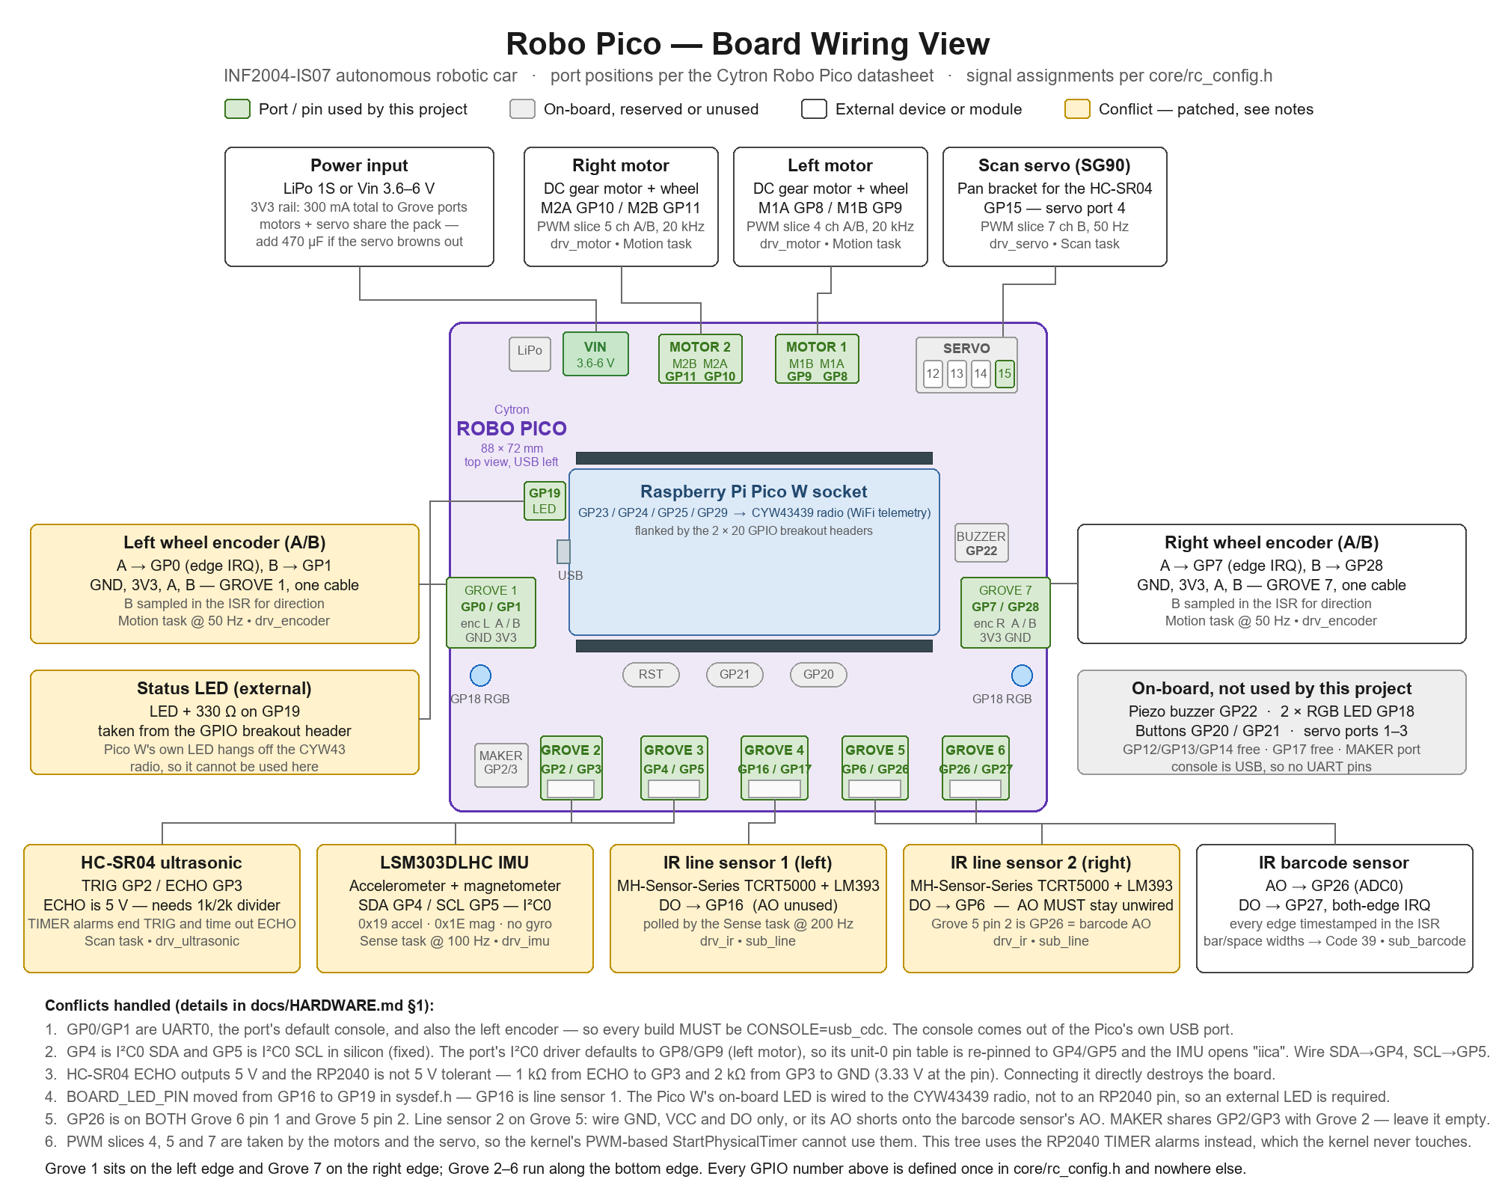
Figure 2b: The same wiring on the physical board — Grove 1 left edge, Grove 7 right edge, Grove 2–6 bottom, motor terminals and servo header top. One Grove cable per device.

3. RTOS Task Table
List the proposed RTOS tasks. Priorities are preliminary at Week 6 and must be justified.

Task | Purpose | Inputs | Outputs | Trigger | Priority
Defer | Run driver bottom halves posted from ISRs | rc_defer_post() queue | Driver callbacks | Event flag set by ISR | 4 (highest)
FAST dispatcher | Drain the FAST event ring and call subscribers: sub_line, sub_barcode, sub_terrain, sub_nav | 64-entry ring (ENCODER_EDGE, BARCODE_EDGE, ULTRA_RESULT, LINE_SAMPLE, IMU_SAMPLE, …) | Steer commands, nav state transitions, BARCODE_DECODED, HUMP_*, AVOIDANCE_PLAN | Event flag on publish | 5
Motion | Per-wheel PID, odometry, queued move / turn completion | Encoder edge counts, target speed / distance / angle | PWM duty, ODOMETRY, MOTION_DONE | Periodic, 20 ms | 6
Sense | Poll the two IR line sensors and the IMU | GPIO16/6, I2C0 | LINE_SAMPLE (5 ms), IMU_SAMPLE (10 ms) | Periodic, 5 ms | 7
Scan | Sequence servo steps and ultrasonic pings; build profile and plan | scan_start flag, ULTRA_RESULT, watch setting | Servo angle, TRIG, OBSTACLE_PROFILE, AVOIDANCE_PLAN | Event flag; 60 ms per step | 7
SLOW dispatcher | Drain the SLOW ring for non-control subscribers (telemetry, nav logging) | 64-entry ring | Subscriber callbacks | Event flag on publish | 9
Telemetry | Snapshot state, frame as JSON, publish via sink; command subscription | Subscribed events, subsystem getters | Topic + payload to console / UDP / MQTT sink; COMMAND_RX | Periodic 250 ms + out-of-band events | 10
Blink | Liveness LED | — | GP19 | Periodic, 500 ms | 10 (lowest)
Initial task (usermain) | Bring-up in dependency order, IMU calibration, start the run, then sleep | — | — | Boot; tk_slp_tsk(TMO_FEVR) afterwards | port default

Priority and ownership justification:
micro T-Kernel priorities: lower number wins. The ordering is driven by what must never wait on what.
• Defer (4) sits above everything because it finishes work an ISR started (e.g. re-arming the echo timeout); leaving it half-done corrupts the next measurement.
• FAST dispatcher (5) runs the control-path callbacks — steering on every LINE_SAMPLE, nav state changes, barcode decode. These are short (no I/O, no blocking) and must pre-empt any periodic loop so a 5 ms steer never queues behind a 20 ms PID cycle.
• Motion (6) is above Sense (7) so the PID update is never delayed by an I2C transaction to the IMU; the PID depends on encoder counts captured in the ISR, not on the Sense task.
• Sense and Scan share 7: both are periodic pollers with bounded work, and neither must starve the other (a scan step is ~60 ms; line sampling is 5 ms and yields with tk_dly_tsk).
• SLOW dispatcher (9) and Telemetry (10) can be late without affecting the car; logging and JSON formatting are the biggest CPU consumers and are deliberately the first to lose the CPU (NFR6).
Ownership: each hardware device is written by exactly one task (see §2 and §9). Shared state crosses tasks only as immutable event payloads copied into the ring, so no mutexes are needed on the control path; the only critical sections are the few-µs ring push/pop (interrupt mask on single core, spinlock + mask under SMP).

4. Task Interaction Diagram
Show RTOS tasks, queues, semaphores, mutexes, event groups, notifications, and data flow. Clearly distinguish software tasks from hardware devices and interrupt service routines.

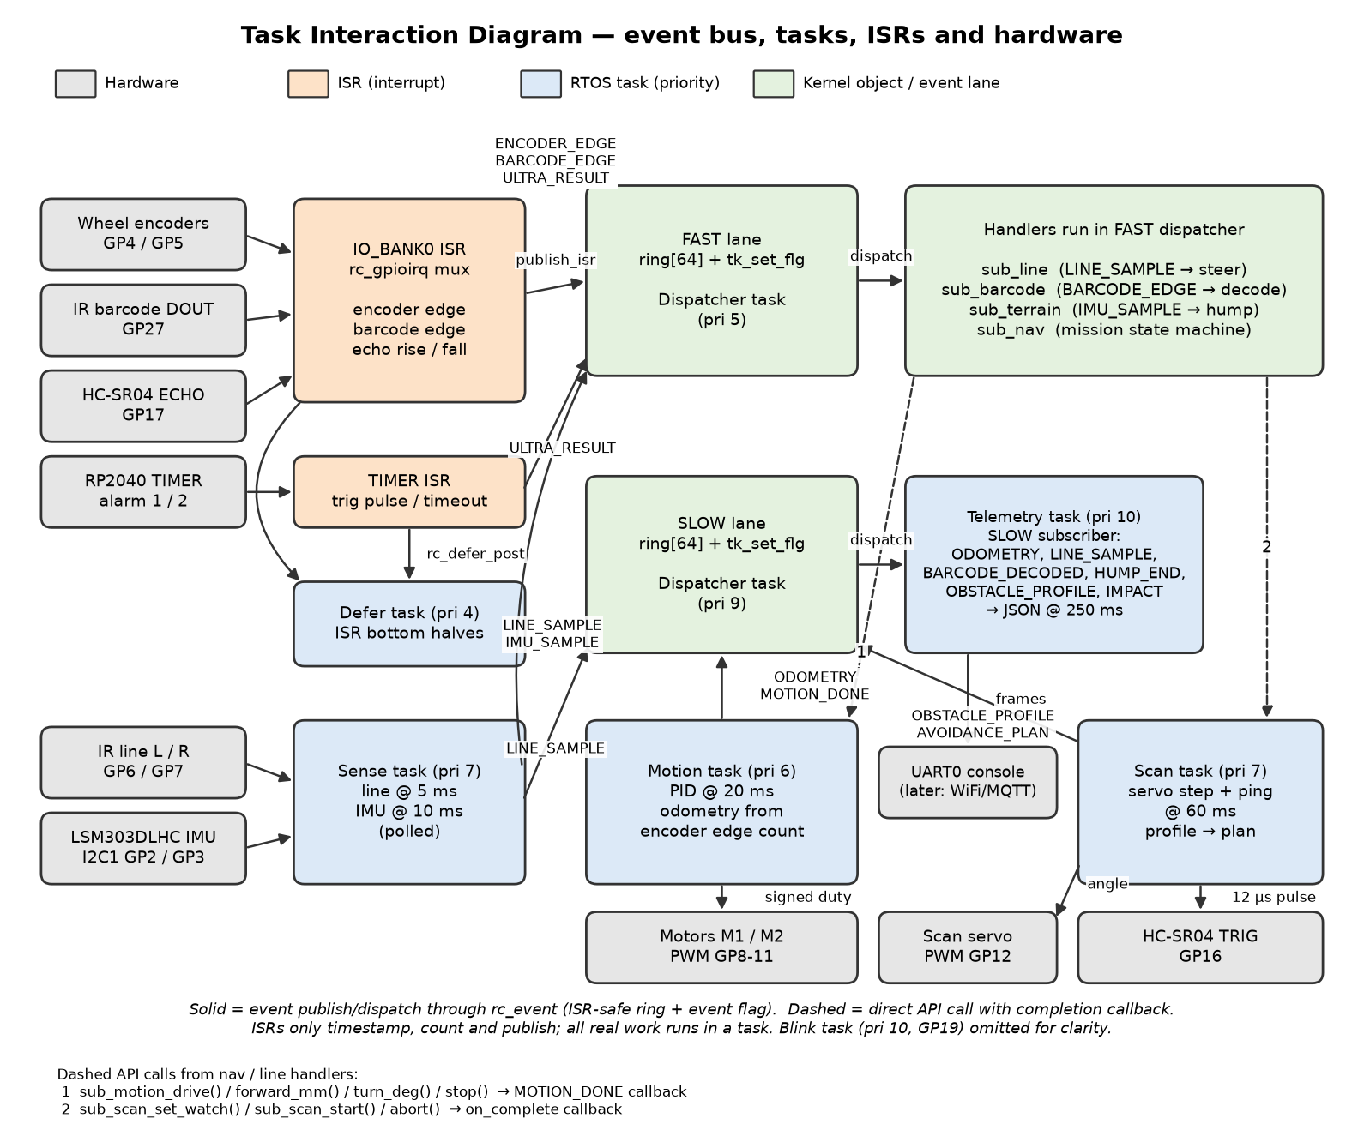

Brief explanation of the main communication paths:
Everything crosses subsystem boundaries through core/rc_event: a producer fills an rc_event_t and publishes it; the bus pushes a copy onto a 64-entry power-of-two ring for each lane that has a subscriber and sets an event flag (tk_set_flg, which is legal from an ISR). The lane's dispatcher task wakes, pops the event and calls every registered callback in turn. Two lanes exist so that control-path callbacks (FAST, pri 5) are never queued behind telemetry (SLOW, pri 9).
ISR paths: the single IO_BANK0 handler in rc_gpioirq demultiplexes GPIO interrupts to drv_encoder (A rising edge → count, B sampled → direction), drv_ir (both edges on GP27 → BARCODE_EDGE with timestamp) and drv_ultrasonic (ECHO rise/fall → ULTRA_RESULT). Two RP2040 TIMER alarms end the 12 µs TRIG pulse and time out a lost echo. Anything longer than a few instructions is posted to the Defer task.
Periodic paths: the Sense task samples the line sensors (5 ms) and IMU (10 ms) and publishes LINE_SAMPLE / IMU_SAMPLE; the Motion task runs PID at 20 ms and publishes ODOMETRY; the Scan task steps the servo and pings at 60 ms.
Direct API calls (dashed) are used only where a caller needs a completion: sub_nav and sub_line call sub_motion_*() and get a MOTION_DONE callback; sub_nav calls sub_scan_start() and gets on_complete. Subsystems otherwise never call each other, which is what lets five buddies develop against stubs and integrate late.

5. System-Level Statechart
Model the operating states of the entire system. Label transition events or conditions. Include relevant fault, stop, or recovery behaviour.

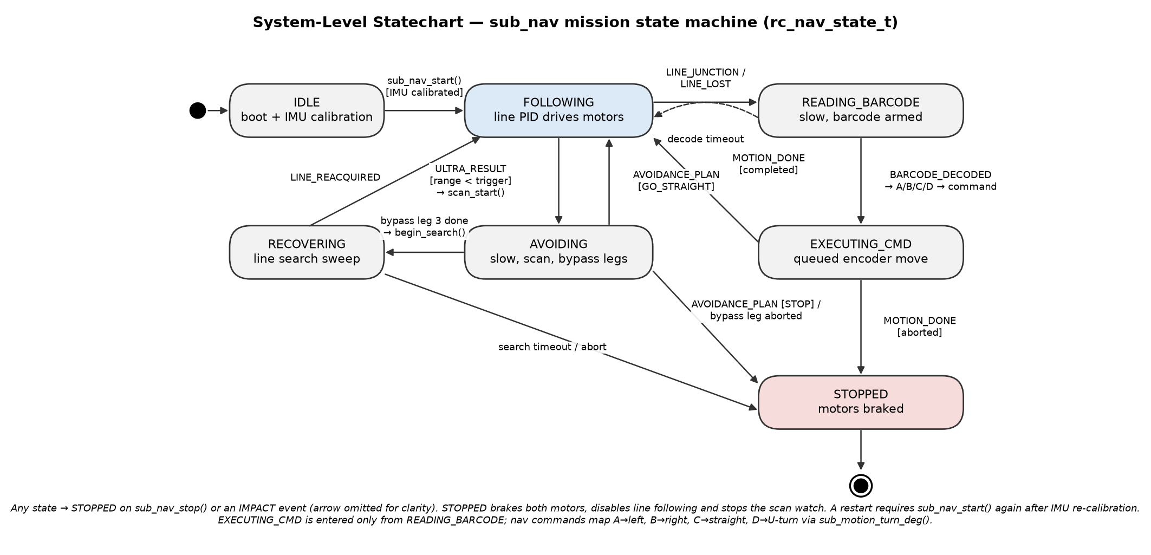

Explain the main states and any important assumptions:
The system state is rc_nav_state_t in subsystems/sub_nav.c. sub_nav owns no hardware and no task: it is a set of event handlers that run in the FAST dispatcher, so every transition is triggered by an event or a completion callback.
IDLE — usermain brings up drivers in dependency order, calibrates the IMU (car must be still), sets base speed 250 mm/s and calls sub_nav_start(). FOLLOWING — sub_line is enabled and steers via sub_motion_drive(); the scan watch pings forward every 60 ms. READING_BARCODE — entered on a junction (both sensors black) or line loss; speed is reduced and sub_barcode is armed; a decode timeout returns to FOLLOWING. EXECUTING_CMD — the decoded symbol is mapped A→left, B→right, C→straight, D→U-turn and issued as a queued encoder move; MOTION_DONE(completed) resumes following, MOTION_DONE(aborted) stops. AVOIDING — a watch ping under the trigger distance slows the car and starts a coarse/fine scan; the AVOIDANCE_PLAN chooses continue, a three-leg bypass (turn, forward, turn back), or STOP if boxed in. RECOVERING — after the bypass sub_line searches; LINE_REACQUIRED resumes FOLLOWING. STOPPED — motors braked; reached from sub_nav_stop(), an IMPACT event, an aborted move or no safe route.
Assumptions: only one barcode per junction; obstacles are static; the IMU is allowed to fail at boot (the car still runs, hump reporting is lost); a fault in any bypass leg is treated as unrecoverable for Week 6.

6. Subsystem Statecharts

Add more sub-systems if needed.

6.1 Subsystem Statechart 1
Field | Student Entry
Subsystem name | Motion control (Buddy 2) — subsystems/sub_motion.c, drivers/drv_motor.c, drivers/drv_encoder.c
Related RTOS task(s) | Motion task (priority 6, 20 ms); encoder edge ISR via rc_gpioirq; callers in the FAST dispatcher (sub_line, sub_nav)
Purpose | Turn speed/distance/angle requests into PWM duty using encoder feedback, and report completion so the caller never blocks.
Reason a statechart is needed | The task body does different work depending on the active mode (continuous steer vs distance goal vs turn goal), and the API must reject or abort moves consistently (RC_ERR_BUSY, MOTION_DONE(aborted)). A mode machine makes the completion contract explicit.

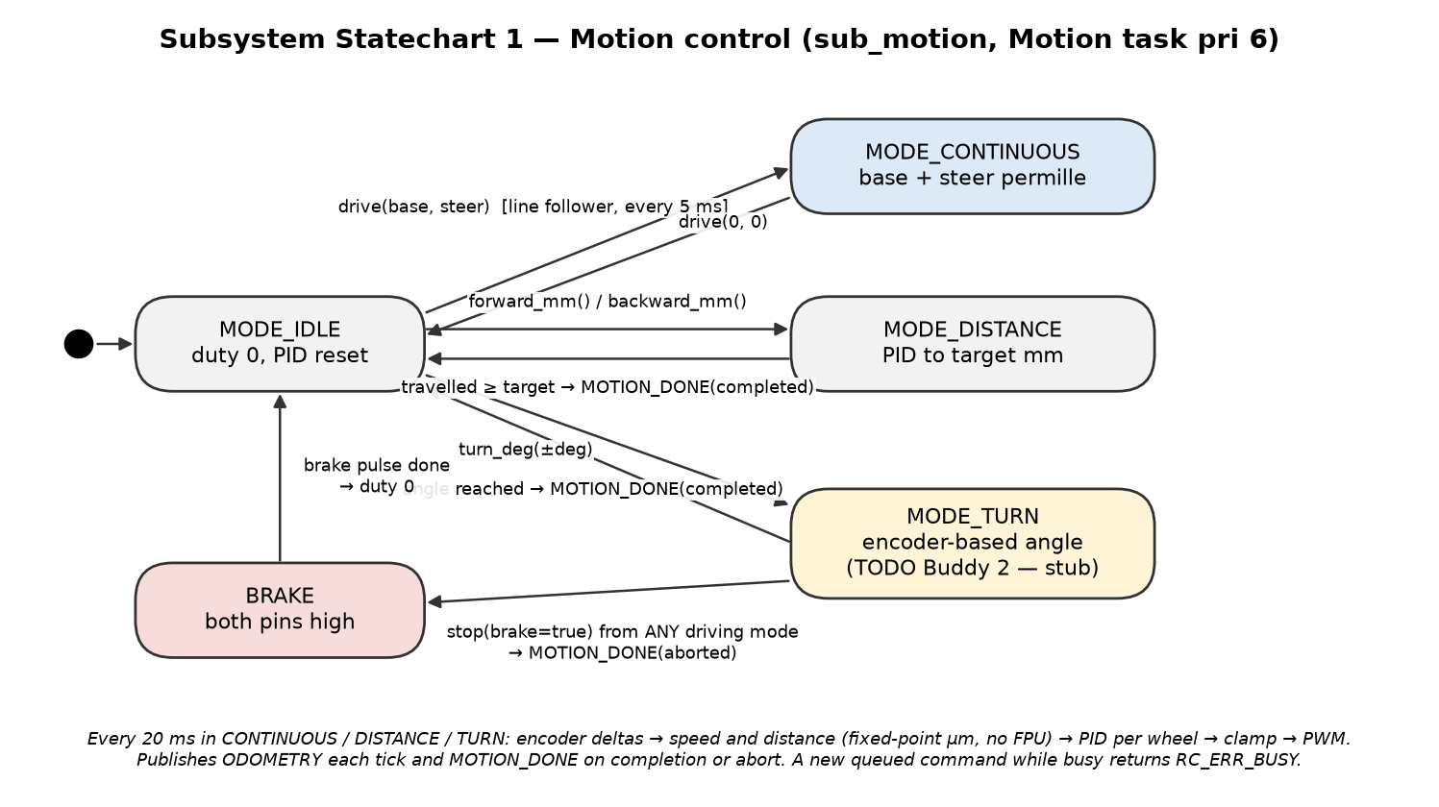
Brief explanation of states, events, and fault handling:
States are the MODE_* enum in sub_motion.c. MODE_IDLE: duty 0, PID integrators reset. MODE_CONTINUOUS: open-ended drive with base + steer permille, used by the line follower every 5 ms; drive(0,0) returns to idle. MODE_DISTANCE: PID holds target speed until the odometer reaches the target, then MOTION_DONE(completed). MODE_TURN: differential drive until the encoder tick difference reaches the target angle (currently a stub — Buddy 2 deliverable). BRAKE: both H-bridge inputs high for a short pulse on stop(true) from any mode, reporting MOTION_DONE(aborted) to the pending callback.
Events: the 20 ms period (tk_dly_tsk), API calls from the dispatcher, and the ISR-maintained encoder counters. Faults: a new queued command while busy returns RC_ERR_BUSY rather than silently replacing the move; an encoder that stops counting while duty is non-zero will be detected as a stall by the PID saturating (to be turned into an explicit STALL fault after bench tests).

6.2 Subsystem Statechart 2
Field | Student Entry
Subsystem name | Line tracking and barcode decoding (Buddy 3) — subsystems/sub_line.c, subsystems/sub_barcode.c, drivers/drv_ir.c
Related RTOS task(s) | Sense task (samples GP16/GP6 every 5 ms); FAST dispatcher (runs sub_line and sub_barcode handlers); GP27 edge ISR
Purpose | Keep the car on the line, recognise the barcode lead-in, decode Code 39 symbols and hand a navigation command to sub_nav.
Reason a statechart is needed | Line loss, junctions and deliberate off-line searching all look similar at the sensor level (0/0 or 1/1); only history distinguishes them. Debounce counts (LOST_N, JUNCTION_N) and the armed/disarmed barcode window are naturally state.

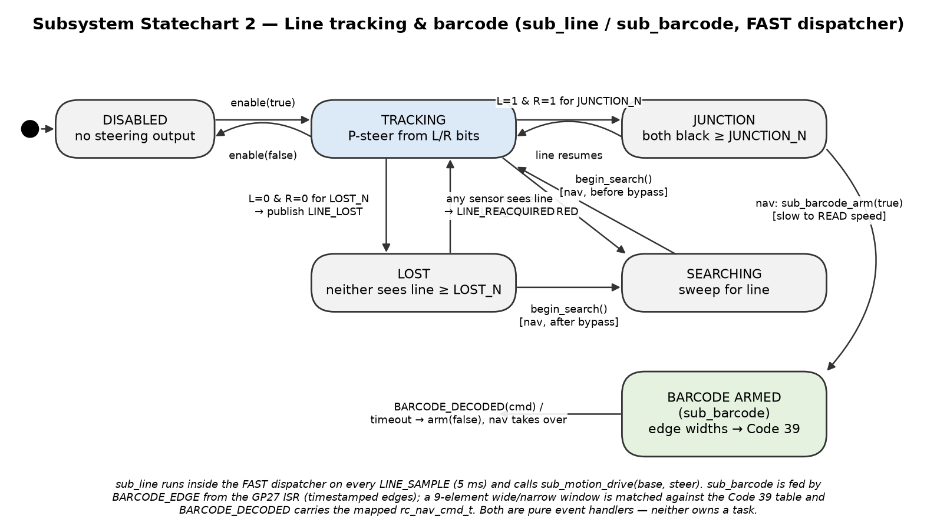
Brief explanation of states, events, and fault handling:
sub_line: DISABLED (no output) → TRACKING on enable(true). In TRACKING each LINE_SAMPLE maps the L/R bits to a steer permille (proportional only) and calls sub_motion_drive(base, steer). 0/0 for LOST_N samples → LOST and LINE_LOST is published; any sensor seeing the line → LINE_REACQUIRED. 1/1 for JUNCTION_N samples → JUNCTION, the barcode lead-in, which sub_nav uses to enter READING_BARCODE and arm the decoder. SEARCHING is entered only on request (begin_search from sub_nav) before and after a bypass.
sub_barcode: when armed, every BARCODE_EDGE (timestamped in the GP27 ISR) appends a bar/space width; a 9-element window is classified wide/narrow against the running median and matched to the Code 39 table ('*', A–D). A match publishes BARCODE_DECODED with the mapped rc_nav_cmd_t and disarms.
Faults: a decode timeout returns sub_nav to FOLLOWING without a command; the table currently has A and B sharing one pattern (placeholder) — see gap G2 in §8.3.

6.3 Subsystem Statechart 3
Field | Student Entry
Subsystem name | Ultrasonic scanning and obstacle profiling (Buddy 5) — subsystems/sub_scan.c, drivers/drv_ultrasonic.c, drivers/drv_servo.c
Related RTOS task(s) | Scan task (priority 7); ECHO edge ISR and TIMER alarm ISRs (drv_ultrasonic); Defer task for bottom halves
Purpose | Watch ahead while following, then on demand sweep the servo, ping at each angle, build an obstacle profile and publish an avoidance plan.
Reason a statechart is needed | A scan is a multi-step sequence spread over ~1 s with two interleaved asynchronous sources (servo settle time and echo interrupts). Without explicit states a lost echo or an abort mid-sweep would leave the servo and the ring in an unknown state.

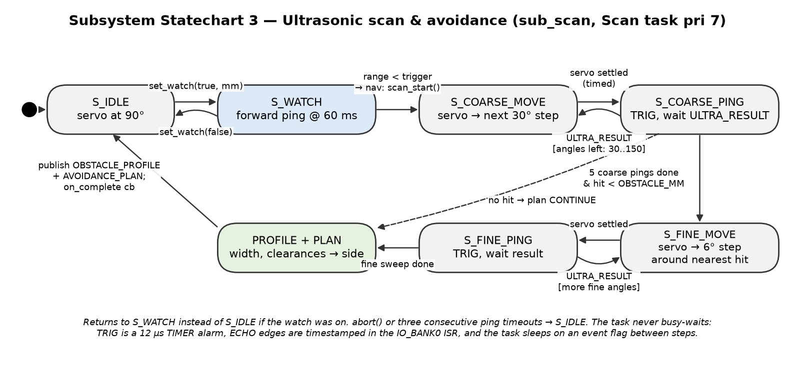
Brief explanation of states, events, and fault handling:
S_IDLE: servo parked at 90°. S_WATCH: while following, one forward ping every 60 ms; sub_nav compares the range with the trigger distance and calls scan_start(). S_COARSE_MOVE / S_COARSE_PING: for 30°, 60°, 90°, 120°, 150° move the servo, wait a fixed settle time, ping, wait ULTRA_RESULT on an event flag. If the nearest valid hit is under OBSTACLE_MM, S_FINE_MOVE / S_FINE_PING re-scan ±30° around it in 6° steps. PROFILE + PLAN then estimates location, width, closest point and left/right clearance and chooses continue / turn left / turn right / stop, publishing OBSTACLE_PROFILE and AVOIDANCE_PLAN and calling the on_complete callback. The task returns to S_WATCH if the watch was on, otherwise S_IDLE.
Faults: three consecutive ping timeouts (echo never returns within 30 ms) abort to S_IDLE and report an invalid profile; abort() from sub_nav does the same. Nothing in this path busy-waits: TRIG is ended by a TIMER alarm, the echo width is measured in the ISR, and the task sleeps on tk_wai_flg between steps.

7. Assumptions
List assumptions that the design depends on. Each assumption must state the risk if it is wrong and how the team will validate it before full integration. Have at least 1 assumption per buddy.
ID | Assumption | Risk if wrong | Validation method | Owner | Status
A1 | The mtk3smp-rp2040 port's CYW43 / lwIP development profile is stable enough to hold a UDP or MQTT session for a full run (≥ 3 min). | Telemetry (FR10/11) cannot be demonstrated over WiFi; only the console sink works. | Bring up station mode on the bench, hold a UDP echo for 10 min and log drops and reconnects; then port an MQTT client behind the sink interface. | Buddy 1 | Open
A2 | Two-channel (A/B) encoders give a reliable direction from channel B at every edge, so odometry does not depend on the commanded duty. | Wheel slip still corrupts distance; encoder-based turns overshoot; a swapped A/B pair on one wheel reads backwards. | Confirm speed reads positive on both wheels when driven forward (else swap A/B); drive 1 m forward and back ten times, compare encoder distance with a tape measure; measure 90° turn repeatability over ten trials. | Buddy 2 | Open
A3 | The placeholder PID gains and mechanical constants (20 slots, 65 mm wheel, 110 mm wheel base) match the real chassis. | Speed oscillation, wrong distance per tick, inaccurate turns. | Measure wheel diameter, base and slot count; step-response tune Kp/Ki/Kd at 250 mm/s and record in the PID tuning report. | Buddy 2 | Open
A4 | Two digital IR sensors sampled at 5 ms give enough line-position resolution for proportional-only steering at 250 mm/s. | Oscillation or line loss on curves and at speed; false LOST events. | Log LINE_SAMPLE and steer output at 150 / 250 / 350 mm/s on the real track; add a derivative term or analogue reads if needed. | Buddy 3 | Open
A5 | Barcode bars are wide enough that edge timing at run speed separates wide and narrow elements reliably. | Barcodes misdecoded or missed → wrong turn or no turn. | Print A–D test cards, log width ratios at 150 and 250 mm/s, require ≥ 95 % decode rate; replace the placeholder Code 39 patterns (A/B duplicated). | Buddy 3 | Open
A6 | Pitch from the LSM303DLHC accelerometer alone (no gyro on this part) is stable enough at 100 Hz to detect humps and estimate height. | Vibration produces false humps; peak height estimate is inaccurate. | Drive over three known-height humps ten times each; compare the estimate with a ruler; tune PITCH_ENTER_DDEG and the filter. | Buddy 4 | Open
A7 | The HC-SR04 returns a valid range for a ≥ 5 cm wide obstacle at every angle from 30° to 150°, and the servo settles within one 60 ms step. | Missed obstacles, profile too coarse, or a scan that is too slow to be useful. | Bench-scan boxes at 15–60 cm at the five coarse angles and log range vs angle; measure servo settle time with a scope. | Buddy 5 | Open
A8 | The port's I2C0 driver can be re-pinned to GP4/GP5, BOARD_LED_PIN moved off GP16, and the console moved to USB CDC without breaking the port. | IMU unreachable (I2C0 default is the right motor pins), the LED toggles line sensor 1, or UART0 drives the left encoder's A pin. | Patch and boot-test the port; confirm the IMU WHO_AM_I read, that GP16 follows line sensor 1, and that GP0 stays quiet with the motors off. | Buddy 5 / all | Open

8. AI-Supported Design Evidence
Document how AI was used to support the design. The aim is not to show that AI produced perfect answers, but to show that the team used AI critically, corrected weak suggestions, and made final engineering decisions.

8.1 Pre-Submission AI Ideation
Buddy | AI prompt or discussion used | Useful AI ideas | Weak or unrealistic AI ideas | Team decision
Buddy 1 | [Team to confirm actual prompt] Asked how to structure telemetry on a µT-Kernel port that ships WiFi only as a development profile and has no MQTT client. | Put the transport behind a small interface (open / publish / close / is_up) so framing, topics and the publish schedule can be built and demonstrated over the console first, then UDP, then MQTT. | AI first proposed pulling a full lwIP + MQTT stack in immediately, and described FreeRTOS-style queues that do not exist in µT-Kernel. | Adopted the sink interface; console sink is the Week 6 baseline; UDP and MQTT sinks are Buddy 1's next deliverables (A1).
Buddy 2 | [Team to confirm actual prompt] Asked how to do odometry and PID on an RP2040 without an FPU and with single-channel slot encoders. | Fixed-point µm per tick, permille duty, infer wheel direction from the last commanded duty, keep the PID at 50 Hz with encoder counts captured in the ISR. | AI suggested floating-point PID, which the Cortex-M0+ has no FPU for; its full 4-state quadrature decoder was also more than needed — sampling B on each A edge gives direction with one register read. | Integer PID at 20 ms; direction now measured from encoder channel B (A2 revised); encoder-tick turning to be implemented and validated (A3).
Buddy 3 | [Team to confirm actual prompt] Asked how to detect and decode barcodes with reflective IR sensors while following a line. | Use the 'both sensors black' condition as the lead-in, timestamp edges in an ISR and classify bar/space widths against a running median; a 9-element Code 39 window. | AI proposed a camera + OpenCV pipeline and the full 43-character Code 39 alphabet, neither of which fits the hardware or the brief. | Two digital sensors for steering, one barcode sensor with ISR edge timestamps; table limited to '*' and A–D (A5).
Buddy 4 | [Team to confirm actual prompt] Asked how to detect humps and estimate their height from an LSM303DLHC. | A pitch-threshold state machine (FLAT / CLIMBING / DESCENDING), height from pitch × distance travelled, keep the run maximum. | AI assumed a gyroscope was available (the LSM303DLHC is accelerometer + magnetometer only) and suggested a Kalman filter that is out of scope. | Accelerometer-derived pitch with a calibration offset, simple threshold FSM, odometry cross-check as a later refinement (A6).
Buddy 5 | [Team to confirm actual prompt] Asked for a fully non-blocking HC-SR04 + servo scanning design under an RTOS. | End the 10 µs trigger with a hardware TIMER alarm, timestamp echo rise/fall in the GPIO ISR, wait on an event flag; two-stage coarse (30°) then fine (6°) sweep. | AI's first answer used delayMicroseconds() and a blocking pulseIn()-style read, which would hold a task for up to 30 ms per ping. | Five-interrupt ping with no busy-wait; coarse → fine sweep; profile and plan published as events (A7).

8.2 Team-Reviewed Architecture Freeze
AI or initial idea | Team decision | Engineering reason | Affected artefact
Wire the five subsystems through a publish/subscribe event bus (core/rc_event) instead of direct function calls. | Accepted | Each buddy can build and test against stubs and integrate late; producers never know who consumes; ISRs can publish safely. sub_nav becomes a pure list of event handlers. | RTOS task table, task interaction diagram, all statecharts
Use µT-Kernel message buffers (tk_snd_mbf) for the event queue. | Rejected — hand-rolled ring + tk_set_flg | tk_snd_mbf can block, so it is not callable from the encoder or echo ISRs. A power-of-two ring under a few-µs critical section plus tk_set_flg is ISR-safe and bounded. | Task interaction diagram, NFR5, NFR8
One dispatcher task for all events. | Modified — two lanes (FAST pri 5, SLOW pri 9) | Telemetry formatting is the largest CPU consumer; a single lane would let a JSON frame delay a 5 ms steering callback. | Task table, priority justification, NFR6
Write the telemetry subsystem directly against an MQTT client. | Modified — transport behind a sink interface | No MQTT client exists in the mtk3smp-rp2040 port. Console sink now proves framing and scheduling; UDP then MQTT can be swapped in without touching sub_telemetry. | FR10, FR11, A1, telemetry task
Abort boot if the IMU fails to initialise. | Rejected | A car that cannot measure humps can still complete the course; IMU init failure is logged and hump reporting is disabled instead. | System statechart (IDLE), FR4, FR5
Poll the line sensors and the IMU from separate tasks. | Modified — single Sense task | Both are polled peripherals on paths the port assigns to one core; one task with a 5 ms base period and a 10 ms IMU sub-period gives deterministic timing with no extra context switches. | Task table, pin layout, NFR1, NFR3
Keep pin numbers next to the driver that uses them. | Rejected — all pins and tuning constants in core/rc_config.h | Several pins are fixed by the Robo Pico and three conflicts (I2C0 vs right motor, LED vs line sensor 1, UART0 vs left encoder) were only visible once every pin sat in one table. | Pin layout, NFR10, A8

8.3 Final AI-Vetted Gap Check
After completing the design, ask AI to act as a strict embedded systems reviewer. The review should identify missing requirements, unclear interfaces, untested assumptions, weak mitigations, timing concerns, task conflicts, or resource contention.
Use one of these Team Response options: Fixed, Partially fixed, Accepted as risk, Deferred, Rejected with reason, or Needs validation. The action and evidence columns must justify the selected response.  AI reviewer prompt used | Act as a strict embedded systems reviewer for an autonomous line-following robotic car on Raspberry Pi Pico W + Cytron Robo Pico running micro T-Kernel 3.0 (mtk3smp-rp2040 port). Check the repository (core/, drivers/, subsystems/, app/) against the project write-up's ten mission requirements, and against this document's requirements, pin layout, RTOS task table, task interaction diagram, statecharts and assumptions. Identify missing requirements, unclear interfaces, untested assumptions, weak mitigations, timing risks, task conflicts and shared-resource problems. Do not rewrite the design; list only gaps the team must review and justify.

AI-identified gap | Team response | Action taken | Evidence or reason
G1 — Turn execution is a stub: MODE_TURN calls finish_move(true) immediately, so FR3 (barcode commands) and the FR8 bypass legs cannot physically execute. | Partially fixed | Kept the queued-move API and the MOTION_DONE contract so callers are unaffected. Buddy 2 to implement encoder-tick turning (ticks per degree from wheel base and µm-per-tick) and validate 90° / 180° repeatability. | sub_motion.c TODO; motion statechart marks MODE_TURN as TODO; A2, A3.
G2 — Code 39 table: 'A' and 'B' share pattern 0x0A1 and only '*' is a real pattern, so 'B' can never decode. | Fixed (design) / Needs validation | Replace with the standard patterns A = 0x109, B = 0x049, C = 0x148, D = 0x019 (bit 8 = first element, 1 = wide) and verify against printed cards. | sub_barcode.c table; A5.
G3 — No WiFi transport exists: sub_telemetry has only the console sink, so FR10 / FR11 are not demonstrable. | Deferred | Framing, topics, schedule and command path are complete and demonstrated over the console. UDP sink, then MQTT sink and connection recovery, are Buddy 1's next deliverables. | FR10, FR11, A1, 8.2 row 4.
G4 — Line follower is proportional-only on two digital sensors with no derivative term; risk of oscillation at speed and on curves. | Needs validation | Log steer output at three speeds on the real track; add a derivative term or analogue reads only if the logs show oscillation. | A4, NFR1, sub_line.c TODO.
G5 — The third bypass leg is a fixed turn rather than a closed-loop return to the line, and no 'reverse and re-attempt' plan exists. | Accepted as risk | RECOVERING + line search already covers reacquisition for Week 6. A reverse plan and a distance-based third leg will be added after bench tests of A7. | sub_nav.c and sub_scan.c TODOs; FR8, FR9.
G6 — Hump height estimate has no independent cross-check; a vibration-induced false hump would corrupt the run maximum. | Needs validation | Cross-check against odometry distance × sin(pitch) and require a minimum duration; validate on three known humps. | A6, FR5, sub_terrain.c TODO.
G7 — Pin conflicts: the port's I2C0 default (GP8/GP9) is the right motor; BOARD_LED_PIN default GP16 is line sensor 1; UART0 default GP0/GP1 is the left encoder; ECHO is 5 V; GP26 is on both Grove 5 and Grove 6. | Fixed | I2C0 re-pinned to GP4/GP5, status LED moved to GP19, console moved to USB CDC, resistor divider on ECHO and the Grove 5 DO-only rule documented in docs/HARDWARE.md. | Pin layout §2; A8.
G8 — About 165 source lines exceed the Barr-C 80-column limit (mostly explanatory comments in sub_telemetry.c and sub_scan.c). | Partially fixed | Re-wrap before Tribunal 1 and add a line-length check to the build. | NFR9.
G9 — The write-up says 'Pico C SDK' but the mtk3smp-rp2040 port builds with GNU make and uses SDK headers only for TinyUSB / CYW43. | Needs validation | Confirm with the module lead that the µT-Kernel port's build satisfies the constraint; document the SDK components actually linked. | Write-up constraints; build notes in TEAM_GUIDE.md.
G10 — A full 64-entry event ring drops events silently; sub_nav could miss a MOTION_DONE and stall in EXECUTING_CMD. | Accepted as risk | Drop counter is kept per lane and will be published in telemetry; ring size is a single constant in rc_config.h. A per-state timeout in sub_nav is planned as a backstop. | NFR8, rc_event.c.

9. Design Consistency
Use this section to demonstrate that the design artefacts describe one coherent system rather than independent diagrams.
Check | Student Response
Which task owns each hardware device? | Motion task: both motors (drv_motor, GP8–GP11) and the encoder counts (drv_encoder: A edges GP0/GP7 counted in the IO_BANK0 ISR, B levels GP1/GP28 sampled there for direction). Sense task: IR line sensors GP16/GP6 and the IMU on I2C0 GP4/GP5. Scan task: servo GP15 and the HC-SR04 TRIG/ECHO GP2/GP3 (drv_ultrasonic, with TIMER alarms and the ECHO edge ISR). FAST dispatcher: the IR barcode sensor edges (GP27) via sub_barcode. Telemetry task: USB CDC console and, later, the CYW43 WiFi sink. Blink task: GP19 LED. rc_gpioirq is the single owner of the IO_BANK0 interrupt and demultiplexes it to the drivers.
Which task has the highest priority, and why? | Defer (4) is highest because it completes work an ISR started and must run before the next interrupt of the same source. FAST dispatcher (5) is next because it runs the control-path callbacks — steering every 5 ms and nav transitions — which must pre-empt the periodic loops. Motion (6) sits above Sense and Scan (7) so PID timing is never disturbed by an I2C transaction or a servo step. SLOW dispatcher (9), Telemetry (10) and Blink (10) are lowest because nothing on the car depends on them.
Which subsystem statechart corresponds to which RTOS task or subsystem? | §5 system statechart → sub_nav (event handlers in the FAST dispatcher). §6.1 → Motion task and sub_motion. §6.2 → sub_line and sub_barcode handlers in the FAST dispatcher, fed by the Sense task and the GP27 edge ISR. §6.3 → Scan task and sub_scan with drv_ultrasonic's ISRs. sub_terrain (FLAT / CLIMBING / DESCENDING) and sub_telemetry (link up / down) are simple enough to be described in the task table without a separate chart.
How are functional requirements reflected in the task and statechart design? | FR1 → Sense task + sub_line TRACKING. FR2 → JUNCTION / BARCODE ARMED and nav READING_BARCODE. FR3 → nav EXECUTING_CMD and MODE_TURN / MODE_DISTANCE. FR4, FR5 → sub_terrain FSM on IMU_SAMPLE and sub_terrain_max_peak_mm. FR6 → S_WATCH ping and the nav trigger check. FR7 → S_COARSE_* / S_FINE_* / PROFILE. FR8 → nav AVOIDING and the three bypass legs. FR9 → nav RECOVERING and sub_line SEARCHING. FR10, FR11 → Telemetry task and sink interface. FR12 → nav STOPPED and sub_motion BRAKE.
What changes are still expected after the Week 6 review? | Implement encoder-based turning (G1) and fix the Code 39 table (G2); bring up the UDP and MQTT sinks (G3); tune PID gains, line thresholds and hump thresholds from logged runs and update NFR timings if the measurements disagree; possibly add a derivative term to the line follower (G4); add a reverse-and-re-attempt avoidance plan (G5); validate A1–A8 and record results; re-wrap long lines for Barr-C (G8); add per-state timeouts in sub_nav (G10). Any change to task priorities or event lanes will be justified with timing logs at Tribunal 1.

