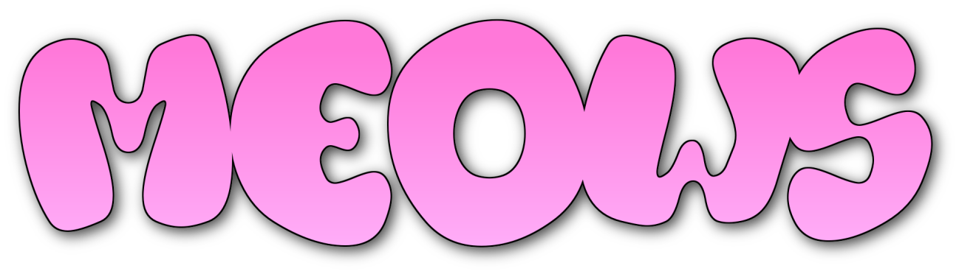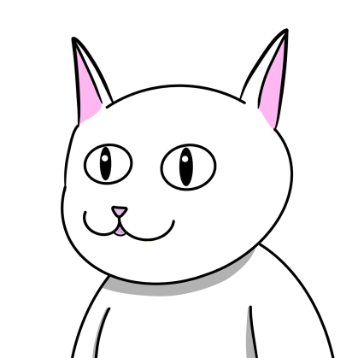

Abstract

we are a nascent community full of challenges to face and many dreams to fulfill today we are an NFT collection tomorrow we will be a value that will not only be monetary but we will achieve freedom in every way

[mderramus@gmail.com](mailto:mderramus@gmail.com)

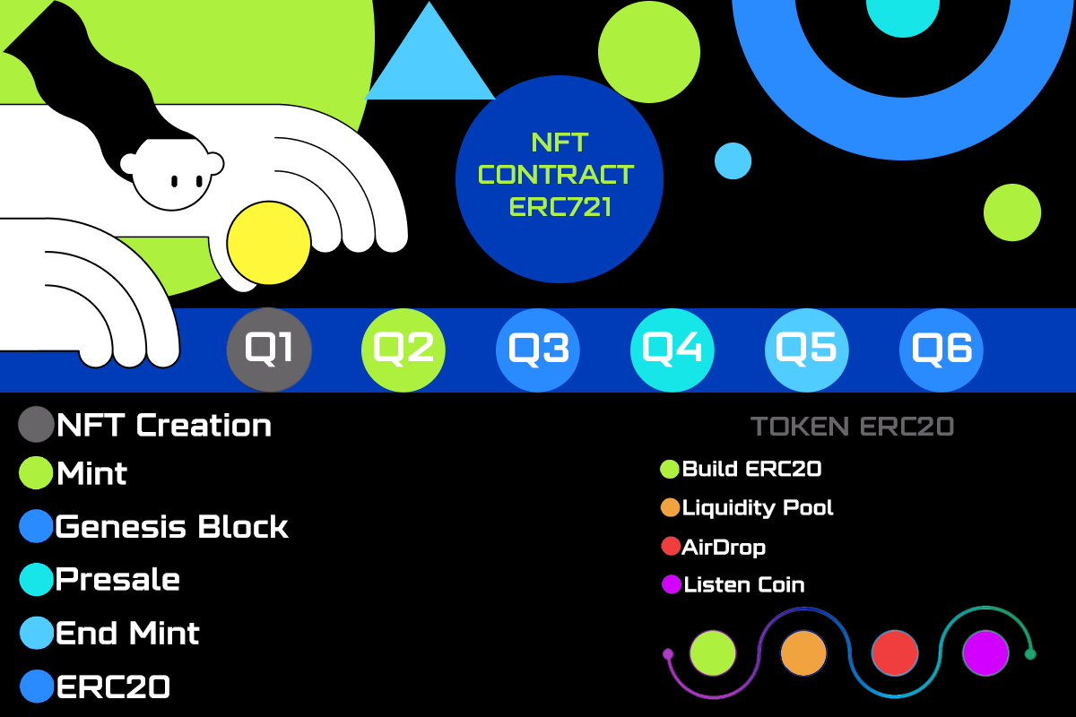

Indice

1. NFT Creation
2. Mint
3. Genesis Block
4. Presale
5. End Mint
6. ERC20

1 NFT Creatión

How does it works

Each Meows collectible is 100% unique and hand-drawn, randomly and programmatically generated from over 150 different traits. A cat has its own set of unique characteristics and it enshrines the following categories

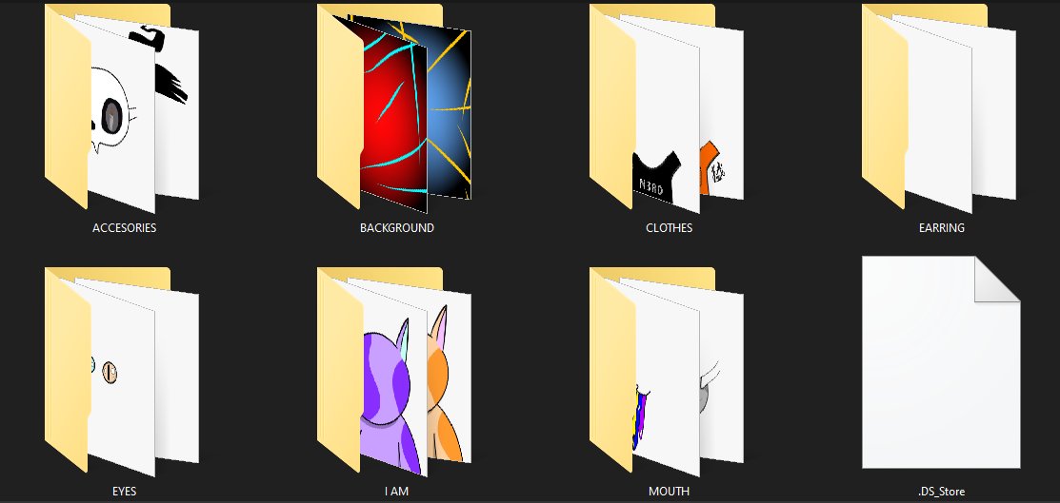

2 Mint

the structure of the smart contract will use the anti-whale functions it will only be possible to mint 5 NFT per wallet the function will also be implemented

function reveal() public onlyOwner {

revealed = true;

}

the polygon network will be used and the price will cost 10 MATIC + fee

3 Génesis Block

Genesis block is a development concept that uses the Meows smart contract 20 NFT will be minted from a collection of 3000 NFT that will serve as incentives in the community after the last NFT minted, follow us on twitter to be more up to date with the new news <https://twitter.com/MeowsCollection>

4 Presale

The team has considered the option of making a pre-sale with staggered values ​​and made the decision not to make a pre-sale or a white list so that everyone can access the collection and the price is unique.

5 End Mint

Once the minting is complete, the team begins with stage 2 of the project. The first action will be to release the funds to the liquidity fund in Quickswap with the meows/matic pair and the stage of rewards will begin for users who have minted one of the 3000 Meows. for more information about the airdrop follow our twitter cannel

6 ERC20

when the second stage of the project begins, already with liquidity in the swap, we will list in coinmarketcap and coingecko, we will also launch a roadmap to explain and determine the usefulness of the token, but for that, a little community is missing, let's go ahead and thank you for trusting us