Lab 2  
CST8912_011  
Yuntian Du  
du000086  
January 20, 2025  
Submitted to :   
Prof. **Ragini Madaan**

# 

Practice creating and monitoring virtual networks on Azure cloud platform

**Introduction or Purpose**

Introduction:

A virtual cloud network refers to a system that has devices, virtual machines, servers, and data centers linked and controlled using wireless technology and software. With virtual cloud networking, an organization can expand their network as they see fit, without having to sacrifice efficiency and functionality.

(VNet) peering is established between pairs of virtual networks. Once a peering connection is established, they appear as one network for connectivity purposes. Devices in each network can communicate with devices in the other network using private IP addresses. The two networks can be in different regions. This is referred to as global peering. Global peering traffic also stays in CSPs private backbone network, and does not traverse the public internet, meaning it provides superior security and performance.

VNet peering is important in many scenarios. One example is when an organization has resources in different regions or subscriptions.

Purpose:

In this lab, you will create a virtual network, including resources in the network, and then create a peering connection with a pre-created virtual network. You will verify that the peering connection allows you to communicate between virtual networks using private addresses.

**Steps covered in the lab**

**Step 1:**

Aim:

Create a Resource Group - CST8912-demo in Canada Central Region.Configure local and global virtual network peering

Steps:

Log into Azure portal homepage and select “Resource Groups” under “Azure Services”, Then choose “Creat”, then select “Azure for Students” under “Subscription” and fill in “CTS8912-demo” under “Resource group”, then select “(Canada) Canada Central” under “Region”.

Finally, click “Review + Create” then click “create”.

**Step 2:**

Aim:

In the Azure portal, search for and select Virtual networks. Create one Virtual Network (cst8912_vnet0) for Canada central region and two Virtual networks (cst8912_vnet1 and cst8912_vnet2) in EAST US region.

Steps:

Under Resource Group CTS8912-demo, choose “Create”. This will lead us to the “Marketplace”. Find “Virtual network” and choose “Creat”. Then create a “Virtual network name” and fill in the requested name for each virtual network in different reigions. Then turn to “IP addresses”. To create a peering network, we need to define different subnets for each virtual network. In my case, vnet0 – 10.0.0.0/16, vnet1 – 10.1.0.0/16, vnet2 – 10.2.0.0/16. Finally, click “Review + create” to create the Vnet.

After deployment, we can choose “Go to resource” to check our Vnets.

**Step 3:**

Aim:

Reviewing Virtual Network Configuration

Steps:

Go to the resource group and click on one virtual network, we can see detailed information there.

**Step 4:**

Aim:

On cst8912_vnet0 virtual network blade click peering to peer with cst8912_vnet1 and cst8912_vnet2 and understand the Virtual Networking Peering Scenario and repeat the same step with vnet 1 and vnet 2.   
Peering link name: cst8912_vnet0_to_ cst8912_vnet1

Steps:

Under “cst8912_vnet0” choose “Peerings”, then choose “Add”. Set “Peering link name” under Remote virtual network summary and Local virtual network summary to “cst8912_vnet0_to_ cst8912_vnet1”, under “Virtual network” choose cst8912_vnet1. Then add this peering.

**Step 5:**

Aim:

On the cst8912-vnet0 virtual network blade, in the Settings section, click Peerings and then click + Add

Peering link name: cst8912_vnet0_to_ cst8912_vnet2  
Steps:

Under “cst8912_vnet0” choose “Peerings”, then choose “Add”. Set “Peering link name” under Remote virtual network summary and Local virtual network summary to “cst8912_vnet0_to_ cst8912_vnet2”, under “Virtual network” choose cst8912_vnet2. Then add this peering.

**Step 6:**

Aim:

Navigate back to the Virtual networks blade and, in the list of virtual networks, click cst8912-vnet1  
Steps:

Just go to “cst8912-vnet1”.

**Step 7:**

Aim:

On the cst8912-vnet1 virtual network blade, in the Settings section, click Peerings and then click + Add.

Peering link name: cst8912_vnet1_to_ cst8912_vnet2  
Steps:

Under “cst8912_vnet1” choose “Peerings”, then choose “Add”. Set “Peering link name” under Remote virtual network summary and Local virtual network summary to “cst8912_vnet1_to_ cst8912_vnet2”, under “Virtual network” choose cst8912_vnet2. Then add this peering.

**Step 8:**

Aim:

In the Azure portal, search for and select **Virtual machines.**  
Steps:

In the Azure portal, search for and select **Virtual machines.**

**Step 9:**

Aim:

In the list of virtual machines, create VM0 in Canada Central on Vnet 0 and VM1 and VM2 in East US (use Windows Server 2022 Datacenter) image on Vnet1 and Vnet 2 respectively.   
Steps:

Set VM’s resource group to “CST8912-demo”, set Virtual machine name to “VM0”, then set region and choose image “Windows Server 2022 Datacenter”, choose “Standard B1S”for this VM, create username and password. Then configure the virtual network to cst8912_vnet0. Finally create this VM. Do the same process to VM1 and VM2 but aware of the region and network.

**Step 10:**

Aim:

Select VM0 and connect using RDP signing in with username and password  
Steps:

Under “VM0” choose “Connect”, then use the Public IP address to connect through RDP.

**Step 11:**

Aim:

Within the RDP, right-click start button and click powershell.  
Steps:

Open powershell as requesteda.

**Step 12 & 13:**

Aim:

In the Windows PowerShell console window, run the following to test connectivity to **vm1** (use private ip) over TCP port 3389:

**Test-NetConnection -ComputerName “ip” -Port 3389 -InformationLevel 'Detailed'**

Example:Test-NetConnection -ComputerName 10.52.0.4 -Port 3389 -InformationLevel 'Detailed'

Examine the output of the command and verify that the connection was successful.

Steps:

Under “VM1” Overview, find the private IP address, and test the connection on VM0.

**Step 14:**

Aim:

Repeat the same step to connect Vm0 to Vm2 and Vm1 to Vm2 and test the connection

Steps:

Under VM0 & VM2 Overview, find the public & private IP address, and test the connection on VM0 & VM1.

**Step 15:**

Aim:

After demo delete all the resources created during this lab and create a lab report documenting all the steps with screenshots

Steps:

Go to Resource group, and delete the whole Resource group.

**Results**

**Step 1:**

**Step 2:**

**Step 3:**

**Step 4:**

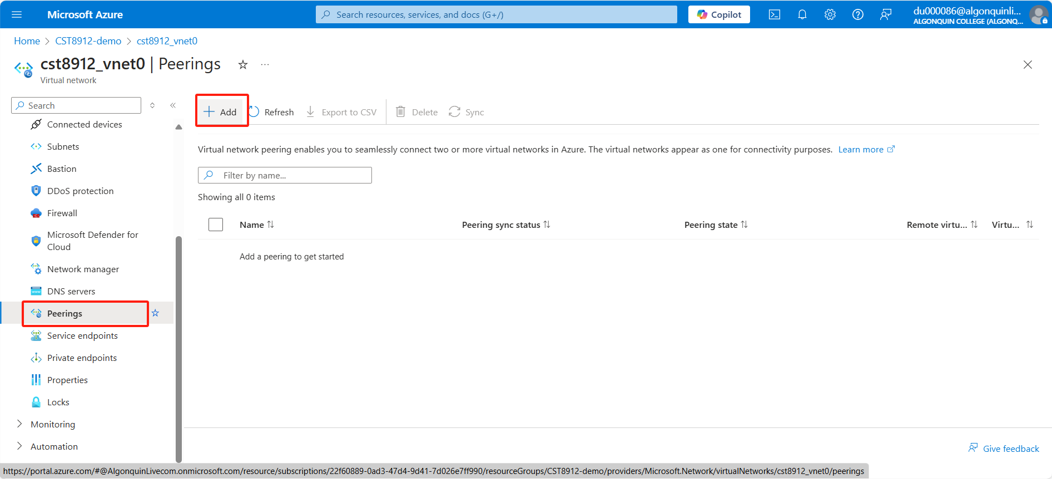

**Step 5:**

**Step 6:**

**Step 7:**

**Step 8:**

**Step 9:**

**Step 10:**

**Step 11:**

**Step 12 & 13:**

**Step 14:**

**Step 15:**

**References**

None.