LOGIN_REGISTER DATABASE

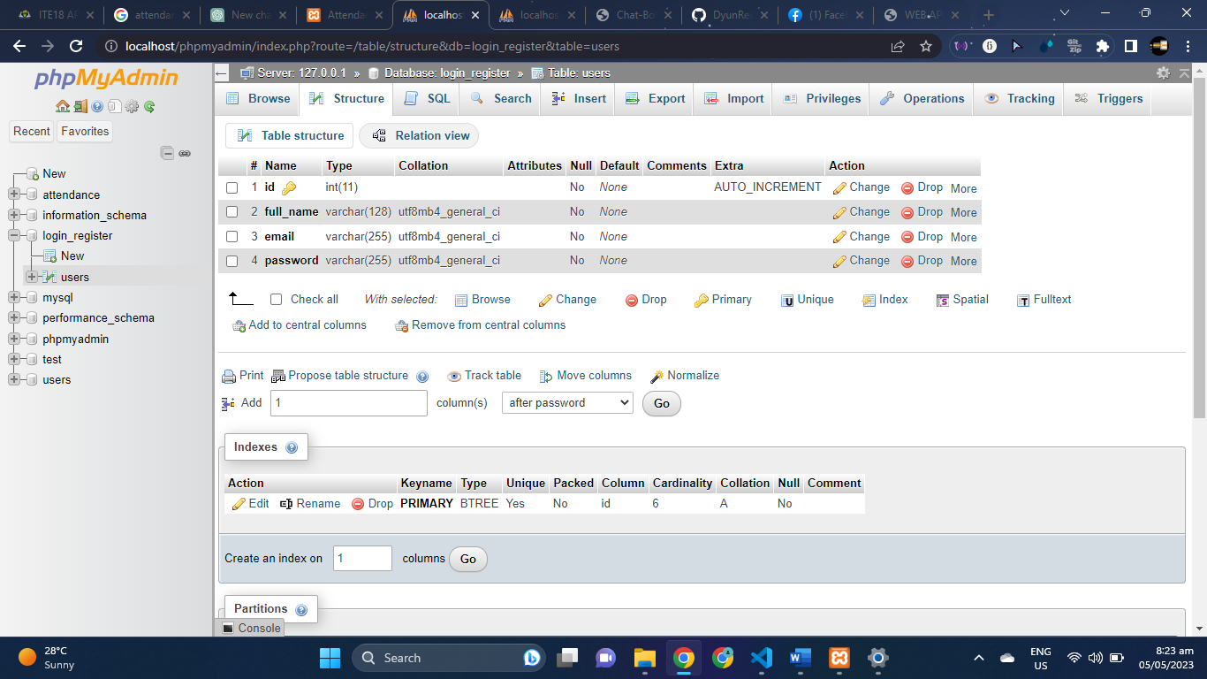

ATTENDANCE DATABASE

