**EGE ÜNİVERSİTESİ**

**MÜHENDİSLİK FAKÜLTESİ**

**BİLGİSAYAR MÜHENDİSLİĞİ BÖLÜMÜ**

**434 GÖRÜNTÜ İŞLEME**

**2019-2020 GÜZ YARIYILI TAKE HOME**

**(Arasınavlardan iki hafta sonraki dersten önce yüklenmeli)**

1. Paint Shop Pro, Photoshop ve GIMP yazılımlarının özelliklerini inceleyiniz ve bu üç yazılımı karşılaştırınız (tablo şeklinde de yazılabilir) [1 sayfa]

Ücretli olanlar internet üzerinden araştırılabilir veya deneme sürümleri indirilebilir. (20 p)

Answer:

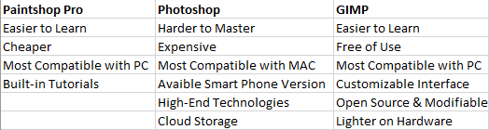

Figure 1 Comprasion of Paintshop Pro, Photoshop and GIMP

1. İki farklı resim bulunuz. Bu resimleri 2 farklı bölütleme (segmentation) yöntemi (threshold, watershed, region growing, split-and-merge, border tracing, …) ile bölütleyiniz. Görüntülerin ilk ve son hallerini rapora ekleyerek, yöntemleri kısaca anlatıp sonuçları yorumlayınız. Görüntülerde kaçar nesne olduğunu saydırınız ve raporda belirtiniz. (20 p)

İpucu : <https://scikit-image.org/docs/dev/api/skimage.segmentation.html>

Answer :

* Threshold Segmentation :

Thresholding is the simplest method of image segmentation. From a grayscale image, thresholding can be used to create binary images. Binary images are one that consists of pixels that can have one of exactly two colors, usually black and white. Binary image processing often arise in digital image processing as masking or thresholding.

Thresholding methods replace each pixel in an image with a black pixel if the image intensity is less than some fixed constant T, or a while pixel if the image intensity is greater than that constant.

Below image is the Thresholding method that is implemented for this document.

It firstly reads an image and then converts it to grayscale in order to transform it to binary image. After throsholding holes that still exist are eliminated with binary_fill_holes method. After processing finishes, each segment is labeled and the maximum label value is outputed as the total number of segments in the image.

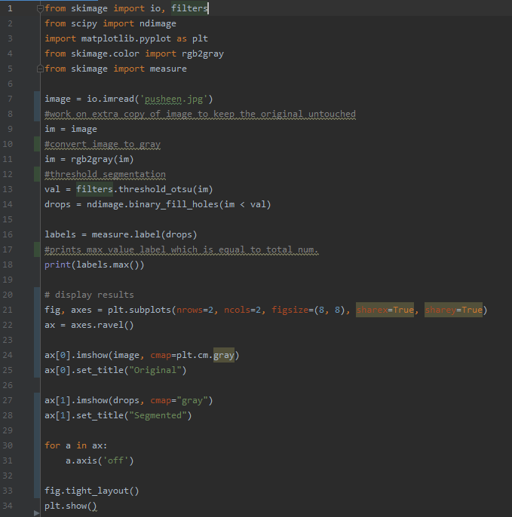

Figure Threshold Segmentation Python Code

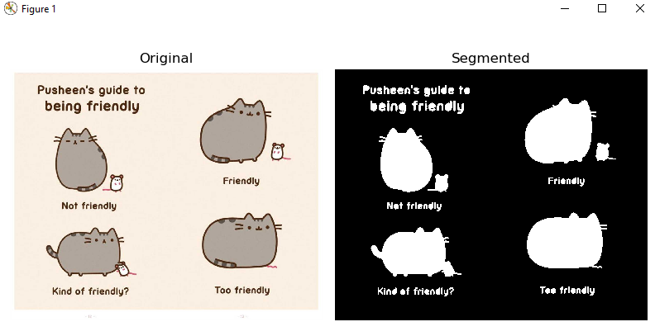

Figure Original Image and Threshold Segmentation Result



Figure Original Image and Threshold Segmentation Result

* Watershed Segmentation :

Watershed is a tranformation defined on a grayscale image. This method seperates adjacent objects in the image. The watershed transformation treats the image as if it is operating upon a topographic map, with the brightness of each point representing the height, and finds the lines that run along the tops of ridges.

Below image is the Watershed method implemented for this document. This method starts by reading an image and converting it to grayscale. After transformation noises are eliminated by using median filtering. When noise is eliminated, then rank.gradient method scans and finds continious objects in the image. After the processing segments are labeled and the max valued label is outputted since it is equal to the total number of segments in the image.

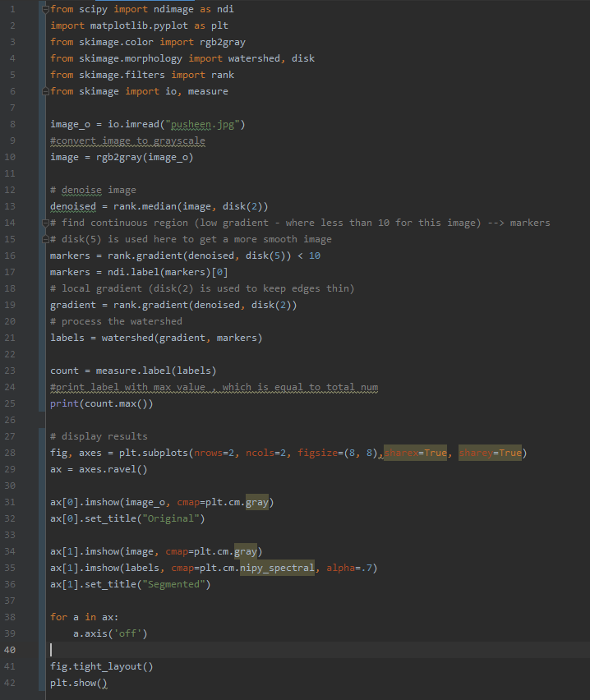

Figure 5 Watershed Segmentation & Labeling Python Code

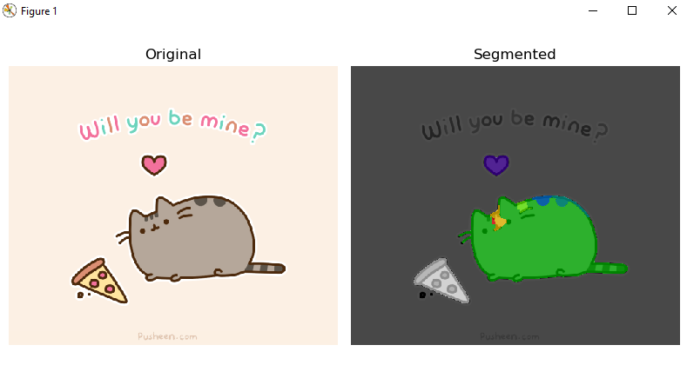

Figure 6 Original Image and Watershed Segmentation & Area Labeling Result

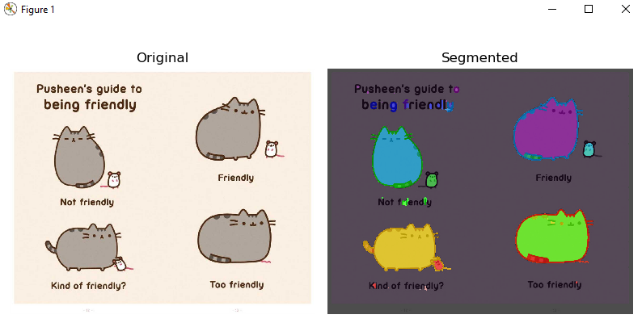

Figure 7 Original Image and Watershed Segmentation & Area Labeling Result

1. Görüntü İşleme ile ilgili olarak, fotoğraflar üzerinde geçmiş yıllarda düşünüp de yaptıramadığınız çok zor olmayan bir işlemi kısaca anlatınız (Böyle bir şey yoksa, P1 ve take-home’da olmayan bir işlem araştırıp onun üzerinden gidebilirsiniz). Derste öğrendiklerinizle birlikte araştırarak bu işlemi kodlayarak yapmaya çalışınız. İşlem ile ilgili görüntüleri rapora ekleyerek kodlamanın sonucunu yorumlayınız. (20 p)

Answer :

People often want to hide their impurities from the photos of themselves. Before the camera beauty filterings started to get popular, filtering photos had been done by using editor programs such as Adobe Photoshop to edit photos. But using an editor program to process each photo taken was taking a lot of time and expertise. To avoid editing photos, camera filterings became quite popular and they work well.

But there is something these camera filterings cannot do, keeping the natural beauty after the filtering. So I have always thought of such an image processing method that could change minor impurities while not changing any other part of the photo to keep it the most natural looking. My thoughts that only eliminating the red acne scars on the face is enough to make the photo beautiful and natural.

There are numerous basic image filtering methods that can be used in combined to achive this filtering.

For achieving this filter, openCv’s inRange method can be used. Firstly red color’s lowest and highest hues are determined. Then image’s color scale is tranformed from BGR to HSV. Then, mask the pixels which are in range of the lowest and the highest red colors and change pixel’s color in this mask to a predefined beige color.

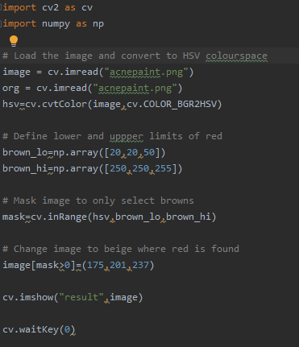

Figure 8 Python Code of Acne Remove Filter

The problem this filter can cause is , if there are red colored objects or make up on the photo this filter will turn them into a beige predefined color which is unwanted.

To enchance this filter instead of replacing pixels’ colors in a range instead use a blob detection segmentation algorithm to mask only the acne shapes and then apply the first filter algorithm on this mask rather than the whole photo.

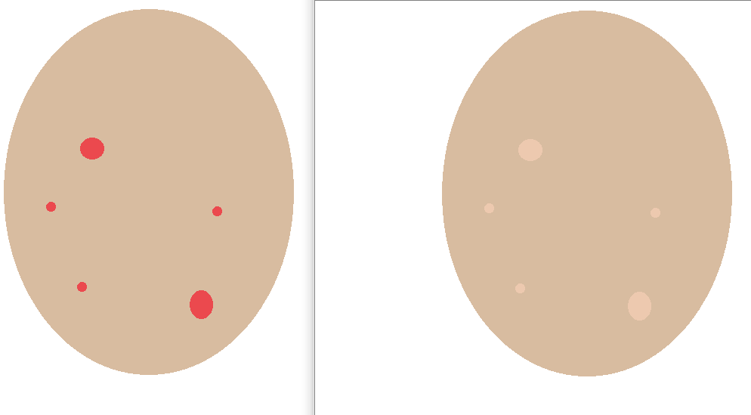

Figure 9 Left Illuıstration of Acne on a Face, Right After Using Filter to Clear Them

1. Aşağıdaki kavramları araştırarak kısaca açıklayınız (20 p):

Answer :

* 1. SIFT (Scale-Invariant Feature Transform)

The scale-invariant feature transform (SIFT) is a [feature detection](https://en.wikipedia.org/wiki/Feature_detection_(computer_vision)) algorithm in [computer vision](https://en.wikipedia.org/wiki/Computer_vision) to detect and describe local features in images.

SIFT keypoints of objects are first extracted from a set of reference images[ and stored in a database. An object is recognized in a new image by individually comparing each feature from the new image to this database and finding candidate matching features based on [Euclidean distance](https://en.wikipedia.org/wiki/Euclidean_distance) of their feature vectors.

From the full set of matches, subsets of keypoints that agree on the object and its location, scale, and orientation in the new image are identified to filter out good matches. The determination of consistent clusters is performed rapidly by using an efficient [hash table](https://en.wikipedia.org/wiki/Hash_table) implementation of the generalised [Hough transform](https://en.wikipedia.org/wiki/Hough_transform). Each cluster of 3 or more features that agree on an object and its pose is then subject to further detailed model verification and subsequently outliers are discarded. Finally the probability that a particular set of features indicates the presence of an object is computed, given the accuracy of fit and number of probable false matches. Object matches that pass all these tests can be identified as correct with high confidence.

* 1. Corner Detection, Harris Corner Detector

A corner is a point whose local neighborhood stands in two dominant and different edge directions. In other words, a corner can be interpreted as the junction of two edges, where an edge is a sudden change in image brightness. Corners are the important features in the image, and they are generally termed as interest points which are invariant to translation, rotation and illumination. Although corners are only a small percentage of the image, they contain the most important features in restoring image information, and they can be used to minimize the amount of processed data for motion tracking, [image stitching](https://en.wikipedia.org/wiki/Image_stitching), building 2D mosaics, [stereo vision](https://en.wikipedia.org/wiki/Computer_stereo_vision), image representation and other related computer vision areas.

As Harris operator is the most simple, efficient and reliable for use in corner detection. This methodology is closely associated with and based on the local structure matrix. Harris corner detector provides good repeatability under changing illumination and rotation, and therefore, it is more often used in stereo matching and image database retrieval. Although there still exists drawbacks and limitations, the Harris corner detector is still an important and fundamental technique for many computer vision applications.

* 1. Hough Transform

The Hough transform is a [feature extraction](https://en.wikipedia.org/wiki/Feature_extraction) technique used in [image analysis](https://en.wikipedia.org/wiki/Image_analysis), [computer vision](https://en.wikipedia.org/wiki/Computer_vision), and [digital image processing](https://en.wikipedia.org/wiki/Digital_image_processing). The purpose of the technique is to find imperfect instances of objects within a certain class of shapes by a voting procedure. This voting procedure is carried out in a [parameter space](https://en.wikipedia.org/wiki/Parameter_space), from which object candidates are obtained as local maxima in a so-called accumulator space that is explicitly constructed by the algorithm for computing the Hough transform.

The classical Hough transform was concerned with the identification of [lines](https://en.wikipedia.org/wiki/Line_(mathematics)) in the image, but later the Hough transform has been extended to identifying positions of arbitrary shapes, most commonly [circles](https://en.wikipedia.org/wiki/Circle) or [ellipses](https://en.wikipedia.org/wiki/Ellipse).

* 1. Laplacian of Gaussian

The Laplacian is a two dimensional isotropic measure of the second spatial derivative of an image. The Laplacian of an image highlights regions of rapid intensity change and is therefore often used for edge detection. The Laplacian is often applied to an image that has f,rst been smoothed with something approximating a Gaussian smoothing filter in order to reduce its sensitivity to noise, and hence the two variants will be described together here. The operator normally takes a single graylevel image as input and produces another graylevel image as output