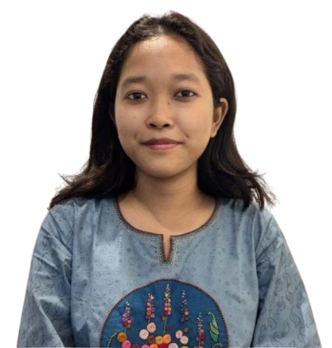
Dyuti Hikary Mrong
Mohammadpur, Dhaka
01403378921
dyutihikary@gmail.com

A Software Engineering student with a strong interest in corporate training and professional development. Experienced in leadership and team activities, proficient in MS Office. Brings strong communication, teamwork and organizational skills with organizations and professionals who value growth and continuous learning . Demonstrates a strong interest in Human Rights and Youth Development, with a genuine desire to contribute to community-based initiatives, including work with indigenous and marginalized communities.

Educational Background

Bachelor of Science in Software Engineering
Daffodil International University, Dhaka
Semester: 6th
Year: 2024-2028

Higher Secondary Certificate (HSC)
Holy Cross College
Year of Passing: 2023

Secondary School Certificate (SSC)
Nalonda High School
Year of Passing: 2021

Skills and Expertise

Programming and Technical Skills
- Programming Languages : C , Python , Java , HTML
- Tools & Platforms : MS word, MS Excel, PowerPoint , Canva
Corporate & Professional Skills
- Skilled in preparing presentations, handouts and learning materials .
- Experienced in venue setup, coordination and smooth execution of training programs
- Fluent and confident in Bangla & English (written & spoken)
- Basic Graphic Design
Soft Skills
- Effective Communication
- Leadership & Team Management
- Critical Thinking & Problem-Solving
- Adaptability & Time Management
- Organizational & Event Planning Skills
- Creativity & Innovative Thinking
Achievements & Certifications
- 2nd Place, Wall Magazine Competition, Holy Cross College Business Festival, 2022
- 5th Place, DIU Typing Titans 2025
- Champion, Scrapbook Segment, Holy Cross College English Festival, 2022
- Participant, Quiz Competition at the 26th Anniversary and Folk Festival, Notre Dame College Cultural Club, 2022
- Champion, Scrapbook of Bermuda Triangle, 7th GSHS National Science Festival 2023
- Best Participant , Foundational Course on Praise & Worship 2021
- Honourable Mention , Correspondent Of Reuters ,IP - CoMUN 2025
- Honourable Mention , Correspondent Of The New York Times ,IP - DIU IMUN 2025
- Honourable Mention , Correspondent Of Associated Press ,IP - The Arc of Diplomats 2026

Extra-curricular Activities
- President , Daffodil International University Indigenous Students’ Association 2026 - 2027
- Joint Secretary, Daffodil International University Indigenous Students Association 2025-2026
- Member of Office & Organizing Wing , Daffodil International University Software Engineering Club
- Former General Secretary, Holy Cross College Debating Club (2022–2023)
- Former Sports Leader , Holy Cross College
- Event Coordinator , SPSC Cultural Fest 2016
- Volunteer, Holy Cross College Science Festival, 2023
- Volunteer, Holy Cross College Science Festival, 2022
- Volunteer, Holy Cross College Debate Festival 2022
- Volunteer, Holy Cross College English Festival 2023
- Participant , Annual Art & Craft Competition , 2022
- Participant, Holy Cross College Intra Debate Competitions
- Participant , Comilla University Model United Nations, 2025 (Verbal Mention)
- Participant, Daffodil International University Model United Nations, 2025 (Verbal Mention)

