DP Work Login Functionality Testing Documentation

## DP Work Login Page:

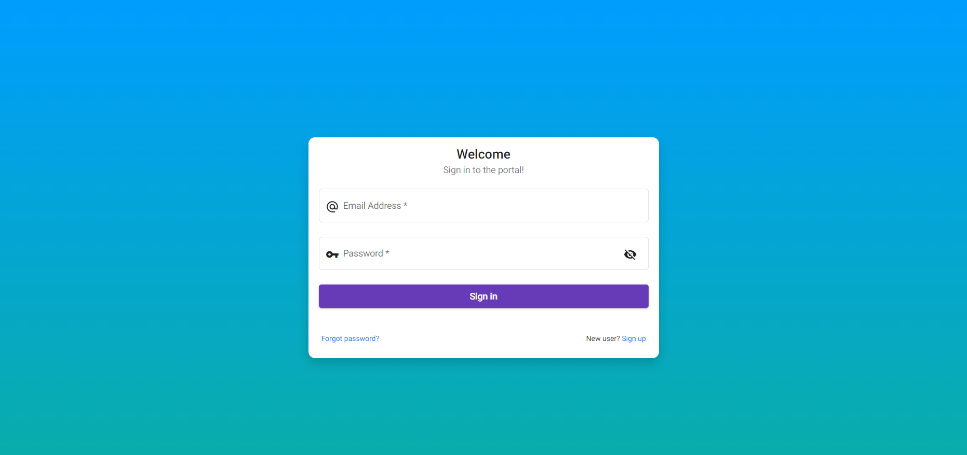

## Scenario

DP worker username - kolkatauser@gmail.com

DP worker password - kolkata@10

Scenario expected result - Fail

## User login into DpWork Portal

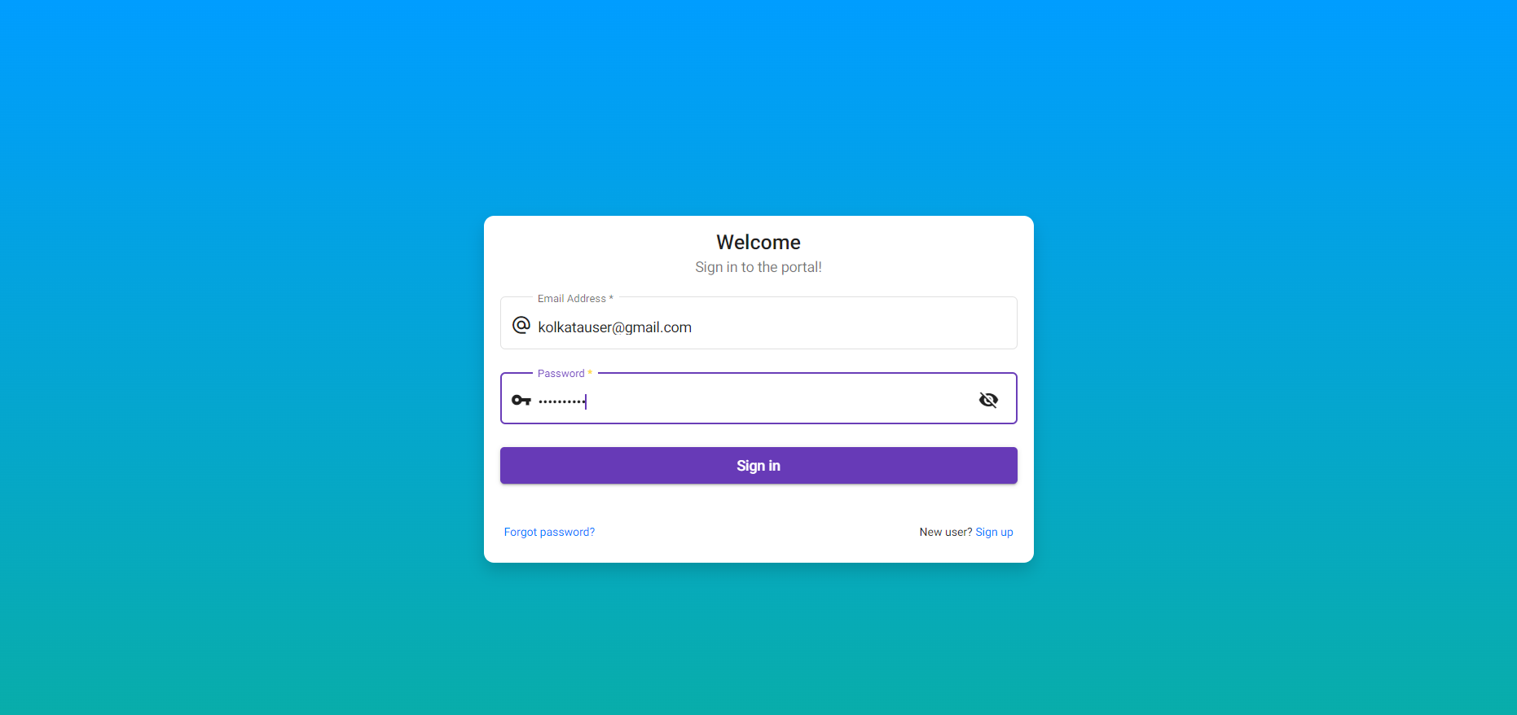

## User clicks on the login button

Scenario actual result:

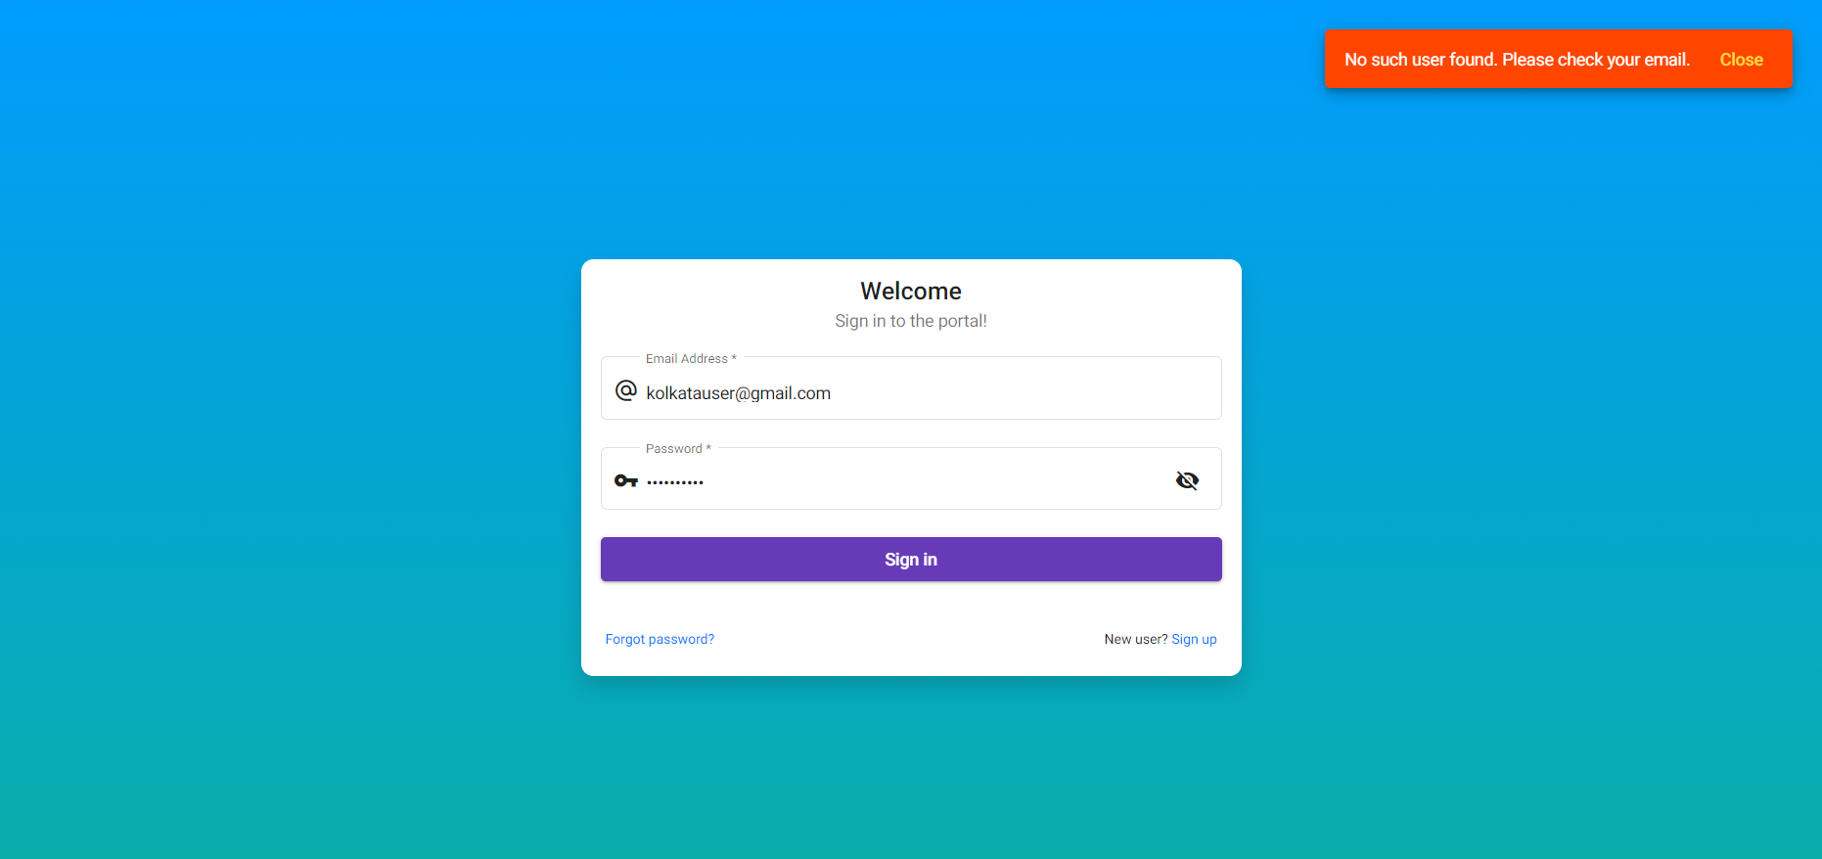

## Scenario

DP worker username - dyutiuser@gmail.com

DP worker password - dyuti@10

Scenario expected result - Fail

## User login into DpWork Portal

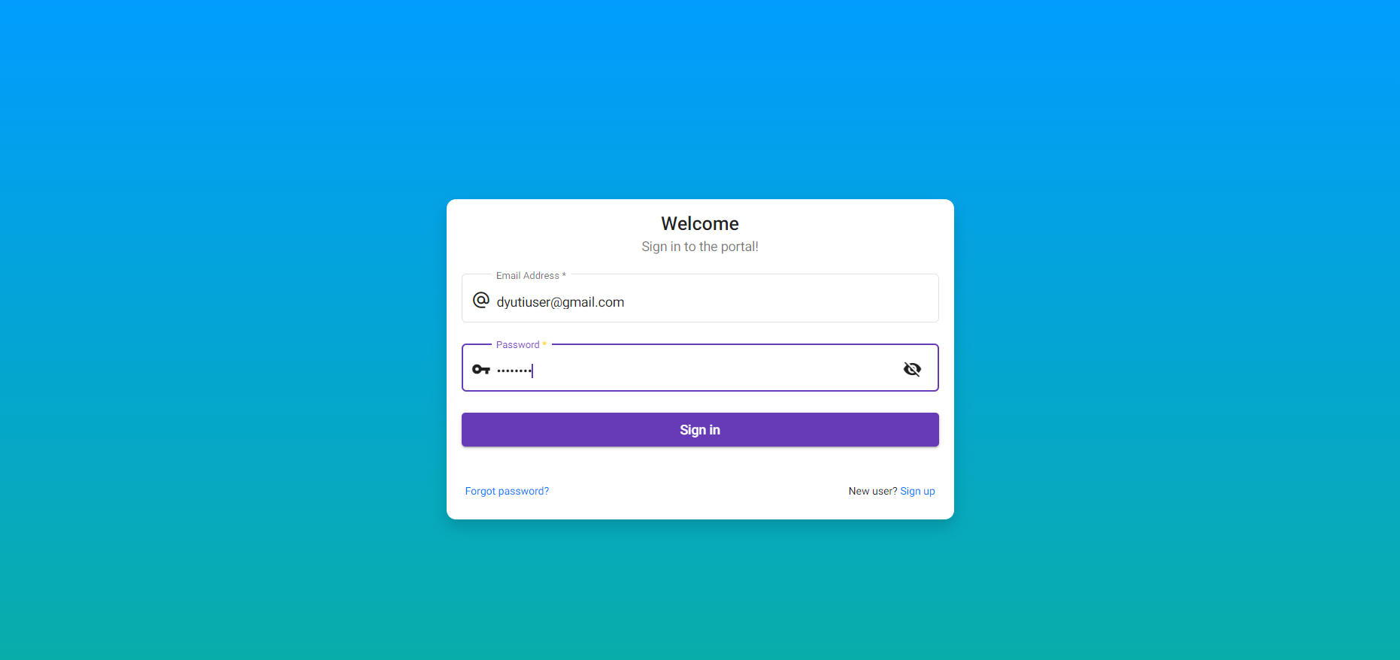

## User clicks on the login button

Scenario actual result:

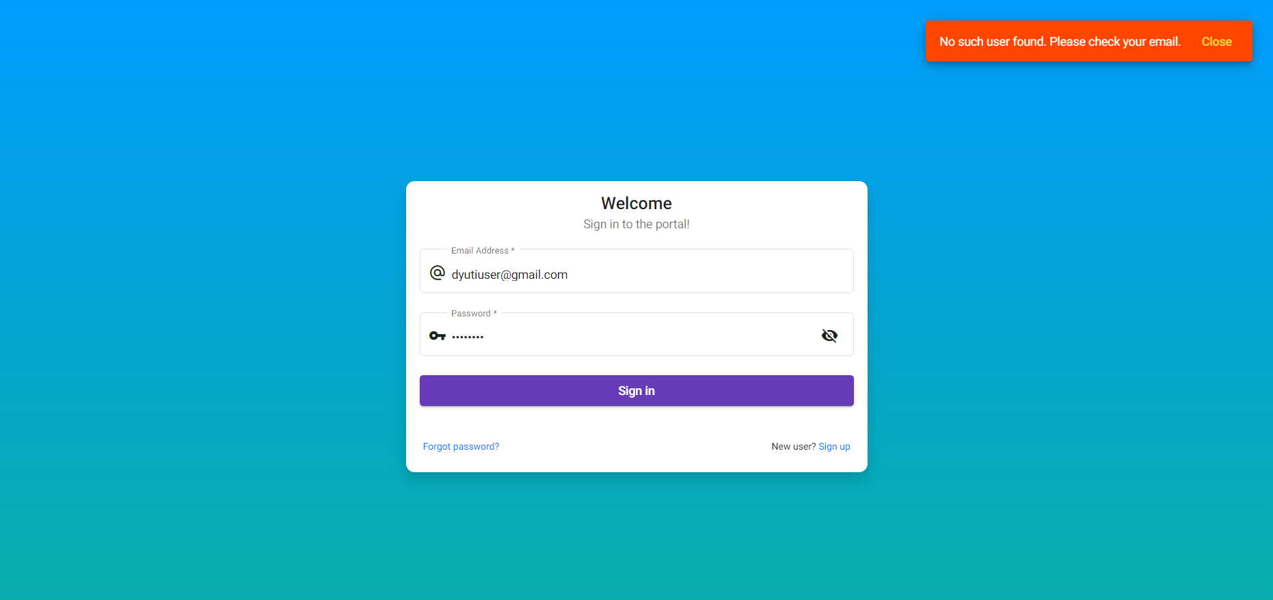

## Scenario

DP worker username - tarzaan@gmail.com

DP worker password - 1234

Scenario expected result - Fail

## User login into DpWork Portal

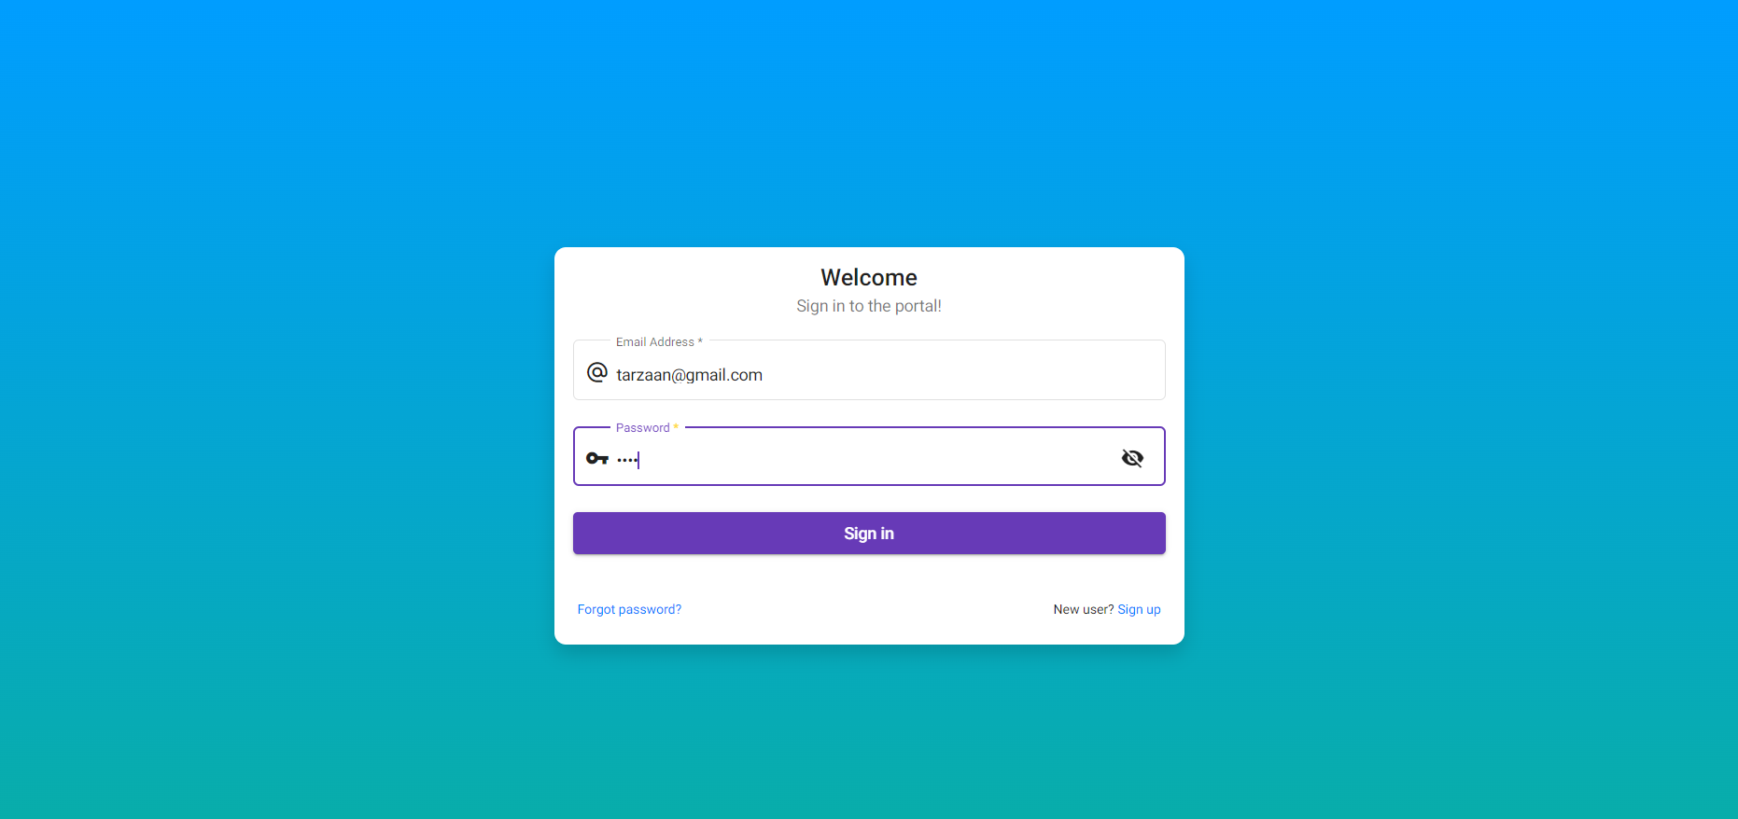

## User clicks on the login button

Scenario actual result:

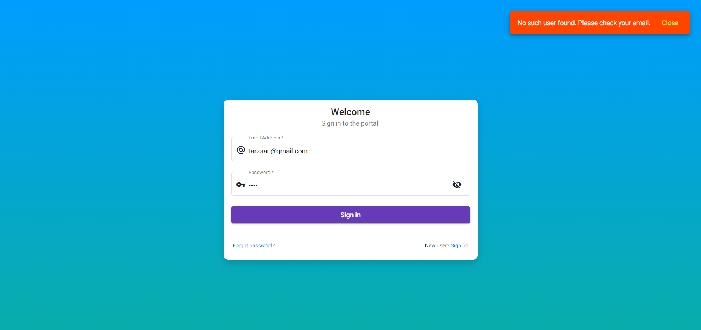

## Scenario

DP worker username - supermodel@test.com

DP worker password - 1234

Scenario expected result - Fail

## User login into DpWork Portal

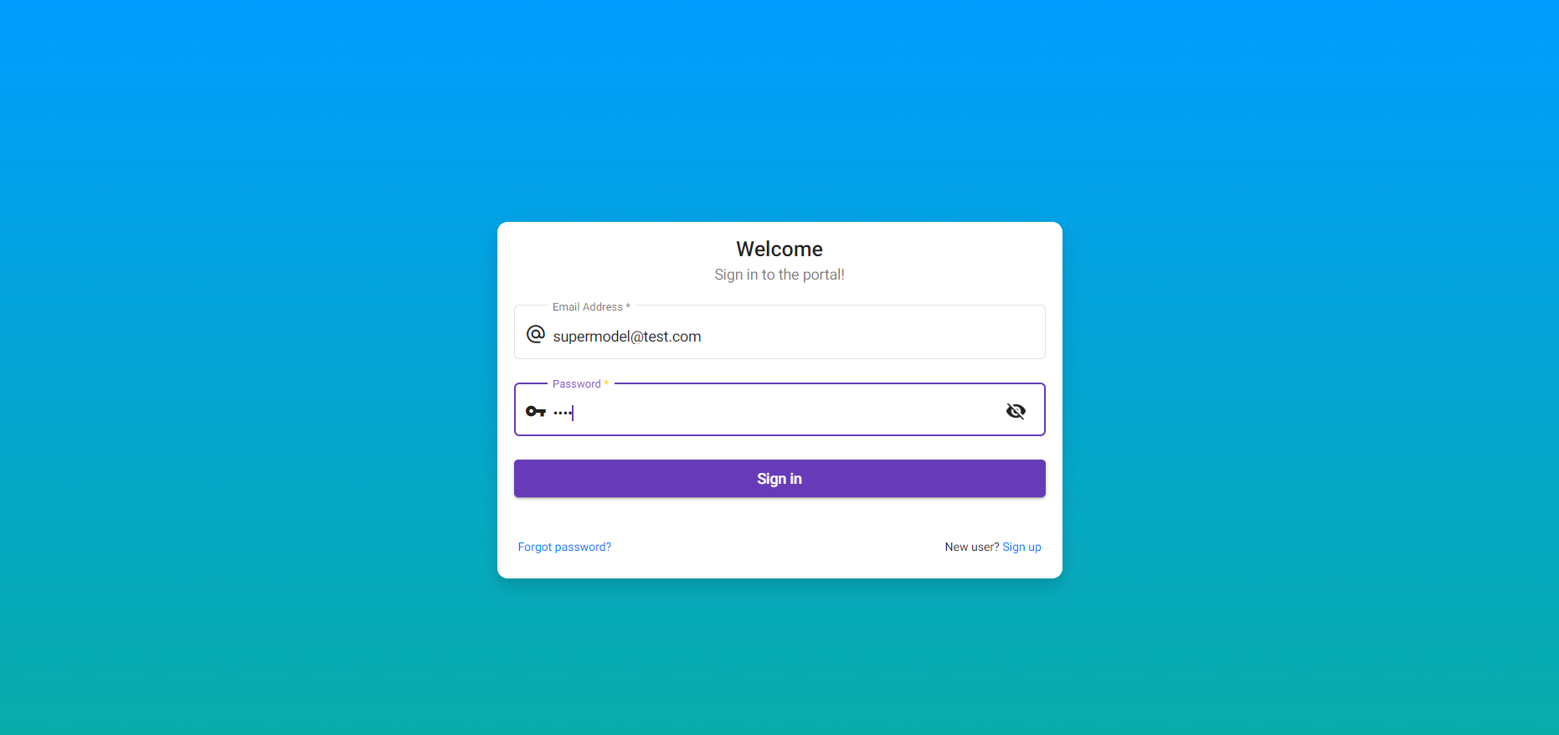

## User clicks on the login button

Scenario actual result:

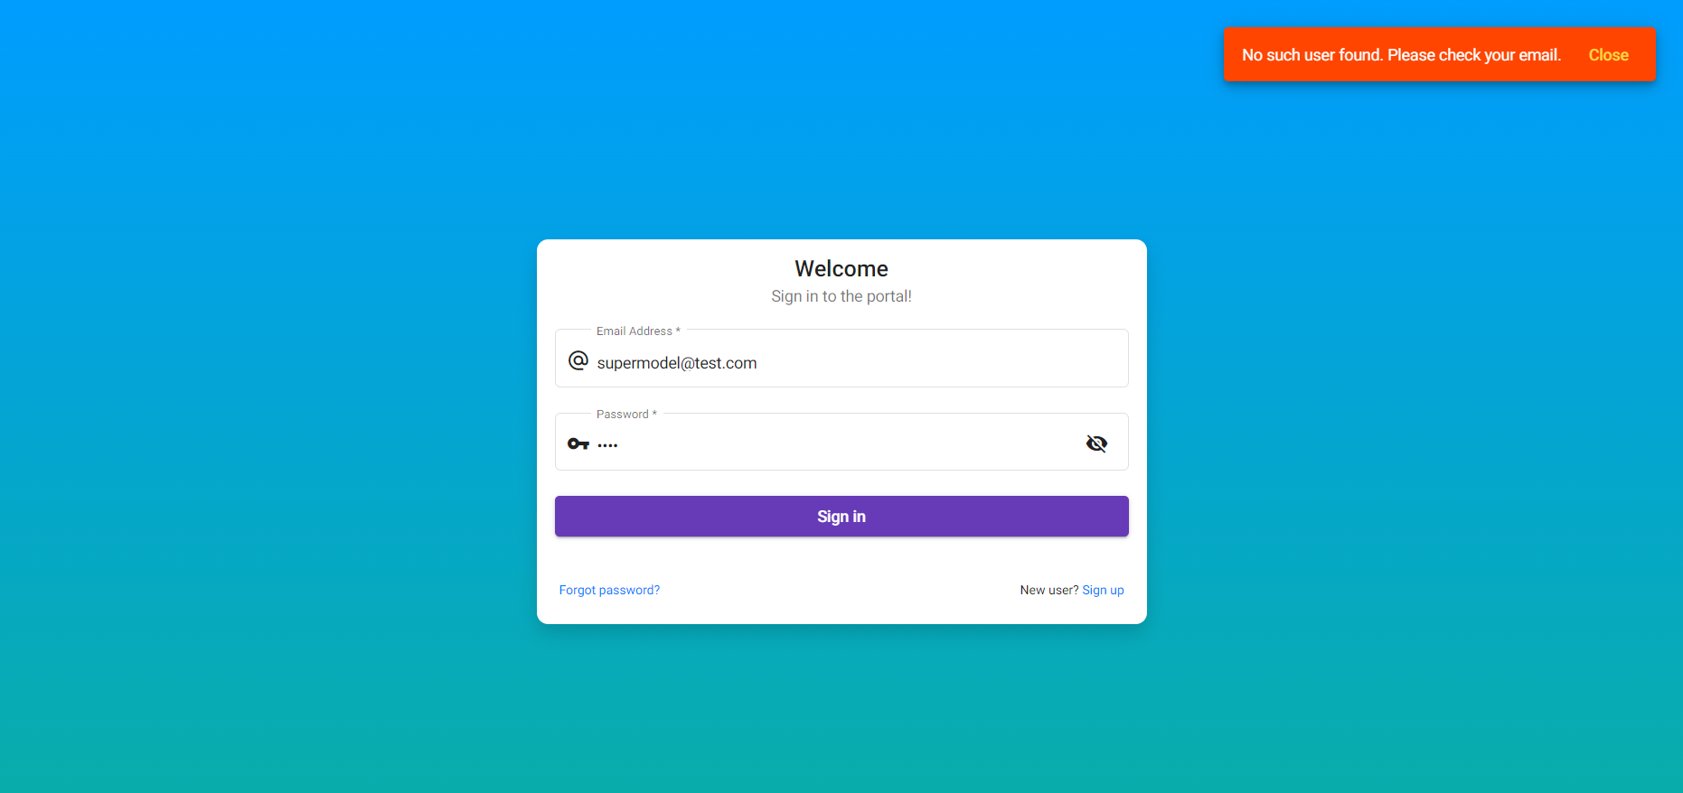

## Scenario

DP worker username - modelsupa@test.com

DP worker password - 1234

Scenario expected result - Fail

## User login into DpWork Portal

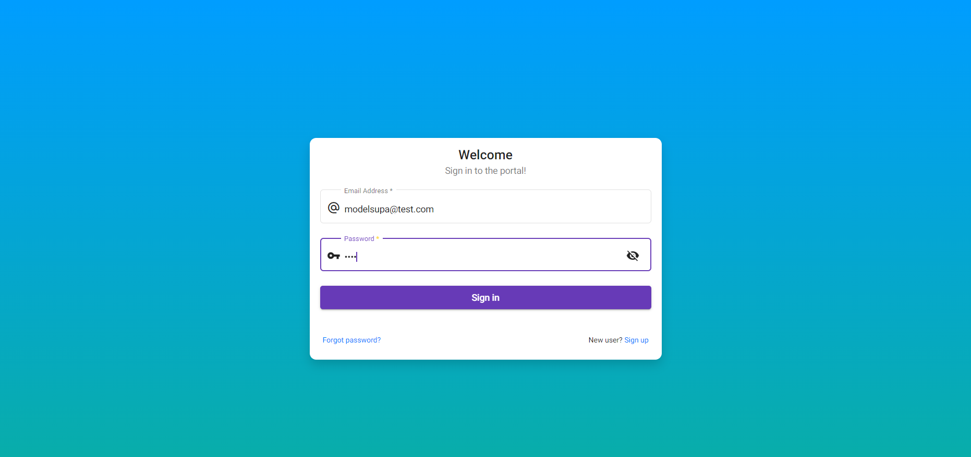

## User clicks on the login button

Scenario actual result:

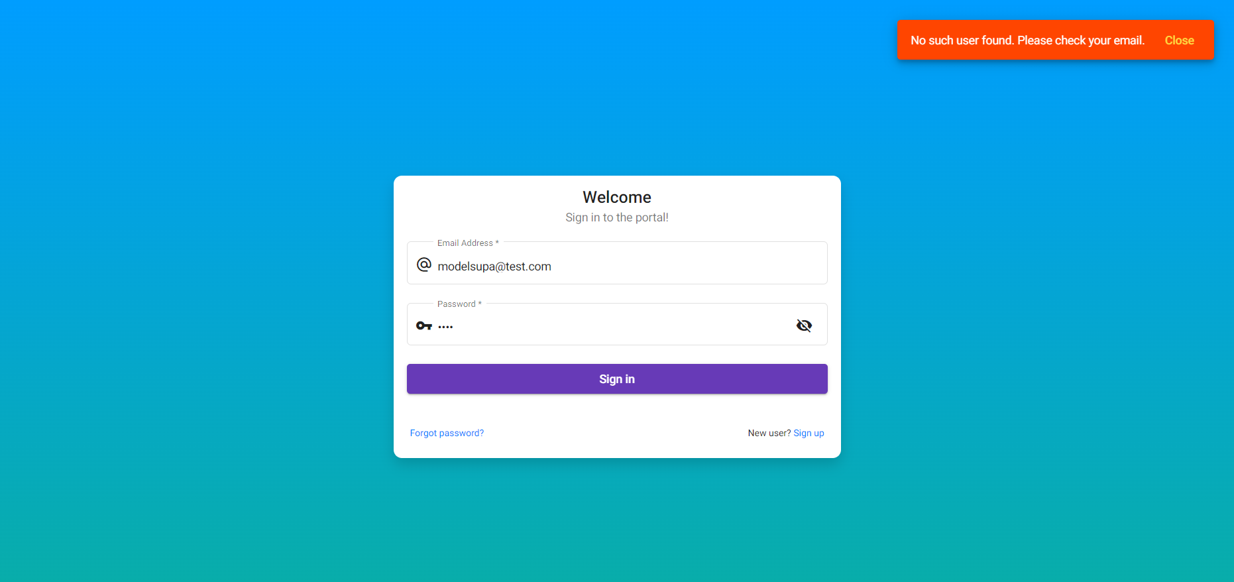

## Scenario

DP worker username - superb@media.com

DP worker password - 1234

Scenario expected result - Fail

## User login into DpWork Portal

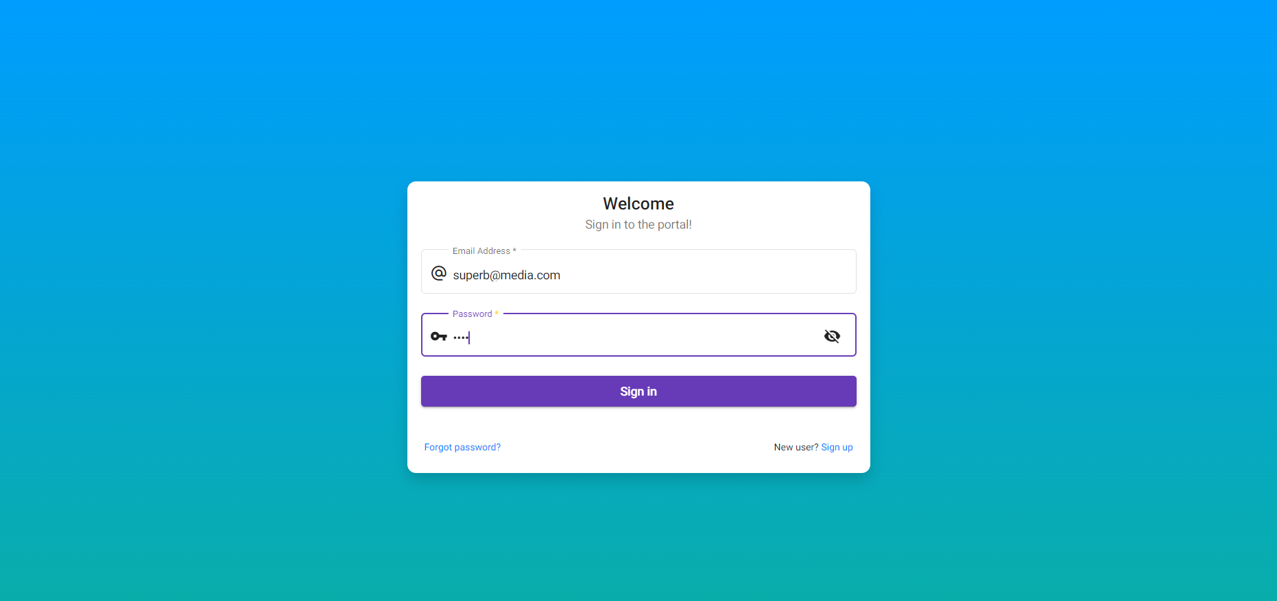

## User clicks on the login button

Scenario actual result:

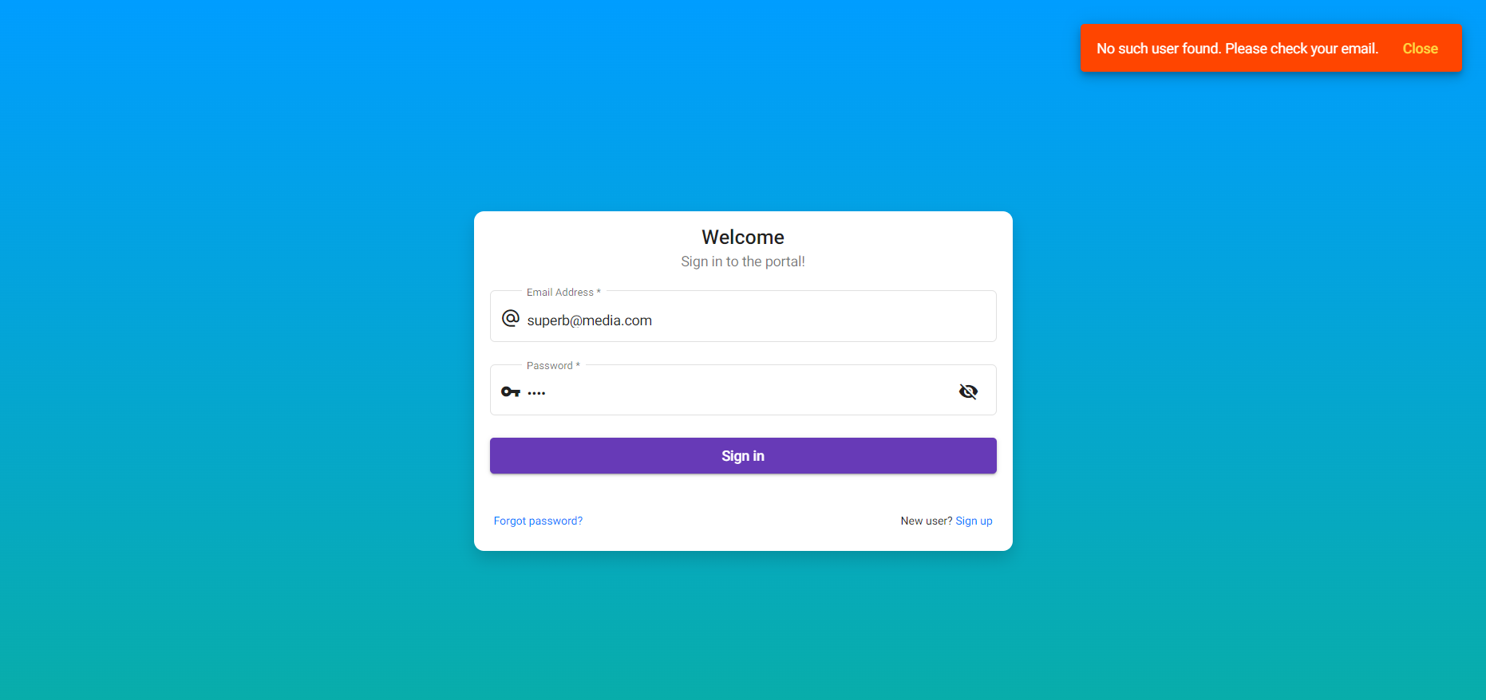

## Scenario

DP worker username - cartoon@network.com

DP worker password - 1234

Scenario expected result - Fail

## User login into DpWork Portal

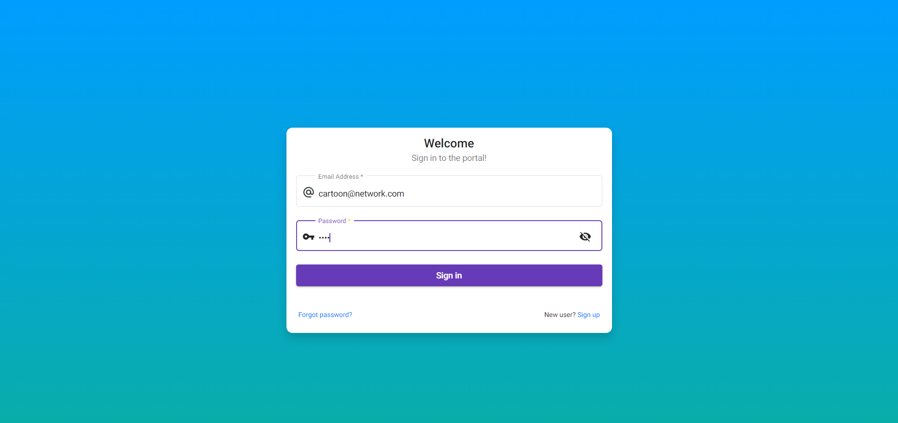

## User clicks on the login button

Scenario actual result:

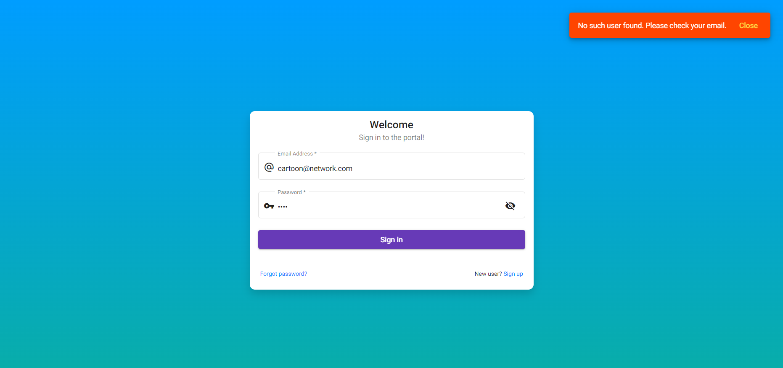

## Scenario

DP worker username - mahesh@babu.com

DP worker password - 1234

Scenario expected result - Fail

## User login into DpWork Portal

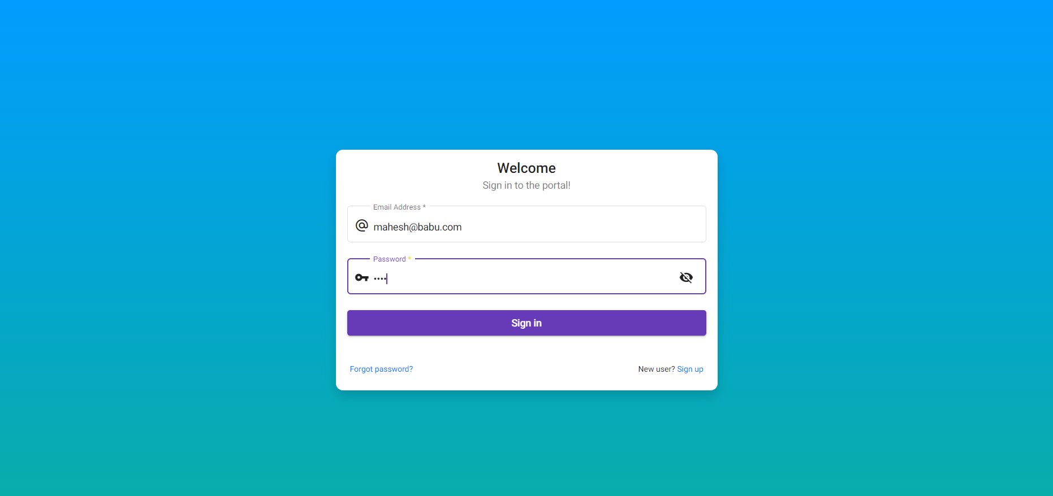

## User clicks on the login button

Scenario actual result:

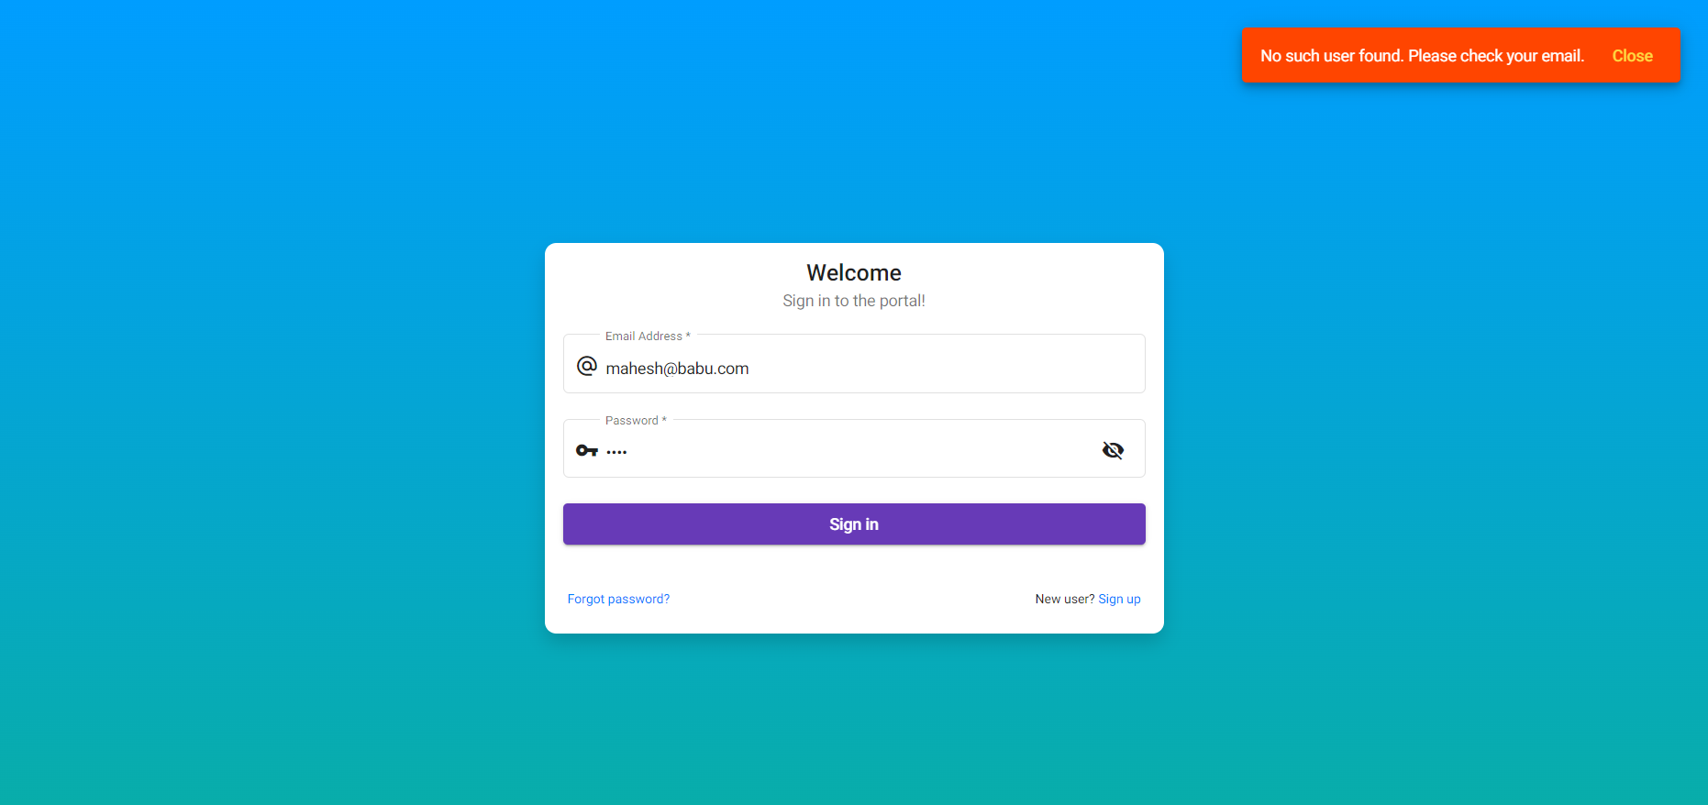

## Scenario

DP worker username - avataar@part.com

DP worker password - 1234

Scenario expected result - Fail

## User login into DpWork Portal

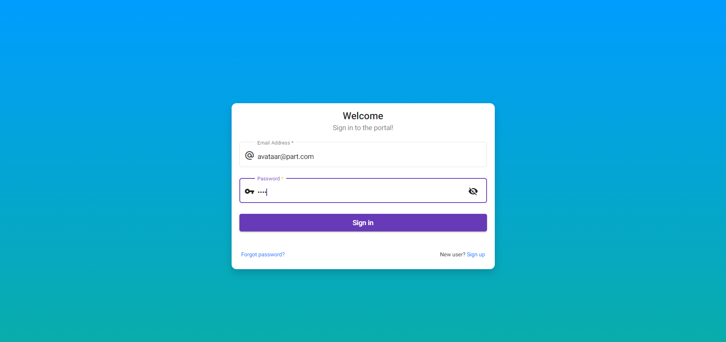

## User clicks on the login button

Scenario actual result:

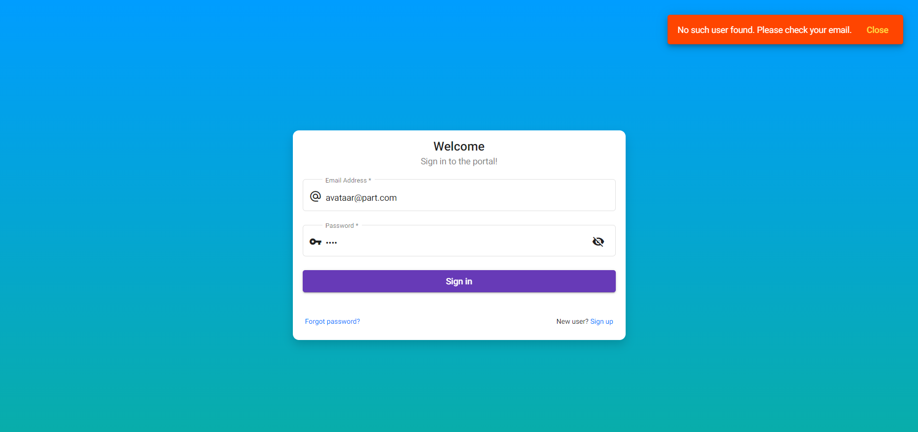

## Scenario

DP worker username - bankura@test.com

DP worker password - 1234

Scenario expected result - Pass

## User login into DpWork Portal

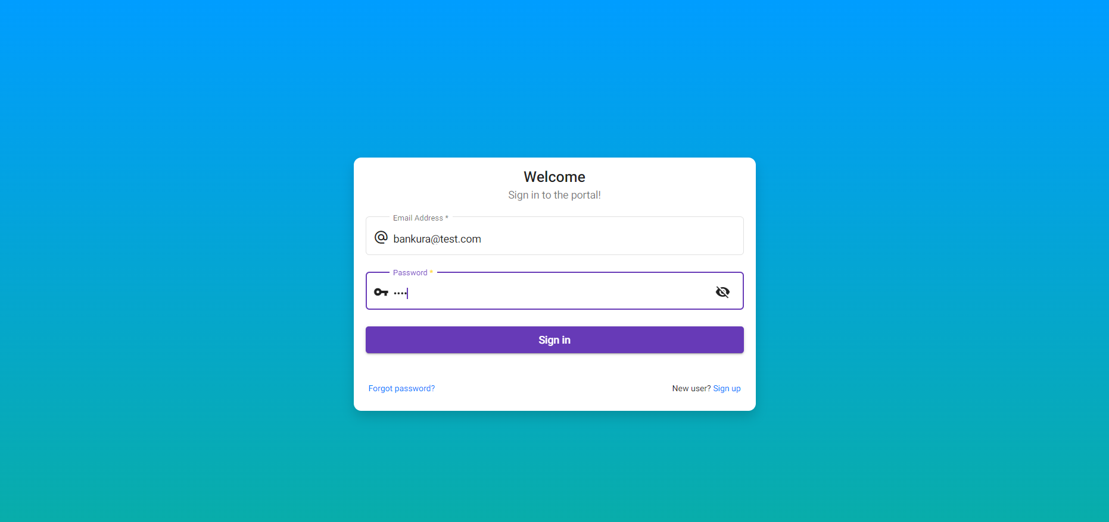

## User clicks on the login button

Scenario actual result:

