NAME: OYESUNLE OLAMILEKAN

MATRIC: 20203181  
  
**EXAM ANSWERS**

**5a)v**

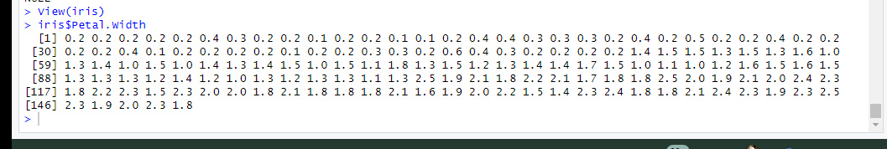

**5a)vi**

5B (VII) AND (viii)

