I-SHOOT MO, I-SHOOT MO
COMPLETE CONSTRUCTION AND PROGRAMMING MANUAL
Approved IoT Carnival Game Project
ESP32 Four Target Version
Prepared for the IoT Final Project and Intelligent Systems Integration

Group Members: __________________________________________________
Course and Section: __________________________________________________
Instructor: __________________________________________________
Date: __________________________________________________
Revision 1.0

DOCUMENT PURPOSE
This manual gives the group a complete path from purchasing parts to presenting a working four-target game. It covers the mechanical target, safe ESP32 wiring, firmware, calibration, testing, operation, troubleshooting, and preparation for later Intelligent Systems software. Build and test one target first, then repeat the proven circuit for the other three targets.

PROJECT SCOPE
- A player throws lightweight foam balls at four impact plates.
- The ESP32 lights one random target at a time for a limited target window.
- A correct hit scores 10 points; wrong hits and missed targets are recorded.
- A 30-second round shows time and score on an OLED display and uses a buzzer for feedback.
- Serial game records prepare the project for a future leaderboard, player profile, and performance analysis application.

IMPORTANT SAFETY LIMITS
- Use only soft foam balls. Do not use marbles, stones, metal balls, or hard plastic balls.
- Disconnect power before changing wiring or soldering.
- Never connect 5 V directly to an ESP32 GPIO pin. GPIO signals are 3.3 V logic.
- Cover solder joints, sharp fasteners, and exposed wire ends before public use.
- Use a regulated 5 V supply. Do not build or modify mains-voltage wiring.

TABLE OF CONTENTS
DOCUMENT PURPOSE 2
TABLE OF CONTENTS 3
1 PROJECT OVERVIEW 4
2 GAME RULES AND SETTINGS 5
3 COMPONENTS AND BUYING GUIDE 6
4 ELECTRICAL DESIGN 8
5 WIRING THE PROTOTYPE 10
6 BUILDING THE TARGET MECHANISM 13
7 MOVING FROM BREADBOARD TO PERFBOARD 15
8 SOFTWARE SETUP 16
9 COMPLETE ESP32 PROGRAM 17
10 UPLOAD AND FIRST RUN 22
11 CALIBRATION AND TESTING 23
12 TROUBLESHOOTING 24
13 ONE MONTH BUILD SCHEDULE 25
14 INTELLIGENT SYSTEMS READINESS 26
15 OPERATION AND MAINTENANCE 27
16 FINAL READINESS CHECKLIST 28

1 PROJECT OVERVIEW

Game Concept
I-Shoot Mo, I-Shoot Mo is a sensor-based carnival throwing game. Four target plates are mounted on a decorated backboard. When one target lights, the player throws a foam ball at that plate. The plate presses a protected microswitch, allowing the ESP32 to validate the hit, calculate the reaction time, update the score, and select another target.

Expected Demonstration
- The game completes a power-on light and buzzer test.
- The START button begins a three-second countdown and a 30-second round.
- Only the illuminated target earns points.
- The OLED shows the remaining time, active target, score, correct hits, wrong hits, and misses.
- The target time becomes shorter after every five correct hits, down to 650 milliseconds.
- The final screen shows the score and performance summary.
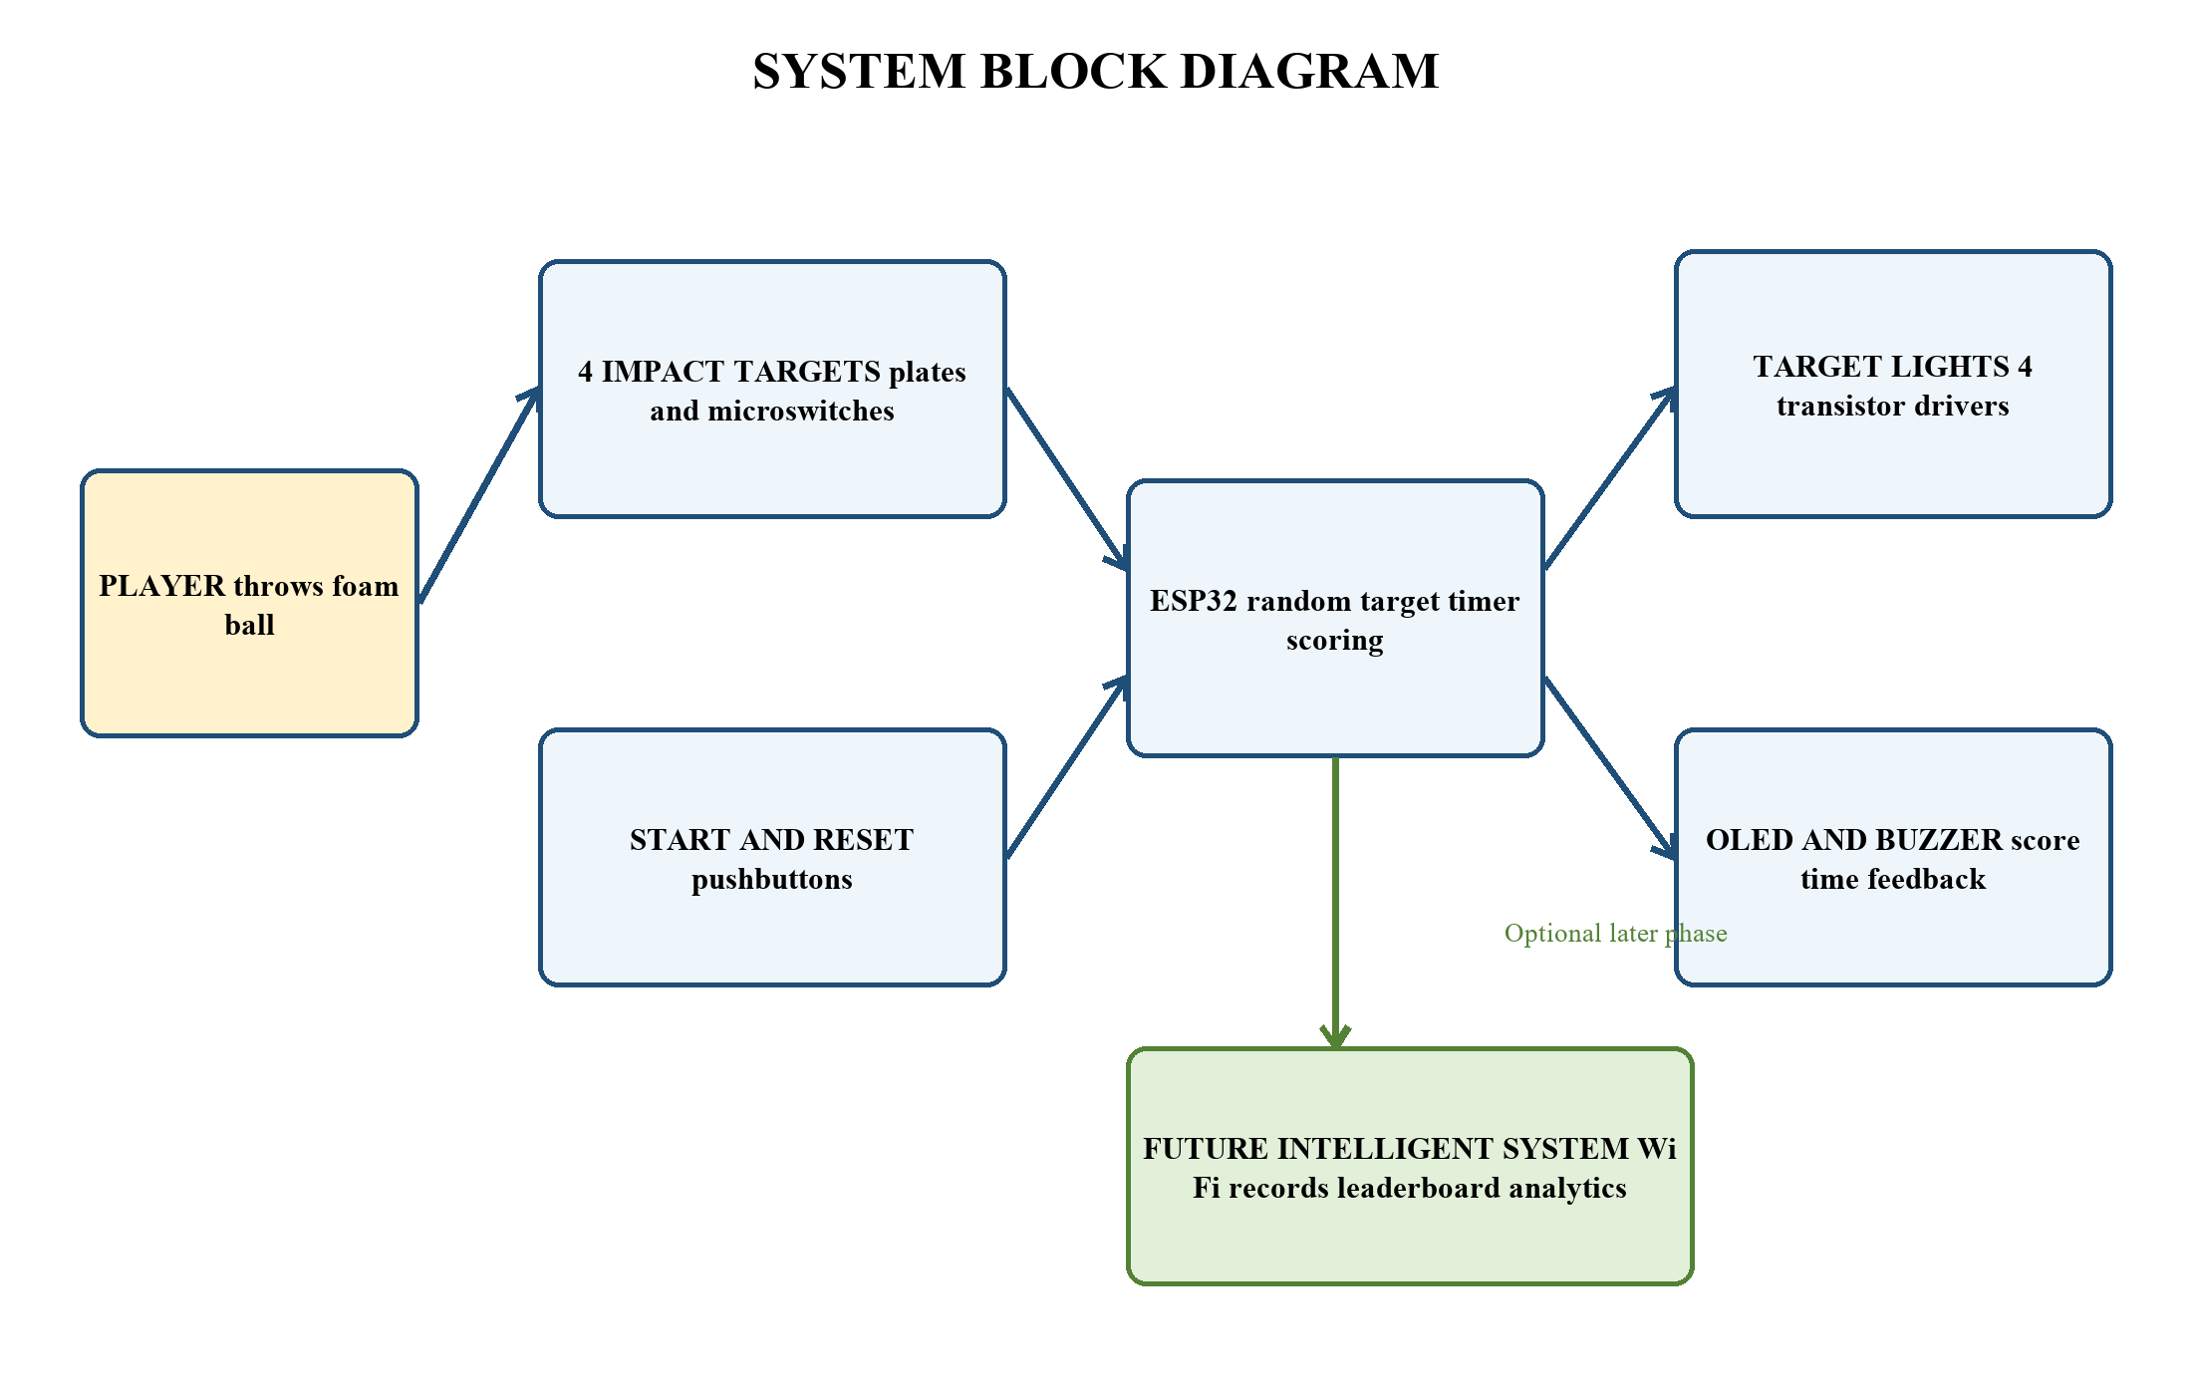
Figure 1. System block diagram for the complete project

Success Criteria
Test Area | Acceptance Check
Target detection | At least 19 of 20 firm test presses register on each target.
False triggers | No false hit occurs during a two-minute idle test and normal table vibration.
Lighting | Only one target light is active during normal play.
Game timing | A round lasts 30 seconds within normal human-observable tolerance.
Public safety | Only foam balls are used, and all electronics and sharp parts are covered.
Data output | The Serial Monitor prints start, target, hit, wrong, miss, and end records.

2 GAME RULES AND SETTINGS

Default Rules
1. The operator retrieves the balls and confirms that all target plates move freely.
2. The player stands behind the marked throwing line and presses START.
3. After the three-second countdown, one target lights.
4. A correct hit adds 10 points and immediately activates the next target.
5. A wrong target records an error but does not subtract points.
6. A target that is not hit within its time window records a miss.
7. The round ends after 30 seconds. The OLED shows the final result.

Settings That Can Be Changed
Code Setting | Default | Meaning
ROUND_MS | 30000 | Total round time in milliseconds
START_WINDOW_MS | 1500 | Initial time allowed for one target
MIN_WINDOW_MS | 650 | Fastest target window
WINDOW_STEP_MS | 100 | Reduction after every five correct hits
DEBOUNCE_MS | 45 | Switch bounce filter
Score line | score += 10 | Points given for a correct hit
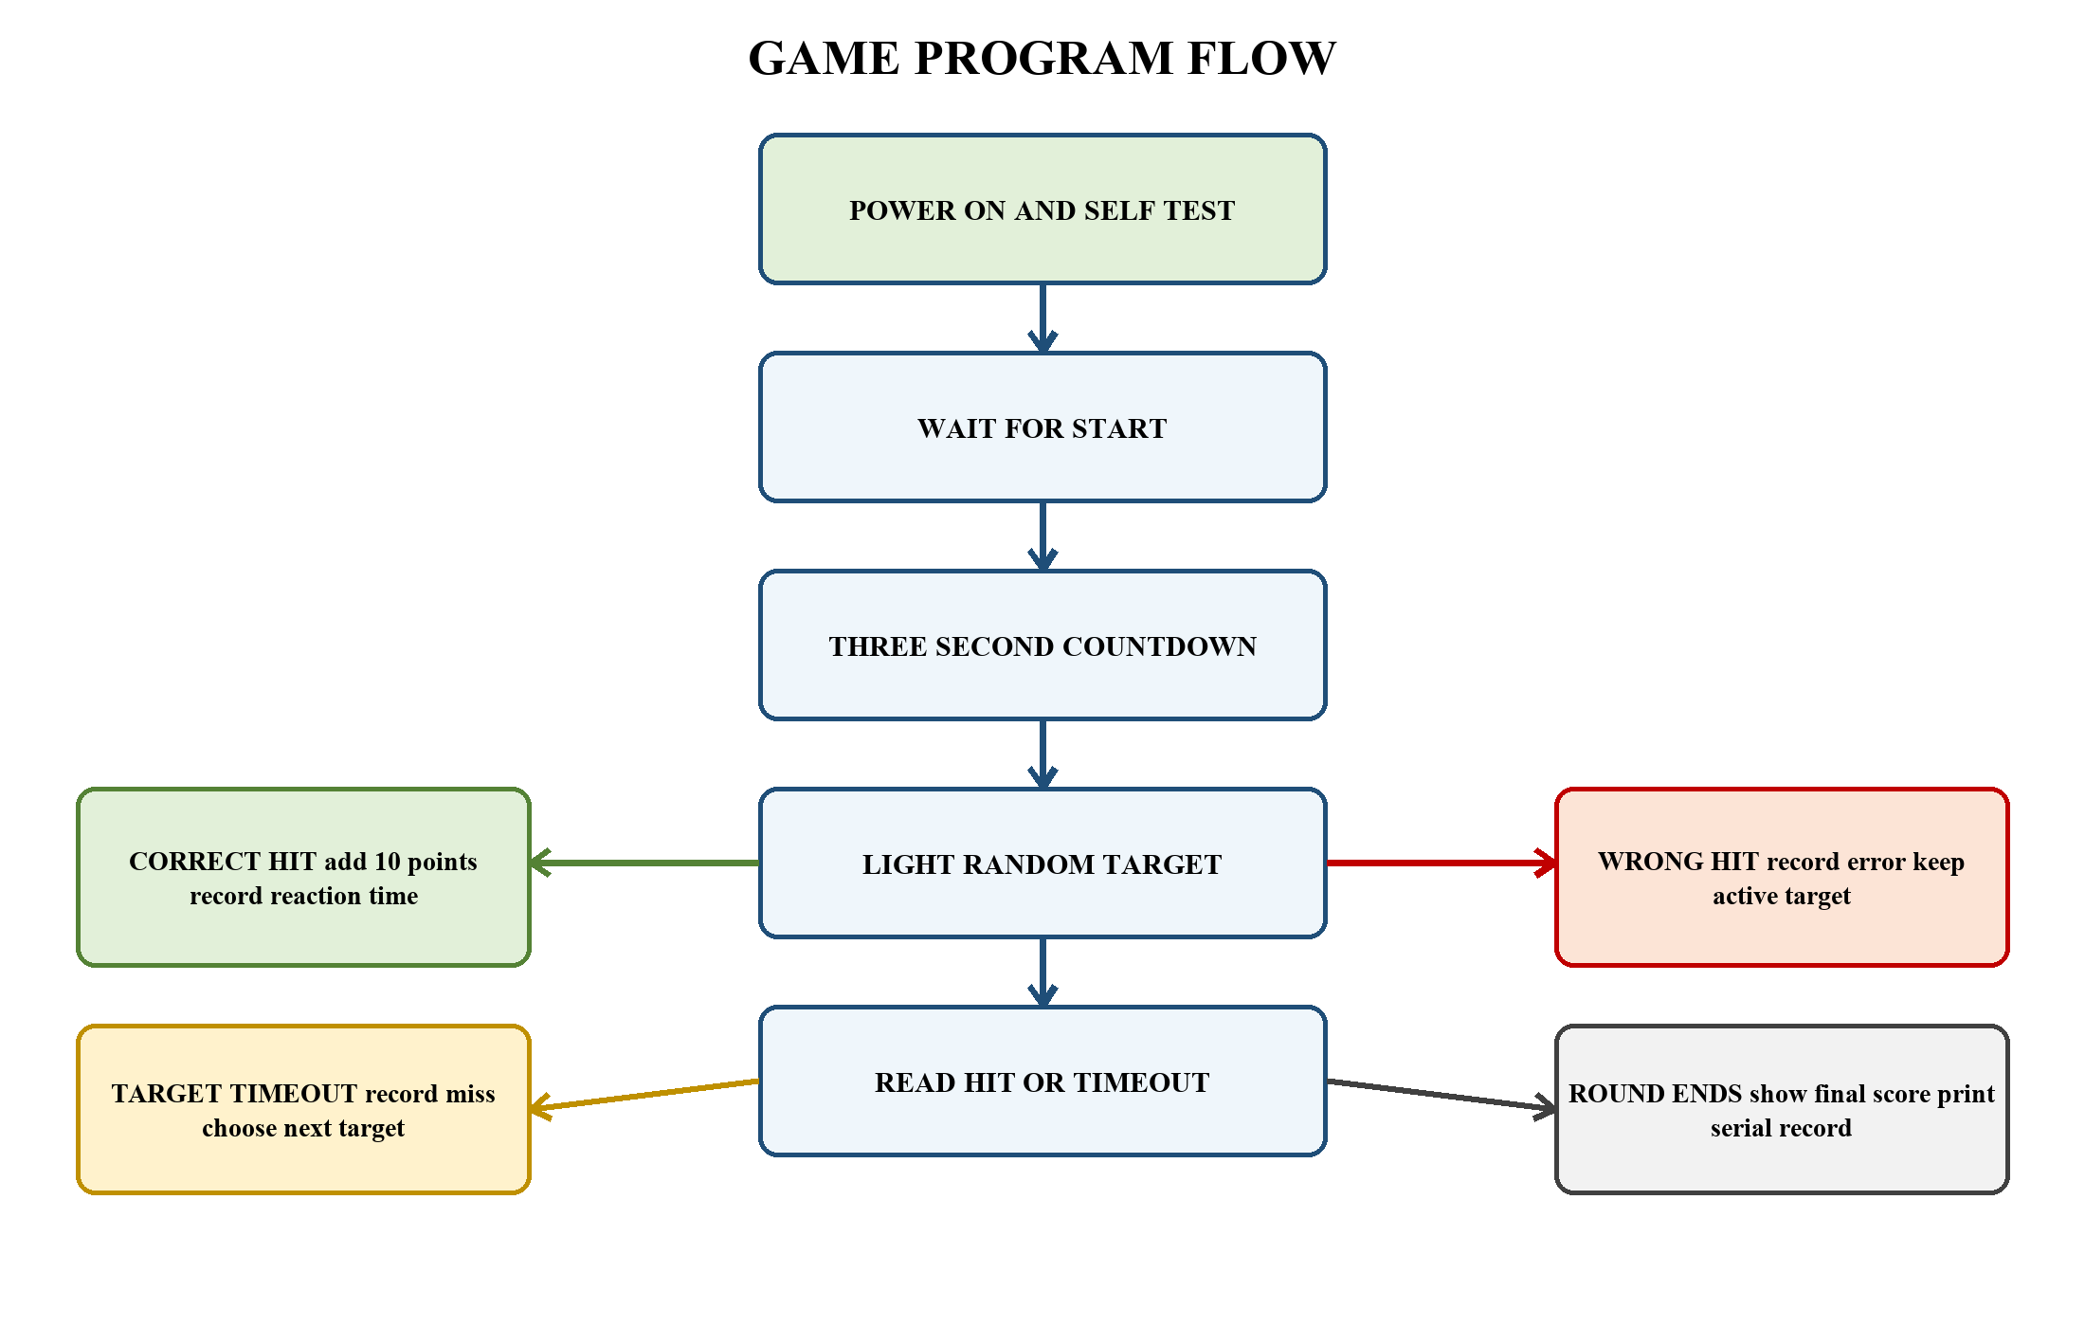
Figure 2. Program flow from power-on to final score

3 COMPONENTS AND BUYING GUIDE
The prices below are planning ranges in Philippine pesos, not fixed quotations. Online prices, shipping fees, seller ratings, and stock change frequently. Each link opens a Shopee Philippines search page so the group can compare current listings. Check the exact voltage, pin type, dimensions, and seller reviews before purchasing.
Component and Specification | Qty | Estimated Cost | Purpose | Shopee
ESP32 DevKit V1, ESP32-WROOM-32 | 1 | PHP 250–400 | Main controller | Open
0.96-inch SSD1306 OLED, I2C, 128×64 | 1 | PHP 100–180 | Score and timer display | Open
KW11 or similar lever microswitch | 6 | PHP 60–150 | Impact detection plus spares | Open
5 mm high-brightness LEDs, assorted | 12 | PHP 30–100 | Target indicators | Open
2N2222 NPN transistor | 6 | PHP 20–60 | LED switching plus spares | Open
220 ohm resistor, 0.25 W | 15 | PHP 20–50 | One per LED | Open
1 kohm resistor, 0.25 W | 6 | PHP 20–50 | Transistor base limit | Open
10 kohm resistor, 0.25 W | 6 | PHP 20–50 | Base pulldown | Open
Three-pin active buzzer module | 1 | PHP 25–70 | Sound feedback | Open
Momentary pushbuttons for START and RESET | 2 | PHP 20–60 | Player controls | Open
Full-size breadboard | 1 | PHP 80–150 | Temporary prototype | Open
Male-to-male and male-to-female jumpers | 1 set | PHP 80–150 | Prototype connections | Open
Large perfboard or universal PCB | 1–2 | PHP 50–170 | Final soldered circuit | Open
Screw terminals, headers, and connectors | 1 set | PHP 80–180 | Removable wiring | Open
Regulated 5 V 2 A adapter | 1 | PHP 150–300 | Power source | Open
ESP32 USB data cable | 1 | PHP 50–100 | Programming and power | Open
470 uF capacitor and 100 nF capacitors | 1 set | PHP 30–80 | Power filtering | Open
22 AWG stranded hookup wire | 5 m | PHP 80–150 | Long target wiring | Open
Soft foam balls, 5–7 cm diameter | 6–10 | PHP 100–250 | Safe throwing pieces | Open
Thin plywood or plastic for impact plates | 1 sheet | PHP 100–250 | Moving target plates | Open
Plywood for backboard and base | 1 set | PHP 200–450 | Main structure | Open
Cardboard or foam board for decoration | 1 set | PHP 100–250 | Carnival finish | Open
Foam pads, hinges or nylon straps | 1 set | PHP 80–200 | Plate return mechanism | Open
Screws, glue, tape, paint, and cable ties | 1 set | PHP 250–500 | Assembly and finish | Open

Estimated Budget
The listed planning ranges total PHP 1,995 to PHP 4,350 before shipping. A practical group budget is PHP 3,200, including small replacement parts. The total can be lower when the group already owns an ESP32, breadboard, jumper wires, tools, paint, plywood scraps, or a suitable 5 V adapter.

Tools Not Included in the Budget
- Soldering iron, solder, stand, and a damp cleaning sponge
- Digital multimeter
- Wire stripper, side cutter, long-nose pliers, and screwdriver set
- Hand drill, small drill bits, craft knife, ruler, pencil, and cutting mat
- Hot-glue gun, clamps, sandpaper, and paintbrushes

4 ELECTRICAL DESIGN

Pin Assignment
Function | ESP32 Pin | Mode | Connection
Target 1 switch | GPIO 32 | INPUT_PULLUP | NO switch terminal to GPIO; COM to GND
Target 2 switch | GPIO 33 | INPUT_PULLUP | NO switch terminal to GPIO; COM to GND
Target 3 switch | GPIO 25 | INPUT_PULLUP | NO switch terminal to GPIO; COM to GND
Target 4 switch | GPIO 26 | INPUT_PULLUP | NO switch terminal to GPIO; COM to GND
Target 1 light | GPIO 16 | OUTPUT | Through 1 kohm resistor to 2N2222 base
Target 2 light | GPIO 17 | OUTPUT | Through 1 kohm resistor to 2N2222 base
Target 3 light | GPIO 18 | OUTPUT | Through 1 kohm resistor to 2N2222 base
Target 4 light | GPIO 19 | OUTPUT | Through 1 kohm resistor to 2N2222 base
START button | GPIO 14 | INPUT_PULLUP | Button to GND
GAME RESET button | GPIO 13 | INPUT_PULLUP | Button to GND
OLED SDA | GPIO 21 | I2C data | OLED powered from 3.3 V
OLED SCL | GPIO 22 | I2C clock | OLED powered from 3.3 V
Buzzer module IN | GPIO 27 | OUTPUT | Module VCC per its label; common GND
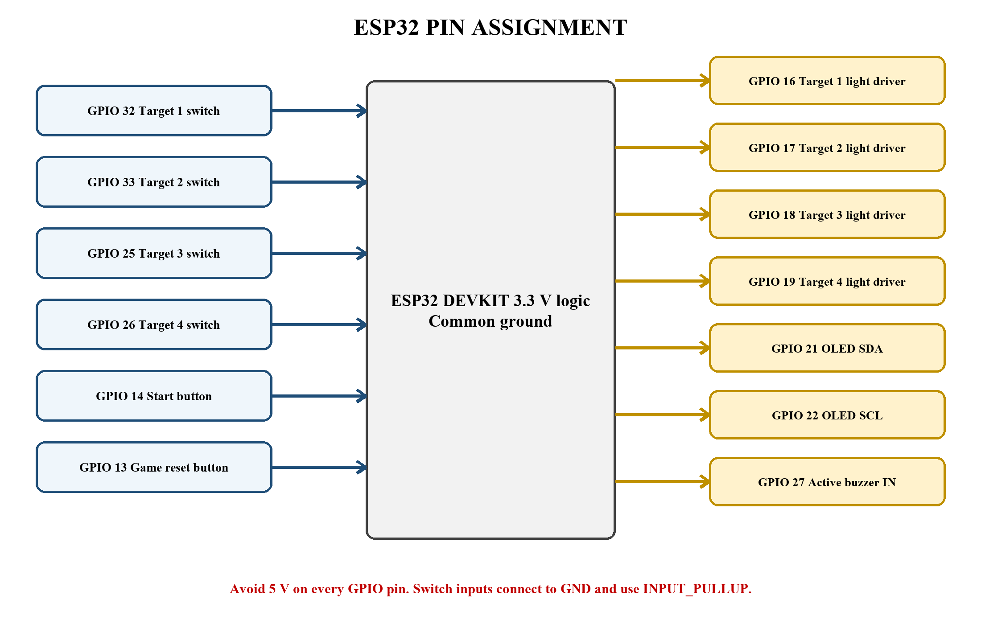
Figure 3. ESP32 pin assignment used by the supplied program

Power Plan
- Use one regulated 5 V 2 A adapter for the completed game.
- Connect 5 V to the ESP32 VIN or 5V pin only when the board is not also receiving power from another source. During programming, the safest method is to power the ESP32 from USB and keep the external lighting supply disconnected.
- Power the OLED from the ESP32 3.3 V pin.
- Power the LED anodes from the 5 V rail through individual 220 ohm resistors.
- Connect the ESP32 GND, 5 V supply negative, transistor emitters, switch returns, OLED GND, and buzzer GND to one common ground.
- Place a 470 uF capacitor across 5 V and GND near the LED drivers. Observe capacitor polarity.

5 WIRING THE PROTOTYPE

Build Order
1. Keep all power disconnected. Place the ESP32 across the breadboard center gap.
2. Connect the breadboard ground rail to an ESP32 GND pin.
3. Wire the OLED to 3.3 V, GND, GPIO 21, and GPIO 22.
4. Wire START between GPIO 14 and GND. Wire GAME RESET between GPIO 13 and GND.
5. Wire one microswitch first: COM to GND and NO to GPIO 32. Leave the NC terminal unused.
6. Build one transistor LED driver using GPIO 16. Confirm the transistor pin order from the exact seller datasheet because 2N2222 packages do not all use the same physical arrangement.
7. Upload the program and test Target 1. Repeat the proven switch and light circuits for Targets 2 through 4.
8. Add the active buzzer module: IN to GPIO 27, GND to common GND, and VCC according to the module marking.
9. Test the complete game on the breadboard before cutting the enclosure or soldering the perfboard.

Target Switch Wiring
Each switch input uses the ESP32 internal pull-up resistor. An unpressed switch reads HIGH. Pressing the plate closes the NO contact to ground, so the input reads LOW. This arrangement needs no external input resistor and reduces loose-wire false readings.
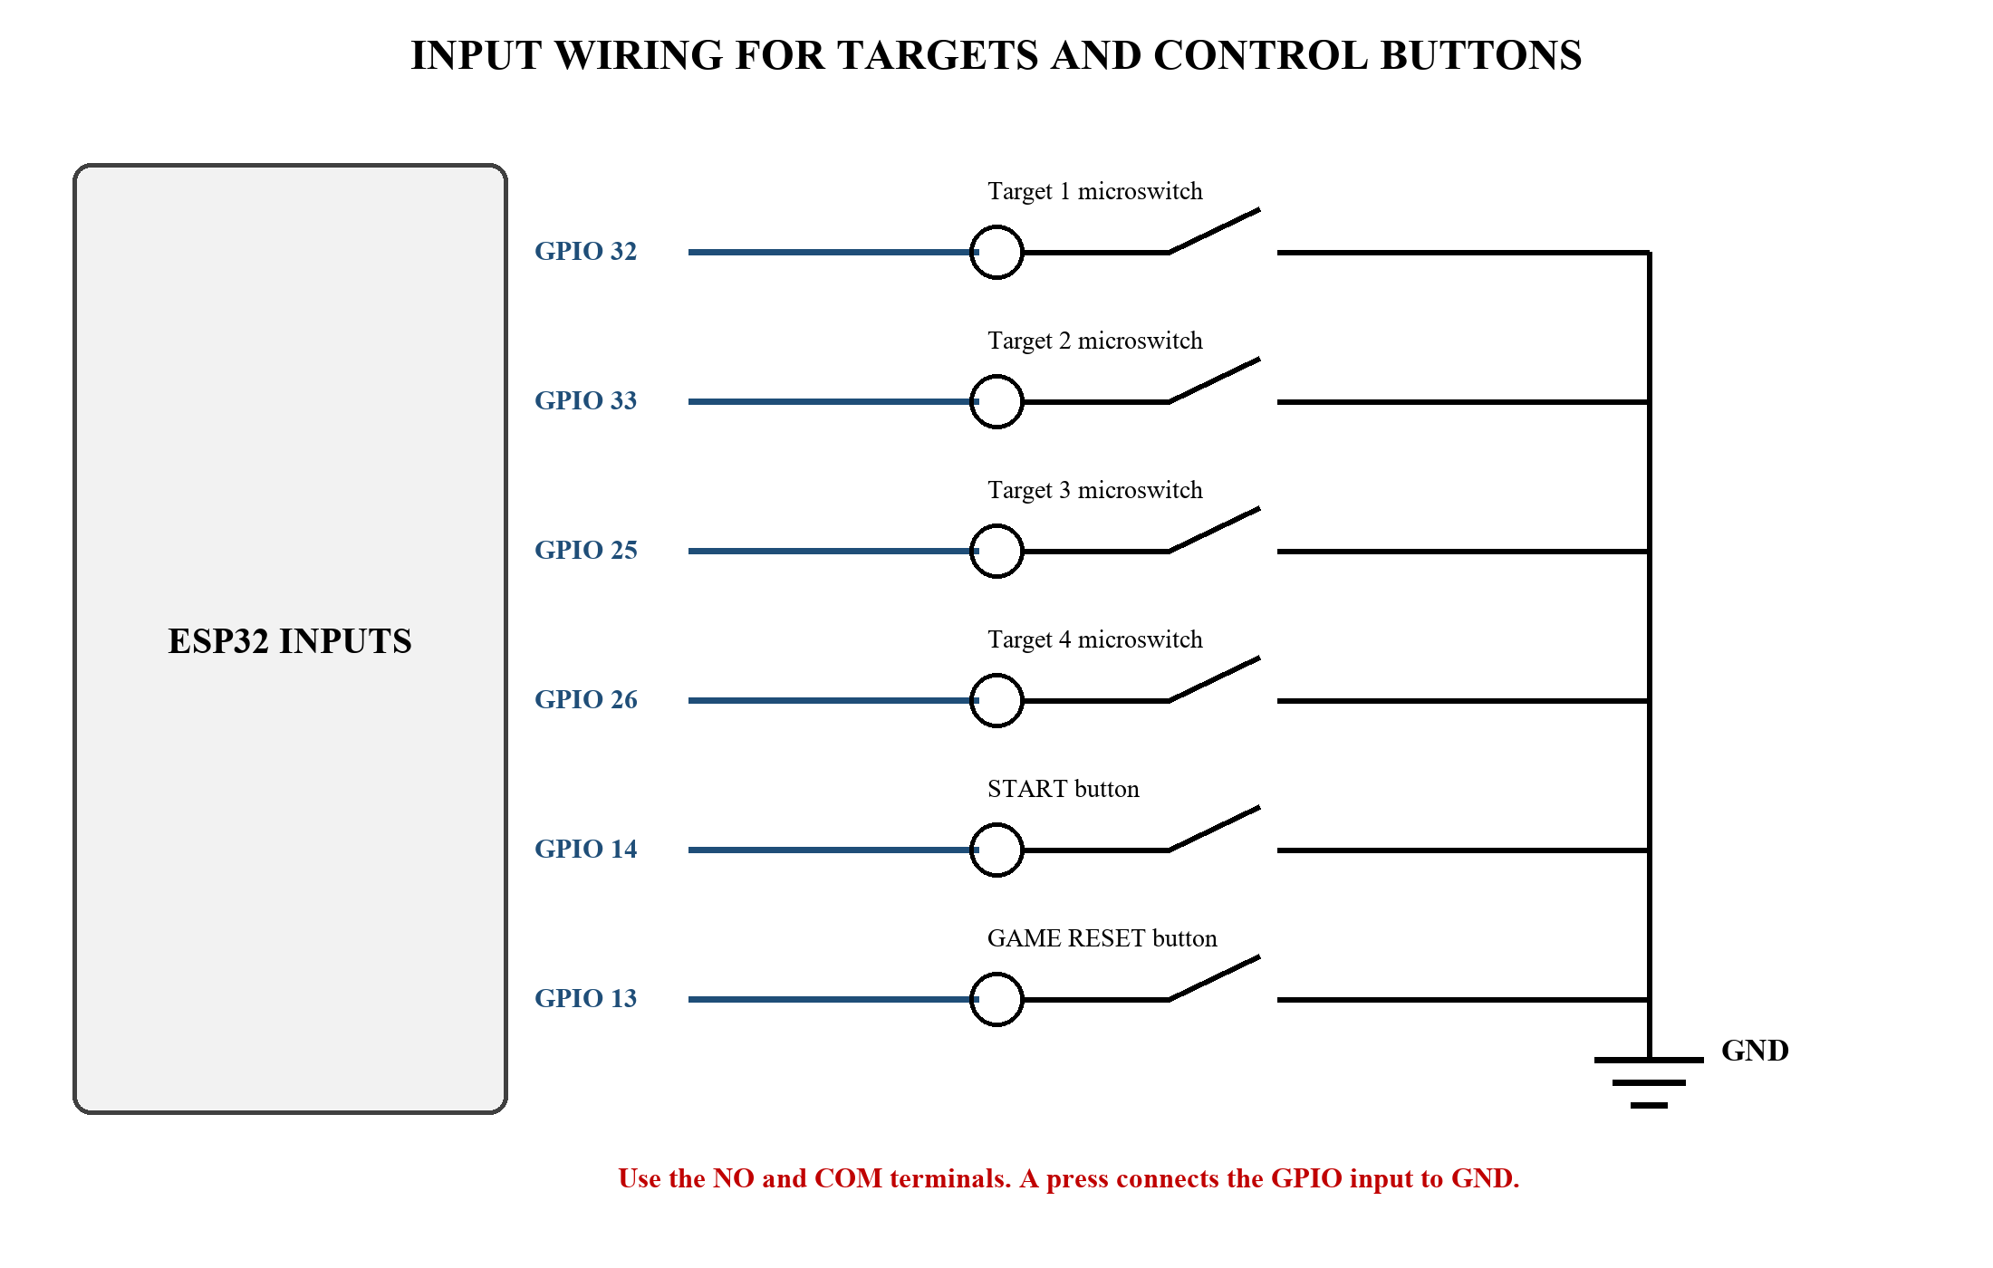
Figure 4. Microswitch and control-button input wiring

Target Light Driver
Each target uses three LEDs. Give every LED its own 220 ohm resistor. The three LED branches share one 2N2222 transistor, which acts as a low-side switch. The ESP32 drives the transistor base through a 1 kohm resistor, and a 10 kohm pulldown keeps the light off while the controller starts.
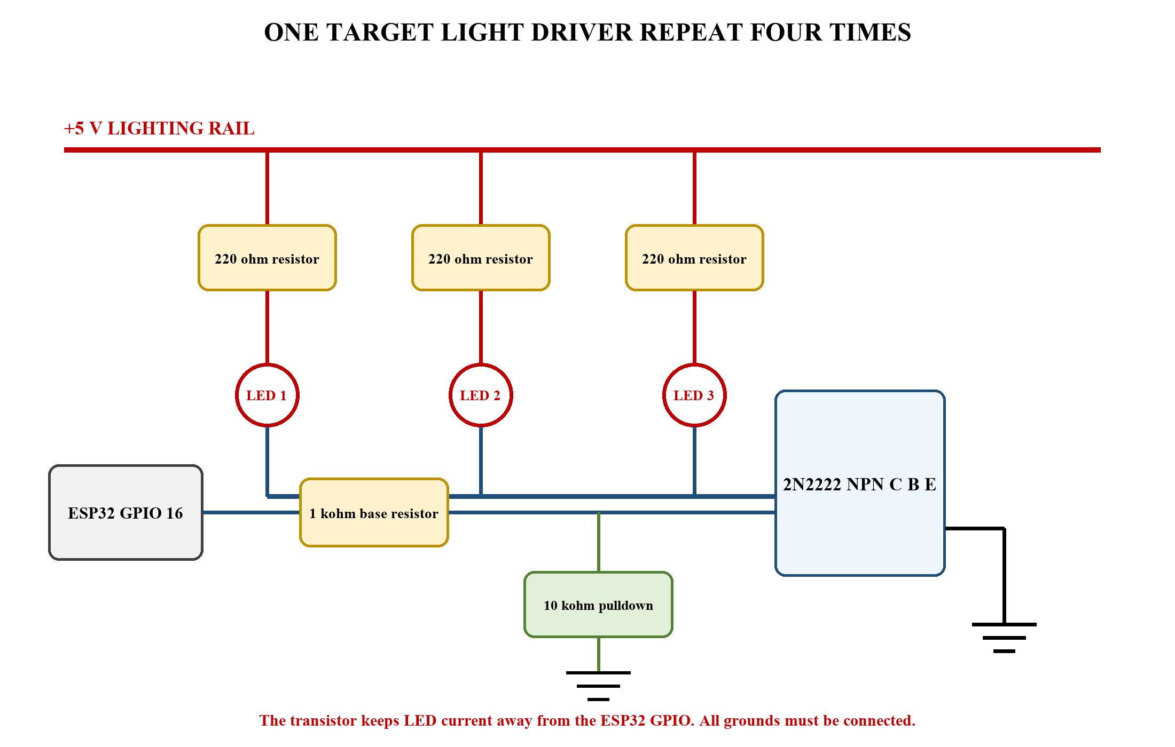
Figure 5. One target light driver repeated for Targets 1 through 4

OLED Buzzer and Supply
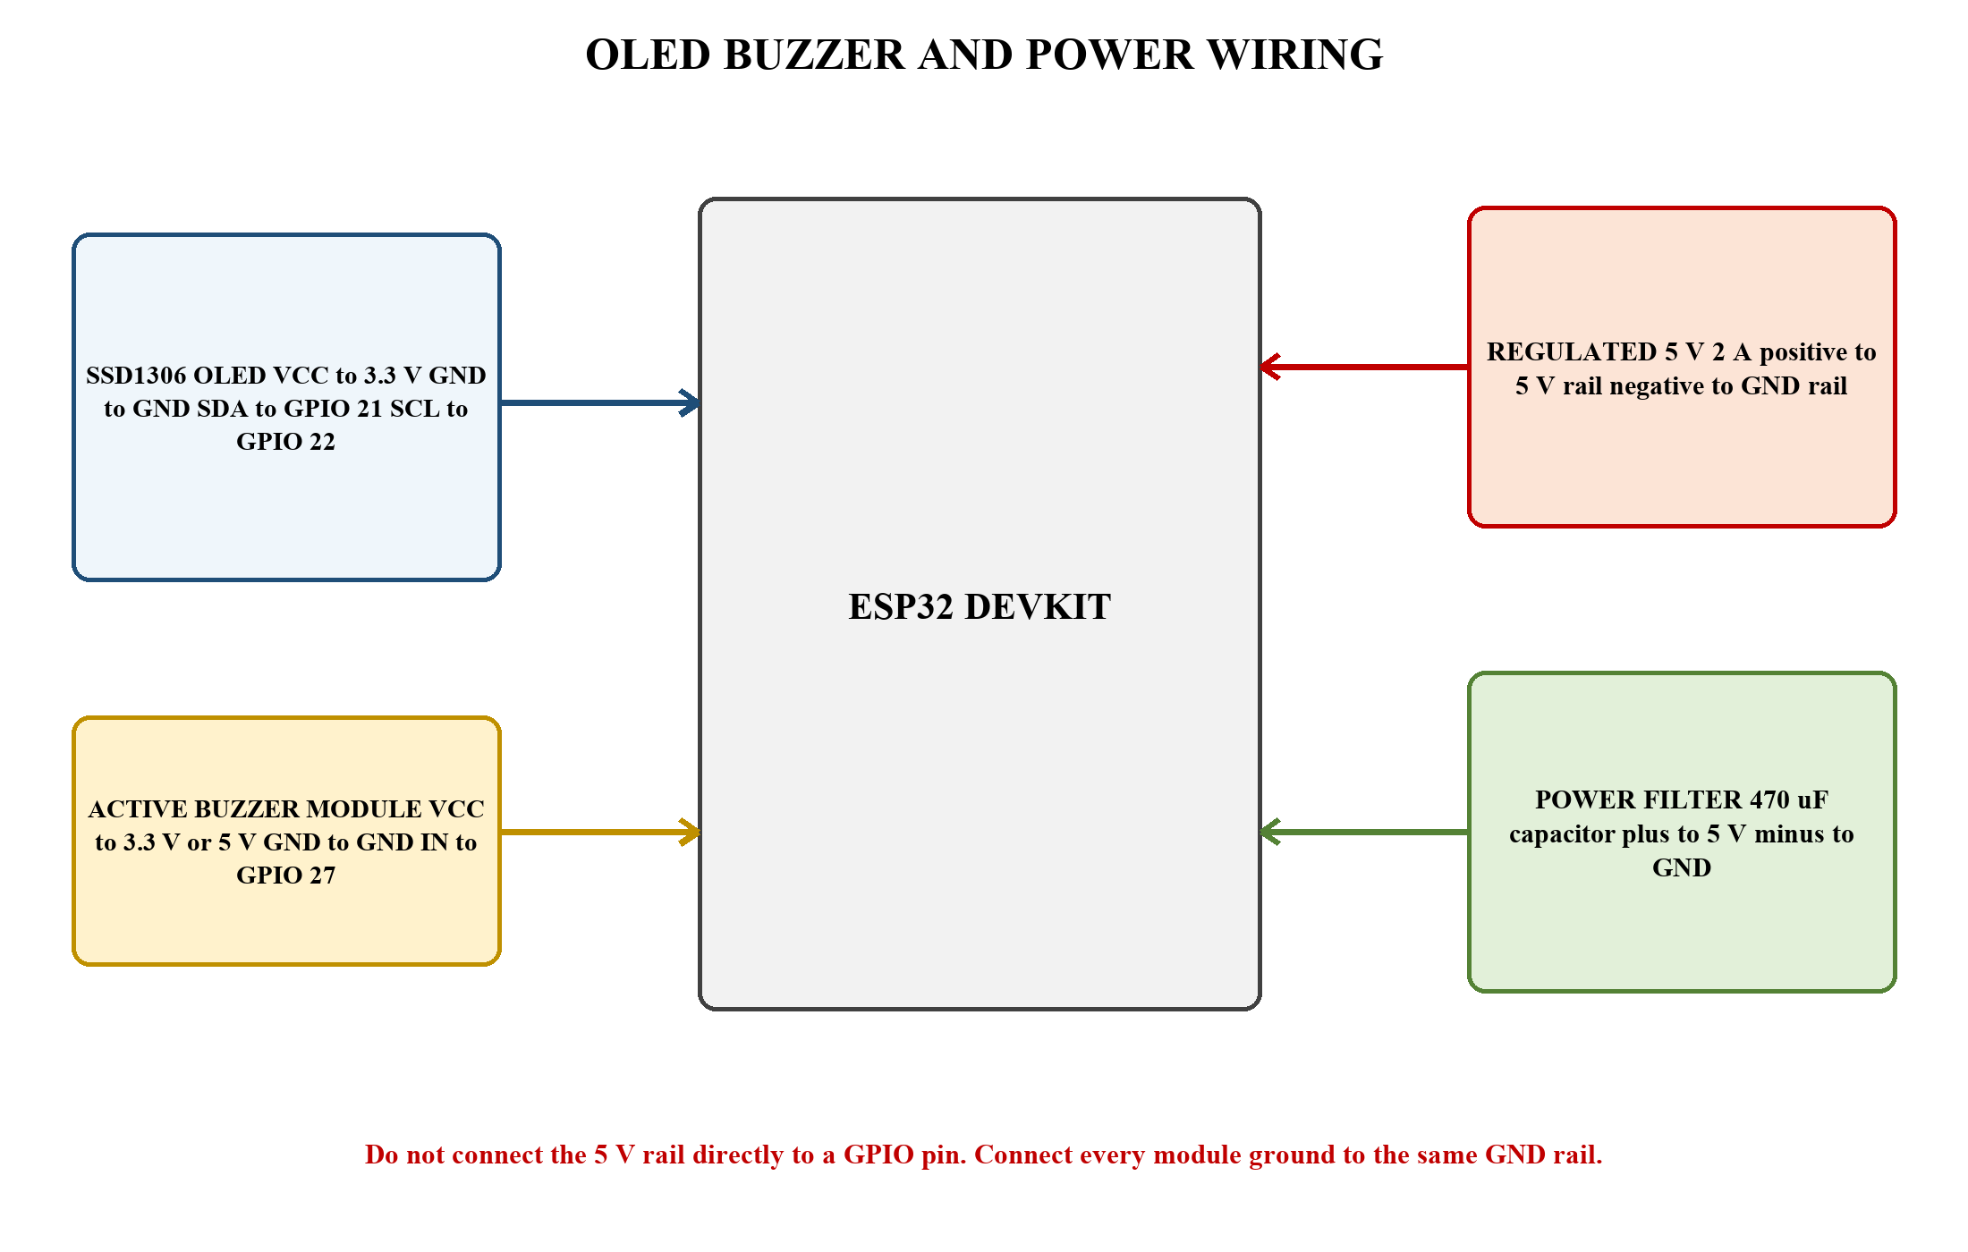
Figure 6. OLED, buzzer, power supply, and common-ground connections

Prepower Inspection
- No 5 V wire reaches GPIO 13, 14, 16, 17, 18, 19, 21, 22, 25, 26, 27, 32, or 33.
- Each LED has its own 220 ohm series resistor.
- Every transistor emitter reaches GND, and its collector reaches the LED cathode bus.
- The electrolytic capacitor negative stripe reaches GND.
- The multimeter shows no direct short between 5 V and GND.
- All long wires have labels on both ends.

6 BUILDING THE TARGET MECHANISM

Recommended Dimensions
- Backboard: about 120 cm wide by 90 cm high
- Impact plate: 15 to 20 cm across
- Space between target centers: at least 35 cm
- Plate movement before switch activation: about 3 to 8 mm
- Throwing line: begin testing at 1.5 m and adjust for the audience
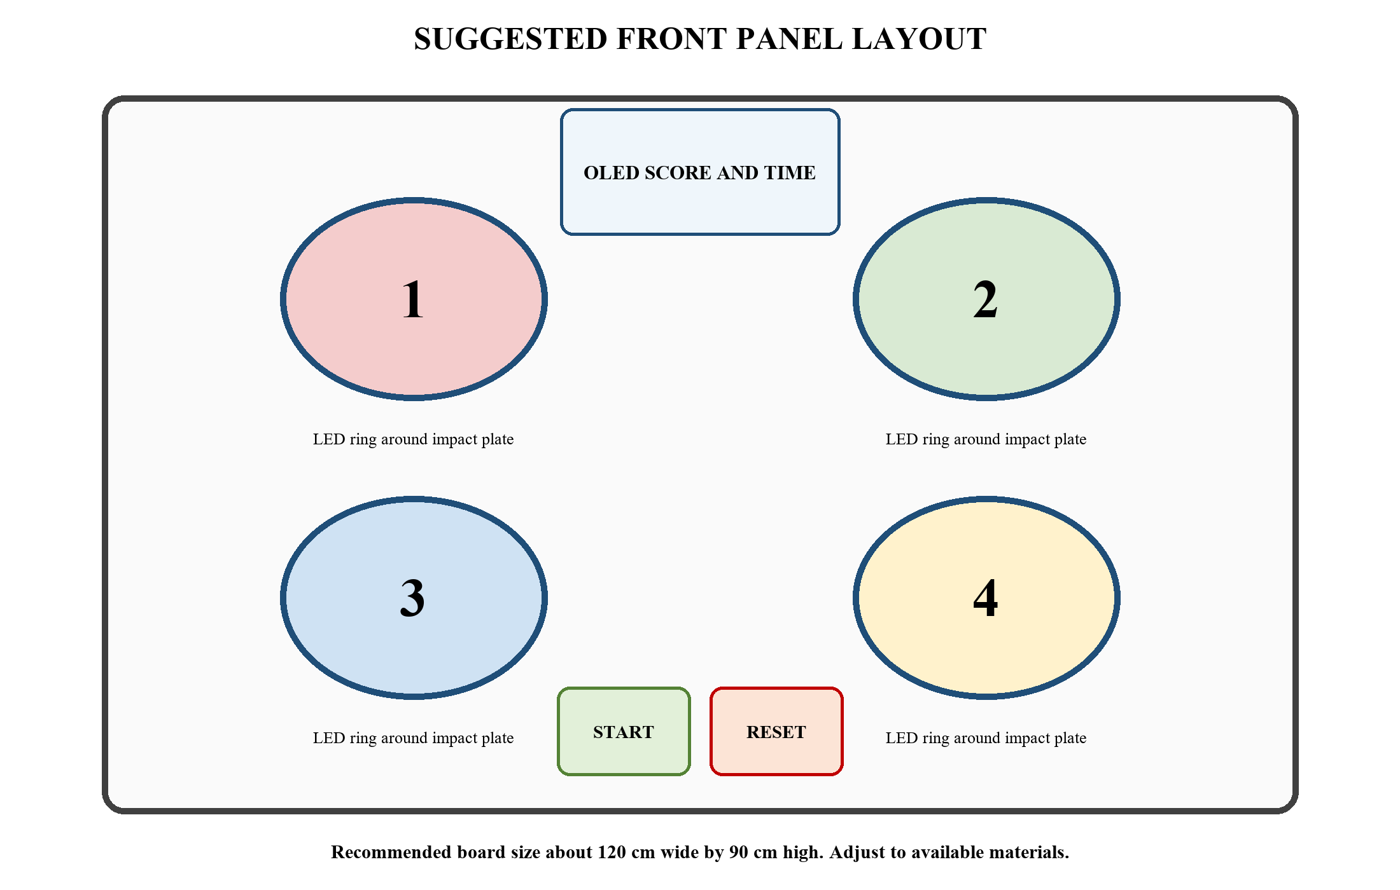
Figure 7. Suggested four-target front panel and control layout

One Target Assembly
1. Cut a round or rounded impact plate from 3 to 6 mm plywood or durable plastic. Sand every edge.
2. Attach the top of the plate to the backboard with a small hinge, nylon strap, or flexible plastic strip.
3. Place soft foam spacers behind the left and right edges. The plate should return to its original position after a hit.
4. Mount the lever microswitch behind the plate. Adjust its position so a firm plate movement causes one clear click.
5. Add a physical stop so a hard throw cannot crush the microswitch body.
6. Install the three LEDs around the plate or behind a translucent ring. Keep LED legs and wires behind the front surface.
7. Press the plate at the center and near each edge. Reposition the switch or add a thin pressure pad until all normal hits register.
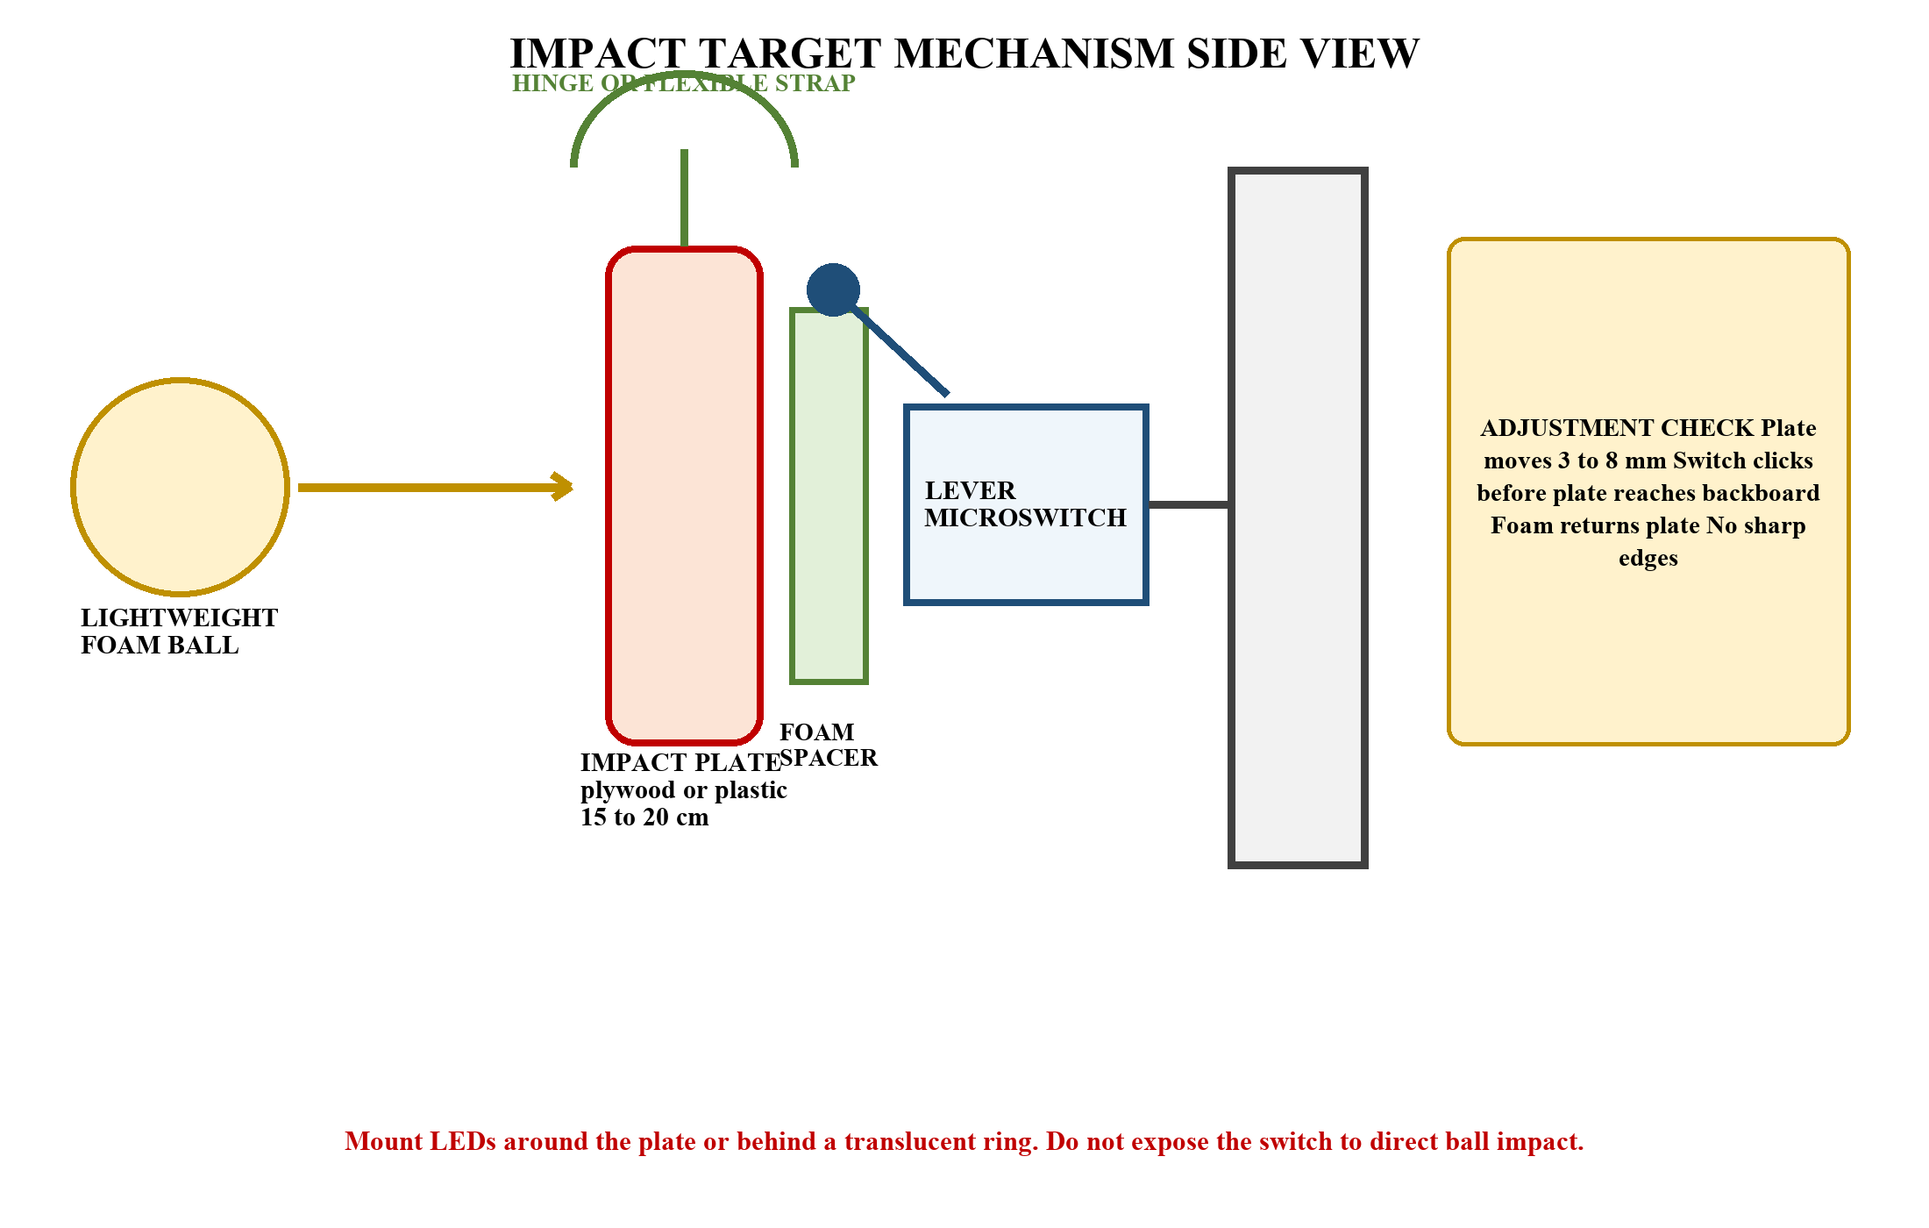
Figure 8. Protected target mechanism with adjustable switch position

Enclosure and Finish
- Mount the electronics in a rear box with ventilation and a removable service cover.
- Secure the ESP32 and perfboard with standoffs rather than loose tape.
- Route signal wires separately from moving target parts.
- Add strain relief where the power cable enters the enclosure.
- Use carnival colors and large target numbers, but keep the OLED and START button easy to see.
- Place a ball-return tray or fabric catch area below the targets when space permits.

7 MOVING FROM BREADBOARD TO PERFBOARD

Recommended Board Sections
- Section A contains screw terminals for 5 V and GND.
- Section B contains four 2N2222 transistors and their 1 kohm and 10 kohm resistors.
- Section C contains removable connectors for the target LEDs and switches.
- Section D contains OLED, buzzer, START, RESET, and ESP32 header connections.

Soldering Procedure
1. Photograph the working breadboard and mark every wire by function.
2. Draw the perfboard plan on paper. Confirm component orientation and connector labels.
3. Solder the power rails first. Test continuity and confirm that 5 V is not shorted to GND.
4. Solder one transistor driver and test it with its target before adding the remaining three.
5. Use sockets or female headers for the ESP32 so it can be removed.
6. Use screw terminals or locking connectors for wires that travel to the moving targets.
7. Trim lead ends, clean the board, inspect for solder bridges, and cover the bottom with insulated standoffs.

Wire Labels
Label | Meaning
T1-SW | Target 1 switch to GPIO 32
T2-SW | Target 2 switch to GPIO 33
T3-SW | Target 3 switch to GPIO 25
T4-SW | Target 4 switch to GPIO 26
T1-L | Target 1 light from Driver 1
T2-L | Target 2 light from Driver 2
T3-L | Target 3 light from Driver 3
T4-L | Target 4 light from Driver 4

8 SOFTWARE SETUP

Arduino IDE Preparation
1. Install Arduino IDE 2.x on the group laptop.
2. Open File, Preferences and add the official Espressif ESP32 board-manager URL if ESP32 support is not installed.
3. Open Boards Manager, search for esp32 by Espressif Systems, and install the package.
4. Open Library Manager and install Adafruit GFX Library and Adafruit SSD1306.
5. Connect the ESP32 with a USB data cable. Select the detected port and the matching ESP32 Dev Module board.
6. Create a sketch named I_Shoot_Mo and replace its contents with the complete program in Section 9.

Library and Board References
- Arduino ESP32 documentation
- ESP32 GPIO reference
- ESP32 I2C reference
- Adafruit SSD1306 library
- Adafruit GFX library

Before Uploading
- Disconnect the external 5 V lighting supply while the ESP32 is connected to the computer by USB.
- Confirm that the OLED address is 0x3C. If the display stays blank, run an I2C scanner and check for 0x3D.
- Confirm that the active buzzer turns on with a HIGH input. If the module is active-low, reverse the two HIGH and LOW states inside the beep function.
- Confirm the 2N2222 emitter, base, and collector order for the exact package purchased.

9 COMPLETE ESP32 PROGRAM
Copy the following code into the Arduino IDE. The program is complete for the four-target wiring in this manual. It does not require Wi-Fi for the first showcase. It prints structured records at 115200 baud so the later Intelligent Systems application can capture game data.
#include <Arduino.h>
#include <Wire.h>
#include <Adafruit_GFX.h>
#include <Adafruit_SSD1306.h>

// I-Shoot Mo, I-Shoot Mo
// Four-target ESP32 carnival game

constexpr uint8_t SCREEN_WIDTH = 128;
constexpr uint8_t SCREEN_HEIGHT = 64;
constexpr int8_t OLED_RESET = -1;
constexpr uint8_t OLED_ADDRESS = 0x3C;

Adafruit_SSD1306 display(SCREEN_WIDTH, SCREEN_HEIGHT, &Wire, OLED_RESET);

constexpr uint8_t NUM_TARGETS = 4;
constexpr uint8_t SWITCH_PINS[NUM_TARGETS] = {32, 33, 25, 26};
constexpr uint8_t LIGHT_PINS[NUM_TARGETS] = {16, 17, 18, 19};
constexpr uint8_t START_PIN = 14;
constexpr uint8_t RESET_PIN = 13;
constexpr uint8_t BUZZER_PIN = 27;
constexpr uint8_t SDA_PIN = 21;
constexpr uint8_t SCL_PIN = 22;

constexpr unsigned long ROUND_MS = 30000;
constexpr unsigned long START_WINDOW_MS = 1500;
constexpr unsigned long MIN_WINDOW_MS = 650;
constexpr unsigned long WINDOW_STEP_MS = 100;
constexpr unsigned long DISPLAY_REFRESH_MS = 100;
constexpr unsigned long DEBOUNCE_MS = 45;

enum GameState { IDLE, PLAYING, RESULTS };
GameState state = IDLE;

struct DebouncedInput {
uint8_t pin;
bool rawState;
bool stableState;
unsigned long changedAt;
};

constexpr uint8_t NUM_INPUTS = NUM_TARGETS + 2;
DebouncedInput inputs[NUM_INPUTS];

int8_t activeTarget = -1;
int8_t previousTarget = -1;
unsigned long roundStartedAt = 0;
unsigned long targetStartedAt = 0;
unsigned long targetWindowMs = START_WINDOW_MS;
unsigned long lastDisplayAt = 0;

uint16_t score = 0;
uint16_t correctHits = 0;
uint16_t wrongHits = 0;
uint16_t misses = 0;
unsigned long totalReactionMs = 0;
unsigned long bestReactionMs = 0;

void allLightsOff() {
for (uint8_t i = 0; i < NUM_TARGETS; i++) {
digitalWrite(LIGHT_PINS[i], LOW);
}
}

void beep(uint16_t durationMs, uint8_t repeats = 1) {
for (uint8_t i = 0; i < repeats; i++) {
digitalWrite(BUZZER_PIN, HIGH);
delay(durationMs);
digitalWrite(BUZZER_PIN, LOW);
if (i + 1 < repeats) delay(60);
}
}

bool pressedEvent(uint8_t inputIndex) {
DebouncedInput &input = inputs[inputIndex];
bool raw = digitalRead(input.pin);
unsigned long now = millis();

if (raw != input.rawState) {
input.rawState = raw;
input.changedAt = now;
}

if ((now - input.changedAt >= DEBOUNCE_MS) &&
(input.stableState != input.rawState)) {
input.stableState = input.rawState;
return input.stableState == LOW;
}
return false;
}

void printCentered(const String &text, uint8_t size, int16_t y) {
int16_t x1, y1;
uint16_t width, height;
display.setTextSize(size);
display.getTextBounds(text, 0, y, &x1, &y1, &width, &height);
display.setCursor((SCREEN_WIDTH - width) / 2, y);
display.print(text);
}

void showIdle() {
display.clearDisplay();
display.setTextColor(SSD1306_WHITE);
printCentered("I-SHOOT MO", 2, 5);
printCentered("I-SHOOT MO", 2, 24);
printCentered("Press START", 1, 51);
display.display();
}

void showCountdown(uint8_t number) {
display.clearDisplay();
display.setTextColor(SSD1306_WHITE);
printCentered("GET READY", 2, 7);
printCentered(String(number), 4, 30);
display.display();
}

void showGame(unsigned long now) {
unsigned long elapsed = now - roundStartedAt;
unsigned long remaining = elapsed >= ROUND_MS ? 0 : ROUND_MS - elapsed;

display.clearDisplay();
display.setTextColor(SSD1306_WHITE);
display.setTextSize(1);
display.setCursor(0, 0);
display.print("Time: ");
display.print((remaining + 999) / 1000);
display.print(" s");
display.setCursor(72, 0);
display.print("Score:");
display.print(score);
display.setTextSize(2);
display.setCursor(0, 19);
display.print("TARGET ");
display.print(activeTarget + 1);
display.setTextSize(1);
display.setCursor(0, 46);
display.print("Hit:"); display.print(correctHits);
display.print(" Wrong:"); display.print(wrongHits);
display.setCursor(0, 57);
display.print("Miss:"); display.print(misses);
display.print(" Win:"); display.print(targetWindowMs);
display.display();
}

void showResults() {
unsigned long average = correctHits ? totalReactionMs / correctHits : 0;
display.clearDisplay();
display.setTextColor(SSD1306_WHITE);
display.setTextSize(1);
display.setCursor(0, 0); display.print("ROUND COMPLETE");
display.setTextSize(2);
display.setCursor(0, 14); display.print("SCORE "); display.print(score);
display.setTextSize(1);
display.setCursor(0, 37); display.print("Hit:"); display.print(correctHits);
display.print(" Wrong:"); display.print(wrongHits);
display.setCursor(0, 48); display.print("Miss:"); display.print(misses);
display.print(" Avg:"); display.print(average);
display.setCursor(0, 58); display.print("START to play again");
display.display();
}

void activateNextTarget() {
allLightsOff();
int8_t next;
do {
next = random(NUM_TARGETS);
} while (NUM_TARGETS > 1 && next == previousTarget);

previousTarget = next;
activeTarget = next;
targetStartedAt = millis();
digitalWrite(LIGHT_PINS[activeTarget], HIGH);

Serial.print("TARGET,");
Serial.print(targetStartedAt - roundStartedAt);
Serial.print(",");
Serial.println(activeTarget + 1);
}

void startRound() {
allLightsOff();
score = 0;
correctHits = 0;
wrongHits = 0;
misses = 0;
totalReactionMs = 0;
bestReactionMs = 0;
targetWindowMs = START_WINDOW_MS;
previousTarget = -1;

for (int8_t n = 3; n >= 1; n--) {
showCountdown(n);
beep(80);
delay(920);
}

roundStartedAt = millis();
state = PLAYING;
Serial.println("SESSION_START,30000");
activateNextTarget();
}

void endRound() {
allLightsOff();
state = RESULTS;
unsigned long average = correctHits ? totalReactionMs / correctHits : 0;
beep(120, 3);
showResults();

Serial.print("SESSION_END,");
Serial.print(score); Serial.print(",");
Serial.print(correctHits); Serial.print(",");
Serial.print(wrongHits); Serial.print(",");
Serial.print(misses); Serial.print(",");
Serial.print(average); Serial.print(",");
Serial.println(bestReactionMs);
}

void resetToIdle() {
allLightsOff();
digitalWrite(BUZZER_PIN, LOW);
activeTarget = -1;
state = IDLE;
showIdle();
Serial.println("GAME_RESET");
}

void processPlaying(unsigned long now) {
if (now - roundStartedAt >= ROUND_MS) {
endRound();
return;
}

for (uint8_t i = 0; i < NUM_TARGETS; i++) {
if (!pressedEvent(i)) continue;

if (i == activeTarget) {
unsigned long reaction = now - targetStartedAt;
correctHits++;
score += 10;
totalReactionMs += reaction;
if (bestReactionMs == 0 || reaction < bestReactionMs) {
bestReactionMs = reaction;
}

Serial.print("HIT,");
Serial.print(now - roundStartedAt); Serial.print(",");
Serial.print(i + 1); Serial.print(",");
Serial.print(reaction); Serial.print(",");
Serial.println(score);

beep(55);
if (correctHits % 5 == 0 && targetWindowMs > MIN_WINDOW_MS) {
if (targetWindowMs > MIN_WINDOW_MS + WINDOW_STEP_MS) {
targetWindowMs -= WINDOW_STEP_MS;
} else {
targetWindowMs = MIN_WINDOW_MS;
}
}
activateNextTarget();
} else {
wrongHits++;
Serial.print("WRONG,");
Serial.print(now - roundStartedAt); Serial.print(",");
Serial.print(i + 1); Serial.print(",");
Serial.print(activeTarget + 1); Serial.print(",");
Serial.println(score);
beep(35, 2);
}
}

if (now - targetStartedAt >= targetWindowMs) {
misses++;
Serial.print("MISS,");
Serial.print(now - roundStartedAt); Serial.print(",");
Serial.print(activeTarget + 1); Serial.print(",");
Serial.println(score);
activateNextTarget();
}

if (now - lastDisplayAt >= DISPLAY_REFRESH_MS) {
lastDisplayAt = now;
showGame(now);
}
}

void setup() {
Serial.begin(115200);

for (uint8_t i = 0; i < NUM_TARGETS; i++) {
pinMode(LIGHT_PINS[i], OUTPUT);
digitalWrite(LIGHT_PINS[i], LOW);
}
pinMode(BUZZER_PIN, OUTPUT);
digitalWrite(BUZZER_PIN, LOW);

const uint8_t pins[NUM_INPUTS] = {
SWITCH_PINS[0], SWITCH_PINS[1], SWITCH_PINS[2], SWITCH_PINS[3],
START_PIN, RESET_PIN
};
for (uint8_t i = 0; i < NUM_INPUTS; i++) {
inputs[i].pin = pins[i];
pinMode(inputs[i].pin, INPUT_PULLUP);
inputs[i].rawState = digitalRead(inputs[i].pin);
inputs[i].stableState = inputs[i].rawState;
inputs[i].changedAt = millis();
}

Wire.begin(SDA_PIN, SCL_PIN);
if (!display.begin(SSD1306_SWITCHCAPVCC, OLED_ADDRESS)) {
Serial.println("ERROR,OLED_NOT_FOUND");
while (true) {
digitalWrite(BUZZER_PIN, HIGH); delay(100);
digitalWrite(BUZZER_PIN, LOW); delay(900);
}
}

display.clearDisplay();
display.display();
randomSeed(analogRead(34) ^ micros());

for (uint8_t i = 0; i < NUM_TARGETS; i++) {
digitalWrite(LIGHT_PINS[i], HIGH); delay(120);
digitalWrite(LIGHT_PINS[i], LOW);
}
beep(80, 2);
showIdle();
Serial.println("READY");
}

void loop() {
unsigned long now = millis();

if (pressedEvent(NUM_TARGETS + 1)) {
resetToIdle();
return;
}

if (state == IDLE || state == RESULTS) {
if (pressedEvent(NUM_TARGETS)) startRound();
return;
}

if (state == PLAYING) processPlaying(now);
}

10 UPLOAD AND FIRST RUN
1. Click Verify. Correct every compile error before connecting the finished hardware.
2. Click Upload. If the IDE cannot connect, hold BOOT while the upload begins, then release it.
3. Open Serial Monitor at 115200 baud. The display should show the title, and the Serial Monitor should print READY.
4. At startup, confirm that all four lights flash in order and the buzzer sounds twice.
5. Press each target manually and confirm that the corresponding input does not trigger another target.
6. Press START. Confirm the countdown, 30-second timer, random targets, score, errors, misses, and final screen.

Expected Serial Records
READY
SESSION_START,30000
TARGET,0,2
HIT,742,2,742,10
WRONG,1210,4,1,10
MISS,2850,1,10
SESSION_END,120,12,2,3,811,504
The SESSION_END fields are score, correct hits, wrong hits, misses, average reaction time in milliseconds, and best reaction time in milliseconds. These records form a simple interface for the later software project.

11 CALIBRATION AND TESTING

Target Calibration
1. Disconnect power and adjust the microswitch so the plate clicks after a small movement.
2. Press the center, top, bottom, left, and right areas of the plate ten times each.
3. Move the switch closer if light hits fail to register. Move it farther away or stiffen the foam if vibration causes false hits.
4. Add a hard stop behind the plate so the switch cannot carry the full impact force.
5. Repeat the test using the actual foam balls from the planned throwing distance.

Electrical Test Record
Test | Expected Result | Pass and Notes
Power off | No short between 5 V and GND
Power on | 5 V rail stays between about 4.75 V and 5.25 V
OLED | Title, timer, score, and results are readable
Target 1 | 19 of 20 test hits register
Target 2 | 19 of 20 test hits register
Target 3 | 19 of 20 test hits register
Target 4 | 19 of 20 test hits register
Idle vibration | No false hit for two minutes
Full round | Correct score, errors, misses, and 30-second finish
Ten rounds | No reset, loose wire, hot part, or unstable display

Gameplay Calibration
- If beginners score fewer than three correct hits, increase START_WINDOW_MS to 1800 or 2000.
- If most players hit every target easily, move the throwing line back or reduce START_WINDOW_MS.
- Keep the minimum window at 650 milliseconds or higher until the mechanism is proven reliable.
- Use the same ball type and throwing distance during calibration and the public demonstration.

12 TROUBLESHOOTING
Problem | Likely Cause | Action
ESP32 does not power on | Wrong cable, weak supply, reversed power, or short | Disconnect everything. Test the USB data cable and ESP32 alone, then inspect the 5 V rail.
OLED is blank | Wrong address or SDA and SCL wiring | Check 3.3 V and GND, confirm GPIO 21 and 22, then scan for address 0x3C or 0x3D.
One target always reads pressed | COM wired to NC or signal shorted to GND | Move the wire to NO and inspect the cable for damage.
One target misses hits | Switch too far from plate or plate flexes unevenly | Move the switch closer and add a wider pressure pad behind the plate.
Multiple hits from one impact | Mechanical bounce exceeds the filter | Increase DEBOUNCE_MS from 45 to 60 or 80 and reduce plate vibration.
LED stays off | LED polarity, transistor pin order, or missing common ground | Test the LED branch, verify emitter-base-collector order, and confirm common GND.
LED is dim | Wrong resistor, weak supply, or poor connection | Confirm 220 ohm per LED, measure the 5 V rail, and inspect solder joints.
ESP32 resets when lights turn on | Voltage drop or poor grounding | Use the 5 V 2 A supply, add the 470 uF capacitor, shorten power wires, and improve ground connections.
Buzzer is always on | Active-low module or wrong signal pin | Confirm GPIO 27 and reverse the HIGH and LOW states in beep if required.
Upload fails | Wrong port, charge-only cable, or boot mode | Select the correct port, use a data cable, and hold BOOT while upload starts.

13 ONE MONTH BUILD SCHEDULE
Period | Focus | Main Work | Required Result
Week 1 | Design and parts | Finalize dimensions; order parts; install Arduino IDE; test ESP32 and OLED; cut one cardboard target mock-up. | Approved dimensions, ordered parts, working controller and display
Week 2 | One complete target | Build and calibrate one impact plate; prototype its switch and LED driver; test the game logic with one target. | One reliable target and confirmed circuit
Week 3 | Full hardware | Build three remaining targets; wire the full breadboard; fabricate the backboard; prepare and solder the perfboard. | Four-target game operating on the enclosure
Week 4 | Reliability and presentation | Run repeated games; fix weak wiring; paint and label the booth; rehearse operation; prepare spare parts and transport plan. | Demonstration-ready system and evidence of testing

Suggested Group Roles
- Project lead tracks the schedule, parts, test record, and instructor requirements.
- Firmware lead uploads the code, adjusts settings, and records the final version.
- Electronics lead builds the breadboard, perfboard, and labeled wiring.
- Mechanical lead builds the plates, backboard, enclosure, and ball-return area.
- Presentation and quality lead manages decoration, safety checks, game rules, and demonstration practice.

14 INTELLIGENT SYSTEMS READINESS
The first presentation can run entirely on the ESP32. The same hardware is ready for later software because it already produces structured event records. A laptop or web application can read the records through USB serial first. Wi-Fi transmission can be added after the physical game is stable.

Minimum Three Core Software Features
1. Player profiles and leaderboard. The application stores a player name or identifier, score, correct hits, errors, misses, average reaction time, and best reaction time.
2. Performance analysis. The application graphs accuracy and reaction time by round and identifies the target number with the most misses.
3. Adaptive difficulty. The application recommends an easier or harder target window based on the player’s recent accuracy and reaction time.

Suggested Record Structure
Record | Fields | Meaning
SESSION_START | round duration | A new game begins
TARGET | elapsed time, target number | A target light turns on
HIT | elapsed time, target, reaction, score | The active target is pressed
WRONG | elapsed time, pressed target, active target, score | A nonactive target is pressed
MISS | elapsed time, active target, score | The target window expires
SESSION_END | score, correct, wrong, misses, average, best | The round finishes

Later Wi Fi Addition
- Keep the game loop local so the game remains playable if Wi-Fi fails.
- Send only completed events or a completed round summary to the application.
- Add a queue so records are not lost during a brief disconnection.
- Do not add Wi-Fi until the target mechanism, scoring, and power system pass the tests in Section 11.

15 OPERATION AND MAINTENANCE

Before Opening the Booth
- Inspect every target plate, screw, wire, and cover.
- Confirm that only soft foam balls are available.
- Run one complete test round and check the score, OLED, buzzer, and Serial Monitor.
- Mark the throwing line and keep spectators outside the ball path.
- Place spare foam balls, one microswitch, one transistor, resistors, tape, cable ties, and a USB cable near the operator.

Operator Procedure
1. Reset the game and explain the 30-second rule.
2. Give the player the approved foam balls and keep the next player behind the line.
3. Watch for unsafe throws or a loose target. Stop the round if needed.
4. Read the final score and retrieve the balls only after the round ends.
5. Inspect the plate if a hit does not register or a target remains pressed.

After Each Session
- Turn off the 5 V supply before opening the rear cover.
- Tighten loose connectors and remove damaged balls.
- Back up recorded scores if the future application is in use.
- Transport the ESP32 and perfboard in a padded, dry enclosure.

16 FINAL READINESS CHECKLIST
Done | Readiness Item | Notes
☐ | ESP32 firmware uploads without errors.
☐ | All four switch inputs register the correct target.
☐ | All four target lights work and only one is active during play.
☐ | OLED shows countdown, time, target, score, and results.
☐ | Buzzer provides start, hit, and end feedback.
☐ | A full 30-second round ends correctly.
☐ | Target plates return after every hit and protect the switches.
☐ | No sharp edge, bare conductor, loose screw, or exposed circuit faces the player.
☐ | Only foam balls are packed for the demonstration.
☐ | The power adapter and USB cable are labeled and strain-relieved.
☐ | Serial Monitor records a complete round.
☐ | The group has spare parts, tools, printed rules, and assigned operator roles.
☐ | The game passes ten consecutive practice rounds without a reset or loose connection.

Final Build Sequence
Purchase the parts, test the ESP32 and OLED, build one target, prove its switch and light circuit, repeat the circuit three times, assemble the backboard, transfer the tested wiring to perfboard, upload the final program, calibrate every plate, complete ten reliable practice rounds, and then finish the carnival decoration. This sequence keeps failures small and easy to locate.

Technical Notes
- The manual assumes a common ESP32 DevKit V1 board. Verify printed pin labels before wiring because board layouts vary.
- The LED circuit assumes red, yellow, or green 5 mm LEDs with one 220 ohm resistor per LED. If different lighting is used, recalculate current and use the correct driver. Keep the named connections even if final wire colors differ.

