INTERNSHIP REPORT
ON
SMART CITY TRAFFIC PATTERN FORECASTING
USING MACHINE LEARNING
Submitted To :
Mrs. Soniya Sharma
School of Computer Science and Engineering
IILM University, Greater Noida, U.P.
In partial fulfilment of the requirements for the degree of
Bachelor of Technology in Computer Science and Engineering
Specialization: Artificial Intelligence and Machine Learning
By
Yash Arvind
Roll Number: 25SCS1003002423
Batch: 2025–2029
2nd Year – 3rd Semester
2026–27

CANDIDATE'S DECLARATION
I, Yash Arvind, do hereby declare that the internship report titled “Smart City Traffic Pattern Forecasting Using Machine Learning” has been completed by me in partial fulfilment of the requirements for the award of the degree of Bachelor of Technology in Computer Science and Engineering with specialization in Artificial Intelligence and Machine Learning at IILM University.
The work presented in this report is based on the learning, implementation, analysis, and documentation carried out during my internship at Codec Technologies Pvt. Ltd. from 20 July 2026 to 20 August 2026.
I have acknowledged the references and learning resources used in preparing this report. To the best of my knowledge, this report has not been submitted elsewhere for the award of any other degree or diploma.
I understand that I am responsible for the accuracy of the information provided in this report and for complying with applicable academic and copyright requirements.
Signature: Yash Arvind
Student Name: Yash Arvind
Roll No.: 25SCS1003002423

ACKNOWLEDGEMENT
I would like to express my gratitude to everyone who supported me during the completion of my internship and this project report.
I am thankful to Codec Technologies Pvt. Ltd. for providing me with the opportunity to undertake a one-month internship in the field of Artificial Intelligence. The internship provided exposure to practical concepts related to Machine Learning, data processing, model development, and project documentation.
I am also grateful to the faculty and Department of Computer Science and Engineering at IILM University for providing academic guidance and the opportunity to undertake internship work as part of my academic development.
I would also like to thank my parents and everyone who supported me throughout the internship period.
Signature: Yash Arvind
Student Name: Yash Arvind
Roll No.: 25SCS1003002423

INTERNSHIP OFFER LETTER


INTERNSHIP COMPLETION CERTIFICATE


LETTER OF RECOMMENDATION


TABLE OF CONTENTS
Chapter No. | Chapter Name | Page
1 | Candidate's Declaration | i
2 | Acknowledgement | ii
3 | Internship Offer Letter | iii
4 | Internship Completion Certificate | iv
5 | Letter of Recommendation | v
6 | Project Description | 1
6.1 | Introduction | 1
6.2 | Organization Profile | 2
6.3 | Problem Statement | 3
6.4 | Project Objectives | 4
6.5 | Scope of the Project | 5
6.6 | Technologies and Tools Used | 6
6.7 | System Architecture | 7
6.8 | Methodology | 8
6.9 | Implementation and Model Results | 10
6.10 | Expected Outcomes | 13
7 | Bibliography / References | 15

PROJECT DESCRIPTION
Smart City Traffic Pattern Forecasting Using Machine Learning

6.1 Introduction
Smart cities generate large amounts of information through transportation systems, sensors, cameras, and other connected infrastructure. Traffic volume is an important form of data because it reflects how vehicles move through urban roads and junctions.
Traffic levels vary according to the time of day, day of the week, junction location, and other temporal factors. Understanding these patterns can support transportation planning and help identify periods of higher or lower traffic demand.
This internship project focuses on forecasting traffic patterns for multiple city junctions using historical traffic observations. The supplied dataset contains timestamped vehicle counts for four junctions. Machine Learning techniques were applied to identify relationships between time-related features, junction information, and traffic volume.
The implementation follows a supervised regression approach. Historical records are processed to create useful temporal features, several regression algorithms are trained and compared, and the best-performing model is used to generate predictions for the supplied test records.
The final model selected for the implementation is Random Forest Regression because it achieved the strongest validation performance among the tested models.

6.2 Organization Profile
Codec Technologies Pvt. Ltd. is the organization where the internship was completed. The internship offer letter describes Codec Technologies as a global platform focused on empowering learners and connecting talent with career opportunities, while providing IT and business consultancy services across multiple countries.
The internship was conducted for one month from 20 July 2026 to 20 August 2026. The official offer letter specifies the designation as Artificial Intelligence Intern, with the location and mode described as Pan India, Hybrid, and reporting to assigned project head(s).
The internship provided an opportunity to study foundational Artificial Intelligence and Machine Learning concepts and apply them to an assigned project. The project documented in this report is Smart City Traffic Pattern Forecasting.
Organization Details
- Organization Name: Codec Technologies Pvt. Ltd.
- Designation: Artificial Intelligence Intern
- Internship Duration: 20 July 2026 – 20 August 2026
- Duration: 1 Month
- Field: Artificial Intelligence
- Location & Mode: Pan India, Hybrid
- Reporting: Assigned Project Head(s)
- Program Manager: Dr. Anurag Shrivastava
- AICTE ID: CORPORATE6759d549ce59e1733940553

6.3 Problem Statement
Urban traffic is not constant. The number of vehicles passing through a junction can change significantly according to the hour of the day, day of the week, calendar period, and junction location.
When traffic information is available as historical observations, manually estimating future traffic levels becomes difficult as the number of observations increases. A data-driven forecasting approach can learn recurring patterns from historical records and produce numerical estimates for future observations.
The problem addressed by this project is to develop a Machine Learning based system that can forecast the number of vehicles at different city junctions using historical traffic data and timestamp-related information.
The training dataset contains DateTime, Junction, Vehicles, and ID fields. The test dataset contains DateTime, Junction, and ID, while the Vehicles value must be predicted.
Junction + DateTime-derived Features → Predicted Number of Vehicles
The project was therefore formulated as a regression problem in which the model learns from historical observations and predicts a continuous vehicle count.

6.4 Project Objectives
The primary objective was to develop a basic Machine Learning based traffic forecasting system using the supplied smart-city traffic dataset.
- Understand the structure and characteristics of the supplied traffic data.
- Process timestamp information for Machine Learning.
- Create useful calendar and time-based features from DateTime.
- Use junction information as an input feature.
- Formulate traffic forecasting as a supervised regression problem.
- Implement and compare multiple regression algorithms.
- Evaluate models using MAE, RMSE, and R².
- Select the best-performing model using validation results.
- Generate traffic predictions for the supplied test dataset.
- Document the implementation, results, limitations, and future improvements.

6.5 Scope of the Project
The scope of the project covers the preparation and analysis of historical traffic observations and the development of a Machine Learning model for traffic-volume forecasting.
The supplied data represents four city junctions. The implementation uses the timestamp and junction information available in the data.
- Loading and examining the training and test datasets.
- Parsing DateTime values into usable temporal information.
- Creating year, month, day, hour, day-of-week, week-of-year, and day-of-year features.
- Creating a weekend indicator.
- Creating cyclical representations of hour and day-of-week.
- Encoding the junction variable.
- Training regression models on historical traffic records.
- Using a chronological validation period for model comparison.
- Selecting the best-performing model.
- Training the selected model on the complete training data.
- Generating predictions for the supplied test records.
The project does not claim to be a complete real-world traffic management platform. Weather, accidents, road closures, public events, and live sensor information were not included because those variables were not part of the supplied dataset. They can be considered for future development.

6.6 Technologies and Tools Used
The project was implemented using Python-based tools commonly used for Data Science and Machine Learning.
Technology / Tool | Purpose
Python | Programming language used for data processing and model development.
Pandas | Loading, organizing, and manipulating tabular traffic data.
NumPy | Numerical calculations and cyclical feature generation.
Scikit-learn | Preprocessing, regression models, pipelines, and evaluation metrics.
Matplotlib | Creating model-comparison and actual-versus-predicted visualizations.
Git / GitHub | Version control and online code/project submission.
The Machine Learning models used in the implementation were Linear Regression, Gradient Boosting Regression, and Random Forest Regression.

6.7 System Architecture
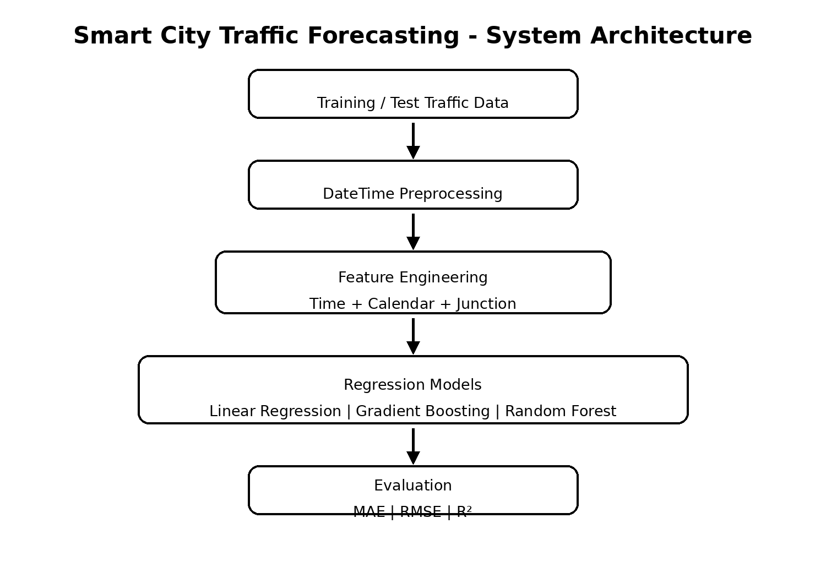
Figure: High-level architecture of the traffic forecasting system.
The system begins with the supplied traffic data. DateTime values are processed to obtain temporal information, while the junction identifier is retained as a categorical feature.
The resulting feature set is passed through the Machine Learning models. The models are trained and evaluated using a chronological validation period. The best-performing model is then retrained on the complete training dataset and used to generate predictions for the supplied test records.

6.8 Methodology

1. Data Collection and Understanding
The supplied training dataset contains 48,120 records and the test dataset contains 11,808 records. Training data includes the target variable Vehicles, while the test data requires Vehicles to be predicted.

2. Data Preprocessing
DateTime values were converted into a datetime representation so individual time components could be extracted. Junction information was retained as a categorical input.

3. Feature Engineering
Year, month, day, hour, day of week, week of year, and day of year were extracted. A weekend indicator was also created. Cyclical sine and cosine features were generated for hour and day of week to represent repeating temporal patterns.

4. Model Selection
Linear Regression, Gradient Boosting Regression, and Random Forest Regression were implemented and compared.

5. Validation Strategy
The final 30 days of the training data were used as a chronological validation period. This preserves the temporal order of the observations.

6. Evaluation
MAE, RMSE, and R² were used to compare the models. Lower MAE and RMSE indicate lower error, while a higher R² indicates stronger explanatory performance.

7. Final Prediction
Random Forest was selected after validation and retrained using the complete training dataset. It was then used to generate predictions for all 11,808 test records.

6.9 Implementation and Model Results
The implementation was developed as a Python Machine Learning pipeline. The preprocessing and model stages were combined so that the same transformations could be applied consistently during training and prediction.
The main input variables were the junction identifier and the time-derived features. The target variable was the number of vehicles.
The validation results obtained from the implemented models are shown below.
Model | MAE | RMSE | R²
Random Forest | 3.7753 | 6.5125 | 0.9514
Gradient Boosting | 6.4846 | 10.4628 | 0.8745
Linear Regression | 10.2147 | 15.6203 | 0.7203
Random Forest produced the strongest validation performance, with an MAE of 3.7753, RMSE of 6.5125, and R² of 0.9514. It was therefore selected as the final model.
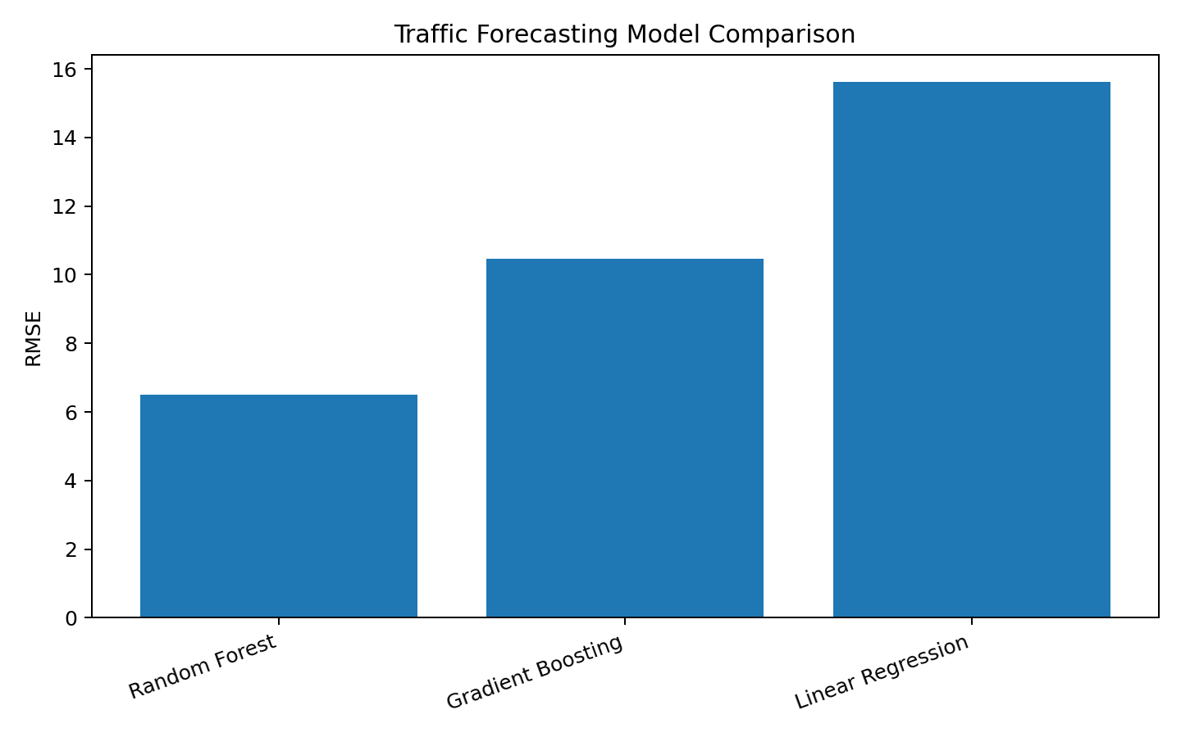
Figure: Validation RMSE comparison.

6.9 Implementation and Model Results (continued)
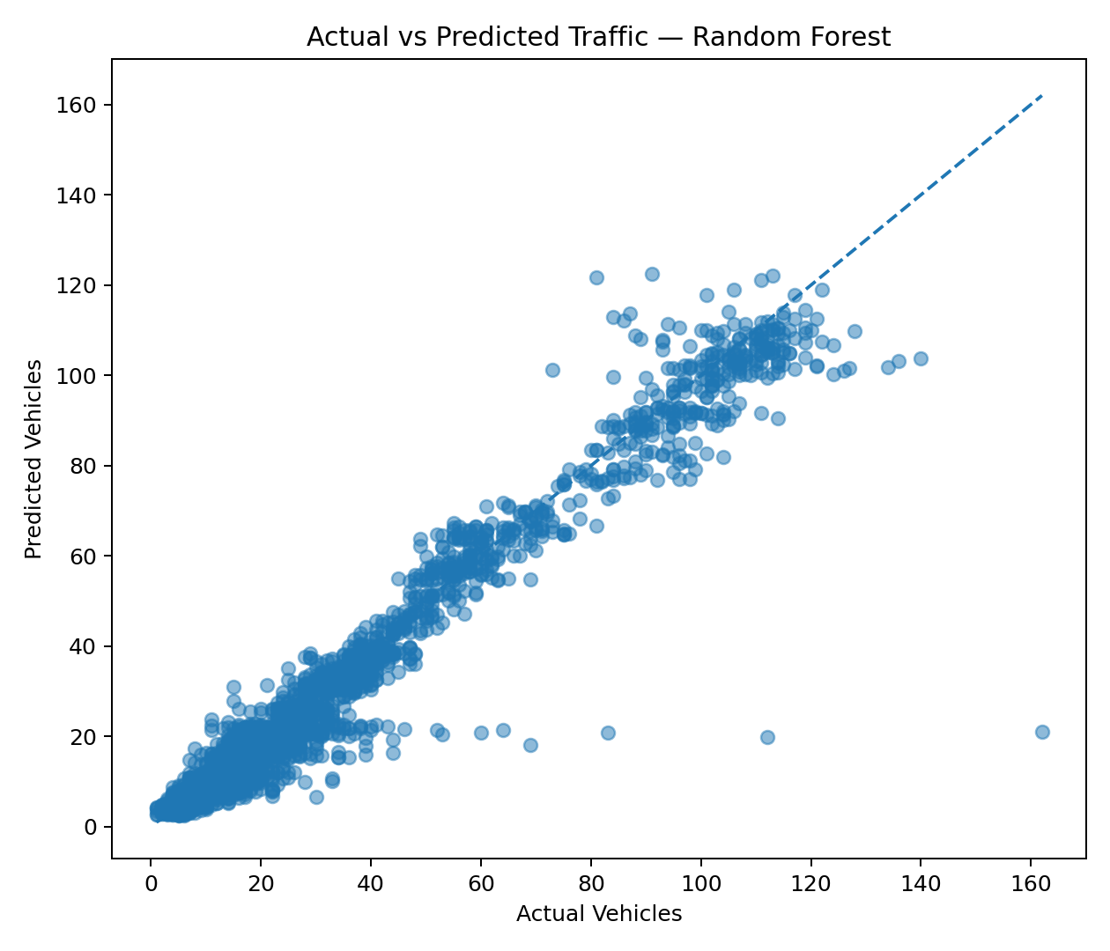
Figure: Actual versus predicted vehicle counts for the Random Forest validation set.
The actual-versus-predicted visualization provides a visual comparison between observed vehicle counts and the values estimated by the selected model. The points follow the expected increasing relationship, indicating that the model captures a substantial portion of the traffic-volume pattern.
After model comparison, Random Forest was trained on the complete training dataset and used to generate predictions for the 11,808 test records.
The implementation, supporting results, visualizations, and prediction output are maintained in the project repository:
https://github.com/Dyza-CZN/Smart-City-Traffic-Forecasting
The validation results should be interpreted in the context of the supplied dataset and validation period. They do not guarantee identical performance under all future traffic conditions.

6.10 Expected Outcomes
- A structured traffic dataset suitable for Machine Learning.
- Useful temporal features extracted from timestamp information.
- A regression-based traffic forecasting approach.
- A comparison of multiple Machine Learning models.
- Quantitative evaluation using MAE, RMSE, and R².
- Selection of Random Forest as the best-performing model under the chosen validation setup.
- Predictions for the supplied test dataset.
- A reusable Python implementation and GitHub repository.
- Practical experience with preprocessing, feature engineering, model training, and evaluation.

Limitations and Future Improvements
- Add weather, accident, roadwork, and public-event information.
- Include explicit holiday and special-event calendar data.
- Explore lag features from previous traffic observations.
- Compare additional time-series forecasting methods.
- Use larger and more recent traffic datasets.
- Develop a dashboard for visualization and forecasting.

CONCLUSION
The Smart City Traffic Pattern Forecasting project demonstrated how historical traffic observations can be processed and used to develop a Machine Learning based forecasting system.
The project involved understanding the supplied data, extracting temporal information from timestamps, creating features, training regression models, evaluating their performance, and selecting the most suitable model.
Three regression approaches were evaluated. Random Forest achieved the best validation performance with an MAE of 3.7753, RMSE of 6.5125, and R² of 0.9514. The selected model was subsequently trained on the complete training dataset and used to generate predictions for the supplied test records.
The project provided practical experience in applying Python, Pandas, NumPy, Scikit-learn, and Matplotlib to a traffic forecasting problem. It also demonstrated the importance of preserving time order when evaluating models on time-dependent data.
The current implementation provides a foundation that could be expanded with additional traffic, weather, event, and infrastructure information to create a more comprehensive smart-city forecasting system.

7. BIBLIOGRAPHY / REFERENCES
1. Codec Technologies Pvt. Ltd. Internship Offer Letter, dated 20 July 2026.
2. Codec Technologies Pvt. Ltd. Internship Completion Certificate, covering 20 July 2026 to 20 August 2026.
3. Codec Technologies Pvt. Ltd. Letter of Recommendation, dated 20 August 2026.
4. Scikit-learn Documentation — Machine Learning algorithms, preprocessing, regression, and model evaluation.
5. Pandas Documentation — Data manipulation and analysis using Python.
6. NumPy Documentation — Numerical computing with Python.
7. Matplotlib Documentation — Data visualization in Python.
8. Python Software Foundation — Python documentation.
9. Supplied Smart City Traffic Pattern Forecasting internship project specification and dataset.
10. GitHub repository: Smart City Traffic Forecasting — Yash Arvind.
https://github.com/Dyza-CZN/Smart-City-Traffic-Forecasting

SUPPORTING DOCUMENTS
The official internship documents attached in this report are the documents supplied by the student:
- Internship Offer Letter
- Internship Completion Certificate
- Letter of Recommendation
The documents are reproduced in the report for academic submission and verification.

