**Process Water Mixing Description**

**Dzakwan Afif / Github : DzakwanAfifPLCS**

**Description for Hot-Cold Water Mixing Tank Process**

**1- I&C Design Project Map**

To make the documentation easier and more manageable to be made, the document is used the project workflow that had been mentioned in Bela G Liptak : Instrumentation Engineer’s Handbook; Process Software and Digital Networks.

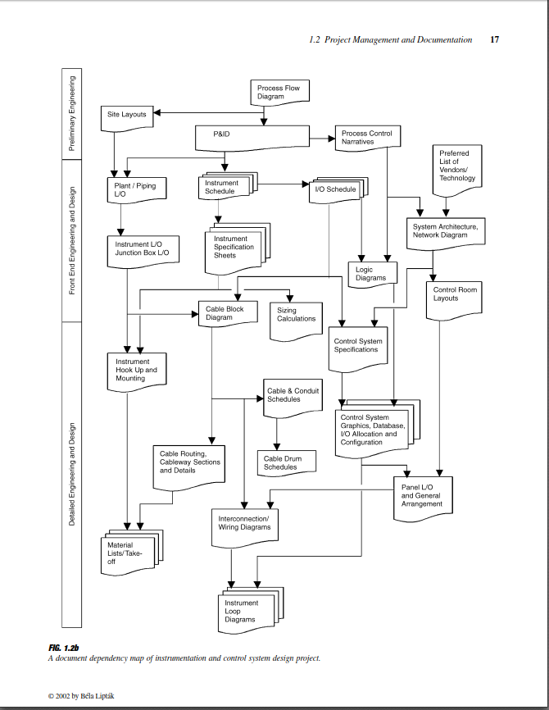

**2- Define Process Description**

Process Purposes : Mixing Hot and Cold Water in Atmospheric Tanks

Process Output : Result of the mixing as the product flow

|  |  |  |
| --- | --- | --- |
| Process Variable (PV) | PV Value | PV Unit |
| Cold Water Temperatue | 20 | °C |
| Cold Water Flowrate | 0-100 | L/s |
| Hot Water Temperature | 90 | °C |
| Hot Water Flowrate | 0-100 | L/s |
| Product Temperature | 40-50 | °C |
| Product Flowrate | 0-100 | L/s |
| Water Density | 997.01 | Kg/m3 |
| Specific Water Heat Capacity | 4182 | J/kg°C |

After the process properties is defined, the process variable need to be defined also to see what the process variable that need to be controlled and what variable to be manipulated to achieve the setpoint desired.

The Disturbance variable is optional to be added, so we know what variable that could change our process variable stability

|  |  |  |
| --- | --- | --- |
| Controlled Variable (CV) | Manipulated Variable (MV) | Disturbance (D) |
| Tank Level | Hot Fluid Flowrate | Product Flowrate |
| Cold Water Flowrate |
| Product Temperature | Cold Fluid Flowrate | Hot Water Flowrate |

After that, the Process Flow Diagram and P&ID could be made as per process requirement as seen above:  
  
See the P&ID Visio here

//if seen from Github, please refer to the repository itself

If the P&ID is finalized, then need to list all the Instrument, Valve/Actuator, and the Equipment needed in the systems :

|  |  |  |  |  |
| --- | --- | --- | --- | --- |
| Codename | Equipment Name | Brand / Model | Specification | Serial Number |
| PUMP1-1 | Centrifugal Pump | xxxxxxxxxxx | Xxxxxxxxx L/s  Head xxxxx m | xxxxxxxxxxx |
| PUMP1-2 | Centrifugal Pump | xxxxxxxxxxx | Xxxxxxxxx L/s  Head xxxxx m | xxxxxxxxxxx |
| PUMP1-3 | Centrifugal Pump | xxxxxxxxxxx | Xxxxxxxxx L/s  Head xxxxx m | xxxxxxxxxxx |

|  |  |  |  |  |
| --- | --- | --- | --- | --- |
| Codename | Instrument Name | Brand / Model | Specification | Serial Number |
| FE11  FT11 | Turbine Flowmater | xxxxxxxxxxx | Xxxxxxxxx L/s | xxxxxxxxxxx |
| FE12  FT12 | Turbine Flowmater | xxxxxxxxxxx | Xxxxxxxxx L/s | xxxxxxxxxxx |
| FE13  FT13 | Turbine Flowmater | xxxxxxxxxxx | Xxxxxxxxx L/s | xxxxxxxxxxx |
| FIC11 | Flow Indicator Controller | PLC/DCS xxxx | xxxxxxxxxxx | xxxxxxxxxxx |
| FIC12 | Flow Indicator Controller | PLC/DCS xxxx | xxxxxxxxxxx | xxxxxxxxxxx |
| FIC13 | Flow Indicator Controller | PLC/DCS xxxx | xxxxxxxxxxx | xxxxxxxxxxx |
| LG11 | Level Gauge | xxxxxxxxxxx | Xxxxxxxxxx m | xxxxxxxxxxxx |
| LT11 | Level transmitter | xxxxxxxxxxxx | Xxxxxxxxxx m | xxxxxxxxxxxx |
| LSH11 | Level Switch High | Xxxxxxxxxxx | Xxxxxxxxxx | Xxxxxxxx |
| LSL11 | Level Switch Low | xxxxxxxxxxx | xxxxxxxxxx | xxxxxxxx |
| LIC11 | Level Indicator Controller | PLC/DCS xxxx | xxxxxxxxxxx | xxxxxxxxxxx |
| PSHL11 | Pressure Switch High Low | xxxxxxxxxxx | xxxxxxxxxxx | xxxxxxxxxxx |
| PSHL12 | Pressure Switch High Low | xxxxxxxxxxx | xxxxxxxxxxx | xxxxxxxxxxx |
| PSHL13 | Pressure Switch High Low | xxxxxxxxxxx | xxxxxxxxxxx | xxxxxxxxxxx |
| TE11  TT11 | RTD Temp Transmitter | xxxxxxxxxxx | xxxxxxxxxxx | xxxxxxxxxxx |
| TE12  TT12 | RTD Temp Transmitter | xxxxxxxxxxx | xxxxxxxxxxx | xxxxxxxxxxx |
| TE13  TIT13 | RTD Temp Transmitter | xxxxxxxxxxx | xxxxxxxxxxx | xxxxxxxxxxx |
| TIC11 | Temperature Indicator Transmitter | PLC/DCS xxxx | xxxxxxxxxxx | xxxxxxxxxxx |

|  |  |  |  |  |
| --- | --- | --- | --- | --- |
| Codename | Valve  Name | Brand / Model | Specification | Serial Number |
| FCV11 | Diapraghm Control Valve Linier Fail Closed | xxxxxxxxxxx | XXXXXXXX | xxxxxxxxxxx |
| LCV11 | Diapraghm Control Valve Linier Fail Closed | xxxxxxxxxxx | XXXXXXXXXX | xxxxxxxxxxx |
| TCV11 | Diapraghm Control Valve Linier Fail Closed | xxxxxxxxxxx | XXXXXXXXXX | xxxxxxxxxxx |
| SDV11 | Solenoid Shutdown Valve | xxxxxxxxxxx | XXXXXXXXXX | XXXXXXXXXX |
| SDV12 | Solenoid Shutdown Valve | xxxxxxxxxxx | XXXXXXXXXX | XXXXXXXXXX |
| SDV13 | Solenoid Shutdown Valve | xxxxxxxxxxx | XXXXXXXXXX | XXXXXXXXXX |

//Gate valve for Control Valve Maintenance bypass and all check valve assume not defined.

//All model, specs, and serial number would be updated after further searching and research.

For Temperature inside tanks is following the Black Rules, which the heat transferred is equal to heat received multiplied by the tanks heat absorb efficiency. Assume that tank efficieny is 95%.

Hot Water

T2

90oC

T3

ColdWater

T1

20oC

**3- Process Control Narative**

As seen from P&ID and Process Variable Requirement, the process control would be derivated into 3 main process control  
  
A. Tank Level Control

To maintain the Tanks level always on the optimum level and not overlevel nor underlevel, the tank level would be manipulated trough the hot fluid intake into the tanks.

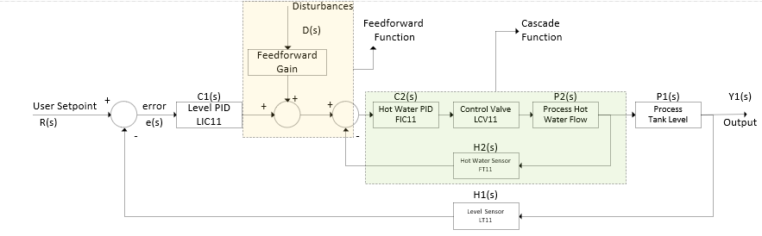

Shown that the block diagram for the Tank Level Control could be accommodate 3 control strategy : Simple Feedback, Cascade Control, and Feedforward Control. User can choose what control strategy that want to be used for their operation later.

B. Product Temperature Control

To maintain the product temperature, agreed that the manipulated variable that need to control to achieve the desired product temperature is to manipulate cold water flowarate  
  
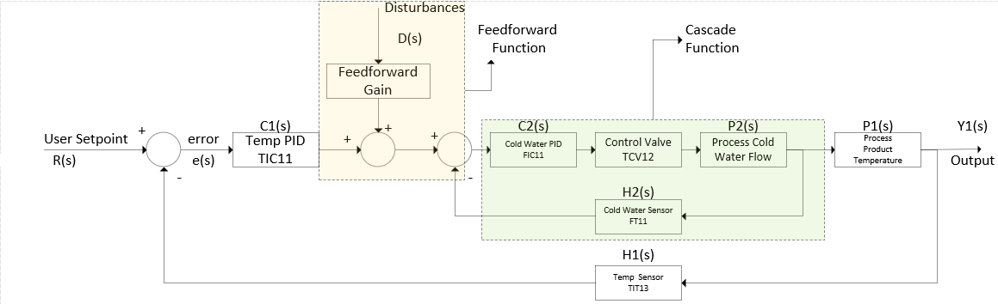

The description is same with the level block diagram, refer above.

C. Product Flowrate Control

The product flowrate is just disturbances variable into other system, so no need any advanced control strategy, feedback only is enough.

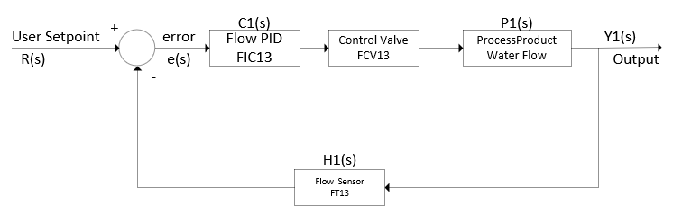

**4- Basic Process Control System Algorithm**

After the Block Diagram is built, the program at PLC would be followed the block diagram before as the main references.

//Would be Finished after the program study is finished

**5- Safety Control Narative**

Safety Automation need to be considered after the basic control system scheme already established. The safety hazard in this system need to be defined first :

|  |  |  |
| --- | --- | --- |
| Equipment | Potential Hazard | Action Taken |
| Atmospheric Tank | Overspill | Turn Off Cold Water Flow |
| Turn Off Hot Water Flow |
| Maximize Product Flowrate |
| Underlevel | Maximize Hot Water Flow |
| Turn Off Product Water Flow |
| Pipeline | High Pressure | Turn Off flowrate in pipeline |
| Turn Off Pump |

After Hazard analysis is defined, then the logic block diagram is needed to make a simple algorithm how the safety system works.

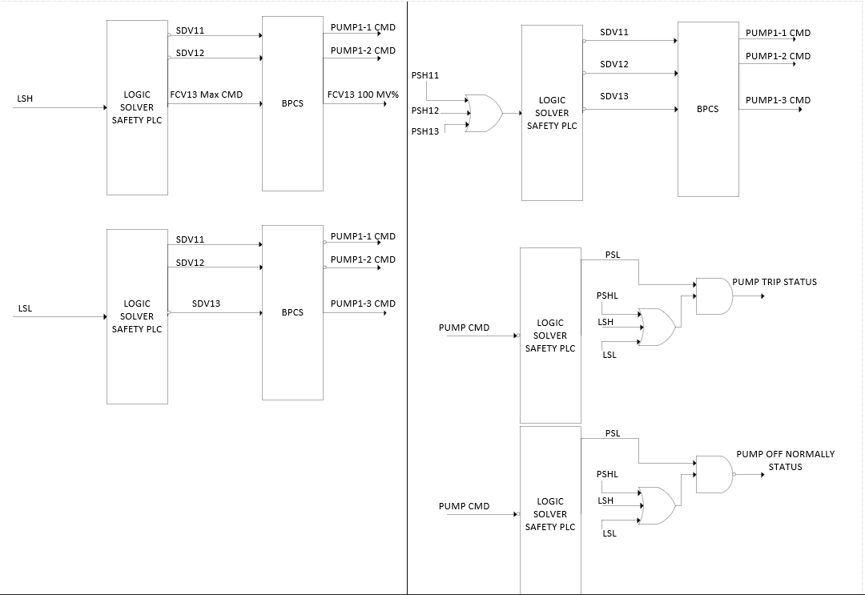

After the logic diagram had been made, it clearly shows what equipment and device that need to be operated. The details can be tabulated in the SAFE Chart to be more precise.

[Link to SAFE Chart](DzakwanAfifPLCS_Projects_SAFE%20Chart.xls)

// For Github, refer to the repository itself

For information, the device used for safety is already following the recommendation practice from API API RP14 C Safety system for offshore production, 6 ed.

Pustaka:

1- ANSI / ISA-5.1-1984 (R1992) Instrumentation Symbols and Identification

2- ANSI / ISA-5.5-1985 Graphics Symbols for Process Display

3- API MPMS Chapter-5 Metering

4- API RP554 1995 Process Instrumentation and Control

5- API RP14 C Safety system for offshore production, 6 ed

6- Bela G Liptak : Instrumentation Engineer’s Handbook; Process Software and Digital Networks Vol 3-2

7- Lesson in Industrial Instrumentation, R Kuphaldt