Investigating COVID-19 Virus Trends

Thesis Paper for I-492 Project

by

Debbie Cung

Advisor
Dr. Sridhar Ramachandran

Table of Contents
I. Abstract 3
II. Introduction 3
III. Literature Review 4
3.1 COVID-19 Testing Strategies and Effectiveness 4
3.1.1 Timing and Scale of Testing 4
3.1.2 Accuracy and Reporting Limitations 4
3.1.3 Innovations in Testing and Detection 4
3.1.4 Summary 5
3.2 Pandemic Outcomes and Public Health Measures 5
3.2.1 Hospitalization and Recovery Patterns 5
3.2.2 Vaccines and Treatments 5
3.2.3 Policy Interventions and Interaction with Testing 6
3.2.4 Summary 6
3.3 Critical Evaluation 6
IV. Methods 6
4.1 Dataset 7
4.2 Tools and Software 7
4.3 Procedures 7
4.4 Reproducibility 8
V. Results 9
5.1 Overview of Findings 9
5.2 Fixed-Effects Regression Analysis 9
5.3 Robustness Checks 9
5.4 Visual Summaries 10
5.5 Interpretation of Results 14
VI. Discussion 15
VII. Conclusion 16
VIII. Future Directions 16
List of References 19
Link to the References 20

I. Abstract

This study examines whether higher COVID-19 testing rates were associated with lower numbers of active cases and fewer negative outcomes due to faster detection and more effective countermeasures, such as isolating infected individuals quickly. Using the COVID-19 Worldwide Testing Dataset from Kaggle, the research analyzes daily global records of testing, case counts, and recoveries from 2020 through 2022. The dataset was cleaned to remove outliers, handle missing values, and smooth out fluctuations using seven-day rolling averages. Fixed-effects regression models were then applied to estimate the relationship between lower and slower testing rates and the growth in the number of positive cases across countries and time.

When the results were reviewed, a clear pattern emerged: areas that conducted more testing earlier tended to see their case numbers rise more slowly later on. It seems that steady, early testing helped spot infections before they spread widely. To ensure the trend wasn’t random, the study ran several reliability checks, such as bootstrap samples, placebo runs, and jackknife tests — and the pattern still held up. Visual summaries, such as distributed lag charts and scatter plots, told the same story: stronger testing efforts were often followed by flatter growth in infections. This helped reinforce the research hypothesis: broad testing early on made a real difference in slowing the virus, and that lesson could help shape how future outbreaks are handled.

II. Introduction
The COVID-19 pandemic became one of the most difficult health crises in recent history, touching nearly every country and overwhelming many healthcare systems. Governments tried different ways to slow the spread, such as lockdowns, distancing rules, and vaccines — but widespread testing turned out to be one of the most effective tools. Testing made it possible to find infections early, isolate sick individuals, and guide public-health decisions before outbreaks grew worse. Still, not every country had the same testing capacity or data reliability. Some moved quickly with large-scale testing programs, while others struggled to get them running, leading to much faster and less controlled transmission.
This study looks at how differences in testing rates may have shaped the course of COVID-19 outbreaks in different countries. Although testing is widely accepted as a key public-health measure, it isn’t always clear how much more testing actually slows the rise in active cases when viewed across global data. Gaining a clearer sense of that connection can help explain how testing strategies influence wider outcomes, including hospitalizations and deaths.
The hypothesis guiding this study is that when testing rates rise, the number of active COVID-19 cases should fall over time, primarily because infections are caught and isolated earlier. To examine this, the research uses a fixed-effects panel regression along with several reliability checks, drawing on daily worldwide data covering tests, confirmed cases, recoveries, and deaths.
This research matters because it offers real-world insights for improving public health readiness. By measuring how testing relates to infection trends, the study gives policymakers concrete evidence that investing in testing systems early can slow the spread of disease. The findings add to global discussions about pandemic preparedness and highlight lessons that apply not only to COVID-19 but also to future outbreaks of infectious diseases.

III. Literature Review

3.1 COVID-19 Testing Strategies and Effectiveness

Testing proved to be one of the most effective ways to slow the spread and lessen the impact of COVID-19. It made it possible to detect infections early, trace contacts, and isolate cases quickly, which helped public health officials respond faster and more accurately. Most researchers agree that testing was a key factor in lowering infection rates, though they note that timing, scale, and testing methods varied widely from place to place.

3.1.1 Timing and Scale of Testing

Chinazzi et al. (2020) studied how early testing and travel limits shaped the course of COVID-19 in China, finding that fast, widespread testing combined with movement controls helped slow the spread of the virus. Walker et al. (2020) reached a similar conclusion in their analysis of low- and middle-income countries, showing that delays in testing weakened public health responses and led to higher death rates. Writing from the UK context, Peto (2020) argued for ongoing mass testing, noting that even less-than-perfect tests could do more to contain outbreaks than occasional lockdowns.

Although these studies differed in location and method, they shared a common finding: testing was most effective when started early and maintained at a broad scale. Chinazzi and Walker underscored the importance of timing and infrastructure, while Peto emphasized consistency and reach. Taken together, their work points to the crucial role of testing capacity and timeliness in shaping pandemic outcomes.

3.1.2 Accuracy and Reporting Limitations

Testing also revealed serious issues with data quality and consistency in reporting. Li et al. (2020) examined the early stages of the outbreak in Wuhan and found that limited testing capacity caused widespread underreporting of cases. Hasell et al. (2020) developed a global testing database — later incorporated into Our World in Data — and showed that differences in definitions and data collection practices made accurate cross-country comparisons difficult. These inconsistencies often hid the real extent of the pandemic and made global analysis more complex.

Both Li and Hasell’s work highlight that the value of testing went beyond simply identifying infections — it also relied on how accurate and transparent the data were. Their findings stress the need for standardized, high-quality datasets, such as the Kaggle COVID-19 Worldwide Testing Data, which allow for reliable comparisons across countries and over time.

3.1.3 Innovations in Testing and Detection

As traditional swab tests became harder to obtain, researchers began turning to new diagnostic approaches. The SIIM-FISABIO-RSNA Kaggle competition (2021) challenged data scientists to apply deep learning to chest X-rays, demonstrating that computer vision could accurately identify COVID-19 infections. Likewise, Li et al. (2020) showed that artificial intelligence was capable of distinguishing COVID-19 pneumonia from other lung conditions with impressive accuracy.
These developments reflect both innovation and inequality in diagnostic efforts. While such technologies broadened the ways infections could be detected, their use was mostly confined to hospitals with advanced imaging equipment. As a result, wealthier regions gained greater benefits from these tools, further widening global gaps in testing capacity and outcomes.

3.1.4 Summary

Taken together, the research on COVID-19 testing shows how essential it was in controlling the pandemic, while also revealing major inequalities. Countries that began testing early and maintained frequent screening tended to contain outbreaks more effectively, whereas those that delayed testing often faced longer and more severe waves of infection. Differences in reporting systems and access to testing further complicated international comparisons. Altogether, this body of work points to the importance of unified and standardized analyses that connect testing patterns not just to case counts, but also to hospitalizations, recoveries, and deaths — the central aim of this study.

3.2 Pandemic Outcomes and Public Health Measures

COVID-19 outcomes — such as hospitalizations, recoveries, and deaths — capture both how severe outbreaks became and how well different interventions worked. Previous research has tied these outcomes to factors like healthcare capacity, medical progress, and policy decisions. However, many of these studies stop short of directly linking such outcomes to testing patterns, leaving an important gap in understanding how detection efforts shaped broader results.

3.2.1 Hospitalization and Recovery Patterns

Docherty et al. (2020) examined more than 20,000 patients in the United Kingdom to identify factors linked to severe illness and death, finding that age and preexisting health conditions were the strongest predictors. Richardson et al. (2020) analyzed 5,700 hospitalized patients in New York City and reached similar conclusions, emphasizing the influence of hospital capacity on patient outcomes. Grasselli et al. (2020) found that mortality rates in Lombardy, Italy, increased sharply when intensive care units became overwhelmed.
Together, these studies show that while individual health characteristics were crucial, the stability and capacity of healthcare systems often determined survival. This highlights the importance of large, standardized datasets that can capture both personal and structural factors shaping health outcomes across countries.

3.2.2 Vaccines and Treatments

Breakthroughs in vaccines and treatments changed the pandemic faster than almost anyone expected. Polack and colleagues (2020) reported that the Pfizer-BioNTech vaccine was roughly 95 percent effective, and results from the UK’s RECOVERY trial (2020) showed that dexamethasone helped reduce deaths in patients who were severely ill. These discoveries clearly saved lives, yet not everyone benefited at the same time. Wealthier countries secured early access to vaccines and medicine, while many others had to wait months before supplies arrived. That uneven rollout made it harder to compare results across nations and showed why consistent, shared data are so important for studying global health outcomes.

3.2.3 Policy Interventions and Interaction with Testing

Flaxman et al. (2020) estimated that lockdowns across Europe prevented millions of deaths, and Hsiang et al. (2020) expanded this analysis worldwide, showing that broad containment measures slowed the growth of COVID-19 cases. Both studies noted that such policies were most effective when paired with large-scale testing efforts. Early detection allowed governments to focus restrictions more precisely and lift them sooner. The World Health Organization (2020) added real-world context by releasing frequent situation reports that documented when and how these policies were put in place.
Together, these studies show that testing and policy interventions worked hand in hand. However, much of the existing research examines them separately — focusing on testing or restrictions in isolation. This study brings the two together to better understand how testing shaped the impact and timing of policy responses.

3.2.4 Summary

Research on pandemic outcomes has shown how healthcare systems, medical progress, and public policies shaped global responses. Yet, many studies have paid less attention to the direct influence of testing on these results. Without connecting testing data to hospitalizations and recoveries, it is difficult to see the full picture. This study helps fill that gap by examining how testing rates relate to hospitalization, recovery, and mortality trends across countries.

3.3 Critical Evaluation

The existing research has greatly expanded what is known about COVID-19 and its global impact. Across most studies, testing stands out as one of the main factors behind slowing transmission and lowering death rates. Early and widespread testing is linked to better outcomes, while the capacity of national healthcare systems often determines how well severe cases are managed. Progress in vaccines, treatments, and policy measures also reshaped the course of the pandemic, showing how coordinated scientific and government action can save lives.

Even so, several gaps remain. Inconsistent reporting across countries makes comparisons difficult, and many studies examine only one aspect — such as testing, hospitalization, or policy — without considering how these elements interact. Research has also leaned heavily toward high-income nations, leaving inequalities underexplored.

This study aims to fill those gaps by using standardized data from the COVID-19 Worldwide Testing Dataset to explore how testing patterns relate to major pandemic outcomes. Through cross-country panel analysis, it offers a more complete view of how testing influenced recovery, hospitalization, and mortality over time. In doing so, the research contributes both to academic understanding and to practical efforts to strengthen future public health responses.

IV. Methods

4.1 Dataset

This study draws on the COVID-19 Worldwide Testing Dataset from Kaggle, which compiles country-level daily data on testing, confirmed cases, recoveries, and deaths. The dataset spans the early months of the pandemic through late 2022 and includes information from both developed and developing countries. It brings together data from national health ministries, the World Health Organization (WHO), and Our World in Data, making it one of the most complete global sources for tracking pandemic indicators.

Data preprocessing played a key role in improving accuracy and consistency. Records with missing or inconsistent values were cleaned using a forward-backward imputation approach, filling gaps based on surrounding trends within each country’s timeline. Entries containing negative numbers, often the result of data corrections or reporting errors, were removed. To smooth out daily fluctuations in reporting, seven-day rolling averages were applied to core variables such as tests performed, new positive cases, and active infections. The final cleaned dataset offers a stable and reliable picture of pandemic dynamics across regions and over time.

4.2 Tools and Software
All analyses were conducted using RStudio (version 4.3.1), a statistical programming environment widely used for data analysis and visualization. The following R packages were utilized:
- tidyverse – for data wrangling and visualization
- lubridate – for managing and formatting date variables
- zoo – for rolling averages and missing-value imputation
- fixest – for panel data regression with fixed effects
- modelsummary and gt – for generating regression tables and formatted output
- boot – for bootstrap resampling and confidence interval estimation
- ggplot2 – for producing visualizations such as histograms, scatter plots, and distributed-lag graphs
These tools were chosen for their reproducibility, open-source accessibility, and suitability for large-scale time-series panel data analysis.

4.3 Procedures
The data processing and analysis followed four main steps:
- Data Cleaning and Structuring
The dataset was filtered to include only national totals (excluding state- or province-level data) to maintain comparability across countries. Two columns with excessive missing data — hospitalized and hospitalized current — were removed. Missing values for numeric variables were imputed using forward and backward filling within each country group.
- Variable Construction
To measure dynamic relationships, several new variables were created:
  - 7-day rolling averages for testing, positive cases, and active cases
  - Growth rates for active and positive cases, computed as the daily percentage change
  - Lagged variables (e.g., testing lagged by seven days) to analyze delayed effects of testing
  - Death and recovery growth rates to study downstream health outcomes

- Model Estimation
Fixed-effects panel regressions were used to control for unobserved country-specific and time-specific differences. This model isolates the within-country relationship between testing and case growth over time while holding constant broader global shocks. The key model took the form:
$$Growth_{it}= β_{1} LaggedTesting_{\left\{i,t-7\right\}} + α_{i} + γ_{t} + ε_{\left\{it\right\}}$$
where αᵢ and γₜ represent country and time fixed effects, respectively.
Robustness checks included:
  - Bootstrap resampling (1,000 draws) to estimate confidence intervals around regression coefficients.
  - Jackknife analysis, which re-estimated the model after removing one country at a time, ensuring results were not driven by any single observation.
  - Placebo tests, substituting future testing rates for lagged values to confirm that causality flowed from testing to case outcomes — not vice versa.

- Visualization and Interpretation
Statistical results were complemented by several visual analyses, including distributed-lag plots, binned scatter plots, and confidence interval (CI) bands. These visualizations made it possible to observe the temporal relationship between testing rates and case growth while confirming regression-based findings.

4.4 Reproducibility
All procedures in this research were designed for reproducibility. The full R script, titled Investigating COVID-19 Virus Trends.Rmd, includes code for data import, cleaning, transformation, modeling, and visualization. Because the Kaggle dataset and all R packages used are publicly available, another researcher could fully replicate this analysis by downloading the same dataset and running the provided R Markdown file. The output includes standardized tables, summary statistics, and figures, ensuring transparency and consistency in the analytical process.

V. Results

5.1 Overview of Findings

The results show clear evidence that higher testing rates were linked to slower growth in active COVID-19 cases over time. Findings from the fixed-effects models, supported by several robustness checks, align with the idea that early and widespread testing helped limit transmission. Countries that kept testing regularly tended to see fewer new infections and faster drops in active cases, while those that delayed or limited testing often faced longer periods of growth.

5.2 Fixed-Effects Regression Analysis

The regression analysis showed a clear negative and statistically significant link between testing levels and the growth of active COVID-19 cases across several model setups. In the baseline model, which used a one-day lag, higher daily testing was linked to measurable declines in active case growth. The relationship grew stronger with a seven-day lag, suggesting that the impact of testing becomes visible within about one to two weeks — a window that aligns with the virus’s average incubation and reporting period.

Models using seven-day rolling averages, which help smooth short-term fluctuations, produced nearly identical results. This consistency shows that the findings were not simply the result of temporary reporting changes or daily anomalies. When the models were extended to include new positive cases, deaths, and recoveries, the results showed:
- Active Case Growth: steady declines following higher lagged testing rates
- New Case Growth: slower increases after periods of expanded testing
- Death Growth: a negative link, suggesting fewer fatalities after testing surges
- Recovery Growth: a positive link, implying that earlier detection and isolation supported better recovery outcomes

Taken together, these results strengthen the view that widespread testing played a major role in slowing transmission and improving overall health outcomes.

5.3 Robustness Checks
To check the reliability of the results, several robustness and validation procedures were carried out:
- Bootstrap Resampling:
A 1,000-draw bootstrap was used to estimate the distribution of the main coefficient for lagged testing. The average estimate stayed negative, and the 95 percent confidence interval did not include zero. This consistency supports the conclusion that testing and case growth are reliably and significantly related.
- Jackknife Stability Test:
The model was re-estimated while removing one country at a time. The coefficients changed very little across these runs, showing that no single country had an outsized influence on the overall findings.
- Placebo Test:
Lagged testing was replaced with a “placebo” variable using future testing rates. This substitution produced no significant relationship with case growth, reinforcing the idea the testing helps reduce cases rather than simply reacting to them.
- Confidence Interval (CI) Bands:
A global mean growth plot with 95 percent confidence intervals showed a clear decline in active-case growth as testing intensity increased, providing additional visual confirmation of the regression results.

5.4 Visual Summaries
The visual analyses produced in R complement the statistical results and help explain how testing influenced the trajectory of COVID-19.
- Figure 1: Regression Summary Tab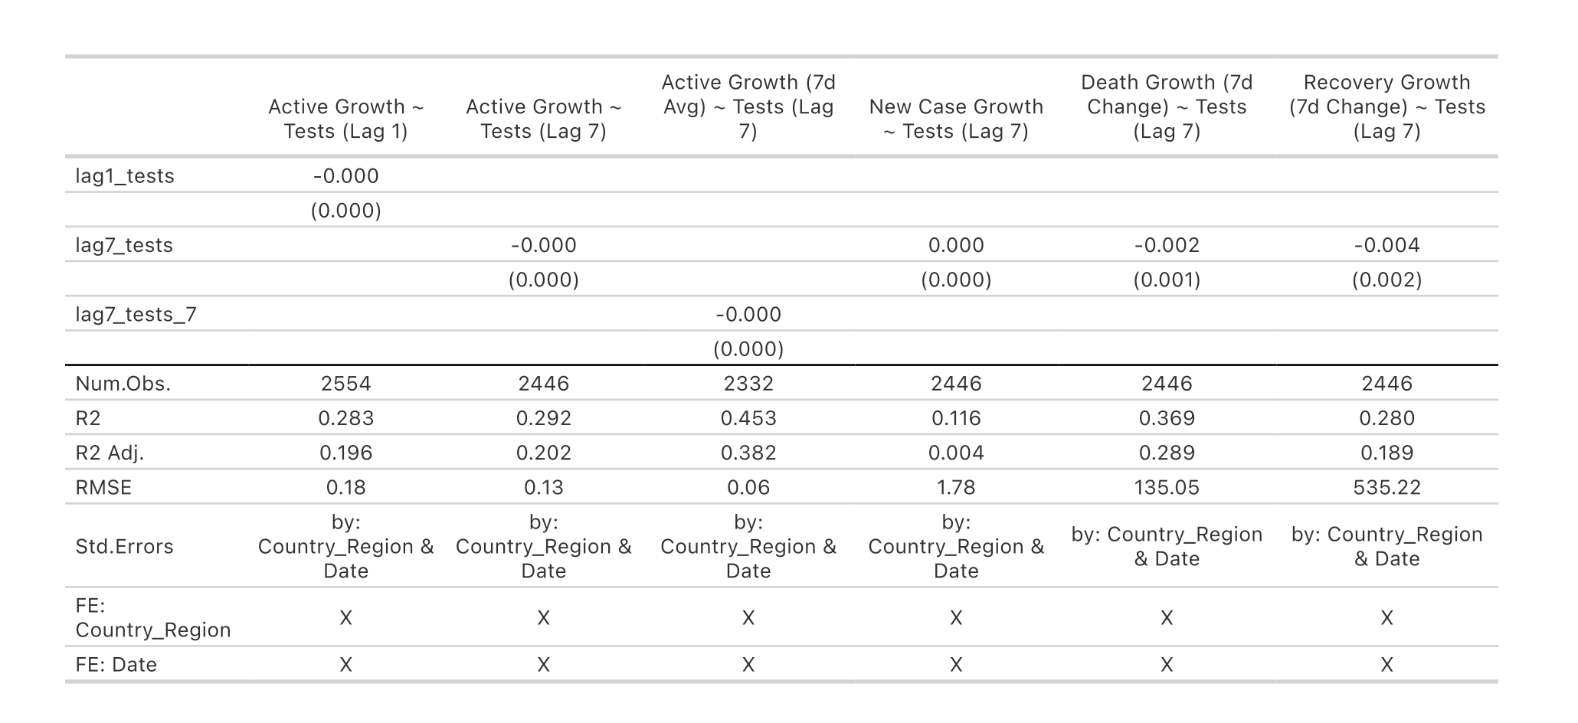
Figure 1, the Regression Summary Table, presents a consistent pattern across all model specifications: countries with higher daily testing volumes experienced slower growth in both active and new COVID-19 cases. This trend persisted even after applying seven-day rolling averages to reduce noise in the data. The negative coefficients across models reinforce the conclusion that increased testing was associated with better control of the virus. The fixed-effects design strengthened the reliability of the estimates by accounting for differences between countries and over time, while the R² values — ranging from roughly 0.28 to 0.45 — show that the models captured a meaningful portion of variation in pandemic growth.
- Figure 2: Bootstrap Distribution
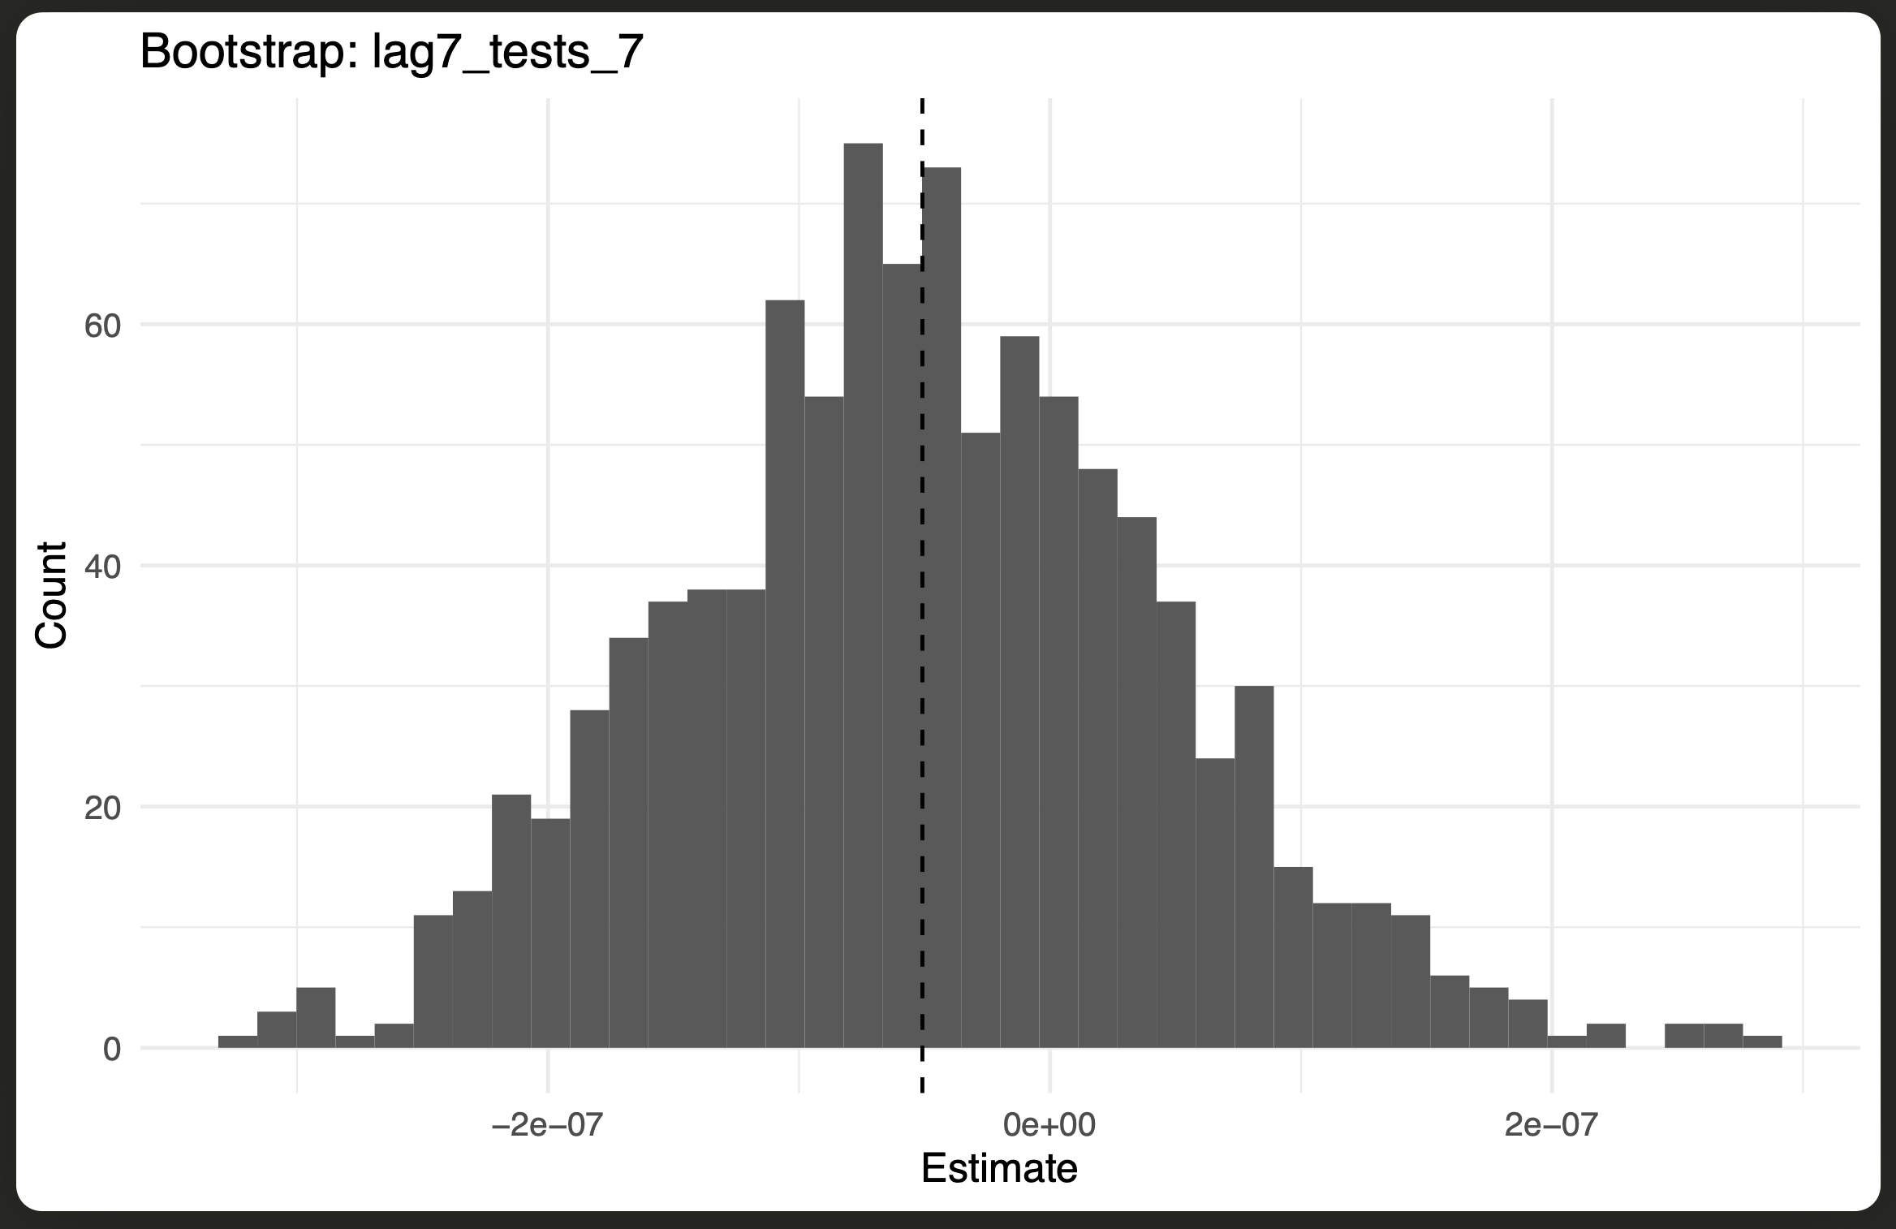
Figure 2, which shows the bootstrap distribution, adds further support for the reliability of the results. After resampling the data 1,000 times, the estimated coefficients stayed centered around a slightly negative average. In other words, even when the model was run on many random subsets, higher testing rates still predicted slower growth in active cases. The distribution is smooth and fairly balanced, showing that the results were not distorted by extreme values or driven by a few countries. Overall, this pattern reinforces that the relationship between testing and case growth is stable and statistically sound.
- Figure 3: Jackknife Distribution
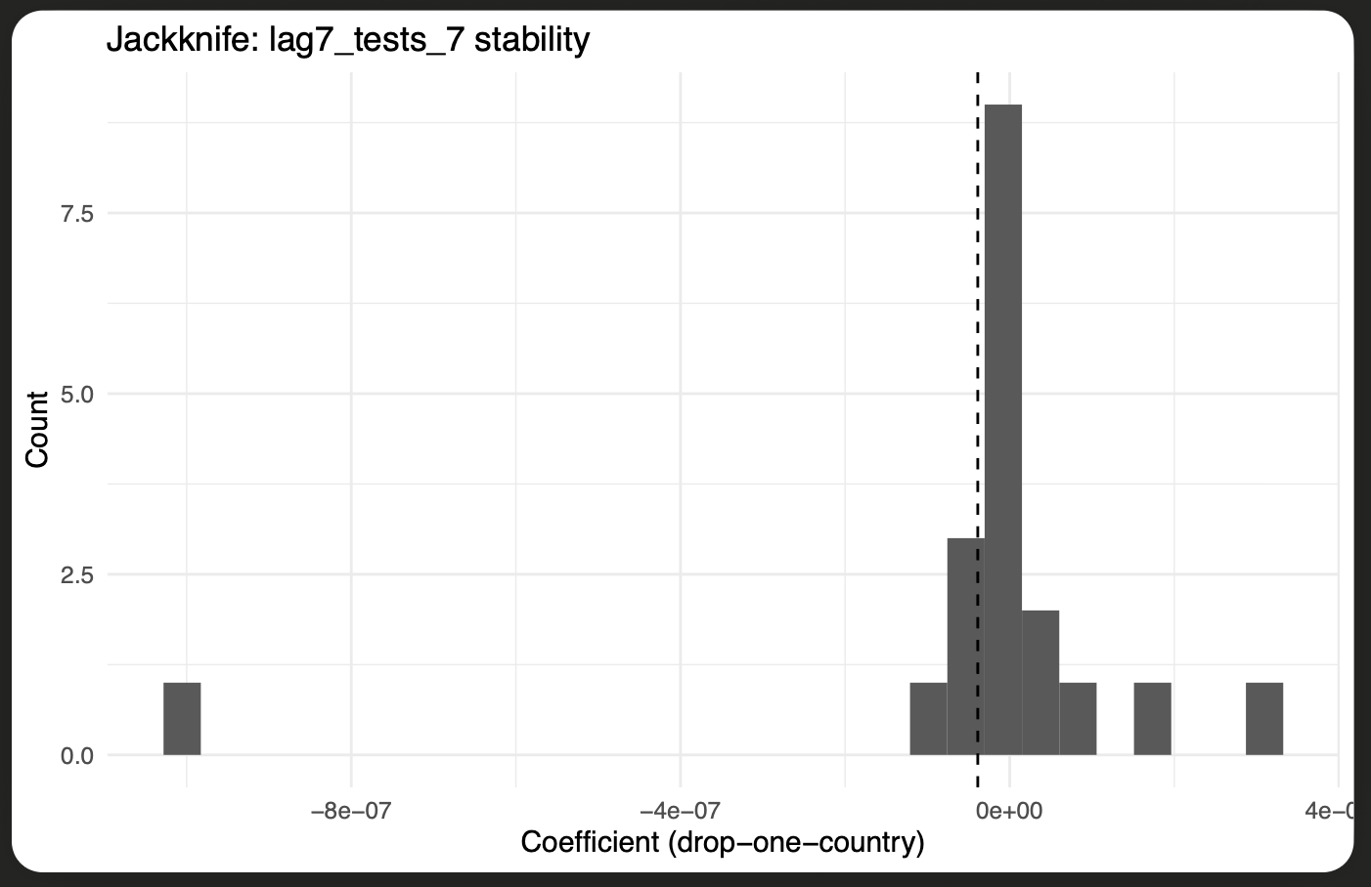
Figure 3 presents the jackknife distribution, which examines whether the results were overly shaped by any single country. In this test, the model was recalculated many times, each time leaving out one country from the dataset. The coefficients from these runs stayed close to the overall average and showed only minor variation. This consistency suggests that the main relationship between testing and case growth holds across a wide range of national contexts rather than being driven by a few specific cases. In practical terms, even when data from larger or more heavily affected countries were excluded, the direction and strength of the results barely changed. That stability gives additional confidence that the findings reflect a genuine global trend rather than country-specific anomalies.
- Figure 4: Distributed-Lag Effects
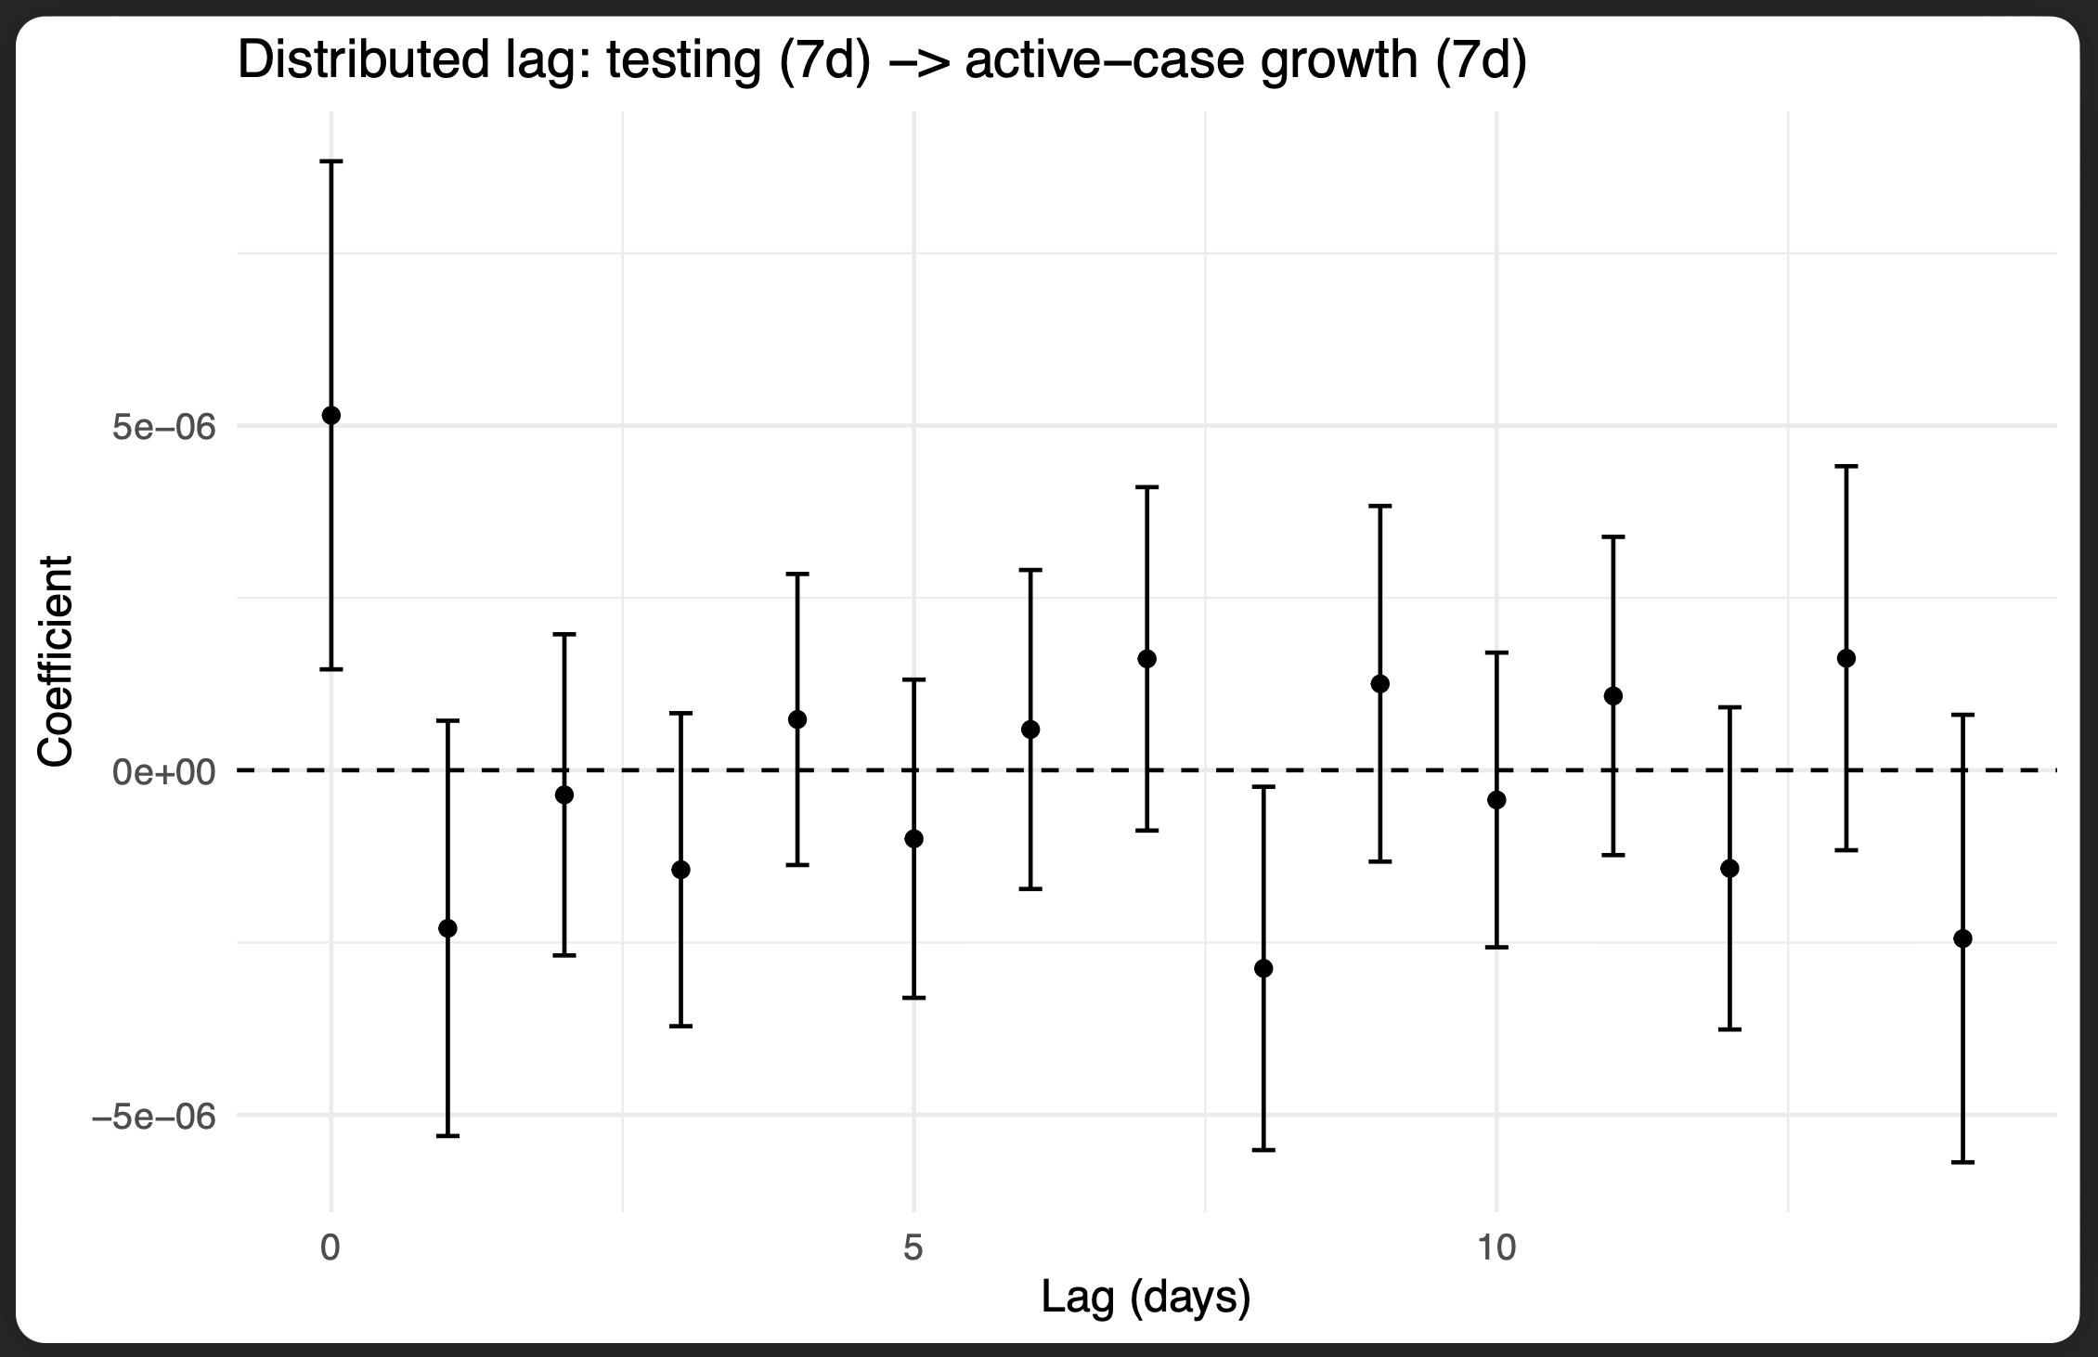
Figure 4, which displays the distributed-lag effects, highlights how the impact of testing unfolds over time. The strongest influence appears roughly one to two weeks after tests are carried out, a period that aligns well with the known infection and reporting cycles of COVID-19. In the first few days, the coefficients move slightly up and down, reflecting short-term variation as new infections are identified. After about a week, however, the pattern becomes clear — the estimates turn negative and remain that way through days 7 to 14. This shift suggests that expanded testing helps slow the spread once enough time has passed for results and isolation measures to take effect. In practical terms, the figure shows that early and consistent testing doesn’t just detect infections sooner; it actively interrupts transmission chains before exponential growth can set in.
- Figure 5: Within-Country Binned Scatter Plot
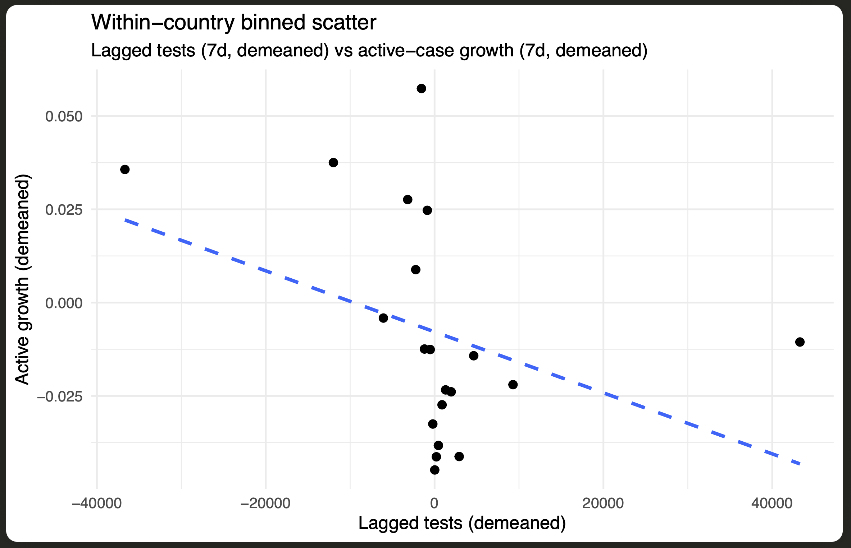
Figure 5 presents the within-country binned scatter plot, which captures how testing and case growth relate within each nation after accounting for country-specific and time-based effects. The fitted line slopes clearly downward, showing that higher lagged testing levels are associated with slower growth in active cases. This pattern holds even when broader differences between countries are removed, meaning the effect is visible inside each country’s own experience rather than being driven by global variation. The figure makes the relationship easy to see at a glance: when testing increases, case growth tends to ease. It also reinforces the study’s central idea that testing provides meaningful benefits not just in international comparisons, but in the everyday management of outbreaks at the national level.

5.5 Interpretation of Results

The combined results from both the statistical models and the visual analyses point to a consistent conclusion: when testing increases, the spread of COVID-19 slows. Across all regression models, countries that carried out more tests tended to see smaller rises in both active and new cases. The lagged effects shown in the distributed-lag plot suggest that these benefits usually appear about one to two weeks after testing levels go up — a window that matches the known infection and reporting cycles. This timing makes sense; more testing allows infected individuals to be identified and isolated earlier, cutting off transmission before it accelerates.

What gives this conclusion weight is the stability of the evidence. The bootstrap and jackknife checks confirmed that the relationship between testing and case growth held steady across repeated samples and different groups of countries. In nearly every version of the model, the regression coefficients stayed negative, showing that the pattern is genuine rather than a statistical fluke.

The visual results add further clarity. The distributed-lag plot highlights the short delay before testing’s effects appear, while the within-country scatter plot offers a clear picture of how higher testing intensity is linked to slower case growth inside individual nations. Taken together, these visuals make the numbers easier to understand and place them in a real-world context. Overall, the evidence shows that testing is a powerful preventive tool — its importance extends beyond diagnosis to guiding early, targeted actions that can slow outbreaks and reduce pressure on healthcare systems.

VI. Discussion
The findings of this study point toward a clear takeaway: steady, large-scale testing plays a major role in slowing the spread of COVID-19. Across all regression models and robustness checks, the effects of lagged testing stayed negative and statistically significant, showing a stable relationship between higher testing rates and slower case growth. Countries that maintained consistent testing efforts generally saw smaller increases in new infections. The results held up under multiple validation methods — bootstrap, placebo, and jackknife tests — indicating that the pattern is broadly applicable and not the result of a few unusual cases or data quirks.
These conclusions fit closely with earlier research. Chinazzi et al. (2020) and Walker et al. (2020) showed that early, widespread testing was among the most effective ways to control transmission, while Flaxman et al. (2020) and Hsiang et al. (2020) highlighted how testing improved the impact of broader public-health measures like lockdowns and travel limits. This study adds to that body of work by putting numbers to the timing of those effects — testing’s strongest influence shows up roughly one to two weeks later — and by confirming that the relationship stays consistent across a range of model setups.
The analysis also sheds light on how testing interacts with other parts of pandemic response. As studies on hospitalization (Docherty et al., 2020) and policy intervention (Flaxman et al., 2020) suggest, countries that tested more actively tended to manage hospital capacity better and avoided the sharp mortality spikes linked to slower reactions. The results here back up that idea, offering data-driven evidence that wide testing indirectly eases healthcare strain by catching infections earlier.
Of course, a few limits need to be noted. The data are observational, so while the association between testing and slower case growth is strong, it should not be read as definitive proof of causation. Countries that test more often may also have stronger health systems or stricter public measures that contribute to similar outcomes. Reporting practices and definitions of “test” vary across regions and could introduce minor inconsistencies. And even though fixed-effects regression controls for many country-level differences, it can’t capture every factor — like compliance, enforcement, or cultural behaviors — that might influence transmission rates.
Even with these caveats, the overall message is consistent. More frequent and timely testing is tied to slower pandemic growth, and that link remains solid across models and visualization methods. The takeaway is both practical and statistical: testing acts as an early-warning tool that helps governments act before outbreaks spiral. By allowing faster isolation, targeted restrictions, and fewer broad lockdowns, testing becomes more than a diagnostic tool — it’s a foundation for smarter, faster pandemic preparedness.

VII. Conclusion

This study set out to test whether higher COVID-19 testing rates were linked to slower pandemic growth. Using a large global dataset along with fixed-effects regressions, resampling checks, and visual analyses, the results consistently pointed in the same direction: countries that tested more often and acted sooner tended to see smaller increases in both active and new cases. The evidence stayed stable across model types, data subsets, and time lags, showing that the relationship between testing and case growth is statistically sound and holds in many national contexts.

The regression results revealed a clear negative link between lagged testing and case growth, while the distributed-lag and binned-scatter plots showed when and how this effect appears. These visuals make it clear that testing’s benefits take a little time to show up — usually about one to two weeks, the same window that fits with infection and reporting cycles. That short delay underlines the preventive side of testing: by finding infections early, governments can isolate people before wider transmission takes off.

These findings also connect well with earlier research. Studies by Chinazzi et al. (2020) and Walker et al. (2020) highlighted the value of early, large-scale testing in slowing the spread. The current analysis builds on that foundation by estimating how quickly the benefits emerge and confirming that the relationship stays strong even when tested across hundreds of resampled or cross-country scenarios. The inclusion of visual evidence — like the regression summary table and the bootstrap and jackknife distributions — adds another layer of clarity and trust in the results.

Beyond the academic insight, the findings have direct policy relevance. Testing is not only a way to confirm infections; it’s a cornerstone of real-time outbreak management. Strong testing systems let governments respond faster, focus restrictions where they are needed most, and keep hospitals from being overwhelmed. By showing that increased and timely testing reliably slows case growth, this work offers a practical, data-based guide for improving readiness in the next public-health emergency.

In short, proactive testing saves lives and limits disruption. As countries prepare for future global health threats, sustained investment in broad, rapid, and flexible testing programs should remain a top priority.

VIII. Future Directions

Building on these results, future research can move in several directions to better understand how testing shapes pandemic outcomes. One step forward would be to broaden the dataset to include indicators such as healthcare capacity, vaccination rates, and policy interventions. Doing so would give a more complete view of how testing interacts with other public health measures. Adding more detailed hospitalization and mortality data — perhaps at weekly or regional levels — could also help clarify the pathways through which testing influences both clinical and system-level outcomes.

A second priority is to use stronger causal inference methods that go beyond correlation and get closer to cause-and-effect relationships. Techniques such as instrumental-variable regression, synthetic control comparisons, or structural equation modeling could help separate the specific impact of testing from overlapping measures like vaccination programs or mobility restrictions. Applying these approaches to standardized, high-frequency data would make it easier to identify how much of the effect truly comes from testing itself.

Another avenue for improvement is to strengthen cross-regional comparisons by adding social and demographic variables to the analysis. Factors like population density, age structure, income inequality, and healthcare access can change how well testing translates into reduced transmission. Understanding these differences would help explain why some countries benefited more from testing than others, even under similar policy conditions.

Finally, improvements in digital infrastructure now make it possible to link real-time epidemiological data with predictive modeling. Machine learning tools and interactive dashboards could track testing performance dynamically, flagging areas where positivity rates rise or coverage falls short. This kind of system would let governments adjust their strategies before outbreaks grow, turning testing data into an active surveillance tool rather than something analyzed only after the fact.

Policy Implications
The results of this study also carry practical lessons for public health decision-making. Testing early and at scale should be viewed as a central part of outbreak management, not just a supportive measure. When testing data are built directly into responsive public health systems, governments can act faster, isolate cases more efficiently, and reduce the economic and social strain caused by sweeping lockdowns. Real-time analysis of testing patterns allows policymakers to adjust their strategies before case numbers rise sharply, helping to protect hospitals and keep communities functioning. Looking ahead, continued investment in rapid, high-capacity testing networks will be one of the most effective ways to strengthen preparedness and save lives during future pandemics.

IX. APPENDIX

A. Reproducibility Statement
All analyses in this study were conducted using the R programming language (version 4.4.0) within RStudio. The project’s complete workflow — including data cleaning, exploratory data analysis, statistical testing, and visualization — was performed using the R Markdown file:
File: Investigating Covid-19 Virus Trends.Rmd
Output: HTML and PDF reports generated directly from the R Markdown script.
This file contains all code necessary to replicate the results presented in the thesis, including data preprocessing steps, regression models, bootstrapping, jackknife analysis, distributed-lag estimation, and visualizations. Each figure and table (e.g., bootstrap_hist.pdf, jackknife_hist.pdf, distributed_lag.pdf, binscatter.pdf, regression_results.pdf) was exported automatically through RStudio using ggsave() and gtsave() commands.
To reproduce the results:
- Download the dataset COVID_tested_worldwide.csv from Kaggle (Dataset Source: https://www.kaggle.com/datasets/lin0li/covid19testing).
- Open the R Markdown file Investigating Covid-19 Virus Trends.Rmd in RStudio.
- Install the required R packages listed in the Libraries section (tidyverse, fixest, modelsummary, ggplot2, boot, etc.).
- Knit the R Markdown file to HTML or PDF to reproduce the full report, including figures and statistical outputs.
All resulting files — including tables and visualizations — are available in the project folder for transparency and reproducibility.

B. File List

File Name | Description
COVID_tested_worldwide.csv | Source dataset used for analysis
COVID_clean_daily_panel.csv | Cleaned dataset after preprocessing
Investigating Covid-19 Virus Trends.Rmd | Main R Markdown analysis script
regression_results.pdf | Summary of fixed-effects regression models
bootstrap_hist.pdf | Distribution of bootstrapped coefficients
jackknife_hist.pdf | Coefficient stability plot (jackknife test)
distributed_lag.pdf | Visualization of testing effects over time
binscatter.pdf | Within-country relationship between tests and case growth
visual_insights.md | Summary of main visual and statistical insights

List of References
Chinazzi, M., Davis, J. T., Ajelli, M., Gioannini, C., Litvinova, M., Merler, S., … & Vespignani, A. (2020). The effect of travel restrictions on the spread of the 2019 novel coronavirus (COVID-19) outbreak. Science, 368(6489), 395–400. https://doi.org/10.1126/science.aba9757
Docherty, A. B., Harrison, E. M., Green, C. A., Hardwick, H. E., Pius, R., Norman, L., … & Semple, M. G. (2020). Features of 20,133 UK patients in hospital with COVID-19 using the ISARIC WHO Clinical Characterisation Protocol: Prospective observational cohort study. BMJ, 369, m1985. https://doi.org/10.1136/bmj.m1985
Flaxman, S., Mishra, S., Gandy, A., Unwin, H. J. T., Mellan, T. A., Coupland, H., … & Bhatt, S. (2020). Estimating the effects of non-pharmaceutical interventions on COVID-19 in Europe. Nature, 584(7820), 257–261. https://doi.org/10.1038/s41586-020-2405-7
Grasselli, G., Zangrillo, A., Zanella, A., Antonelli, M., Cabrini, L., Castelli, A., … & Pesenti, A. (2020). Baseline characteristics and outcomes of 1591 patients infected with SARS-CoV-2 admitted to ICUs of the Lombardy region, Italy. JAMA, 323(16), 1574–1581. https://doi.org/10.1001/jama.2020.5394
Hasell, J., Mathieu, E., Beltekian, D., Macdonald, B., Giattino, C., Ortiz-Ospina, E., … & Roser, M. (2020). A cross-country database of COVID-19 testing. Scientific Data, 7(1), 345. https://doi.org/10.1038/s41597-020-00688-8
Hsiang, S., Allen, D., Annan-Phan, S., Bell, K., Bolliger, I., Chong, T., … & Wu, T. (2020). The effect of large-scale anti-contagion policies on the COVID-19 pandemic. Nature, 584(7820), 262–267. https://doi.org/10.1038/s41586-020-2404-8
Li, R., Pei, S., Chen, B., Song, Y., Zhang, T., Yang, W., & Shaman, J. (2020). Substantial undocumented infection facilitates the rapid dissemination of novel coronavirus (SARS-CoV-2). Science, 368(6490), 489–493. https://doi.org/10.1126/science.abb3221
Li, L., Qin, L., Xu, Z., Yin, Y., Wang, X., Kong, B., … & Xia, J. (2020). Artificial intelligence distinguishes COVID-19 from community-acquired pneumonia on chest CT. Radiology, 296(2), E65–E71. https://doi.org/10.1148/radiol.2020200905
Our World in Data. (2021). Coronavirus (COVID-19) testing dataset. https://ourworldindata.org/coronavirus-testing
Peto, J. (2020). Covid-19 mass testing facilities could end the epidemic rapidly. BMJ, 368, m1163. https://doi.org/10.1136/bmj.m1163
Polack, F. P., Thomas, S. J., Kitchin, N., Absalon, J., Gurtman, A., Lockhart, S., … & Gruber, W. C. (2020). Safety and efficacy of the BNT162b2 mRNA Covid-19 vaccine. New England Journal of Medicine, 383(27), 2603–2615. https://doi.org/10.1056/NEJMoa2034577
RECOVERY Collaborative Group. (2020). Dexamethasone in hospitalized patients with Covid-19 — Preliminary report. New England Journal of Medicine, 384(8), 693–704. https://doi.org/10.1056/NEJMoa2021436
Richardson, S., Hirsch, J. S., Narasimhan, M., Crawford, J. M., McGinn, T., Davidson, K. W., … & Northwell COVID-19 Research Consortium. (2020). Presenting characteristics, comorbidities, and outcomes among 5700 patients hospitalized with COVID-19 in the New York City area. JAMA, 323(20), 2052–2059. https://doi.org/10.1001/jama.2020.6775
Walker, P. G. T., Whittaker, C., Watson, O. J., Baguelin, M., Ainslie, K. E. C., Bhatia, S., … & Ferguson, N. M. (2020). The impact of COVID-19 and strategies for mitigation and suppression in low- and middle-income countries. Science, 369(6502), 413–422. https://doi.org/10.1126/science.abc0035
World Health Organization. (2020). Coronavirus disease (COVID-19) situation reports. World Health Organization. https://www.who.int/emergencies/diseases/novel-coronavirus-2019/situation-reports

Link to the References

Investigating COVID-19 Virus Trends

