**ENTS 656 INTRODUCTION TO CELLULAR COMMUNICATION NETWORKS**

BASE STATION SIMULATION PROJECT REPORT

Name : Rohith Prabha Krishnan

UID : 114203274

**INTRODUCTION**

The basestation that needed to be simulated was a sectored base station, having 3 sectors namely alpha , beta and gamma having 15 taffic channels on each sector.

**NOTATIONS USED IN SCREENSHOTS (For each sector):**

Unused_ch: Number of curently unsused channel

Call_A: Call Attempts

Call_C: Call Completed

HO_A: Handoff Attempted

HO_S: Handoff Successfully completed

HO_F: Failed Handoffs

DR_S: Dropped call due to low signal strength

DR_C: Dropped call due to capacity constraint

BL_C: Blocked call due to capaciy constraint

Each variable shown above is calculated on an hourly basis and printed out, and at the end of simulation, the cumulative report is also shown.

The simulation was written in python on the PyCharm IDE. The following screenshots were also taken from the IDE.

Q1.

When the simulation is run under default conditions, we find that the base station performs really well. For this simulation, the number of succesful attempts and handoffs are the same. Also there are no dropped call due to capacity problems.

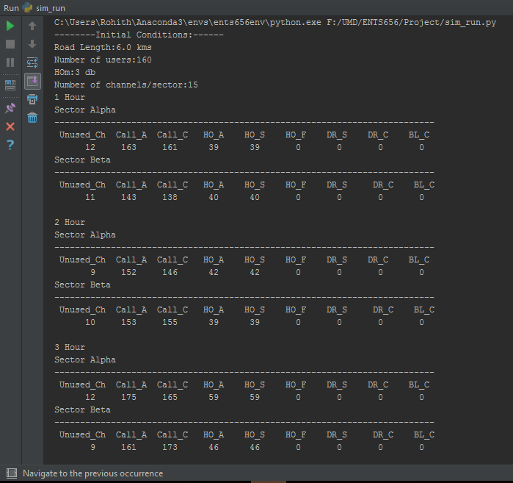

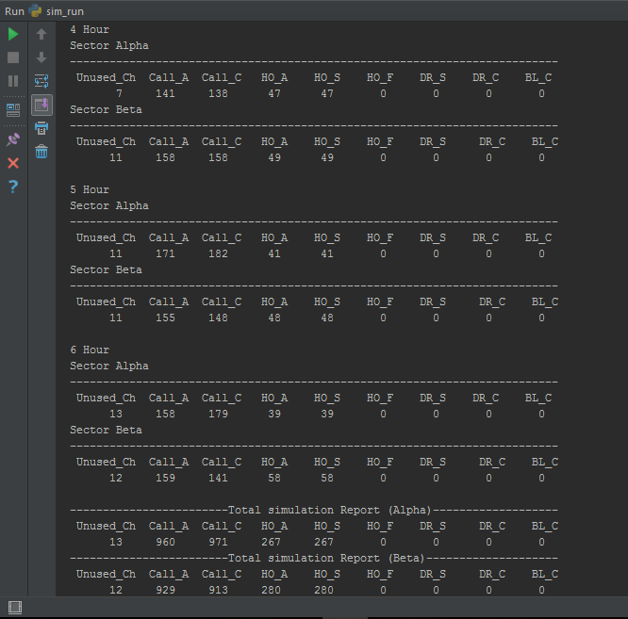

Q.2

When the length of the road is increased we find that there is a considerable increase in the number of dropped calls due to signal strength in Beta sector. This is due the fact that Alpha sector antenna is able to cover almost entire length of the road towards the north (Direction of antenna and the users are almost aligned), whereas for Beta sector this is not the case. As you move southwards, the RSL keeps decreasing and when it goes beyond the threshold, the call is dropped.

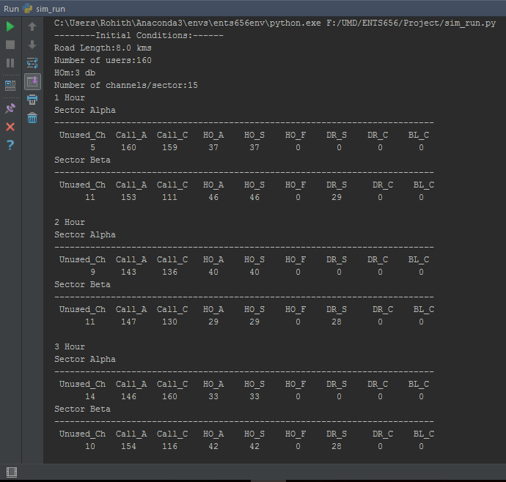

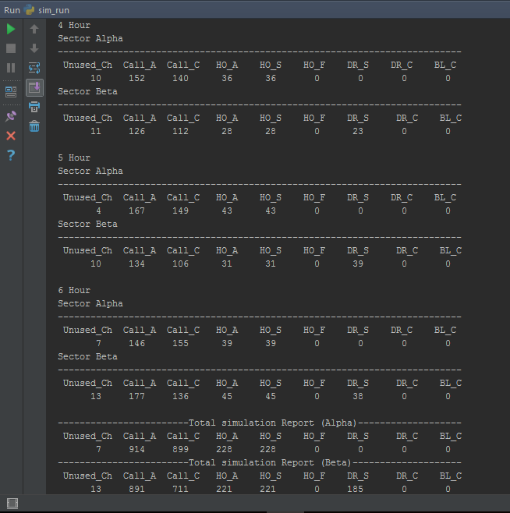

Q3.

When the number of users are doubled, the average number of calls per hour also go up i.e. 320*2 = 640 calls/hour. Since there are only 15 channels available per sector, there is a possibility that all 15 channels are being used and a call is being initiated. The call will have to be dropped and as expected the number of blocked calls due to capacity, handoff failures etc. go up.

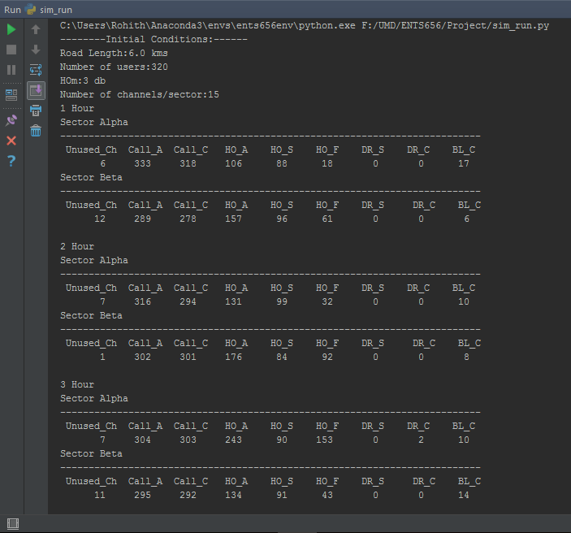

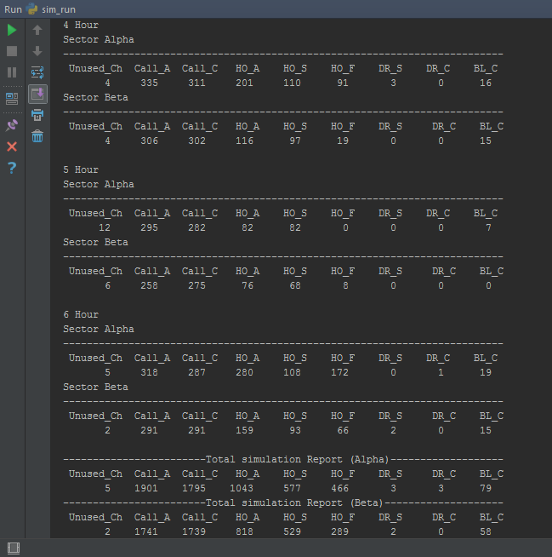

Q.4

a) When the HOm is made 5db, the number of handoffs in each sector has gone down compared to 3db.

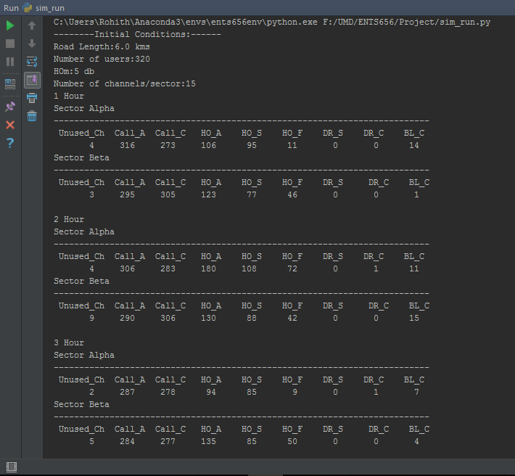

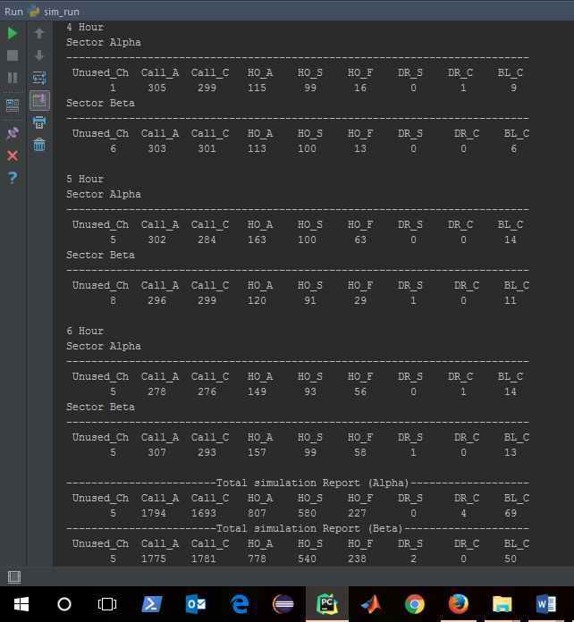

b) When the HOm is reduced to 0 dB, we find that the number of handoffs in each sector has increased.

