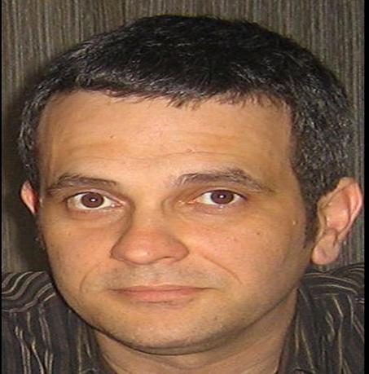

**Dzhon Entonii Peppe**

**E-Mail: johnpeppe@gmail.com**

**Skype: jp021569**

**Telephone: +380503808387**

|  |
| --- |
|  |

**GENERAL QUALIFICATIONS:**

* Over 15 years of success in software product development and management
* Main skills: Leadership; Analytical, Organizational, Agile, Lean, Scrum, Javascript, Java, iOS & Android Development; OOP & OOD

**EDUCATION: 1992, AAS** ofComputer Information Systemsat **DeVry University**

**1999 BSc** in Business Information Technology at **University of Phoenix**

**2004 MBA** at **The George Washington University**

**TECHNICAL SUMMARY:**

**SOFTWARE:** **Programming languages** (elementary)**:** SWIFT, JavaScript, HTML 5, CSS 3

**Operating Systems:** Mac OS, Windows 10/8

**IDE/Compilers/Tools:** , Xcode, Eclipse, Git, BitBucket

**Project Management Tools:** Redmine, Trello, JIRA, Confluence, Visio

**Project Management Frameworks:** Scrum, Agile, Kanban

**DataBases:** MySQL, PostgreSQL, MongoDB, Cassandra

**CERTIFICATIONS:** PMI: Project Management Professional

Scrum Alliance – Certified Scrum Product Owner

FreeCodeCamp - Certified Front-End Developer

Certified Mango Developer

University of Alberta (Canada) – Product Management Professional

**PROFESSIONAL EXPERIENCE:**

**Dec/16– Current 247 Labs**

*Chief Product Officer*

Act as product owner for up to 8 concurrent customer (outsourced) projects and lead scrum teams of 3-7 engineers plus Scrum Master (in most cases) and Designer for each client engagement. Specializing in delivery of native and cross platform mobile apps in the Financial Services, Telecom and Ecommerce industries.

Establish companywide processes and procedures for business analysis, requirements documentation, and agile – scrum mix project management.

Act as Chief Product Owner for companywide project realization and customer requirement process improvements. Projects delivered: [www.lennylemons.com](http://www.lennylemons.com); [www.foscam.com/us](http://www.foscam.com/us); 247 ARApp Wordpress Plugin; Auto-Tagger AI Shopify Plugin; [www.huntinglocatop/maps](http://www.huntinglocatop/maps); 247 Blockchain / crypto currency Proof of Concept

**Dec/16– Aug/2017 DevArt**

*WebApp Consultant*

Product owner on Skyvia WebApp to create and improve back office commercial automations and reporting systems. Architected and developed the back-up and integration platforms specifically.

**Oct/16– Mar/17 Freelance**

*Project Management and Mobile Software**Developer*

***PokeRadar***

***Scribesoft***

***Salsa Labs***

***Devslopes***

Contribute to creation and development of iOS and Web applications. This includes contributions to the number 2 most downloaded gaming app in the iTunes app store

**Aug/15– Nov/16** **Global Fleet Management (http://www.positrace.com/)**

*Product Owner and Scrum Master - Mobile Application*

***Positrace***

Organized and managed the development and positioning of the mobile versions (iOS and Android) of the popular asset tracking system. The app is available for download on the Apple App Store and at Google Play.

**Jan/10– Jul/15 Scorto (http://www.scorto.com)**

*Chief Product Owner and Head of Marketing*

Acted as product owner and project director in the creation of 2 new platforms/business lines (TK Lender(MERN stack)) and Credit Bureau Platform (C# / .NET) and delivering solutions to 22 countries  worldwide. Helped expand the company commercially 17 new countries and 2 new business segments (elending and credit bureaus).

**Nov/08– Dec/09 Intetics (www.intetics.com)**

*Vice President of Sales and Marketing*

Developed and lead sales and marketing operations for large ITO.

**Sep/05- Nov/08 UT Starcom**

*Director of Engineering and Operations*

Product owner and program director for all aspects of software related design and implementation / deployment in mobile handsets as well as infrastructure solutions & interfaces.

**Apr/99- Sep/05 Nextel Communications**

*Director of Handset Application Development*

Project manager for first on-line mobile app marketplace (inc/sync 2001). Product owner for first group of commercially available Java Based (J2ME) mobile handset applications (tracking system, timesheets, supply chain (ordering, invoicing, etc.)

**Languages:** English (Native)

Russian (Upper Intermediate)

Italian (Intermediate)

Ukrainian (Lower Intermediate)

**Citizenship:** Ukrainian

**References:** Available on Request