Development of integration of Media App and PDM is done in [branch PDM-Integration](https://github.wdf.sap.corp/DPP-showcase-application/news_paper_scenario/tree/PDM-Integration) of media app repository.

# Steps done

* Create PDM instance, name: pdm-media-app, used [config](file:///C:\Users\I335272\Desktop\mini%20assignment\(https:\github.wdf.sap.corp\DPP-showcase-application\news_paper_scenario\blob\PDM-Integration\src\main\resources\dpp\creationConfig.json)
* Bind PDM instance pdm-media-app to application: media-app, used [config](https://github.wdf.sap.corp/DPP-showcase-application/news_paper_scenario/blob/PDM-Integration/src/main/resources/dpp/config.json)
* Create PDM metadata file (for [Customers, Subscriptions, Orders](https://github.wdf.sap.corp/DPP-showcase-application/news_paper_scenario/blob/PDM-Integration/src/main/resources/dpp/pdmMetadata.json))
* Expose PDM metadata file via [service](https://github.wdf.sap.corp/DPP-showcase-application/news_paper_scenario/blob/PDM-Integration/src/main/java/com/sap/showcase/dpp/controllers/DppController.java#L26)
* Grant/Set authorization for PDM to call Media App services (for app media-app set user variable SAP_JWT_TRUST_ACL to: "[{\"clientid\":\"sb-pdm-personal-data-manager-clone!b35|personal-data-manager!b37\",\"identityzone\":\"*\"}]"). Currently scopes are not used in Media App so no need to set them.
* Create API to search for data subjects - endpoint [/api/dpp/v1/customers](https://github.wdf.sap.corp/DPP-showcase-application/news_paper_scenario/blob/PDM-Integration/src/main/java/com/sap/showcase/dpp/controllers/DppController.java#L32), supports optional search fields customerNumber, firstName, lastName, email
* Create API to retrieve information of a data subject, created endpoints [/api/dpp/v1/subscriptions](https://github.wdf.sap.corp/DPP-showcase-application/news_paper_scenario/blob/PDM-Integration/src/main/java/com/sap/showcase/dpp/controllers/DppController.java#L44) and [/api/dpp/v1/orders](https://github.wdf.sap.corp/DPP-showcase-application/news_paper_scenario/blob/PDM-Integration/src/main/java/com/sap/showcase/dpp/controllers/DppController.java#L54), both support optional parameter customerNumber to filter data
* The URL for pdm in different landscapes is as mentioned below -
  + In canary - https://<tenant>-pdm-portal.cfapps.sap.hana.ondemand.com – for which you need to create JIRA from clone [HCPSR-25177](https://jtrack.wdf.sap.corp/browse/HCPSR-25177), to onboard for every tenant.
  + In EU10 – https://<tenant>.pdm-portal.cfapps.eu10.hana.ondemand.com.
* Subscribe tenant, done via email from member of PDM team. We have fixed tenant sap-icf.
* In CF cockpit create Role Collection PDM and add to it all PDM roles and assign it to users
* Test on <https://sap-icf-pdm-portal.cfapps.sap.hana.ondemand.com/sites#Shell-home>

# Endpoints

All these are for GET call:

* <https://media-app.cfapps.sap.hana.ondemand.com/api/dpp/v1/metadata>
* <https://media-app.cfapps.sap.hana.ondemand.com/api/dpp/v1/customers> - supports search parameters customerID, firstName, lastName and email
* <https://media-app.cfapps.sap.hana.ondemand.com/api/dpp/v1/subscriptions> - supports search parameters customerID
* <https://media-app.cfapps.sap.hana.ondemand.com/api/dpp/v1/orders> - supports search parameters customerID

# Example data

<https://revcloud-dev-eu10-temp-pdm-portal.cfapps.eu10.hana.ondemand.com/sites#Shell-home>

logon, use customer = 5419379605

# Solved problems

If you get error when creating Personal Data Manager service instance (both via cf client and web dashboard): FAILED Server error, status code: 502, error code: 10001, message: Service broker error: Internal Server Error, it is caused by wrong parameters.

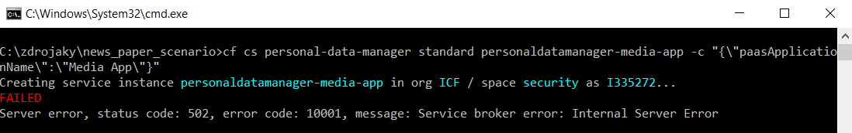

There is a new version of Personal Data Manager PAAS Application Onboarding document – it is called: Personal Data Manager PAAS Application Onboarding.docx and can be found at: <https://jam4.sapjam.com/groups/Zys5oEXhQIvDej2ReIn99f/content?folder_id=n2zyZSxj2rSEFz0AmDANSI>

This new version explains right parameters.

No filters in Manage Personal Data application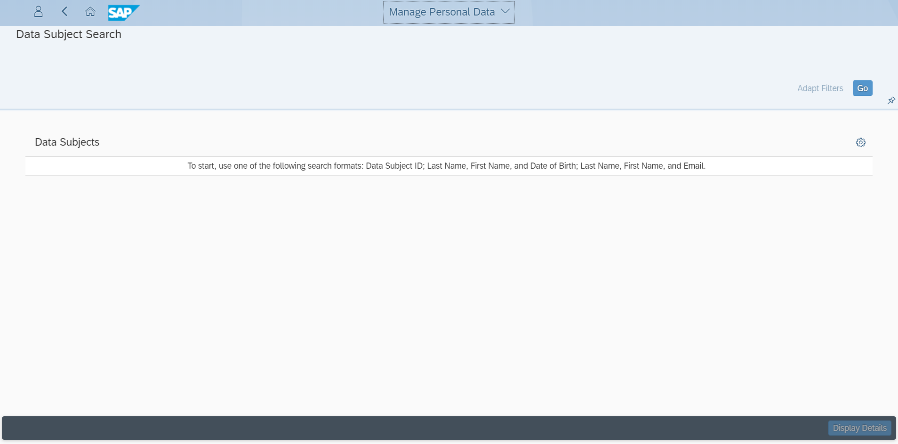

It is caused by not working communication between PDM and media app. The error when getting metadata file from PD was that: No verification key was found.

This was solved bz updating dependency java-container-security from version 0.27.3 to version 0.30.1.